**Assignment- 1**

1. Snapshot of **Report View** from **Power BI Desktop.**

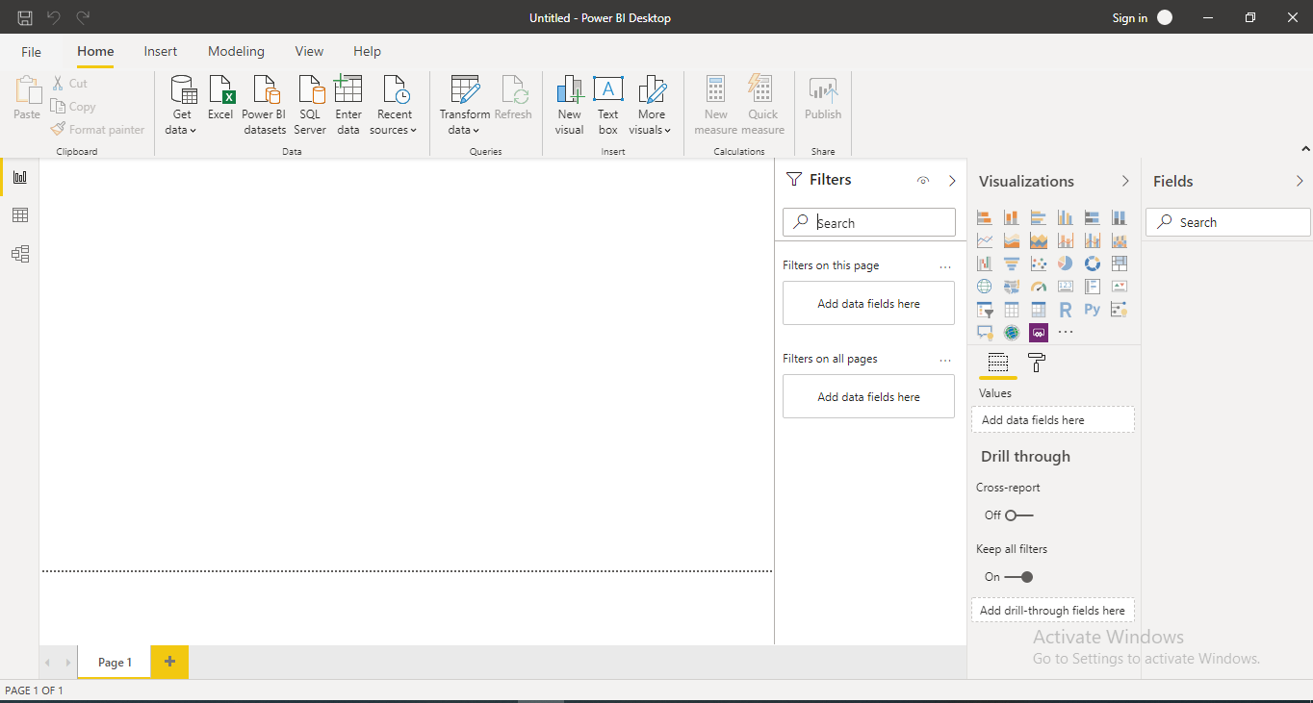

1. Snapshot of **Power Query Editor**

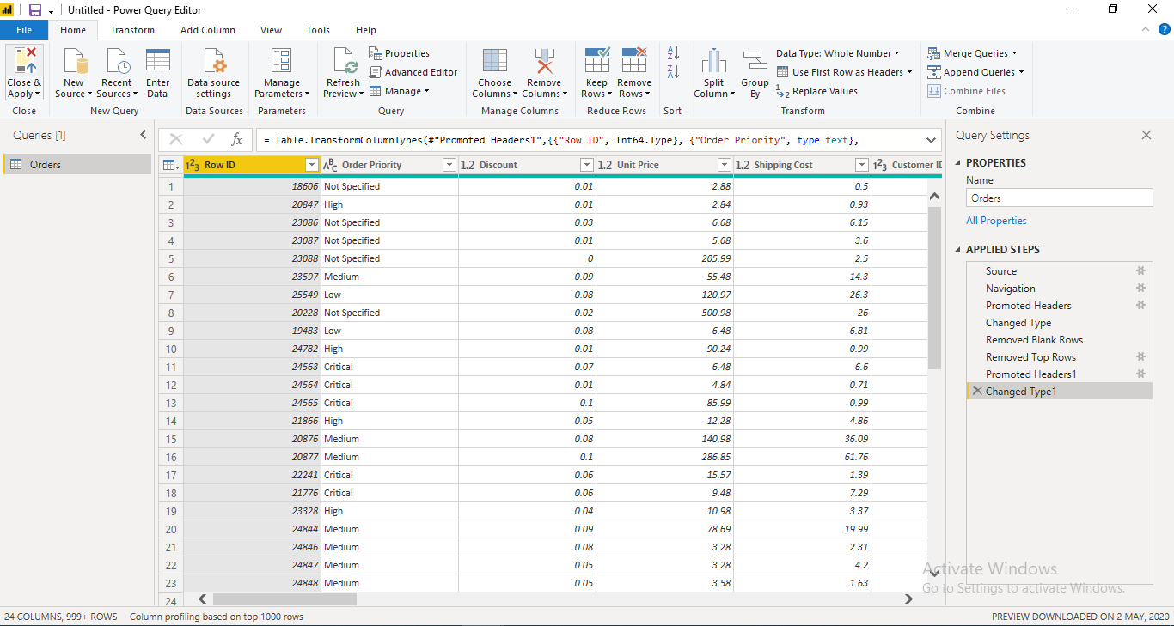

1. Snapshot of **Advanced Editor** from **Power Query Editor**

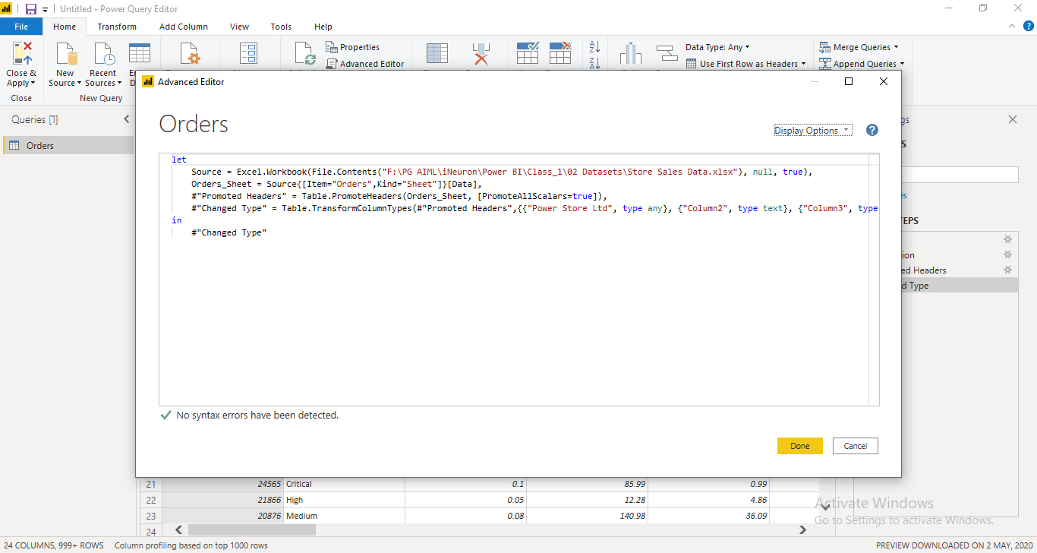

1. Snapshot of **Report** view

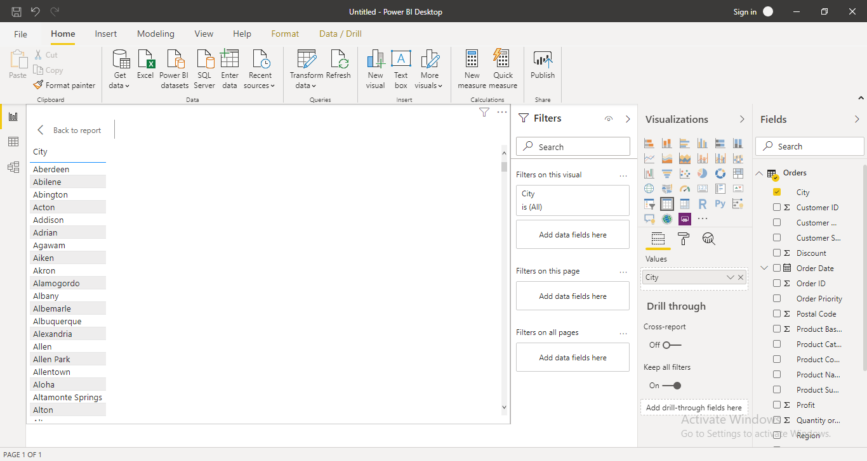

1. Snapshot of **Data** view

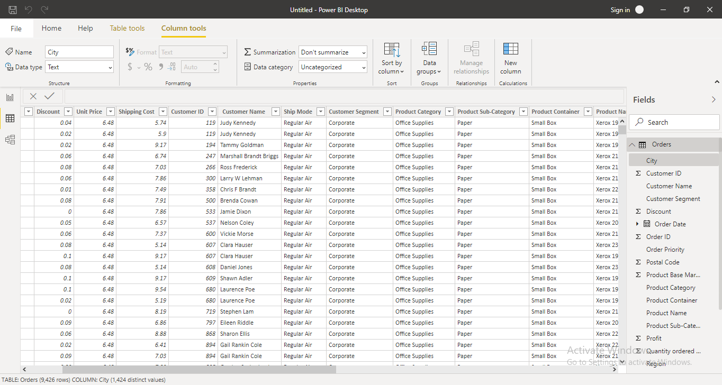

1. Snapshot of **Model** view

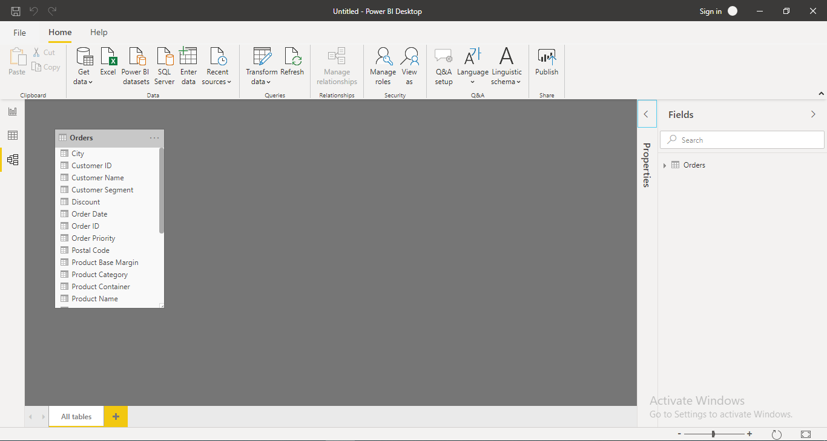

1. Snapshot of **Pro** and **Premium** prices

