# Phase 5: IOT Based FLOOD MONITORING AND EARLY WARNING SYSTEM

**Introduction:**

“IOT-based-Cantralized-Remote-Sensing-for-Early-Flood-Detection” the objective of this telemetry based project is to monitor the flood situation at the earliest and send a notification in case of danger on the webpage. The notification sent can be read globally through IOT. An ultrasonic sensor is connected to the microcontroller that measures the value of water in the dams or rivers and sends that information to the microcontroller. The GPRS sends that notification through the internet on the webpage using IOT network.

 “Flood Monitoring and Early Warning System Using Ultrasonic Sensor”  it envisions a safe, prepared and less casualty community before, during and after typhoon devastation. The model also promotes the use of real-time monitoring system through the developed web-based application and SMS notification system as an easy medium in disseminating information particularly in the remote areas. By allowing the system in two-way communication, it gives more flexibility in providing important information to the community.

“SMS Based Early Flood Warning System Using Raspberry PI” [3] this project is about designing a system that can measure the speed of the rise of the water level at the potential flooded area. Raspberry Pi is used to collect the data from the water sensor and transmit the data to GSM Module to send the alert by using an SMS via a mobile phone. The analysis will be done to show how the Raspberry Pi will be integrated with the smartphone to give an alert. The system will be tested in order to ensure that all specifications needed have been met. A performance test will also be run in order to see the efficiency of the system.

**The solution**

The Community-based Flood Early-warning System is an ICT-enabled system to detect and respond to flood emergencies that are prepared and managed by the communities. The wireless system manages flood or flash flood risk by providing early warnings to downstream communities and enhances cooperation between upstream and downstream communities in the sharing of flood information.

This ICT solution consists of two units – a transmitter and a receiver. The transmitter is installed along the riverbank, and the receiver is installed at a house near the river. A flood sensor attached to the transmitter detects rising water levels. When the water reaches a critical level, a signal is wirelessly transmitted to the receiver. The flood warning is then disseminated via mobile phone to concerned agencies and vulnerable communities downstream. Critical flood levels are set with the help of the local community.

**New innovative system for early flood warning**

An innovative system developed through a Tamworth Regional Council-led project will give residents of Bundle and Wolman earlier flood warning notice. Tamworth Regional Council and the NSW State Emergency Service Western Region has worked with consultants Water Technology Pty Ltd and the Bureau of Meteorology over the last year to develop the Flood Early Warning System.

The project was jointly funded by Council, the NSW Government and the Australian Government under the Natural Disaster Resilience Program.

Tamworth Regional Council Manager Strategy, Assets and Design, Graeme McKenzie said the system is the first of its type in the NSW State Emergency Service Western Region.

“The system uses flow monitoring in creeks and rivers in conjunction with predicted rainfall from the Bureau of Meteorology to identify the risk of flooding and the possible magnitude of the flooding,” he said. “The SES and Council will receive automated alerts and the Wolman and rundle communities will benefit significantly through improved flood management and earlier warning of flood events in the upper reaches of the Peel Catchment.’’

Tamworth Regional Council storm water engineer Aidan Pugh said the key to the new system was the addition of a river gauge in Duncan’s Creek.

“With Wolman being at the junction of the Peel River and Duncan’s Creek, flooding of Wolman can occur from either source,” he said. “The installation of the gauge provides real time monitoring of flows – this has not been available for the SES or Council before.

“The remainder of the system is the really clever bit which uses the predicted rainfall and actual rainfall to allow early warning in relation to possible flooding.”

Residents of rundle and Wolman have been invited to a community information session tomorrow at Wolman Community Hall from 10.30am to learn more about the Flood Early Warning System and have the chance to increase their knowledge of flood in Wolman. They will also be encouraged to sign-up to receive SMS notifications to ensure they are better prepared for moderate or major flooding.

**HC-SR04 Ultrasonic Distance Sensor:**

|  |  |
| --- | --- |
| **VCC** | **Voltage supply (5V)** |
| **TRIG** | **Pulse to start the measurement** |
| **ECHO** | **Measure the high pulse length to get the distance** |
| **GND** | **Ground.** |

**Operation**[**​**](https://docs.wokwi.com/parts/wokwi-hc-sr04#operation)**:**

**To start a new distance measurement set the TRIG pin to high for 10uS or more. Then wait until the ECHO pin goes high, and count the time it stays high (pulse length). The length of the ECHO high pulse is proportional to the distance. Use the following table to convert the ECHO pulse length in microseconds into centimeters / inches.**

**A piezoelectric buzzer:**

**Operation modes**[**​**](https://docs.wokwi.com/parts/wokwi-buzzer#operation-modes)**:**

**The buzzer can operate in two modes: "smooth" (the default) and "accurate".**

**"smooth" sounds better and is suitable for simple, single-frequency tones. Use it when playing a melody or playing tones with Arduino's tone() function. Complex and polyphonic sounds may not play correctly (or not play at all) in "smooth mode"**

**Use the "accurate" mode when you need to play complex sounds. It will accurately play the sound you feed in. However, it'll add audible click noises to your sound. These noises are due to fluctuations in the simulation speed - it's not always able to provide the complete sound buffer in real time**.

**Digital Humidity and Temperature sensor.**

|  |  |
| --- | --- |
| **VCC** | **Positive voltage** |
| **SDA** | **Digital data pin (input/output)** |
| **NC** | **Not connected** |

**Flood Monitoring and Early Warning System:**

This IOT-based project involves building a smart water management system that can remotely monitor a particular liquid’s level and prevent it from overflowing. This project holds immense value for the industrial sector that uses large volumes of fluids in its day-to-day operations. Apart from detecting a liquid’s level, this monitoring system can also be used to track the usage of specific chemicals and to detect leaks in pipelines.

The system is fitted with ultrasonic, conductive, and float sensors. A Wi-Fi module helps connect the system to the Internet and facilitates data transmission. Four ultrasonic sensors help transmit the data on the liquid level and alert the user on the same.

**Flood Monitoring and Early Warning System:**

Floods are a common natural disaster that occurs almost every year in our country. Floods not only destroy agricultural fields and produce, but they also cause significant damage to vast stretches of area and property. This is why early flood detection is extremely vital to prevent the loss of life and valuable assets.

This IOT-based flood detection system is built to monitor and track different natural factors (humidity, temperature, water level, etc.) to predict a flood, thereby allowing us to take the necessary measures to minimize the damage caused. This IOT project uses sensors to collect data for all the relevant natural factors. For instance, a digital temperature humidity sensor detects fluctuations in humidity and temperature. On the other hand, a float sensor continually monitors the water level.

Besides providing a system equipped with temperature sensors and float sensors to gauge the possible flood conditions, comprehending the geographical features of the space can help create shelters and collect required amenities beforehand. At the same time, flood detection systems are capable enough to gauge the time a fresh wave of the flood could take to reach a particular location. Systems like these are significant to maintaining the well-being of communities. Advanced detection systems created through IOT projects for final year can alert residents in time, allowing for early evacuation planning.

**Benefits of Flood Detection System**

* Risk Management
* Helps in saving lives
* Allows the stakeholders to save infrastructure
* Cost-effective
* Time effective
* Real-time data
* Flood forecasting
* Mapping using GIS

**Components of Flood Detection System-**

* Water Sensor
* Wind Sensor
* Data management
* Ultrasonic sensor
* Power Supply
* Microcontrollers
* Modem

Web Development Based on IOT:

**1. Improved Efficiency and Productivity**

One of the primary advantages of IOT projects is the ability to streamline processes and optimize resource usage. Businesses can monitor and manage operations in real time by deploying IOT-enabled sensors and devices. This leads to enhanced efficiency, reduced downtime, and improved overall productivity. For instance, in manufacturing, IOT sensors can track production lines, identifying bottlenecks and potential failures, allowing for timely maintenance and minimal disruptions.

**2. Enhanced Data Collection and Analysis**

IOT projects generate vast amounts of data from connected devices and sensors. This data offers valuable insights into operations, customer behavior, and equipment performance. Businesses can make informed decisions, identify trends, and predict outcomes through data analysis, leading to better planning and resource allocation.

**3. Cost Savings and Resource Management**

Optimizing resource usage not only improves efficiency but also leads to cost savings. IOT projects help organizations monitor energy consumption, water usage, and other resources, allowing for better control and conservation. Smart grids, for instance, can adjust energy distribution based on real-time demand, reducing waste and cutting costs for both providers and consumers.

**4. Remote Monitoring and Control**

IOT projects enable remote monitoring and control of devices and systems, offering convenience and safety. For example, IOT-enabled medical devices can transmit patient data to healthcare providers, enabling remote monitoring and timely intervention. Similarly, farmers can remotely monitor crops and irrigation systems in agriculture, optimizing agricultural practices and minimizing manual labor.

**5. Enhanced Customer Experience**

IOT applications can potentially revolutionize the customer experience by providing personalized and connected services. Smart homes with IOT devices offer seamless automation and control, enhancing comfort and convenience for residents. Retailers can leverage IOT data to offer personalized recommendations and targeted marketing, increasing customer satisfaction and loyalty.

**6. Predictive Maintenance**

One of the most significant advantages of IOT projects is predictive maintenance. By continuously monitoring the condition of equipment and machinery, businesses can predict when maintenance is needed before a breakdown occurs. This approach reduces downtime, extends the lifespan of assets, and minimizes maintenance costs.

**7. Safety and Security**

IOT projects ideas can significantly improve safety in various environments. In industrial settings, IOT sensors can monitor workplace conditions, detect potential hazards, and ensure safety regulations compliance. Smart cities can use IOT to monitor traffic and public spaces, enhancing security and emergency response capabilities.

**8. Sustainable and Eco-Friendly Solutions**

IOT projects contribute to sustainability efforts by promoting smart and eco-friendly practices. Smart buildings can optimize energy consumption based on occupancy levels, reducing carbon footprints. IOT-enabled waste management systems can also improve recycling efforts and reduce waste generation.

**9. Innovation and Competitiveness**

Organizations that embrace IOT projects ideas gain a competitive edge by offering innovative solutions and services. IOT-driven insights and data analytics open new opportunities for businesses to differentiate themselves in the market and adapt to evolving customer needs.

**10. Transforming Industries and Creating Smart Cities**

They are instrumental in transforming industries and creating smart cities. IOT enables remote patient monitoring and telemedicine in healthcare, revolutionizing healthcare delivery. IOT-based precision farming techniques enhance crop yields while minimizing resource usage in agriculture. For transportation, IOT applications improve logistics and public transportation efficiency, reducing congestion and carbon emissions in smart cities.

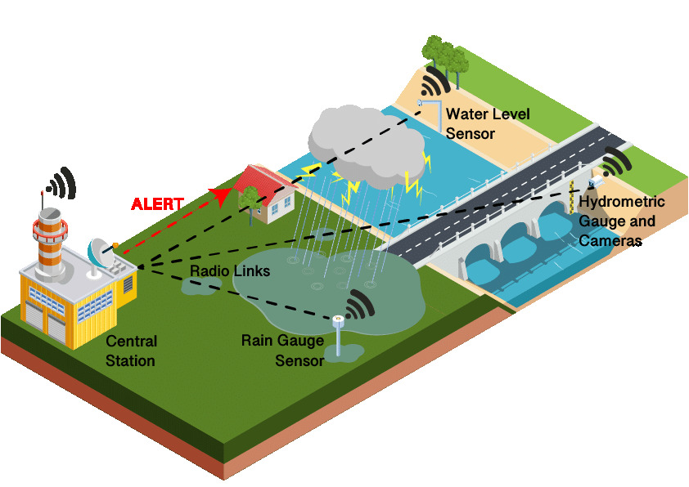

**Program:**

**import time**

**import machine**

**import dht**

**TRIG_PIN = machine.Pin(2, machine.Pin.OUT)**

**ECHO_PIN = machine.Pin(3, machine.Pin.IN)**

**BUZZER_PIN = machine.Pin(4, machine.Pin.OUT)**

**DHT_PIN = machine.Pin(5)**

**LED_PIN = machine.Pin(6, machine.Pin.OUT)**

**def distance_measurement():**

**TRIG_PIN.on()**

**time.sleep_us(10)**

**TRIG_PIN.off()**

**while not ECHO_PIN.value():**

**pass**

**pulse_start = time.tick**

**while ECHO_PIN.value():**

**pass**

**pulse_end = time.ticks_us()**

**pulse_duration = time.ticks_diff(pulse_end, pulse_start)**

**distance = pulse_duration / 58**

**return distance**

**def read_dht_sensor():**

**d = dht.DHT22(DHT_PIN)**

**d.measure()**

**return d.temperature(), d.humidity()**

**buzz_start_time = None**

**while True:**

**dist = distance_measurement()**

**temp, humidity = read_dht_sensor()**

**if dist > 50:**

**BUZZER_PIN.on()**

**LED_PIN.on()**

**status = "Flooding Detected"**

**buzz_start_time = time.ticks_ms()**

**elif buzz_start_time is not None and time.ticks_diff(time.ticks_ms(), buzz_start_time) >= 60000:**

**BUZZER_PIN.off()**

**LED_PIN.off()**

**status = "No Flooding Detected"**

**else:**

**status = "No Flooding Detected"**

**print(f"Distance: {dist:.2f} cm")**

**print(f"Temperature: {temp:.2f}°C, Humidity: {humidity:.2f}%")**

**print("Status:", status)**

**time.sleep(2)**

**OUTPUT:**

**Distance: 260.59 cm**

**Temperature: 24.00°C, Humidity: 40.00%**

**Status: Flooding Detected**