PROJECT DOCUMENTATION
UPI Payment Behaviour, Failure and Fraud Analytics Using 2024 Transaction Data
Python (Google Colab) and Power BI
Prepared by: Vinoth
Course: Data Analytics with AI (Entri Elevate)
Dataset: UPI Transactions 2024 (Kaggle)
Date: October 2026

1. Project Overview and Objective
This project analyses 250,000 UPI (Unified Payments Interface) transactions from 2024 to understand how customers, merchants and banks use digital payments, and where payments fail or face fraud. The raw data was cleaned and explored in Python (Google Colab), and two interactive Power BI dashboards were built to present the results.
Objectives
- Clean and prepare the raw transaction data for analysis
- Measure payment failure and fraud rates by network, month, hour and transaction amount
- Understand customer, merchant and bank behaviour by time, category, age group, state and bank
- Present the results in interactive dashboards and turn them into practical recommendations

2. Data Source
Item | Details
Dataset | UPI Transactions 2024 (upi_transactions_2024.csv)
Source | Kaggle, public dataset
Timeline | January to December 2024
Domain | Digital payments / FinTech
Raw data | 17 columns: 13 categorical and 4 numerical
Cleaned data | upi_cleaned.csv: 250,000 rows and 28 columns

3. Problem Statement
To analyse UPI payment behaviour, failure and fraud patterns in 2024 transaction data, and to give evidence-based recommendations for improving payment reliability, security and customer engagement.
Key questions
- Which networks, months and hours have the highest payment failure rates?
- How does fraud vary by month and by transaction amount?
- When do customers pay (day and time of day), and what do they pay for?
- Which age groups, states and banks drive most UPI traffic?
- How much of the activity is between accounts of the same bank?

4. Attribute (Column) Details
The table lists the key columns used in the analysis.
Attribute name | Data type | Description
transaction_id | String (ID) | Unique identifier of each transaction
timestamp | Date and time | Date and time of the transaction
transaction_type | Categorical | P2P, P2M, Bill Payment or Recharge
merchant_category | Categorical | Type of merchant paid, such as Grocery, Food or Shopping
amount_inr | Numeric (decimal) | Transaction amount in Indian rupees
transaction_status | Categorical | Whether the transaction succeeded or failed
sender_age_group | Categorical | Age group of the sender (18-25 to 56+)
receiver_age_group | Categorical | Age group of the receiver
sender_state | Categorical | State of the sender
sender_bank | Categorical | Bank of the sender
receiver_bank | Categorical | Bank of the receiver
device_type | Categorical | Device used for the payment
network_type | Categorical | Network used: 3G, 4G, 5G or WiFi
fraud_flag | Numeric (0 or 1) | 1 if the transaction was flagged as fraud
hour_of_day | Numeric (integer) | Hour of the transaction (0 to 23)
day_of_week | Categorical | Day of the week
is_weekend | Numeric (0 or 1) | 1 if the transaction took place on a weekend
month, quarter | Derived | Month and quarter taken from the timestamp
time_of_day | Derived (categorical) | Night, Morning, Afternoon, Evening or Late Night, based on the hour
amount_category | Derived (categorical) | Low, Medium, High or Very High, based on the amount
same_bank | Derived | Shows whether sender and receiver use the same bank

5. Tools and Technologies
Tool | Purpose
Python (pandas), Google Colab | Data loading, cleaning, pre-processing and exploratory data analysis
Power BI Desktop | Data modelling, DAX measures, visualisation and interactive dashboards
DAX | Calculated measures and helper columns
Kaggle | Source of the dataset

6. Data Pre-Processing (Python, Google Colab)
Tasks performed
- Loaded the raw CSV file and checked its shape, data types and summary
- Checked for missing values and duplicate records and treated them
- Standardised column names and formats (lower case with underscores)
- Converted the timestamp to a date-time type
- Created derived columns: month, quarter, time_of_day, amount_category and same_bank
- Saved the final file as upi_cleaned.csv (250,000 rows, 28 columns) for Power BI

7. Exploratory Data Analysis
Univariate, bivariate and multivariate analysis was carried out in Google Colab. Each chart is followed by a written interpretation in the notebook (Stage 3). The main patterns found were then built into the Power BI dashboards.

8. Data Modelling and DAX (Power BI)

Data model
The cleaned data is a single flat table with one row per transaction, so the model uses one table, upi_cleaned, and no relationships were needed.
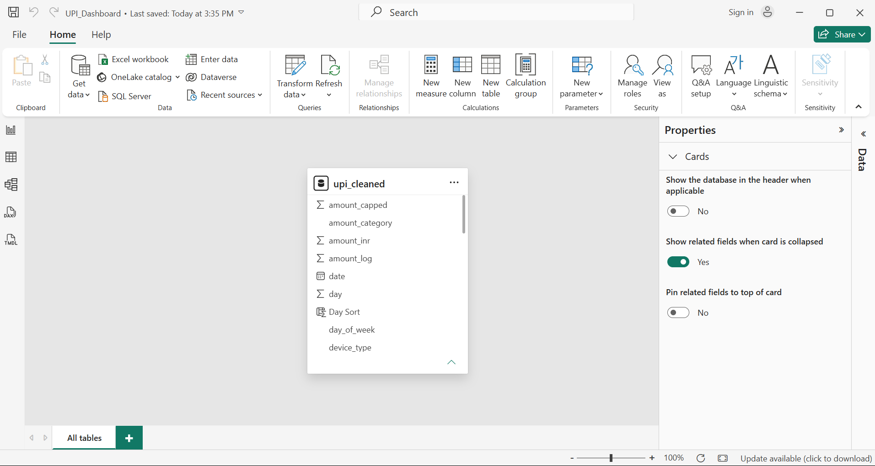

DAX measures and calculated columns
Name | Type | What it calculates
Total Transactions | Measure | Number of transactions (count of rows)
Total Amount | Measure | Sum of all transaction amounts in INR
Failure Rate | Measure | Failed transactions divided by total transactions
Fraud Rate | Measure | Fraud-flagged transactions divided by total transactions
Avg Daily Transactions | Measure | Total transactions divided by the number of days
Avg Transaction Value | Measure | Total amount divided by total transactions
Weekend Share % | Measure | Weekend transactions divided by total transactions
Same-Bank Share % | Measure | Same-bank transactions divided by total transactions
Day Sort, Time Sort | Calculated columns | Sort order for days of the week and times of day in the matrix

9. Analysis and Visualisations (Power BI)
Two dashboards were built in the same Power BI file (UPI_Dashboard.pbix) using the Midnight Emerald theme. Every visual has a clear title and data labels.

Dashboard 1: UPI Payment Behaviour, Failure and Fraud Analytics (2024)
Visual | Type | What it shows
Total Transactions, Total Amount (INR) | Cards | Overall volume (250K) and value (328M INR)
Failure Rate, Fraud Rate | Cards | Overall failure rate (4.95%) and fraud rate (0.19%)
Failure Rate by Network Type | Bar chart | Failure rate for 3G, 4G, WiFi and 5G
Failure Rate vs Transaction Volume by Hour | Combo chart | Hourly volume against hourly failure rate
Monthly Failure Rate | Line chart | Failure rate trend across the 12 months
Monthly Fraud Rate | Area chart | Fraud rate trend across the 12 months
Fraud Rate by Amount Category | Column chart | Fraud rate for Low, Medium, High and Very High amounts
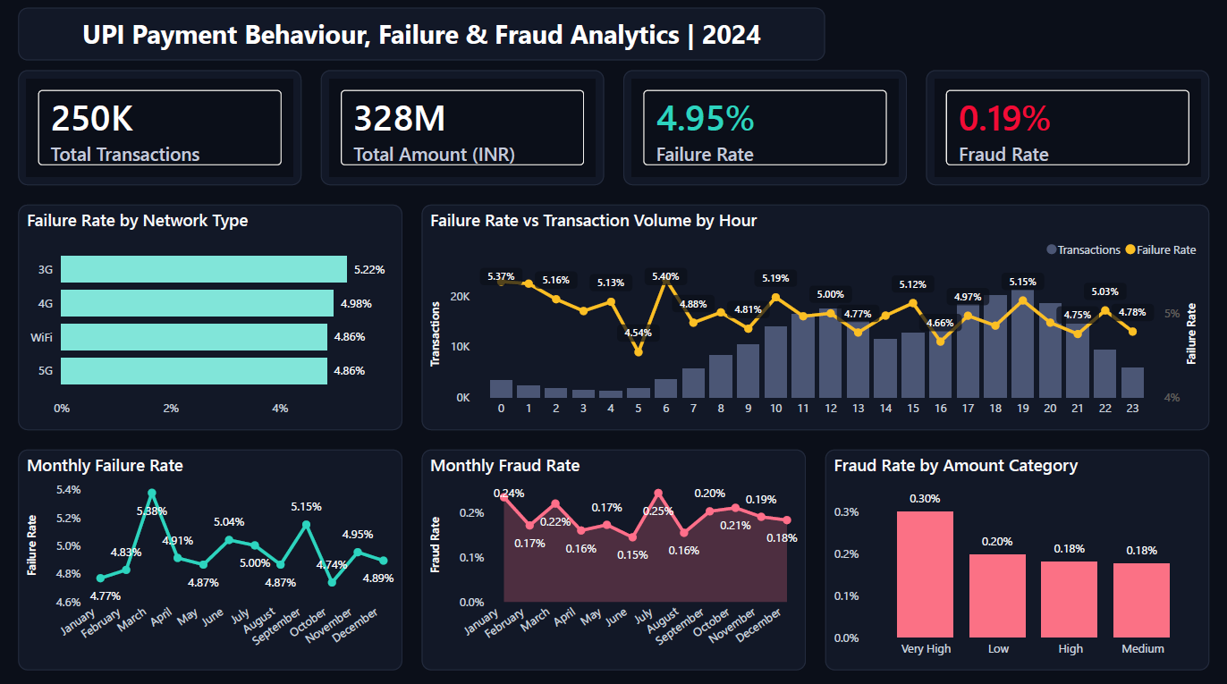
Figure 1: Dashboard 1, Payment Behaviour, Failure and Fraud Analytics

Dashboard 2: UPI Customer, Merchant and Bank Behaviour Analytics (2024)
Visual | Type | What it shows
Quarter, Transaction_Type, Device_Type, Sender_State, Sender_Age_Group | 5 slicers | Filter every card, matrix and chart on the page
Reset Filters | Button with bookmark | Clears all slicers in one click
Avg Daily Transactions, Avg Transaction Value | Cards | Typical daily volume (685) and value per transaction
Weekend Share %, Same-Bank Share % | Cards | Weekend usage (28.53%) and same-bank payments (14.53%)
Transactions by Day and Time of Day | Matrix | Transactions for each day across five time slots
Transactions by Merchant Category | Bar chart | What customers pay for
Transaction Type Share | Donut chart | Share of P2P, P2M, Bill Payment and Recharge
Transactions by Sender State | Bar chart | States that send the most transactions
Transactions by Sender Age Group | Column chart | Which age groups use UPI the most
Transactions by Sender Bank | Bar chart | Banks that send the most transactions
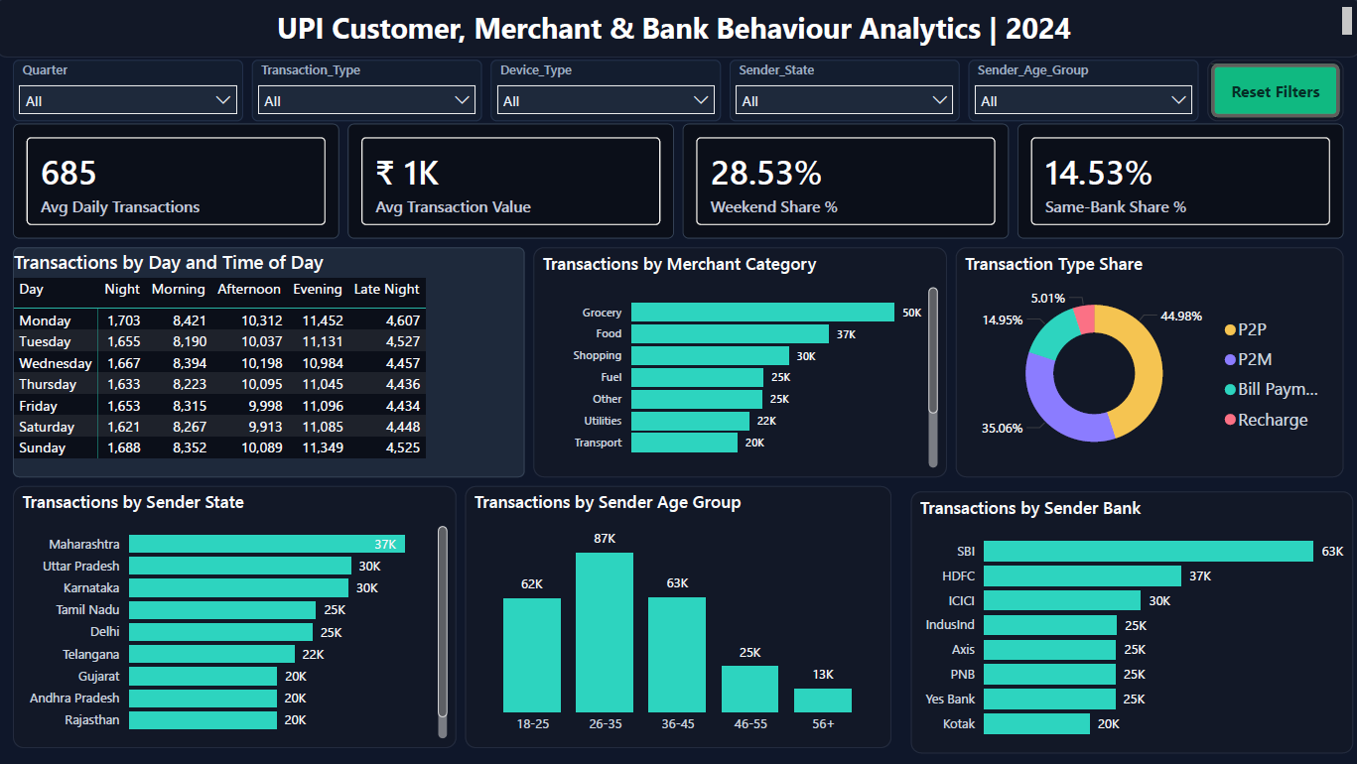
Figure 2: Dashboard 2, Customer, Merchant and Bank Behaviour Analytics

Interactivity
- Five slicers on Dashboard 2 filter all cards, the matrix and all charts together
- Visuals cross-filter each other when a bar, slice or column is selected
- The Reset Filters button uses a bookmark to return the page to its original view
- Both dashboards use one consistent colour theme, clear titles and data labels

10. Insights and Conclusions

Key findings
- Network: 3G has the highest failure rate (5.22%). 5G and WiFi have the lowest (4.86%).
- Month: Failure peaks in March (5.38%) and is lowest in October (4.74%). Fraud peaks in July (0.25%) and is lowest in June (0.15%).
- Hour: Failure is highest at 6 AM (5.40%) and midnight (5.37%) and lowest at 5 AM (4.54%). Transaction volume builds through the day and peaks in the evening hours.
- Amount: Very High amount transactions have the highest fraud rate (0.30%). High and Medium are lowest (0.18%).
- Time of day: Evening (31%) and Afternoon (28%) carry about 60% of all transactions. Usage is steady all week, and the weekend share is 28.53%.
- Spending: Grocery (50K), Food (37K) and Shopping (30K) make up about 47% of transactions. P2P (44.98%) and P2M (35.06%) make up about 80%.
- Customers: The 26-35 age group is the largest (87K, about 35%). Ages 18 to 45 together make up about 85%.
- Banks and states: SBI (63K), HDFC (37K) and ICICI (30K) send about 52% of transactions. Maharashtra is the top state (37K). Only 14.53% of payments are between accounts of the same bank.

Analysis by type
- Descriptive (what happened): 250K transactions worth 328M INR, with a 4.95% failure rate and a 0.19% fraud rate. Evening is the busiest time, P2P and P2M lead the payment types, and Grocery is the top category.
- Diagnostic (why it happened): The higher failure rate on 3G points to network quality. Very High amount transactions carry the highest fraud rate, which shows higher risk on large payments. Heavy afternoon and evening use fits daily spending after work.
- Predictive (what may happen): If these patterns continue, evening demand will stay the highest and failures will stay higher on weaker networks. The March failure peak and July fraud peak may repeat.
- Prescriptive (what to do): Improve 3G reliability, add checks on very high-value transactions, add capacity for peak hours and monitor failure and fraud every month.

11. Recommendations
- Improve reliability on 3G with better retry options and a lighter payment flow
- Review the hours with the highest failure rates (6 AM and midnight) and add capacity
- Add extra verification for very high-value transactions
- Track failure rate and fraud rate monthly on a dashboard, with extra attention to March and July
- Add server capacity for afternoon and evening traffic and plan maintenance for the night slot
- Run evening merchant offers for Grocery, Food and Shopping, and target the 26-35 age group

12. Conclusion and Future Enhancement
The analysis of 250,000 UPI transactions in 2024 shows clear patterns in timing, spending categories, age groups, banks and states, and it shows where payments fail most and where fraud risk is highest. Python and Power BI worked well together: Python for cleaning and exploration, and Power BI for interactive dashboards that make the findings easy to read and act on.
Future enhancement
- Use a larger or more recent dataset for deeper insights
- Automate parts of the analysis with scripts or dashboards
- Add advanced visualisations and interactive dashboards in Power BI or Tableau
- Extend the analysis to predictive modelling for forecasting
- Add bank-wise failure and fraud analysis to find weak points
- Add alerts for high-failure hours and high-value transactions

