# NTTPC-VoIP-Deployment-CI Pipeline

## Create a Project in Emerio GITlab server with following configuration

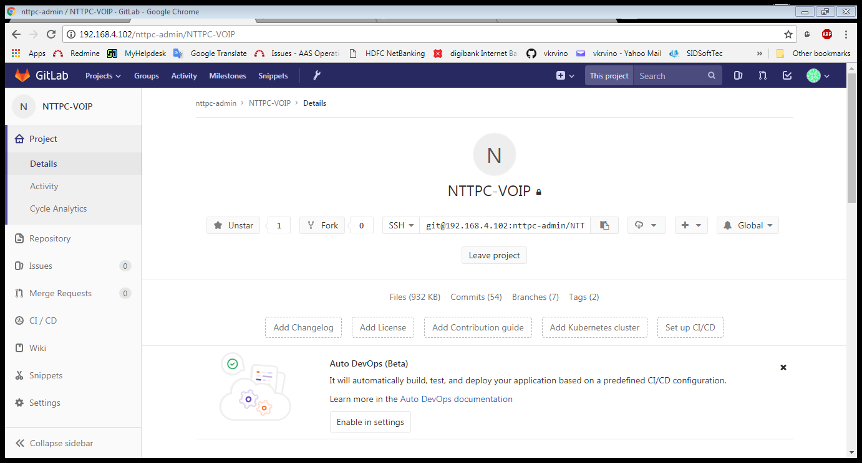

## Push code from local repository to GITlab repo via HTTP

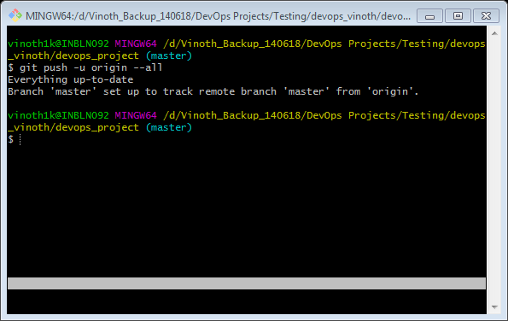

## Create Branches to the GITlab project as confirmed with development team

* Master
* Develop
* QA
* UI

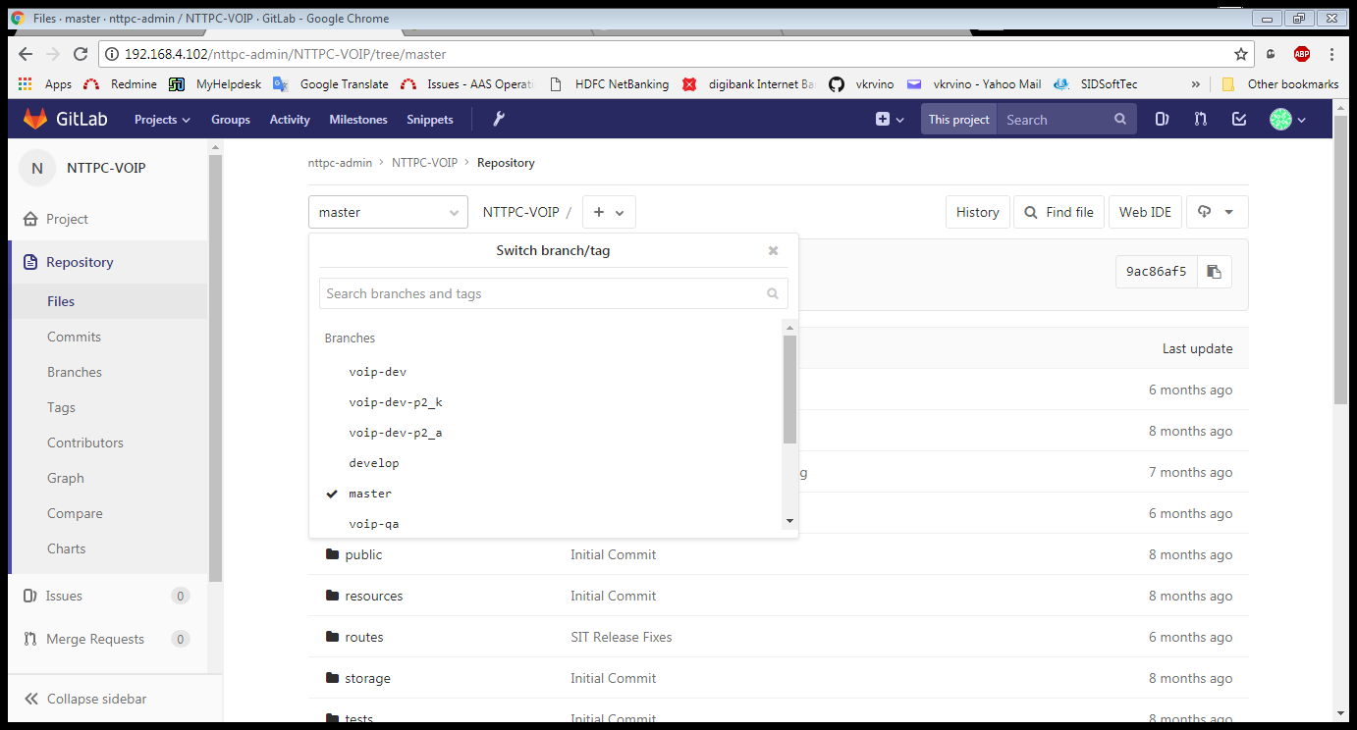

## Create Jenkins JOB for CI Pipeline

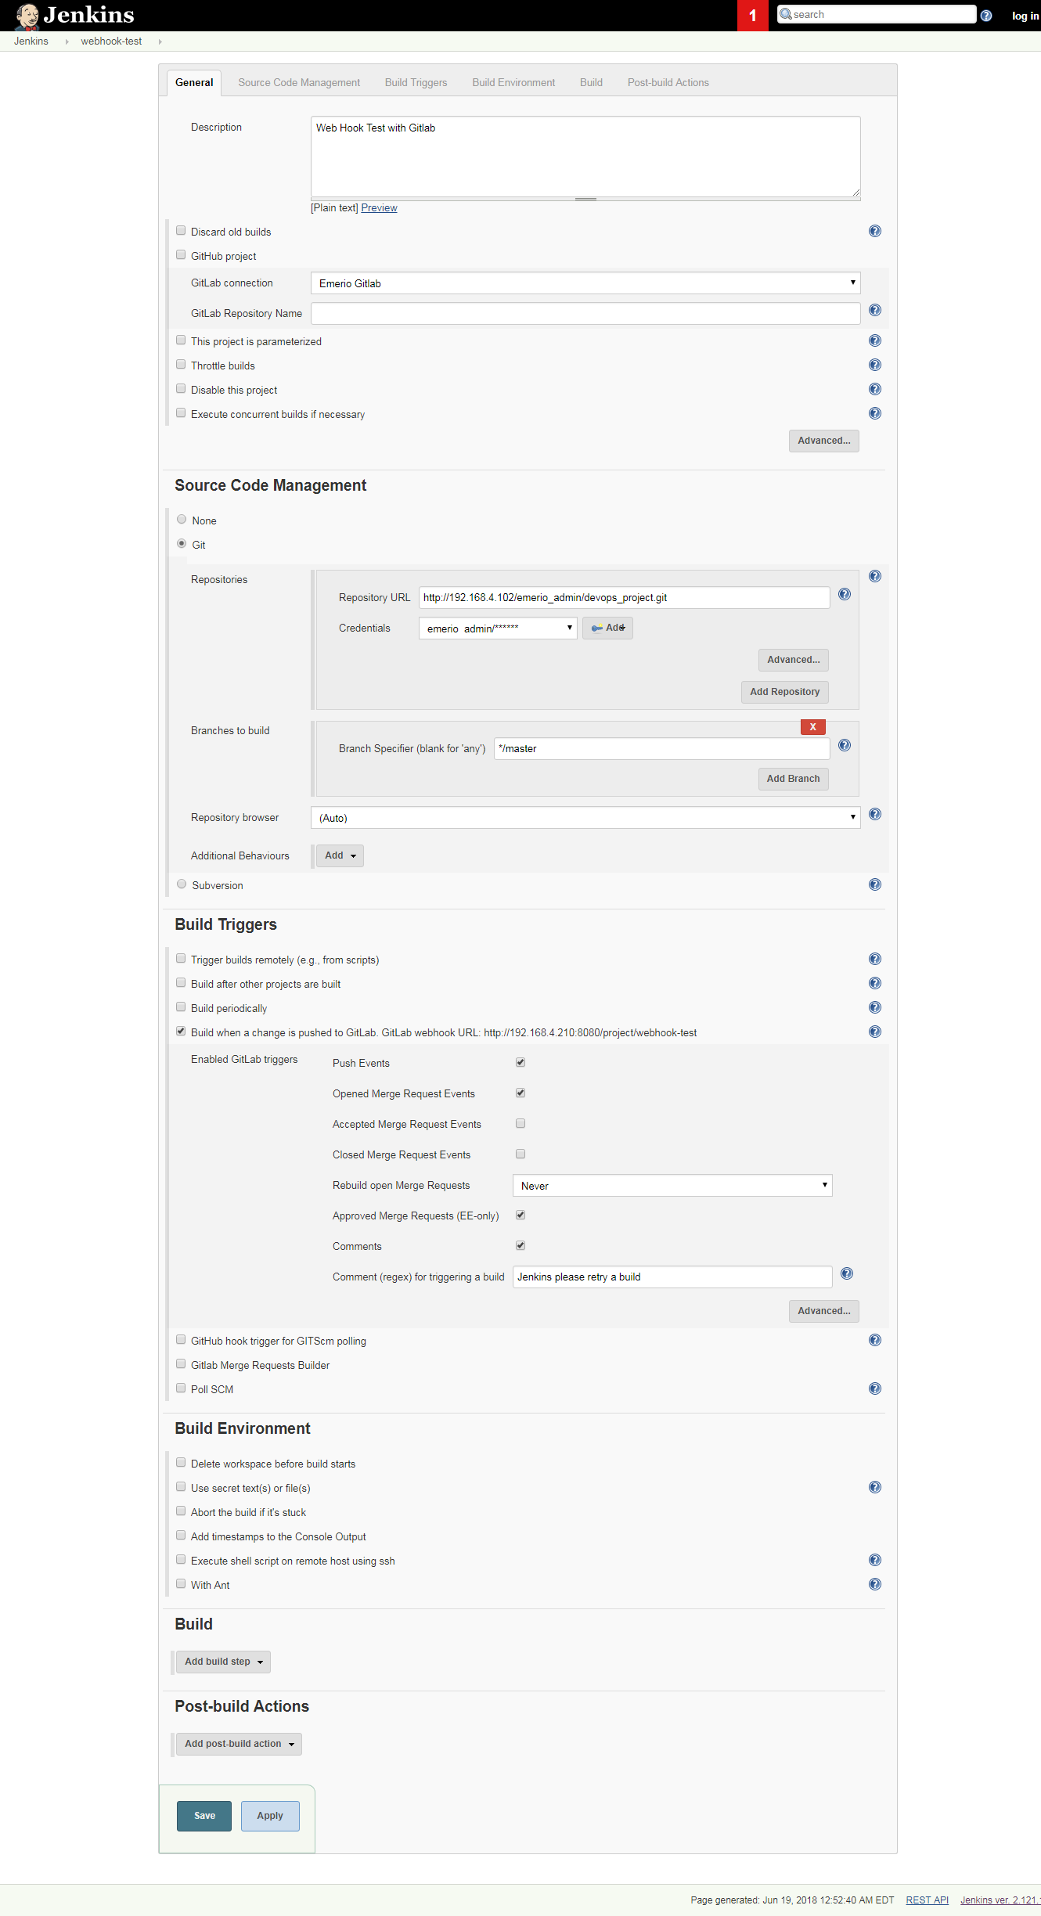

## Create a Webhook with the GITlab using Jenkins job

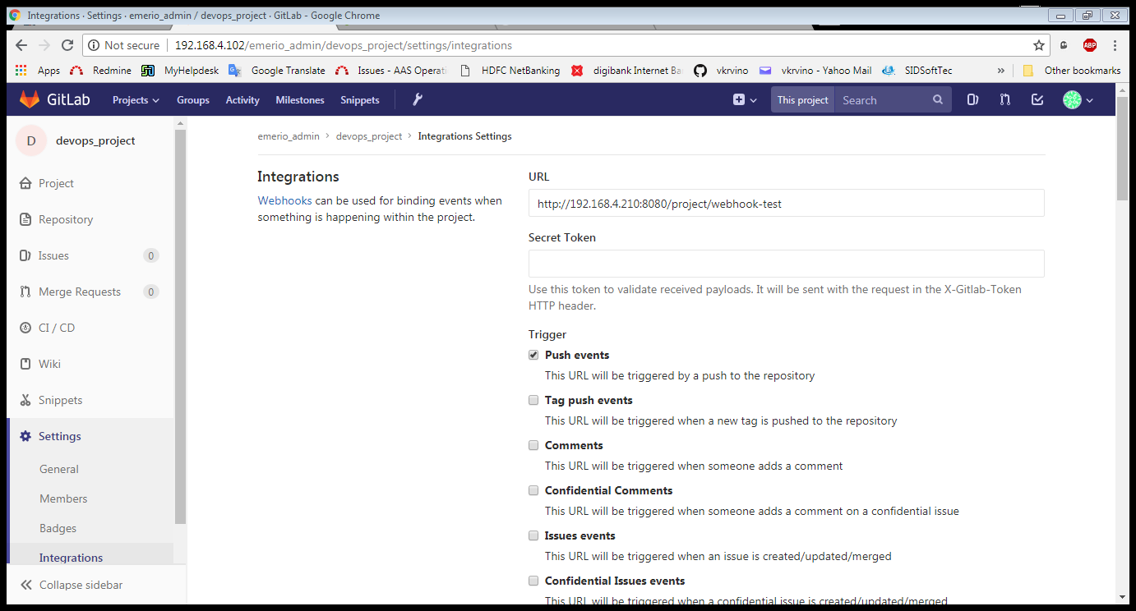

## Test the Jenkins WebHook in Gitlab.

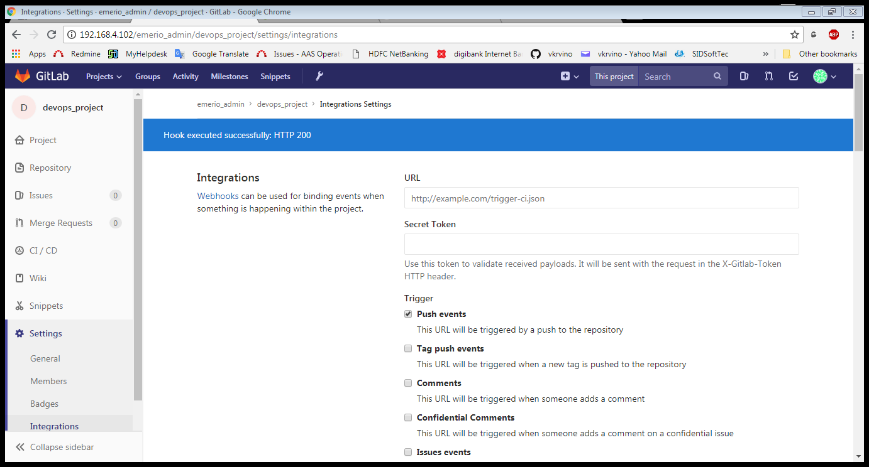

## Test The CI Integration with Jenkins.

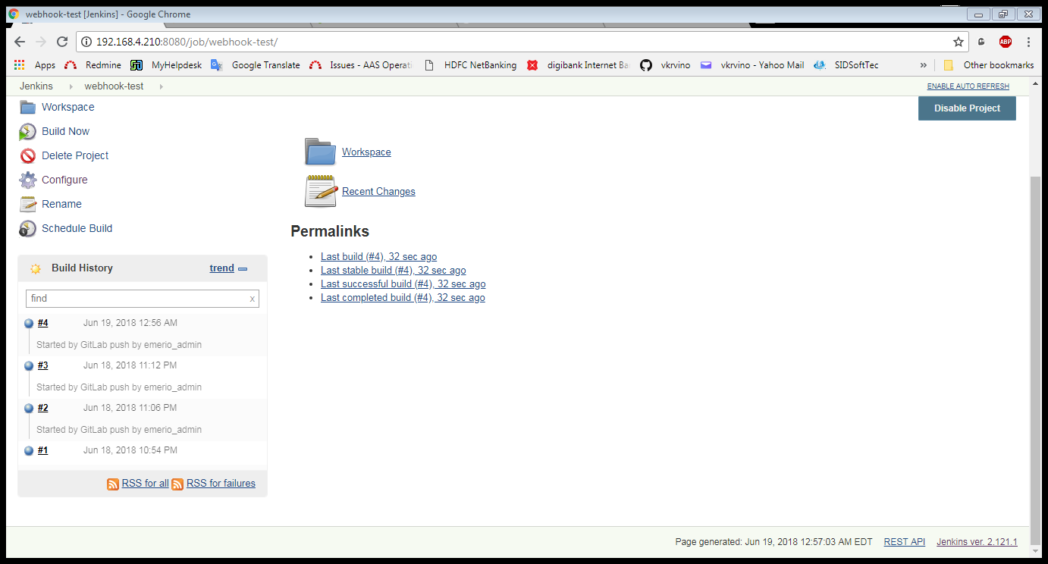

## Do a commit in local repo and check the Job is auto build in Jenkins

## Test the Reflection in GITlab

## Confirm the Auto Job Trigger in Jenkins