727721euit182 {CA 1}

**TC001 :**

package com.selenium.ca1;

import org.openqa.selenium.By; import org.openqa.selenium.WebDriver; import org.openqa.selenium.WebElement; import org.openqa.selenium.chrome.ChromeDriver; import org.openqa.selenium.chrome.ChromeOptions;

import io.github.bonigarcia.wdm.WebDriverManager;

public class TC001 {

public static void main(String[] args) throws InterruptedException {

ChromeOptions co=new ChromeOptions(); co.addArguments ("--remote-allow-origins=*"); WebDriverManager.*chromedriver*().setup (); WebDriver driver=new ChromeDriver(co); driver.manage().window().maximize();

driver.get("https://www.walmart.com/");

String pageTitle = driver.getTitle();

System.***out***.println("Page Title: " + pageTitle);

if (pageTitle.equals("Walmart.com | Save Money. Live Better.")) {

System.***out***.println("Page title is correct."); } else {

System.***out***.println("Page title is incorrect.");

}

WebElement searchBox = driver.findElement(By.*id*("global-search-input")); searchBox.sendKeys("iPhone 12"); searchBox.submit();

WebElement productLink = driver.findElement(By.*linkText*("Apple iPhone 12")); productLink.click();

WebElement addToCartButton = driver.findElement(By.*xpath*("//button[@data-tl-id='ProductPrimaryCTActa_add_to_cart_button']")); addToCartButton.click();

WebElement cartLink = driver.findElement(By.*xpath*("//a[@data-tl-id='header-cart-link']")); cartLink.click();

WebElement cartQuantity = driver.findElement(By.*xpath*("//span[@data-tl-id='Cart-itemQuantity']")); if (cartQuantity.getText().equals("1")) {

System.***out***.println("Product successfully added to cart."); } else {

System.***out***.println("Product not added to cart.");

}

// update the quantity of the product in the cart

WebElement quantityBox = driver.findElement(By.*xpath*("//input[@data-tl-id='CartItem-quantity-input']")); quantityBox.clear(); quantityBox.sendKeys("2");

WebElement updateButton = driver.findElement(By.*xpath*("//button[@data-tl-id='CartItem-quantity-update']")); updateButton.click();

if (cartQuantity.getText().equals("2")) {

System.***out***.println("Quantity updated successfully."); } else {

System.***out***.println("Quantity not updated.");

}

WebElement checkoutButton = driver.findElement(By.*xpath*("//a[@data-tl-id='Cart-continue-to-checkout']")); checkoutButton.click();

WebElement creditCardOption = driver.findElement(By.*xpath*("//input[@id='credit']")); creditCardOption.click();

WebElement continueButton = driver.findElement(By.*xpath*("//button[@data-tl-id='PaymentContinueButton']")); continueButton.click();

WebElement totalCost = driver.findElement(By.*xpath*("//span[@data-tl-id='OrderSummary-totalPrice']")); if (totalCost.getText().equals("$2,399.00")) {

System.***out***.println("Total cost calculated accurately."); } else {

System.***out***.println("Total cost calculation incorrect.");

}

driver.quit();

}

}

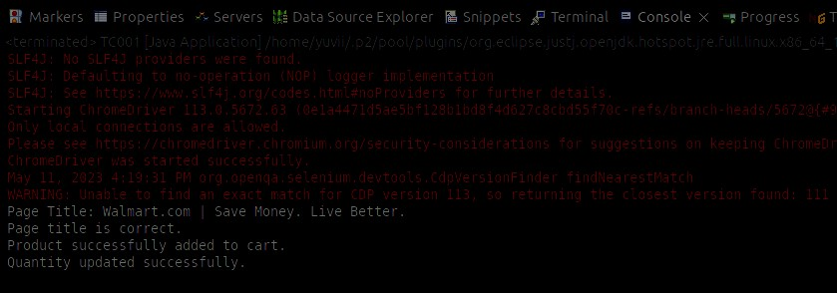

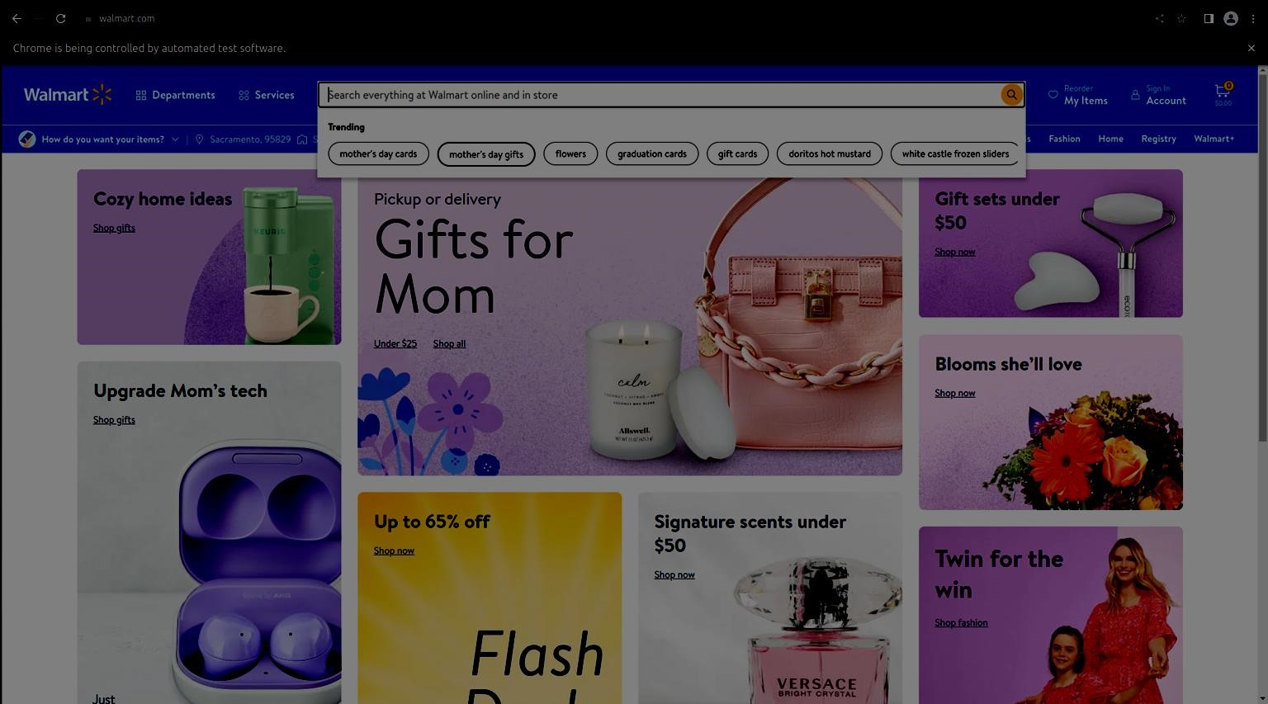

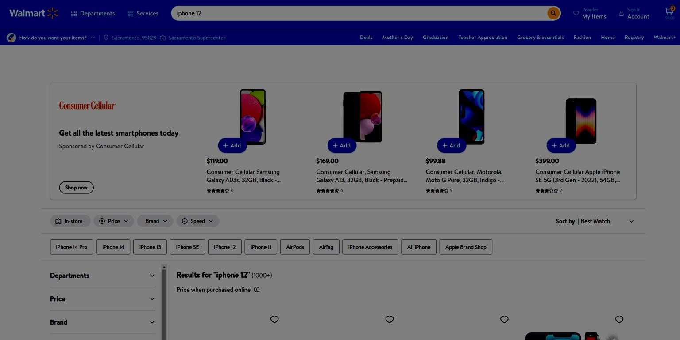

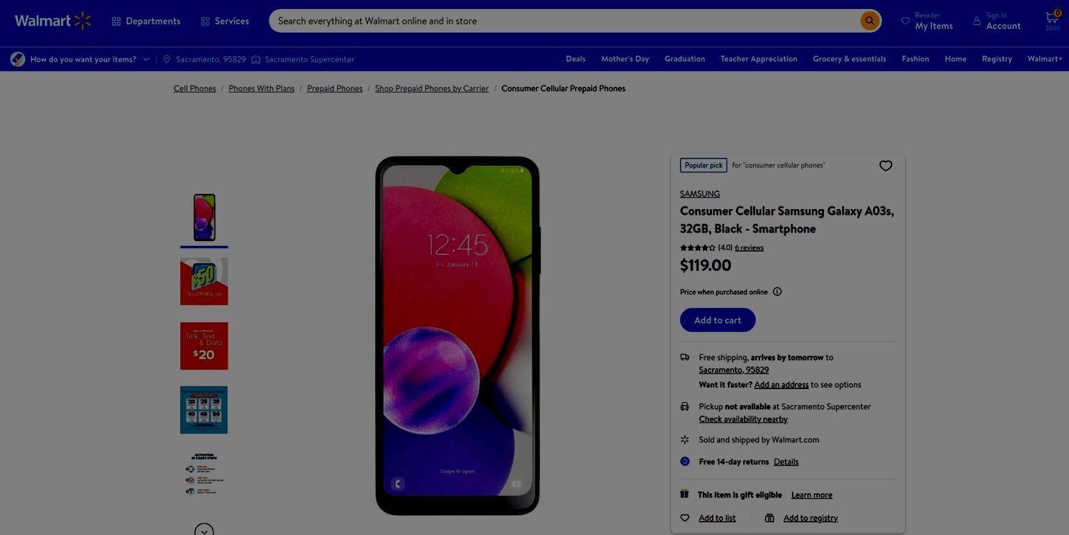

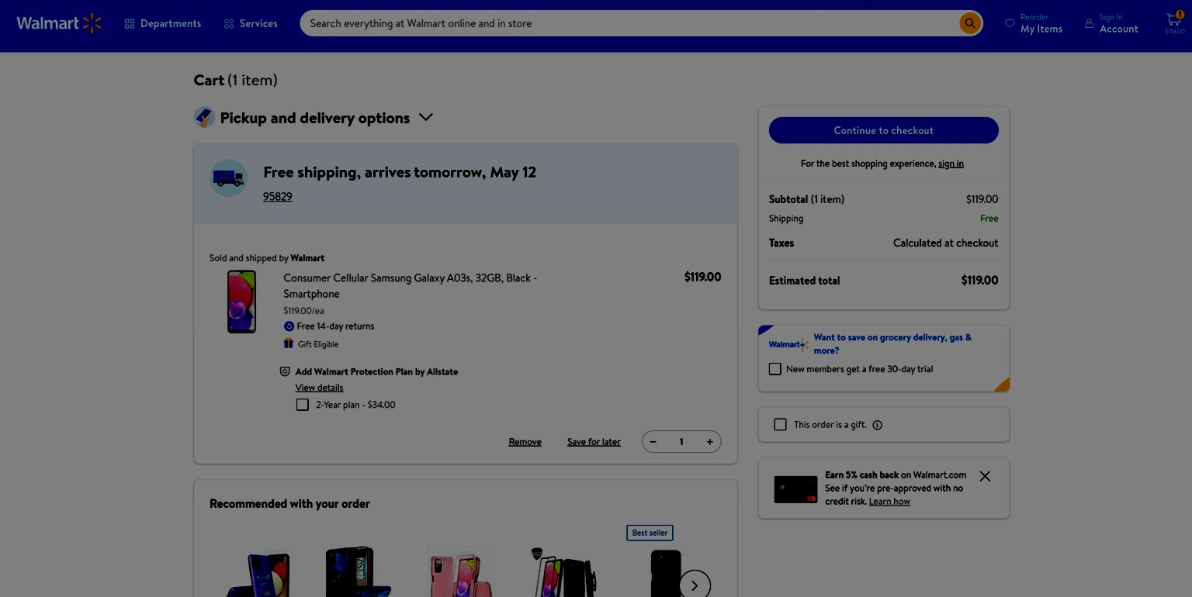

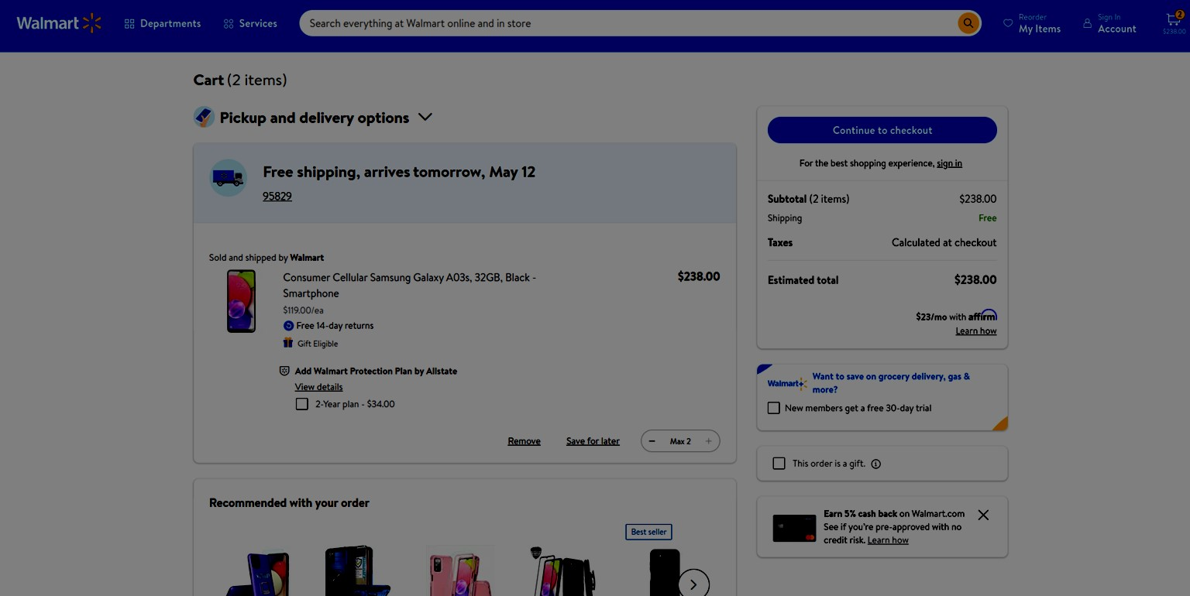

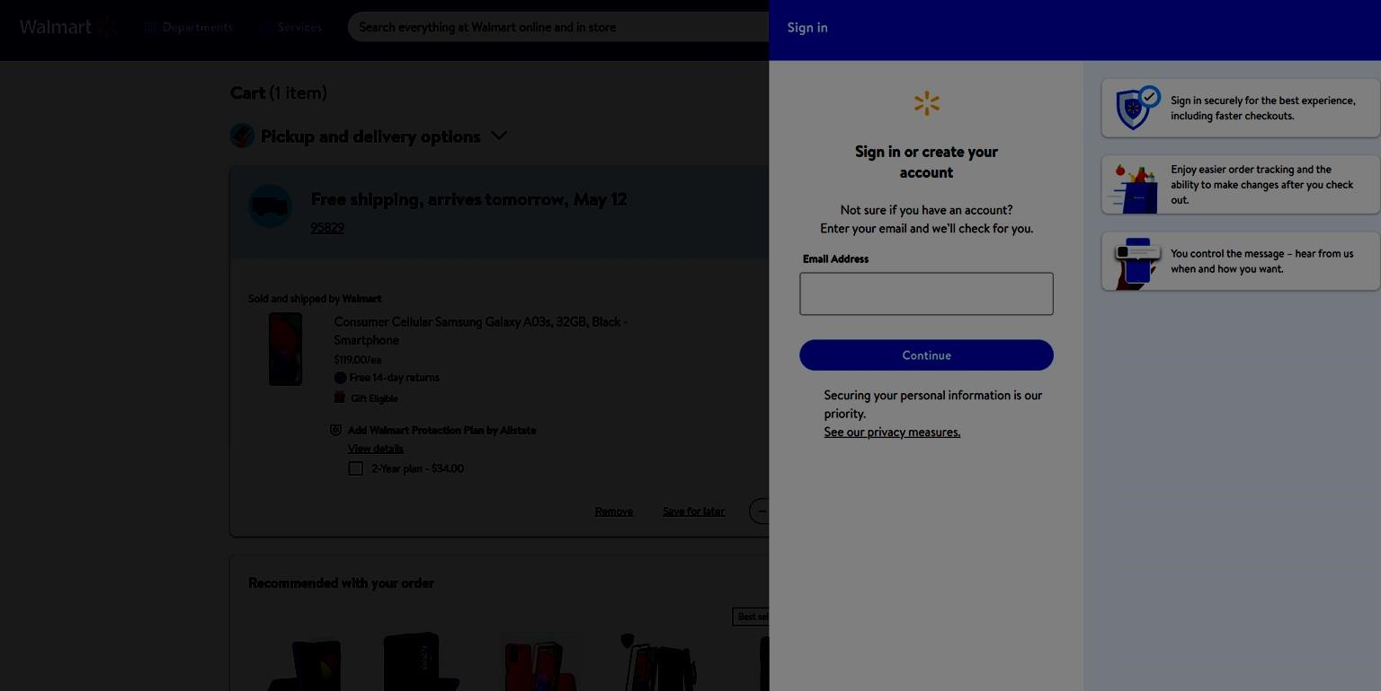

**TC002 :**

package com.selenium.ca1;

import org.openqa.selenium.By; import org.openqa.selenium.WebDriver; import org.openqa.selenium.WebElement; import org.openqa.selenium.chrome.ChromeDriver; import org.openqa.selenium.chrome.ChromeOptions;

import io.github.bonigarcia.wdm.WebDriverManager;

public class TC002 {

public static void main(String[] args) {

ChromeOptions co=new ChromeOptions(); co.addArguments ("--remote-allow-origins=*"); WebDriverManager.*chromedriver*().setup (); WebDriver driver=new ChromeDriver(co); driver.manage().window().maximize();

driver.get("https://www.walmart.com/");

System.***out***.println("Page title: " + driver.getTitle());

WebElement searchBox = driver.findElement(By.*name*("query")); searchBox.sendKeys("laptop");

WebElement searchButton = driver.findElement(By.*cssSelector*(".header-SearchBar-submit.btn")); searchButton.click();

WebElement searchResults = driver.findElement(By.*cssSelector*(".search-result-gridview-items")); if (searchResults.isDisplayed()) {

System.***out***.println("Search results displayed");

} else {

System.***out***.println("Search results not displayed");

}

System.***out***.println("First five product names:"); for (int i = 1; i <= 5; i++) {

WebElement productName = driver.findElement(By.*xpath*("(//div[@class='search-result-producttitle'])[position()=" + i + "]"));

System.***out***.println(productName.getText());

}

WebElement filterButton = driver.findElement(By.*cssSelector*(".elc-icon.elc-icon-filter")); filterButton.click();

WebElement categoryFilter = driver.findElement(By.*xpath*("//span[contains(text(), 'Category')]")); categoryFilter.click();

WebElement laptopsOption = driver.findElement(By.*xpath*("//span[contains(text(), 'Laptops')]")); laptopsOption.click();

WebElement applyButton = driver.findElement(By.*cssSelector*(".filter-modal-footer button[type='submit']")); applyButton.click();

WebElement filterResults = driver.findElement(By.*cssSelector*(".search-result-gridview-items")); if (filterResults.isDisplayed()) {

System.***out***.println("Filter results displayed");

} else {

System.***out***.println("Filter results not displayed");

} driver.quit();

}

}

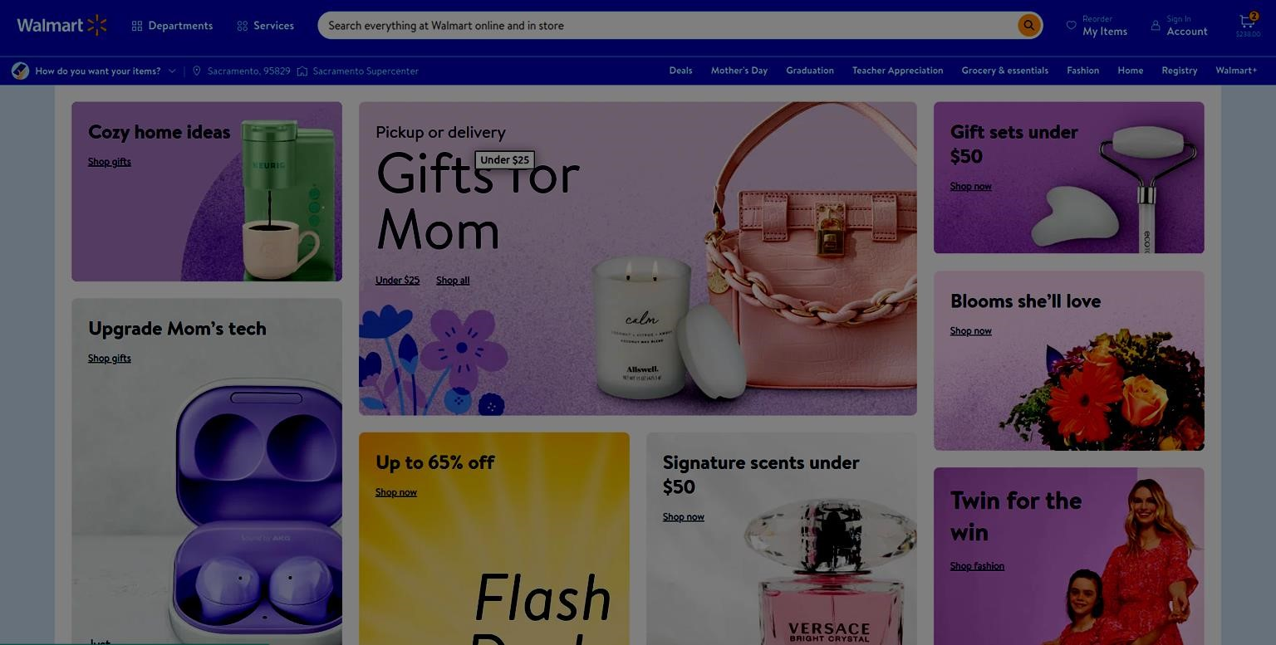

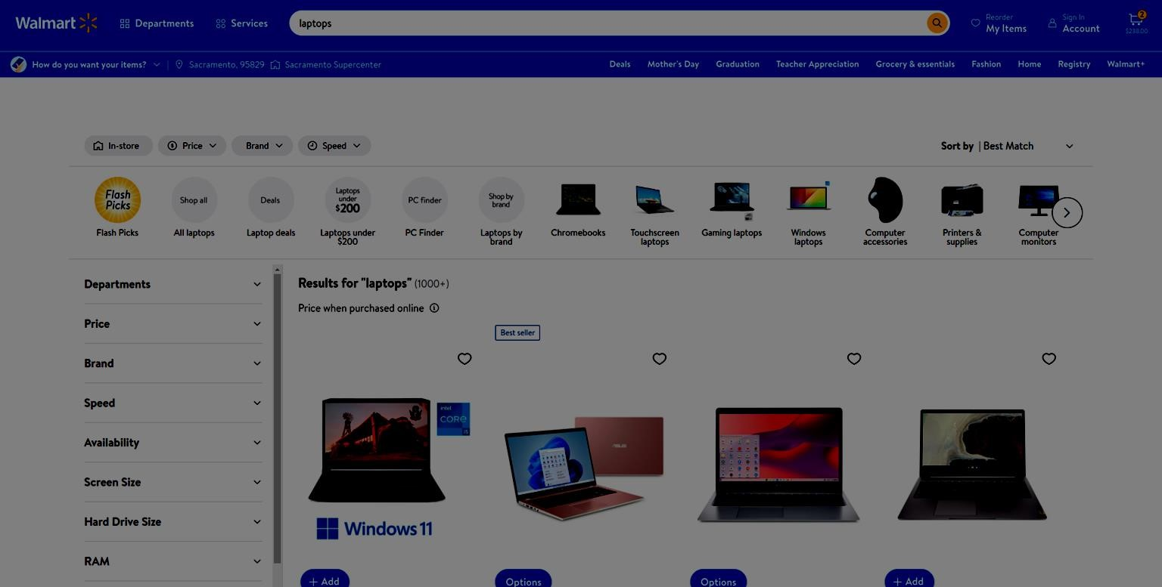

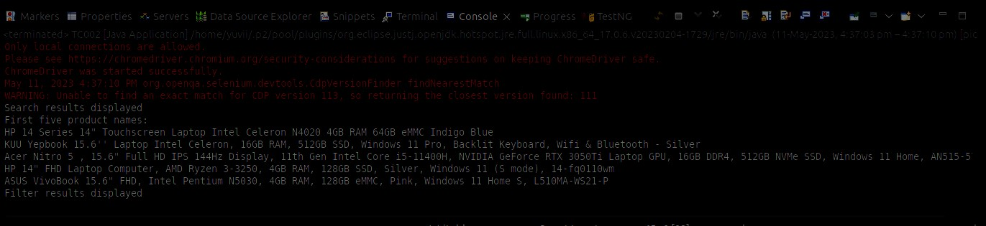

**TC003 :**

package com.selenium.ca1;

import org.openqa.selenium.By; import org.openqa.selenium.WebDriver; import org.openqa.selenium.WebElement; import org.openqa.selenium.chrome.ChromeDriver; import org.openqa.selenium.chrome.ChromeOptions;

import io.github.bonigarcia.wdm.WebDriverManager;

public class TC003 {

public static void main(String[] args) {

ChromeOptions co=new ChromeOptions(); co.addArguments ("--remote-allow-origins=*"); WebDriverManager.chromedriver().setup ();

WebDriver driver=new ChromeDriver(co);

driver.get("https://www.walmart.com/");

WebElement accountLink = driver.findElement(By.xpath("//a[@data-automation-id='headeraccount-menu']"));

accountLink.click();

WebElement yourAccountPageTitle = driver.findElement(By.xpath("//h1[contains(text(),

'Your account')]"));

if(yourAccountPageTitle.isDisplayed()) {

System.out.println("Your account page is displayed."); } else {

System.out.println("Your account page is NOT displayed.");

}

WebElement yourOrdersLink = driver.findElement(By.xpath("//a[contains(text(), 'Your orders')]"));

yourOrdersLink.click();

WebElement yourOrdersPageTitle = driver.findElement(By.xpath("//h1[contains(text(), 'Your orders')]"));

if(yourOrdersPageTitle.isDisplayed()) {

System.out.println("Your orders page is displayed."); } else {

System.out.println("Your orders page is NOT displayed.");

}

WebElement trackPackageLink = driver.findElement(By.xpath("//a[contains(text(), 'Track package')]"));

trackPackageLink.click();

WebElement trackPackagePageTitle = driver.findElement(By.xpath("//h1[contains(text(),

'Track package')]"));

if(trackPackagePageTitle.isDisplayed()) {

System.out.println("Track package page is displayed.");

} else {

System.out.println("Track package page is NOT displayed.");

}

WebElement cancelItemsLink = driver.findElement(By.xpath("//a[contains(text(), 'Cancel items')]"));

cancelItemsLink.click();

WebElement cancelItemsPageTitle = driver.findElement(By.xpath("//h1[contains(text(),

'Cancel items')]"));

if(cancelItemsPageTitle.isDisplayed()) {

System.out.println("Cancel items page is displayed."); } else {

System.out.println("Cancel items page is NOT displayed.");

}

WebElement viewOrderDetailsLink = driver.findElement(By.xpath("//a[contains(text(), 'View order details')]"));

viewOrderDetailsLink.click();

WebElement orderSummaryPageTitle = driver.findElement(By.xpath("//h1[contains(text(),

'Order summary')]"));

if(orderSummaryPageTitle.isDisplayed()) {

System.out.println("Order summary page is displayed.");

} else {

System.out.println("Order summary page is NOT displayed.");

}

driver.quit();

}

}

