Home Assignment Updation:
Note: The Convert to JSON option is applicable only for test cases.
To resolve the identified issue, please follow the steps below:
1. User Stories: There is no need to use the Convert to JSON option. Please use the pre-provided stories.json file located at src → data → stories.json.
2. Test Cases: Test case files must be converted to JSON using the Convert to JSON option.
3. After conversion, embed the generated JSON data into the database.
Screenshots:
User Stories:
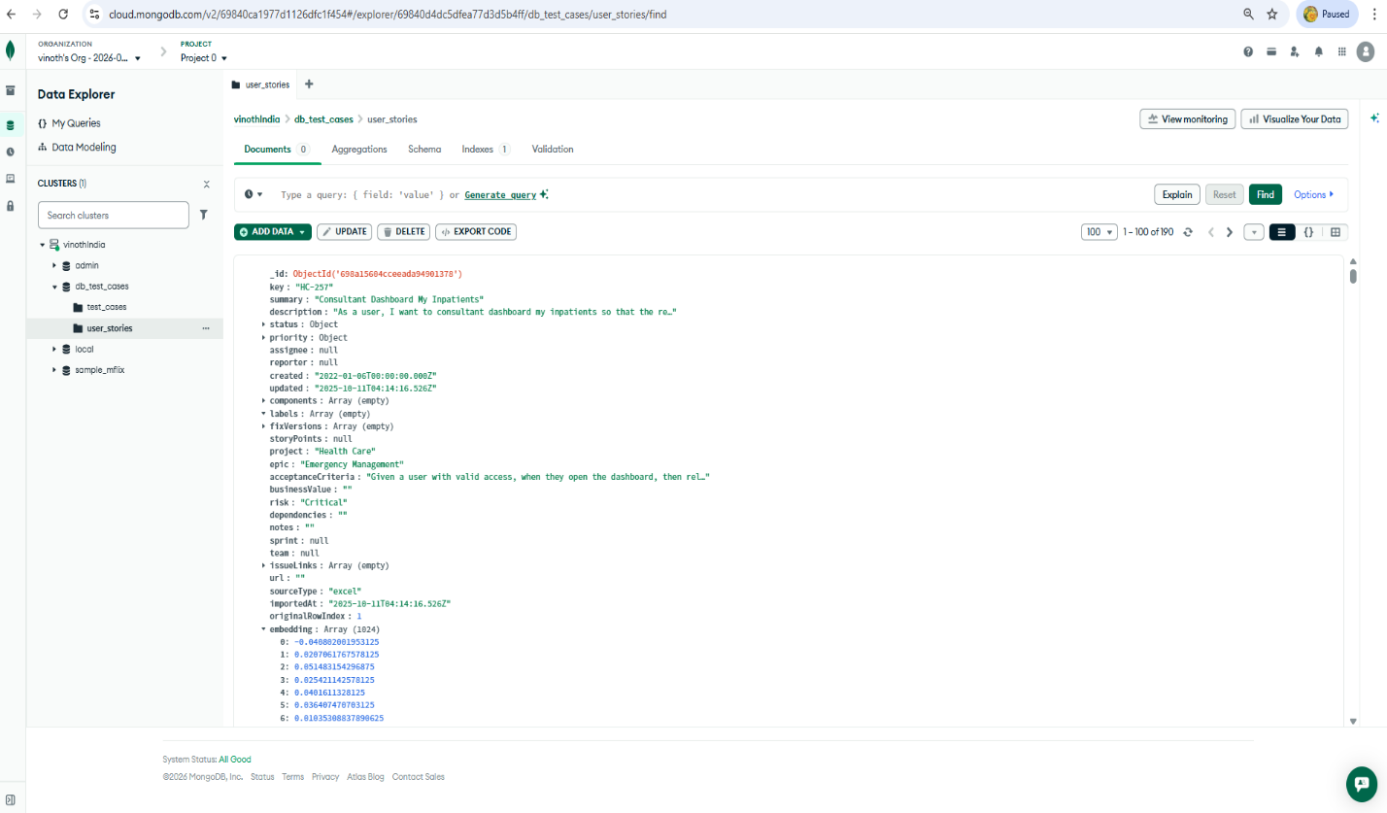

Test Cases
