1) With vibe coding implement the playwright/typescript or any other tool which you work say Selenium/Python
Actual Response:
Feature: Login to Facebook

Scenario Outline: Successful login with valid credentials
Given I open the Facebook login page
When I type "<username>" into the Email field
And I type "<password>" into the Password field
And I click the Log in button
Then I should be logged in successfully

Examples:
| username | password |
| test@example.com | test123 |
| user@example.com | user123 |

import { Given, When, Then, Before, After } from '@cucumber/cucumber';
import { chromium, Browser, Page } from 'playwright';

let browser: Browser;
let page: Page;

Before(async function () {
browser = await chromium.launch();
page = await browser.newPage();
});

After(async function () {
await browser.close();
});

Given('I open the Facebook login page', async () => {
await page.goto('https://www.facebook.com/');
});

When('I type {string} into the Email field', async (username: string) => {
await page.locator('#email').fill(username);
});

When('I type {string} into the Password field', async (password: string) => {
await page.locator('#pass').fill(password);
});

When('I click the Log in button', async () => {
await page.locator('button[data-testid="royal-login-button"]').click();
});

Then('I should be logged in successfully', async () => {
await page.waitForTimeout(5000); // wait for 5 seconds
const isLoggedIn = await page.locator('h2').isVisible();
expect(isLoggedIn).toBe(true);
});

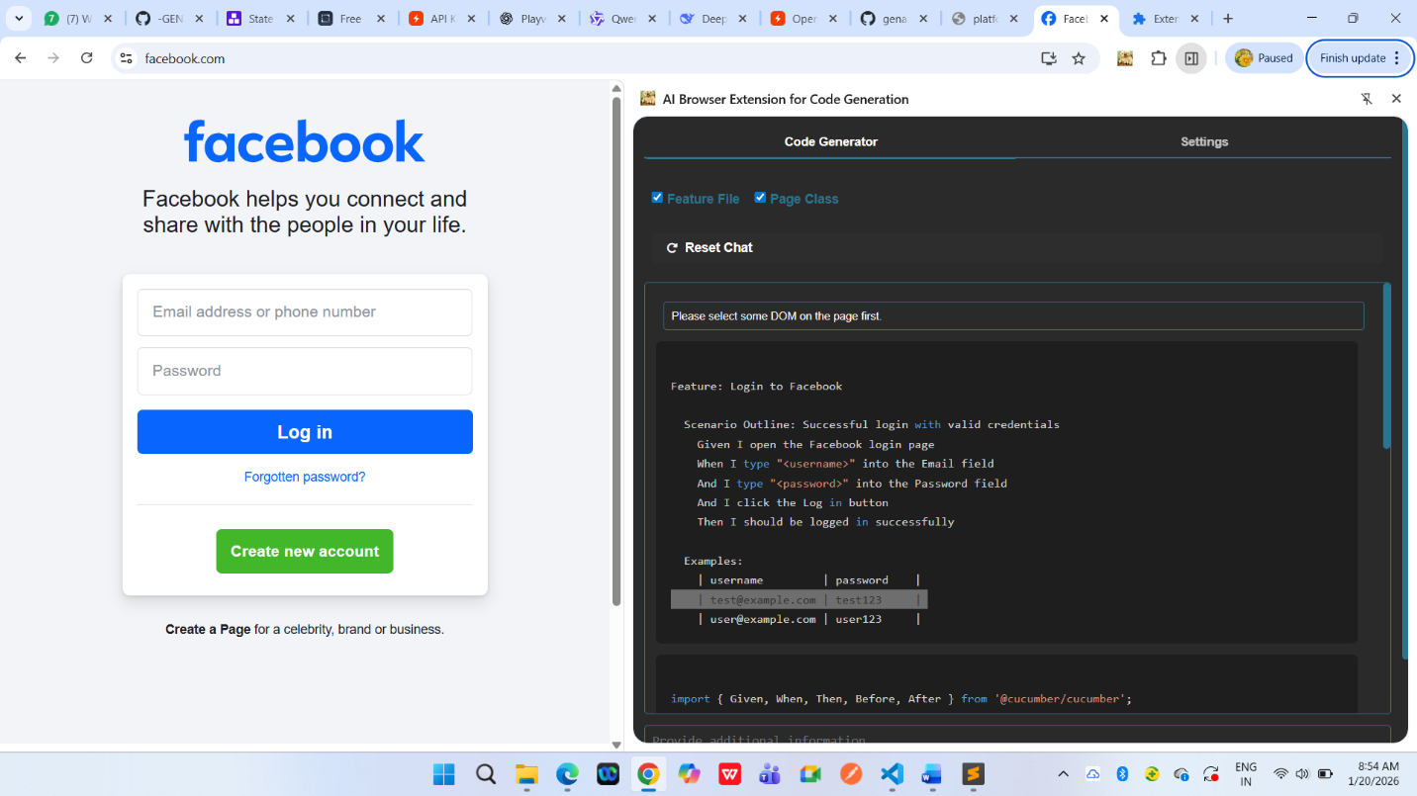

Use Bugmagnet extension for form filling
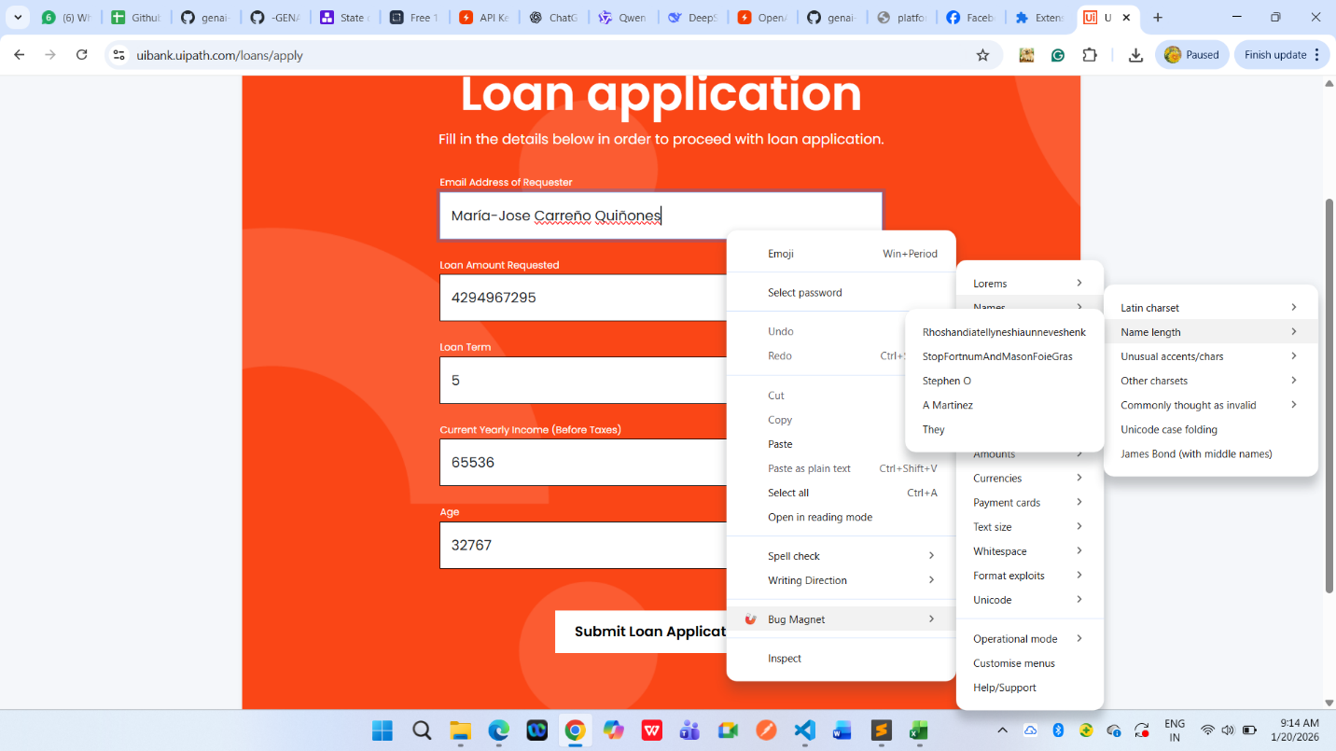
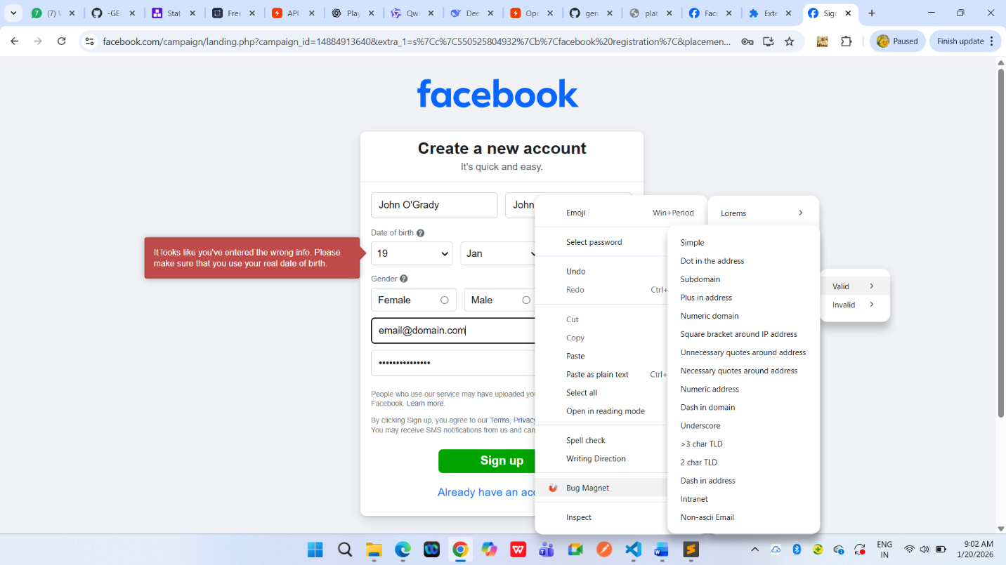
Use grammarly extension to correct the mistakes in your content
