**Manual Start of Message Flows :**

Following are the states that can be configured,

**Maintained**

This value is the default and indicates that the flow or application is started when deployment is complete and remains running until a stop command is issued. After a stop command has been issued, the flow or application remains stopped until a start command is issued.

The state of the flow or application remains unchanged after redeployment, or after the integration node, integration server, or containing application has been restarted. When an application holds one or more flows, the state of the flows within the application is preserved if the application is stopped and then started again. However, on redeployment of an application, the status of the flows inside the application is not preserved.

**Manual (What we are looking)**

This value indicates that the flow or application must always be started manually after deployment or after the integration node, integration server, or containing application has been restarted.

The flow or application is in stopped state after deployment or redeployment, and after the integration node, integration server, or containing application is restarted, even if the flow or application was running before the deployment or restart.

**Automatic**

This value indicates that the flow or application is always started automatically after deployment, redeployment, or after the integration node, integration server, or containing application is restarted.

As per the example given in the info center, it is throwing error when we try to update for the whole application,



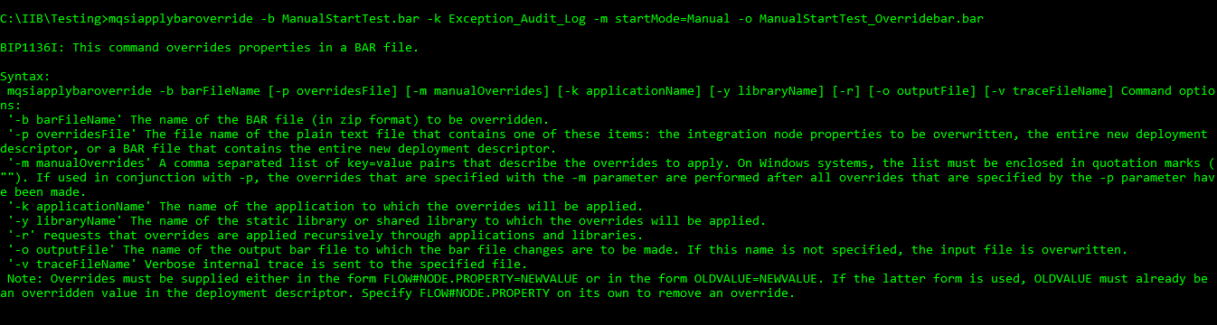

Instead, we can manually start each flow wise,

|  |
| --- |
| *mqsiapplybaroverride* -b *ManualStartTest*.bar -k *Exception_Audit_Log* -m "ExceptionAuditLog.Notification_QueueDepthWarning#startMode=Manual" -o *ManualStartTest_Overridebar.bar* |

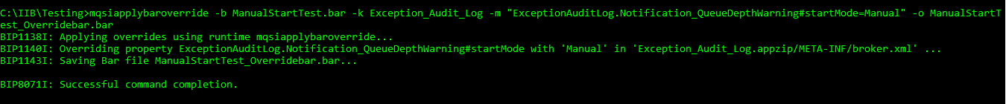

|  |  |
| --- | --- |
| Before Deployment of new override bar file | After Deployment of new override bar file |
|  |  |