EVENTFORCE MANAGEMENT SYSTEM
Salesforce Implementation

PROJECT DOCUMENTATION

College Name: Alpha College of Engineering
College Code: 2101
University Name: Anna University

Team ID: SWTID-2026-8495
Team Leader: Vinothan B (210123104046)
Team Member: Mohan K (210123104024)
Team Member: Subash M (210123104040)
Team Member: Sirajul Athiyab T (210123104036)

Table of Contents
1. Project Overview
2. Objectives
3. Phase 1 – Requirement Analysis & Planning
4. Phase 2 – Backend Development & Configuration
5. Phase 3 – UI/UX Development & Customization
6. Phase 4 – Data Migration, Testing & Security
7. Phase 5 – Deployment, Documentation & Maintenance
8. Testing Results
9. Conclusion – Project Learnings & Outcomes

1. Project Overview
The EventForce Management System is a Salesforce-based Customer Relationship Management (CRM) solution designed to digitize and coordinate event management operations. The system brings client bookings, venue reservations, vendor coordination, event scheduling, feedback collection, automation, reporting, and controlled access into a single CRM environment.
The platform replaces fragmented manual activities with centralized records, automated workflows, approval processes, real-time visibility, and analytics. The implementation uses Salesforce custom objects, relationships, validation rules, Flow automation, Apex classes and triggers, a Lightning App, reports, dashboards, and layered security controls.
The data model includes six custom objects: Event, Client, Vendor, Venue, Feedback, and the Event Vendor junction object. Relationships support client and venue associations, feedback tracking, and the many-to-many relationship between events and vendors.
All features were built and tested in a Salesforce Developer Edition org, covering the complete implementation lifecycle from requirements and data modelling through automation, UI customization, data preparation, testing, security, and deployment planning.

2. Objectives
The primary objective is to create a comprehensive CRM platform that digitizes and automates event management operations, streamlining client bookings, venue reservations, vendor coordination, and feedback collection while providing real-time operational visibility.

2.1 Business Goals
- Centralize event, client, vendor, venue, and feedback information in Salesforce.
- Automate event scheduling, client reminders, cancellation approvals, and notification workflows.
- Improve data accuracy through validation rules, formula fields, lookup filters, and controlled relationships.
- Prevent operational conflicts such as double-booking a venue on the same date.
- Provide role-based access and controlled record visibility for administrators, coordinators, vendor managers, and clients.
- Provide reports and dashboards for upcoming events, budgets, vendor activity, and operational insights.
- Reduce manual processes by 60% and improve booking efficiency by 40%.

2.2 Expected Business Value
Business Outcome | Target
Reduction in manual processes | 60%
Improvement in booking efficiency | 40%
Client satisfaction | Improved through timely reminders and communication
Decision making | Data-driven insight from integrated reports and analytics

3. Phase 1 – Requirement Analysis & Planning
Phase 1 establishes the business and technical requirements for the EventForce CRM. The system is planned as a single Salesforce platform for managing event planners, clients, vendors, venues, and feedback.

3.1 Functional Scope
- Custom objects: Event, Client, Vendor, Venue, Feedback, and Event Vendor junction object.
- Lookup, Master-Detail, and many-to-many relationship modelling.
- Flows for reminders, feedback notifications, and approval updates.
- Validation rules and formula fields for data accuracy and automatic event budget calculation.
- Approval process for event cancellation requests with email notifications.
- Profiles, Roles, Permission Sets, and Sharing Rules for user-level access and record visibility.
- Reports and Dashboards for event summaries, vendor performance, and upcoming-event insights.

3.2 Stakeholder Mapping
Stakeholder | Role in the System
Clients | Request event services, provide feedback, and view event updates
Event Coordinators | Manage event scheduling, client communication, and approval workflows
Vendors | Handle assigned event services like catering, décor, and logistics
Venue Managers | Manage venue availability and reservations
Event Administrators | Oversee system operations, security, and data monitoring

3.3 Execution Roadmap
- Object & Field Setup – creation of Event, Client, Vendor, Venue, Feedback, and Event Vendor objects.
- Automation Flows – record-triggered flow for event reminders.
- Validation Rules & Formula Fields – enforce data accuracy and budget calculations.
- Profiles, Roles & Permission Sets – configure user access and record visibility.
- Approval Process – automate the event cancellation workflow with notifications.
- Apex Classes & Triggers – update venue availability and prevent double bookings.
- Reports & Dashboards – analytics for upcoming events and performance insights.

4. Phase 2 – Backend Development & Configuration
Phase 2 builds the functional backend of EventForce. Salesforce declarative automation and Apex are combined to create a dynamic, automated, and secure CRM solution.

4.1 Core Data Architecture
Object (API Name) | Key Fields | Purpose
Event__c | Event Name, Event Date, Event Type, Event Status, Event Budget | Event details, status and budget
Client__c | Client Name, Email, Phone, Address, Country, City | Client contact information
Vendor__c | Vendor Name, Email, Phone, Service Type, Status | Vendor details and services
Venue__c | Venue Name, Address, Location (URL), Capacity, Availability Status | Venue details and availability
Feedback__c | Feedback ID (Auto Number F-{0000}), Rating, Comments | Client ratings and comments
EventVendor__c | Master-Detail to Event and Vendor (junction) | Links Event ↔ Vendor many-to-many
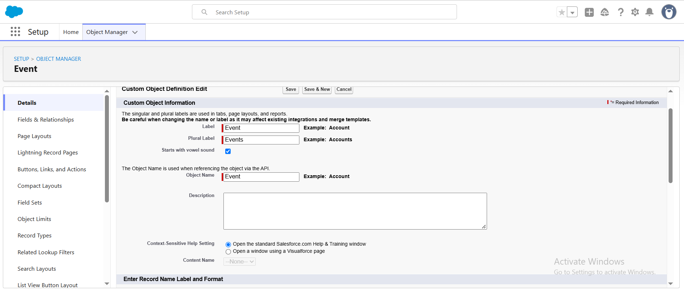
Figure 1 – Event custom object creation
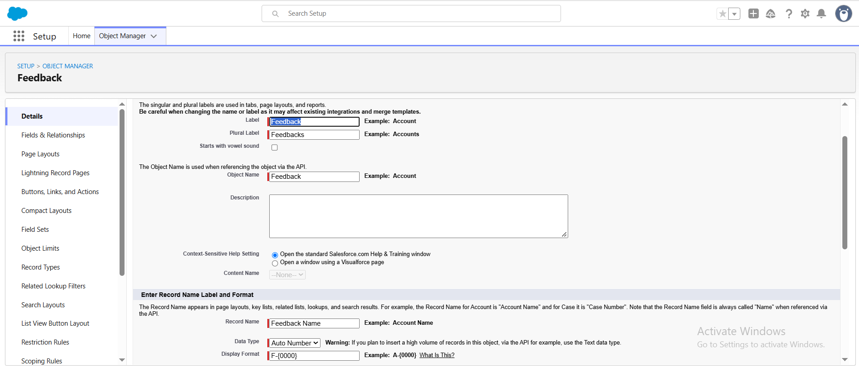
Figure 2 – Feedback custom object with Auto Number record name

4.2 Fields Created per Object
Object | Field | Data Type | Values / Notes
Event | Event Type | Picklist | Wedding, Corporate, Birthday, Anniversary, Festival, Concert, Other
Event | Event Date | Date | Date the event takes place
Event | Event Status | Picklist | Planned, Confirmed, Completed, Pending Cancellation, Canceled, Rejected
Event | Event Budget | Formula (Currency) | Derived from Event Type
Client | Email / Phone / Address | Email / Phone / Text Area | Contact details
Client | Country / City | Picklist | 14 countries; 24 cities
Vendor | Service Type | Multi-select Picklist | Catering, Décor, Photography, Videography, Lighting, Stage Setup, Makeup Artist, DJ/Music, Transportation, Hosting/Anchor
Vendor | Status | Picklist | Available, Booked, Cancelled
Venue | Address / Location / Capacity | Text Area / URL / Number | Venue details and map link
Venue | Availability Status | Picklist | Available, Reserved, Not Available
Feedback | Rating | Picklist | 1, 2, 3, 4, 5
Feedback | Comments | Long Text Area | Client comments
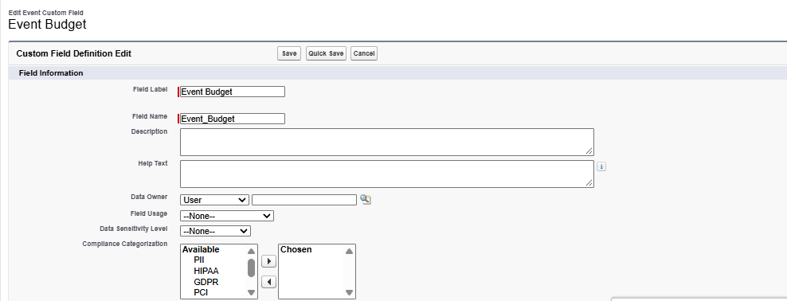
Figure 3 – Event Budget formula field (syntax check passed)

4.3 Relationships
Relationship | Type
Event → Client | Lookup
Event → Venue | Lookup
Feedback → Event | Lookup
Feedback → Client | Lookup
EventVendor → Event | Master-Detail
EventVendor → Vendor | Master-Detail
Salesforce does not support direct many-to-many relationships, so the EventVendor__c junction object with two Master-Detail fields links Events and Vendors.

4.4 Lookup Filter (Feedback → Event)
A lookup filter on the Feedback object's Event field ensures that after a client is selected, only that client's events appear in the Event lookup. Filter criteria: Event: Client__c equals Field: Feedback: Client__c.
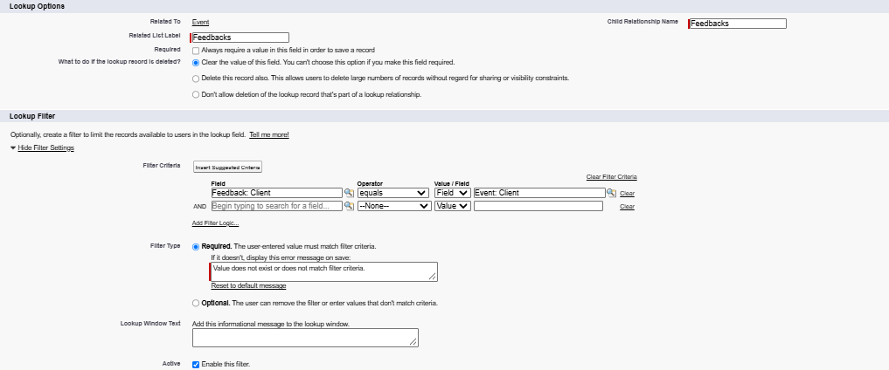
Figure 4 – Lookup filter on the Feedback → Event field

4.5 Validation Rule – Email Format
A validation rule on the Client object blocks saves when the email format is invalid.
NOT(REGEX(Email__c, "^[a-zA-Z0-9._]+@[a-zA-Z0-9.]+\.[a-zA-Z]{2,}$"))
Error message: "Please Enter Valid Email Address", shown on the Email field.
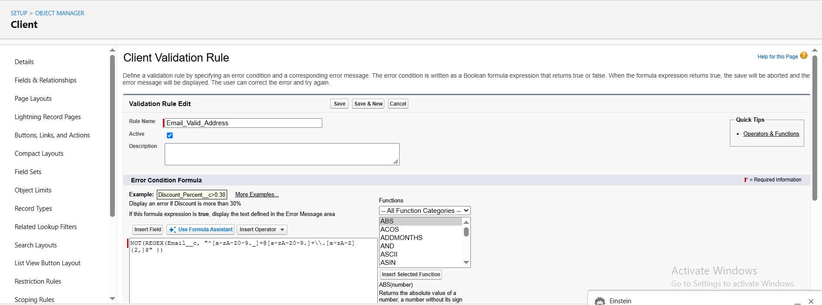
Figure 5 – Email_Valid_Address validation rule

4.6 Approval Process – Event Cancellation
The Event_Cancellation_Process ensures an event is canceled only after manager approval, with automatic notifications to all parties. Four classic email templates were created first:
Template | Subject | Used For
Event Cancellation Request Notification | Approval Request: Cancel Event {!Event__c.Name} | Alert on submission
Email to Client After Cancellation | Event Cancellation Notice – {!Event__c.Name} | Client notified of approval
Approval Notification to Event Owner | Event Cancellation Approved: {!Event__c.Name} | Owner notified of approval
Rejection Notification to Event Owner | Event Cancellation Rejected: {!Event__c.Name} | Owner notified of rejection
- Entry criteria: Event Status equals Pending Cancellation.
- Approver: assigned automatically to the submitter's manager.
- Initial submitter: Event Owner.
- Final approval actions: field update Event Status = Canceled; email alert to Event Owner.
- Final rejection actions: field update Event Status = Rejected; email alert to Event Owner.
- Approval step: Manager Review, activated after configuration.
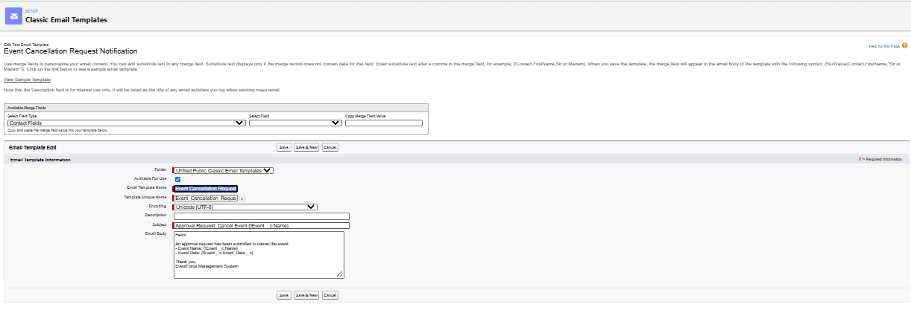
Figure 6 – Classic email template: cancellation request notification
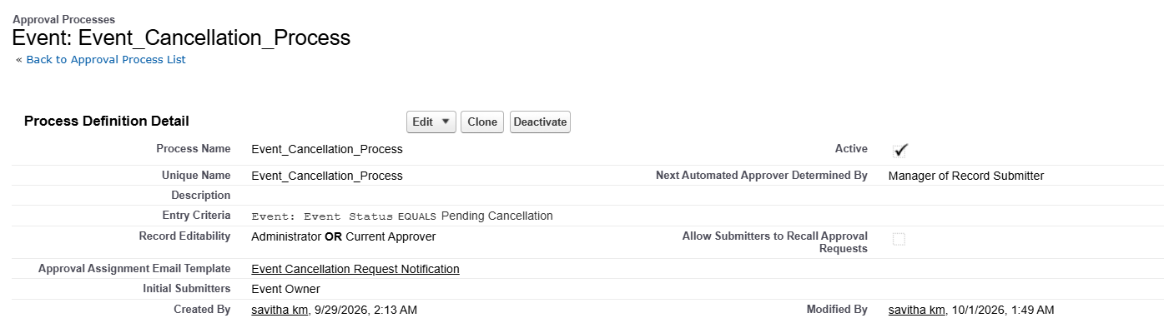
Figure 7 – Event_Cancellation_Process activated

4.7 Flow – 3-Day Reminder Email
A record-triggered flow sends the client a reminder email three days before a confirmed event. Configuration:
- Object: Event; trigger: record is created or updated; condition: Event Status = Confirmed.
- Optimize for: Actions and Related Records.
- Scheduled path 3_Days_Before: time source Event__c: Event Date, offset 3 days before.
- Text templates Subject and Body composed with record merge fields.
- Send Email action (Alert_Client_3Day_Reminder): recipient = Client Email, CC = Event Owner.
- Flow label: Client Reminder – 3 Days Before; saved and activated.
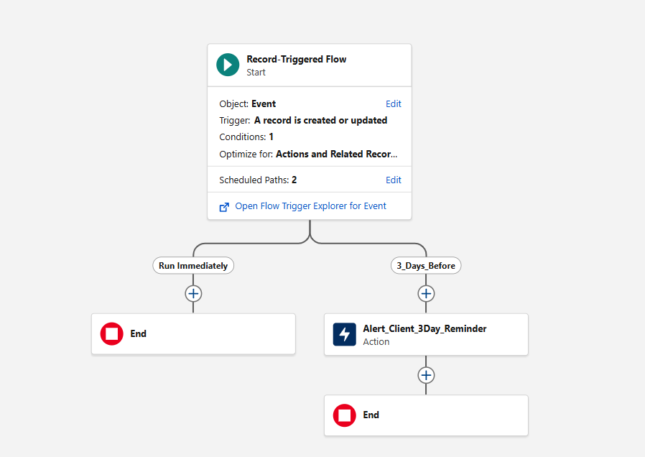
Figure 8 – Client Reminder – 3 Days Before flow

4.8 Apex – Venue Status Automation
Scenario: when an Event with a Venue is confirmed, the venue's Availability Status becomes Reserved; when the event is canceled it returns to Available. Logic is held in a helper class called from a thin trigger.
public with sharing class VenueStatusHelper { ... }
trigger EventTrigger13 on Event__c (after insert, after update) { VenueStatusHelper.updateVenueStatus(Trigger.new); }
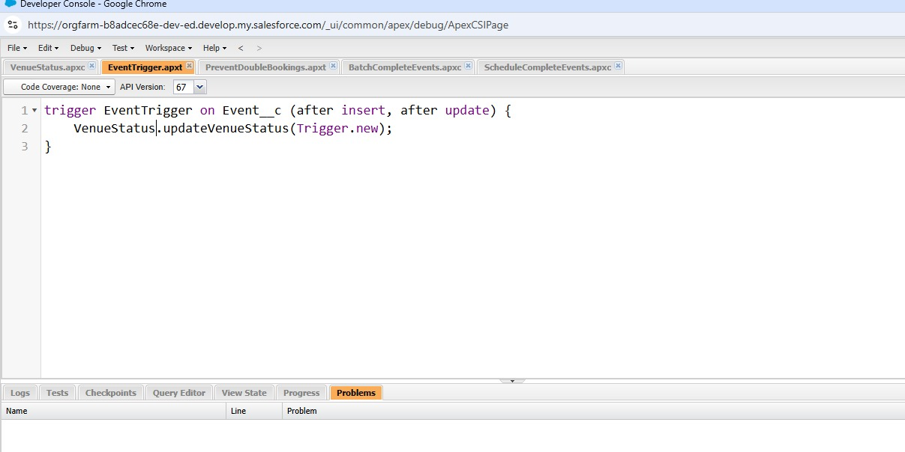
Figure 9 – EventTrigger13 calling VenueStatusHelper

4.9 Apex – Prevent Double Booking
A before-insert / before-update trigger gathers the venues involved, fetches existing events at those venues in a single bulk-safe query, and raises an error when another event already holds the same date: "This Venue is already booked on this date."
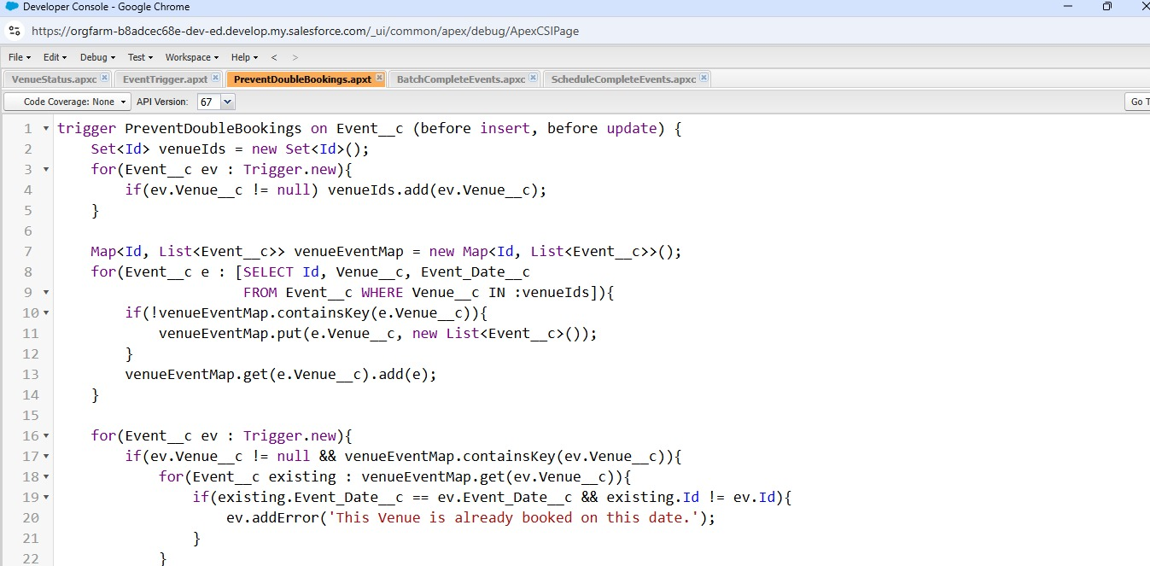
Figure 10 – PreventDoubleBooking trigger

4.10 Batch & Scheduled Apex – Nightly Completion
BatchCompleteEvents queries events where Event Date < TODAY and status ≠ Completed and marks them Completed. The ScheduleCompleteEvents schedulable class launches the batch nightly via Setup → Apex Classes → Schedule Apex (job: Daily Event Completion, 8:00 PM, every day).
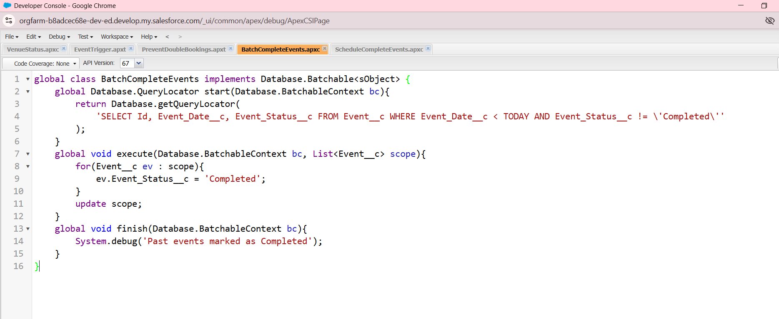
Figure 11 – BatchCompleteEvents class
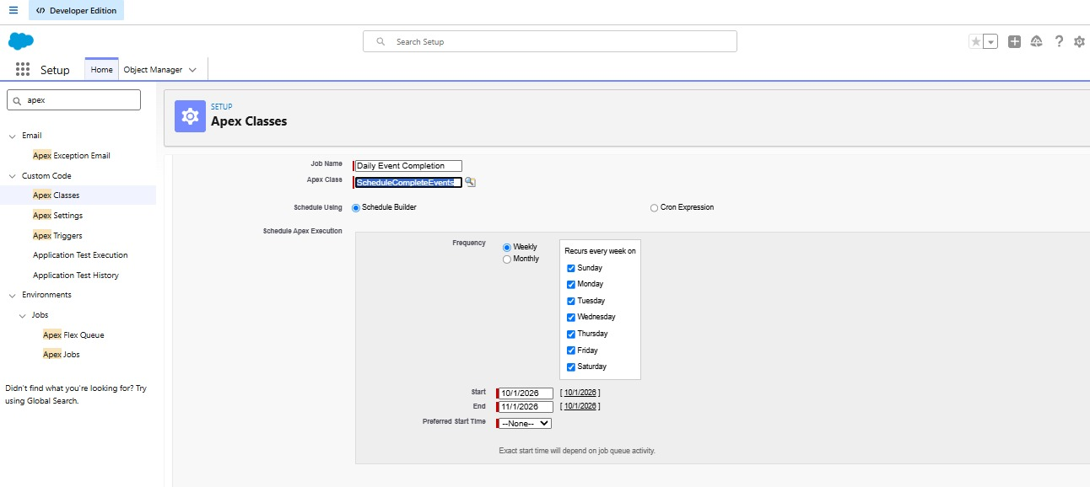
Figure 12 – Scheduled job: Daily Event Completion

5. Phase 3 – UI/UX Development & Customization

5.1 Lightning App – Event Planner
A custom Lightning App gathers every module into one workspace. Created via Setup → App Manager → New Lightning App with navigation items: Events, Clients, Vendors, Venues, Feedbacks, Reports, Dashboards; System Administrator profile assigned.
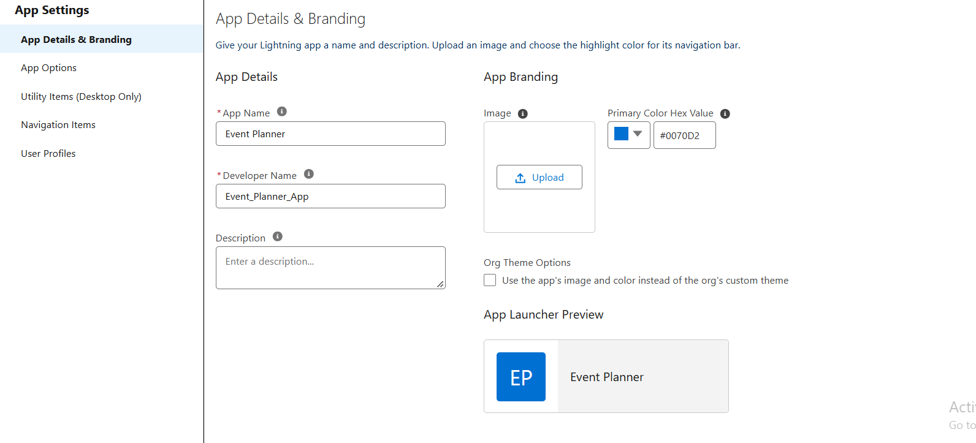
Figure 13 – Event Planner Lightning App

5.2 Reports
An "EventForce Report" folder was created and shared with the Event Coordinator and Vendor Manager roles (View access). The report Upcoming Events by Month groups events by calendar month with row counts and a SUM of event budgets, filtered to Event Date ≥ TODAY and Event Status ≠ Canceled, with a column/line chart.
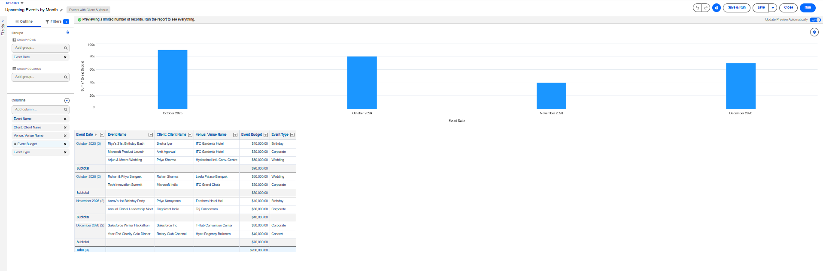
Figure 14 – Upcoming Events by Month report

5.3 Dashboards
The EventForce Operations Dashboard visualizes the report as a donut chart (max 6 values, light theme) showing the upcoming events overview.
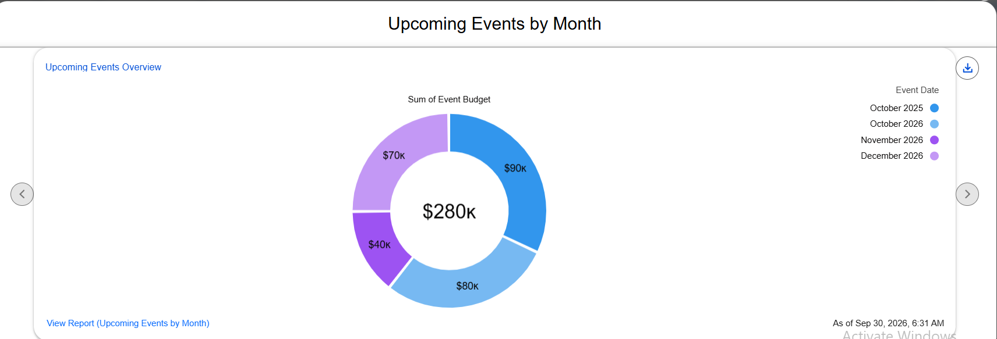
Figure 15 – EventForce Operations Dashboard

6. Phase 4 – Data Migration, Testing & Security

6.1 Data Migration
Records for Events, Clients, Vendors, Venues, and Feedback were imported using the Salesforce Data Import Wizard after pre-validation checks to avoid duplicates and maintain data integrity.

6.2 Profiles
Object | Event Coordinator | Vendor Manager | Client Profile | Event Admin
Event | CRUD | Read Only | Read Only (own events) | Full
Client | Read, Edit | Read Only | No access | Full
Vendor | Read | CRUD | No access | Full
Venue | Read | Read Only | No access | Full
Feedback | Create, Read | Read Only | Create, Read | Full
Event Admin was cloned from System Administrator (inherits Modify All Data and full CRUD). The other three profiles were cloned from Standard Platform User: Event Planner set as default app, session timeout 2 hours, passwords never expire, minimum password length 8.
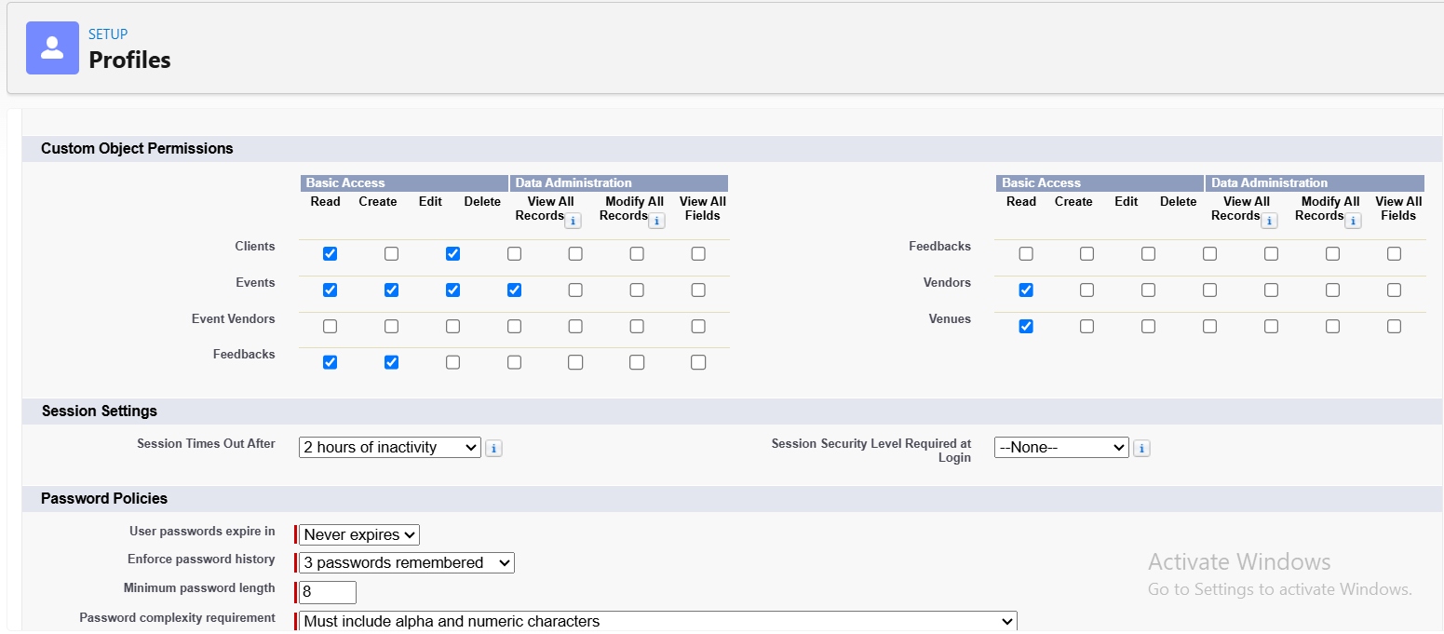
Figure 16 – Event Coordinator profile object permissions

6.3 Roles
Role | Reports To
Event Admin | CEO
Event Coordinator | Event Admin
Vendor Manager | Event Admin
Client | Event Admin

6.4 Users
Users were created with matching role, license, and profile: Event Admin (Salesforce license) and Event Coordinator, Vendor Manager, and Client (Salesforce Platform license). Note: a Developer Edition org has limited Salesforce licenses — deactivate an unused user or change the license type if none is free.
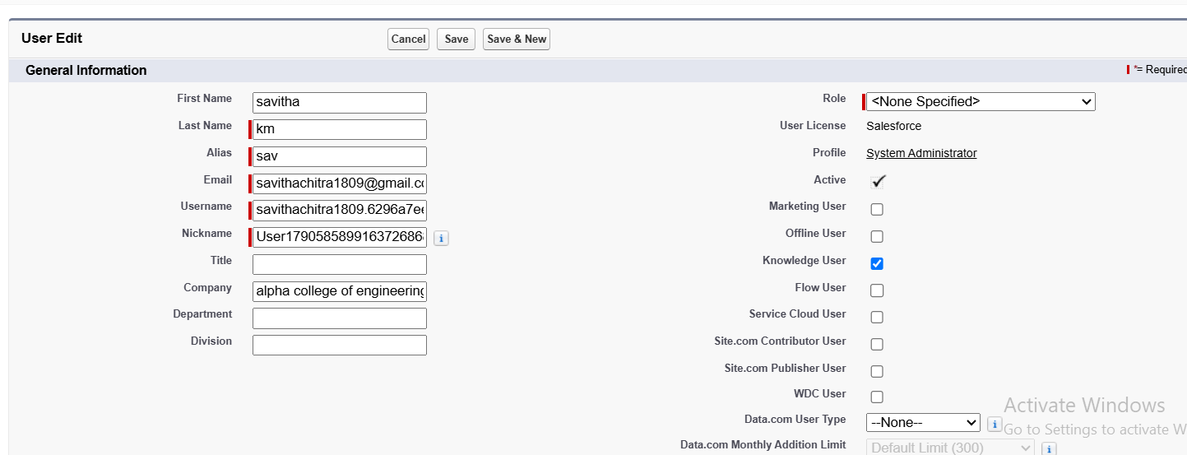
Figure 17 – All Users list

6.5 Permission Set – Feedback Manager
A Feedback Manager permission set grants Read/Create/Edit/Delete on the Feedback object and is assigned to the Event Coordinator user, extending permissions without changing the profile.
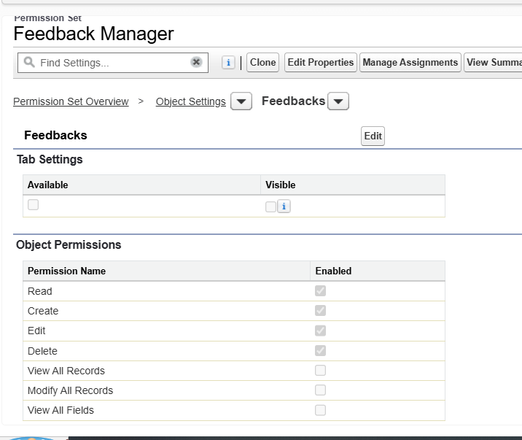
Figure 18 – Feedback Manager permission set

6.6 Sharing Settings
Organization-Wide Defaults for Event were set to Private (internal and external). An owner-based sharing rule Event_Sharing_For_Vendors shares records owned by the Event Coordinator role with the Vendor Manager role at Read Only access — sharing rules extend access and never restrict it.
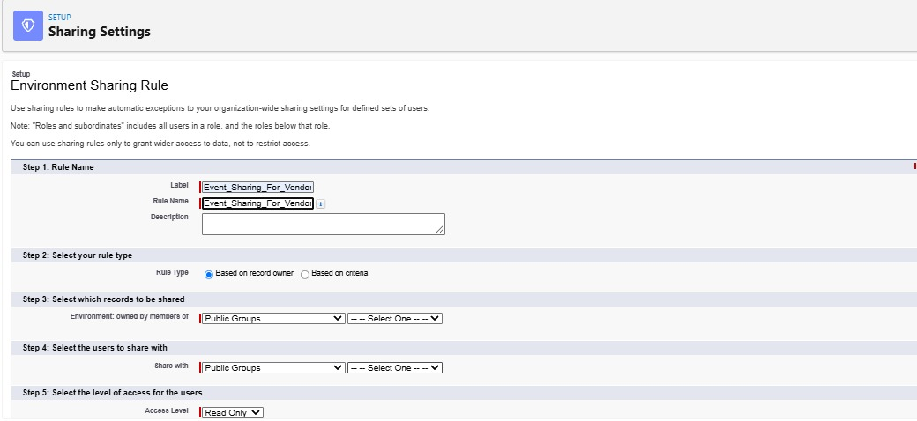
Figure 19 – Event_Sharing_For_Vendors sharing rule

7. Phase 5 – Deployment, Documentation & Maintenance

7.1 Deployment Strategy
All configurations, customizations, and automations were built and tested within a Salesforce Developer Edition org. Production deployment was not performed because Developer Edition orgs are standalone environments; real deployments require sandbox environments, change sets, or Salesforce DevOps tooling (GitHub CI/CD, Salesforce DX).
A real enterprise deployment would follow this path:
- Build and unit-test in a Developer or Developer Pro sandbox.
- Promote metadata (objects, fields, flows, Apex, approvals, reports, dashboards) to a Partial or Full sandbox for UAT via change sets or Salesforce DX.
- Run Apex tests — a minimum of 75% code coverage is required to deploy to production.
- Deploy in a low-usage window, then activate flows, approvals and scheduled jobs and assign permission sets.
- Load production data, train users, and provide post-go-live support.

7.2 Maintenance, Monitoring & Troubleshooting
- Keep event, client, vendor, venue, and feedback records accurate and current.
- Monitor Flows, Apex jobs, scheduled jobs, and pending approvals for failures.
- Resolve user-access errors by checking profiles, permission sets, roles, and sharing rules.
- Debug Apex triggers and Flow logic using debug logs and the Developer Console.
- Adjust validation rules and sharing settings as business requirements change; run periodic duplicate checks.

7.3 Documentation Summary
This document records the purpose, data model, configuration, automation, security, and testing of EventForce. It covers the business overview and objectives, phase-wise implementation, the data model and relationships, automation components (Flows, Approval Process, validation rules, Apex), the security model (profiles, roles, permission sets, OWD, sharing rules), and testing results with screenshots — providing a blueprint for future developers and administrators and supporting training, maintenance, and knowledge transfer.

8. Testing Results
Functional and performance testing was carried out in the Developer Edition org across configuration, automation, and security. All features behaved as expected.
# | Area | Test Scenario | Expected Result
1 | Validation rule | Save a Client with an invalid email such as 'abc@' | Save blocked with 'Please Enter Valid Email Address'
2 | Formula field | Create an event of each Event Type | Event Budget fills in per the CASE formula
3 | Double booking | Create two events at the same venue on the same date | Error: 'This Venue is already booked on this date.'
4 | Venue status | Set an event to Confirmed, then Canceled | Venue becomes Reserved, then Available
5 | Approval process | Set status to Pending Cancellation and submit | Approval request and alert emails sent
6 | Approval – approve | Approver approves the request | Status = Canceled; owner notified
7 | Approval – reject | Approver rejects the request | Status = Rejected; owner notified
8 | Flow | Confirm an event 3+ days ahead with a client email | Reminder sent three days before the event date
9 | Batch Apex | Run the batch with past-dated events | Past events marked Completed
10 | Lookup filter | Pick a client on Feedback, open Event lookup | Only that client's events listed
11 | Security | Log in as each user type | Each user sees only permitted tabs, objects, and records
12 | Sharing rule | Vendor Manager views coordinator-owned events | Events visible as Read Only

9. Conclusion – Project Learnings & Outcomes
The EventForce Management System demonstrates how Salesforce can be configured as an integrated CRM platform for event-management operations. The project covers the complete implementation lifecycle from requirements and data modelling through automation, UI customization, data preparation, testing, security, and deployment planning.
Key learnings include:
- Designing a scalable data model, including a junction object for many-to-many links.
- Combining declarative tools (Flows, approvals, validation rules) with Apex for advanced business logic.
- Writing bulk-safe Apex triggers and using Batch and Schedulable Apex for asynchronous processing.
- Layering security with profiles, roles, permission sets, OWD, and sharing rules.
- Turning operational data into decisions through reports and dashboards.
- Mapping an academic Developer Org build to real deployment, maintenance, and documentation practice.
The completed design provides a structured foundation for managing events, clients, vendors, venues, and feedback in one CRM environment, and the documented deployment and maintenance practices provide a path toward a controlled production rollout.

Thank You

