**JENKINS**

**1.What is Jenkins?**

Jenkins is a free open source Continuous Integration tool and automation server to monitor continuous integration and delivery. It is written in Java.

It is known as an automated Continuous Delivery tool that helps to build and test the software system with easy integration of changes to the system. Jenkins follows Groovy Scripting.

Also, it enables developers to continuously check in their code and also analyze the post-build actions. The automation testers can use to run their tests as soon as the new code is added or code is modified.

**2.Continuous Integration, Continuous Delivery, and Continuous Deployment?**

**Continuous Integration:** A software development process where the changes made to software are integrated into the main code as and when a patch is ready so that the software will be always ready to be – built, tested, deployed, monitored – continuously.

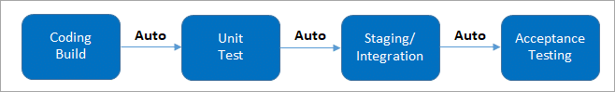

(It involves keeping the latest copy of the source code at a commonly shared hub where all the developers can check to fetch out the latest change in order to avoid conflict.)

**Continuous Delivery:** This is a Software Development Process where the continuously integrated (CI) changes will be tested & deployed continuously into a specific environment, generally through a manual release process, after all the quality checks are successful

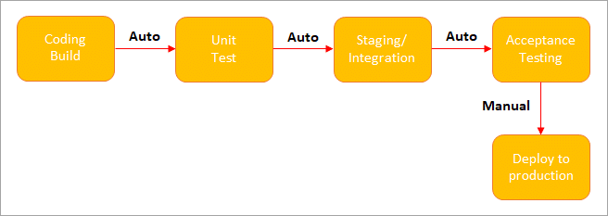

(**Manual Deployment to Production.**It does not involve every change to be deployed.)

**Continuous Deployment:** A Software Development practice where the continuously integrated (CI) changes are deployed automatically into the target environment after all the quality checks are successful

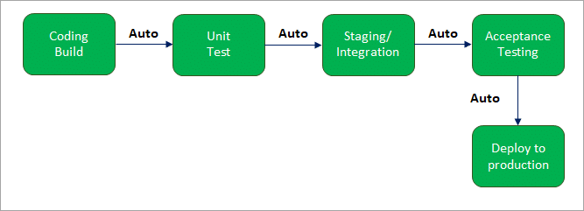

(**Automated Deployment to Production.**Involves every change to be deployed automatically.)

**3.What are the common use cases Jenkins is used for?**

Jenkins being open-source automation can be used for any kind of software-based automation. Some of the common use-cases include but not limited to –

* Software build jobs
* Sanity/Smoke/CI/Regression test jobs
* Web/Data Scraping related jobs
* Code coverage measurement jobs
* General-purpose automation
* Reverse Engineering jobs
* Key Decoding jobs & many other jobs where software automation will be applicable.

## 4.What is the requirement for using Jenkins?

## To use Jenkins you require

* A source code repository which is accessible, for instance, a Git repository
* A working build script, e.g., a Maven script, checked into the repository

**5.Mention some of the useful plugins in Jenkin?**

* Maven 2 project
* Amazon EC2
* HTML publisher
* Copy artifact
* Join
* Green Balls

## 6.Mention what are the commands you can use to start Jenkins manually?

To start Jenkins manually, you can use either of the following

(Jenkins_url)/restart: Forces a restart without waiting for builds to complete  
(Jenkin_url)/safeRestart: Allows all running builds to complete

## 7.How do you install Jenkins?

To install Jenkins, make sure the following are installed –

Java (version 8)  
Apache Tomcat (version 9)  
Download the Jenkins war file and deploy it using Tomcat. You can choose to install the plugins suggested by Jenkins during the installation itself. Once the installation is done, you will be able to see the Jenkins dashboard.

## 8.What is meant by Jenkins pipeline?

A pipeline is a group of interlinked jobs done one after the other in a sequence. To integrate and implement continuous delivery pipelines, Jenkins pipelines provides a combination of plugins. The instructions to be performed are given through code.

## 9.What is a job in Jenkins?

A job or build job is a task or step in the entire build process. It could be compiling the source code, running unit tests, deploying the application to the web server and so on.

## 10. How can you create a job?

On the dashboard page, you can just select a ‘New Job’. When you create a job, you can choose options such as the SCM, triggers to control, the build script and notifications.

**11.What are the system requirements to install Jenkins?**

The minimum configuration required is –

* 256MB of RAM
* 1 GB of drive space
* Java
* Web browser

## 12.Give a simple use case/scenario to explain how Jenkins works.

Let us say a developer is working on some code changes and eventually commits them to the repository.  
Jenkins server, which constantly checks for changes in the repository, detects the change and pulls the changes to trigger a build.  
The build can fail, in which case the developer is informed with reports.  
If the build passes, it is deployed on to the test server.  
Once the testing is complete, a test report is generated and sent to the developers. This process continues till all the tests are successful, after which code is deployed to production.