**VINOTHINI S**

Application Overview

Table of Contents

**1.** **Technical Overview** 2

**1.1.** **Architecture Context Diagram:** 2

**1.2.** **Technical Details** 2

**1.3.** **Technical Flow for Table Maintenance Screen** 2

**2.** **Functionality Overview** 3

**2.1.** **Table Maintenance – Navigation** 3

**2.2.** **Security – Security Group** 4

**2.2.1.** **Search Results** 4

**2.2.2.** **Insert Row** 4

**2.2.3.** **Delete Row** 5

**2.2.4.** **Save As** 6

**2.2.5.** **Save As Table Maint Import File** 7

**Reserves Repository - Application Overview**

This application functions as a data warehouse for information of reserves through out the client and their associated legal entities. This is the centralized place for viewing and analyzing reserves for all business units of Clients and their affiliates.

# **Technical Overview**

## **Architecture Context Diagram:**

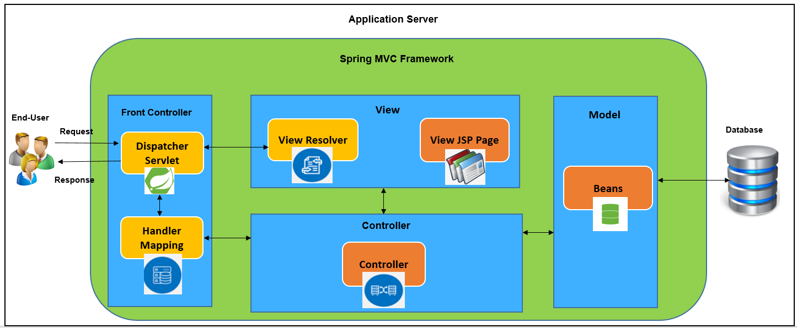

## **Technical Details**

* spring-webmvc – 5.3.13
* spring-security-web, spring-security-taglibs, spring-security-config – 5.6.0
* spring-session-jdbc – 2.6.0
* ojdbc7 – 12.1.0.2.0

## **Technical Flow for Table Maintenance Screen**

* When user selects a particular functionality (Insert/Update/Delete) from the UI screen, the relevant controller is invoked with the use of ***Front Controller*** (Dispatcher Servlet and Handler Mapping).
* From the controller the flow goes to ***Service Layer*** where all the business logics reside. The relevant changes/additions are done and then the flow goes to ***Database layer***.
* ***JDBCTemplate*** from Spring Framework is used for the database related functionalities.
* Once the database operation is done the flow comes back to Controller via Service.
* In Controller, the response is mapped to the corresponding VO, content type is set and also the page is forwarded to the relevant jsp based on the success or failure response. (***Model and View***)

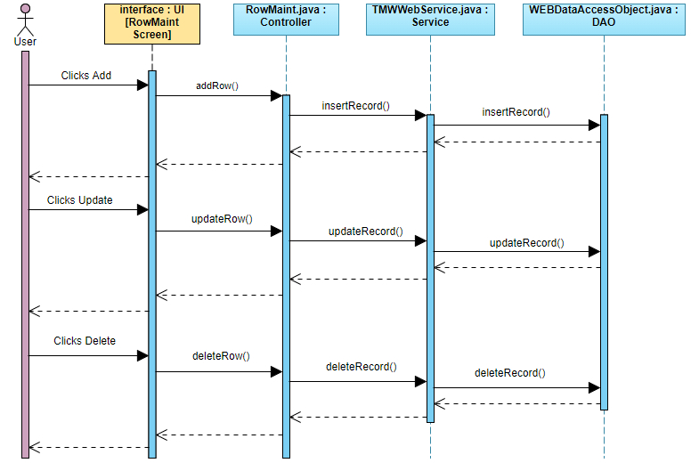

# **Functionality Overview**

Application includes the below functionalities where each of these are maintained as a separate tab.

1. Home
2. Table Maintenance
3. Exceptions
4. Rejection
5. Adjustments
6. Control
7. General Ledger
8. Val Cells
9. Managed States
10. Reports

Here we can see the functionality for *Table Maintenance* screen

## **Table Maintenance – Navigation**

1. Login into the Application and navigate to ‘Table Maintenance’ tab.

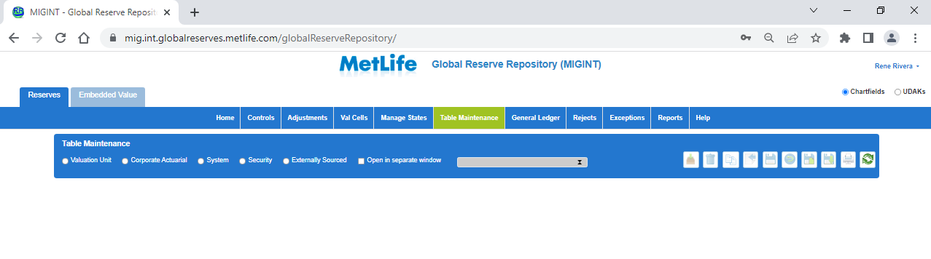

Table maintenance is specifically used to retrieve and modify the reserves details based on the user’s authorization level.

* ***Valuation Unit*** – Benefit Type, Valuation Basis, Valuation Product, Valuation Standard etc.
* ***Corporate Actuarial*** – Account Type, Adjustment Reason, Business Segment, Currency, Legal Entity, Tax Code, Tax Selection Code, Year End Tax Period etc.
* ***System*** – Mapping Type, Object Description, Report Names, Report Types, Stored Procedure Criteria etc.
* ***Security*** – Security Group, User, User Group etc.
* ***Externally Sourced*** – Country Code Lookup, Currency Conversion etc.

## **Security – Security Group**

* Select the Security radio button and then select Security Group from the dropdown.
* Click on Retrieve.

## **Search Results**

* Search Results will be displayed as shown below. (Search Result Table details are dynamic that changes according to the table selected)

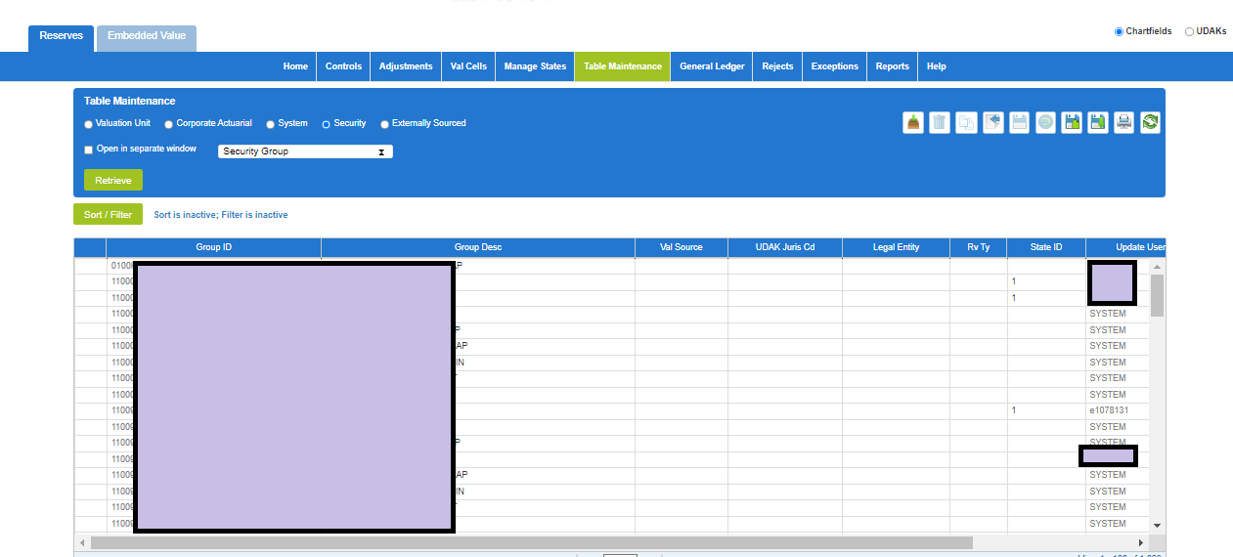

## **Insert Row**

* Click on the ‘Insert Row’ icon at the top. A blank row will be added at the top the search results table.
* Enter the values to be inserted and click on ‘Save Changes’. The values will be inserted into the table and now shown in the search results.

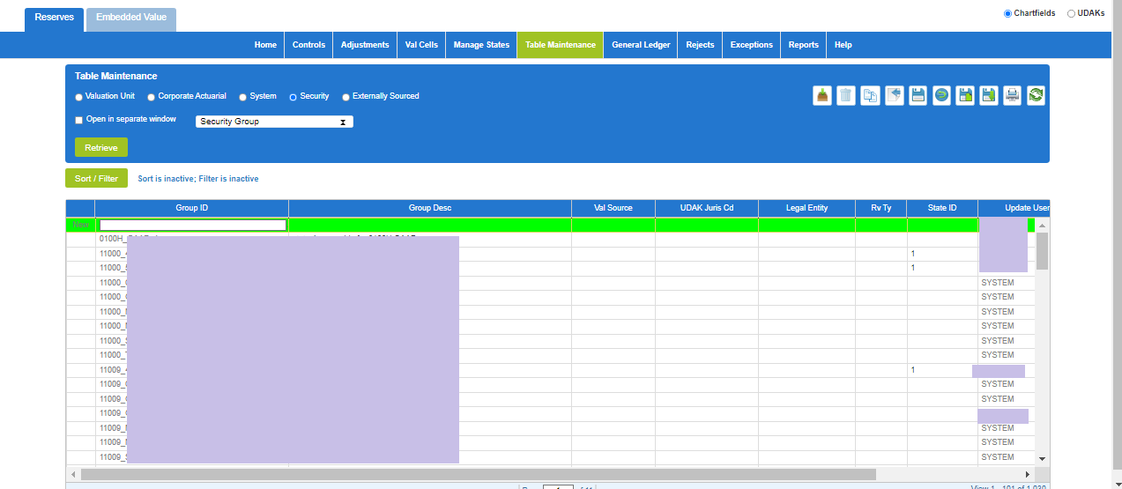

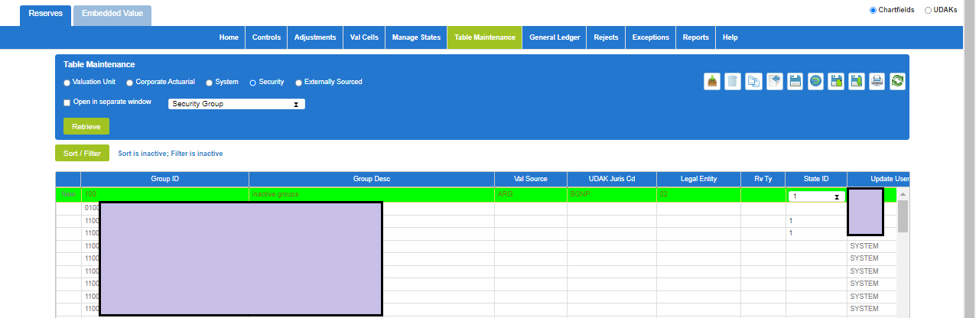

## **Delete Row**

* Select the row to be deleted and click on ‘Delete Row’ icon. The selected row will be removed from the database and also the changes are reflected in Search Results screen.

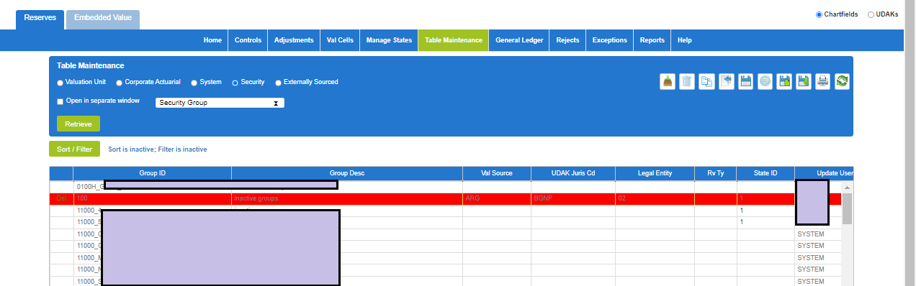

## **Save As**

* From the search results page, click on the Save as icon.
* All the search results visible on the screen should be exported into the excel file in the selected format (.xls, .xlsx, .txt)

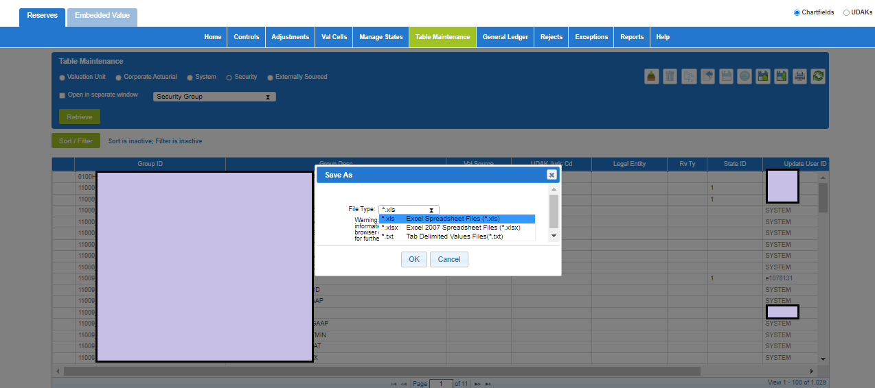

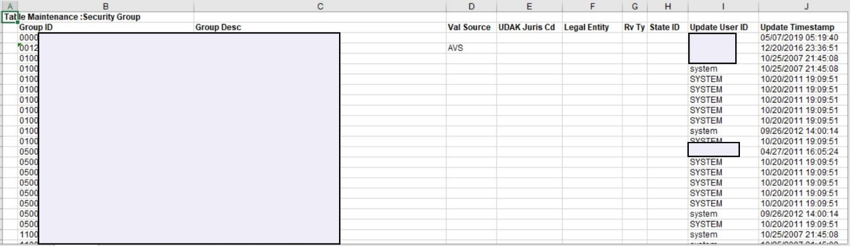

## **Save As Table Maint Import File**

* From the search results page, click on the ‘Save as Table Maint import’ file.
* File should be saved in the selected format (.xls, .xlsx, .txt). Imported file should not have Update User ID and Updated Timestamp columns.

