CreateLead DataSet:
===HTML===
<input type="text" class="inputBox" name="companyName" size="30" maxlength="100" id="createLeadForm_companyName">
<input type="text" class="inputBox" name="firstName" size="30" maxlength="100" id="createLeadForm_firstName">
<input type="text" class="inputBox" name="lastName" size="30" maxlength="100" id="createLeadForm_lastName">
<input type="submit" class="smallSubmit" name="submitButton" value="Create Lead" id="ext-gen556">
===JAVA===
package com.leaftaps.pages;
import com.framework.selenium.api.design.Locators;
import com.framework.testng.api.base.ProjectSpecificMethods;
/**
* Page object representing the View Lead page.
* Provides methods to verify lead details and perform actions like delete.
* @author Auto-generated
*/
public class CreateLeadPage extends ProjectSpecificMethods {
public CreateLeadPage enterCompanyName(String companyName) {
clearAndType(locateElement(Locators.ID,"createLeadForm_companyName"),companyName);
reportStep(companyName+" username is entered successfully", "pass");
return this;
}
public CreateLeadPage enterFirstName(String firstName) {
clearAndType(locateElement(Locators.ID,"createLeadForm_firstName"),firstName);
reportStep(firstName+" username is entered successfully", "pass");
return this;
}
public CreateLeadPage enterLastName(String lastName) {
clearAndType(locateElement(Locators.ID,"createLeadForm_lastName"),LastName);
reportStep(lastName+" username is entered successfully", "pass");
return this;
}
public CreateLeadPage clickCreateLeadButton() {
click(locateElement(Locators.Locators.NAME, "submitButton"));
reportStep("Create Lead button is clicked successfully", "pass");
return new ViewLeadPage();
}
}
Training-Data Created and Uploaded:
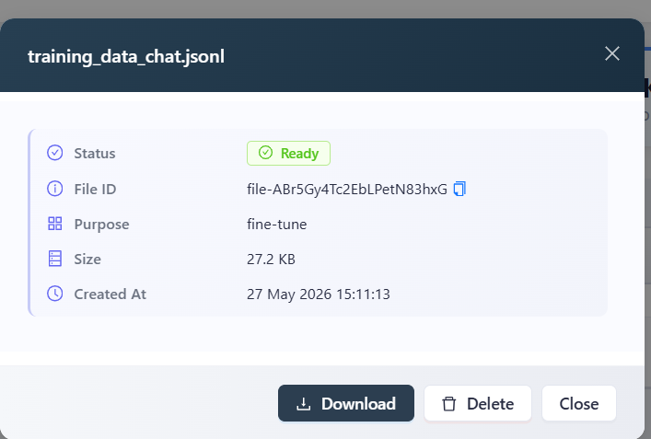

Fine-Tuning Result:
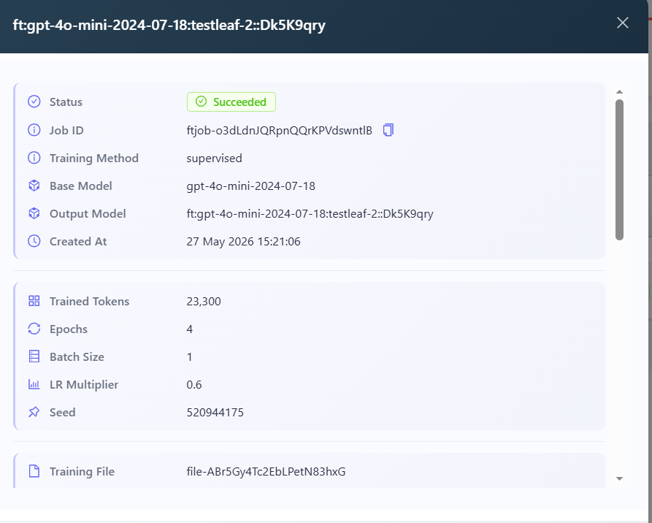

Implementation and Code in AI-Extension:
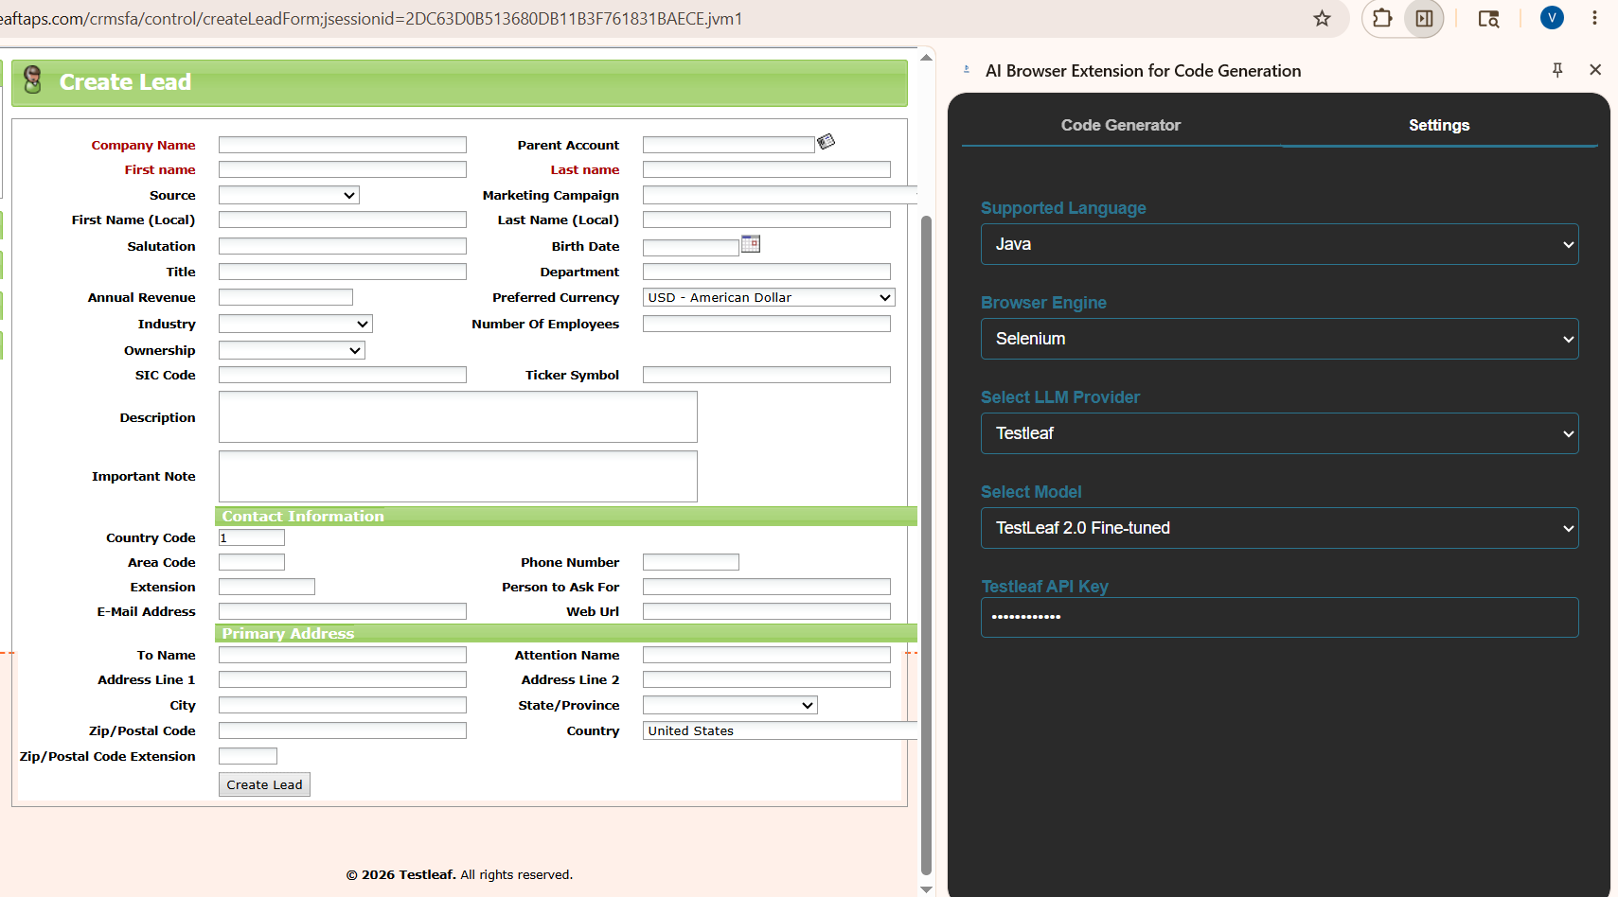
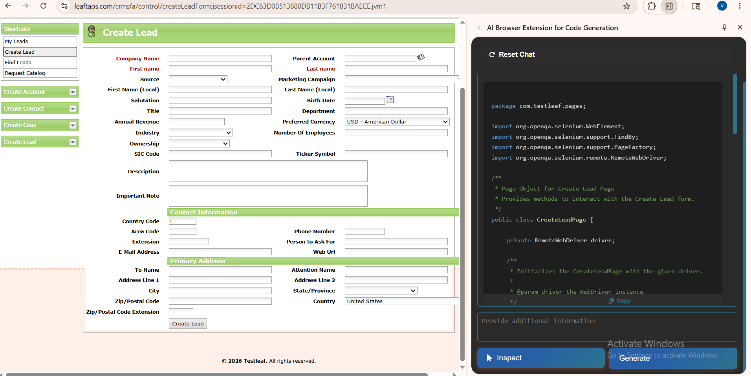
Code Generated:
package com.testleaf.pages;

import org.openqa.selenium.WebElement;
import org.openqa.selenium.support.FindBy;
import org.openqa.selenium.support.PageFactory;
import org.openqa.selenium.remote.RemoteWebDriver;

/**
* Page Object for Create Lead Page
* Provides methods to interact with the Create Lead form.
*/
public class CreateLeadPage {

private RemoteWebDriver driver;

/**
* Initializes the CreateLeadPage with the given driver.
*
* @param driver the WebDriver instance
*/
public CreateLeadPage(RemoteWebDriver driver) {
this.driver = driver;
PageFactory.initElements(driver, this);
}

@FindBy(id = "createLeadForm_companyName")
private WebElement companyNameField;

@FindBy(id = "createLeadForm_firstName")
private WebElement firstNameField;

@FindBy(id = "createLeadForm_lastName")
private WebElement lastNameField;

@FindBy(name = "submitButton")
private WebElement createLeadButton;

/**
* Enters the company name in the company name field.
*
* @param companyName the company name to enter
* @return the current CreateLeadPage instance
*/
public CreateLeadPage enterCompanyName(String companyName) {
companyNameField.clear();
companyNameField.sendKeys(companyName);
return this;
}

/**
* Enters the first name in the first name field.
*
* @param firstName the first name to enter
* @return the current CreateLeadPage instance
*/
public CreateLeadPage enterFirstName(String firstName) {
firstNameField.clear();
firstNameField.sendKeys(firstName);
return this;
}

/**
* Enters the last name in the last name field.
*
* @param lastName the last name to enter
* @return the current CreateLeadPage instance
*/
public CreateLeadPage enterLastName(String lastName) {
lastNameField.clear();
lastNameField.sendKeys(lastName);
return this;
}

/**
* Clicks the Create Lead button to submit the form.
*
* @return the LeadViewPage instance after submission
*/
public LeadViewPage clickCreateLeadButton() {
createLeadButton.click();
return new LeadViewPage(driver);
}
}

