1 Design DFA to accept bcaaaaaaaaaaaaaa, bc, and c

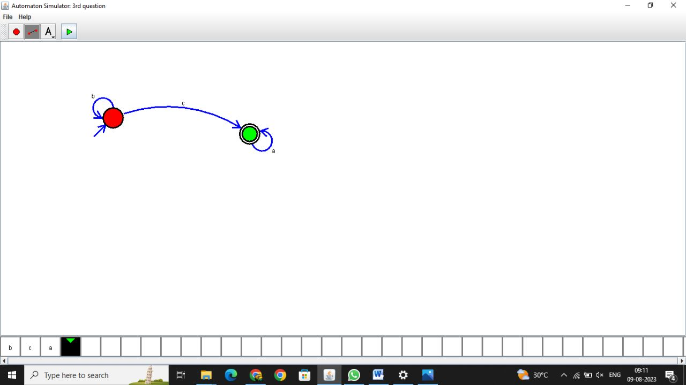

**Result:**

**Thus the program was executed successfully**

2.Design NFA to accept aaaaaa

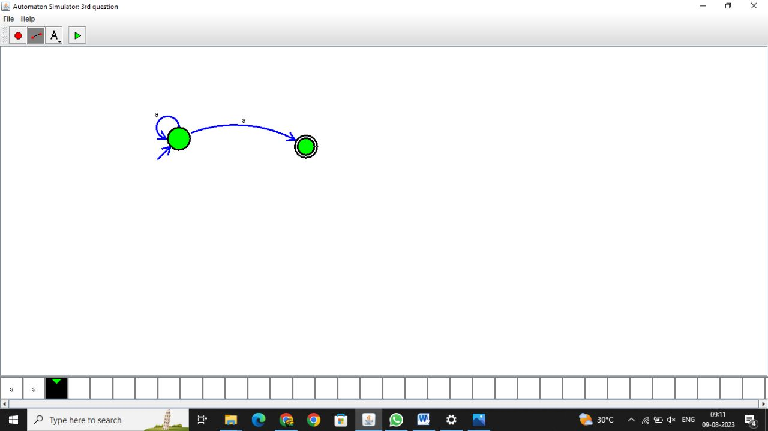

**Result: thus the program was executed successfully**

3.Design PDA for the input a^nb^n

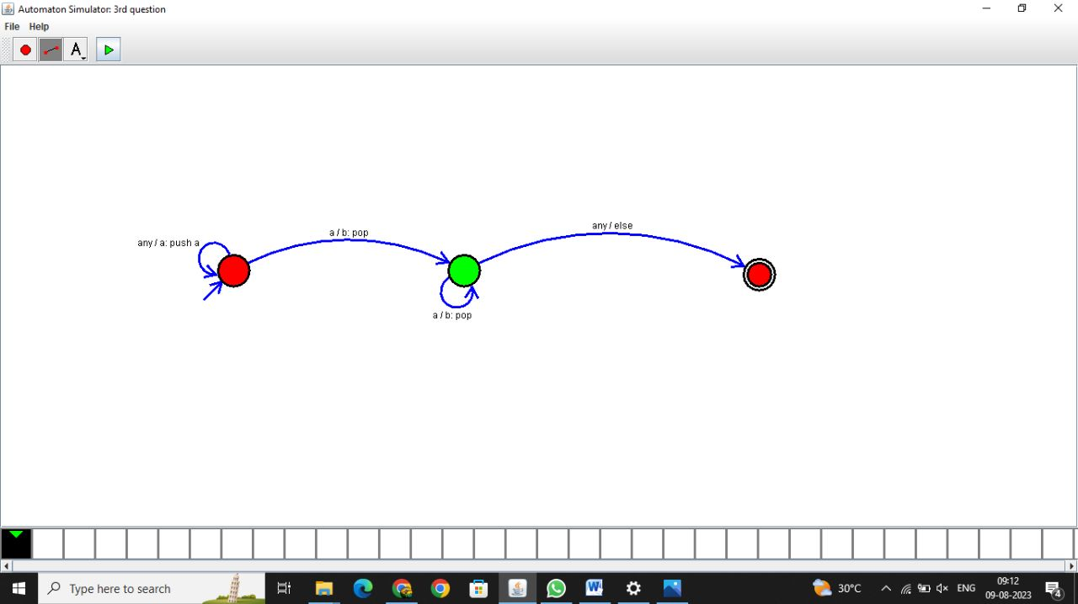

**Result: thus the program was executed successfully**

4.Design Tm For input a^nb^n

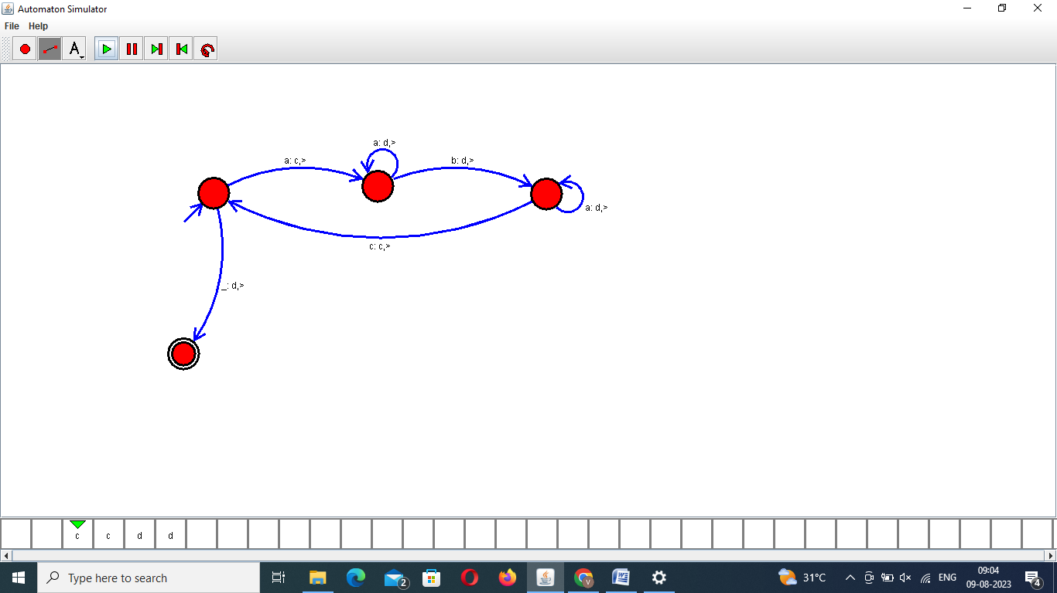

**Result: thus the program was executed successfully**

5 .Design PDA for input aabbbbc ( L=a^nb^2n)

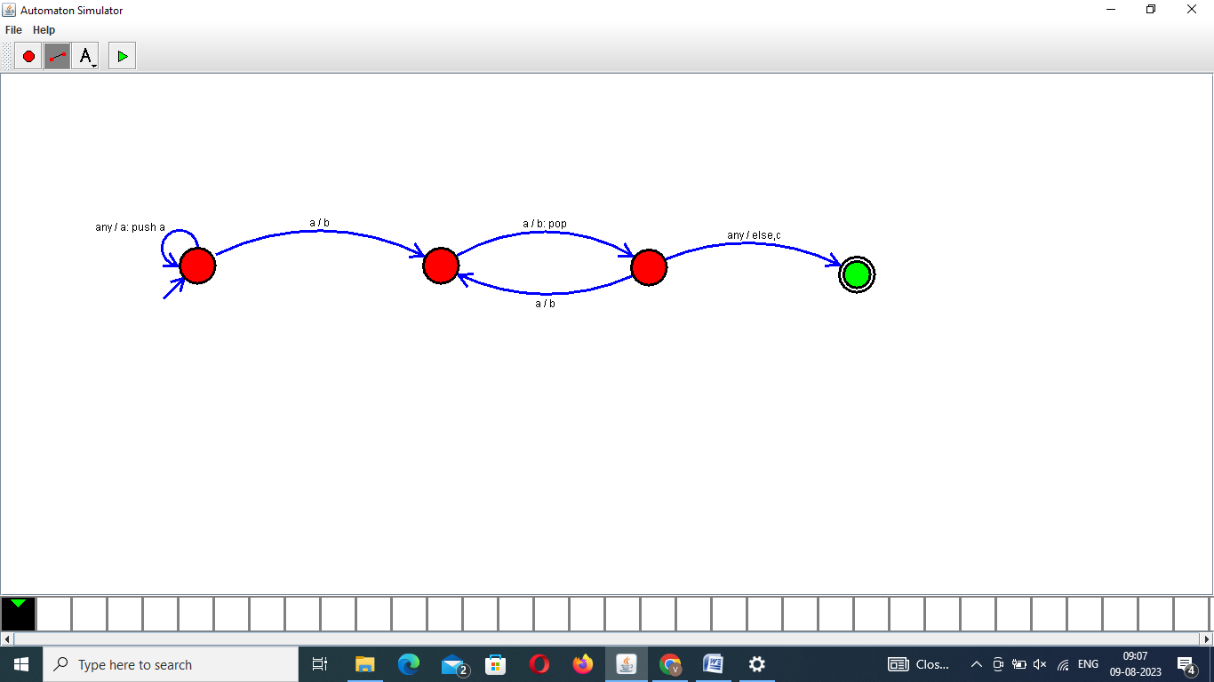

**Result: thus the program was executed successfully**

6.TM Simulation for Palindrome W= ababa c

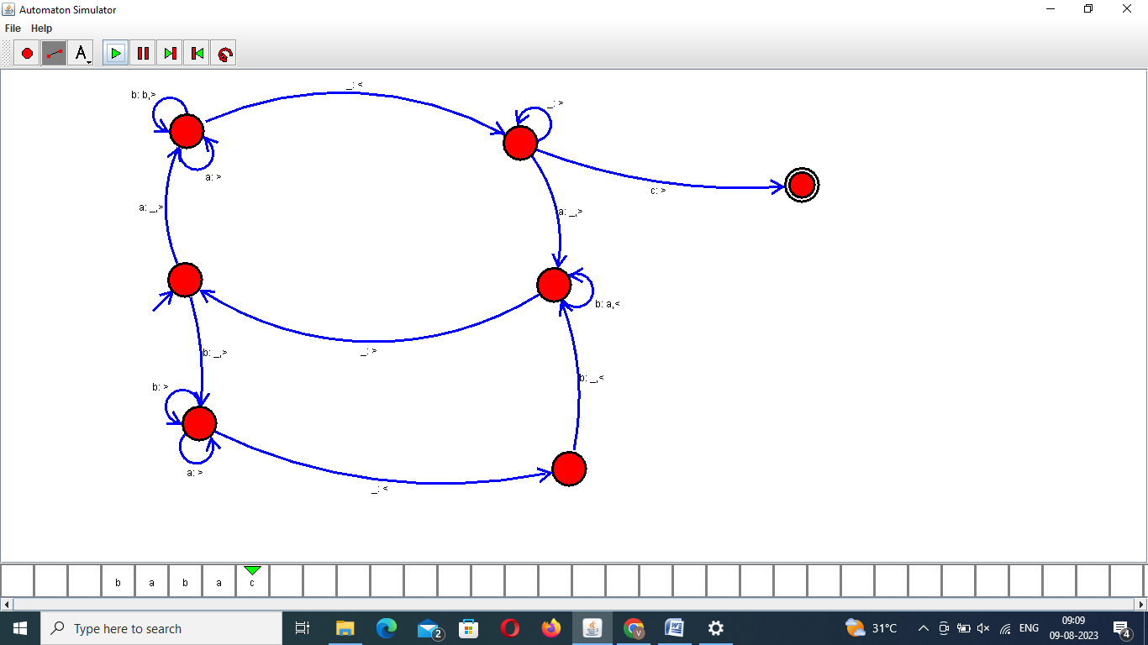

**Result: thus the program was executed successfully**

7.Design TM to perform addition of followingW= aa + aaaaAfter Addition of a’s = aaaaaa

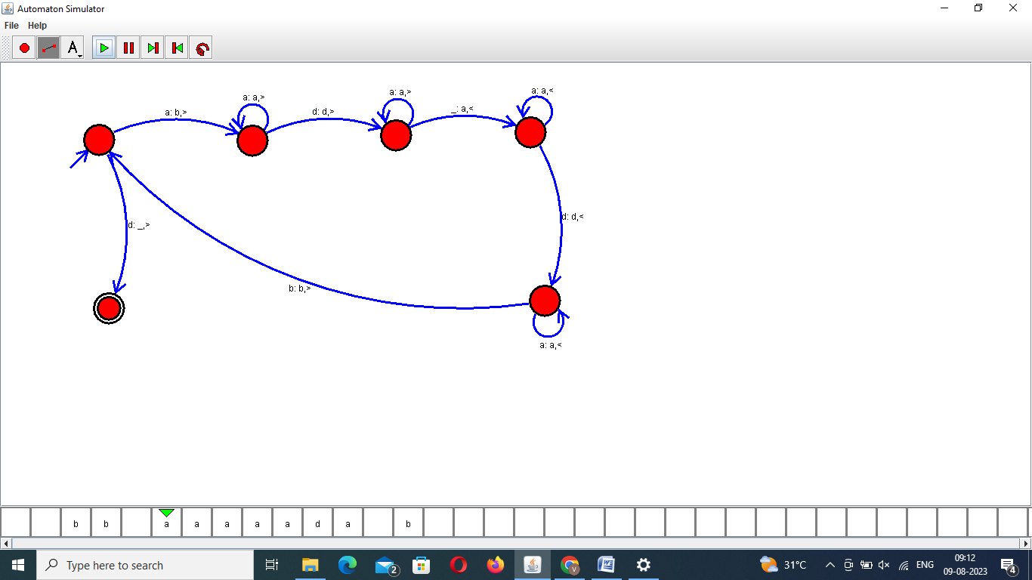

**Result: thus the program was executed successfully**

8.Design TM to perform subtraction W= aaa-aaThe Result of Subtraction is = a

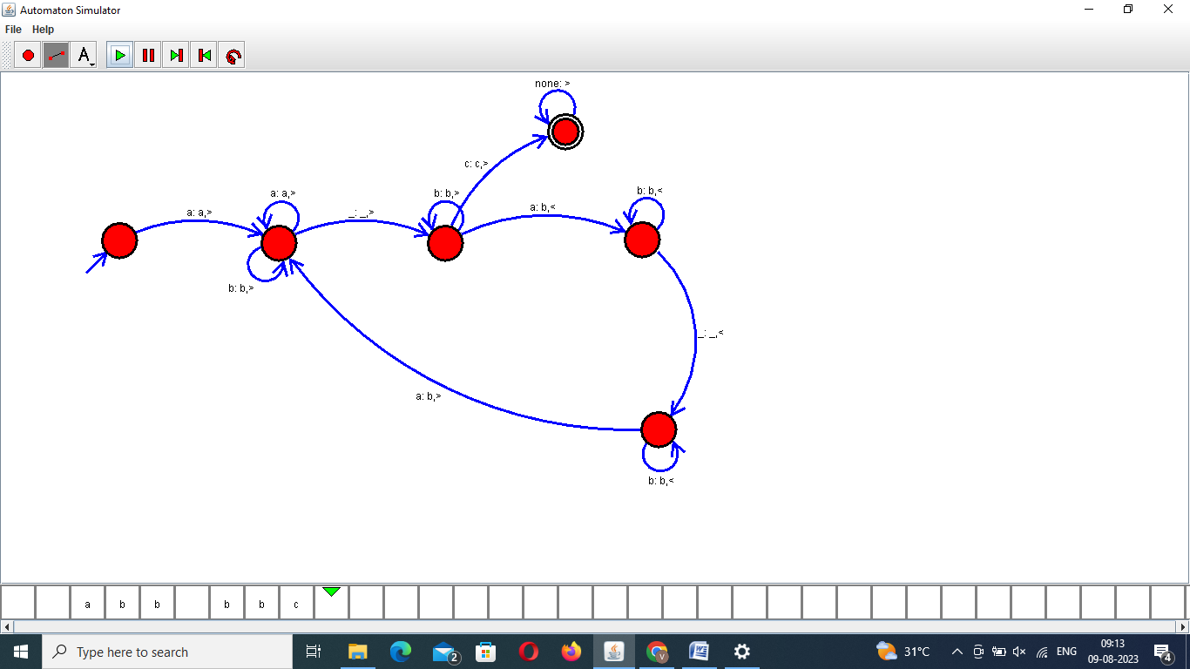

**Result: thus the program was executed successfully**

9.Design TM to perofrm string comparison

W = aba aba

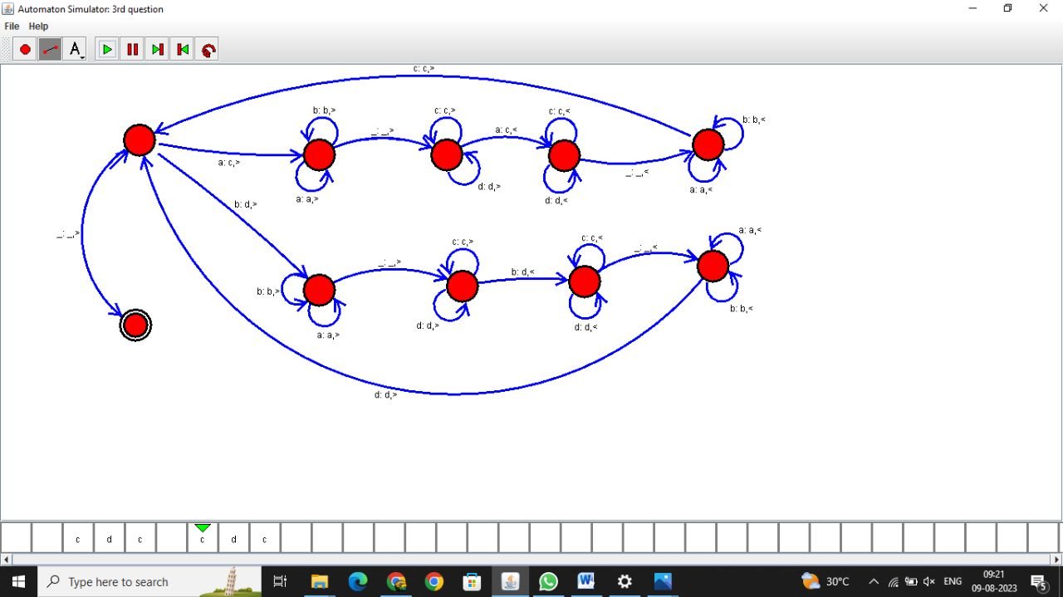

**Result: thus the program was executed successfully**