**Social media sharing buttons, interactive maps, and comment sections to enhance user engagement and interaction.**

**Name: Vinothkumar R**

**Reg No: 921821106305**

**1. Social Media Sharing Buttons:**

**a. Choose Platforms:**

Decide which social media platforms are most relevant to your audience. Common choices include Facebook, Twitter, LinkedIn, Pinterest, and Instagram.

**b. Use Third-Party Plugins or Custom Code:**

You can use third-party plugins or integrate social media sharing buttons manually using the respective APIs. Many content management systems (CMS) and website builders offer plugins for this purpose.

**c. Placement:**

Position the sharing buttons prominently, typically near the content or images you want users to share. Consider placing them at the beginning or end of articles and blog posts.

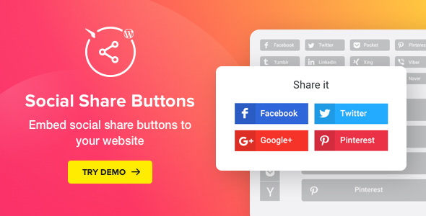

**2. Interactive Maps:**

**a. Choose a Mapping Service:**

Select a mapping service such as Google Maps or Mapbox based on your requirements. Ensure that the service provides an embeddable map feature.

**b. Embed the Map:**

Obtain the embed code from the mapping service and embed it into your website. Most mapping services provide customization options, allowing you to adjust the size, zoom level, and style of the map.

**c. Utilize Geolocation:**

If applicable, consider using geolocation to personalize the map based on the user's location. This can enhance the user experience and engagement.



**3. Comment Sections:**

**a. Choose a Comment System:**

Decide whether you want to use a built-in comment system or a third-party service. Popular options include Disqus, Facebook Comments, and native comment systems provided by CMS platforms.

**b. Enable Moderation:**

If using a comment system, enable moderation features to filter and manage user comments. This helps maintain a positive and constructive environment.

**c. Encourage Engagement:**

Prompt users to leave comments by asking questions or inviting them to share their thoughts. Responding to comments promptly can also foster community engagement.

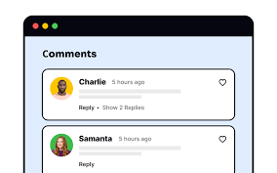

**4. Responsive Design:**

Ensure that your website is mobile-friendly and that these interactive elements work seamlessly on various devices. Many users access websites through mobile devices, so optimizing for responsiveness is crucial.

**5. Performance Considerations:**

Optimize the performance of your website by minimizing the impact of these features on page load times. This can be achieved through lazy loading, asynchronous loading, and other optimization techniques.

**6. Analytics:**

Implement analytics to track user engagement with these features. Understand how users interact with social media buttons, maps, and comment sections to refine your strategy over time.

By integrating these elements thoughtfully, you can create a more engaging and interactive user experience on your website.

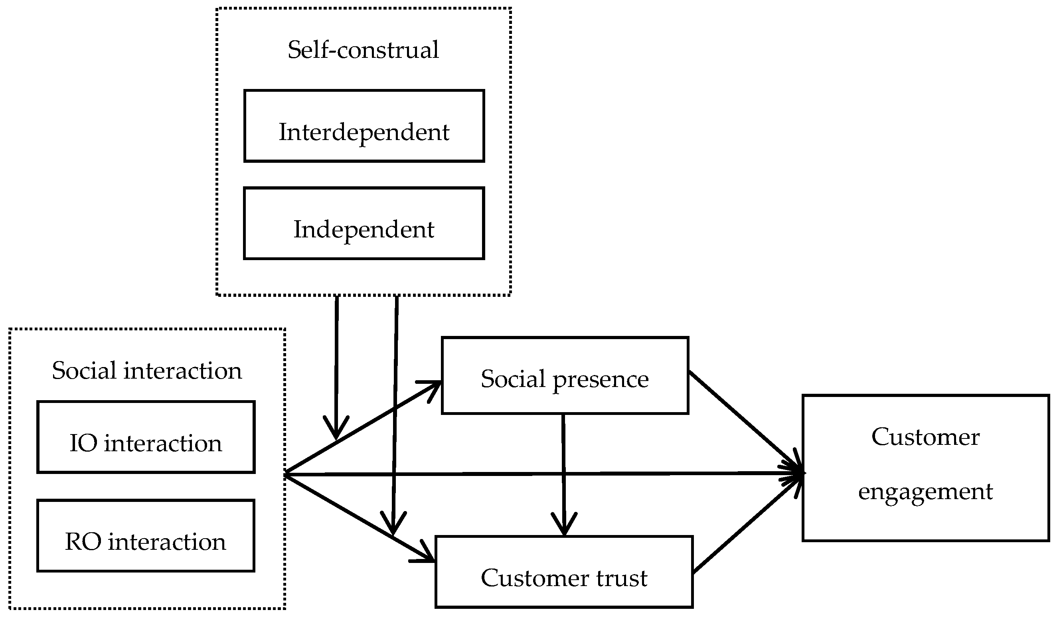

**Benefits:**

**1. Community Building:**

Comment sections foster a sense of community. Users can interact with each other, share opinions, and engage in discussions related to your content.

**2. User Feedback:**

- Comments provide valuable feedback on your content. Users may share their thoughts, ask questions, or offer suggestions, helping you understand your audience better.

**3. Increased Time on Site:**

- Interactive comment sections can keep users on your site for longer periods. Engaging discussions can encourage visitors to explore more content.

**4. SEO Benefits:**

- User-generated content, such as comments, can contribute to improved search engine optimization (SEO). Search engines often view active comment sections positively



**5. Building Trust:**

- A visible comment section can build trust. When users see that others are actively engaging with your content, it adds credibility to your website.

**Considerations:**

**1. Moderation:** Implement a moderation system to filter out spam and inappropriate content. This ensures a positive and respectful environment for users.

**2. Responsive Design:** Ensure that the comment section is mobile-friendly. Many users access websites from mobile devices, and a responsive design contributes to a better user experience.

**3. Integration with Social Media:**

- Allow users to log in or comment using their social media accounts. This can streamline the commenting process and increase user participation

**4. Encourage Quality Discussions:**

- Set a positive tone by encouraging users to provide constructive feedback and engage in meaningful discussions. Consider posing questions in your content to prompt thoughtful comments.

**5. Notification System:**

- Implement a notification system to alert users when someone responds to their comments. This encourages ongoing conversations and a sense of community.

**6. User Privacy:**

 - Clearly communicate your privacy policy regarding user data. Ensure that users feel comfortable sharing their thoughts without concerns about privacy.

**7. Regular Engagement:**

- As a website owner or moderator, actively engage with users in the comment section. Respond to questions, acknowledge feedback, and participate in discussions to show that you value user input

**8. Customization Options:**

- Depending on your platform, consider offering customization options for users, such as profile pictures or the ability to edit and delete their comments. Incorporating a well-managed comment section into your website can turn it into a dynamic space where users feel connected to your content and each other. Regularly assessing and improving your approach to comments will help maintain a positive and engaging environment.

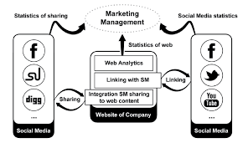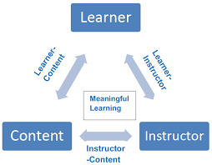

**Social Media Sharing Buttons**

<!DOCTYPE html>

<html lang="en">

<head>

<meta charset="UTF-8">

<meta name="viewport" content="width=device-width, initial-scale=1.0">

<title>Your Website Title</title>

<style>

/* Style for the sharing buttons */

.share-buttons

{

display: flex;

gap: 10px;

}

.share-buttons a

{

display: inline-block;

padding: 8px;

background-color: #007BFF; /* Adjust the color to your liking */

color: white;

text-decoration: none;

border-radius: 5px;

}

</style>

</head>

<body>

<!-- Your website content goes here -->

<!-- Social media sharing buttons -->

<div class="share-buttons">

<!-- Facebook -->

<a href="https://www.facebook.com/sharer/sharer.php?u=YOUR_URL" target="_blank" rel="noopener noreferrer">Share on Facebook</a>

<!-- Twitter -->

<a href="https://twitter.com/intent/tweet?url=YOUR_URL&text=Your%20Tweet%20Text" target="_blank" rel="no opener no referrer">Share on Twitter</a>

<!-- LinkedIn -->

<a href="https://www.linkedin.com/shareArticle?url=YOUR_URL&title=Your%20LinkedIn%20Title" target="_blank" rel="no opener no referrer">Share on LinkedIn</a>

</div>

**Interactive Maps coding**

<!DOCTYPE html>

<html lang="en">

<head>

<meta charset="UTF-8">

<meta name="viewport" content="width=device-width, initial-scale=1.0">

<title>Your Website Title</title>

<style>

/* Set the map container size */

#map

{

height: 400px;

width: 100%;

}

</style>

</head>

<body>

<!-- Your website content goes here -->

<!-- Interactive map container -->

<div id="map"></div>

<!-- Include the Google Maps API script with your API key -->

<script src="https://maps.googleapis.com/maps/api/js?key=YOUR_API_KEY&callback=initMap" async defer></script>

<script>

// Initialize the map

function initMap()

{

// Set the initial map coordinates

const mapCenter = { lat: 37.7749, lng: -122.4194 }; // San Francisco, CA

// Create a new map instance

const map = new google.maps.Map(document.getElementById('map'), {

center: mapCenter,

zoom: 10 // Adjust the zoom level

}

);

// Optional: Add a marker to the map

const marker = new google.maps.Marker

({

position: mapCenter,

map: map,

title: 'Your Marker Title' // Replace with your marker title

});

}

</script>

</body>

</html>

**comment sections to enhance user engagement and interaction**

<!DOCTYPE html>

<html lang="en">

<head>

<meta charset="UTF-8">

<meta name="viewport" content="width=device-width, initial-scale=1.0">

<title>Your Website Title</title>

<link rel="stylesheet" href="styles.css">

</head>

<body>

<!-- Your website content goes here -->

<!-- Comment section -->

<div id="comments">

<!-- Comments will be dynamically loaded here -->

</div>

<!-- Comment form -->

<form id="commentForm">

<label for="username">Name:</label>

<input type="text" id="username" name="username" required>

<label for="comment">Comment:</label>

<textarea id="comment" name="comment" rows="4" required></textarea>

<button type="submit">Submit</button>

</form>

<script src="comments.js"></script>

</body>

</html>