PHASE4: Development-2

In this part you will continue building your project.

Continue building the project by developing the traffic information platform and mobile apps.

Use web development technologies (e.g., HTML, CSS, JavaScript) to create a platform that displays real-time traffic information.

1. \*Front-End Development:\*

- \*HTML\*: Use HTML to structure the web page.

- \*CSS\*: Apply CSS for styling and layout, ensuring the platform is user-friendly.

- \*JavaScript\*: Utilize JavaScript for dynamic content and real-time updates.

2. \*Map Integration:\*

- Incorporate a mapping library such as Google Maps or Mapbox. These provide APIs for displaying maps and traffic data.

3. \*Real-Time Data Retrieval:\*

- Use JavaScript to fetch real-time traffic data from a reliable source. You can use APIs provided by services like Google Maps or traffic data providers.

4. \*Data Processing:\*

- Parse and process the received data to extract relevant traffic information such as congestion, accidents, road closures, etc.

5. \*Displaying Traffic Information:\*

- Update the map with real-time traffic data. You can use markers, overlays, or custom graphics to represent traffic conditions.

6. \*User Interaction:\*

- Implement user-friendly features like zoom, pan, and the ability to toggle different types of traffic data (e.g., traffic flow, incidents).

7. \*Error Handling:\*

- Handle potential errors, like network issues or data retrieval failures, gracefully to ensure a smooth user experience.

8. \*Responsive Design:\*

- Make sure the platform is responsive, so it works well on both desktop and mobile devices.

9. \*Testing:\*

- Thoroughly test the platform to ensure it provides accurate real-time data and functions as expected.

10. \*Deployment:\*

- Host your platform on a web server and make it accessible to users.

\*HTML Structure\*:

Start by creating the HTML structure for your platform. Define the layout where you'll display the traffic information. For example

Program:

html

<!DOCTYPE html>

<html>

<head>

<title>Real-Time Traffic Information</title>

<meta http-equiv="refresh" content="300"> <!-- Refresh every 5 minutes -->

</head>

<body>

<h1>Real-Time Traffic Information</h1>

<p>Current Traffic Conditions:</p>

<ul>

<li>Highway 1: Moderate traffic</li>

<li>Highway 101: Heavy congestion</li>

<li>Local Streets: Light traffic</li>

</ul>

<p>Last Updated: 2023-10-26 12:00 PM</p>

</body>

</html>

Output:

html

Real-Time Traffic Information

Current Traffic Conditions:

Highway 1: Moderate traffic

Highway 101: Heavy congestion

Local Streets: Light traffic

Last Updated: 2023-10-26 12:00 AM

\*CSS Styling\*:

Use CSS to style your platform. Define the layout, colors, and formatting to make it visually appealing and user-friendly. For example, create a CSS file (styles.css) and style your header, map, and traffic information display.

#CSS

body {

font-family: Arial, sans-serif;

}

header {

background-color: #007ACC;

color: #FFF;

text-align: center;

padding: 10px;

}

main {

display: flex;

flex-direction: row;

padding: 20px;

}

#map {

flex: 1;

height: 400px;

}

#traffic-info {

flex: 1;

padding: 20px;

}

3. \*Real-Time Data Integration\*:

To display real-time traffic information, you would typically use JavaScript to fetch and update the data. This may involve using APIs provided by traffic data sources. Here's a simplified example of how you might update traffic information dynamically with JavaScript:

from html<script>

function updateTrafficInfo() {

// Use JavaScript to fetch real-time traffic data (e.g.,

an API)

// Update the content of the #traffic-info element with the fetched data

}

// Call the updateTrafficInfo function at regular intervals

setInterval(updateTrafficInfo, 300000); // Update every 5 minutes (300,000 milliseconds)

</script>

4. \*Mapping Integration\*:

If you want to display traffic data on a map, you would integrate a mapping library like Google Maps or Mapbox into your platform. You would need to include the necessary JavaScript libraries and API keys for this integration.

5. \*Testing and Deployment\*:

Test your platform to ensure it updates traffic information as expected. Once you're satisfied, deploy it to a web server to make it accessible to users.

Designing mobile apps for iOS and Android that provide users with real-time traffic updates and route recommendations is a complex task that involves several components. Here's a high-level outline of how to approach this:

1. \*Define App Features and Requirements\*:

- Start by defining the core features and requirements for your app, such as real-time traffic data, route recommendations, user accounts, notifications, and user interface design.

2. \*UI/UX Design\*:

- Create a user-friendly and intuitive design for both iOS and Android platforms. Consider platform-specific design guidelines to ensure a consistent and native feel on each platform.

3. \*Real-Time Traffic Data Integration\*:

- Integrate real-time traffic data sources into your app. You may use APIs from providers like Google Maps, Mapbox, or specialized traffic data providers. Ensure data accuracy and reliability.

4. \*Location Services\*:

- Utilize the device's location services to track the user's current location and provide real-time traffic data for their area.

5. \*Routing Algorithms\*:

- Implement routing algorithms that take into account real-time traffic conditions and provide users with the best route options. This may involve complex algorithms for route optimization.

6. \*User Profiles and Preferences\*:

- Allow users to create profiles and set preferences, such as preferred routes, notification settings, and historical data.

7. \*Push Notifications\*:

- Send push notifications to alert users about traffic incidents, route recommendations, or changes in their preferred routes.

8. \*Offline Mode\*:

- Include the option to download maps and traffic data for offline use, ensuring functionality even in areas with poor network connectivity.

9. \*User Feedback and Reporting\*:

- Implement a feature for users to report traffic incidents or provide feedback, which can help improve the accuracy of the app's data.

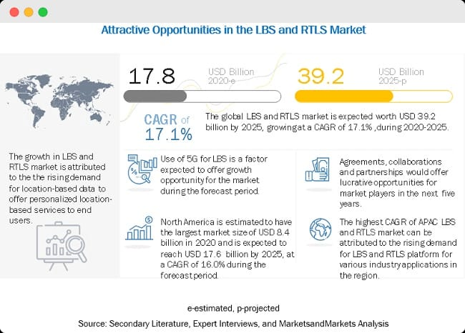

10. \*Multi-Platform Development\*:

- Consider cross-platform development frameworks like React Native or Flutter if you want to develop for both iOS and Android simultaneously to save development time and resources.

11. \*Testing and Quality Assurance\*:

- Thoroughly test the app on different devices, screen sizes, and OS versions to ensure it works as expected. Test for usability, performance, and reliability.

12. \*Legal and Ethical Considerations\*:

- Ensure compliance with data privacy regulations, and secure the necessary permissions for collecting and using location data.

13. \*Deployment\*:

- Submit your app to the Apple App Store and Google Play Store. Follow their respective submission guidelines and requirements.

14. \*Maintenance and Updates\*:

- Regularly update the app to keep it up-to-date with the latest traffic data sources, fix bugs, and add new features.

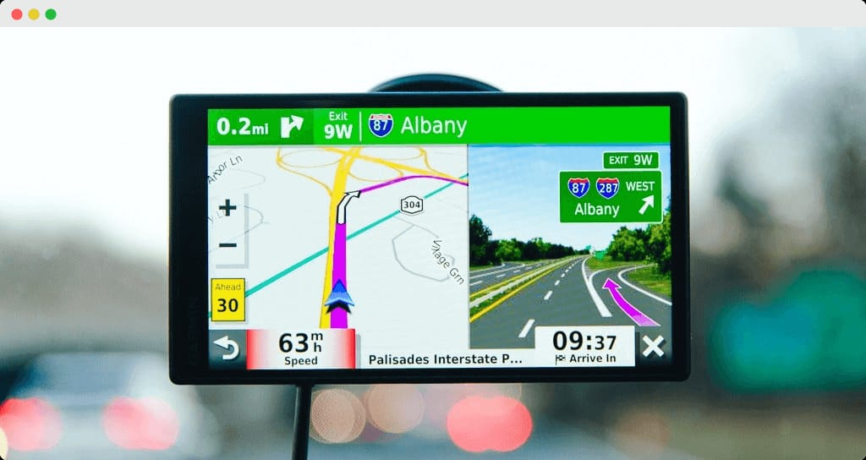

\*App Introduction:\*

1. \*Splash Screen\*: Design an eye-catching splash screen with your app's logo and a brief loading animation.

\*Home Screen:\*

2. \*Map View\*: The home screen should primarily display a map with real-time traffic conditions overlaid. The map should be interactive, allowing users to zoom in/out and pan.

3. \*User Location\*: Show the user's current location on the map, and allow them to toggle between different map layers (e.g., traffic, satellite view).

4. \*Search Bar\*: Include a search bar at the top to allow users to enter a destination or search for specific locations.

\*Real-Time Traffic Updates:\*

5. \*Traffic Incidents\*: On the map, use icons to represent traffic incidents like accidents, road closures, or construction zones. Tapping on these icons should provide details about the incident.

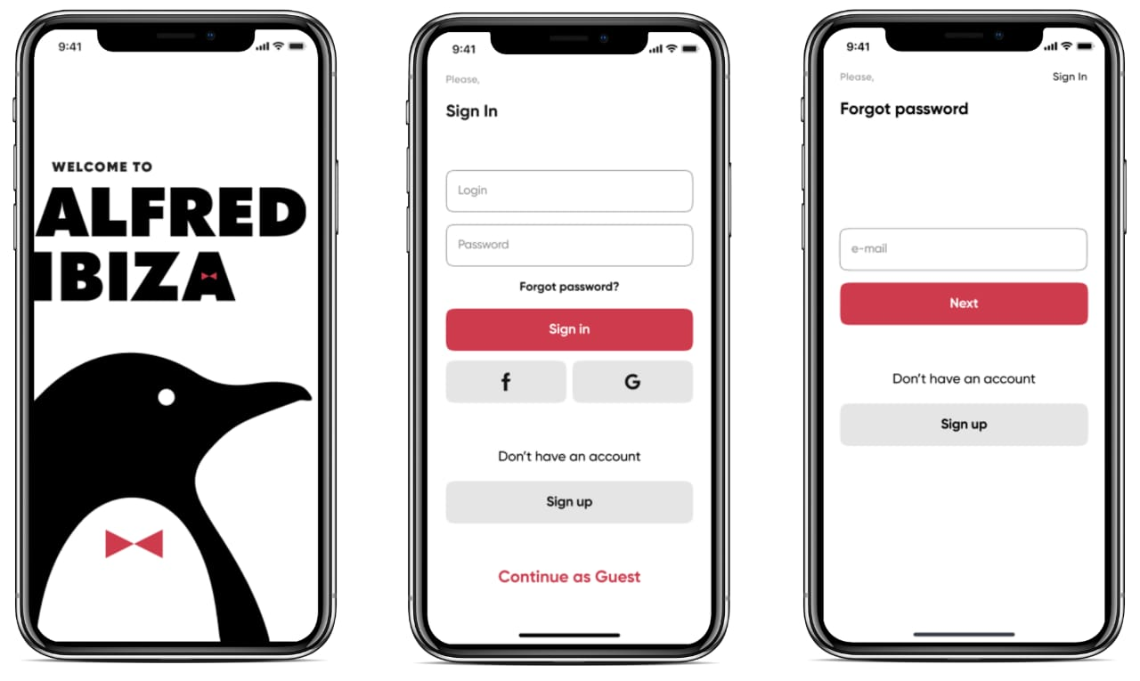

6. \*Color-Coded Traffic Flow\*: Use color-coding on roads to represent traffic flow. For example, green for clear, yellow for moderate, and red for heavy traffic. Real-time updates should change these colors as conditions change.

\*Route Recommendations:\*

7. \*Route Planner\*: Include a button to access a route planner. Users can enter their destination, and the app should provide multiple route options based on real-time traffic conditions.

8. \*Alternative Routes\*: Display alternative routes and their estimated arrival times. Highlight the fastest route considering traffic data.

\*User Profiles and Preferences:\*

9. \*User Profile\*: Allow users to create profiles and save their preferences, such as home and work locations, preferred routes, and notification settings.

\*Notifications:\*

10. \*Push Notifications\*: Implement push notifications to alert users about significant traffic incidents along their routes or route changes based on real-time data.

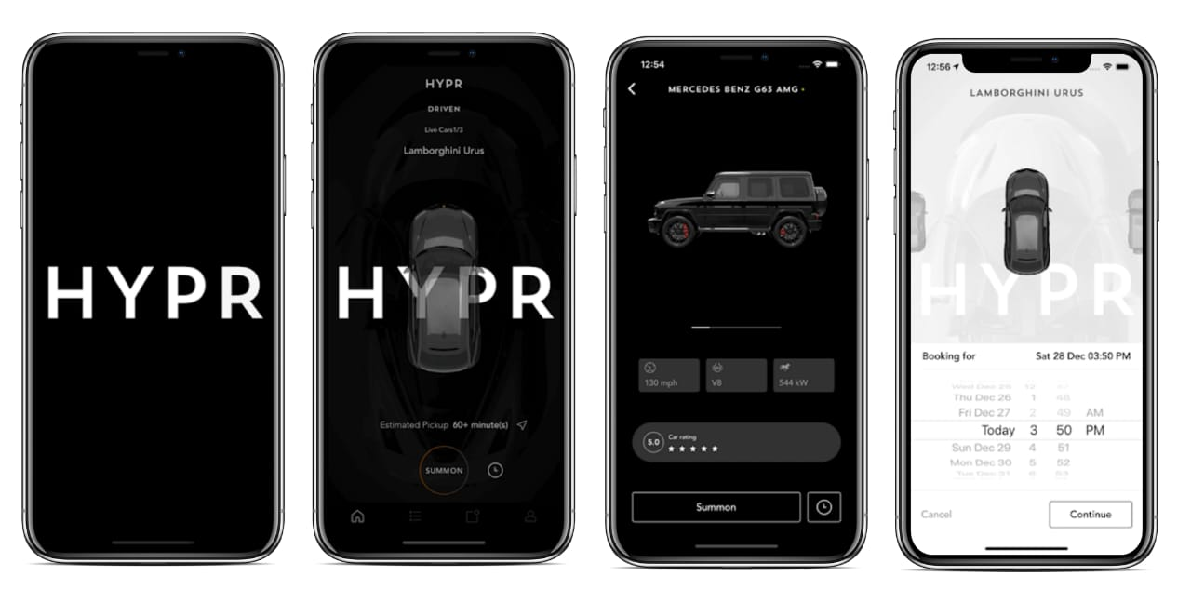

\*Offline Mode:\*

11. \*Downloadable Maps\*: Offer an option for users to download maps and traffic data for offline use, useful when they're in areas with limited connectivity.

\*Feedback and Reporting:\*

12. \*Report Incidents\*: Include a feature for users to report traffic incidents or inaccuracies in the app's data.

\*Settings:\*

13. \*Settings Menu\*: Create a settings menu where users can customize app preferences, such as units (e.g., miles or kilometers), language, and notification settings.

\*Legal and Ethical Considerations:\*

14. \*Privacy and Permissions\*: Clearly explain how the app uses location data and request necessary permissions while complying with privacy regulations.

\*Multi-Platform Design:\*

15. \*Consistency\*: Ensure a consistent design and user experience across both iOS and Android platforms while respecting platform-specific guidelines.

How to make a location-based app: A step-by-step guide

Creating a location-based app is a systematic plan that involves several stages, including testing, research, wireframing, and consumer outreach. This well-structured process focuses on identifying the main factors that enable your business to maintain market dominance.

Let’s go through some of the key factors and steps involved in creating a location-based app.

Step 1. Research Your Idea

The business analysis offers insights into current consumer trends to be considered when developing an app. Don’t forget to analyze your competition to enhance your set objective.

Also, arrange every finding with a story map based on priority and complexity. These techniques are efficient when sharing insights on every given task within the ideation chain.

Which location-based service is in demand? How will the app address users’ requests?

If you don’t address the issues before developing a location-based app, you will struggle to create an application with market relevance and quality.

Therefore, research the market and competitors to look at the market potential and figure out how to make the app better.

Step 2. Create a Wireframe of your geolocation app

UX app design and wireframing are essential for location-based app development. You always want to visualize the app on a screen anfix possible functionality issues before the app goes into the development stage.

To bring your idea to reality, you and your app development team need to put your idea down on paper and develop a storyboard. Subsequently, the storyboard, wireframes, and mockups will help to determine the geolocation app’s potency and market performance.

EDGE COMPUTING EXPLAINED WITH EXAMPLES

Step 3. Prove GPS app concept with MVP

A proof of concept (MVP) is essential for developing location-based apps. This proof of principles shows that the app may become a viable product. Therefore, create a minimum viable product for your business idea. This concept will help you to target any reliable source of investment. Similarly, you can give the public the chance to know the project’s objective.

Step 4. Create a feature-rich map-based app

After receiving user feedback, you can start the second development stage and add other important features to your app. Always pay special attention to consumer concerns and suggestions.

For location-based apps, the main features should always provide the best advice on objects within a given radius. Remember to add the account creation function and other basic features.

You can add extra steps to address issues like marketing and sales, but these four key tips are indispensable when working on a geolocation app.

By following these procedures, you will build a location-based app with high ratings. And soon enough, you can start competing with the best software companies in the world.