**Pointers**

1. Introduction

2. What Do You Mean By Time Clock System?

3. Why to Go for Clock-in and Clock-out Apps?

4. Top 9 Clock-In And Clock-Out Apps Of 2022

4.1. Workstatus

4.2. TimeCamp

4.3. Quickbooks

4.4. Hubstaff

4.5. Jibble

4.6. TimeClick

4.7. Deputy

4.8. Homebase

4.9. Time Clock Wizard

Closing Thoughts

primary-- **clock in and out app**

**gps time tracker**

clock in app with gps

**time tracker app with gps**

time clock app free

time clock at work

**work clock**

**time clock app**

**app for clocking in and out**

interlinking

**geofencing time tracking app**

employee monitoring software

**face recognition attendance app**

**time tracking software**

**Top 9 Clock-In And Out Apps To Look For In 2022**



[**Source**](https://myventurepad.com/the-benefits-of-using-a-time-clock-system-for-business/)

Imagine having your employees' data at your fingertips without needing to sift through heaps of paperwork.

It may sound too good to be accurate, but it isn't. All you need is a fantastic time clock software program to do all the heavy lifting.

But how can one find the best clock-in app for one's business? There are so many apps available, and it would take forever to look through them.

Had you not found this blog post, it would have taken years for you to find the solution.

Now that you're here, you can sit back and relax because these 9 of the best **clock-in and out apps** will change your life!

**What Do You Mean By Time Clock System?**

Before we use the apps, let's explore what a time clock system is and why we need it. A time clock system enables you to keep track of employees' work hours so that they're paid fairly for their work.

But, if you've ever attempted to track employees' hours or kept tabs on what days they work so as not to lose time and money due to filling out timesheets - then you are likely familiar with different time clock systems.

However, if you're looking for a different ‌solution or want to know which system is best for you, here are some of your options-

**a. Manual Clock System:** It usually involves logging in and out manually and entering the arrival and departure times on a timecard.

**b. Punch Card System:** Even though punch cards aren't used very often these days, we can still find them in many industries. These usually involve workers arriving at work by inserting a punch card into a machine that records the time of their arrival.

**c. Digital Clock System:** This new system acts as an upgraded punch card system where employees would come in and clock themselves onto the timecard in one of three ways:

* Scanning a QR code
* Entering a PIN code
* Swiping their magnetic stripe card

**d. Time Clock Software System:** It provides the best of all worlds and streamlines workflows. This time clock system usually comes as a time tracker or a clock in app that employees can use on any device. Most times, such time clock systems also offer features like scheduling, time-off requests, timesheets, etc.

**Why To Go For Clock In And Out Apps?**

A lot of time clock systems do what they're designed to do.

Unlike other clock systems, **clock in and out apps** are designed to:

* Streamline your payroll process
* Reduce the need for employees to track their own hours so they can focus on other responsibilities

A great clock-in and clock-out app can also help you:

* Get valuable insights about productivity
* No errors while calculating employees' work hours
* Hassle-free employee attendance management, and more

**Top 9 Clock In And Out Apps Of 2022**

**1. Workstatus**

Workstatus is a free **face recognition attendance app** that lets you stay on top of all your employees' work hours. With Workstatus, you can manage various tasks without forgetting about keeping track of how many people are working for you and when they're done for the day.

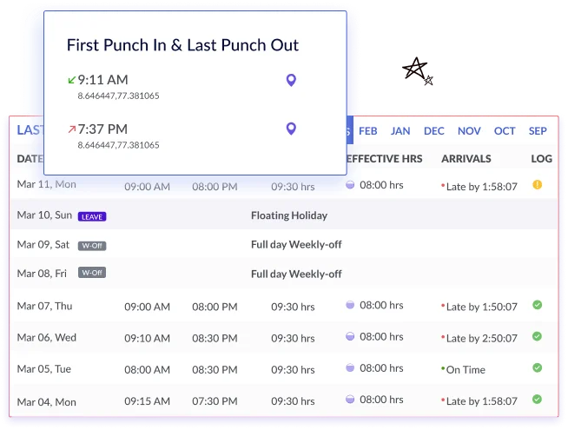

#### **Why Choose Workstatus For Clocking In And Out?**

Apart from the convenience of clocking in through any device, Workstatus is excellent for monitoring employee attendance and breaks.

Workstatus's easy-to-use interface lets you clock in and out within seconds, no matter what device you're using. Whether you want to clock in and out from a shared device or log your attendance via a personal device, Workstatus can easily handle it.

This **time clock app** also includes a **GPS time tracker**, real-time reporting, and an alert reminding the user when to clock in or out of work.

After integrating the new clock-in system into your company's workflow, administrators could see who was available to do specific tasks and complete them faster; ‌exporting timesheets would make it easier for payroll.

You can also download the iOS and Android mobile apps to manage everything on the go.

**Pricing**

* Free Forever Package: $0 forever
* Starter Package: $4.99 /user/month
* Scale Package: $9.99 /user/month
* Enterprise Package: $18 /user/month

Are you now ready to get started?

Sign up to try the best **geofencing time tracking app** to automate your attendance management system and manage your remote or WFH employees more effectively and efficiently-

**2. TimeCamp**

TimeCamp is a time tracking and **work clock** tool that keeps managers informed of their employees' hours and productivity levels. Managers can use TimeCamp to track overtime, customize reports, and stay updated on the progress of individual team members or entire teams.

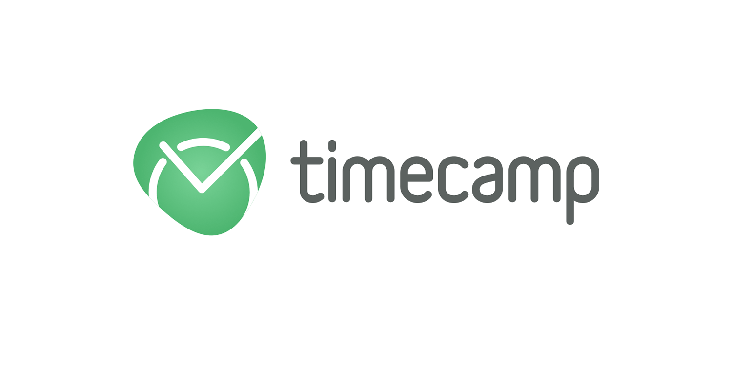

#### **Why Choose TimeCamp For Clocking In And Out?**

TimeCamp allows its members to clock in and out of work automatically; however, there are exceptions when it comes to account activity. When this happens, TimeTracker (a timer) will detect the change in behavior and switch to idle mode if there are no changes in the activity.

TimeCamp provides employees with easy access to reports and logs. They can also send alerts and emails through TimeCamp, which allows for customization of notification settings.

**Pricing**

* Free: $0
* Basic: $5.25/user/month
* Pro: $7.50/user/month
* Enterprise: Contact for pricing

**3. Quickbooks**

Even though Quickbooks primarily functions as accounting software, it has all the ‌features for monitoring employee hours, including a time clock kiosk, a payroll app, and more.

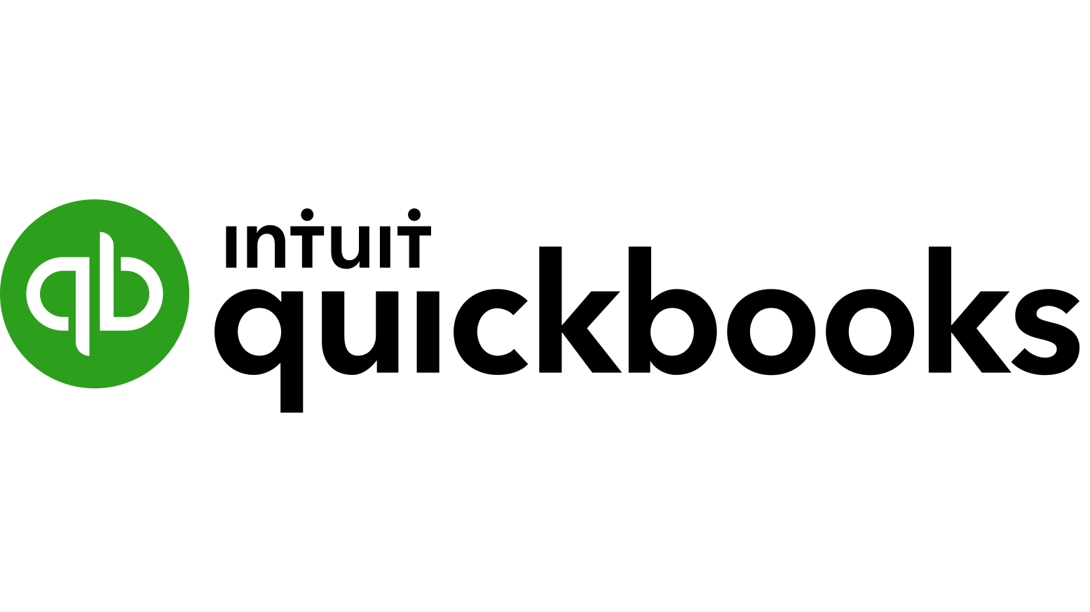

#### **Why Choose Quickbooks For Clocking In And Out?**

If you're looking for a quick and efficient way to track your employees' hours, Quickbooks offers time kiosks that work seamlessly across various devices—whatever fits your company's needs.

You'll also find integration options with payroll apps. So, the moment employees clock in or out, they'll be able to submit their timesheets—and the data will instantly show up in your preferred accounting software.

**Pricing:**

* Simple Start: $12/mo
* Essentials: $25/mo
* Plus: $40/mo
* Advanced: $90/mo

**4. Hubstaff**

Hubstaff is an easy-to-use **app for clocking in and out** for employers that provides a full range of features. These include controlling employees' schedules, keeping track of their absences from work, and enabling managers to monitor each individual's progress.



**Why Choose Hubstaff For Clocking In And Out?**

Like its competitors, Hubstaff provides an easy-to-use clock-in system that reduces the number of times employees need to confirm their status.

This time-keeping app also allows users to choose whether they want to. Employees can automatically clock in or out depending on their location or start the timer as soon as their workday begins. It also comes with a reliable **time tracker app with GPS** to track field workers' time more accurately.

**Pricing:**

* Desk Free: $0 for one user only
* Desk Starter: $7/user/month
* Desk Pro: $10/user/month

**5. Jibble**

This time clock solution gives you a wealth of options for automation for attending work. It has an integrated timesheet, graphical reporting capabilities, and the ability to log in and out instantly.

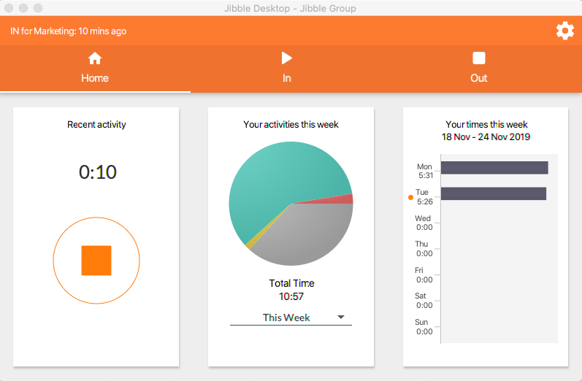

[**Source**](https://blog.jibble.io/)

**Why Choose Jibble For Clocking In And Out?**

Jibble is an excellent choice for companies looking to automate their clock-in/clock-out process and businesses searching for a simple payroll solution linked to a time clock kiosk.

This time clock app has GPS location and automated clock-in reminders. But, it may not be good for businesses that operate at different hours each day - since there isn't an option to assign multiple schedules to one employee.

**Pricing:**

* Free: €0 forever
* Premium: €2.25 /month/user
* Ultimate: €4.50 /month/user
* Enterprise: Contact for pricing

**6. TimeClick**

TimeClick is a time management tool designed for small businesses to make their workflows more efficient. With an intuitive interface and many features related to employee attendance, it makes work simpler than ever before.

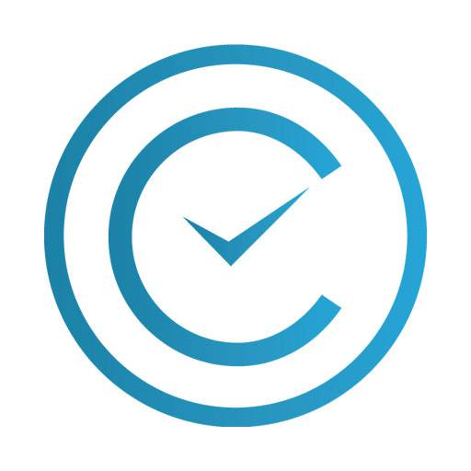

**Why Choose TimeClick For Clocking In And Out?**

With features such as easy navigation and a one-of-a-kind interface, TimeClick can be an optimal timekeeping solution for small business owners.

This time clock app provides a user-friendly interface where you can easily track hours spent on the job.

TimeClick does not provide a web-based platform. You can only use the app's Windows desktop, iOS, and Android versions.

**Pricing:**

* Prime: $249/year
* Premium: $499/year
* Plus: $699/year
* Platinum: $999/year

**7. Deputy**

Deputy is an app for time management with various features to help you maximize your productivity. The tool has a reporting system, bulk approval for timesheets, and quick exporting capabilities so you can easily share what you've done.



**Why Choose Deputy For Clocking In And Out?**

Deputy provides various features that help boost efficiency and accountability, including an automated time clock kiosk and a web-based platform for tracking employee workdays.

Deputy has built-in facial and voice recognition technology to reduce the time spent waiting in line to scan ID cards. But Deputy's face unlocks feature is only available in selected locations worldwide.

**Pricing:**

* Scheduling: $3.50/month
* Time & Attendance: $3.50/month
* Premium: $4.90/month
* Enterprise: Contact for pricing

**8. Homebase**

Homebase is an innovative time-keeping solution that offers a variety of features designed to automate employee scheduling, time tracking, and clocking in/out.

Homebase also allows users to compile hours worked onto their timesheet to track labor costs associated with each job.

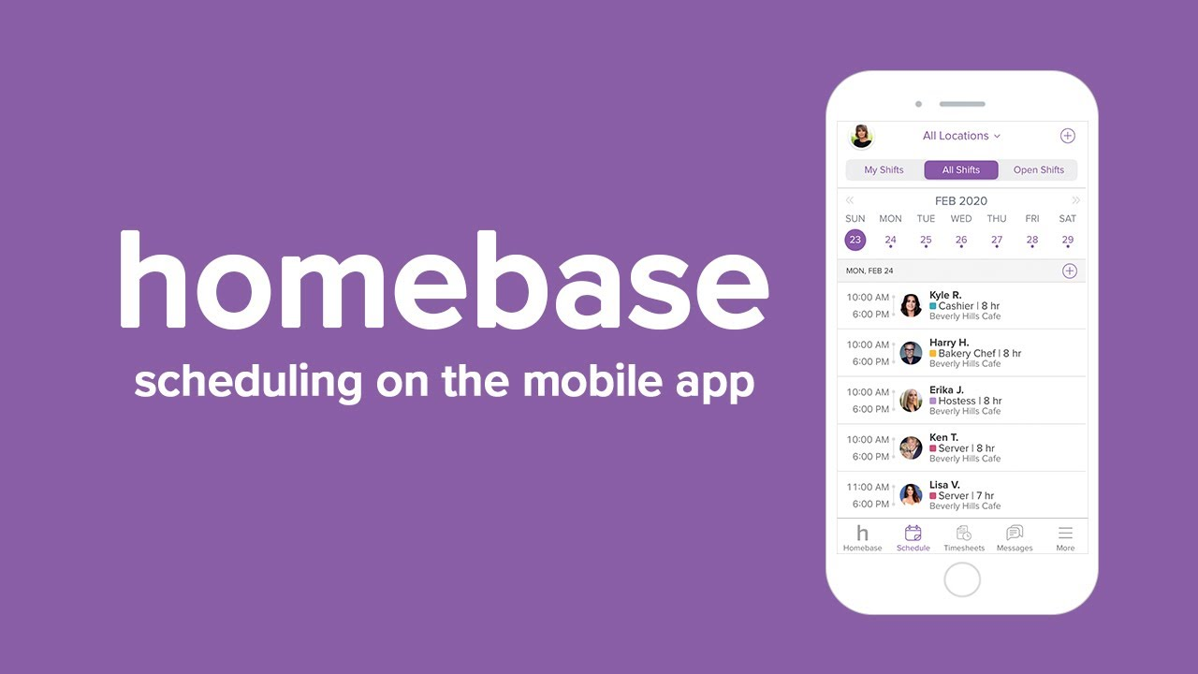

**Why Choose Homebase For Clocking In And Out?**

Apart from strengthening the company-wide transparency, the time clock option ‌Homebase brings to the table also simplifies calculating working hours.

However, despite its helpful features for tracking employees’ attendance patterns, Homebase offers only basic report customization options.

In addition, since this app was developed primarily for shift-based schedules, it may prove challenging to handle if your company operates on a flexible schedule.

**Pricing:**

* Basic: Free
* Essentials:$24.95/month/location
* Plus: $59.95/month/location
* All in One: $99.95/month/location

**9. Time Clock Wizard**

Time Clock Wizard is an easy-to-use time clock software that provides accurate employee attendance insights, streamlines payroll processes, and tracks time spent on tasks.

It also has a handy photo capture feature for quick clocking in at the start of each shift.

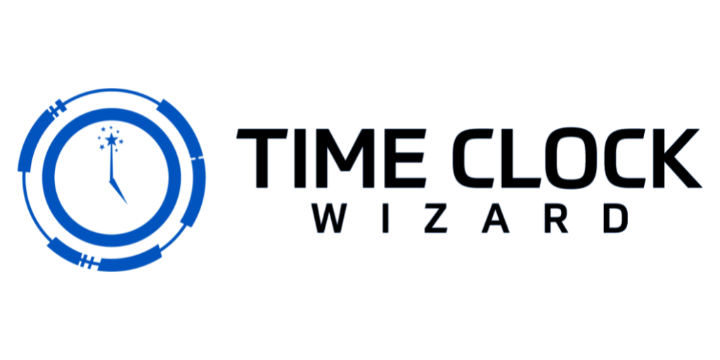

**Why Choose Time Clock Wizard For Clocking In And Out?**

The Time Clock Wizard app simplifies the clocking-in process so that your employees can clock in remotely and work at home.

This time clock app also enables employees to set up location restrictions and create different clock points for team members that are working on site.

**Pricing:**

* Free: $0/month
* Value: $24.95/month
* Pro: $44.95/month
* Enterprise: $199.95/month

**Closing Thoughts**

Now that we've evaluated 9 of the most popular clock-in and clock-out apps, it's time for them to leave the stage.

But what about your **time tracking software**? What is the complete solution for recording employee attendance when employees clock in and out of work?

The good news is this one falls on your shoulders.

You should examine what your company requires from a software program and decide if you are interested in simplicity and ease of use or if you want something more complicated, considering the size of your business. There are many other factors to consider when making this decision, including how well it will work for what you need and its cost.

And if you're still undecided, try them out for yourself.

You will soon discover that you already know your favorite time clock app.

Thanks for reading!!