 | THE IRON MASK  FTC #38460

Sponsorship packet
OUR STORY / OUR PEOPLE / OUR NEXT CHAPTER
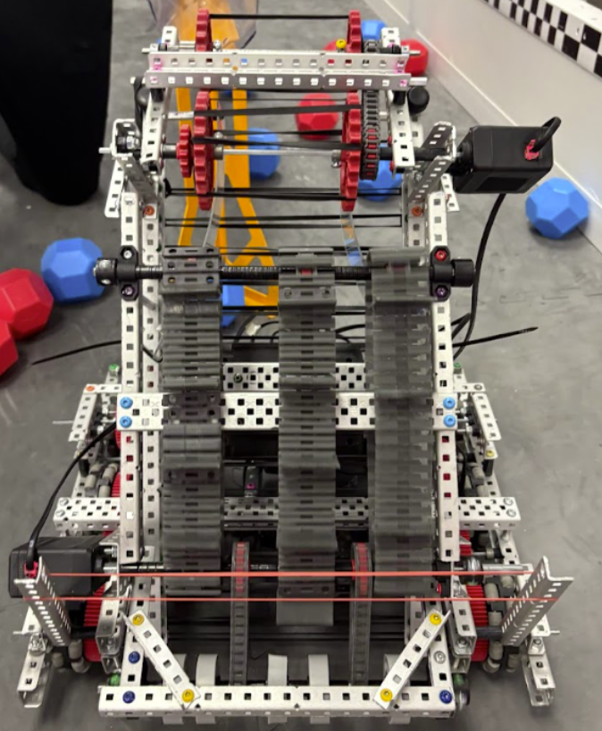
01 History of VEX
Our robotics journey began in 2024 through VEX V5RC. Along the way, we earned awards and learned the value of hard work, teamwork, and persistence. Every design challenge gave us a reason to test new ideas and improve.
Now, as The Iron Mask, we bring that experience to FTC. Our next chapter is about building a stronger robot, growing as a team, and sharing our enthusiasm for engineering with others.

02 Who we are
We are The Iron Mask, FTC Team #38460: 10 students from different schools in Dallas–Fort Worth, Texas. Through Wheelhouse Foundation, we come together to design, build, and improve a competition robot.
What makes us different?
We are a community team of students from different schools and backgrounds. Without dedicated school funding, we rely on sponsors to pay for robot parts, registration, and travel. Limited funding could keep us from competing and sharing robotics with our community.
DESIGN • CODE • BUILD • TEST

03 Our season goals
01 BUILD  Build a reliable robot through better mechanisms, autonomous programming, and repeated testing.  Success: consistent performance | 02 COMPETE  Improve at each event and work toward qualifying for the 2027 FTC World Championship.  Goal: FTC Worlds 2027 | 03 GIVE BACK  Share robotics through hands-on demos and encourage younger students to explore STEM.  Plan: demos and workshops

SEASON 2026–2027 | 10 STUDENTS | DALLAS–FORT WORTH, TEXAS
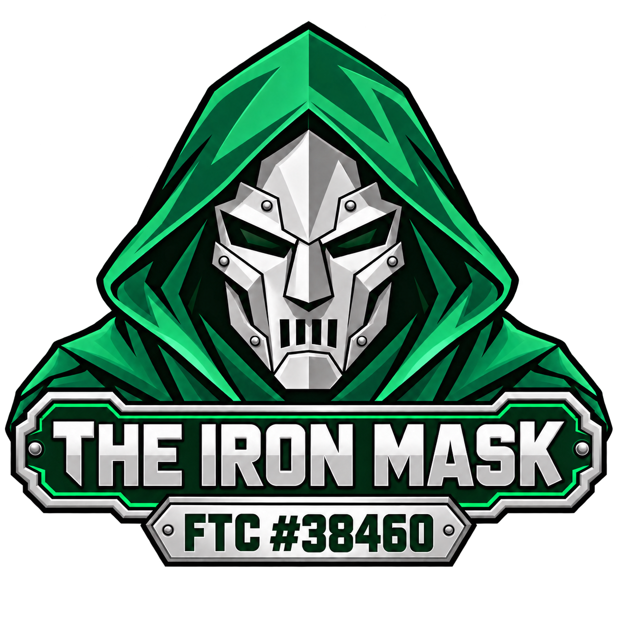 | THE IRON MASK  Sponsorship opportunities  FTC #38460 / SEASON 2026-2027

HELP US BUILD WHAT COMES NEXT
Our season fundraising goal is $5,000. Your support will help fund robot parts, competition expenses, and opportunities to share robotics with our community.

SILVER SPONSOR  $ 750 - 2,000  HELPS FUND  Robot components, workshop supplies, and the tools needed to test and improve our designs.  BENAFITS  • Thank-you on team social media  • Company name or logo on banner and t-shirt  • Season progress update | EMERALD SPONSOR  $ 2,000 or more  HELPS FUND  Major robot improvements, competition participation, and community outreach.  BENAFITS  • Special thanks on social media and at competitions  • Company name or logo on banner, t-shirt, and robot  • Optional Robot demo by arrangement

What your support makes possible
SEASON COSTS AMOUNT  Robot parts and tools $2,300  Registration and events $700  Travel and outreach $1,000  Miscellaneous Fees $1,000 | THE STUDENT IMPACT  Your support gives 10 students more opportunities to practice engineering, programming, teamwork, and communication while working toward a shared goal, as well as help us help our community with more robotics opportunities.

MORE WAYS TO JOIN IN
Parts and tools • Technical mentoring • Workspace • Event support
Mentors Needed! - As a first-year FTC team, we are looking for mentors who can share their experience in engineering, programming, design, or team management. Even a few hours of guidance can help our team solve problems, build confidence, and make the most of our first season.

Become a sponsor today
Contact: Wheelhouse Foundation DFW
Email: [team email]
Phone / website: [phone or link]
Next step: [how to contribute or arrange a visit]

