**TO CREATE BRAND NAME, BRAND EMAIL, BRAND LOGO**

|  |  |
| --- | --- |
| **TEAM MEMBER** | **NM ID** |
| COLLINS VINSHA A | 93C0C4AD30B6V31993A4F253B32D896C |
| AYSWARYA M | D9F93B4B472E138AC1E4A74A4B9EF345 |
| AMIE SHERIN D | 9C2C75562F8545C908D409FD85728C54 |
| ADLIN BABI K | 27837F9F488982D9CD64F3A39DB5E5EF |

**BRAND NAME:** RETRO BELLA

**BRAND EMAIL:** [retro.bella@domain.in](mailto:retro.bella@domain.in)

**BRAND LOGO:**

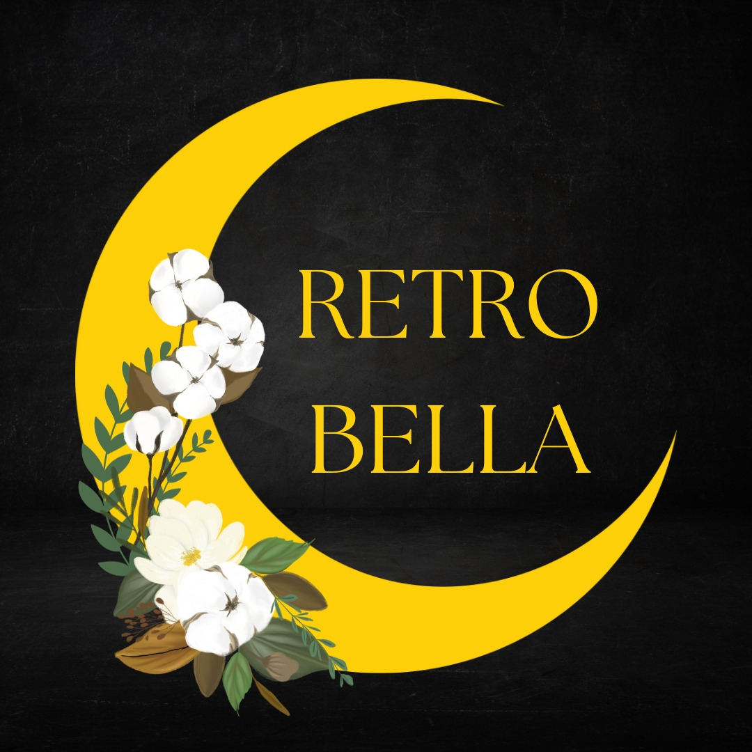

**VIDEO LINK:** <https://drive.google.com/file/d/18g8SxwzhHvIRozsEod9ZvWLzInJGTrb5/view?usp=sharing>