Отчёт к лабораторной работе #4

С дисциплины “Вычислительная геометрия и компьютерная графика”

Студента группы ПА-19-2

Ильяшенко Егора

Постановка задачи:

#include <iostream>

#include <string>

#include <glew.h>

#include <glfw3.h>

#include "GLShader.h"

#include "Vertices.h"

#include "GLWindow.h"

#include "GLRenderSystem.h"

#include "stb_image.h"

#include "MyModel.h"

#include <glm/glm.hpp>

#include <glm/gtc/matrix_transform.hpp>

#include <glm/gtc/type_ptr.hpp>

void framebuffer_size_callback(GLFWwindow* window, int width, int height);

void mouse_callback(GLFWwindow* window, double xpos, double ypos);

void scroll_callback(GLFWwindow* window, double xoffset, double yoffset);

void processInput(GLFWwindow* window);

bool firstMouse = true;

float yaw = -90.0f;

float pitch = 0.0f;

float lastX = 800.0f / 2.0;

float lastY = 600.0 / 2.0;

float fov = 45.0f;

const unsigned int SCR_WIDTH = 800;

const unsigned int SCR_HEIGHT = 600;

float deltaTime = 0.0f;

float lastFrame = 0.0f;

glm::vec3 cameraPos = glm::vec3(0.0f, 0.0f, 3.0f);

glm::vec3 cameraFront = glm::vec3(0.0f, 0.0f, -1.0f);

glm::vec3 cameraUp = glm::vec3(0.0f, 1.0f, 0.0f);

Vintall::GLWindow* my_window;

Shader* shader;

Model*dirt, *grass, *stone;

void InitWindow()

{

my_window = new Vintall::GLWindow("Lab_4_Vintall", 640, 480);

glfwMakeContextCurrent(my_window->getGLFWHandle());

glewExperimental = true;

if (glewInit() != GLEW_OK)

{

fprintf(stderr, "Невозможно инициализировать GLEW\n");

exit(0);

}

}

void InitModel()

{

shader = new Shader("BrightAndDim_VertexShader.vs", "BrightAndDim_FragmentShader.fs");

shader->use();

dirt = new Model("dirt/cube.fbx");

glTexParameteri(GL_TEXTURE_2D, GL_TEXTURE_MAG_FILTER, GL_NEAREST);

grass = new Model("grass/cube.fbx");

glTexParameteri(GL_TEXTURE_2D, GL_TEXTURE_MAG_FILTER, GL_NEAREST);

stone = new Model("stone/cube.fbx");

glTexParameteri(GL_TEXTURE_2D, GL_TEXTURE_MAG_FILTER, GL_NEAREST);

}

int map_size = 10;

int MapSinX(int coord, int max_value)

{

int result;

double sin_res = sin(coord) * 5;

return sin_res < 0 ? -1 * (int)sin_res : (int)sin_res;

}

int MapSinY(int coord, int max_value)

{

int result;

double sin_res = sin(coord+0.5f) * 5;

return sin_res < 0 ? -1 * (int)sin_res : (int)sin_res;

}

int*** InitMap() //0-air 1-stone 2-dirt 3-grass

{

int*** map_ = new int** [map_size];

for (int i = 0; i < map_size; i++)

{

map_[i] = new int* [map_size];

for (int j = 0; j < map_size; j++)

map_[i][j] = new int [map_size];

}

for (int i = 0; i < map_size; i++)

for (int j = 0; j < map_size; j++)

for (int k = 0; k < map_size; k++)

{

map_[i][j][k] = rand() % 2;

}

for (int i = 0; i < map_size; i++)

for (int j = 0; j < map_size; j++)

for (int k = 0; k < map_size; k++)

{

if (map_[i][j][k] == 1)

{

for (int o = 0; o < map_size; o++)

{

if (map_[i][j][o] == 0)

{

map_[i][j][o] = 1;

map_[i][j][k] = 0;

break;

}

}

}

}

int all_count;

all_count = 0;

for (int i = 0; i < map_size; i++)

for (int j = 0; j < map_size; j++)

{

int count = 0;

for (int k = 0; k < map_size; k++)

{

if (map_[i][j][k] != 0)

count++;

else

break;

}

all_count += count;

}

all_count /= (map_size * map_size);

for (int i = 0; i < map_size; i++)

for (int j = 0; j < map_size; j++)

{

int row_count = 0;

for (int k = 0; k < map_size; k++)

if (map_[i][j][k] != 0)

row_count++;

else

break;

row_count = (row_count + all_count) / 2;

for (int k = 0; k < map_size; k++)

{

if (k < row_count)

map_[i][j][k] = 1;

else

map_[i][j][k] = 0;

}

}

for (int i = 0; i < map_size; i++)

for (int j = 0; j < map_size; j++)

for (int k = map_size-1; k >=0 ; k--)

{

if (map_[i][j][k] != 0)

{

map_[i][j][k] = 3;

if (k - 1 >= 0)

map_[i][j][k - 1] = 2;

if (k - 1 >= 0)

map_[i][j][k - 2] = 2;

break;

}

}

int*** map_buff = new int** [map_size];

for (int i = 0; i < map_size; i++)

{

map_buff[i] = new int* [map_size];

for (int j = 0; j < map_size; j++)

{

map_buff[i][j] = new int[map_size];

for (int k = 0; k < map_size; k++)

{

map_buff[i][j][k] = map_[i][j][k];

}

}

}

for (int i = 1; i < map_size-1; i++)

for (int j = 1; j < map_size - 1; j++)

for (int k = 1; k < map_size - 1; k++)

{

if (map_[i][j][k] != 0

&& map_[i - 1][j][k] != 0

&& map_[i][j - 1][k] != 0

&& map_[i][j][k - 1] != 0

&& map_[i + 1][j][k] != 0

&& map_[i][j + 1][k] != 0

&& map_[i][j][k + 1] != 0)

{

map_buff[i][j][k] = 0;

}

}

for (int i = 1; i < map_size - 1; i++)

for (int j = 1; j < map_size - 1; j++)

for (int k = 1; k <= map_size - 1; k++)

{

map_[i][j][k] = map_buff[i][j][k];

}

return map_;

}

int main(int argc, char** argv)

{

if (argc == 2)

map_size = atoi(argv[1]);

fprintf(stdout, "Made by Vintall");

InitWindow();

InitModel();

int*** map = InitMap();

glfwMakeContextCurrent(my_window->getGLFWHandle());

glfwSetFramebufferSizeCallback(my_window->getGLFWHandle(), framebuffer_size_callback);

glfwSetCursorPosCallback(my_window->getGLFWHandle(), mouse_callback);

glfwSetScrollCallback(my_window->getGLFWHandle(), scroll_callback);

glfwSetInputMode(my_window->getGLFWHandle(), GLFW_CURSOR, GLFW_CURSOR_DISABLED);

glEnable(GL_DEPTH_TEST);

glEnable(GL_CULL_FACE);

glCullFace(GL_FRONT_FACE);

shader->use();

glm::mat4 projection = glm::perspective(glm::radians(fov), (float)SCR_WIDTH / (float)SCR_HEIGHT, 0.1f, 100.0f);

shader->setMat4("projection", projection);

glfwMakeContextCurrent(my_window->getGLFWHandle());

glClearColor(0.8f, 0.8f, 1, 1.0f);

while (glfwGetKey(my_window->getGLFWHandle(), GLFW_KEY_ESCAPE) != GLFW_PRESS && glfwWindowShouldClose(my_window->getGLFWHandle()) == 0)

{

float currentFrame = glfwGetTime();

deltaTime = currentFrame - lastFrame;

lastFrame = currentFrame;

processInput(my_window->getGLFWHandle());

glClear(GL_COLOR_BUFFER_BIT | GL_DEPTH_BUFFER_BIT);

glm::mat4 view = glm::lookAt(cameraPos, cameraPos + cameraFront, cameraUp);

shader->setMat4("view", view);

glm::mat4 model = glm::mat4(1.0f);

model = glm::rotate(model, glm::radians(-90.f), glm::vec3(1.0f, 0.f, 0.f));

for (int i = 0; i < map_size; i++)

for (int j = 0; j < map_size; j++)

for (int k = 0; k < map_size; k++)

{

model = glm::translate(model, glm::vec3(i * 2, j * 2, k * 2));

shader->setMat4("model", model);

switch (map[i][j][k])

{

case 1:

stone->Draw(*shader);

break;

case 2:

dirt->Draw(*shader);

break;

case 3:

grass->Draw(*shader);

break;

}

model = glm::translate(model, glm::vec3(-i * 2, -j * 2, -k * 2));

}

glfwSwapBuffers(my_window->getGLFWHandle());

glfwPollEvents();

}

glfwDestroyWindow(my_window->getGLFWHandle());

glfwTerminate();

return 0;

}

void processInput(GLFWwindow* window)

{

if (glfwGetKey(window, GLFW_KEY_ESCAPE) == GLFW_PRESS)

glfwSetWindowShouldClose(window, true);

float cameraSpeed = 20 * deltaTime;

if (glfwGetKey(window, GLFW_KEY_W) == GLFW_PRESS)

cameraPos += cameraSpeed * cameraFront;

if (glfwGetKey(window, GLFW_KEY_S) == GLFW_PRESS)

cameraPos -= cameraSpeed * cameraFront;

if (glfwGetKey(window, GLFW_KEY_A) == GLFW_PRESS)

cameraPos -= glm::normalize(glm::cross(cameraFront, cameraUp)) * cameraSpeed;

if (glfwGetKey(window, GLFW_KEY_D) == GLFW_PRESS)

cameraPos += glm::normalize(glm::cross(cameraFront, cameraUp)) * cameraSpeed;

}

void framebuffer_size_callback(GLFWwindow* window, int width, int height)

{

glViewport(0, 0, width, height);

}

void mouse_callback(GLFWwindow* window, double xpos, double ypos)

{

if (firstMouse)

{

lastX = xpos;

lastY = ypos;

firstMouse = false;

}

float xoffset = xpos - lastX;

float yoffset = lastY - ypos;

lastX = xpos;

lastY = ypos;

float sensitivity = 0.1f;

xoffset *= sensitivity;

yoffset *= sensitivity;

yaw += xoffset;

pitch += yoffset;

if (pitch > 89.0f)

pitch = 89.0f;

if (pitch < -89.0f)

pitch = -89.0f;

glm::vec3 front;

front.x = cos(glm::radians(yaw)) * cos(glm::radians(pitch));

front.y = sin(glm::radians(pitch));

front.z = sin(glm::radians(yaw)) * cos(glm::radians(pitch));

cameraFront = glm::normalize(front);

}

void scroll_callback(GLFWwindow* window, double xoffset, double yoffset)

{

fov -= (float)yoffset;

if (fov < 1.0f)

fov = 1.0f;

if (fov > 45.0f)

fov = 45.0f;

}

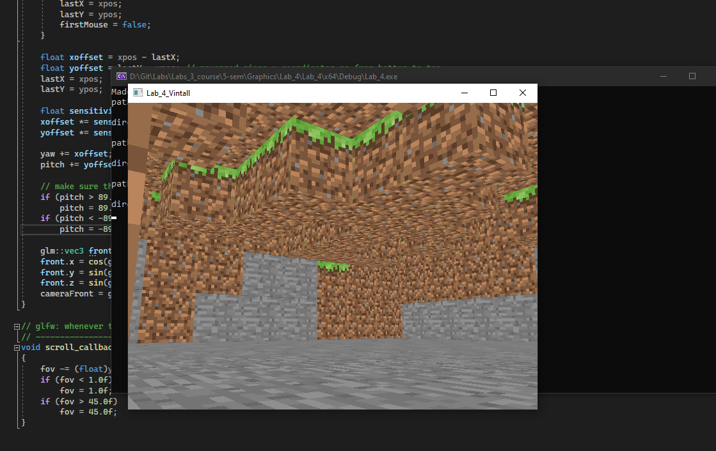

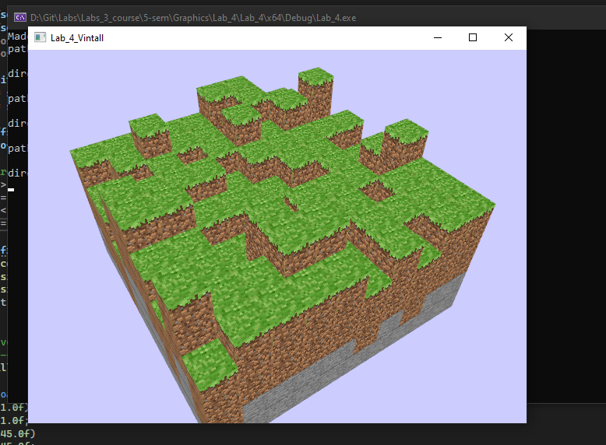

Заключение: сделал Minecraft :D

Разобрался с шейдерами, моделями, текстурами, камерой.