Direct sampling w. noise  
noise ~ $N(⋅;μ=0, σ=0.1)$

2d Numerical Inverse Transform sampling

True distribution



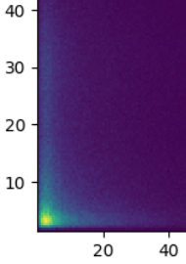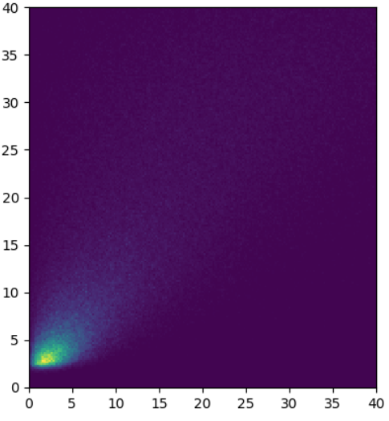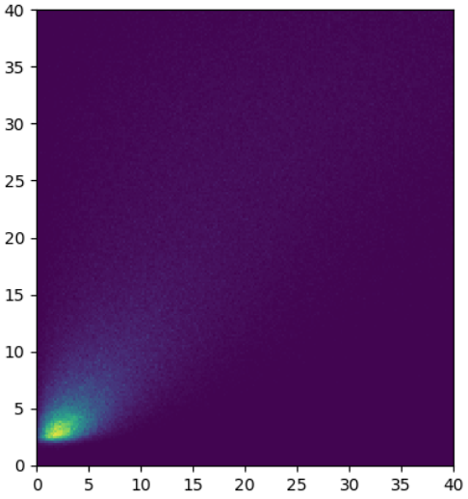

[deg]

Solid Angle [deg]