Question 1 : Count how many cities are there in each country.
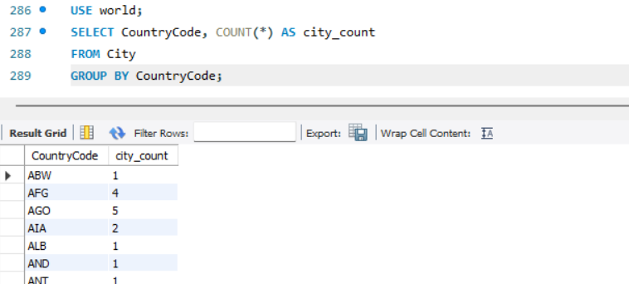
Question 2 : Display all continents having more than 30 countries.

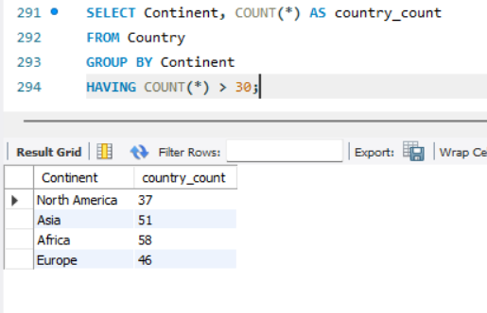

Question 3 : List regions whose total population exceeds 200 million.

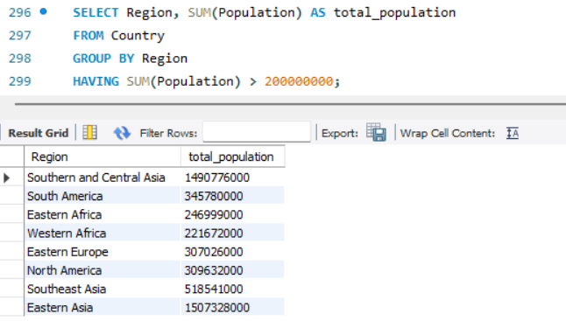

Question 4 : Find the top 5 continents by average GNP per country.
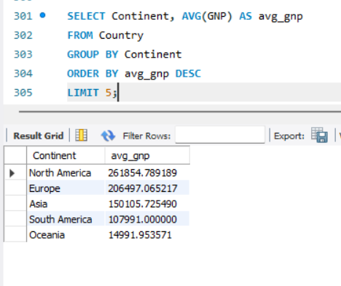
Question 5 : Find the total number of official languages spoken in each continent
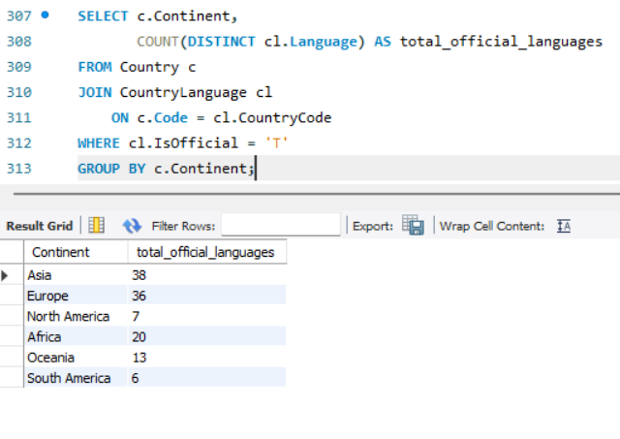
Question 6 : Find the maximum and minimum GNP for each continent.
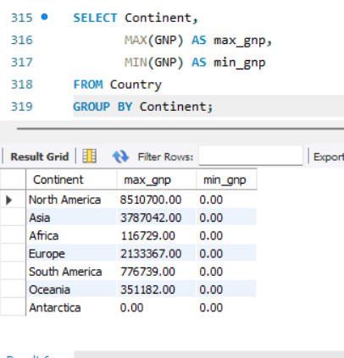

Question 7 : Find the country with the highest average city population.

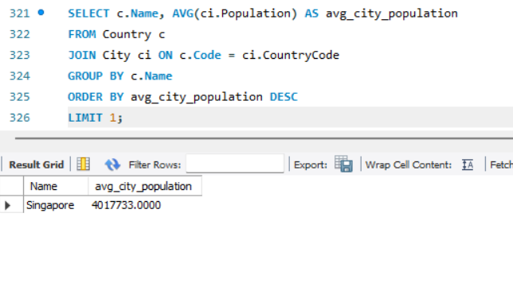
Question 8 : List continents where the average city population is greater than 200,000.
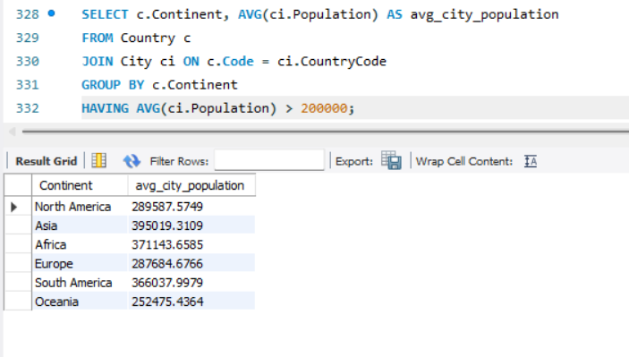

Question 9 : Find the total population and average life expectancy for each continent, ordered by average life expectancy descending.

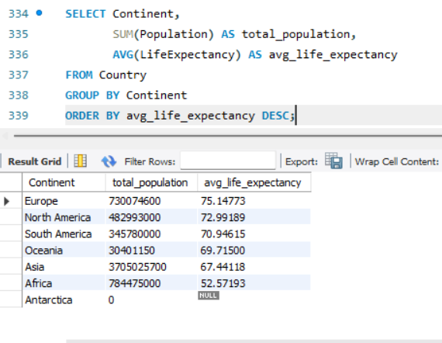

Question 10 : Find the top 3 continents with the highest average life expectancy, but only include those where the total population is over 200 million
