Basic Level
Retrieve the names of employees who earn more than the average salary of all employees.

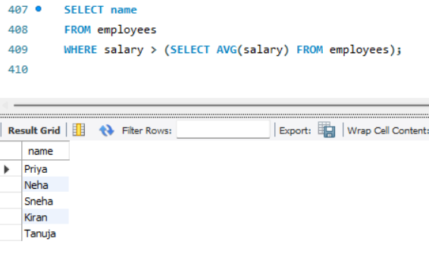

Find the employees who belong to the department with the highest average salary.
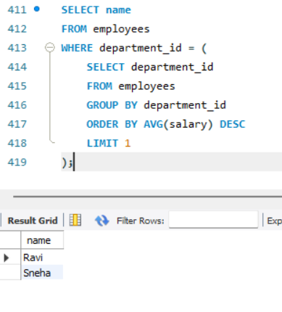

List all employees who have made at least one sale.

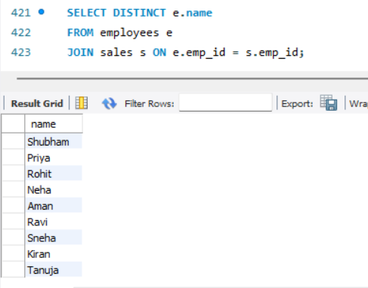

Find the employee with the highest sale amount.

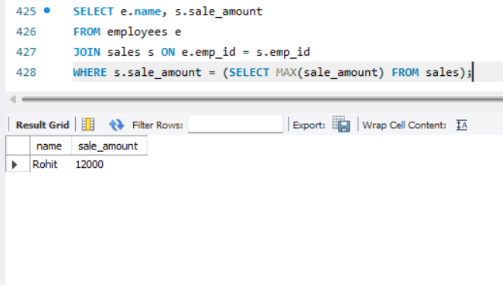

Retrieve the names of employees whose salaries are higher than Shubham’s salary.

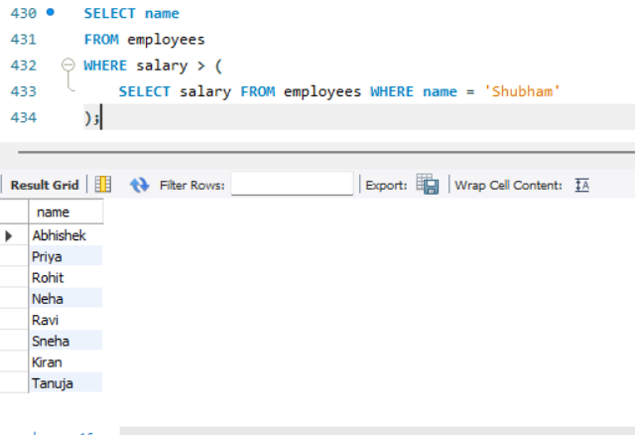

Intermediate Level
Find employees who work in the same department as Abhishek.
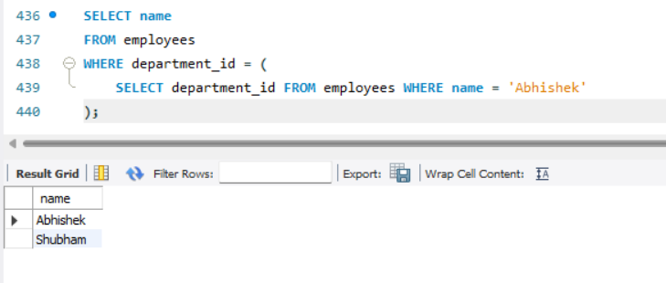

List departments that have at least one employee earning more than ₹60,000.
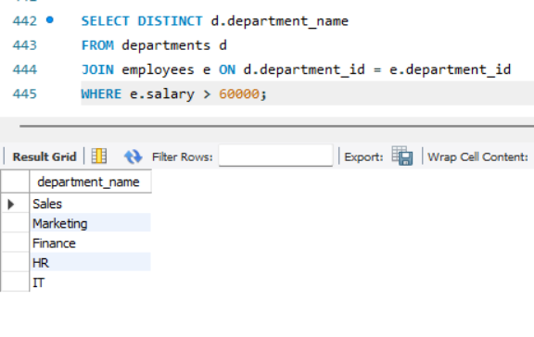

Find the department name of the employee who made the highest sale.

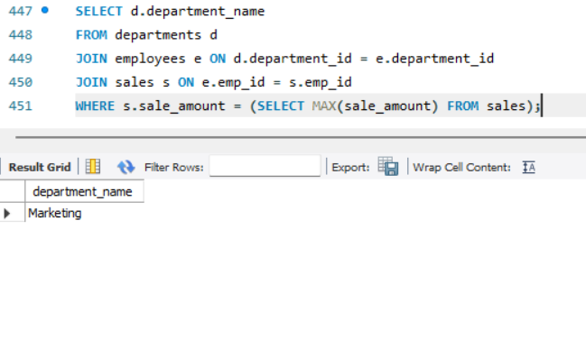

Retrieve employees who have made sales greater than the average sale amount.

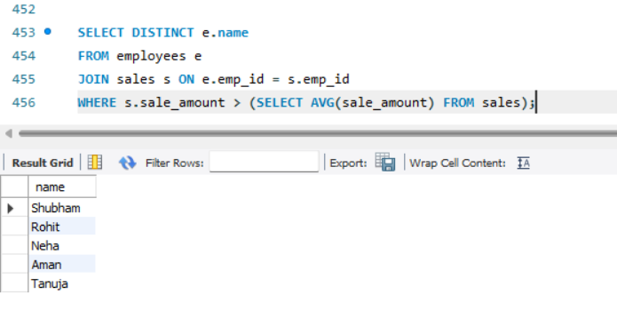

Find the total sales made by employees who earn more than the average salary.

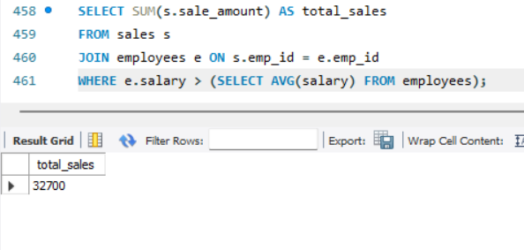

Advanced Level

Find employees who have not made any sales.
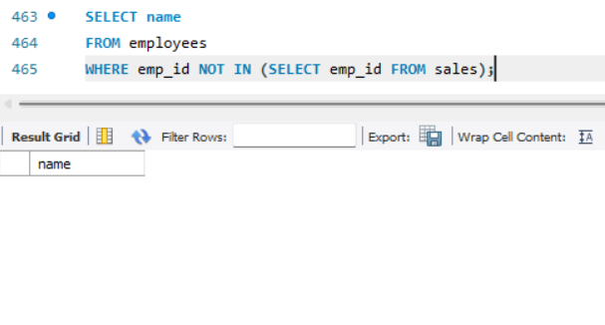
List departments where the average salary is above ₹55,000.
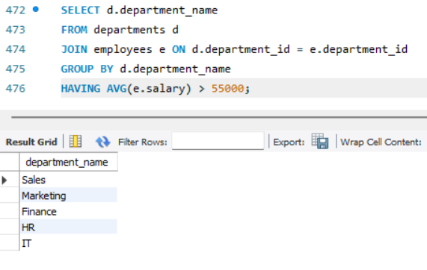

Retrieve department names where the total sales exceed ₹10,000.

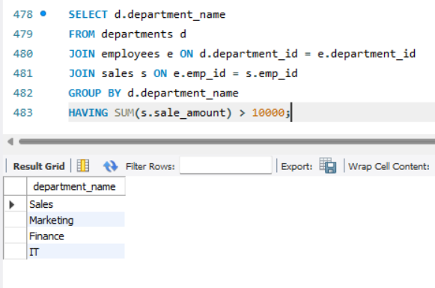

Find the employee who has made the second-highest sale.
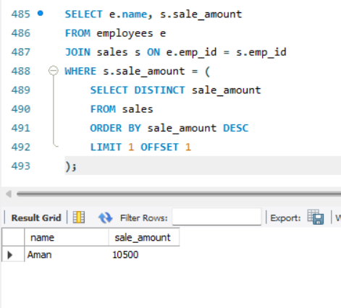

Retrieve the names of employees whose salary is greater than the highest sale amount recorded
