Question 1 : What is Python and why is it widely used in Data Analytics? Mention any three reasons.
Python is a high-level programming language used for data analysis, machine learning, web development, and automation.
Reasons why Python is widely used in Data Analytics:
- Easy to learn and read.
- Provides powerful libraries such as NumPy, Pandas, and Matplotlib.
- Handles large amounts of data efficiently and supports data visualization.

Question 2 : Explain the difference between List and Tuple in Python.
List | Tuple
Mutable (can be changed) | Immutable (cannot be changed)
Uses square brackets [] | Uses parentheses ()
Slower than tuples | Faster than lists
Example: [1,2,3] | Example: (1,2,3)

Question 3 : What is a function in Python? Why are functions useful?
A function is a block of reusable code that performs a specific task.
Why functions are useful:
- Reduce code repetition.
- Improve code readability.
- Make programs easier to maintain and debug.

Question 4 : Write a Python program to take a user's name as input and print a greeting message.
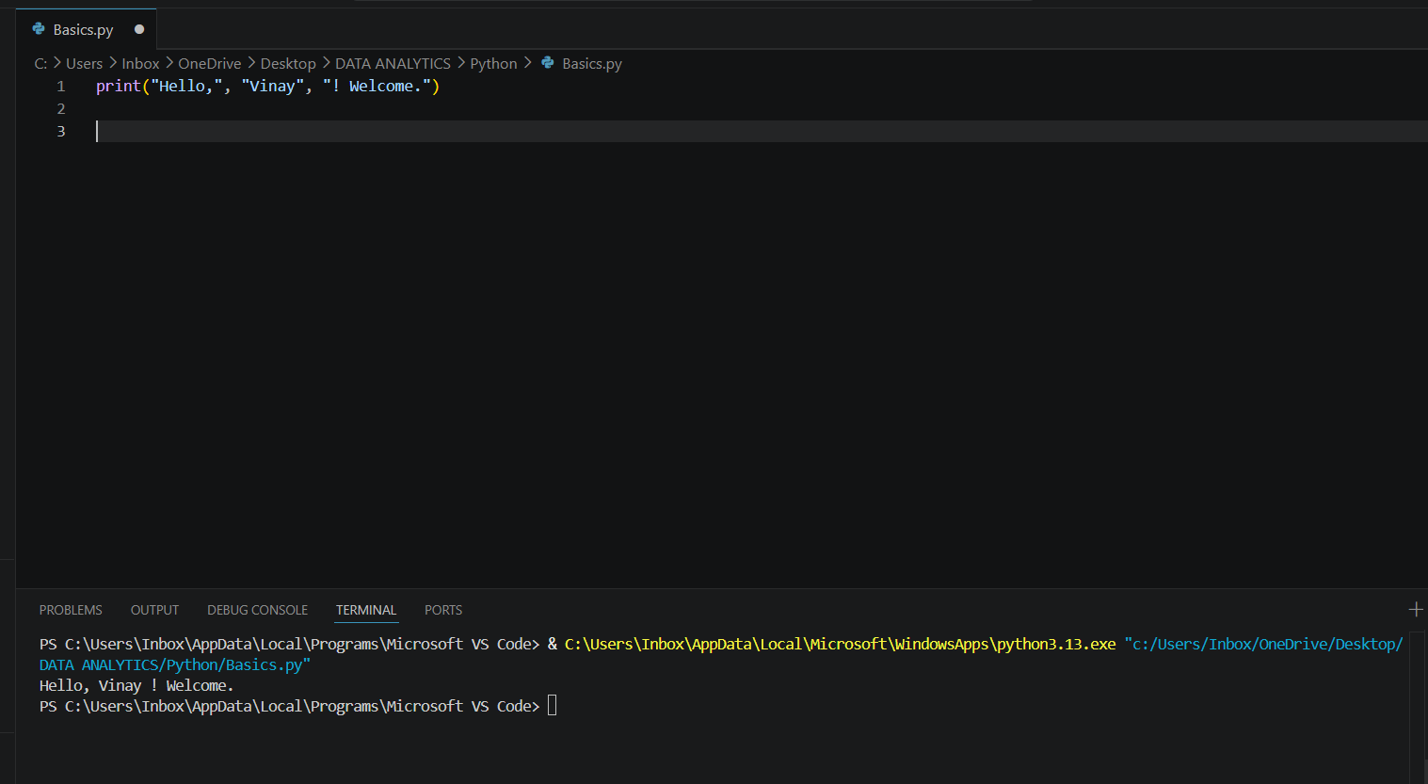

Question 5 : Write a Python program to check whether a number is even or odd using conditional statements.
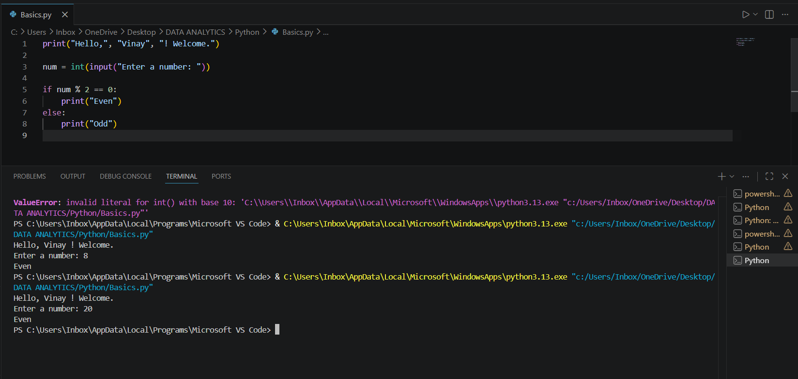

Question 6 : Write a program to print numbers from 1 to 10 using a loop.
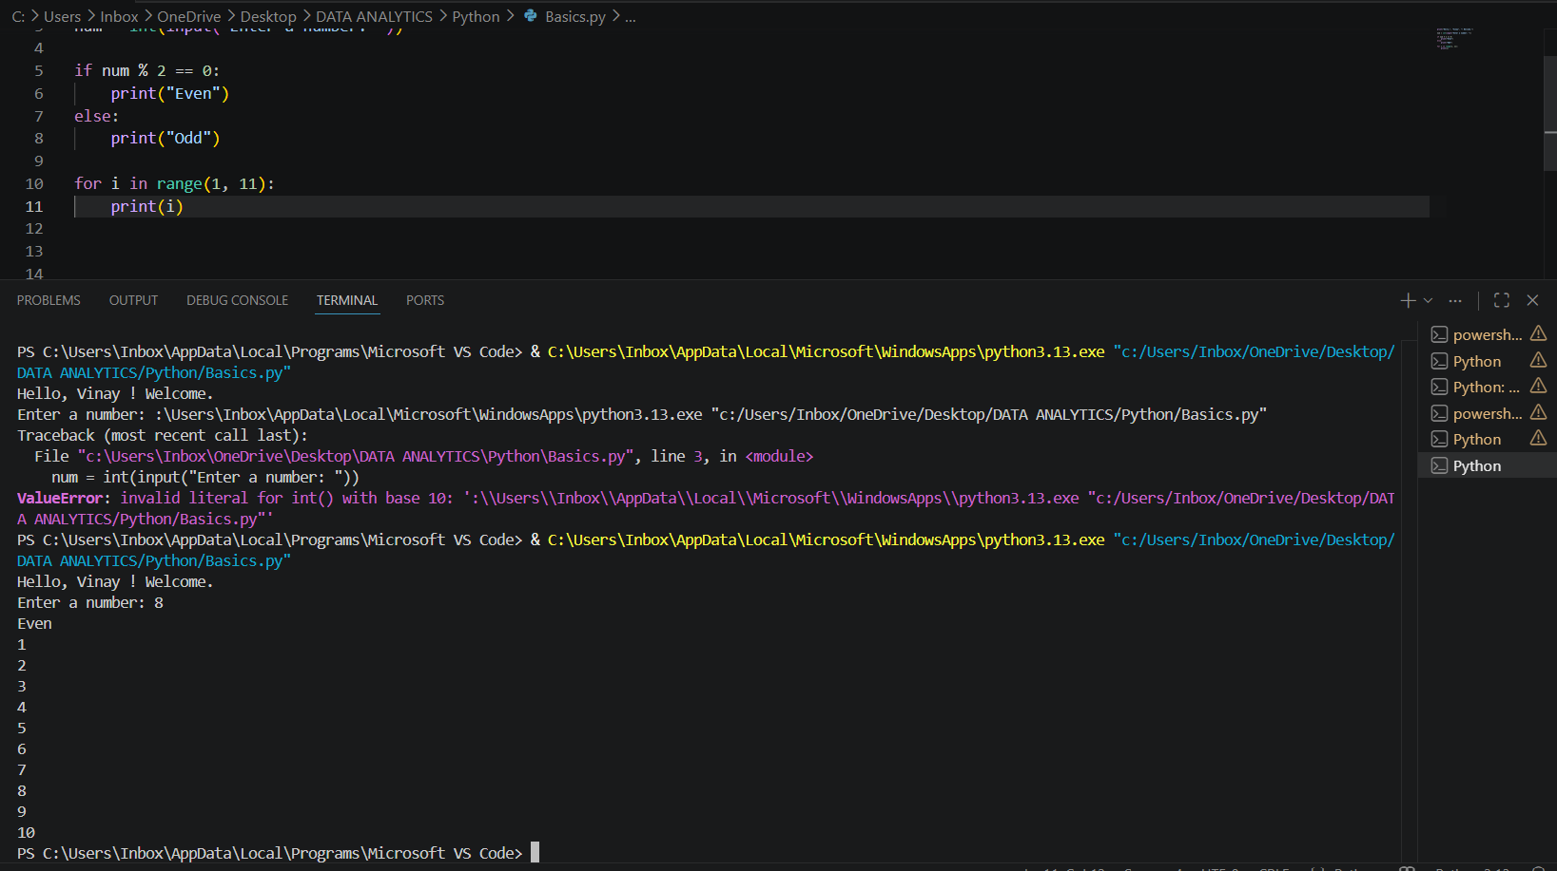

Question 7 : Create a list of five numbers and print the maximum number from the list.

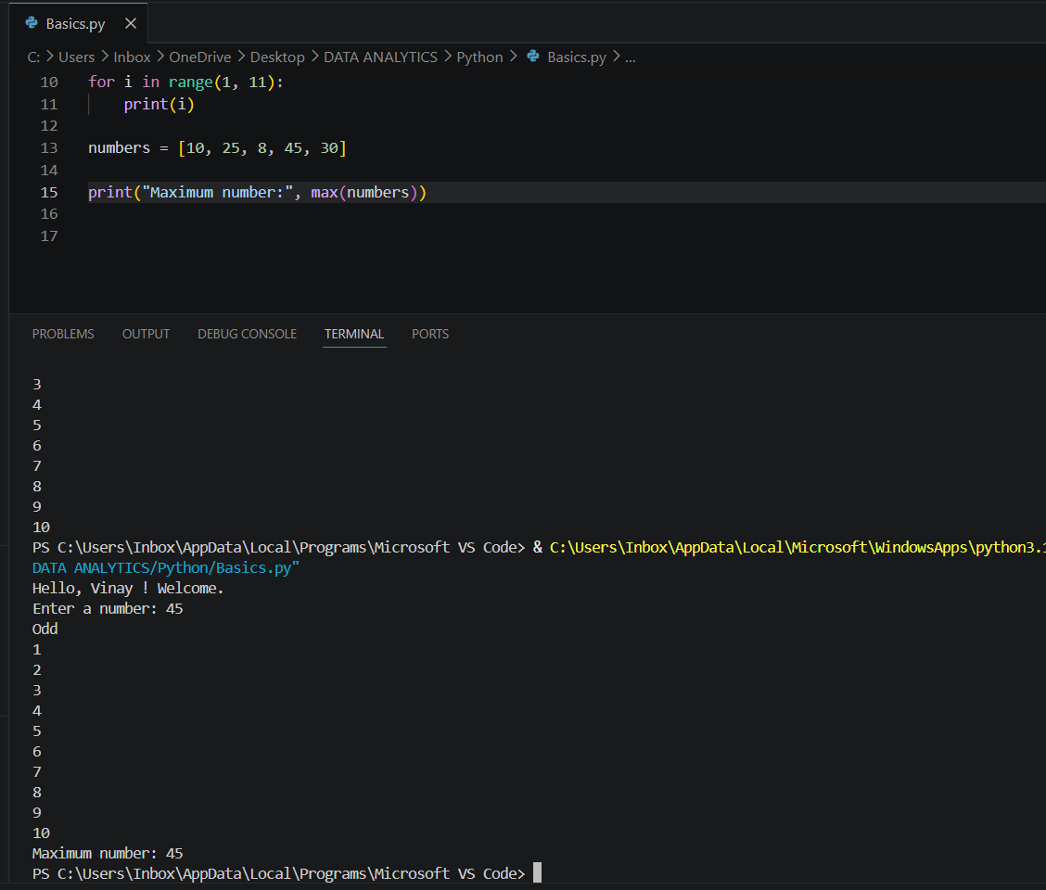

Question 8 : Write a Python program to remove duplicate values from a list using a set.
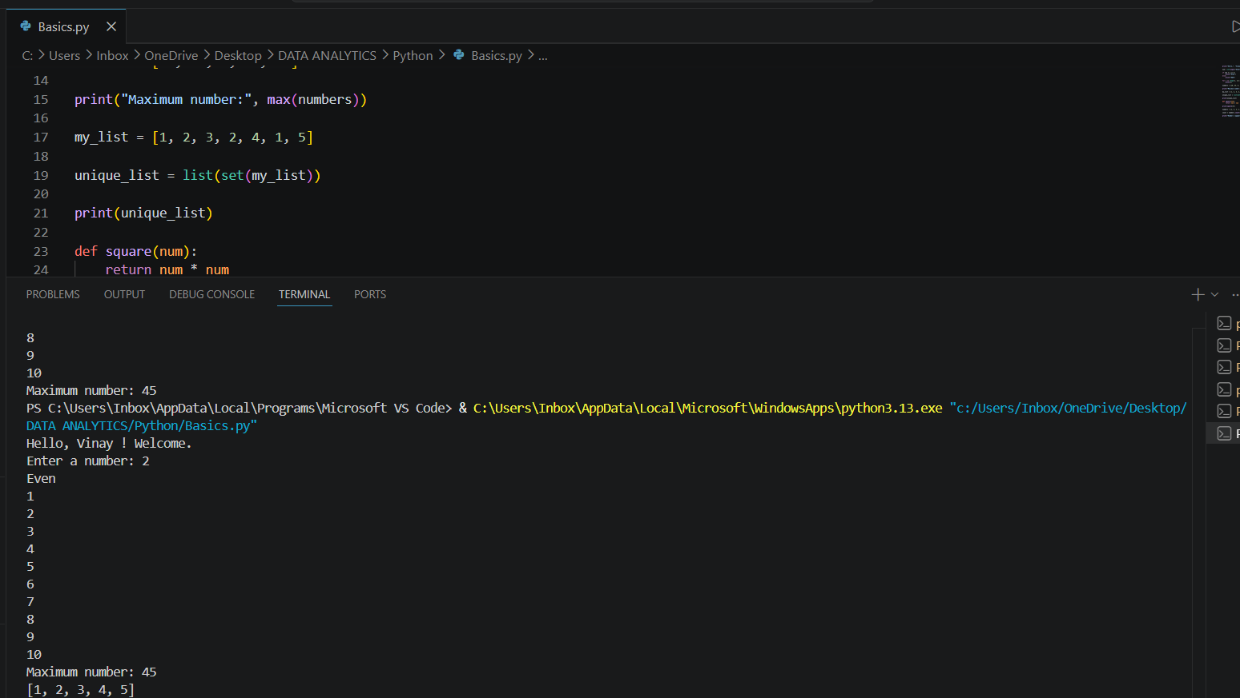

Question 9 : Write a function that returns the square of a number.
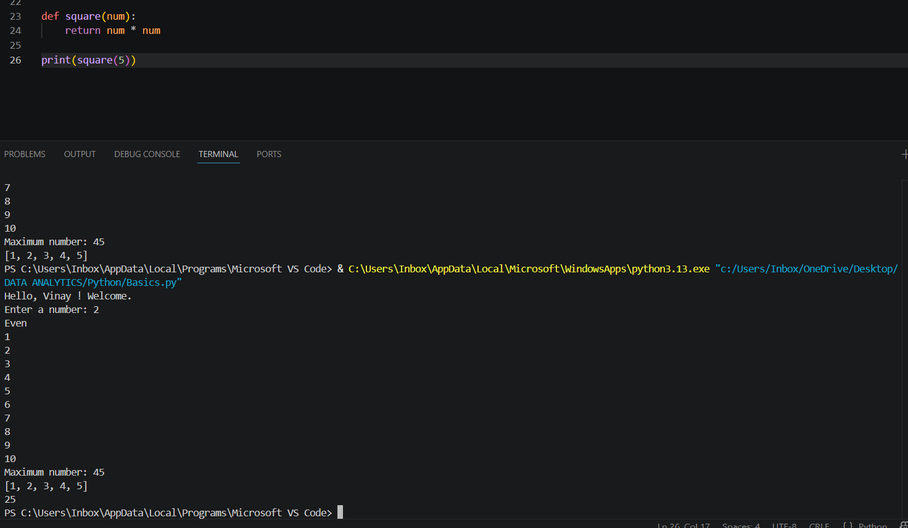

Question 10 : Write a Python program to count how many times a number appears in a list. Example List [2,3,4,2,5,2]
