SOFTWARE ENGINEERING SPRINT 1 GROUP 11-F

SCRUM MASTER

NAME: Nathaniel Ani

STUDENT ID: ANI22523763

TEAM MEMBERS

NAME: UCHECHUKWU GOODNESS ANINTA

STUDENT ID: ANI22512677

PRODUCT OWNER

NAME: DON VINU RASUNTHA WIJAYAMANNA BASNAYAKE

STUDENT ID: WIJ22523510

CODE OF CONDUCT

1. Respect is fundamental within our group, and every member is expected to treat others with courtesy and consideration.
2. Effective communication is key. Members must use proper language, tone, and volume to ensure clear and comprehensible interactions.
3. Roles within the group are well-defined. Nathaniel serves as the Scrum Master, Vinu as the Product Owner, and Uchechukwu as a Team Member are responsible for providing essential data during the first sprint.
4. Punctuality and attentiveness are essential. All members are expected to be on time for meetings. Out of the two meetings one was online using Microsoft Teams. Despite Vinu missing the first meeting due to health reasons, their active participation in the later meeting was appreciated.
5. Commitment to the project is crucial. Each member is expected to contribute their time and knowledge, with meetings lasting at least 2 hours.
6. Self-monitoring and support are encouraged. Team members are responsible for overseeing their assignments and are urged to report any challenges or roadblocks to enhance individual and group performance.
7. The Product Owner, diligently oversees the team and product, carefully reviewing each team member's completed work.

GitHub Repository link:- <https://github.com/VinuDVR/SE-Coursework>

PROCESSES IN SETTING UP DOCKER IN VSCODE

**COMMAND LINES FOR DOCKERFILE**

**DOCKERFILE CREATING A CONTAINER FROM AN IMAGE**

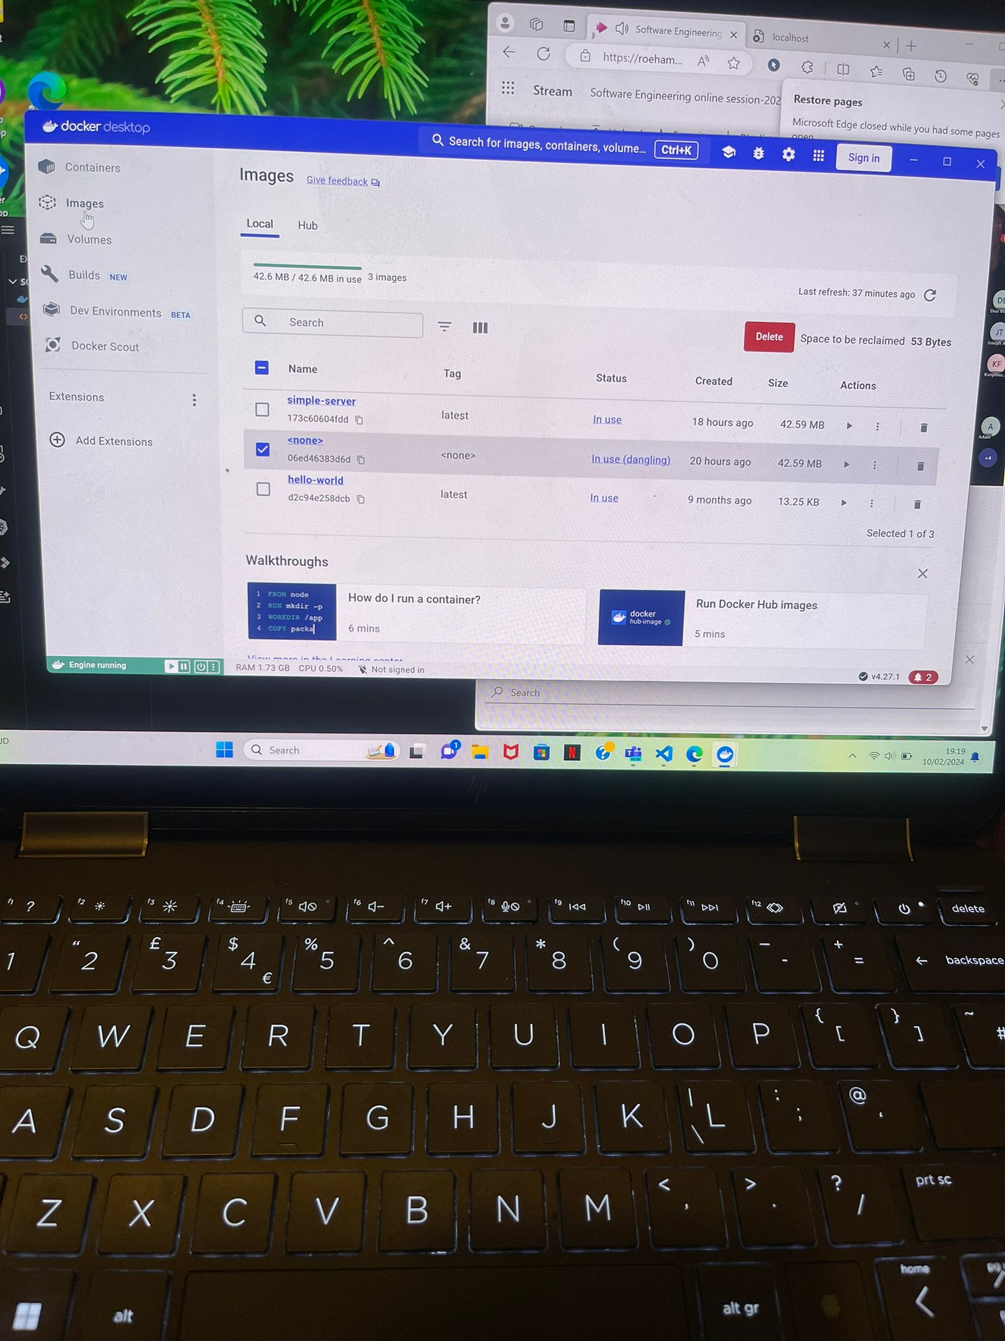

**IMAGE CREATED IN DOCKERFILE**

**HTMLFILE CONTENT**

**DOCKERFILE CONTENT**

**LOCALHOST OUPUT**

**PRODUCT BACKLOG**