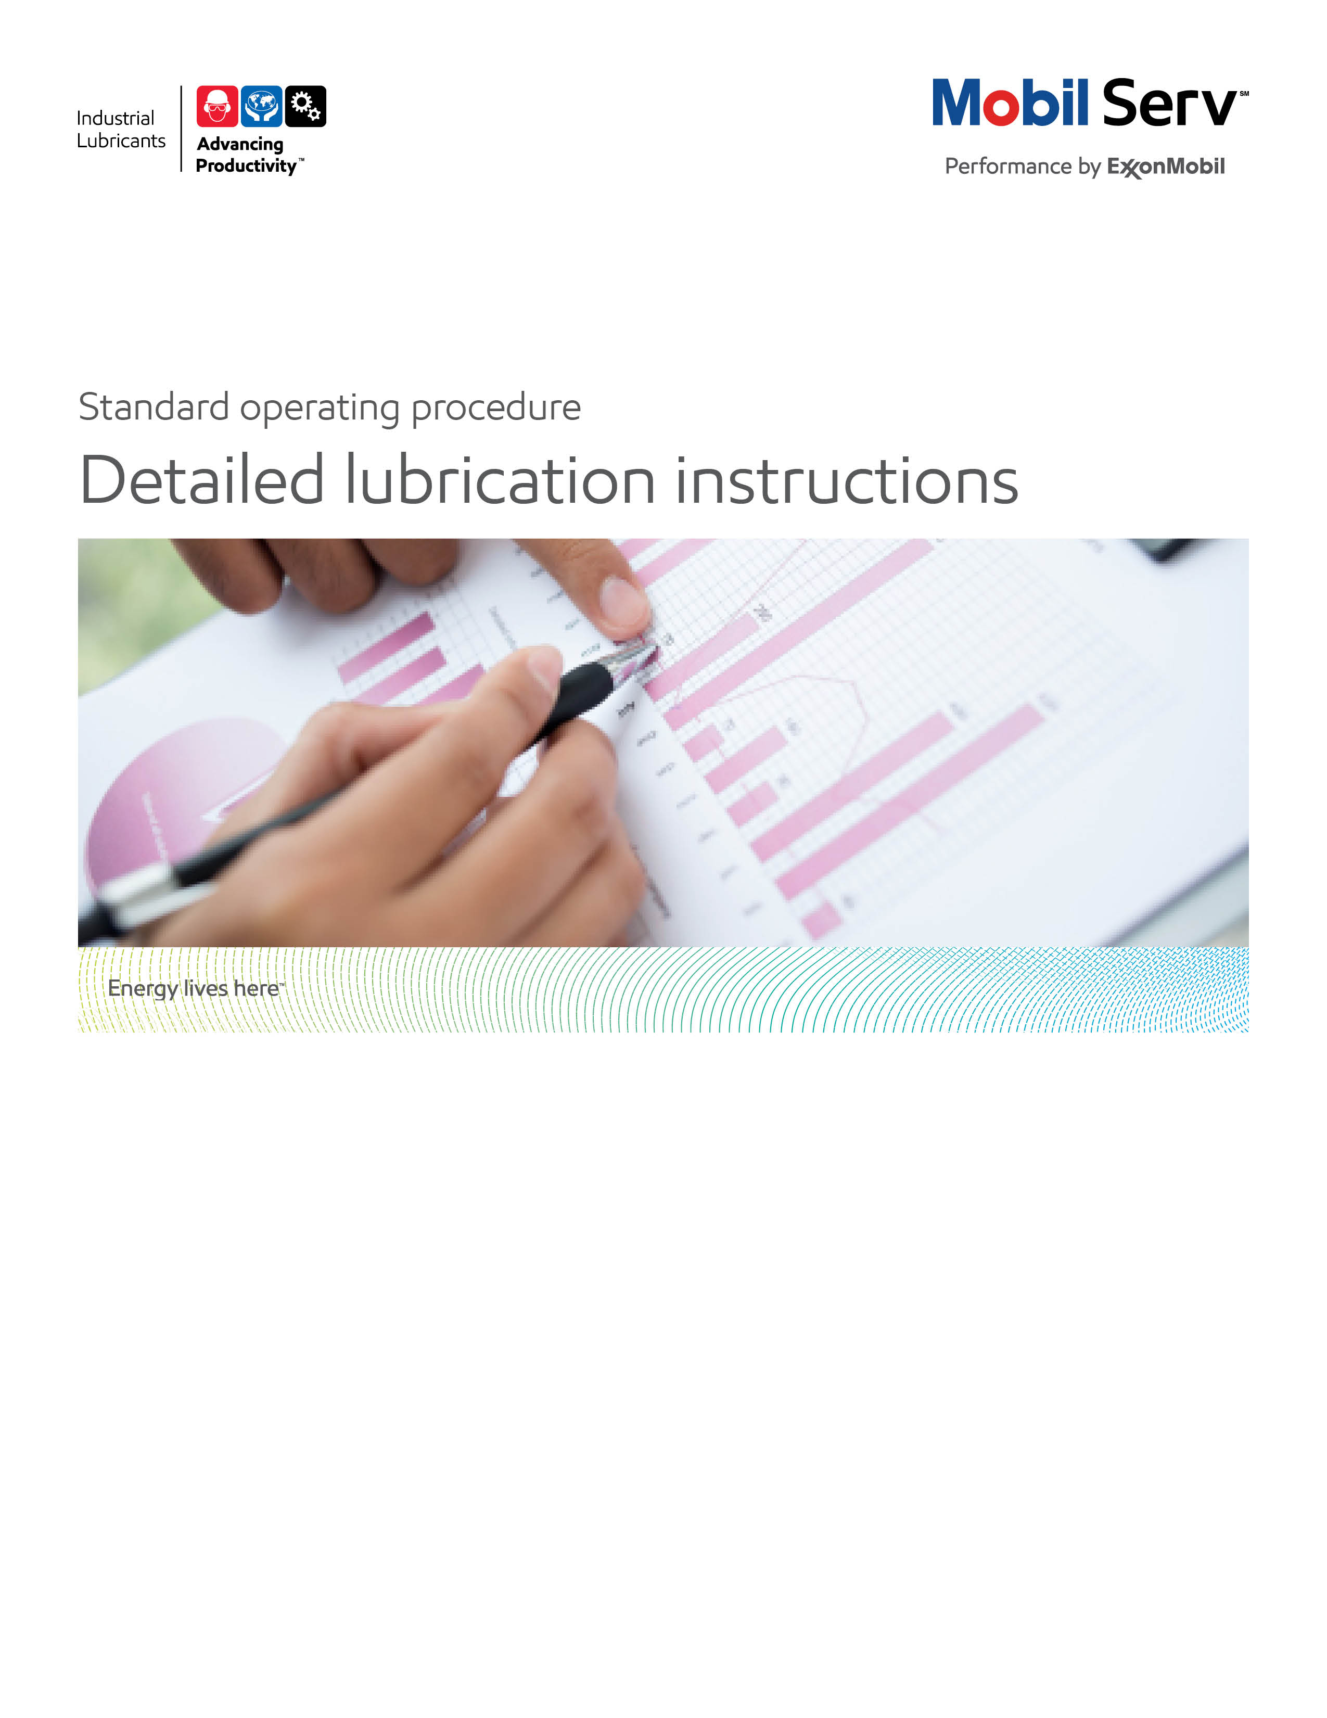

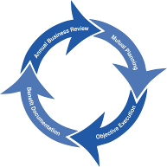
Standard Operating Procedure (SOP)
Read all of the steps in this SOP before beginning work. Follow customer labor requirements (i.e. respect Union work)

SOP: LUBRICATION INSTRUCTIONS |  | DATE  4/19/2013 | NEW  REVISED  ___ Number |  | PAGE 1 of 10
TYPICAL CUSTOMERS  Manufacture, Plastics, Cement, Mining, Sugar, Energy, Pulp & Paper, etc. | WORK TYPE  Lubrication Instructions | WORK ACTIVITY (Description)  Collect data from the equipment on site to develop lubrication instructions
DEVELOPMENT TEAM | POSITION / TITLE | REVIEWED BY/DATE |  | POSITION / TITLE
Juan J. Martínez | Mex Lube Engineer | Luis Rojas 4/23/2013 |  | FES Supervisor Mex CCA
Daniel Castaño | CCA Lube Engineer | Bill Fuller 7/25/2013 |  | FES Advisor USA West
Ricardo Orta | Mex Lube Engineer | Thomas Schiff 7/25/2013 |  | Americas FES Manager
PLEASE UTLIZE ATTCHED GENERAL JSA AS GUIDANCE AND, IF YOU HAVE DONE A SITE SPECIFIC JSA.
http://intratta.na.xom.com/emdn/sbps/docs/safety/jsa/JSA_Lube_Survey_General_Plant.xls
PLEASE ASSESS YOUR OWN CONDITIONS OR SPECIFIC SAFETY REQUIRMENTS OR 3rd PARTY SITES, AND BE SAFE: http://intratta.na.xom.com/emdn/sbps/safety/third_party_site_safety.html
EQUIPMENT INDEPENDENT OF JSA DESIRED DOCUMENTATION
CLIPBOARD OR IPAD / TABLET PC  IR GUN  FLASHLIGHT(with safety hand string)  SAMPLE THIEF, BOTTLES & LABELS  RAGS LINT FREE  CAMERA (with safety hand string)  ENERGY TESTER |  | DATE OF – (ESN) Engineering Service Notice as a leave behind  FINAL – (ESR) Engineering Service Report OR PROPOSAL WITH TOTAL COST OF OWNERSHIP (TCO )SAVINGS WITH LUBE INSTRUCTIONSHEETS  OTHER (SPECIFY)  INSPECTION SPREADSHEET (AS NEEDED)  PLANT ANALYSIS BOOKLET (AS NEEDED)
TIME ESTIMATED TO COMPLETE THIS TASK NUMBER OF PEOPLE TO PERFORM THIS TASK
APROX. 4 HRS PER PROCESS SECTION |  | 2
FREQUENCY TO PERFORM THIS TASK SKLLS REQUIREED TO PERFORM THIS TASK
DERIVED FROM IDENTIFIED CUSTOMER NEEDS OR IN ACCORDANCE WITH THE PIPELINE WORK PLAN. |  | CONDITION EQUIPMENT DETAILED OBSERVATION: ABNORMAL NOISE, HIGH TEMPERATURES, LEAKING, OVERLOAD, CAVITATION, AEREATION, VIBRATIONS, FUMES.  WAREHOUSE AND STORAGE INSPECTION
JOB COMPETANCIES REQUIRED TO PERFORM THIS TASK |  | TRAINING REQUIRED TO PERFORM THIS TASK
UOA INTERPRETATION  BASIC LUBRICATION IN: GEAR BOXES AND REDUCERS, HYDRAULICS SYSTEMS, TURBINES, BEARINGS, COMPRESSORS, ENGINES, ETC.  PSPS (PROFESSIONAL SELLING PROCESS SKILLS) /  SPIN SELLING  TCO / BENEFIT REPORT WRITTING  STORAGE, HANLDING AND DISPENSING OF LUBRICANTS GUIDANCE |  | lms e-Learning– GEARS, BEARINGS & COUPLINGS  lms e-Learning– HYDRAULICS SYSTEMS & COMPRESORS  lms e-Learning- SYNTHETICS & FOOD INDUSTRY  lms eLearning- CVL OFF HWY, PLASTIC, PAPER,  Plant equipment inspection training (file attached)  ON THE JOB TRAINING, SHADOWING THE LUBE ENGINEER
OTHERS RESORCES OR RELATED INTEREST SITES
TECHNICAL HELP DESK (THD) (tsc.amerias@exxonmobil.com)
Tel. 001 800 966 2910
www.mobilindustrial.com
www.looble.com

PURPOSE – To describe the process for producing Lubrication Instructions for a new customer or when updates are necessary for existing customers. The Main objective through Lubrication Instructions is to establish the fewest correct lubricants, reduce miss-application, and optimize lubrication activity.is to. A final Engineering Service Report (ESR) with Lubrication Instructions that documents detailed lubrication recommendations for each piece of equipment is the deliverable containing lubrication recommendations for all equipment including change frequency, service intervals and method of application. In special cases we may provide photographic lube instructions.This ESR should produce value to the customer in terms of Productivity, Safety and Sustainability to support the general Marketing Offer.

External Offer Sheet: http://intratta.na.xom.com/emdn/sbps/technical/engg_services/Americas/Detailed_Lubrication_Instructions.pdf

LOCATION | JOB STEPS
Prior your call, collect customer information | - Identify customer sector and prep for suffering points for this industry.  - Determine why the Lubrication Instructions are needed without being offensive. Work to determine how they will be valued.  - Get preliminary information: Equipment Name, Equipment Asset Numbers, Current Lube Routes, Current Lubricant used, OEM, Model, and Current Lubrication Instructions.  - Get process diagrams to understand customer equipment and nomenclature.  - Try to get an electronic version to make the lube survey work efficiently.  - Adhere to our lubrication instructions standard service offer. If customer wants and we can justify then we should include photos in lube charts but needs to be part of account planning session.  - If customer wants and we can justify we should add lube volumes (e.g. grease shots based on standard calculations/experience) and again endorsed as part of account plan  - Determine if data collection will be with paper, Tablet PC’s or iPad and become familiar with electronic tools.  - Consult support information and owner & OEM manuals.  - Be ready with SPIN questions regarding the equipment: Gear reducer, turbines, engines, bearings, journal bearings, hydraulics, etc.
Lubrication Instruction Development at Equipment | - Be accompanied by a customer representative.  - Follow a department logical sequence of equipment for the manufacturing process. List all equipment components that require lubrication per the agreed on format. Typical information would include:  - Lube Route with person responsible name  - Equipment Drivers (electric motor bearings, internal combustion engine, turbine, hydraulic system, etc.)  - Coupling  - Gear box, reducer or force multiplier  - Moving parts / devices  - List the Lubricant – note abbreviations can help the data collection phase go more efficiently. Make sure to have a Legend established to put the correct Mobil lubricant name in the final lubrication instructions.  - List the Method of Application (see Enclosure for Choices)  - List the Service and Change Frequencies  - Take notes and ask questions regarding:  - OEM recommendations  - current lubricant in use  - maintenance frequency  - lubrication periods  - quantities applied, leakage issues  - oil drain Interval  - application method  - filter used, beta ratio  - used oil analysis  - Use IR Gun, flashlight and proper equipment to note for future projects:  - operating temperatures  - operating conditions  - lubricant leakage issues  - vibrations  - contaminants  - unusual odors, fog, vapors, environment, abnormal conditions  - Take photographs of the equipment to highlight improvement opportunities (ask for permission previously)  - In special cases, we may provide photo graphic lube instructions that have a photo of the equipment with lines pointing to each lubricated (or sampled) component with a number that mataches a number in the lube instruction table.  - At the end of the visit write an Engineering Service Notice to the customer, highlighting the main items covered, agreements next steps, and timeframe
Storage and Dispensing Containers | - Create a list of current lubricants, delivery container sizes and usage by department using storeroom, lube storage areas and lube cabinets.  - Determine what can be consolidated.  - Observe types of containers for proper oil labeling  - Observe types of containers for preventing ingression of contaminants (are they sealed)  - Review if containers are dedicated by product  - Make a general note on housekeeping of containers and materials management.  - Take photographs if you have permission.
Home Office – analyzing lubrication instruction sheets, (Information Analysis) | - Confirm any lubricant applications utilizing; the Technical Help Desk (THD), Looble, EMEBS, and/or your Field Engineer.  - Ask your colleagues about similar situations and how they were solved.  - Review in Inside Sales – Technical – Model Reports and the VDR site for similar applications, products and how others have built a benefit report.  - Consult OEM Manuals. Compare actual conditions vs. operating conditions design.  - Obtain all MSDS and PDS’s.
Prepare the ESR | - Using the 3D Report Writer format, prepare the ESR.  - Apply the applicable TCO Categories: Revenue, Assets, Process, Expenses and Others.
Set a follow up meeting with customer to review draft. | - Confirm your recommendations and make necessary changes. Gain acceptance of the Value determined from the Lubrication Instructions project in terms of: Productivity, Safety and Sustainability.  - Explain the next steps to achieve this value and express as opportunities for improvement.
Manage implementation and expand relationships | - Get customers cooperation to implement your recommendation  - Offer your technical post-sale expertise expand relationships
Feedback about this SOP - send to Chief Engineer

Follow next guidelines to find opportunities and calculate where savings and benefits may come from. Lubrication instructions ESR (See page 8 for further guidance):

Revenue Enhancement Worksheet

To build potential savings for this category, Lube Engineer needs to investigate all the shutdowns coming from equipment failures that have impacted process productivity, within a specific period of time (i.e. last year, last month, etc.)

Calculations for this TCO category come from unscheduled downtime in process equipment at all the plant: electric motors, couplings, pumps, servo valves in hydraulic systems, filters, gear drives, bearings, fans, conveyors, supporting and bearing systems of mills and ovens, compressor failures (bearings, piston, shutdowns), turbines failures (bearings, filters, servo mechanisms, valve plugging), fluid separation systems failures (gearbox failure, disc plugging), transport equipment for final product.

Profit improvement = annual unit improvement x (unit value – increased cost)

Calculate the impacted cost of downtime in process as a result of equipment failures = throughput * lost time * unit production cost. Example: Profit improvement = 100 tons/hr * 4 hrs downtime * $10/ton = $4,000

Asset Improvement Worksheet

This category refers to the benefit for productivity customer assets have as a result of the identified improvements in terms of lubrication.

Lube Engineer must identify assets to be improved: possession cost of any equipment which has reduced depreciation costs as a result of an extended productive lifetime using our lubricants. Also include the benefit cost of reduced materials inventory: freed warehouse space of a specific material, for productivity improvement and less usage. Typical possession cost is around 20%

Asset improvement = (quantities reduced * value of asset) * % possession cost

Example: 1 pump freed/yr * $5,000/pump * 20% = $1,000/yr

Process Improvement Worksheet

Lube Engineer will investigate the hourly wages (including burden) for personnel to perform existing tasks for replacing the failed equipment. Labor hour should include equipment replacements and lubricant change outs. If lubricant usage is reduced, use the time to handle drums and the time to dispose of used lube.

Process improvement = (past process cost * frequency of past use) – (current process cost * frequency of current use)

Example: Hourly wage cost for lube change: $20. Time to perform oil change: 2 hrs. Changes/yr = 3. As a result of the lube recommendation only 1 change will be performed per year.

Process improvement = ($20 * 2 * 3) – ($20 * 2 * 1) = $80 / year

Expenditure Reduction Worksheet

As a result of Lube Engineer recommendation, quantities in lubricants, replacement parts, and other provided services (training, oil recollection, plant studies, used oil analysis etc.) are included here. In several occasions, this number can be negative, meaning that the investment is higher than the original (i.e. when switching to synthetics). This amount in almost all of the cases will be compensated with the rest of the savings, providing a net benefit to our customer.

Expenditure reduction = annual quantity reduced * price difference

Example: as a result of a lubricant upgrade, replacement cost has been reduced from 2 to 1gear boxes per year. Unit cost is $30,000

Expenditure reduction = 1 gear box * $30,000 / gear box = $30,000

Transport equipment savings as a result of oil drain intervals extension should be included in this section.

Sustainability

Identify how the key elements apply to the work completed:

- Safety – reduced manhours expended when extending oil drain intervals with Flagship and Premium products and reduced equipment repair.
- Environment – less oil to dispose from fewer lubricants purchased and extended oil drain intervals. Also less grease frequencies. Reduced CO2 from less emissions (tons or Kg).
- Productivity – less equipment downtime from extended equipment life between failures from recommendations including use of Flagship and Premium products and services like Mobil Serv. Reduced energy costs.

APPENDIX 1 - MASTER LUBRICATION CHART
Lube Chart Template

Engineering Service PES - Reference

After clicking the link above, go to lube charts as shown:

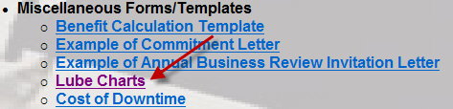

APPENDIX 2 - EXAMPLE OF ESR AS A RESULT OF LUBRICATION INSTRUCTIONS

Lube instructions model report

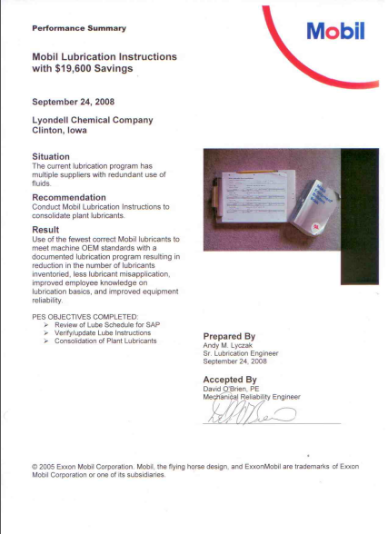 | 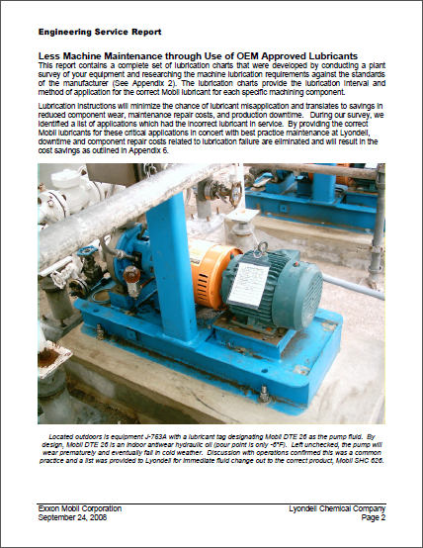

APPENDIX 3 - RELATED DOCUMENTS TO LUBRICATION INSTRUCTIONS

- SPIN questions for several industries

- TCO Categories

APPENDIX 4 - GLOSSARY

Annual Unit Improvement: In almost all cases, the impact a supplier has results in a greater level of output. How many additional units of product was the customer able to produce due to this event?

Unit Value: Anything being manufactured by the customer has “value” to the customer. Either it will be sold or used internally. If it is sold, the selling price is the value. If it is for internal use, there is a transfer value the customer uses (usually low) or you can indicate the market price if other companies produce it.

Increased Costs: In some cases, the improvement in output requires an increase in costs to achieve it. Such as a higher price for the product that allowed the increase in output to be achieved.

Profit Improvement: Once the numbers in the other columns of the worksheet have been complete, you can determine the value you provided by completing the equation in this column

Assets Affected: Name the asset(s) the customer was able to eliminate.

Quantities reduced: The physical number of units of an asset that the customer is no longer required having on hand.

Value of Asset: This is either the book value for the asset if it is not depreciated or the price paid if the customer is not depreciating it.

Possession Cost: The annualized cost for owning as asset as compared to the purchase or replacement value of that asset. The costs can include interest, maintenance, taxes, shrinkage, insurance, etc.

Processes Improved: Name the processes that were improved so the customer and others understand where the impact occurred that you are showing as having reduced costs.

Past Process Cost: Evaluate the impact you had, you must know what it cost the customer to perform these tasks. The cost is based on the amount of time required to perform the tasks involved and the value (wages) of the people’s time performing these tasks.

Frequency of Past Use: To measure the annual cost incurred for performing the tasks (processes), the number of times the process is performed each year must also be estimated.

Current Process Cost: Once the change is made, the new processing costs need to be measured. Again, this is based on the time it takes the customer’s personnel to complete the tasks involved and the cost (wages) of the people’s time for completing these tasks.

Frequency of Current Use: Changes in the number of times a task must be performed can also impact the total annual cost to the customer for performing a specific process.

Process Savings: By performing the equation shown in this column of the worksheet, suppliers can measure the total reduction in processing costs they helped their customers achieve.

Expenditure: The specific item(s) that required less payment over the originally planned expenditures.

Annual Quantities Reduced: An estimate of the number of times the customer should be able to take advantage of the lower pricing opportunity that you are providing. In many cases this may be a “one shot” deal or may need to be documented each time it occurs because of differences in the specific item(s) being purchased or the cost reduction involved.

Price Difference: The difference between what the customer was planning to pay and what they actually had to pay.

Annual Savings: This column uses the equation provided to determine the annualized spending you helped your customer avoid.

