Exploratory Data Analysis: Heart Disease Dataset
Objective: analyse the dataset to uncover patterns and trends, identify correlations and the key factors influencing heart disease.

1. Dataset Overview
- Records: 50,000; Columns: 21 (20 features + target).
- Missing values: 0; duplicate rows: 0. 'None' in Alcohol_Intake means no alcohol, so it was treated as a category.
- Class balance: class 0 = 53.7%, class 1 = 46.3%.
- Numerical features: Age, Weight, Height, BMI, Systolic_BP, Diastolic_BP, Heart_Rate, Blood_Sugar_Fasting, Cholesterol_Total.
- Binary risk factors: Hypertension, Diabetes, Hyperlipidemia, Family_History, Previous_Heart_Attack.
- Categorical features: Gender, Smoking, Alcohol_Intake, Physical_Activity, Diet, Stress_Level.
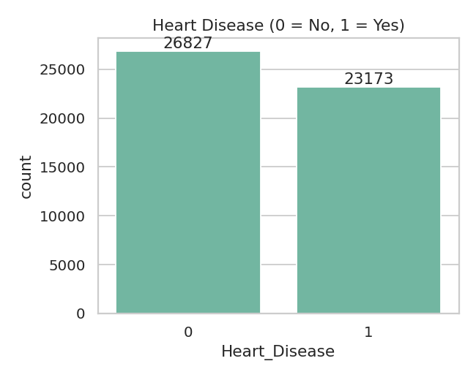
Figure 1: Target distribution

2. Statistical Summaries
feature | mean | std | min | median | max
Age | 54.46 | 14.44 | 30.0 | 54.0 | 79.0
Weight | 84.55 | 20.21 | 50.0 | 85.0 | 119.0
Height | 174.46 | 14.42 | 150.0 | 174.0 | 199.0
BMI | 28.98 | 6.37 | 18.0 | 29.0 | 40.0
Systolic_BP | 139.3 | 23.08 | 100.0 | 139.0 | 179.0
Diastolic_BP | 89.53 | 17.26 | 60.0 | 90.0 | 119.0
Heart_Rate | 84.45 | 14.49 | 60.0 | 85.0 | 109.0
Blood_Sugar_Fasting | 124.49 | 31.69 | 70.0 | 125.0 | 179.0
Cholesterol_Total | 224.56 | 43.16 | 150.0 | 225.0 | 299.0

Skewness: Age = 0.01, Weight = -0.00, Height = -0.00, BMI = 0.00, Systolic_BP = 0.01, Diastolic_BP = -0.00, Heart_Rate = 0.00, Blood_Sugar_Fasting = 0.00, Cholesterol_Total = -0.01.
Outliers (IQR rule): Age = 0, Weight = 0, Height = 0, BMI = 0, Systolic_BP = 0, Diastolic_BP = 0, Heart_Rate = 0, Blood_Sugar_Fasting = 0, Cholesterol_Total = 0.
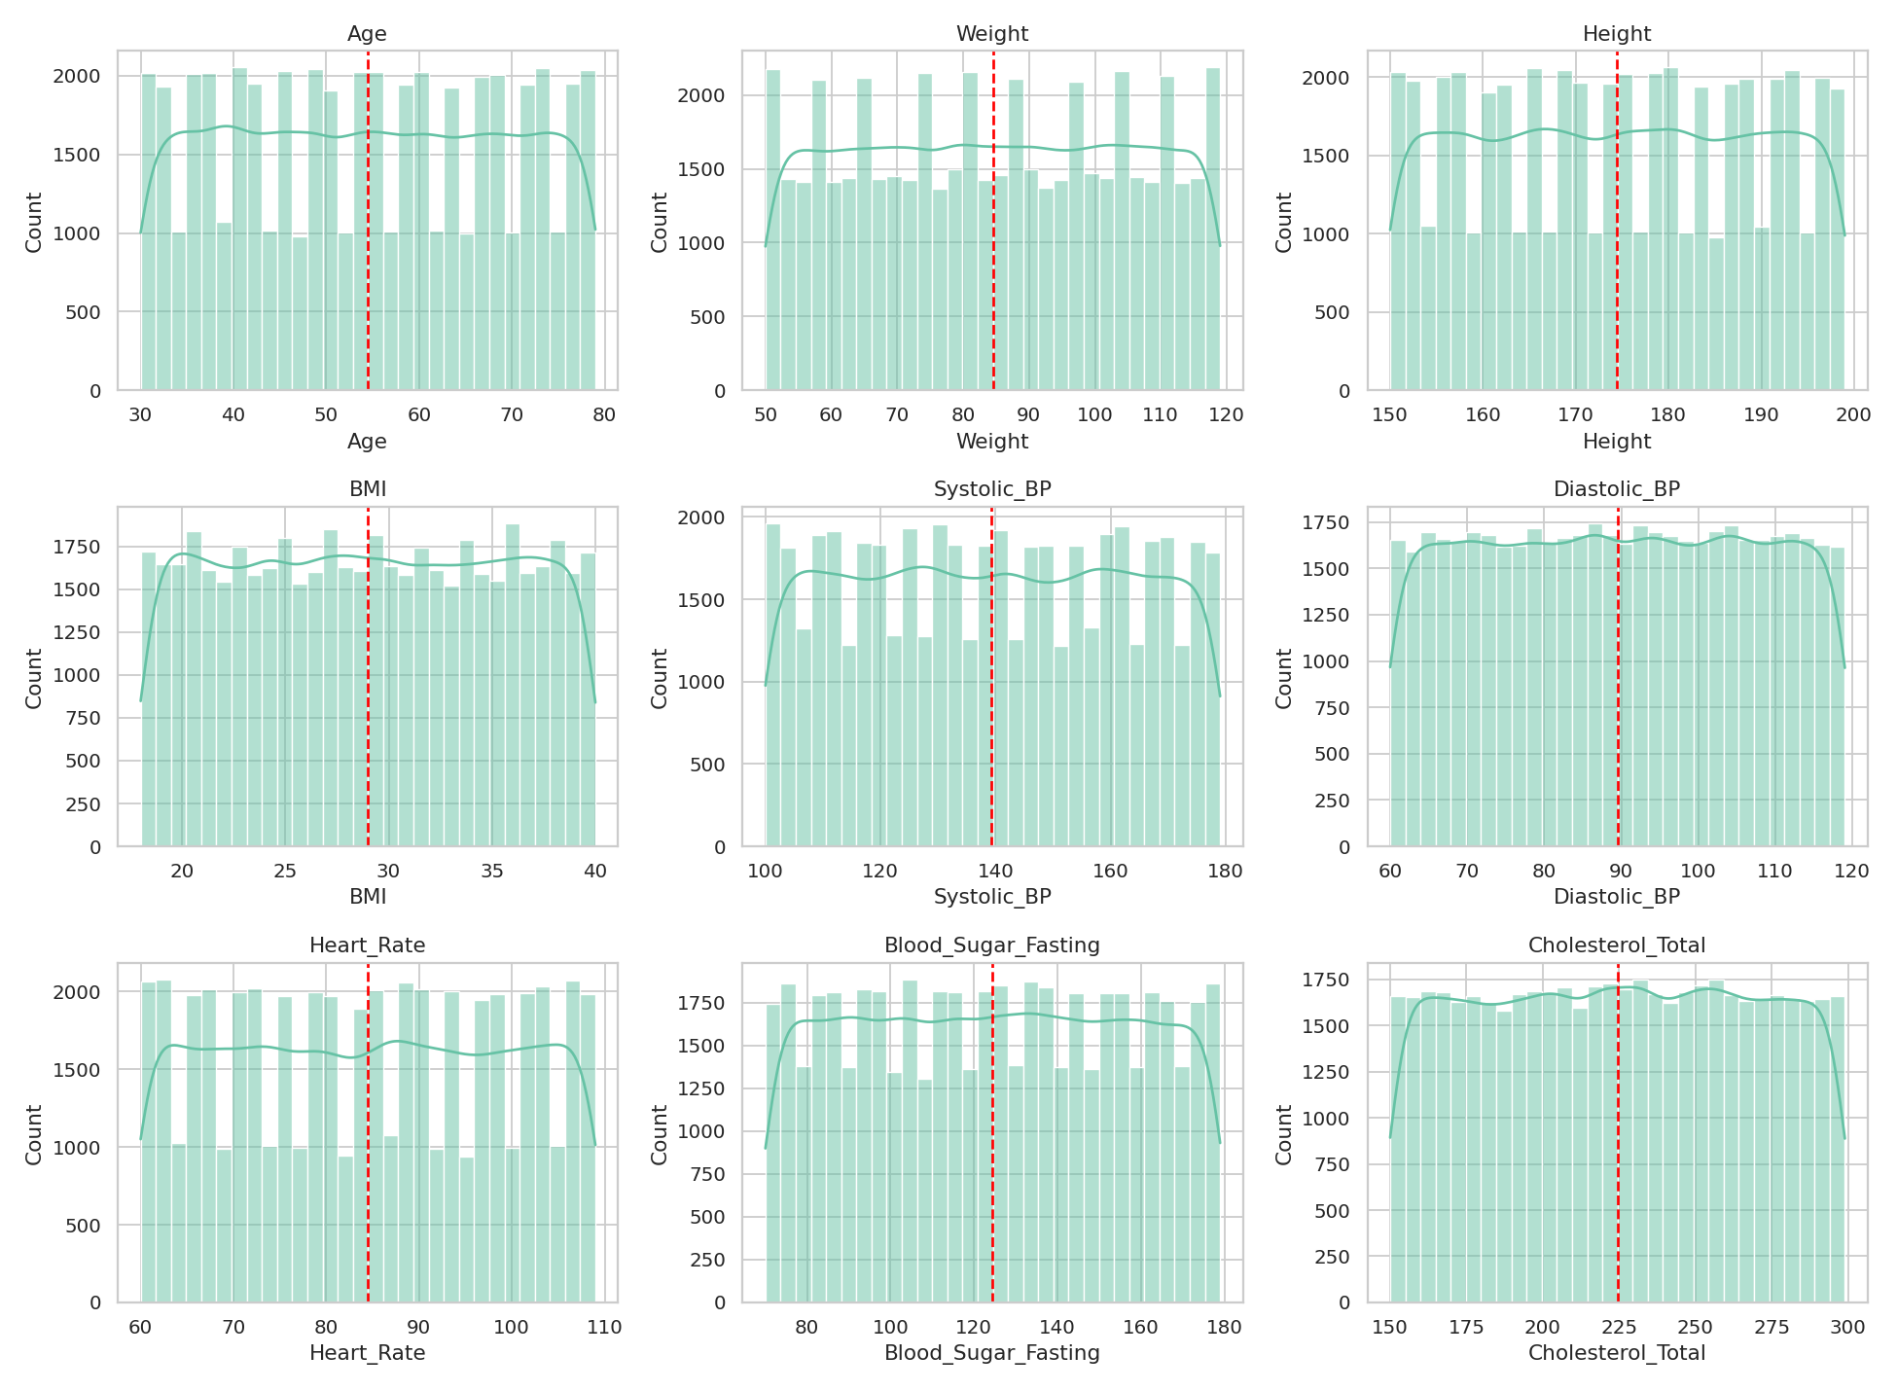
Figure 2: Distributions of numerical features

3. Visual Exploration

3.1 Numerical features vs target
Heart_Disease | Age | Weight | Height | BMI | Systolic_BP | Diastolic_BP | Heart_Rate | Blood_Sugar_Fasting | Cholesterol_Total
0.0 | 49.36 | 84.65 | 174.47 | 29.02 | 139.31 | 89.48 | 84.55 | 124.59 | 209.55
1.0 | 60.37 | 84.43 | 174.44 | 28.94 | 139.28 | 89.59 | 84.34 | 124.38 | 241.93
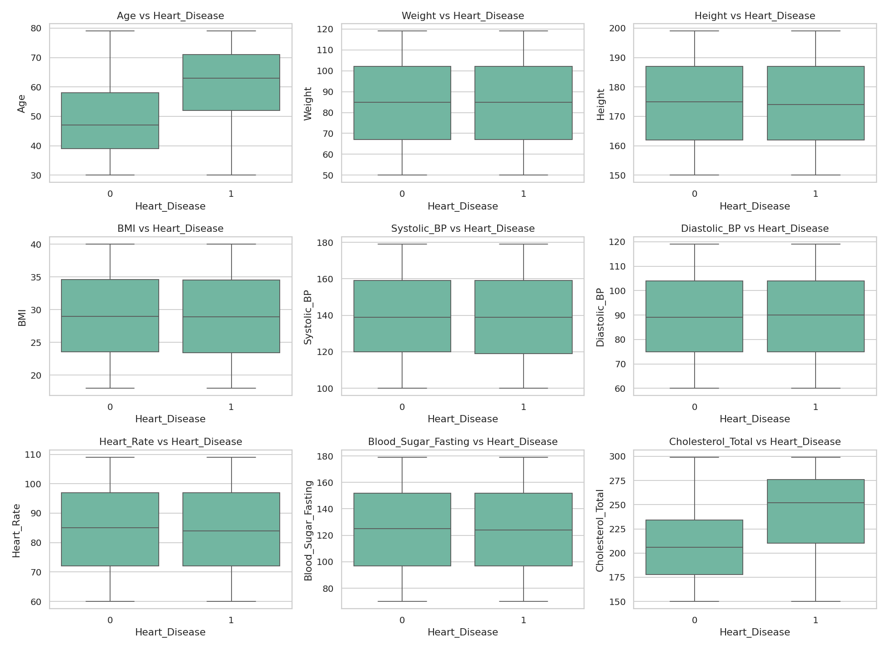
Figure 3: Boxplots by heart disease status
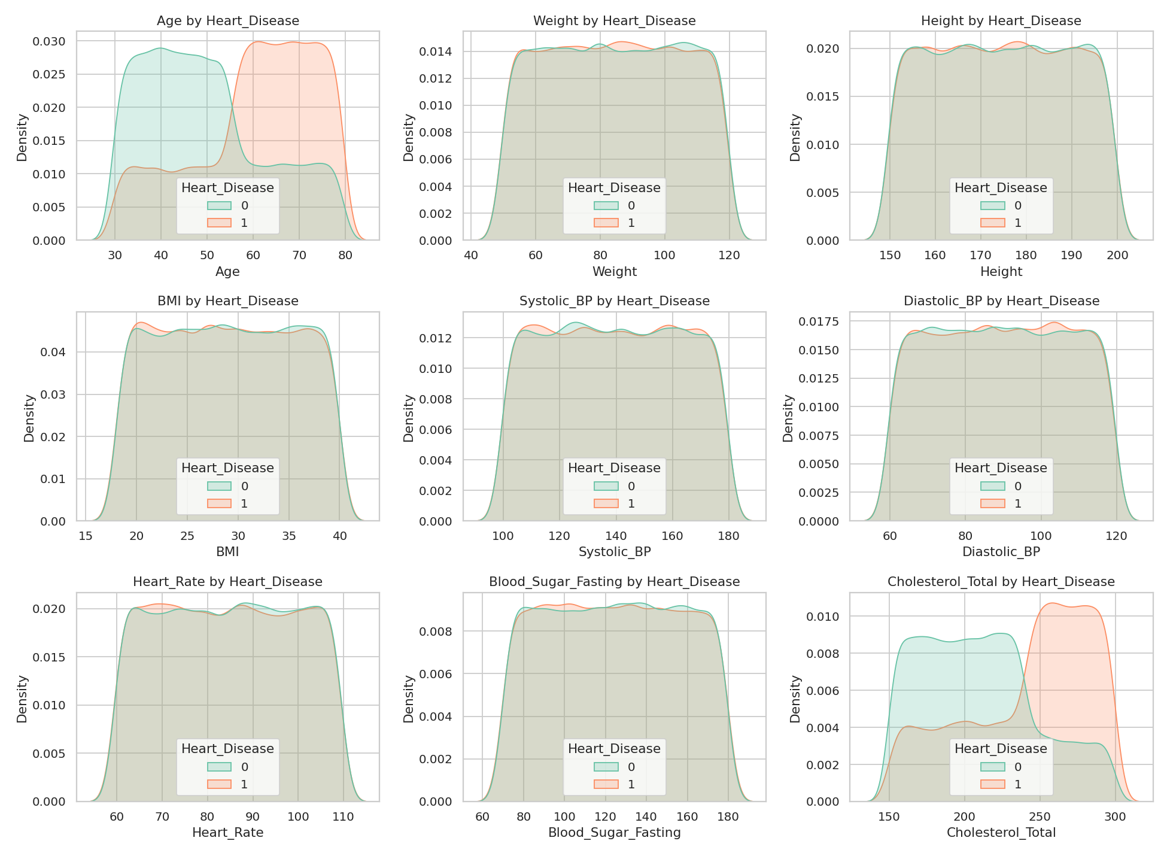
Figure 4: Density plots by heart disease status

3.2 Categorical features vs target
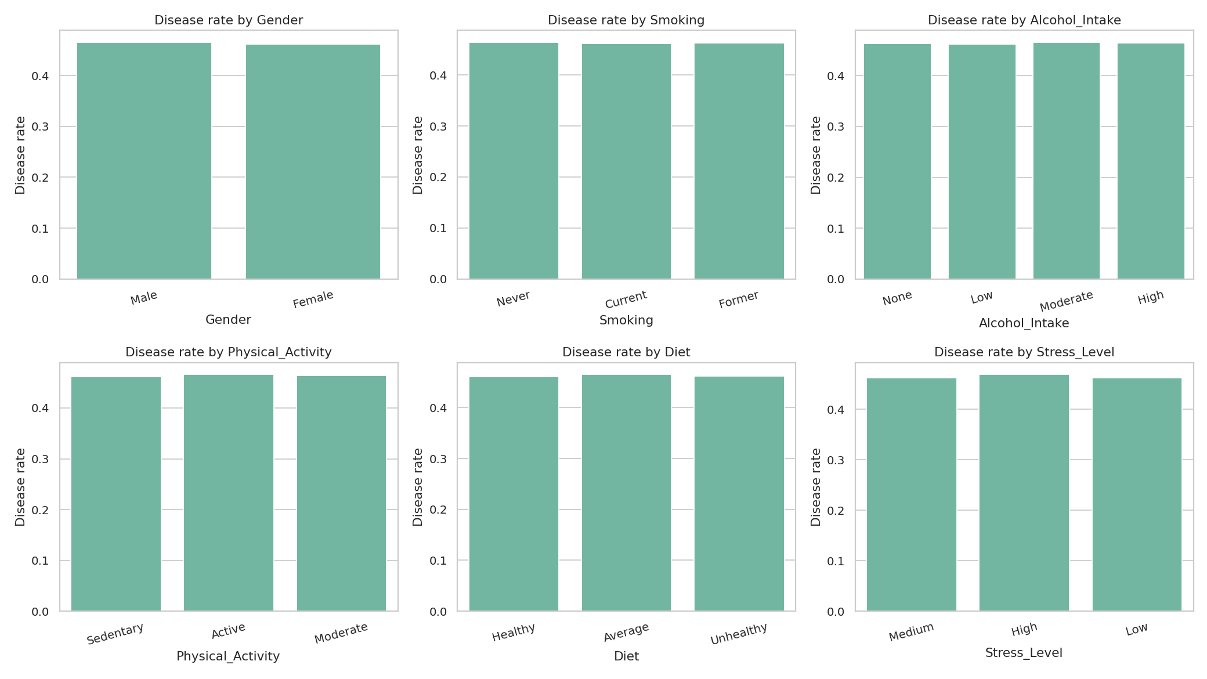
Figure 5: Disease rate by lifestyle categories

3.3 Medical risk factors
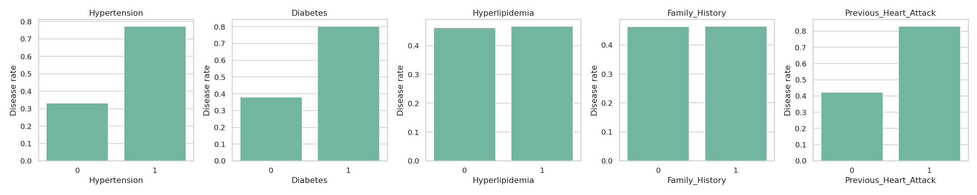
Figure 6: Disease rate by medical history
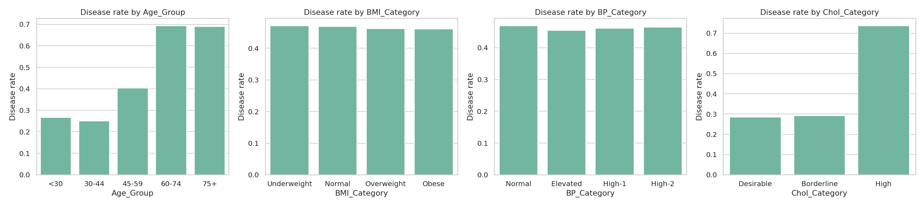
Figure 7: Disease rate by age, BMI, BP and cholesterol group

4. Correlations and Key Influencing Factors
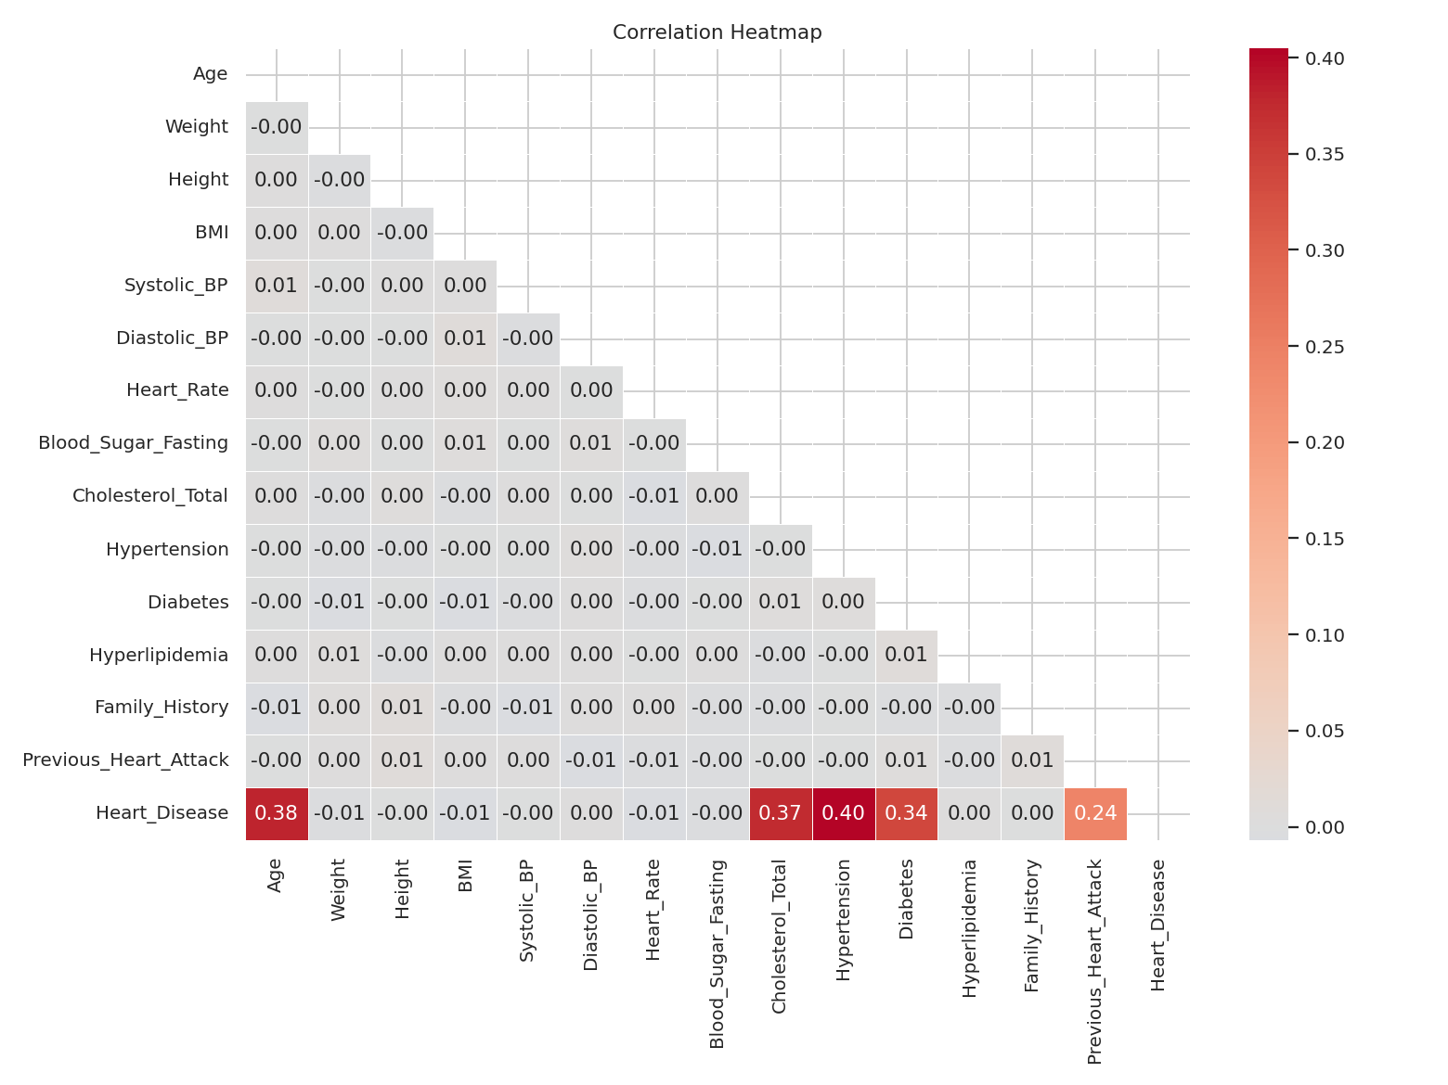
Figure 8: Correlation heatmap
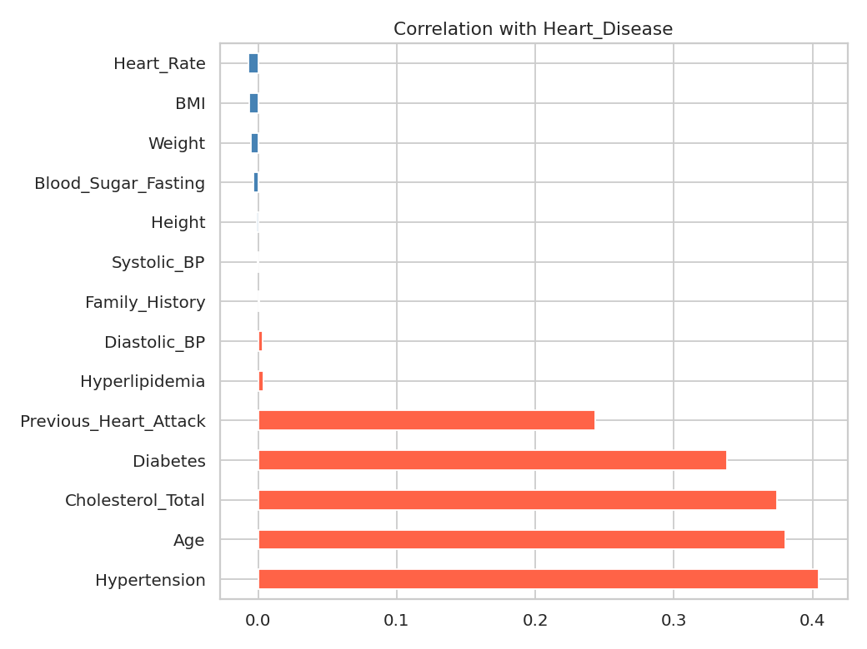
Figure 9: Correlation with Heart_Disease
Strongest positive correlations: Hypertension (0.40), Age (0.38), Cholesterol_Total (0.37), Diabetes (0.34).
Features with near-zero correlation: Hyperlipidemia, Diastolic_BP, Family_History, Systolic_BP, Height, Blood_Sugar_Fasting, Weight, BMI, Heart_Rate.

Statistical significance (p < 0.05)
Numerical (Welch t-test): Age, Cholesterol_Total.
Categorical/binary (chi-square): Hypertension, Diabetes, Previous_Heart_Attack.
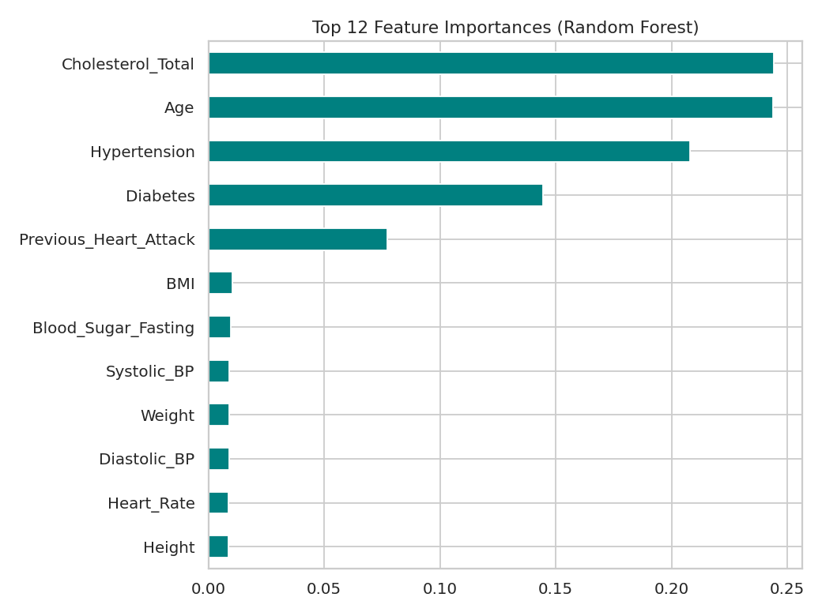
Figure 10: Random Forest feature importance
A quick Random Forest gave accuracy 100.00% and ROC-AUC 1.000. Top features: Cholesterol_Total, Age, Hypertension, Diabetes, Previous_Heart_Attack.
Such a near-perfect score suggests the synthetic target was generated from a rule based on a few features (the top ones above), while the other features carry almost no signal.

5. Key Insights
- Disease rate by age group: <30: 26.6%, 30-44: 25.0%, 45-59: 40.4%, 60-74: 69.2%, 75+: 69.0%.
- By hypertension (0/1): 0: 33.1%, 1: 77.2%.
- By diabetes (0/1): 0: 37.9%, 1: 80.2%.
- By previous heart attack (0/1): 0: 42.3%, 1: 82.9%.
- By cholesterol category: Desirable: 28.5%, Borderline: 29.1%, High: 73.5%.
- By smoking status: Current: 46.2%, Former: 46.3%, Never: 46.4%.
- By physical activity: Active: 46.6%, Moderate: 46.4%, Sedentary: 46.1%.
- By gender: Female: 46.2%, Male: 46.5%.
- Features that are both highly correlated and important in the model are the most reliable drivers of heart disease in this dataset.
Note: this is a synthetic dataset, so findings describe patterns in this data and should not be treated as real medical evidence.

6. Conclusion and Next Steps
- EDA identified which clinical and lifestyle factors separate patients with and without heart disease.
- Next: encode categorical variables, scale numeric ones, and build models (Logistic Regression, Random Forest, XGBoost).
- Evaluate with accuracy, precision, recall, F1 and ROC-AUC.

