Titanic Large Dataset: Data Analytics & Machine Learning Report
End-to-end analysis of 100,000 passenger records using Python (Pandas, NumPy, Matplotlib, Seaborn, SciPy, scikit-learn)

Executive Summary
This project analyses a large Titanic-style dataset of 100,000 passengers to understand which factors influenced survival and to build models that predict it. The workflow covers data auditing, cleaning, feature engineering, exploratory analysis, statistical testing, machine learning and model evaluation, and produced 26 charts, a cleaned dataset and a written summary.
Headline findings
- Overall survival rate was 39.6% (39,619 of 100,000).
- Gender was the strongest factor: women survived at 54.9% versus 29.5% for men.
- Passenger class was second: 1st class 54.1%, 2nd class 40.1%, 3rd class 34.1%.
- Combined, a 1st-class woman had a 69.5% survival rate while a 3rd-class man had only 24.4%.
- Children aged 0 to 12 had the highest survival of any age group (50.9%).
- Port of embarkation had no effect on survival (p = 0.82).
- The best model, Gradient Boosting, reached a test ROC-AUC of 0.683 and accuracy of 65.6%.
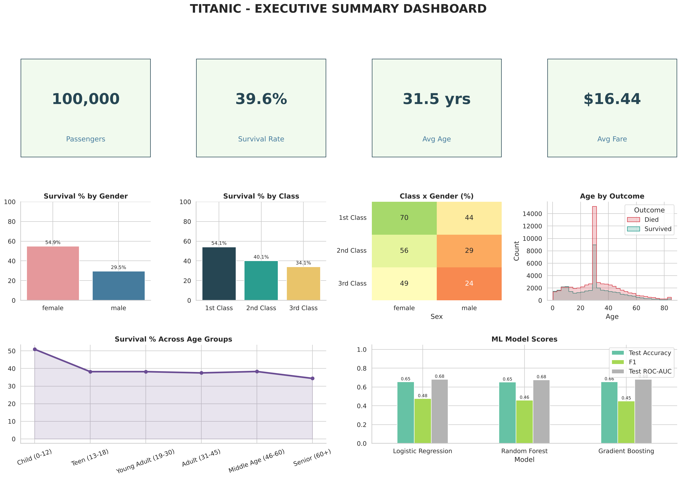
Executive summary dashboard

1. Objectives
- Audit and clean the dataset.
- Identify the factors that influence survival.
- Test the findings statistically rather than relying on charts alone.
- Build and compare machine learning models that predict survival.
- Present results in a form suitable for a portfolio or academic submission.

2. Dataset Overview
Item | Value
Records | 100,000 passengers
Original columns | 11 (PassengerId, Survived, Pclass, Name, Sex, Age, SibSp, Parch, Ticket, Fare, Embarked)
Target variable | Survived (0 = died, 1 = survived)
Class balance | 39.6% survived, 60.4% died
Columns after feature engineering | 25

3. Methodology
The analysis is organised as 14 sequential stages in one reproducible Python script: data loading, quality audit, cleaning and feature engineering, descriptive statistics, univariate analysis, survival analysis, multivariate analysis, correlation analysis, hypothesis testing, machine learning, feature importance, executive dashboard, final report, and export of the cleaned data.

4. Data Quality Audit
Check | Result
Missing values | Only Age is missing: 19,856 records (19.86%)
Duplicate rows / IDs | None found
Age outliers (IQR rule) | 0
Fare outliers (IQR rule) | 10,726 (10.73%), long right tail up to 348.91
SibSp / Parch outliers | 2.34% / 0.77%
Invalid values | No negative or zero ages, no negative fares; 500 passengers have a fare of 0
Handling decisions
- Missing ages were filled with the median age within each Passenger Class and Title group, which is more accurate than one global median. A flag column (AgeMissing) records which rows were imputed.
- Fare is strongly right-skewed (skewness 3.59), so a log-transformed version (LogFare) was created for modelling and plotting.
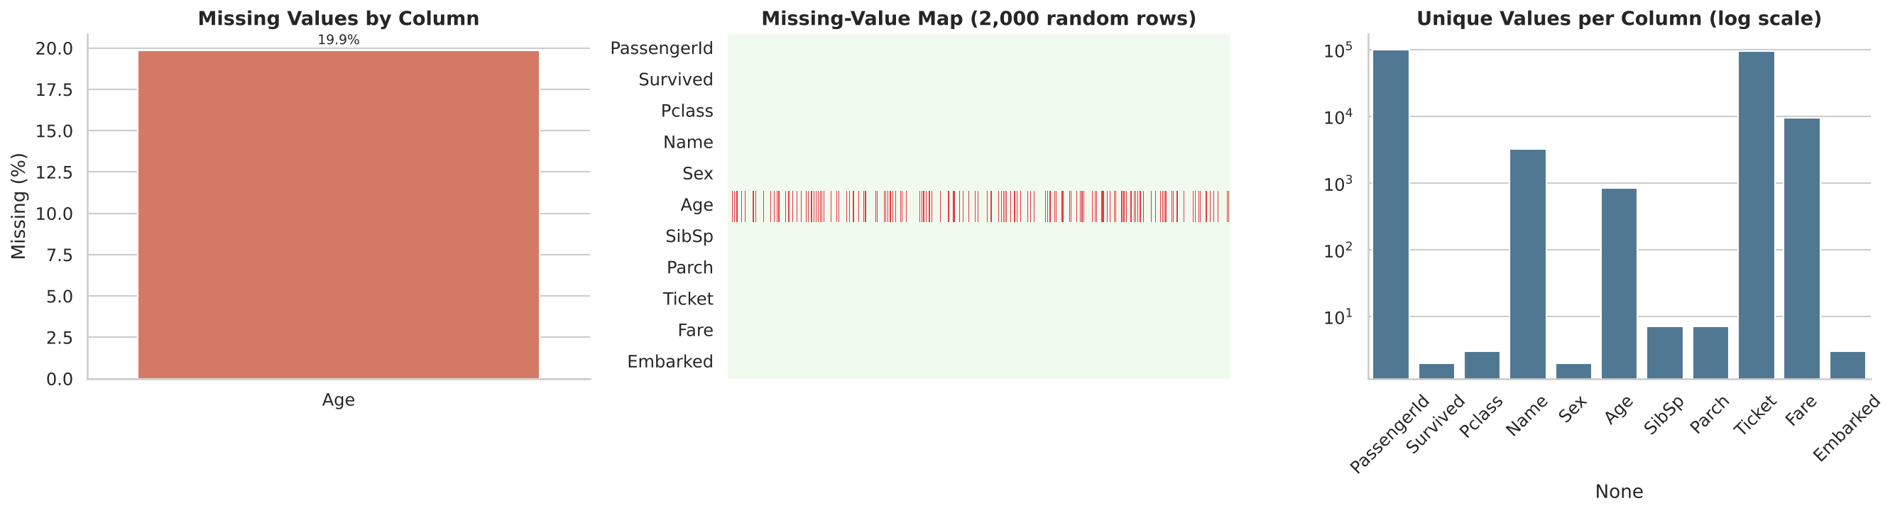
Data quality overview

5. Feature Engineering
New feature | How it was created | Purpose
Title / TitleGroup | Extracted from Name (Mr, Mrs, Miss, Master, Rare) | Social status and age proxy
FamilySize | SibSp + Parch + 1 | Group travel effect
IsAlone / FamilyType | FamilySize = 1; Alone, Small (2-4), Large (5+) | Family-size effect
AgeGroup | Six bands, Child (0-12) to Senior (60+) | Age-based comparison
FareBand, LogFare, FarePerPerson | Quintiles, log1p, Fare / FamilySize | Wealth proxies
AgeMissing | 1 if age was imputed | Lets models detect imputation
ClassLabel, PortLabel | Readable labels | Cleaner charts

6. Exploratory Analysis: Key Results

6.1 Survival by gender and class
Group | Passengers | Survival rate
Female | 39,793 | 54.9%
Male | 60,207 | 29.5%
1st class | 19,961 | 54.1%
2nd class | 25,132 | 40.1%
3rd class | 54,907 | 34.1%
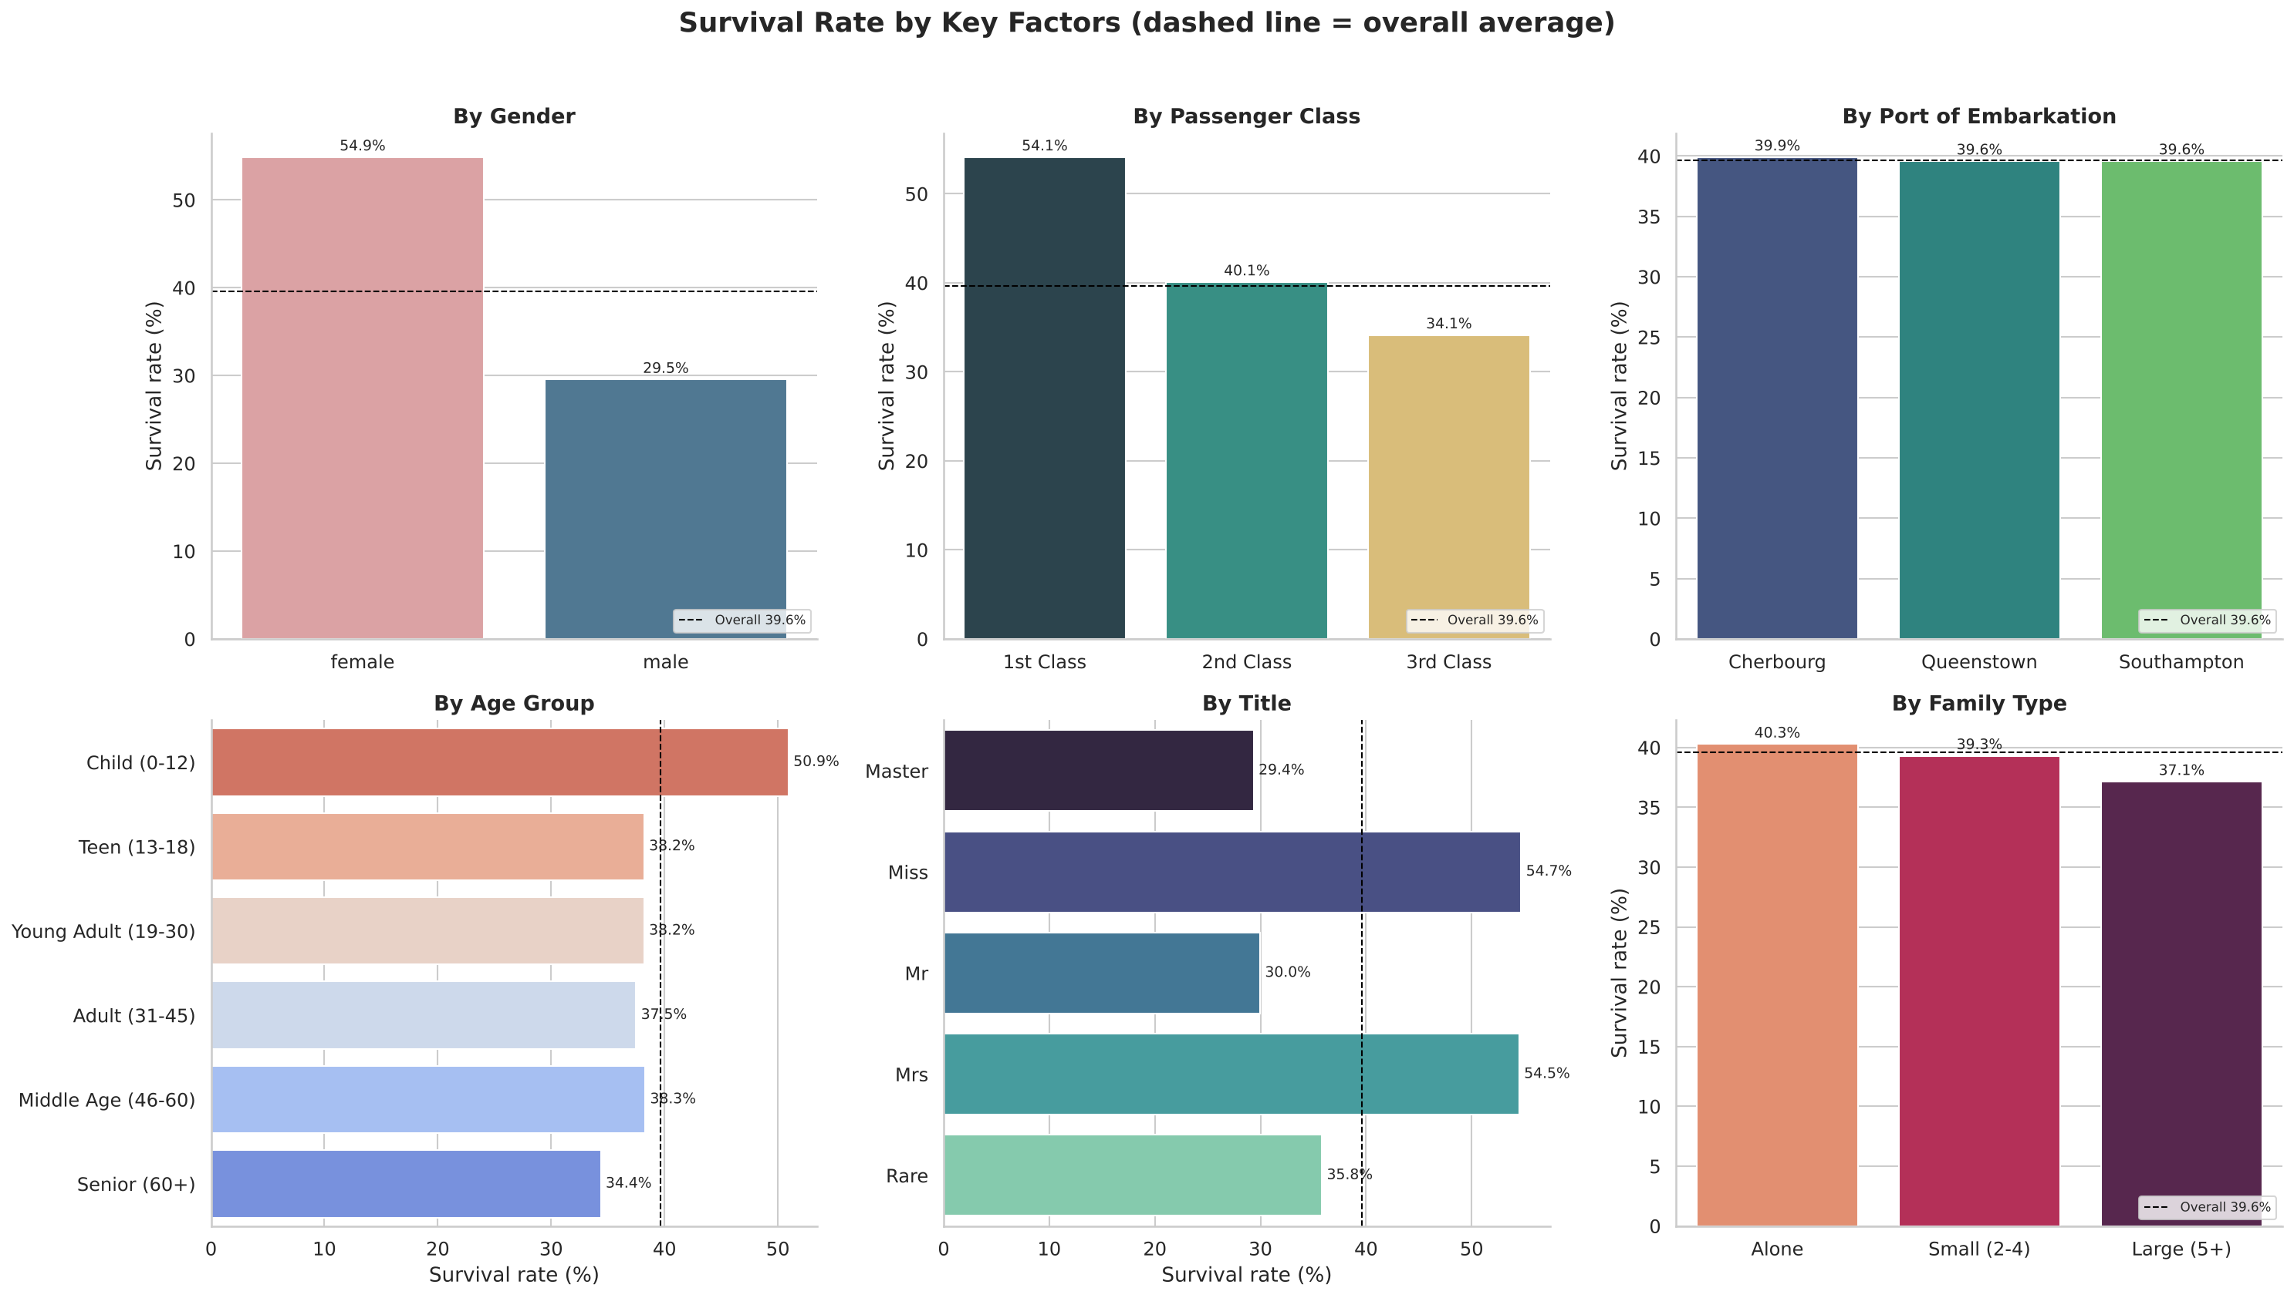
Survival rate by key factors

6.2 Class and gender combined (survival %)
 | Female | Male
1st class | 69.5% | 43.8%
2nd class | 56.3% | 29.4%
3rd class | 48.8% | 24.4%
Gender and class act independently and add up: a woman in 3rd class (48.8%) still survived more often than a man in 1st class (43.8%).
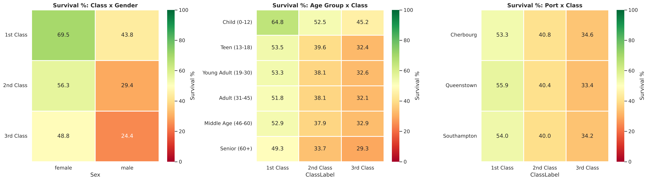
Survival heatmaps

6.3 Survival by age group
Age group | Survival rate
Child (0-12) | 50.9%
Teen (13-18) | 38.2%
Young Adult (19-30) | 38.2%
Adult (31-45) | 37.5%
Middle Age (46-60) | 38.3%
Senior (60+) | 34.4%
Only children stand out; ages 13 to 60 are nearly flat, and seniors are lowest.
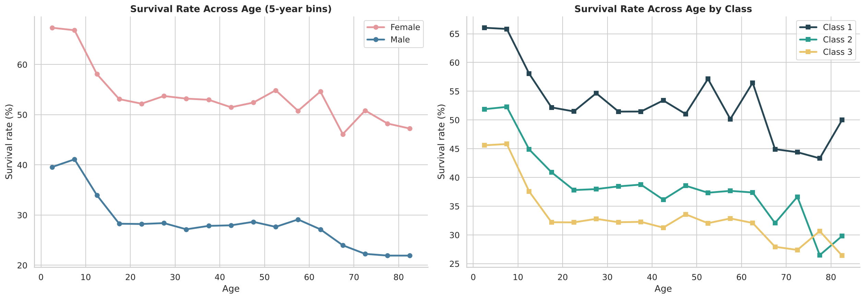
Survival rate across age

6.4 Other factors
- Fare: survival rises with fare quintile, from 34.0% (lowest) to 51.2% (highest).
- Embarkation port: Cherbourg 39.9%, Queenstown 39.6%, Southampton 39.6%. Effectively identical.
- Family type: Alone 40.3%, Small 39.3%, Large 37.2%. Differences are very small.

6.5 Descriptive statistics
Variable | Mean | Median | Std | Min | Max
Age | 31.55 | 30.70 | 17.00 | 0.40 | 85.00
Fare | 16.44 | 7.50 | 23.82 | 0.00 | 348.91
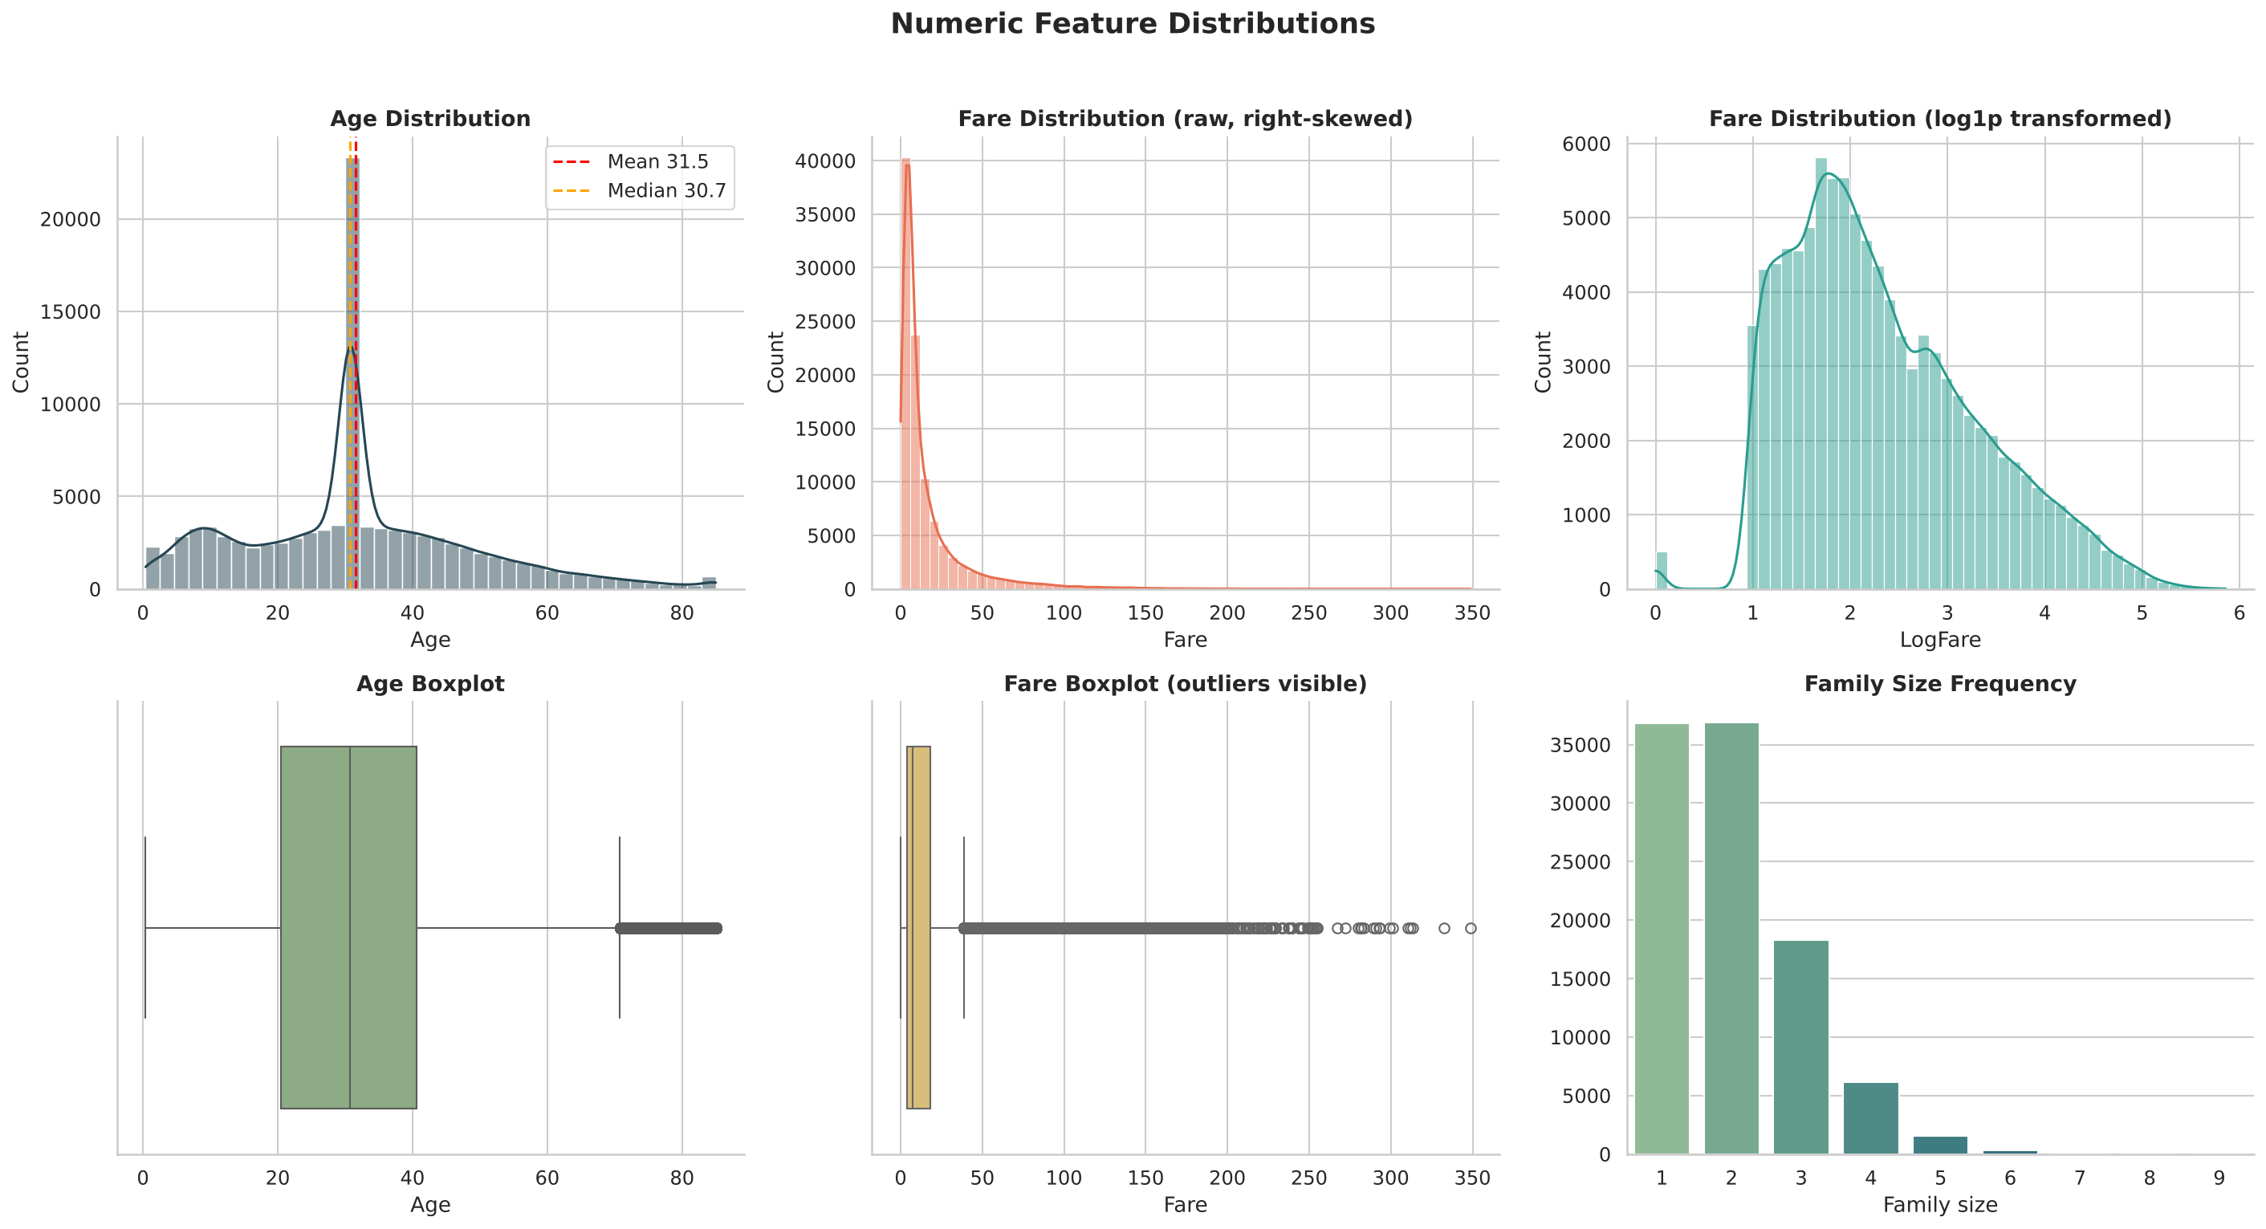
Numeric distributions

7. Statistical Hypothesis Testing
All tests use a significance level of 0.05. With 100,000 records almost any difference becomes statistically significant, so effect sizes are reported to show which differences actually matter.
Variable | Test | p-value | Effect size | Verdict
Sex | Chi-square | < 0.001 | Cramer’s V = 0.254 | Significant, moderate
Title group | Chi-square | < 0.001 | V = 0.208 | Significant, moderate
Passenger class | Chi-square | < 0.001 | V = 0.157 | Significant, small to moderate
Age group | Chi-square | < 0.001 | V = 0.100 | Significant, small
Family type | Chi-square | 0.0009 | V = 0.012 | Significant but negligible
Is alone | Chi-square | 0.0012 | V = 0.010 | Significant but negligible
Embarked | Chi-square | 0.822 | V = 0.002 | Not significant
Fare | Welch t-test | < 0.001 | Cohen’s d = 0.22 | Significant, small
Age | Welch t-test | < 0.001 | Cohen’s d = -0.15 | Significant, small
Fare across classes | ANOVA / Kruskal-Wallis | < 0.001 | n/a | Fares differ strongly by class
Non-parametric Mann-Whitney U tests gave the same conclusions as the t-tests, confirming the results hold despite the skewed Fare distribution.
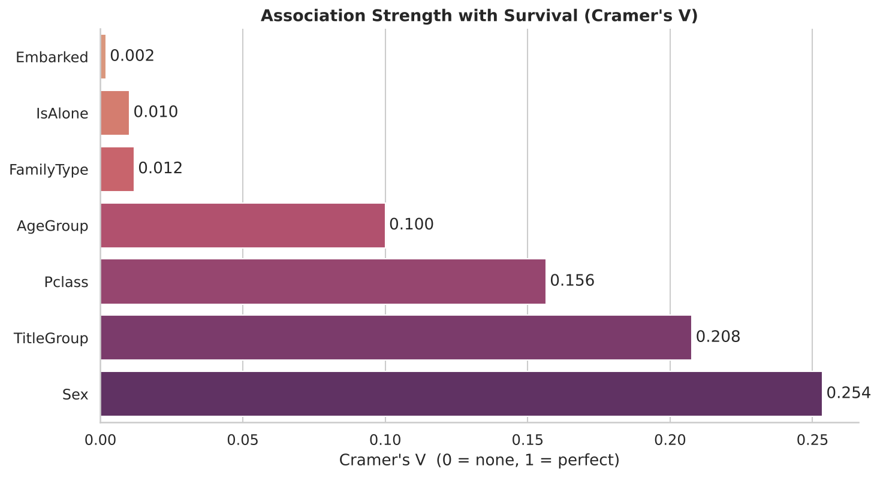
Association strength with survival (Cramer’s V)

8. Correlation Analysis
The strongest linear correlations with survival were Sex (female) r = +0.254 and Passenger class r = -0.153. All other numeric features had weak correlations. Pearson and Spearman matrices gave consistent results.
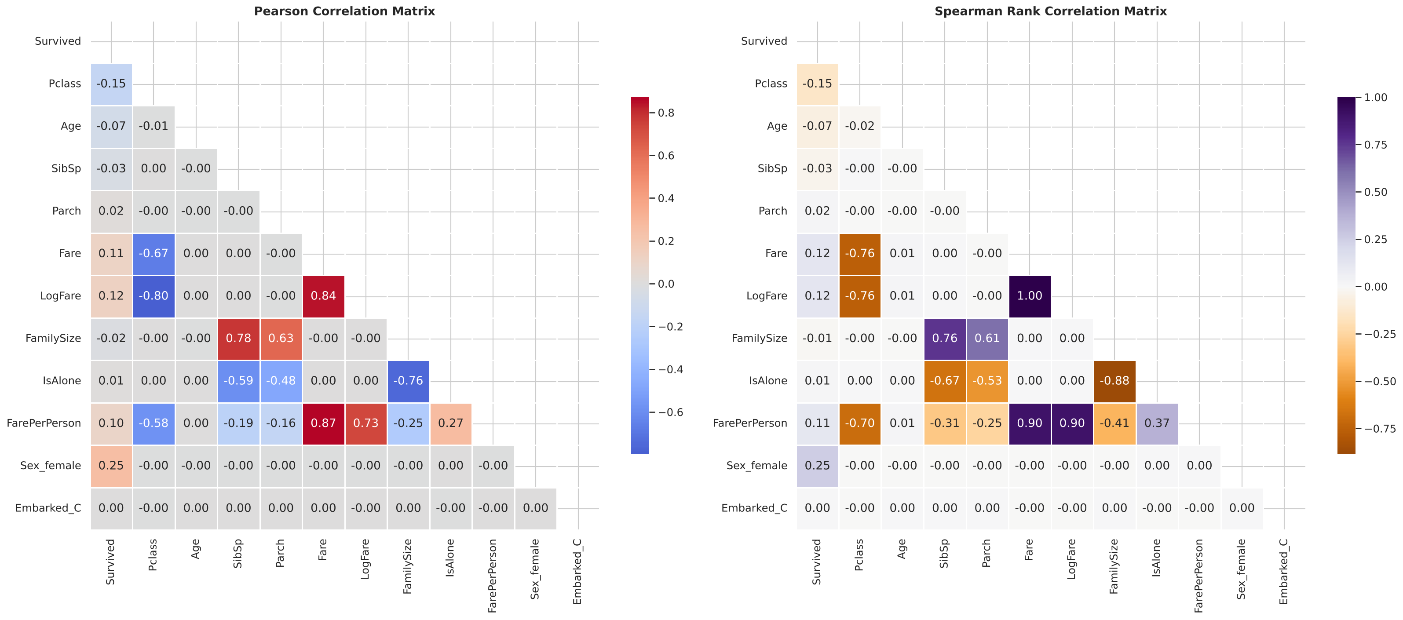
Correlation matrices

9. Machine Learning
Setup: 80/20 stratified train-test split (80,000 / 20,000), 5-fold stratified cross-validation, standardised numeric features for logistic regression, one-hot encoded categorical features.
Features used: Age, SibSp, Parch, Fare, LogFare, FamilySize, IsAlone, FarePerPerson, AgeMissing, Pclass, Sex, Embarked, TitleGroup.
Model | CV AUC | Accuracy | Precision | Recall | F1 | Test ROC-AUC
Logistic Regression | 0.678 | 65.5% | 0.598 | 0.395 | 0.476 | 0.682
Random Forest | 0.673 | 65.2% | 0.598 | 0.372 | 0.459 | 0.677
Gradient Boosting | 0.678 | 65.6% | 0.612 | 0.358 | 0.451 | 0.683
Interpretation
- All three models perform almost identically, which suggests the available features carry limited signal and model choice is not the bottleneck.
- The cross-validation standard deviation is only about 0.004, so results are stable.
- At the default 0.5 threshold the models are cautious: precision about 0.60 but recall only 0.36 to 0.40. Threshold tuning can trade precision for recall depending on the goal.
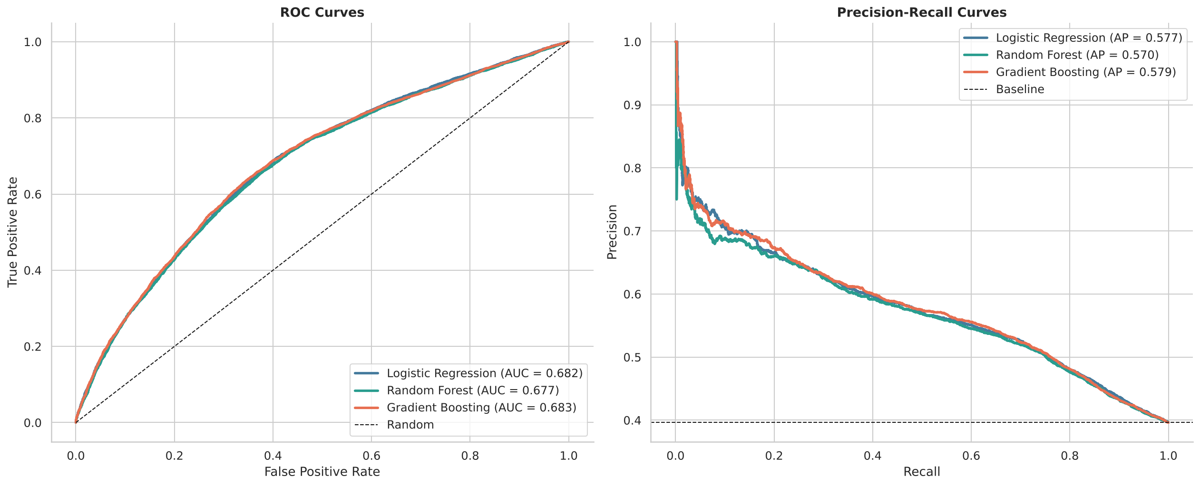
ROC and precision-recall curves
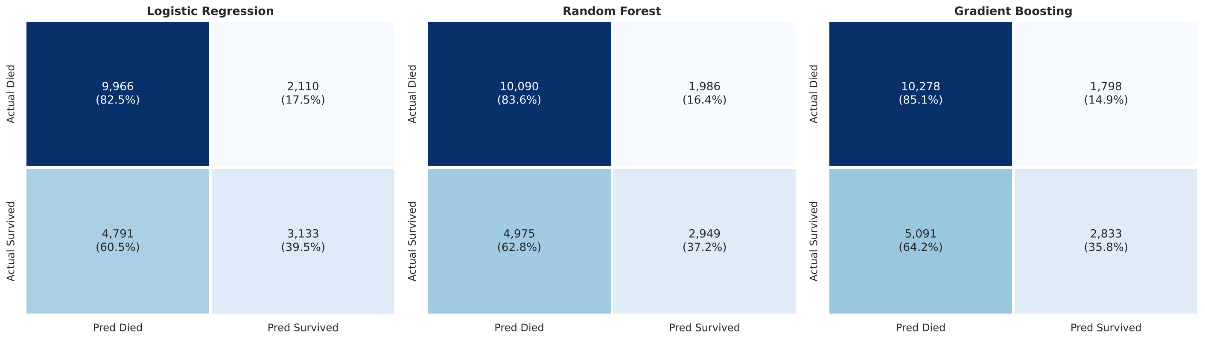
Confusion matrices

Ranking quality
Sorting passengers by predicted probability separates them well: the top-risk decile had a 68.5% actual survival rate versus 21.7% in the lowest decile. Predicted and actual rates track closely in every decile, so the probabilities are well calibrated.
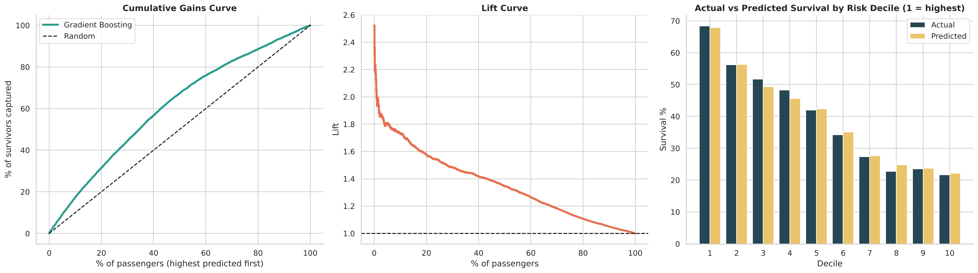
Gains, lift and decile analysis

10. Feature Importance
Rank | Permutation importance (AUC drop) | Logistic regression odds ratio
1 | Sex: 0.118 | Female 1.68 / Male 0.54
2 | Passenger class: 0.043 | 1st class 1.59 / 3rd class 0.66
3 | Age: 0.015 | Age 0.85 per standard deviation
4 | FarePerPerson: 0.004 | n/a
Random Forest’s built-in importance ranks Age, LogFare and Fare highest, but that method favours continuous variables with many unique values. Permutation importance is more reliable and agrees with the statistical tests: Sex, Class and Age drive survival, while port, family size and title add almost nothing once those are known.
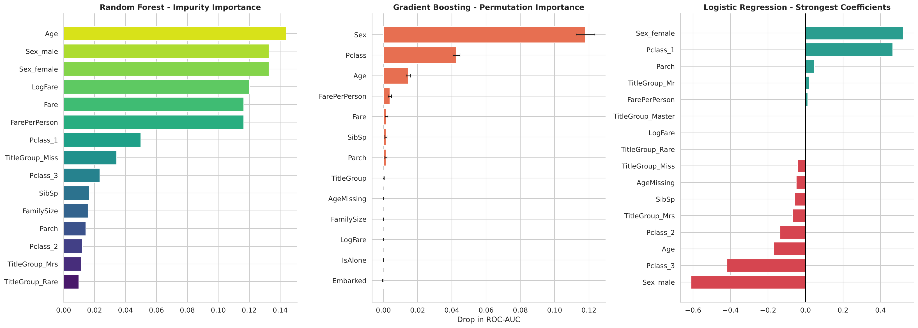
Feature importance (three methods)

11. Limitations
- The dataset appears to be synthetic. Some patterns do not match historical Titanic data: titles are implausibly distributed (24,797 “Dr” and 15,113 “Rev”), and “Master” (normally a young boy) is not linked to age. This is why model accuracy (about 65%) is well below the roughly 80 to 85% usually achieved on the real Titanic dataset.
- Age imputation (19.9% of rows) creates an artificial spike near age 30 in the age histogram.
- Fare outliers were kept, since they reflect real price differences between classes.
- The analysis shows association, not causation.

12. Conclusions and Recommendations
- Survival was driven mainly by who the passenger was (gender, class, and to a lesser extent age), not where they boarded or how big their family was.
- The pattern is consistent with a “women and children first” rule combined with class-based advantages.
- Statistical tests and three different importance methods agree, which makes these conclusions robust.
- Predictive accuracy is limited by the data, so future work should focus on better data or features (cabin location, deck, ticket group) rather than more complex models.
- Possible next steps: hyperparameter tuning, SHAP explanations, an interactive Plotly or Streamlit dashboard, and deployment as a small prediction app.

Appendix: Project Deliverables
File | Description
titanic_analysis.py | Complete analysis script (14 sections)
titanic_next_cells.py | Notebook cells: dashboard, gains and lift, report, export
charts (26 PNG files) | All charts produced by the analysis
analysis_report.txt | Plain-text results summary
titanic_cleaned_features.csv | Cleaned dataset with engineered features

