ASSESSMENT-23 Vinutha S

Azure- Databricks 30/12/2023(sat)

1. Open the Azure portal, navigate to the Azure Databricks service dashboard, and click on the Create button to create a new instance. Provide the required details like subscription, resource group, pricing tier, workspace name and the region in which the instance will be created. Using the standard tier, we can proceed and create a new instance.

[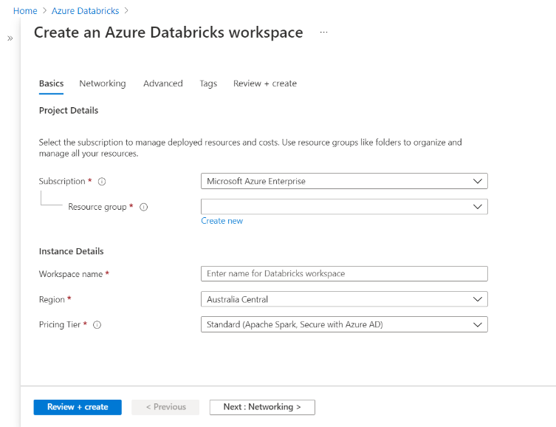](https://www.sqlshack.com/wp-content/uploads/2021/10/create-workspace-1.png)

1. Once the Azure Databricks instance is created, launch the workspace which would open in a new window with the home page as shown below.

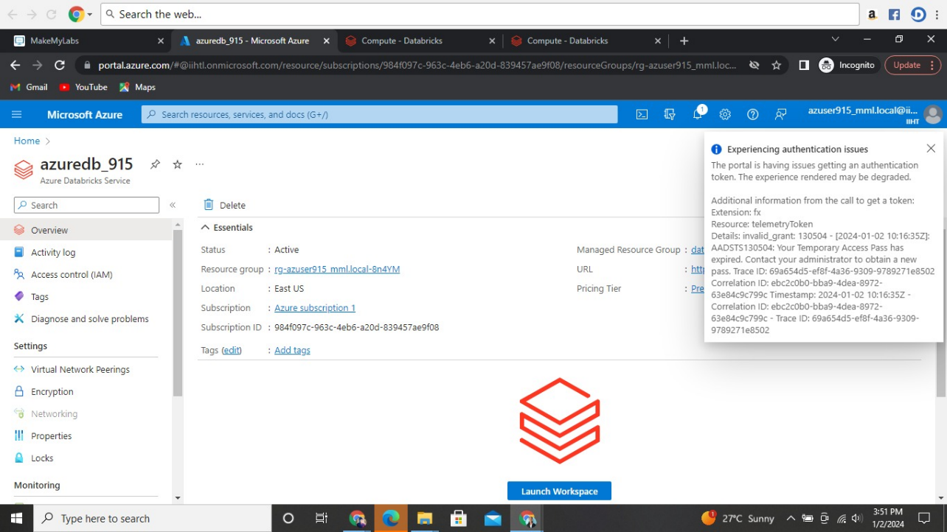

**Visualizations in Databricks notebooks**

1. After creating a new Work space with the name “azuredb_915” I created a new cluster.

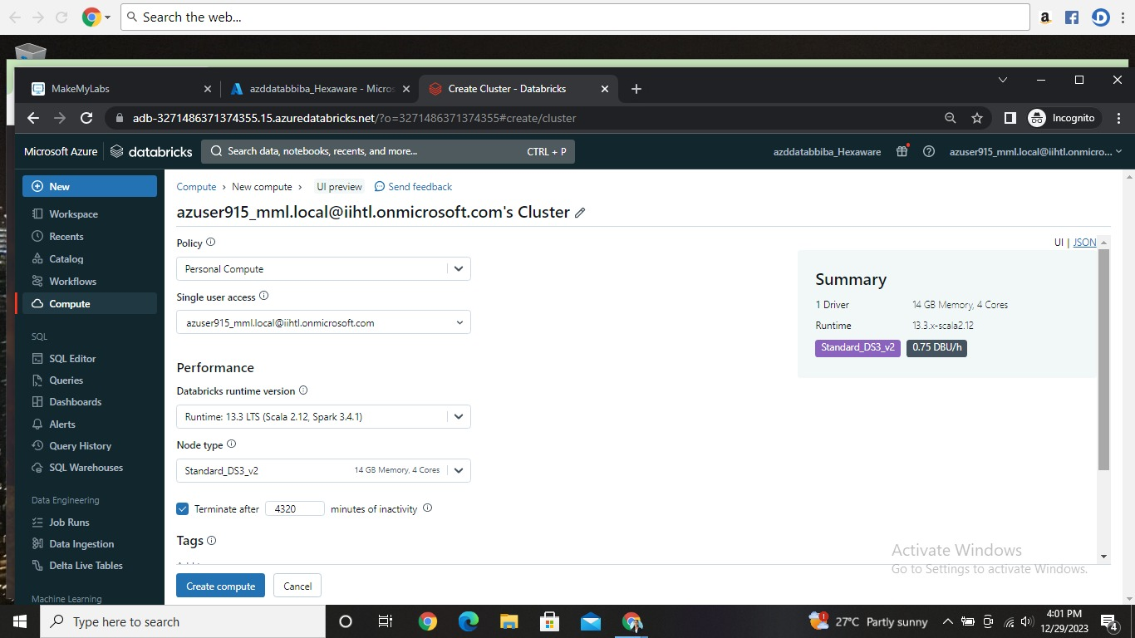

1. Then by clicking the new at left top followed by notepad we can access a new notepad.

There I ran a program with csv file as shown below.

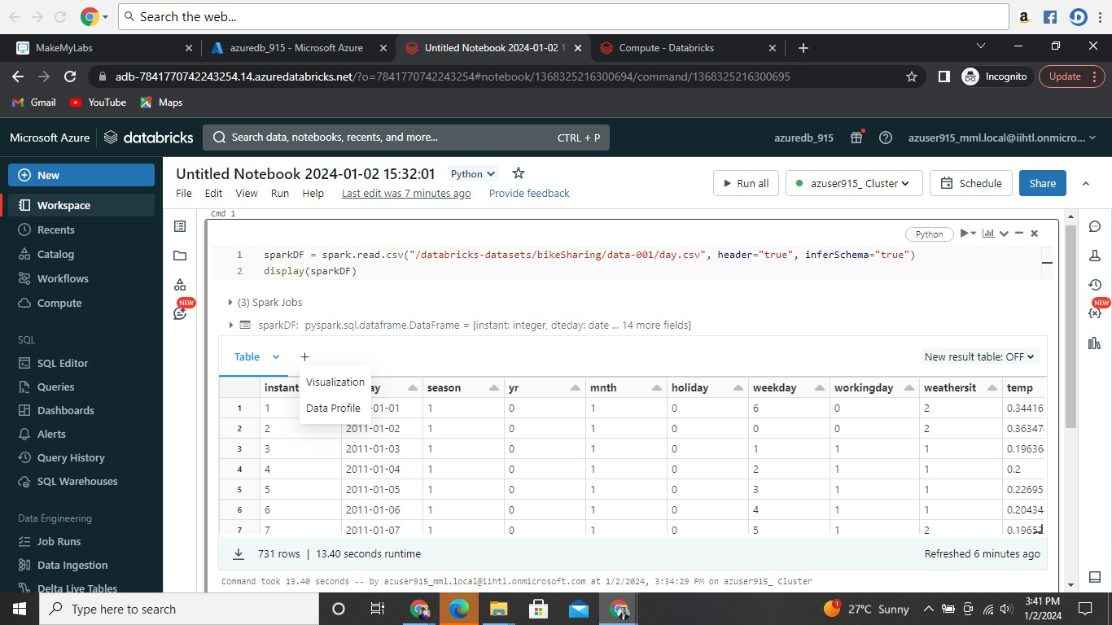

1. As shown above we can find the outputs in a table. In the **Visualization Type** drop-down, choose a type.

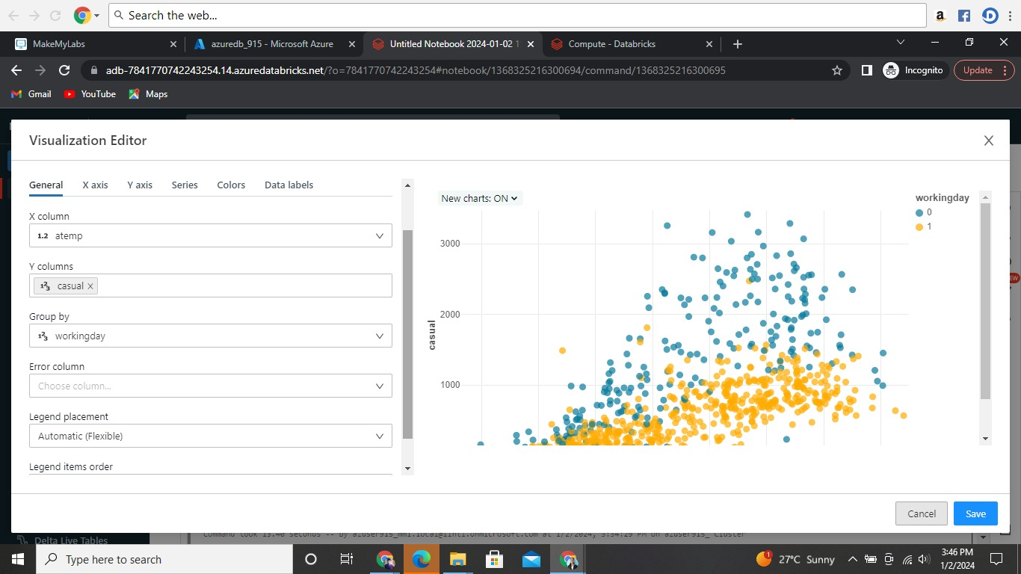

1. Select the data to appear in the visualization. The fields available depend on the selected type. Click **Save**.

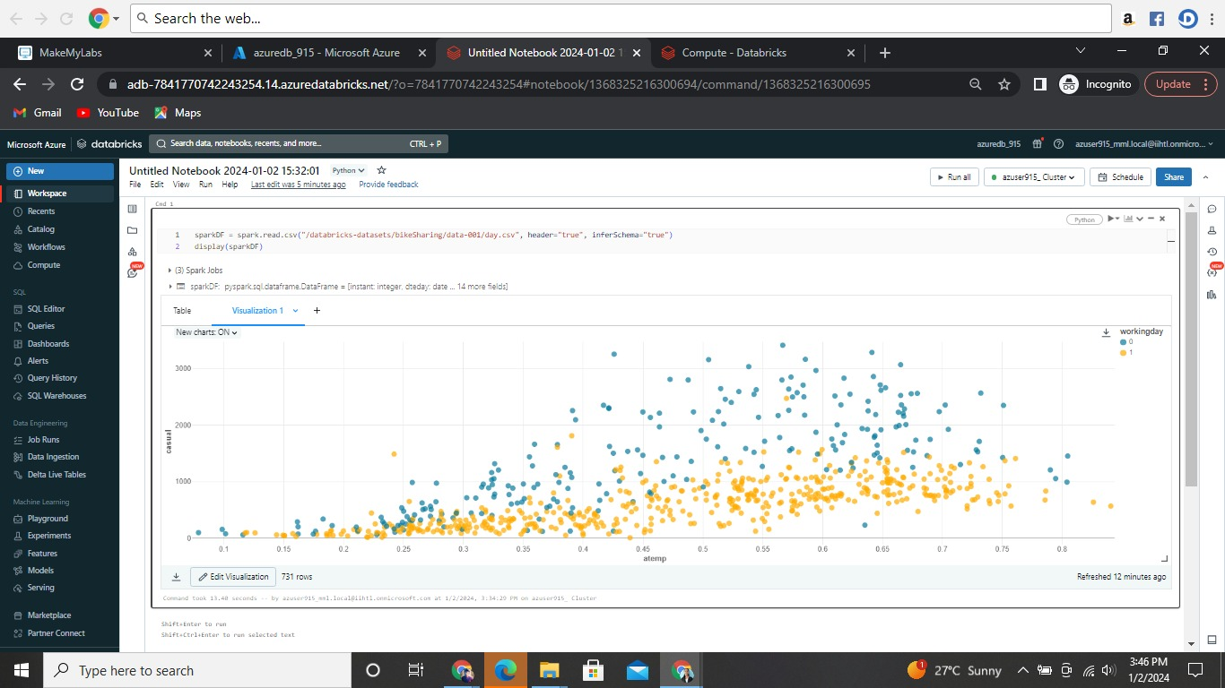

Create a new data profile

Data profiles display summary statistics of an Apache Spark DataFrame, a pandas DataFrame, or a SQL table in tabular and graphic format. To create a data profile from a results cell, click **+** and select **Data Profile**.

Databricks calculates and displays the summary statistics.

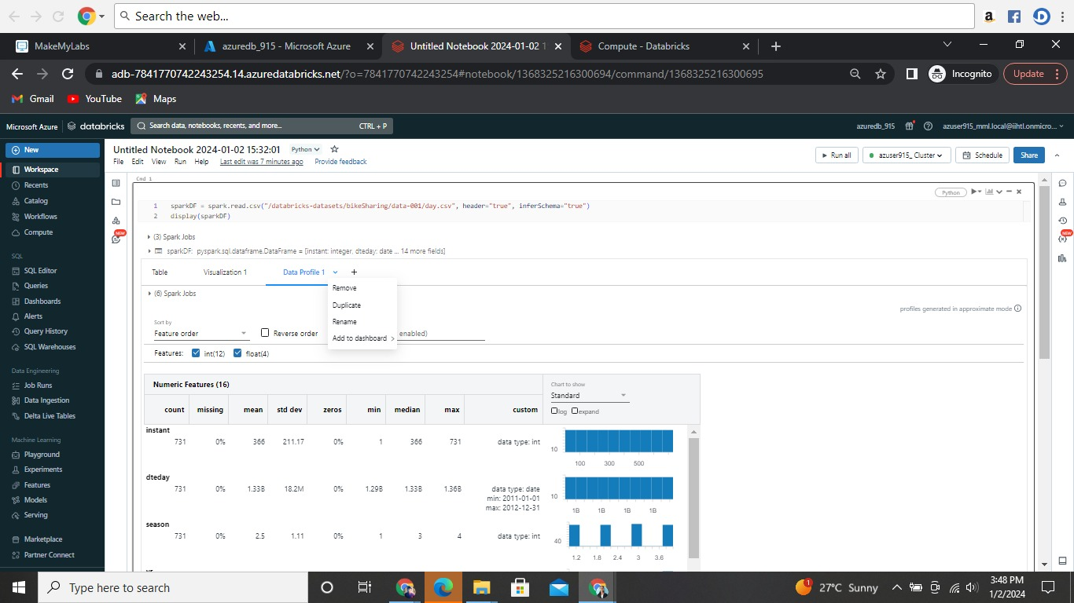

1. Finally this is my workspace page

