**ASSESSMENT-2 Vinutha S**

I Have used DDL commands like **CREATE, ALTER, DROP, TRUNCATE** and DML commands like **SELECT, INSERT, UPDATE, DELETE.**

1. 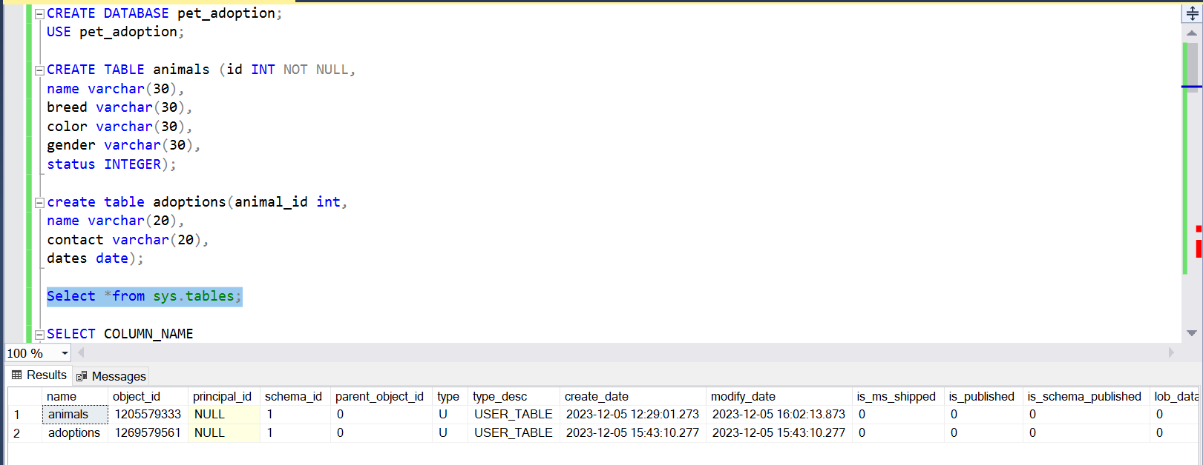**SHOWING THE TABLES CREATED**
2. SHOWING COLUMNS OF TABLE-1

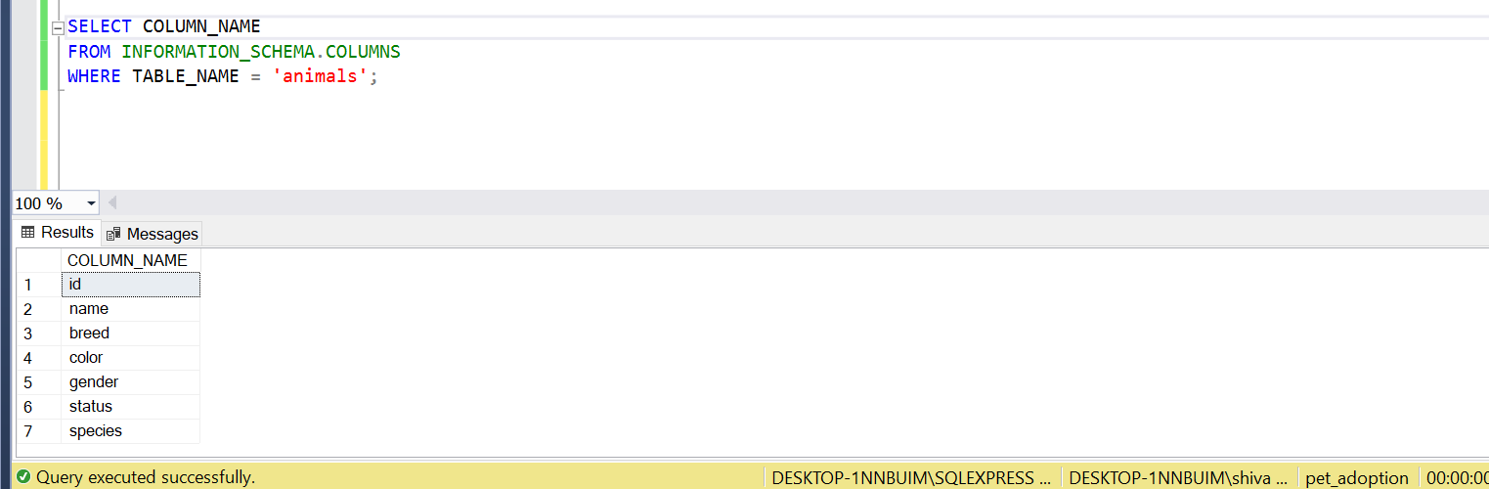

1. INSERTING VALUES TO TABLE-1

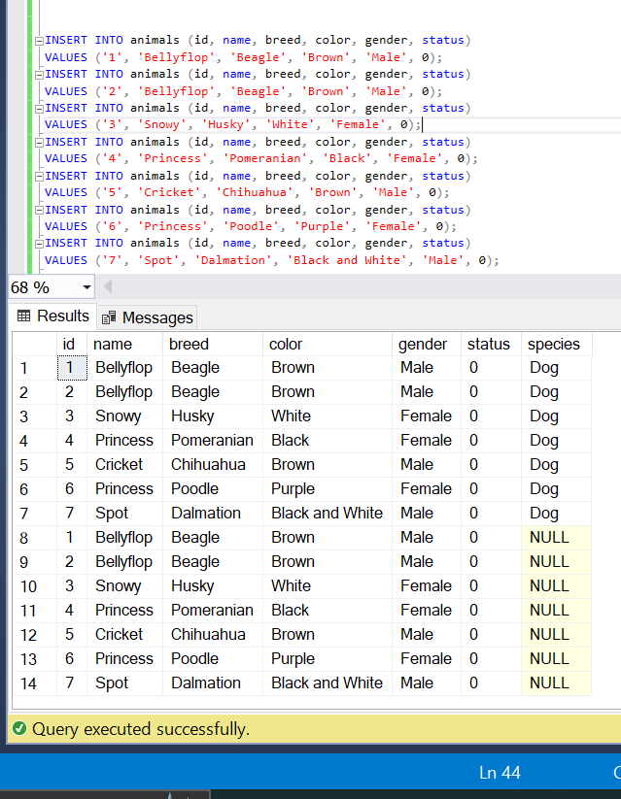

1. SELECTING PARTICULAR VALUE USING WHERE CLAUSE

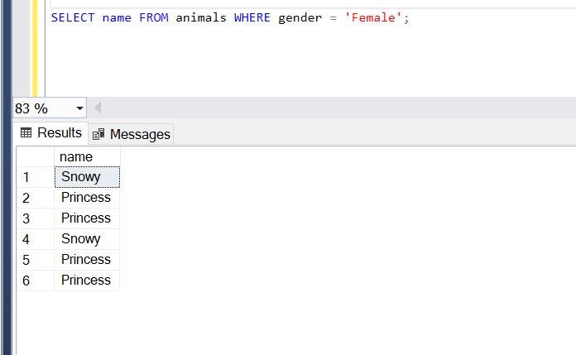

1. UPDATING TABLE-1 VALUES

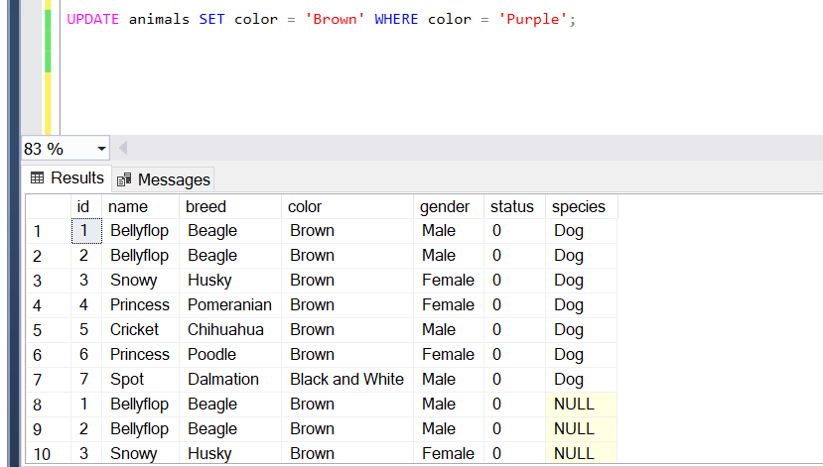

1. DROPING TABLE-1 (As the table get deleted it shows invalid object as an error)

