Burndown Chart:

Increment 1: 2 issues

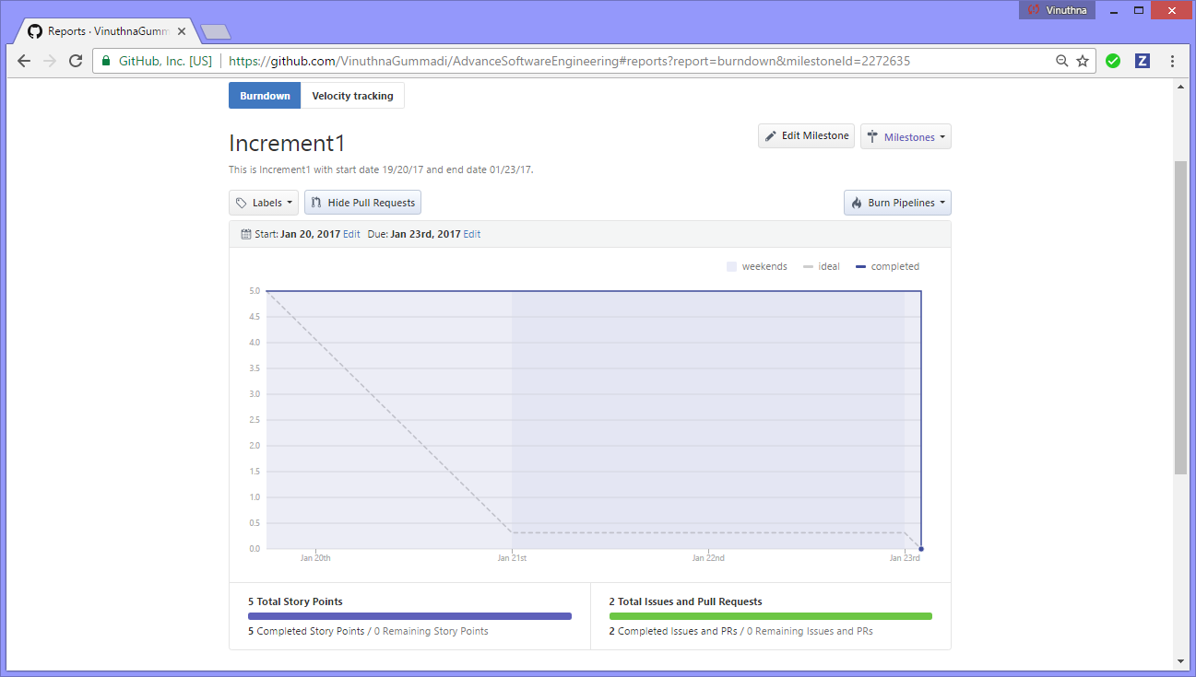

Increment 2: 2 issues

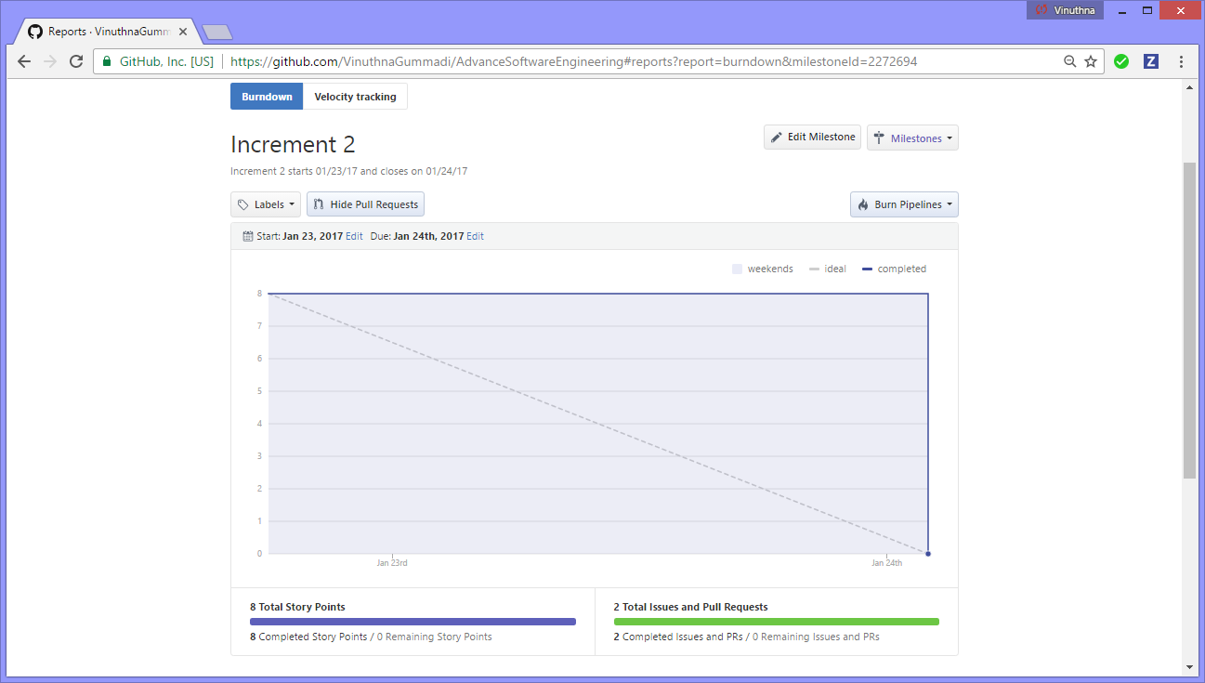

Increment 3: 2 issues

