# ASSIGNMENT 2

1. Git Hub Finder:

Source:

Login.html

*<!--A Design by W3layouts  
Author: W3layout  
Author URL: http://w3layouts.com  
License: Creative Commons Attribution 3.0 Unported  
License URL: http://creativecommons.org/licenses/by/3.0/  
-->*<!DOCTYPE **HTML**>  
<**html**>  
<**head**>  
 <**title**>GitHubFinder</**title**>  
 <**meta name="viewport" content="width=device-width, initial-scale=1"**>  
 <**meta http-equiv="Content-Type" content="text/html; charset=utf-8"** />  
 <**meta name="keywords" content="Movie_store Responsive web template, Bootstrap Web Templates, Flat Web Templates, Andriod Compatible web template,  
Smartphone Compatible web template, free webdesigns for Nokia, Samsung, LG, SonyErricsson, Motorola web design"** />  
 <**script type="application/x-javascript"**> *addEventListener*(**"load"**, **function**() { *setTimeout*(*hideURLbar*, 0); }, **false**); **function** *hideURLbar*(){ ***window***.scrollTo(0,1); } </**script**>  
 <**link href="css/bootstrap.css" rel='stylesheet' type='text/css'** />  
 <**link href="css/style.css" rel="stylesheet" type="text/css" media="all"** />  
 *<!-- start plugins -->* <**script type="text/javascript" src="js/jquery-1.11.1.min.js"**></**script**>  
 <**link href='http://fonts.googleapis.com/css?family=Roboto+Condensed:100,200,300,400,500,600,700,800,900' rel='stylesheet' type='text/css'**>  
</**head**>  
<**body**>  
  
<**div class="container"**>  
 <**div class="container_wrap"**>  
 <**div class="header_top"**>  
 <**div class="col-sm-3 logo"**><**a href="index.html"**><**img src="images/logo.png" alt="" width="20%" height="20%"**/></**a**></**div**>  
 <**div class="clearfix"**> </**div**>  
 <**div**><**h3**>Git Hub Fider</**h3**></**div**>  
 <**div class="clearfix"**> </**div**>  
 </**div**>  
 <**div class="content"**>  
 <**div class="register"**>  
 <**div class="register-bottom-grid"** >  
 <**h3**>User Login</**h3**>  
 <**div**>  
 <**span**>Email Address<**label**>*</**label**></**span**>  
 <**input type="text"**>  
 </**div**>  
 <**div**>  
 <**span**>Password<**label**>*</**label**></**span**>  
 <**input type="password"**>  
 </**div**>  
 <**div class="clearfix"**> </**div**>  
 <**div class="clearfix"**> </**div**>  
 <**div class="register-but"**>  
 <**form action="home.html"**>  
 <**input type="submit" value="submit"**>  
 <**div class="clearfix"**> </**div**>  
 </**form**>  
 </**div**><**br**>  
 <**div**>  
 Not Registered? <**a href="register.html"**>Register</**a**>  
 </**div**>  
  
 </**div**>  
 <**div class="clearfix"**> </**div**>  
 </**div**>  
 </**div**>  
 </**div**>  
</**div**>  
  
  
  
<**script type="text/javascript"**>  
  
 **var *p*** = ***document***.createElement(**'script'**);  
 ***p***.**type**=**'text/javascript'**;  
 ***p***.**async**=**true**;  
 ***p***.**src**=**'https://apis.google.com/js/client:plusone.js?onload=onloadFunction()'**;  
 **var *s*** = ***document***.getElementsByTagName(**'script'**)[0];  
 ***s***.parentNode.insertBefore(***p***,***s***);  
  
  
</**script**>  
  
<**script src="http://connect.facebook.net/en_US/all.js"**></**script**>  
<**script type="text/javascript"**>  
 ***window***.fbAsyncInit = **function**() {  
 FB.init({  
 **appId** : **'1927270067503561'**,  
 **xfbml** : **true**,  
 **version** : **'v2.8'**,  
 **status** : **true** });  
 };  
 (**function**(d, s, id){  
 **var** js, fjs = d.getElementsByTagName(s)[0];  
 **if** (d.getElementById(id)) {**return**;}  
 js = d.createElement(s); js.**id** = id;  
 js.**src** = **"//connect.facebook.net/en_US/sdk.js"**;  
 fjs.parentNode.insertBefore(js, fjs);  
 }(***document***, **'script'**, **'facebook-jssdk'**));  
</**script**>  
</**body**>  
</**html**>

Register.html

*<!--A Design by W3layouts  
Author: W3layout  
Author URL: http://w3layouts.com  
License: Creative Commons Attribution 3.0 Unported  
License URL: http://creativecommons.org/licenses/by/3.0/  
-->*<!DOCTYPE **HTML**>  
<**html**>  
<**head**>  
<**title**>GitHubFinder</**title**>  
<**meta name="viewport" content="width=device-width, initial-scale=1"**>  
<**meta http-equiv="Content-Type" content="text/html; charset=utf-8"** />  
<**meta name="keywords" content="Movie_store Responsive web template, Bootstrap Web Templates, Flat Web Templates, Andriod Compatible web template,   
Smartphone Compatible web template, free webdesigns for Nokia, Samsung, LG, SonyErricsson, Motorola web design"** />  
<**script type="application/x-javascript"**> *addEventListener*(**"load"**, **function**() { *setTimeout*(*hideURLbar*, 0); }, **false**); **function** *hideURLbar*(){ ***window***.scrollTo(0,1); } </**script**>  
<**link href="css/bootstrap.css" rel='stylesheet' type='text/css'** />  
<**link href="css/style.css" rel="stylesheet" type="text/css" media="all"** />  
*<!-- start plugins -->*<**script type="text/javascript" src="js/jquery-1.11.1.min.js"**></**script**>  
<**link href='http://fonts.googleapis.com/css?family=Roboto+Condensed:100,200,300,400,500,600,700,800,900' rel='stylesheet' type='text/css'**>  
</**head**>  
<**body**>  
<**div class="container"**>  
 <**div class="container_wrap"**>  
 <**div class="header_top"**>  
 <**div class="col-sm-3 logo"**><**a href="index.html"**><**img src="images/logo.png" alt="" width="20%" height="20%"**/></**a**></**div**>  
 <**div class="clearfix"**> </**div**>  
 <**div**><**h3**>Git Hub Fider - Registration</**h3**></**div**>  
 <**div class="clearfix"**> </**div**>  
 </**div**>  
 <**div class="content"**>  
 <**div class="register"**>  
 <**form**>   
 <**div class="register-top-grid"**>  
 <**h3**>Personal Information</**h3**>  
 <**div**>  
 <**span**>First Name<**label**>*</**label**></**span**>  
 <**input type="text"**>   
 </**div**>  
 <**div**>  
 <**span**>Last Name<**label**>*</**label**></**span**>  
 <**input type="text"**>   
 </**div**>  
 <**div**>  
 <**span**>Email Address<**label**>*</**label**></**span**>  
 <**input type="text"**>   
 </**div**>  
 <**div class="clearfix"**> </**div**>  
 <**a class="news-letter" href="#"**>  
  
 </**a**>  
 </**div**>  
 <**div class="register-bottom-grid"**>  
 <**h3**>Login Information</**h3**>  
 <**div**>  
 <**span**>Password<**label**>*</**label**></**span**>  
 <**input type="password"**>  
 </**div**>  
 <**div**>  
 <**span**>Confirm Password<**label**>*</**label**></**span**>  
 <**input type="password"**>  
 </**div**>  
 <**div class="clearfix"**> </**div**>  
 </**div**>  
 </**form**>  
 <**div class="clearfix"**> </**div**>  
 <**div class="register-but"**>  
 <**form action="login.html"**>  
 <**input type="submit" value="submit"**>  
 <**div class="clearfix"**> </**div**>  
 </**form**>  
 </**div**><**br**>  
 <**div**>Have an account?<**a href="login.html"**>Login</**a**></**div**>  
 </**div**>  
 </**div**>  
 </**div**>  
</**div**>  
  
</**div**>   
</**body**>  
</**html**>

Home.html

*<!--A Design by W3layouts  
Author: W3layout  
Author URL: http://w3layouts.com  
License: Creative Commons Attribution 3.0 Unported  
License URL: http://creativecommons.org/licenses/by/3.0/  
-->*<!DOCTYPE **HTML**>  
<**html**>  
<**head**>  
 <**title**>GitHubFinder</**title**>  
 <**meta name="viewport" content="width=device-width, initial-scale=1"**>  
 <**meta http-equiv="Content-Type" content="text/html; charset=utf-8"** />  
 <**meta name="keywords" content="Movie_store Responsive web template, Bootstrap Web Templates, Flat Web Templates, Andriod Compatible web template,  
Smartphone Compatible web template, free webdesigns for Nokia, Samsung, LG, SonyErricsson, Motorola web design"** />  
 <**script type="application/x-javascript"**> *addEventListener*(**"load"**, **function**() { *setTimeout*(*hideURLbar*, 0); }, **false**); **function** *hideURLbar*(){ *window*.scrollTo(0,1); } </**script**>  
 <**link href="css/bootstrap.css" rel='stylesheet' type='text/css'** />  
 <**link href="css/style.css" rel="stylesheet" type="text/css" media="all"** />  
 *<!-- start plugins -->* <**script type="text/javascript" src="js/jquery-1.11.1.min.js"**></**script**>  
 <**link href='http://fonts.googleapis.com/css?family=Roboto+Condensed:100,200,300,400,500,600,700,800,900' rel='stylesheet' type='text/css'**>  
 <**script src="js/script.js"**></**script**>  
</**head**>  
<**body**>  
<**div class="container"**>  
 <**div class="container_wrap"**>  
 <**div class="header_top"**>  
 <**div class="col-sm-3 logo"**><**a href="index.html"**><**img src="images/logo.png" alt="" width="20%" height="20%"**/></**a**></**div**>  
 <**div class="clearfix"**> </**div**>  
 <**div**><**h3**>Git Hub Fider</**h3**></**div**>  
 <**div class="clearfix"**> </**div**>  
 </**div**>  
 <**div class="content"**>  
 <**div class="register"**>  
  
 <**div class="register-top-grid"**>  
 <**h3**>Search for the user</**h3**>  
 <**div**>  
 <**span**>User<**label**>*</**label**></**span**>  
 <**input id="searchUser" type="text"**>  
 </**div**>  
  
 <**div class="clearfix"**> </**div**>  
 <**a class="news-letter" href="#"**>  
  
 </**a**>  
 </**div**>  
  
 <**div id="profile"**>  
 </**div**>  
 <**div class="clearfix"**> </**div**>  
  
  
 <**div class="clearfix"**> </**div**>  
  
 </**div**>  
 </**div**>  
 </**div**>  
</**div**>  
  
</**div**>  
</**body**>  
</**html**>

***$***(***document***).ready(**function**(){  
 ***$***(**"#searchUser"**).on(**'keyup'**,**function**(e){  
 let username=e.**target**.**value**;  
 ***$***.ajax({  
 **url**:**'https://api.github.com/users/'**+username,  
 **data**:  
 {  
 **client_id**:**"ab91b905f85e14dac255"**,  
 **client_secret**:**"329f81b45c5e9a16a37f14d44ed2a6cea3fadd9a"** }  
 }).**done**(**function**(user){  
 ***$***.ajax({  
 **url**:**'https://api.github.com/users/'**+username+**'/repos'**,  
 **data**:  
 {  
 **client_id**:**"ab91b905f85e14dac255"**,  
 **client_secret**:**"329f81b45c5e9a16a37f14d44ed2a6cea3fadd9a"** }  
 }).**done**(**function**(repos){  
 ***$***.each(repos,**function**(index,repo){  
 ***$***(**"#repos"**).append(**`  
 <div class="well">  
 <div class="row">  
 <div class="col-md-2">  
 <strong><u>**${repo.name}**</u></strong>  
 </div>  
 `**);  
 });  
  
 });  
 ***$***(**'#profile'**).html(**`  
<div class="panel panel-default">  
 <div class="panel-heading">  
 <h3 class="panel-title">**${user.**name**}**</h3>  
 </div>  
 <div class="panel-body">  
 <div class="row">  
 <div class="col-md-3">  
 <img class="thumbnail avatar img-responsive" src="**${user.avatar_url}**"/>  
 </div>  
 <div class="col-md-9">  
 <span >Public Repos:** ${user.public_repos}**</span>  
 <span >Public Gists:** ${user.public_gists}**</span>  
 <span >Followers:** ${user.followers}**</span>  
 <span >Following:** ${user.following}**</span>  
 <br>  
 <br>  
 <ul class="list-group">  
 <li class="list-group-item">Company:** ${user.company}**</li>  
 <li class="list-group-item">Website/Blog:** ${user.blog}**</li>  
 <li class="list-group-item">Location:** ${user.location}**</li>  
 <li class="list-group-item">Member Since:** ${user.created_at}**</li>  
 </ul>  
 </div>  
 </div>  
 </div>  
</div>  
<h3 class"page-header">Repositories</h3>  
<div id="repos"></div>  
`**);  
 });  
 });  
});

Screenshots:

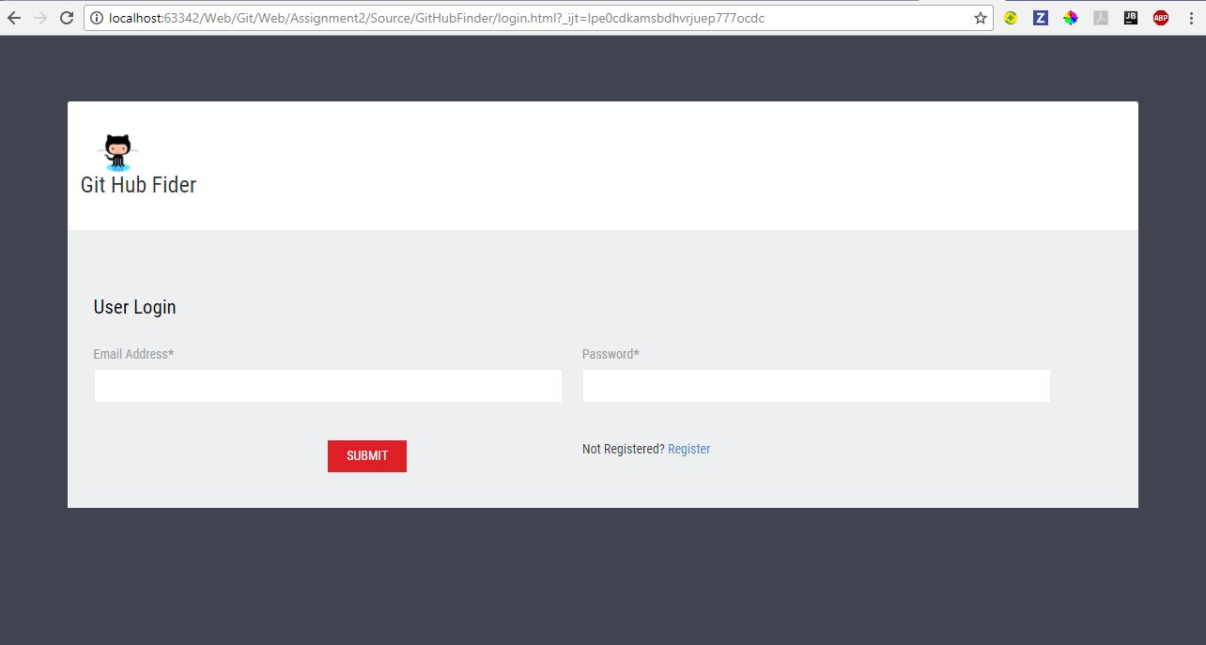

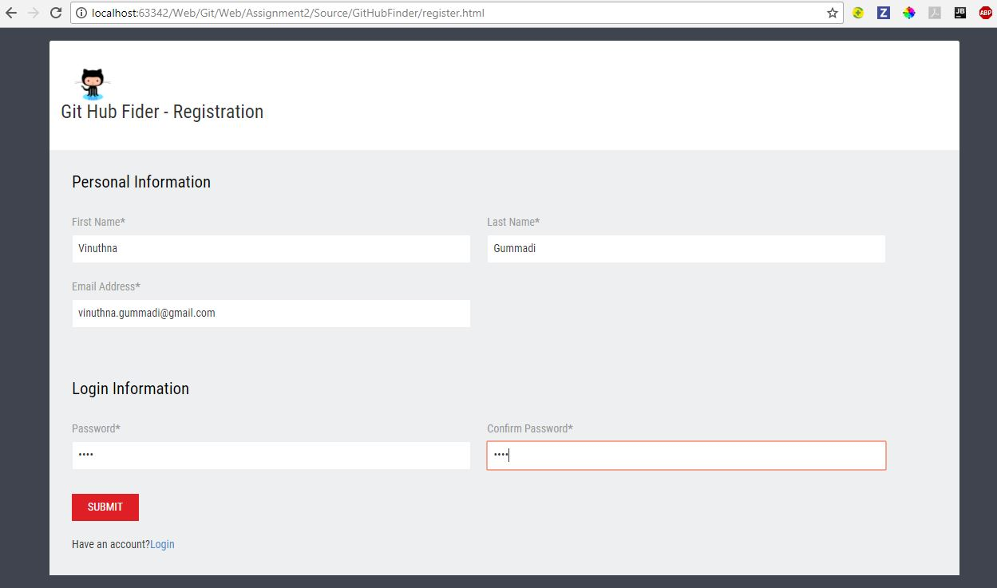

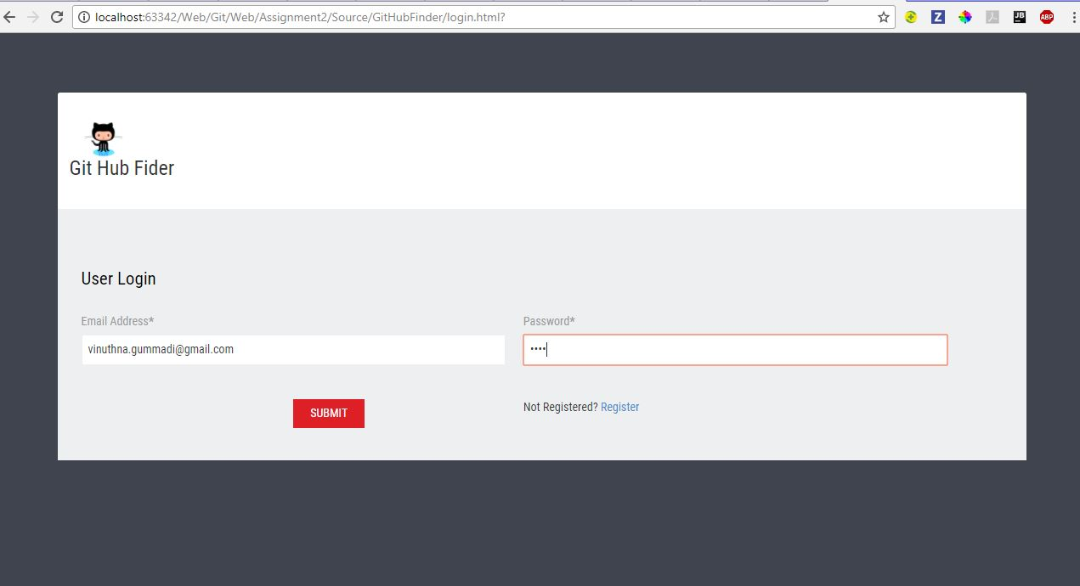

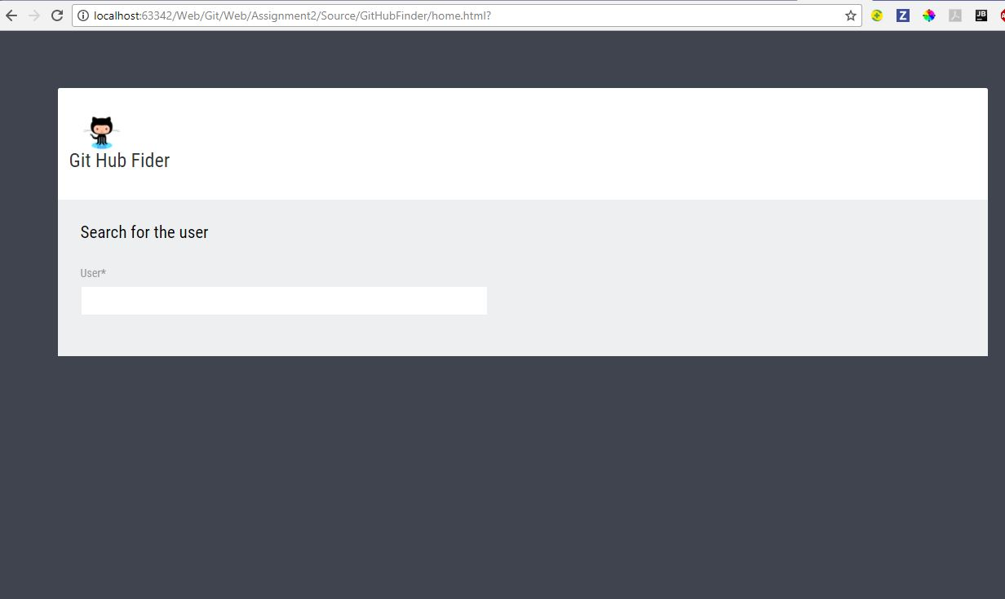

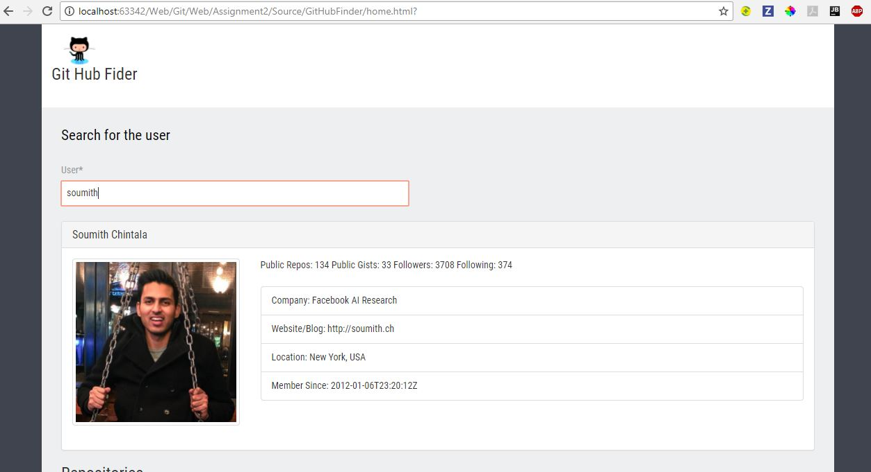

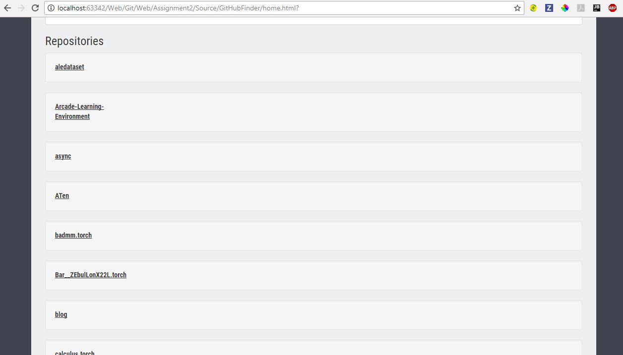

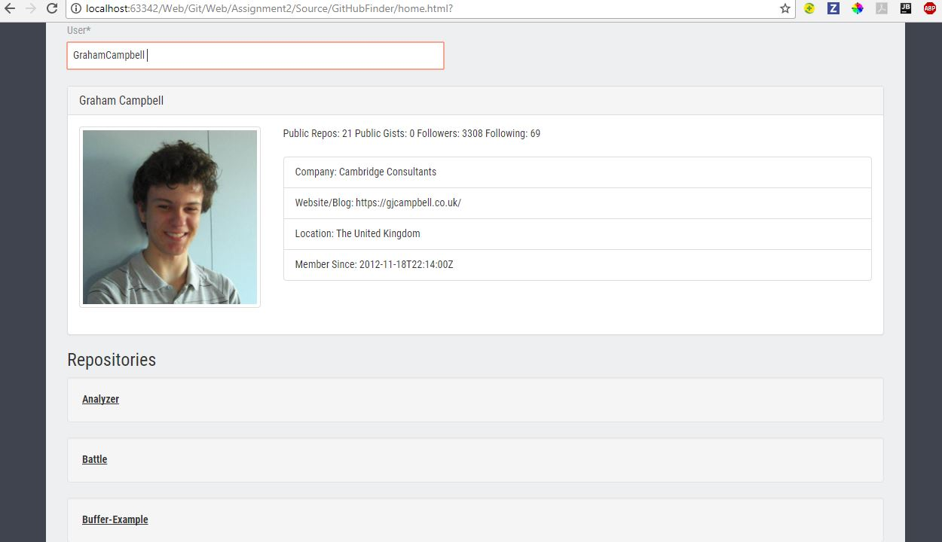

1. Angular 2 tictactoe game

Source:

Index.html

<**html**>  
  
 <**head**>  
 <**title**>Angular 2 Tic-tac-toe</**title**>  
  
 <**script src="node_modules/angular2/bundles/angular2-polyfills.js"**></**script**>  
 <**script src="node_modules/systemjs/dist/system.src.js"**></**script**>  
 <**script src="node_modules/rxjs/bundles/Rx.js"**></**script**>  
 <**script src="node_modules/angular2/bundles/angular2.dev.js"**></**script**>  
  
 <**script**>  
 System.config({  
 packages: {  
 dist: {  
 format: **'register'**,  
 defaultExtension: **'js'** }  
 }  
 });  
 System.import(**'dist/boot'**)  
 .then(**null**, console.error.bind(console));  
 </**script**>  
  
 <**link rel="stylesheet" href="styles.css"** />  
  
 </**head**>  
  
 <**body**>  
 <**my-app**>Loading...</**my-app**>  
 </**body**>  
  
</**html**>

App.components.ts

**import** {Component} **from 'angular2/core'**;  
**import** game **from './game'**;  
  
@Component({  
 **selector**: **'my-app'**,  
 **template**: **`  
 <h1>Angular 2 Tic Tac Toe</h1>  
 <div class="board">  
 <div *ngFor="#row of board;#rowNo=index" class="row">  
 <div *ngFor="#cell of row;#colNo=index" class="cell" (click)="cellClicked(rowNo, colNo)">  
 <span class="marker" *ngIf="cell===0">X</span>  
 <span class="marker" *ngIf="cell===1">O</span>  
 </div>  
 </div>  
 </div>  
 <div class="gameResults" *ngIf="winner===0">Winner: First Player</div>  
 <div class="gameResults" *ngIf="winner===1">Winner: Second Player</div>  
 <button class="restart" (click)="restart()">Restart</button>`**})  
  
**export class** AppComponent {  
 **public currentPlayer** = 0;  
 **public board** = game.createBoard();  
 **public winner**;  
  
 restart() {  
 **this**.**board** = game.createBoard();  
 **this**.**winner** = **null**;  
 **this**.**currentPlayer** = 0;  
 }  
  
 cellClicked(row, col) {  
 **if** (**this**.**board**[row][col] === 0 || **this**.**board**[row][col] === 1 || **this**.**winner** != **null**)  
 **return**;  
  
 **this**.**currentPlayer**++;  
 **this**.**board**[row][col] = **this**.**currentPlayer** % 2 ? 0 : 1;  
  
 **var** checkResult = game.checkBoard(**this**.**board**);  
  
 **if** (checkResult) {  
 **this**.**winner** = checkResult.**winner**;  
 }  
 }  
}

board.component.ts

**import** {Component} **from 'angular2/core'**;  
**import** { Row } **from './row.component'**;  
  
@Component({  
 **selector**: **'.board'**,  
 **template**: **'<div class="row" *ngFor="#value of values">{{value}}</div>'**,  
 **directives**: [ Row ]  
})  
**export class** Board {  
 **values**: **number**[] = [1, 2, 3];  
}

cell.component.ts

**import** {Component} **from 'angular2/core'**;  
  
@Component({  
 **selector**: **'.cell'**,  
 **template**: **'<span class="marker">X</span>'**})  
**export class** Cell {  
}

row.component.ts

**import** {Component} **from 'angular2/core'**;  
**import** { Cell } **from './cell.component'**;  
  
@Component({  
 **selector**: **'.row'**,  
 **template**: **'<div class="cell" *ngFor="#value of values"></div>'**,  
 **directives**: [ Cell ]  
})  
**export class** Row {  
 **values**: **number**[] = [1, 2, 3];  
}

game.ts

**let** DIMENSION = 3;  
  
**function** *boardLoop*(board, fn) {  
 **for** (**let** row = 0; row < DIMENSION; row++) {  
 **for** (**let** col = 0; col < DIMENSION; col++) {  
 fn(board[row][col], { row, col });  
 }  
 }  
}  
  
**let** game = {  
 createBoard() {  
 **let** board = [];  
 **for** (**let** row = 0; row < DIMENSION; row++) {  
 board[row] = [];  
 **for** (**let** col = 0; col < DIMENSION; col++) {  
 board[row][col] = **null**;  
 }  
 }  
  
 **return** board;  
 },  
  
 set(board, val, row, col) {  
 **if** (board[row][col] != **null**) {  
 ***console***.warn(**`Attempted to set on cell that has a value: row:** ${row} **col:** ${col} **value:** ${val}**`**);  
 **return** board;  
 }  
  
 **return** [  
 ...board.slice(0, row),  
 [  
 ...board[row].slice(0, col),  
 val,  
 ...board[row].slice(col+1)  
 ],  
 ...board.slice(row+1)  
 ];  
 },  
  
 check(arr) {  
 **let** clone = arr.slice(0);  
 **let** sum = 0;  
 **while**(clone.**length**) {  
 **let** val = clone.pop();  
 **if** (val == **null**) {  
 **return**;  
 }  
 sum += val;  
 }  
 **if** (sum === 0 || sum === DIMENSION) {  
 **return** {  
 **winner**: sum / DIMENSION || 0  
 };  
 }  
 **return**;  
 },  
  
 checkBoard(board) {  
 **let** winner;  
  
 *// Check rows* winner = board.reduce((hasWon, row) => hasWon || game.check(row), **false**);  
  
 *// Check cols* **let** cols = [];  
 **for** (**let** i = 0; i < DIMENSION; i++) {  
 cols.push(board.*map*(row => row[i]));  
 }  
 winner = winner || cols.reduce((hasWon, col) => hasWon || game.check(col), **false**);  
  
 **let** diagonals = [  
 board.*map*((row, i) => row[i]),  
 board.*map*((row, i) => row[DIMENSION-1-i])  
 ];  
 winner = winner || diagonals.reduce((hasWon, diagonal) => hasWon || game.check(diagonal), **false**);  
  
 **return** winner;  
 },  
  
 display(board) {  
 **let** display = **''**;  
 **let** prevRow;  
 *boardLoop*(board, (val, coord) => {  
 **if** (coord.row !== prevRow) {  
 display += **'\n'**;  
 prevRow = coord.row;  
 }  
 display += **`**${val == **null** ? **'-'** : val} **`**;  
 });  
 display += **'\n'**;  
 ***console***.log(display);  
 }  
};  
  
**export default** game;

Screenshots:

