

EPT Reliability Suite
Essential Performance Tool for Collaborative Reliability
Installation Guide
Install EPT Reliability Suite on Windows, macOS or Linux in a few clicks. No administrator rights and no internet connection required.
Setup package 1.3 · October 2026
DuurveX-Tech · duurvextech.com · Powered by Essential Performance LLC
© 2026 DuurveX-Tech. All rights reserved.
Contents

Note: If this list is empty when the document opens, right-click it and choose Update Field (Word), or Update Index (LibreOffice).

1. Before you start
EPT Reliability Suite is delivered as one small setup package, EPT-Reliability-Suite-Setup-1.3.zip (under 1 MB). Installation takes about one minute and three clicks: extract the ZIP, double-click the installer for your computer, and EPT Reliability Suite opens.
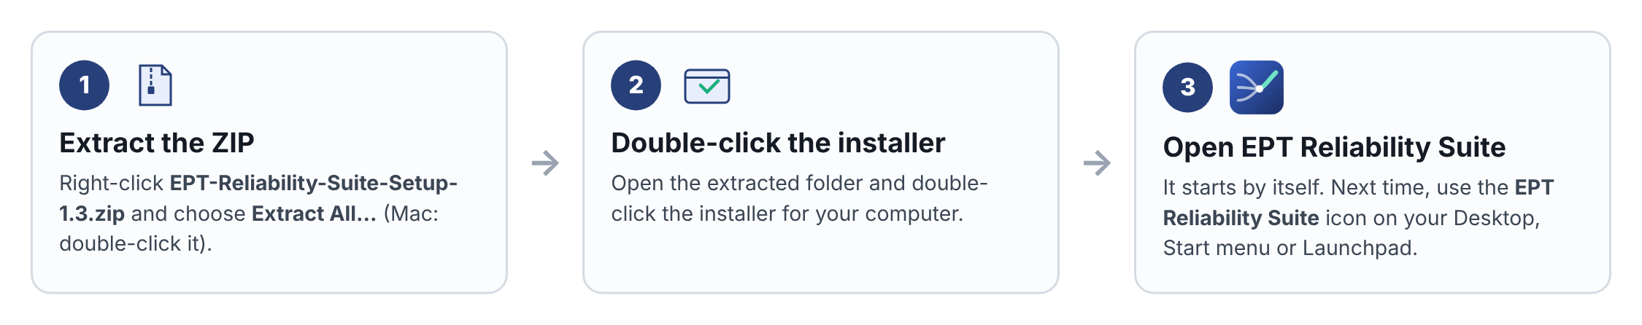
Figure 1. Installation at a glance

1.1 System requirements
Item | Requirement
Windows | Windows 10 or Windows 11. Microsoft Edge (included with Windows) or Google Chrome.
macOS | macOS 11 Big Sur or later. Google Chrome or Microsoft Edge recommended; Safari also works.
Linux | Any desktop with Google Chrome, Chromium or Microsoft Edge; other browsers work through the default browser.
Disk space | About 2 MB for the program. Your projects add a few hundred kilobytes each.
Permissions | A normal user account. Administrator rights are not needed; EPT Reliability Suite installs for the current user only.
Network | None. EPT Reliability Suite runs completely on your computer and works on closed or air-gapped networks.
Screen | 1280 × 800 or larger recommended. Phones and tablets work through the online edition.

1.2 Installed edition and online edition
EPT Reliability Suite is available in two editions. This guide covers the installed edition. All analysis modules are identical in both.
Feature | Installed edition (this guide) | Online edition
All seven analysis modules, examples, tour and 8D | Yes | Yes
Works without internet / on a closed network | Yes | No
Saving | This browser only, and project files on your computer | My projects, Team projects, This browser only, project files
Report and project file downloads | Saved to your Downloads folder | Saved through the online service
Sign-in, team sharing, Admin module access | Not available ("Local mode") | Yes
Generate solution concepts (Clinical needs) | Not available | Yes
Where data is stored | Only on your computer | In your organisation's online workspace

Note: In the installed edition the top-right corner of EPT Reliability Suite shows Local mode. That is expected: nothing you enter leaves your computer.

2. The setup package
When you extract the ZIP you get one folder, EPT-Reliability-Suite-Setup, with everything needed for every operating system.
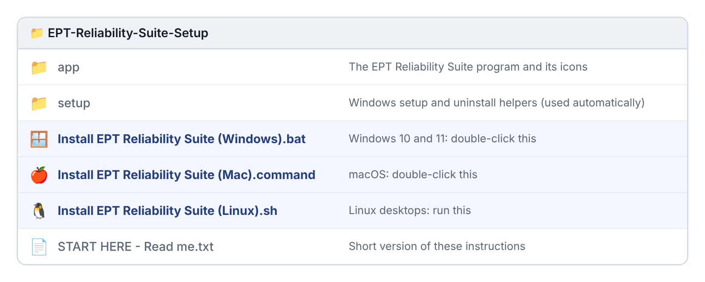
Figure 2. Contents of the EPT-Reliability-Suite-Setup folder
Item | What it is
Install EPT Reliability Suite (Windows).bat | The Windows installer. Double-click it.
Install EPT Reliability Suite (Mac).command | The macOS installer. Double-click it.
Install EPT Reliability Suite (Linux).sh | The Linux installer. Run it.
START HERE - Read me.txt | A one-page summary of this guide.
app folder | EPT-Reliability-Suite.html (the application) and the program icons. You do not need to open it.
setup folder | Helper scripts that the Windows installer uses. You do not need to open it.

Important: Always extract the ZIP first. Double-clicking an installer while it is still inside the ZIP does not work, because the installer cannot see the app folder next to it.
Tip: Windows hides file extensions by default, so the Windows installer may appear simply as Install EPT Reliability Suite (Windows) with a gear-and-window icon. That is the right file.

3. Install on Windows 10 or 11

3.1 Step by step
- Save the setup package. Save EPT-Reliability-Suite-Setup-1.3.zip to your computer, for example to your Downloads folder or Desktop.
- Optional: unblock the ZIP. Right-click the ZIP and choose Properties. If you see a Security line saying the file came from another computer, tick Unblock and click OK. This reduces the security prompts in step 4.
- Extract the ZIP. Right-click the ZIP and choose Extract All…. Leave the suggested folder as it is, keep Show extracted files when complete ticked, and click Extract. A new window opens showing the EPT-Reliability-Suite-Setup folder.
- Open the folder and start setup. Double-click EPT-Reliability-Suite-Setup, then double-click Install EPT Reliability Suite (Windows).
  - If a blue window says Windows protected your PC, click More info, then Run anyway. This appears because the installer is new to Microsoft Defender SmartScreen; it is expected.
  - If a window asks Do you want to allow this app to make changes, you can click No: EPT Reliability Suite does not need administrator rights.
- Watch the setup window. A black setup window shows four steps: copying EPT Reliability Suite, finding a browser, creating shortcuts, and registering the app. It takes a few seconds.
- EPT Reliability Suite opens. When setup finishes, EPT Reliability Suite opens in its own window and shows the licence agreement; tick the box and click I agree to reach the Home screen. The setup window says EPT Reliability Suite is installed; press any key to close it.
- Open it again later from the EPT Reliability Suite icon on your Desktop, or from the Start menu (type EPT Reliability Suite). Right-click the Start menu entry and choose Pin to taskbar for one-click access.
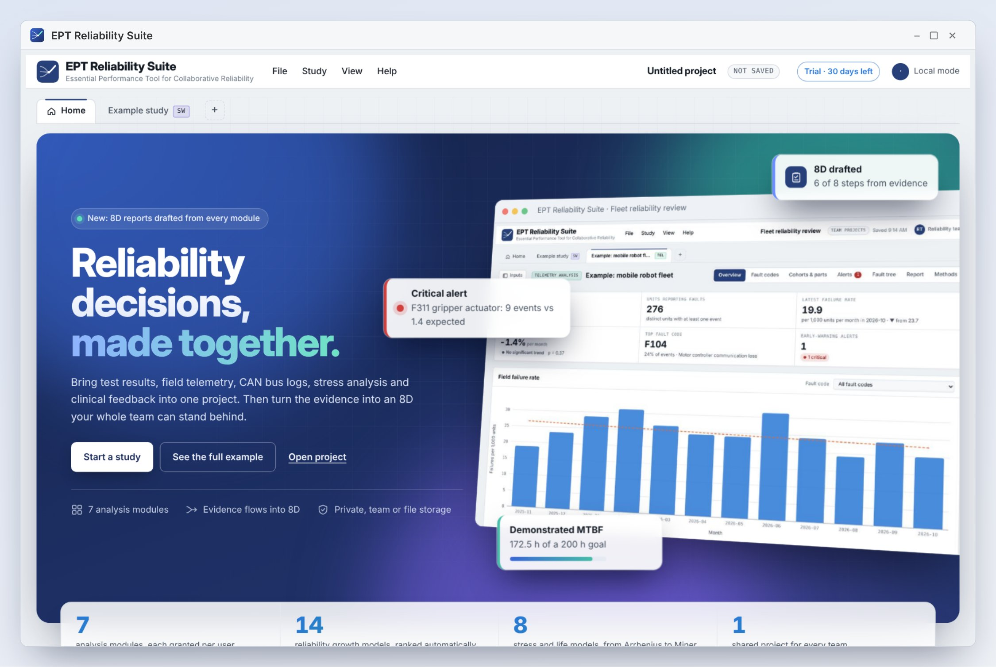
Figure 3. EPT Reliability Suite running in its own window after installation

3.2 What Windows setup does
Action | Details
Installs the program | Copies EPT Reliability Suite to %LOCALAPPDATA%\EPT Reliability Suite (for example C:\Users\yourname\AppData\Local\EPT Reliability Suite).
Creates shortcuts | EPT Reliability Suite on your Desktop and in the Start menu, with the EPT Reliability Suite icon.
Chooses a window | Opens EPT Reliability Suite in its own app window using Microsoft Edge, or Google Chrome if Edge is not present. If neither is found, it uses your default browser.
Registers the app | Adds EPT Reliability Suite to Settings → Apps → Installed apps, so it can be uninstalled like any other program.
Does not change | System files, other users, browser settings, or anything needing administrator rights.

3.3 If Smart App Control blocks the installer
On Windows 11 with Smart App Control turned on, double-clicking Install EPT Reliability Suite (Windows) may show Smart App Control blocked an app that may be unsafe, with no Run anyway button. Smart App Control blocks unsigned script files (.bat, .ps1, .lnk and others) that came from the internet. The EPT Reliability Suite application itself is an ordinary .html file and is not blocked, so you can install it in either of these ways.
Important: Do not turn Smart App Control off to install EPT Reliability Suite. It protects your computer, and on some Windows versions it cannot be turned back on without resetting Windows.

Option A: unblock the ZIP, then run setup
- Delete the EPT-Reliability-Suite-Setup folder you extracted earlier.
- Right-click EPT-Reliability-Suite-Setup-1.3.zip and choose Properties.
- On the General tab, at the bottom, tick Unblock and click OK. (If there is no Unblock box, go straight to Option B.)
- Right-click the ZIP, choose Extract All…, then Extract.
- Double-click Install EPT Reliability Suite (Windows) in the new folder and continue from step 5 in section 3.1.
- If Smart App Control still blocks it, or the setup window shows an error, use Option B.

Option B: install without any script (works with Smart App Control on)
This takes about three minutes and uses only File Explorer. It gives the same result as setup: EPT Reliability Suite in its own window, opened from a Desktop icon.
- Extract the ZIP (right-click → Extract All… → Extract).
- Create the program folder. Open File Explorer, click This PC, double-click Local Disk (C:). Right-click an empty area, choose New → Folder, and name it exactly EPT-Reliability-Suite (with the hyphen, no spaces).
- Copy the program. In the extracted EPT-Reliability-Suite-Setup folder, open the app folder, select all its files (Ctrl A), copy them (Ctrl C), open C:\EPT-Reliability-Suite and paste them (Ctrl V).
- Unblock the program file. In C:\EPT-Reliability-Suite, right-click EPT-Reliability-Suite.html, choose Properties, tick Unblock if you see it, and click OK.
- Create the shortcut. Go to your Desktop, right-click an empty area and choose New → Shortcut. In Type the location of the item, paste this exactly (one line), then click Next:
"C:\Program Files (x86)\Microsoft\Edge\Application\msedge.exe" --app=file:///C:/EPT-Reliability-Suite/EPT-Reliability-Suite.html
- Name it. Type EPT Reliability Suite and click Finish.
- Give it the EPT Reliability Suite icon. Right-click the new shortcut, choose Properties, click Change Icon…, click Browse…, open C:\EPT-Reliability-Suite, choose EPT-Reliability-Suite.ico, then click OK and OK.
- Open EPT Reliability Suite by double-clicking the shortcut. To pin it, right-click it, choose Show more options, then Pin to Start or Pin to taskbar.
Tip: Quickest possible start: double-click EPT-Reliability-Suite.html in C:\EPT-Reliability-Suite. EPT Reliability Suite opens in a normal browser tab straight away, with all features. The shortcut in Option B simply gives it a window and icon of its own.
To remove an Option B installation, delete the C:\EPT-Reliability-Suite folder and the Desktop shortcut. Save project files first (section 7).

4. Install on macOS
- Save the setup package to your Downloads folder.
- Extract it. Double-click EPT-Reliability-Suite-Setup-1.3.zip. macOS creates the EPT-Reliability-Suite-Setup folder next to it.
- Open the folder and double-click Install EPT Reliability Suite (Mac).command.
  - If macOS says the file cannot be opened because it is from an unidentified developer: click Done (or OK), then right-click (or Control-click) the installer, choose Open, and click Open again.
  - On macOS 15 Sequoia and later, if there is no Open button: open System Settings → Privacy & Security, scroll down to the message about Install EPT Reliability Suite (Mac).command, click Open Anyway, and confirm with your password or Touch ID.
- Watch the Terminal window. A Terminal window opens and shows three steps: building the app, setting up the launcher, and done. It takes a few seconds.
- EPT Reliability Suite opens. When setup finishes, EPT Reliability Suite opens on its Home screen. You can close the Terminal window.
- Open it again later from Launchpad, from Spotlight (press Command-Space and type EPT Reliability Suite), or from the Applications folder in your home folder. Drag it to the Dock to keep it one click away.

4.1 What macOS setup does
Action | Details
Builds the app | Creates EPT Reliability Suite.app in the Applications folder inside your home folder (~/Applications), with the EPT Reliability Suite icon.
Chooses a window | Opens EPT Reliability Suite in its own window using Google Chrome, Microsoft Edge, Brave or Chromium if one is installed. Otherwise it opens in Safari.
Does not change | System files, other users or browser settings. No administrator password is needed.

Tip: For the best experience on a Mac, install Google Chrome or Microsoft Edge before running setup. EPT Reliability Suite then opens in a clean window of its own, without browser tabs or an address bar.

5. Install on Linux
- Extract the ZIP with your file manager (right-click → Extract Here) or in a terminal: unzip EPT-Reliability-Suite-Setup-1.3.zip.
- Run the installer. In the file manager, right-click Install EPT Reliability Suite (Linux).sh and choose Run as a Program. Or, in a terminal inside the extracted folder, run: bash "Install EPT Reliability Suite (Linux).sh".
- EPT Reliability Suite opens. It also appears in your applications menu, and as an icon on your Desktop if you have a Desktop folder.
- If the Desktop icon shows a warning the first time, right-click it and choose Allow Launching.
Item | Location
Program | ~/.local/share/ept-reliability-suite
Menu entry | ~/.local/share/applications/ept-reliability-suite.desktop
Uninstaller | ~/.local/share/ept-reliability-suite/uninstall.sh

6. First launch: check that everything works
Take two minutes to confirm the installation. Each step also teaches a basic EPT Reliability Suite action.
- Licence agreement. The first time, EPT Reliability Suite shows its licence agreement. Read it, tick I have read and agree, and click I agree. It is shown again only when the agreement changes.
- Home screen. EPT Reliability Suite opens on Home, with the headline Reliability decisions, made together. The top-right corner shows Local mode.
- Try an example. Scroll to Seven modules, one workspace and click Try example on the Telemetry analysis tile. An example robot fleet study opens with charts.
- Save inside EPT Reliability Suite. Choose File → Save as…, keep the project name or type a new one, select This browser only, and click Save. The top bar changes from Unsaved changes to Saved.
- Save a project file. Choose File → Save project file to computer. A file ending in .eptsuite.json appears in your Downloads folder. Keep this file as your backup.
- Close and reopen. Close EPT Reliability Suite and open it again from its shortcut. Choose File → Open… to see your saved project.
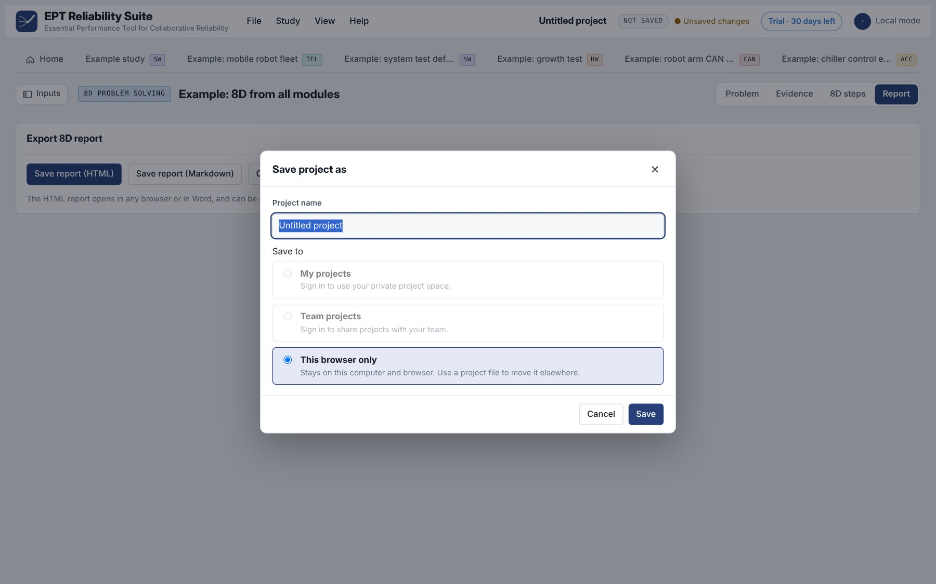
Figure 4. File → Save as, with This browser only selected (sign-in options are for the online edition)

6.1 Free trial and licence activation
EPT Reliability Suite starts with a 30-day free trial in which every module is open. The chip at the top right shows Trial · N days left. During the last week a reminder appears on Home. When the trial ends, modules lock until a licence key is activated; your projects and data are always kept.
- Buy single modules or a bundle from DuurveX-Tech at duurvextech.com. You receive a licence key (text starting with EPTU1-) and a key file ending in .eptkey.
- In EPT Reliability Suite choose Help → Licence and activation…, or click the licence chip at the top right.
- Paste the key into Activate a licence key, or click Load key file… and choose the .eptkey file.
- Click Activate. The dialog shows Licensed to your company, the end date, and which modules are included. The chip changes to Licensed.
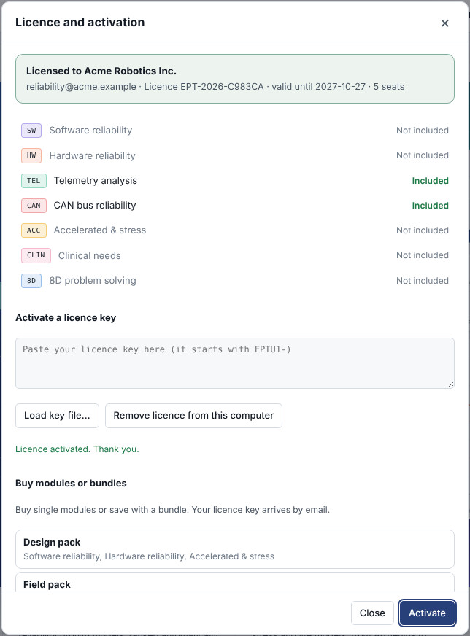
Figure 5. Help → Licence and activation, after activating a Field pack licence
Bundle | Modules included
Design pack | Software reliability, Hardware reliability, Accelerated & stress
Field pack | Telemetry analysis, CAN bus reliability
Clinical pack | Clinical needs, 8D problem solving
Complete suite | All seven modules
Single modules | Any module can also be bought on its own

- The licence is activated per computer and per browser. Activate the same key on each computer covered by your seats.
- Modules outside your licence show Not in your licence with an Unlock link. Studies that use them stay in your projects and open again once the module is licensed.
- Before the end date a reminder appears on Home. Renewing gives you a new key; activate it the same way.
- A licence key works only exactly as issued. A changed or mistyped key is refused.

7. Where your work is stored
The installed edition keeps everything on your computer. There are two ways to store a project, and you should use both.
Storage | How to use it | Good for | Keep in mind
This browser only | File → Save / Save as → This browser only | Everyday work; quick reopening with File → Open | Stored inside the browser profile (Edge or Chrome). Clearing browsing data, resetting the browser or changing user account removes it.
Project file (.eptsuite.json) | File → Save project file to computer; reopen with File → Open project file… | Backups, archiving, email, moving to another computer, sharing with colleagues | Saved to your Downloads folder. Move it to a project or network folder that is backed up.

Important: Projects saved only as This browser only are lost if browser data is cleared. Save a project file at the end of each working session, and before updating or uninstalling EPT Reliability Suite.

7.1 Reports and exports
- 8D reports (Save report (HTML) and Save report (Markdown)) go to your Downloads folder. Open the HTML report in any browser or in Word, and print it to PDF if needed.
- Each module's Report tab has Copy buttons for pasting results into email, Word or PowerPoint.

7.2 Moving to another computer
- On the old computer, open each project and choose File → Save project file to computer.
- Copy the .eptsuite.json files to the new computer (USB drive, network share or email).
- Install EPT Reliability Suite on the new computer as described in sections 3 to 5.
- Choose File → Open project file… and select each file. Then use File → Save as → This browser only to keep it in EPT Reliability Suite.

8. Using EPT Reliability Suite on a closed network
- EPT Reliability Suite needs no internet connection to install or run. All calculations happen on your computer and no data is sent anywhere.
- When the computer is online, EPT Reliability Suite loads its brand fonts from the web. Offline, it uses the system fonts automatically; everything else looks and works the same.
- The setup package can be copied to the closed network by USB drive or internal file share. Each user runs the installer once under their own account.
- IT teams can deploy silently on Windows by running, for each user: powershell -NoProfile -ExecutionPolicy Bypass -File setup\install-windows.ps1 from the extracted folder.
- EPT Reliability Suite does not need or request administrator rights, services, drivers, open network ports or firewall changes.

9. Updating to a new version
- Save a project file for each project you want to keep (File → Save project file to computer).
- Extract the new setup package and run its installer, exactly as for a first installation. It replaces the program files and shortcuts.
- Open EPT Reliability Suite. Projects saved as This browser only are normally still listed under File → Open…. If one is missing, open its project file.
- Check the version under Help → About EPT Reliability Suite.

10. Uninstalling

10.1 Windows
- Open Settings → Apps → Installed apps (Windows 11) or Settings → Apps → Apps & features (Windows 10).
- Find EPT Reliability Suite, click the ⋯ menu (or the entry), and choose Uninstall.
- In the window that opens, type Y and press Enter. EPT Reliability Suite, its shortcuts and its Settings entry are removed.
You can also run Uninstall EPT Reliability Suite from the install folder (%LOCALAPPDATA%\EPT Reliability Suite).

10.2 macOS
Open the Applications folder in your home folder and drag EPT Reliability Suite to the Trash.

10.3 Linux
Run ~/.local/share/ept-reliability-suite/uninstall.sh in a terminal.
Note: Uninstalling never deletes your project files or saved reports. Projects kept as This browser only stay in the browser's storage until browser data is cleared.

11. Troubleshooting
Problem | What to do
Nothing happens or a window flashes and closes when I double-click the Windows installer | The ZIP was probably not extracted. Right-click the ZIP → Extract All…, then run the installer from the extracted folder.
"Windows protected your PC" | Click More info, then Run anyway. To avoid it next time, unblock the ZIP first (section 3.1, step 2).
"The process cannot access the file … because it is being used by another process" or "EPT Reliability Suite is open, so setup cannot replace it" | EPT Reliability Suite is already installed and open, or setup was started twice. Close every EPT Reliability Suite window and every setup window, then double-click the installer once.
"Smart App Control blocked an app that may be unsafe" | Use section 3.3: unblock the ZIP before extracting (Option A), or install without any script (Option B). Do not turn Smart App Control off.
"Running scripts is disabled on this system" or a PowerShell policy message | Your organisation restricts PowerShell. Ask IT to run the silent install command in section 8, or to allow the package.
macOS: "cannot be opened because it is from an unidentified developer" | Right-click the installer → Open → Open. On macOS 15 and later use System Settings → Privacy & Security → Open Anyway.
macOS: EPT Reliability Suite opens in a Safari tab, not its own window | Install Google Chrome or Microsoft Edge, then run the Mac installer again.
The shortcut opens a normal browser tab | Edge or Chrome was not found during setup. Install either one and run setup again.
My saved project is missing from File → Open | It was stored in a different browser or the browser data was cleared. Open its project file with File → Open project file….
Saved reports or project files cannot be found | Look in your Downloads folder. Your browser may ask where to save files; check its download settings.
"This licence key is not valid" | Copy the whole key again exactly as received, or use Load key file… with the .eptkey file. Contact DuurveX-Tech if it still fails.
"This licence expired on …" or modules locked after the end date | Ask DuurveX-Tech for a renewal key and activate it under Help → Licence and activation.
Top-right shows Local mode | Expected in the installed edition. Sign-in and team sharing are part of the online edition.
Text looks slightly different from screenshots | The computer is offline, so system fonts are used. This does not affect results.

12. Support
For licences, the online edition, training or support, contact DuurveX-Tech through duurvextech.com. Please include the version shown under Help → About EPT Reliability Suite, your operating system, and a description or screenshot of the problem.
Companion document: EPT Reliability Suite User Guide, with step-by-step instructions for every module.

