Training quantum neural networks for T1-limited hardware:
what the qg symmetry filter does and does not do
Vicente Humberto Monteverde
Universidad del Museo Social Argentino (UMSA), Argentina
ORCID 0000-0001-8884-4811
Draft of 2 October 2026
Abstract
A quantum neural network (QNN) built from gates that conserve the Hamming weight keeps its data in one weight sector, so the shots that left the sector can be discarded at readout. This is the qg filter of the qang library (Monteverde 2026a, 2026b). We show that, with equal amplitude damping (T1) on every qubit, the filtered readout of such a network is exactly the noiseless one in any weight sector. The kept fraction of shots is ${\left(1−γ\right)}^{k d}$ for weight $k$ and depth $d$, and training under T1 with the filter gives exactly the parameters of noiseless training. We then measure what this is worth on four small classification datasets. Every result is reported with the filter and without it, and every prediction was committed before its run, failures included. Over 60 runs per model, a network trained on a simulator and run under T1 gains $+2.5$ points from the filter at weight 1 (95% CI $\left[0.8,4.1\right]$) and $+16.5$ points at weight 2 ($\left[11.8,21.2\right]$), recovering its noiseless accuracy exactly. A network trained under the calibrated noise without the filter catches up (differences of $0.1$ points), and the filter corrects neither dephasing nor unequal T1 across qubits. These models are classically simulable and no quantum advantage is claimed. The filter is a way to make noise-free training valid under relaxation, at a shot cost known in advance. The models are released as qang.qml (version 0.6.0, pip install qang).

Introduction
Variational quantum classifiers are trained on simulators and run on noisy devices, or trained directly under device noise. Noise-aware training (Wang et al. 2022) is the usual remedy when the two differ. Symmetry verification (Bonet-Monroig et al. 2018; McArdle, Yuan, and Benjamin 2019) is a different remedy: when the ideal circuit conserves a quantity, outcomes that violate it can be discarded. The qang project expresses qubit readouts in qg units ($qg_{Z}=⟨σ_{z}⟩$ and its companions) (Monteverde 2026a). It built a register-mean witness and a shot-level filter for circuits that conserve a Hamming weight (Monteverde 2026b). This note asks a narrow question: for a QNN that conserves the weight, how much does that filter change the accuracy of a classifier on T1-limited hardware, and when does it stop mattering?
We answer with exact simulation, a fixed protocol and an explicit comparison. Every reading is taken with qang (filtered) and without it (raw), on the same trained parameters or the same initialization. The predictions of every study were committed to the repository before the run that tested them. Of 27 pre-registered predictions in the studies summarized here, 22 passed and 5 failed; the failures are reported alongside the passes.

Model and theory

Weight-conserving QNN.
On $n$ qubits, a reconfigurable beam splitter (RBS) gate acts on a pair $\left(a,b\right)$ as a Givens rotation between $|10⟩$ and $|01⟩$ and leaves $|00⟩$ and $|11⟩$ fixed, so it conserves the Hamming weight (Landman et al. 2022). We use $n=5$ and three layers of RBS gates on the pairs $\{\left(0,1\right),\left(2,3\right)\}$, $\{\left(1,2\right),\left(3,4\right)\}$, $\{\left(4,0\right)\}$. That gives 15 angles and depth $d=9$ (sublayers). The readout is z=i​ci qgZi+b with trainable $c_{i},b$ and a logistic loss.

Encodings.
With four features $x∈{\left[−1,1\right]}^{4}$ let $v=\left(x,1\right)/∥\left(x,1\right)∥$; the constant component keeps $∥x∥$. Model E (weight 1) puts $v_{i}$ on the basis state with qubit $i$ excited. Model W (weight 2) puts $v_{i}v_{j}$ on the state with qubits $i<j$ excited, normalized. The sectors have dimensions 5 and 10.

The filter.
With qang, the readout keeps only the shots whose weight equals the input weight $k$ and renormalizes (qang.sectors.filter_distribution). Without qang, all shots are used.

F1/F4: exactness under equal T1.
Let amplitude damping with probability $γ$ act on every qubit after every sublayer. Its no-jump Kraus operator multiplies a basis state with $k$ excitations by ${\left(1−γ\right)}^{k/2}$: the same factor for every state in the weight-$k$ sector. Every jump lowers the weight and leaves the sector. The weight-conserving gates never bring a lowered state back. So, conditioned on the weight being $k$, the state is exactly the noiseless one, and
$$\text{kept fraction}={\left(1−γ\right)}^{k d}.$$
For $γ=0.08$ and $d=9$ this is $0.472$ at weight 1 and $0.223$ at weight 2. If the damping differs between qubits, the no-jump factor is q∈S​1−γq1/2 over the excited set $S$, which is not uniform, and exactness is lost. Dephasing conserves the weight, so the filter cannot see it.

F3: training.
Since the filtered T1 readout equals the noiseless one for every parameter value, the loss and all gradients are identical. Training under T1 with the filter therefore yields the parameters of noiseless training from the same initialization.

F2: simulability.
At weight 1 the network is a $5×5$ orthogonal matrix $O$ on $v$, and $z$ is a quadratic form in $v$. At weight $k$ the sector has dimension $\left({n \atop k}\right)$, polynomial for fixed $k$. These models can be simulated classically. Whether larger, higher-weight versions could not be is a separate question (Cerezo et al. 2023) that this note does not address.

Methods
Datasets (binary): iris (versicolor vs virginica), breast cancer, wine (classes 0 vs 1) and digits (3 vs 8), with 100 samples per class where available. Each run uses a stratified 70/30 split, standardization, PCA to four components where needed, and scaling to $\left[−1,1\right]$; one test sample is worth 2–3 points. Training uses Adam for 120 epochs, with central-difference gradients on the angles. Noise conditions are applied after every sublayer: equal T1 with $γ=0.08$; unequal T1 with $γ_{q}$ from 0.04 to 0.12 (mean 0.08); and equal T1 plus a phase flip with probability 0.03. The simulation is exact. T1 and dephasing keep the density matrix block-diagonal in the Hamming weight, so one block per weight is propagated; this is checked against the full density matrix to ${10}^{−12}$. Protocol: each study’s script, with its predictions written in the header, was committed before the seed of its reported run was used; code was debugged on another seed with few epochs. The commit hashes are in the research notes (Monteverde 2026a).

Results

Single-seed studies.
The weight-conserving QNN that keeps the norm reaches a mean accuracy of 0.960 over the four datasets. That is level with a standard (non-conserving) four-qubit QNN (0.952) and with an RBF support-vector machine (0.957) and a small MLP (0.961). Without the norm component the same network gets 0.791. Trained noiselessly and run under T1 with the filter, it keeps exactly its noiseless accuracy. Training under T1 with the filter reproduces noiseless training to $5×{10}^{−9}$ in the parameters (F3). At $γ=0.08$, a standard QNN trained noiselessly collapses under T1 (0.771); trained under T1 it recovers (0.944).
The predictions that failed:
- arccos encoding gave no accuracy gain;
- the classical quadratic twin did not match the QNN within 1 point at default regularization;
- unequal T1 cost the filter 1.5 points in one run (bound: 1 point);
- weight 2 was less accurate than weight 1 (by 3.7 points);
- trained under T1, the weight-2 model without the filter was 0.6 points ahead of the filtered one.

Replication over 60 runs.
The key comparisons were repeated over 5 seeds $×$ 3 splits $×$ 4 datasets. Table 1 and Fig. 1 give the results; all five pre-registered predictions of this replication passed.
Mean test accuracy over 60 runs per model, with and without the qg filter.
 | E (weight 1) |  | W (weight 2)
reading | with qang | without | with qang | without
exact (no noise) | 0.952 |  | 0.922
T1, trained without noise | 0.952 | 0.928 | 0.922 | 0.757
T1, trained under the noise | 0.952 | 0.951 | 0.922 | 0.924
unequal T1, trained without noise | 0.947 | 0.921 | 0.916 | 0.732
dephasing, trained without noise | 0.918 | 0.792 | 0.882 | 0.656
dephasing, trained under the noise | 0.950 |  | 0.926
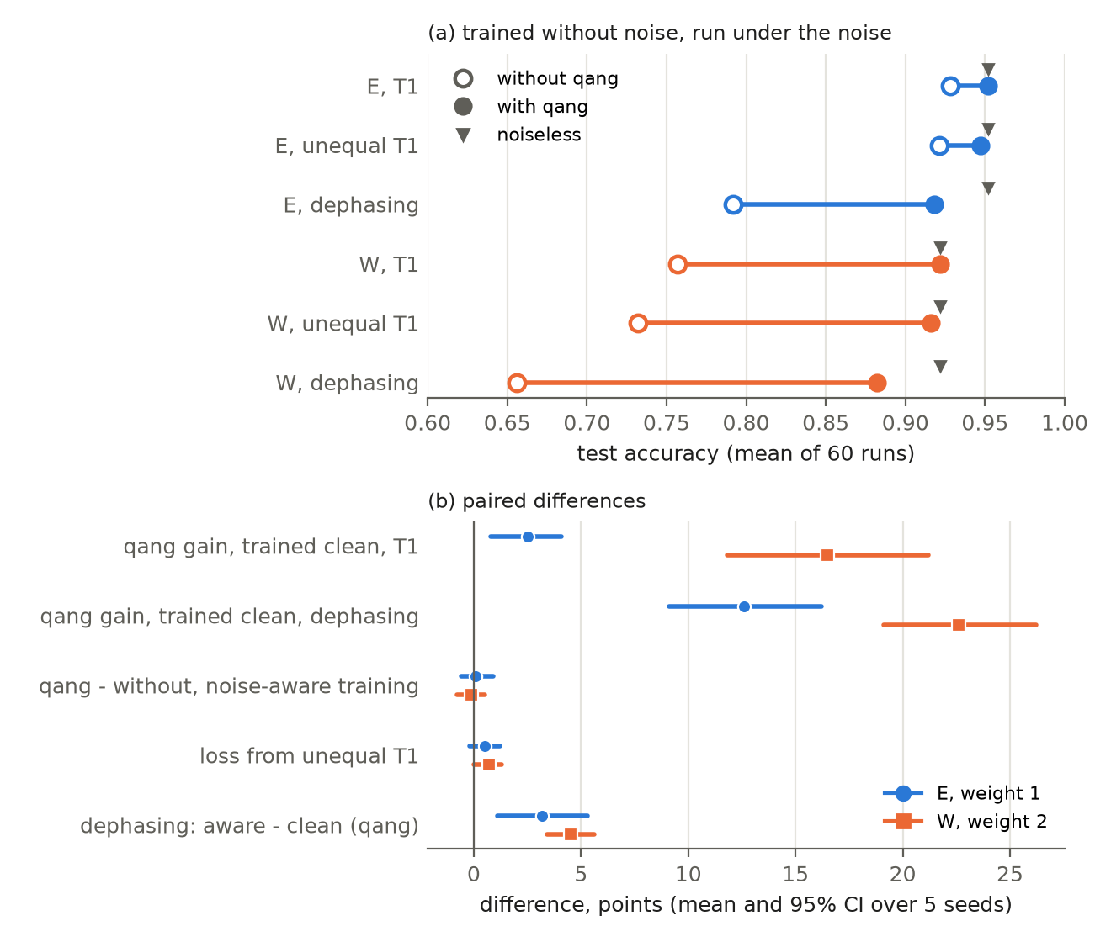
(a) Accuracy of networks trained without noise and run under the noise, without (open) and with (filled) the filter; triangles mark the noiseless accuracy. (b) Paired differences, mean and 95% CI across 5 seeds.
The paired differences (mean, 95% CI across seeds) were as follows.
- Gain from the filter, trained without noise, under T1: $+2.5$ $\left[0.8,4.1\right]$ points (E) and $+16.5$ $\left[11.8,21.2\right]$ (W). The filtered model was ahead or tied in 50/60 (E) and 56/60 (W) runs.
- With noise-aware training: $+0.1$ $\left[−0.6,0.9\right]$ (E) and $−0.1$ $\left[−0.8,0.5\right]$ (W).
- Loss from unequal T1: $0.5$ $\left[−0.2,1.2\right]$ (E) and $0.7$ $\left[0.0,1.3\right]$ (W). The 1.5 points of the earlier run were at the top of the spread.
- Dephasing, noise-aware minus clean training with the filter: $+3.2$ (E) and $+4.5$ (W), both CIs above 0.
- Under dephasing, a model trained without noise still gains $+12.6$ (E) and $+22.6$ (W) points from the filter, which removes the T1 part of the combined noise.
- Weight 2 against weight 1: $−3.0$ $\left[−4.0,−2.0\right]$ points.

Discussion
The difference the filter makes depends on how the network was trained. Trained on a simulator and run under relaxation, the filter is decisive. Its effect grows with the weight, because a weight-$k$ state decays $k$ times faster. Trained under a calibrated noise model, a network without the filter learns the decay, and the filter adds nothing measurable. What the filter provides is therefore procedural rather than an accuracy gain over the best alternative. Under equal T1 it makes noise-free training exactly valid, with no noise model and no noisy training runs, and its cost (the discarded shots) is known before running. Unequal T1 and dephasing are not corrected. On hardware with a large spread of T1 or strong dephasing, the filter complements a noise model and does not replace it.

Limitations.
All noise is simulated. There is one architecture per weight, five qubits, and small datasets in which one test sample is worth 2–3 points. The weight-2 encoding is one choice among many, and it did not use the larger sector well. No quantum advantage is claimed: these networks are classically simulable. A hardware run with the filter is the natural next test.

Code and data availability
Models: qang.qml in qang 0.6.0 (pip install qang), NumPy only, with WeightQNN, kept_fraction and compare_qang. Studies: examples/qnn_*_qg.py and RESEARCH_NOTES §75–§80, with tests in tests/. The Colab notebooks notebooks/qang_qml.ipynb (English) and qang_qml_es.ipynb (Spanish) install the library from PyPI. Repository: https://github.com/Viny2030/qang.
from qang.qml import WeightQNN
m = WeightQNN(n_qubits=5, weight=2).fit(X_train, y_train)
m.score(X_test, y_test, gamma=0.08, qang=True) # = noiseless accuracy
m.score(X_test, y_test, gamma=0.08, qang=False) # raw readout
Bonet-Monroig, Xavier, Ramiro Sagastizabal, M. Singh, and Thomas E. O’Brien. 2018. “Low-Cost Error Mitigation by Symmetry Verification.” Physical Review A 98: 062339.
Cerezo, M. et al. 2023. “Does Provable Absence of Barren Plateaus Imply Classical Simulability? Or, Why We Need to Rethink Variational Quantum Computing.”
Landman, Jonas, Natansh Mathur, Yun Yvonna Li, Martin Strahm, Skander Kazdaghli, Anupam Prakash, and Iordanis Kerenidis. 2022. “Quantum Methods for Neural Networks and Application to Medical Image Classification.” Quantum 6: 881. https://doi.org/10.22331/q-2022-12-22-881.
McArdle, Sam, Xiao Yuan, and Simon Benjamin. 2019. “Error-Mitigated Digital Quantum Simulation.” Physical Review Letters 122: 180501.
Monteverde, Vicente Humberto. 2026a. “The Qang (Qg): A Unified Angular-Probability Unit and Metric for Parametric Quantum Circuit Design.” https://doi.org/10.5281/zenodo.22832150.
———. 2026b. “The Register-Mean Polar Bias as a Symmetry Witness: Error Mitigation, Constrained Optimization and Qubit Characterization in Qg Units.” Zenodo Preprint. https://doi.org/10.5281/zenodo.23036963.
Wang, Hanrui, Jiaqi Gu, Yongshan Ding, Zirui Li, Frederic T. Chong, David Z. Pan, and Song Han. 2022. “QuantumNAT: Quantum Noise-Aware Training with Noise Injection, Quantization and Normalization.” In Proceedings of the 59th ACM/IEEE Design Automation Conference (DAC), 1–6. https://doi.org/10.1145/3489517.3530400.

