Quantum Computing, Information and Physics in qang Space
  - A treatise on the qg unit, the symmetry filter and their applications
Vicente Humberto Monteverde
2026-01-01
Table of contents

Preface
This book gathers, in reading order, the results of a research programme built on a simple idea: describing the qubit by what is measured. The qang unit (qg) expresses a qubit’s state on the scale on which the experiment delivers it, the polar bias $qg_{Z}=⟨σ_{z}⟩$, and that choice yields a practical tool, the qg symmetry filter: when a circuit conserves a number (excitations, photons, neutrino flavour, mass), the shots that violate it can only come from noise and are discarded.
The book goes from the foundations (Parts I and II) to the applications: neutrinos (Part III), teleportation in optical networks (Part IV), information-theoretic models of time loops and black holes (Part V), cryptography (Part VI), quantum machine learning (Part VII), dynamics and chemistry (Part VIII), error correction and characterization (Part IX). Part X gathers the evidence: the method, the confirmed advantages, the limits and the negative results, and the first run on real hardware.

How to read the results
Three conventions run through the book:
- Predictions recorded before running. Every experiment cited fixed its predictions before it was run (a commit or a sha256 hash of the script), and is reported as passed or failed. Failures are not left out: many of the book’s lessons come from them.
- Simulated noise unless stated. Whatever is described “on a device” refers to calibrated noise models of IBM or IonQ processors, except for the real-hardware results, which are marked explicitly (Chapter 31).
- References to the notes. Citations such as (§151) point to the corresponding section of the project’s research notes (RESEARCH_NOTES.md), where the code, the tests and the data are.

Code and data
All the material is open: the qang library (pip install qang), the script of every experiment, the runnable notebooks and the data are at github.com/Viny2030/qang. The software record has the DOI 10.5281/zenodo.22832150.

Status of this edition
The book is written and published chapter by chapter. Chapters marked “in preparation” show their planned contents and are completed in successive editions.
Vicente Humberto Monteverde — Universidad del Museo Social Argentino (UMSA), Argentina. ORCID 0000-0001-8884-4811.

1. The qang unit: definition, milli-qang and the probability equation
A qubit is designed with angles and observed with frequencies. Whoever writes a circuit chooses rotations $R_{y}(θ)$; whoever runs it receives counts of zeros and ones. Between the two descriptions sits a trigonometric function that is rarely named, and that is the source of several practical difficulties: gradients that diverge, error bars that shrink or swell with the state, and parameters that cannot be read directly from the experiment. This chapter builds the foundation of the book in three steps: the definition of the qang unit (qg), the theory of the milli-qang (its submultiple) and the probability equation that ties both to what is measured. Every result is backed by a figure computed with the package itself (qang.probability, §167), so the figures and the text quote the same numbers.

1.1 Definition of the qang
Every pure state of a qubit can be written, up to a global phase, as
$$|ψ⟩=cos\frac{θ}{2} |0⟩+e^{iφ}sin\frac{θ}{2} |1⟩, θ∈[0,π], φ∈[0,2π).$$
The pair $(θ,φ)$ is a point on the Bloch sphere and is the natural way to prepare the state: a rotation $R_{y}(θ)$ followed by a phase $R_{z}(φ)$. A measurement in the computational basis does not return $θ$: it returns, on each shot, the outcome 0 with probability
$$p_{0}=\cos^{2}\frac{θ}{2} \text{(Born’s rule).}$$
Definition. The qang unit takes as its primary coordinate the expectation value of $σ_{z}$, called the polar bias:
$$\boxed{ qg_{Z}=⟨σ_{z}⟩=p_{0}−p_{1}=2p_{0}−1=cosθ } qg_{Z}∈[−1,1].$$
The other two readings of the unit come from the same probability: the qang angle $θ=arccos(qg_{Z})∈[0,π]$ and the superposition spread $qg_{S}=H(p_{0})∈[0,1]$, the Shannon entropy of the outcome (studied below). Figure 1.1 summarizes the definition: the point on the circle is the state, its projection on the vertical axis is $qg_{Z}$, and the scale on the right gives the same reading in milli-qang and in probability.
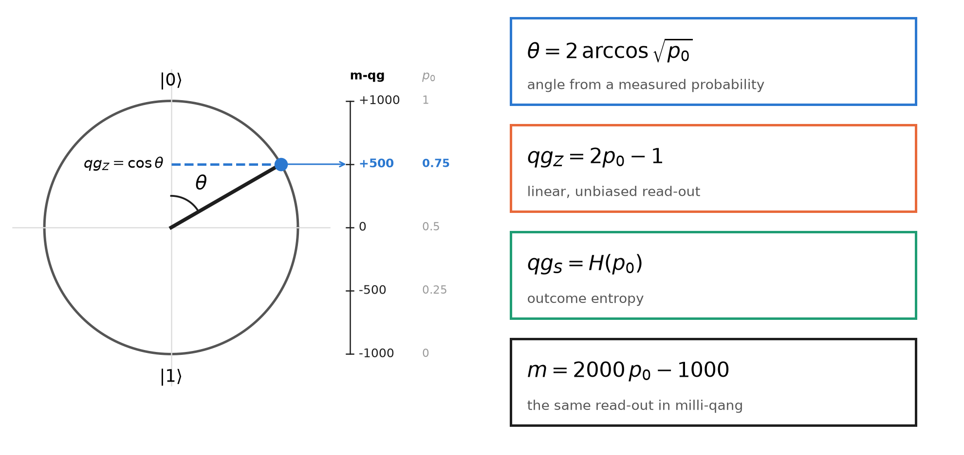
Figure 1.1: The qang circle. The state at angle $θ={60}^{∘}$ has $p_{0}=0.75$, $qg_{Z}=cosθ=0.5$ and a reading of $+500$ m-qg. The four equations on the right are the same probability read in four ways.
Three properties make $qg_{Z}$ a good working coordinate:
- It is a bijection. On $θ∈[0,π]$, $cosθ$ is strictly decreasing and covers $[−1,1]$: each value of $qg_{Z}$ corresponds to a single latitude of the sphere.
- It is directly measurable. ${\hat{qg}}_{Z}=(n_{0}−n_{1})/N$ is the average of the $±1$ outcomes of the shots; it needs no inversion and no fit.
- It holds for any state. For a mixed state, $qg_{Z}=Tr(ρ σ_{z})$, which reduces to $cosθ$ when $ρ=|ψ⟩⟨ψ|$ (§3).
The sign and range have an immediate physical reading: $qg_{Z}=+1$ is the pole $|0⟩$, $qg_{Z}=−1$ the pole $|1⟩$, and $qg_{Z}=0$ any point of the equator, where the measurement outcome is maximally uncertain.
An engineering unit. A useful unit does not need to be a new physical quantity; it needs to make what is measured legible. The decibel adds no physics to power: it expresses it on a scale that makes the gains of a chain of amplifiers additive. The qang plays an analogous role for the qubit: it expresses its state on the scale in which the experiment delivers it, so that preparation, noise and read-out are compared in the same units. It is an operational convention, and like every convention it is worth what it simplifies.

1.2 Theory of the milli-qang

1.2.1 Definition and scale
The deviations that matter in a real qubit are small: calibration errors, drift, read-out noise. A submultiple is convenient to express them, the milli-qang (m-qg):
$$1 \text{qg}=1000 \text{m-qg}, m=1000 qg_{Z} ∈[−1000, +1000] \text{m-qg}.$$
The scale runs from $−1000$ m-qg at the pole $|1⟩$ to $+1000$ m-qg at the pole $|0⟩$, with zero on the equator. A state with $qg_{Z}=0.502$ sits at $501.8$ m-qg; its difference from the ideal $0.5$ is $1.8$ m-qg. The same definition holds for the other axes, $qg_{X}$ and $qg_{Y}$, so the whole Bloch vector can be expressed in m-qg.

1.2.2 Linear in probability, not linear in angle
Since $qg_{Z}=2p_{0}−1$, the milli-qang is linear in probability: one m-qg is always $Δp_{0}=0.0005$, that is, 0.05 percentage points, anywhere on the scale. It is not linear in angle:
$$\frac{dm}{dθ}=−1000 sinθ ⇒ Δθ≈\frac{1}{1000 sinθ} \text{rad per m-qg}.$$
On the equator ($θ={90}^{∘}$) one m-qg is exactly one milliradian; at $θ={30}^{∘}$ it is two. Near a pole the linear relation fails and the exact one must be used: a state $δ$ m-qg below the pole $|0⟩$ makes with it the angle
$$θ_{δ}=arccos​\left(1−\frac{δ}{1000}\right)≈\sqrt{\frac{2δ}{1000}}.$$
One m-qg from the pole is $0.0447$ rad (${2.56}^{∘}$); ten m-qg, ${8.1}^{∘}$. Figure 1.2 shows the consequence: on the milli-qang ruler the probability marks are evenly spaced and the angle marks crowd at the poles. That is why the unit is defined on probability and not on angle: it is the scale in which the instrument delivers the data.
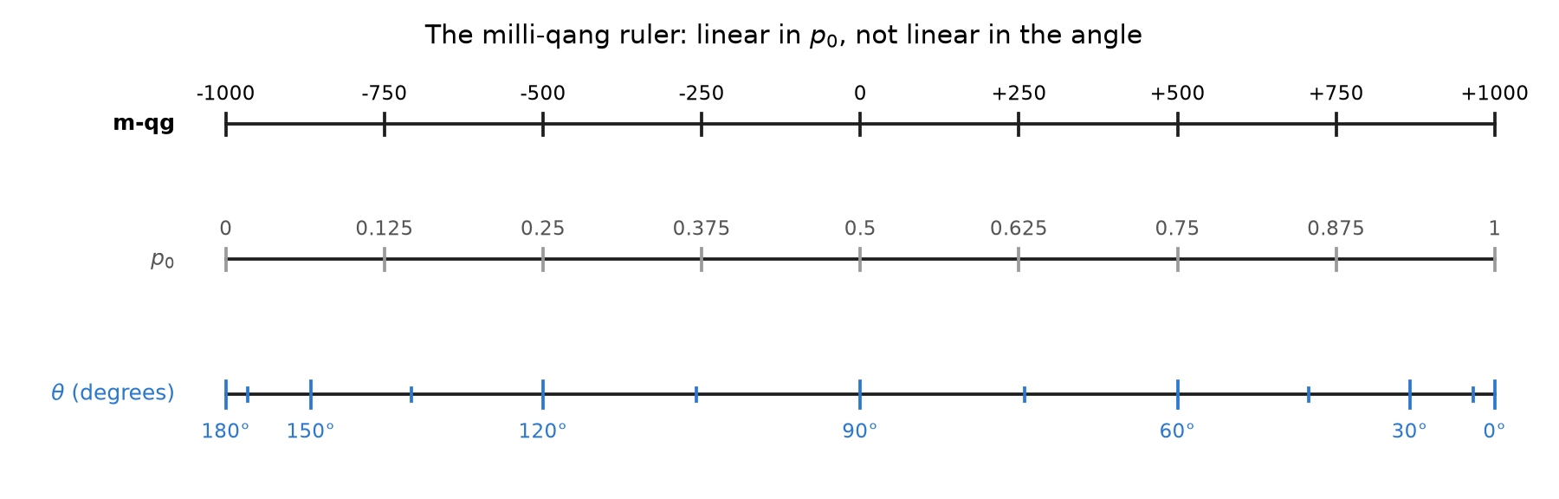
Figure 1.2: The milli-qang ruler. Top, the scale in m-qg; middle, the probability $p_{0}$, aligned and linear; bottom, the qang angle, whose marks every ${15}^{∘}$ are compressed towards the poles.

1.2.3 Resolution from shots
With $N$ shots, ${\hat{qg}}_{Z}$ has variance $\sin^{2}θ/N$ (derived in the arcsine section), so the standard deviation of the reading in milli-qang is
$$σ_{m}=\frac{1000 sinθ}{\sqrt{N}} \text{m-qg}, N_{δ}={\left(\frac{1000 sinθ}{δ}\right)}^{2}$$
where $N_{δ}$ is the number of shots needed to resolve $δ$ m-qg at one sigma. On the equator, resolving 10 m-qg takes ${10}^{4}$ shots and resolving 1 m-qg, ${10}^{6}$. At ${60}^{∘}$ and 1000 shots, $σ_{m}=27.4$ m-qg; to get down to 5 m-qg at that point takes 30,000 shots. Figure 1.3 compares $σ_{m}$ with the uncertainty of the angle, $σ_{θ}=1/\sqrt{N}$: the m-qg reading is more precise near the poles, and the angle’s is the same all around the circle. The two curves touch on the equator, where one m-qg is one milliradian.
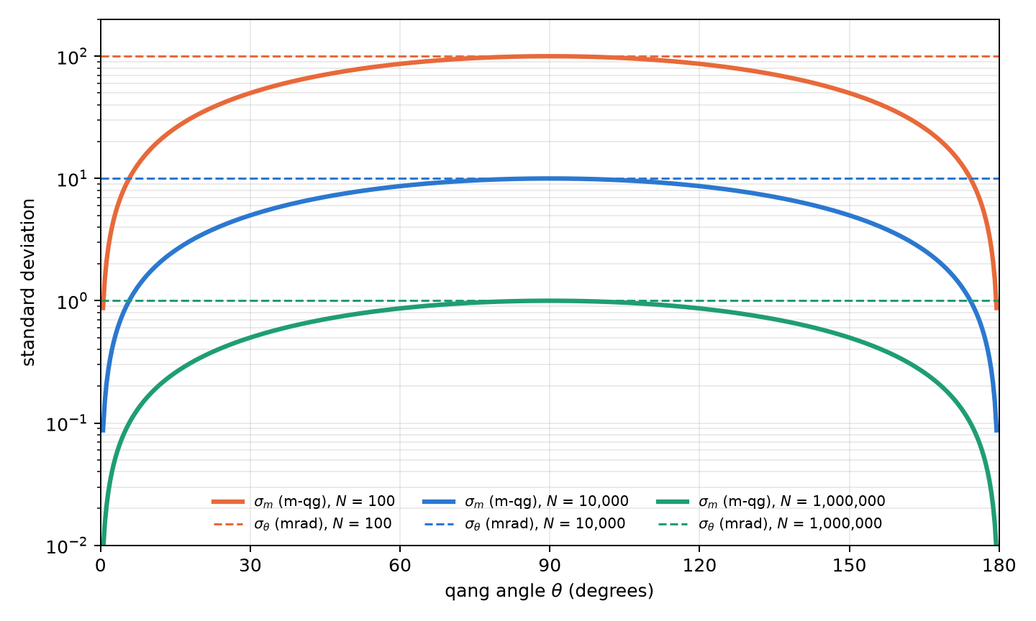
Figure 1.3: Resolution from shots. Solid lines: standard deviation $σ_{m}$ of the m-qg reading; dashed lines: $σ_{θ}$ of the qang angle in milliradians, which does not depend on the state. For each $N$, the two coincide at $θ={90}^{∘}$.

1.2.4 Gate error budget
The scale lets a gate error be expressed in the same units as the read-out. If the amplitude of a pulse has a random relative error of standard deviation $σ$, the expected polar bias after $R_{x}(θ)$ is
$$E[qg_{Z}]=cosθ e^{−θ^{2}σ^{2}/2} ⇒ ε_{m}=1000cosθ\left(e^{−θ^{2}σ^{2}/2}−1\right) \text{m-qg}$$
(§160). The error pulls the reading towards the equator: with $σ=0.05$, an $X$ gate ($θ=π$) delivers $qg_{Z}=−0.988$ instead of $−1$, a shift of $12.3$ m-qg, and it grows with the square of the angle (Figure 1.4). A $π/2$ rotation does not shift at all, because it already sits on the equator. Chapter 2 uses this formula to choose, among equivalent representations of the same gate, the one with the smallest pulse area.
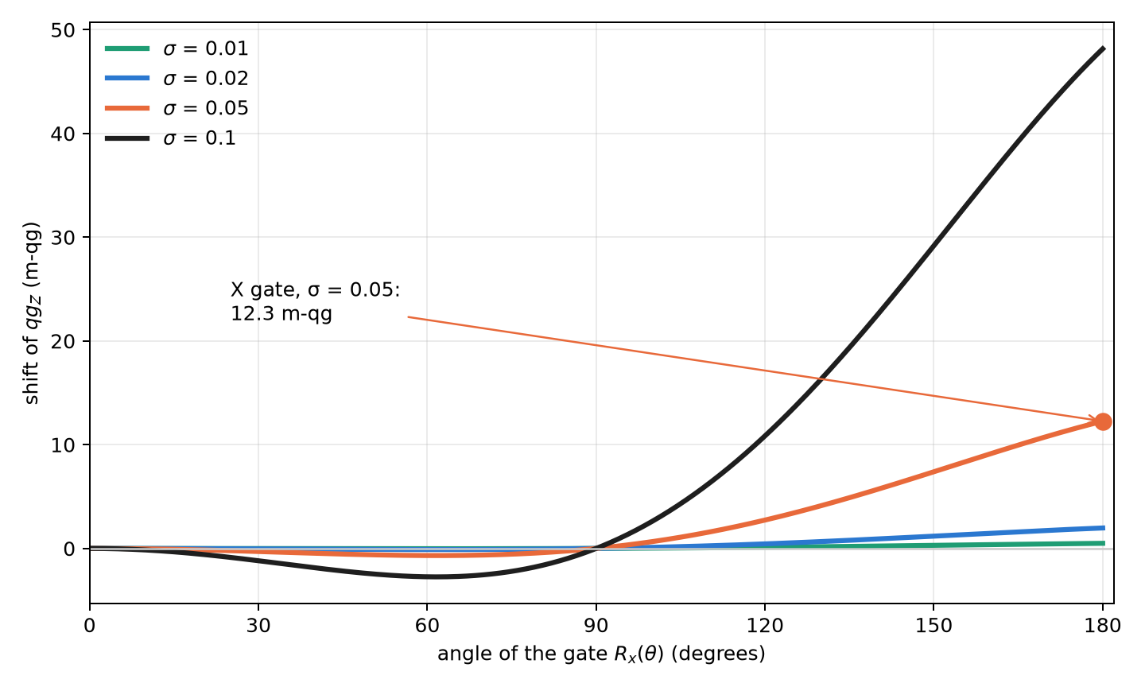
Figure 1.4: Error budget in milli-qang: shift of the polar bias after $R_{x}(θ)$ for several relative amplitude errors $σ$.

1.3 The probability equation of the qang and the milli-qang
The previous sections lead to a single statement, which is the foundation of the whole book: every qang reading of a qubit is an exact function of a single probability, $p_{0}$:
$$\boxed{ θ=2arccos\sqrt{p_{0}}, qg_{Z}=2p_{0}−1, qg_{S}=H(p_{0}), m=2000 p_{0}−1000 \text{m-qg} }$$
and, in the other direction, the probability equation of the milli-qang:
$$p_{0}=\frac{1000+m}{2000}, θ=arccos\frac{m}{1000}.$$
There are no approximations: they are four readings of one number. Figure 1.5 shows them together. $qg_{Z}$ and the milli-qang are the same straight line on two scales; the angle is monotonic but steepens at the poles; the entropy rises up to the equator and falls again, which is why it needs a branch to be inverted. Table 1.1 gives the reference values.
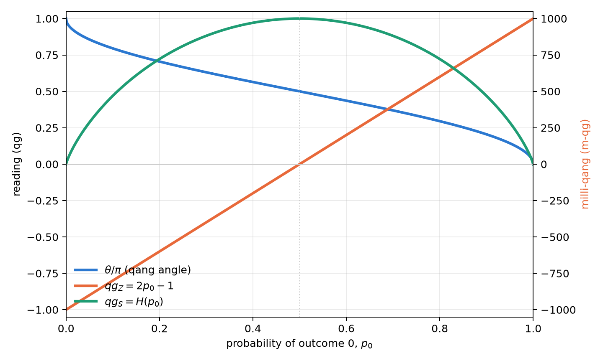
Figure 1.5: The readings of one probability. The right axis expresses $qg_{Z}$ in milli-qang.

Table 1.1: Anchor points of the probability equation.
$θ$​ | $p_{0}$​ | $qg_{Z}$​ | m-qg | state
$0$​ | $1$​ | $+1$​ | $+1000$​ | pole $|0⟩$
$π/4$​ | $0.854$​ | $+0.707$​ | $+707$​
$π/3$​ | $0.75$​ | $+0.5$​ | $+500$​
$π/2$​ | $0.5$​ | $0$​ | $0$​ | equator ($|+⟩$, $|+i⟩$, …)
$2π/3$​ | $0.25$​ | $−0.5$​ | $−500$​
$π$​ | $0$​ | $−1$​ | $−1000$​ | pole $|1⟩$

1.3.1 More than two outcomes: the statistical distance
The equation generalizes to a measurement with several outcomes. For two distributions $p=(p_{k})$ and $q=(q_{k})$, Wootters’ statistical distance (1981), or Bhattacharyya angle, is
d(p,q)=arccosk​pk qk.
For two outcomes, the distance between $(p_{0},1−p_{0})$ and the pole $(1,0)$ is $arccos\sqrt{p_{0}}=θ/2$: up to the factor 2, the qang angle is the statistical distance between what is measured and the reference state. With three outcomes, for example, $p=(0.5,0.3,0.2)$ and $q=(0.4,0.4,0.2)$ are $0.113$ rad apart. This is the door through which the unit leaves the qubit: Part II uses it for the Fisher information and the Fubini–Study metric, and the same geometry holds for any measured proportion, quantum or not.

1.4 Why measure in qg: the geometry–probability gap
The relation $p_{0}=\cos^{2}(θ/2)$ between the control parameter and the observed quantity is non-linear, and its derivative vanishes at the poles. This has concrete consequences. If a variational algorithm wants to adjust the state according to what it measures, the chain rule introduces the factor
$$\frac{dE}{dq}=−\frac{1}{sinθ} \frac{dE}{dθ},$$
which diverges at $θ=0$ and $θ=π$ (research notes, §1). And if $θ$ is to be estimated from $N$ shots, the variance of ${\hat{p}}_{0}$ changes with the state, so the uncertainty of each reading depends on where the qubit is (§5). Neither problem is exotic: both appear as soon as one reasons in terms of what the experiment delivers, and the probability equation is the tool to handle them.

1.5 Inversion and the branch sign
The angle is recovered with $θ=arccos(qg_{Z})$. The inversion has a limit: $cosθ$ is even, so $qg_{Z}$ does not distinguish $θ$ from $−θ$. As long as one works on $[0,π]$ there is no problem, but an optimizer that needs to cross a pole gets stuck. The remedy is to measure the sign of the sine as well: the pair $(qg_{Z},s)$ with $s=sign(qg_{X})$ is one-to-one on the whole circle (§65). In the H₂ molecule the variational optimum is at $θ≈−0.22$; every update that uses only $qg_{Z}$ stops at the Hartree–Fock state, while the signed version reaches the exact energy.

1.6 The outcome entropy: $qg_{S}$
The polar bias says where the qubit points; it does not say how unpredictable the measurement is. That is the role of the superposition spread, the Shannon entropy of the outcome:
$$qg_{S}=H(p_{0})=−p_{0}\log_{2}p_{0}−(1−p_{0})\log_{2}(1−p_{0})∈[0,1].$$
Since $qg_{Z}$ and $qg_{S}$ depend on the same population $p_{0}$, they are tied by an exact, branch-free identity (§7):
$$qg_{S}=H​\left(\frac{1+qg_{Z}}{2}\right),$$
valid for every single-qubit state, pure or mixed, however it was prepared. Its derivative, ${d qg_{S}}/{d qg_{Z}}=1/2\log_{2}{1−qg_{Z}}/{1+qg_{Z}}$, diverges at the poles: it is the entropic counterpart of the gradient singularity. Near a pole, a minimal change of the bias produces an enormous relative change of the entropy.

1.7 Invertibility of $qg_{S}$ and its error bars
Unlike $qg_{Z}$, the entropy is not invertible over the whole domain: $qg_{S}(θ)=qg_{S}(π−θ)$. The population $p_{0}$ decreases from 1 to 0 on $[0,π]$ and $H$ rises up to $p=1/2$ and then falls, so $qg_{S}$ is strictly increasing on $[0,π/2]$ and strictly decreasing on $[π/2,π]$ (Figure 1.5). Inversion requires choosing one of the two halves (§2).
Estimating $qg_{S}$ from finite shots raises a further problem: the entropy is flat at its maximum, and the delta method gives a zero standard error exactly where $qg_{S}≈1$. The native qang solution is to build the Wilson interval for $qg_{Z}$ and map it through the identity above; since $H$ is unimodal, the image is a valid interval. Over 2000 repetitions that interval kept a coverage of 0.90–0.99 in every case tested, even where the Wald interval or the bootstrap fell below 0.40 (§51).

1.8 The qang angle as the arcsine transformation
The central statistical property of the unit follows from propagating shot noise. With ${\hat{qg}}_{Z}=2{\hat{p}}_{0}−1$,
$$Var({\hat{qg}}_{Z})=\frac{\sin^{2}θ}{N}, Var(\hat{θ})≈Var({\hat{qg}}_{Z}){\left(\frac{dθ}{d qg_{Z}}\right)}^{2}=\frac{\sin^{2}θ}{N}⋅\frac{1}{\sin^{2}θ}=\frac{1}{N}.$$
The $\sin^{2}θ$ factors cancel exactly: the uncertainty of the qang angle does not depend on the state (§5), which is the horizontal dashed line of Figure 1.3. It is not a coincidence. Since $p_{0}=\cos^{2}(θ/2)$, the qang angle is, up to the reflection $θ→π−θ$, the classical arcsine transformation of a proportion, $ϕ=2arcsin\sqrt{p}$, introduced by Bartlett (1947), Anscombe (1948) and Freeman and Tukey (1950) precisely to stabilize the variance (§125).
The claim was checked with exact binomial sums, without simulation: with $n=100$, $(n+1/2)Var(\hat{θ})$ lies between 1.000 and 1.001; the coverage of the interval $\hat{θ}±z/\sqrt{n+1/2}$ stays between 0.930 and 0.962 for $n∈\{30,100,1000\}$. The prediction failed in one case, and it is worth saying: with $np≈2.5$ both the angular and the Wald intervals lose coverage. The stabilization is asymptotic, and the regime of very few events requires the exact intervals of chapter 4.

1.9 Mixed states and multi-qubit registers
The definitions extend unchanged to mixed states and to registers:
- Mixed states. $qg_{Z}=Tr(ρσ_{z})$ no longer determines the state. The classical mixture of $|0⟩$ with weight 0.2 and $|1⟩$ with weight 0.8 has $qg_{Z}=−0.6$ and von Neumann entropy 0.72, a combination no pure state reproduces (§3). For a qubit of Bloch length $r<1$, the cancellation of the previous section is no longer exact: $Var(\hat{θ})=\left[1+{1−r^{2}}/{r^{2}\sin^{2}θ}\right]/N$, equal to the quantum Cramér–Rao bound $1/(Nr^{2})$ on the equator (§45).
- Registers. Each qubit has its local profile, obtained by partial trace, and the register has a joint entropy normalized by the number of qubits (§4). The Bell state illustrates it: each qubit has $qg_{Z}=0$ and a local entropy of 1 bit, but the normalized joint entropy is 0.5. The register is globally pure and locally mixed; the local profiles are not enough to describe it, and chapter 5 returns to this point with the Bloch radius.

1.10 Scope and limits of the base
It is worth stating precisely what this base brings and what it does not, before building the rest of the book on it.
What it is not. The qang unit is not new physics. The polar bias is the expectation value of $σ_{z}$, the qang angle is the arcsine transformation of a proportion and the milli-qang is, mathematically, $1000 ⟨σ_{z}⟩$. None of these readings holds information that the probability $p_{0}$ does not already have; the probability equation says so explicitly. Nor does it reduce the shots a given precision requires (Chapter 4).
What it is. A working scale, in the sense of the decibel: it puts preparation, gate error, shot noise and read-out in the same units, so that they add, compare and can be budgeted. The question that matters is then empirical: does reasoning in milli-qang predict what a real processor does?
First test on hardware (§168). It was answered with a pre-registered experiment on one qubit of IQM’s superconducting Garnet processor: 26 circuits of 4000 shots, with four predictions fixed before the run. The result was mixed, and it is reported in full:
- The cost of a gate is measurable and budgetable in m-qg. Chaining 3 to 41 $X$ gates, the shortfall of the reading (corrected for the readout errors measured at the poles) grows with a single slope: 1.64 m-qg per $X$ gate, with a $χ^{2}$ per degree of freedom of 0.81. After 41 gates it is 63 m-qg, eight standard deviations above zero (Figure 1.6, left). Linear rather than quadratic growth points to incoherent error, relaxation during the pulses, and not to a coherent over-rotation.
- The scale makes visible an error that the readout model hides. The affine readout predicted from the poles fits at the equator, but the four intermediate angles read between 16 and 55 m-qg low (Figure 1.6, right). The processor calibrates the angles $0$, $π/2$ and $π$ well; the others carry a rotation error of tens of m-qg. The prediction passed by the 4-of-5 rule, not cleanly.
- One prediction failed. The ten copies of the equator circuit scattered half as much as binomial shot noise allows, something independent shots cannot produce and which happens by chance with probability 0.013. A single run does not decide whether it was a fluke or a property of how the device returns batched circuits.
- Another prediction was badly designed. Fitting two parameters on four points left an extrapolation band so wide that any reading passed. It is recorded as a design flaw, not as a success.
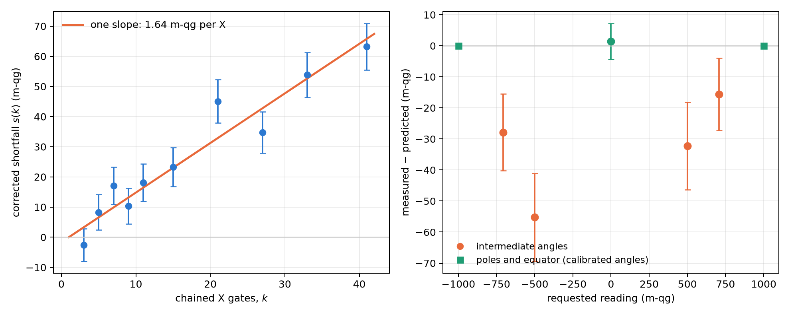
Figure 1.6: First test of the milli-qang on hardware (§168, IQM Garnet, one qubit, 4000 shots per circuit). Left: shortfall of the reading after $k$ $X$ gates, readout-corrected, with the single-slope line. Right: difference between measured and predicted by the affine readout; the poles are zero by construction, because they define the calibration.
The balance: on a real chip, the milli-qang turned the error of a gate into a budgetable number and exposed an angle error that the usual model does not see. But it was tested on one qubit, once, and shot noise did not describe the scatter of repeated circuits. Replication on more qubits and on another day is pending, and the book treats this base as solid mathematically and promising, but not yet consolidated, experimentally.

1.11 Without qang and with qang
Table 1.2: The chapter’s actions without the qang scale and with it.
action | without qang | with qang | difference
describe the outcome of a qubit | the probability $p_{0}$ (or $⟨Z⟩$) | $qg_{Z}$, the angle $θ$, $m$ and $qg_{S}$, all exact functions of $p_{0}$ | none in content: the same information; qang gives it a working scale from $−1000$ to $+1000$
error bar of a reading | $\sqrt{p_{0}(1−p_{0})/N}$, different for each state | the angle has variance $1/N$ for every pure state; in m-qg, $1000sinθ/\sqrt{N}$ | in favour: a single, state-independent bound for planning shots
compare a gate error with shot noise | infidelity on one side, binomial deviation on the other, in different units | both in m-qg (on Garnet, 1.64 m-qg per $X$ gate against the run’s shot noise) | in favour: one scale for the error budget
improve the device | — | — | none: the scale measures, it does not correct; prediction M2 of §168 failed

Balance. The base adds no information to $p_{0}$: it reorganizes it. What it gains is a uniform error bar in the angle and a common unit for gate errors and shot noise, which are exactly the two things the rest of the book uses.

1.12 In code
The qang.probability module is this chapter’s analysis tool: it reads counts and returns every reading, each with its interval.
import math
from qang import probability as pb
pb.readings_from_p0(0.75) # theta = 1.047 (60°), qg_Z = 0.5, qg_S = 0.811, 500 m-qg
# 750 zeros in 1000 shots, against a target qg_Z = 0.5
r = pb.analyze(750, 1000, target_qg_z=0.5)
r.milliqang # (500.0, 444.5, 551.7) m-qg: estimate and Wilson interval
r.theta # (1.047, 0.986, 1.110) rad = 60.0°, 56.5°, 63.6°
r.qg_s # (0.811, 0.768, 0.852)
r.deviation_milliqang # 0.0 m-qg from the target
pb.angle_per_milliqang(math.pi / 2) # 0.001 rad: one m-qg is one milliradian on the equator
pb.pole_angle(1.0) # 0.0447 rad: one m-qg below the pole
pb.shots_for_resolution(10, math.pi / 2) # 10000 shots to resolve 10 m-qg
pb.pulse_error_milliqang(math.pi, 0.05) # 12.3 m-qg: X gate with a 5 % amplitude error
pb.statistical_angle([0.5, 0.3, 0.2], [0.4, 0.4, 0.2]) # 0.113 rad
The figures of this chapter are generated by tools/make_cap01_figures.py, which uses the same functions.

1.13 Summary
- Definition. The polar bias $qg_{Z}=⟨σ_{z}⟩=2p_{0}−1=cosθ$ is bijective, directly measurable and valid for mixed states; the qang angle $θ=arccosqg_{Z}$ and the entropy $qg_{S}=H(p_{0})$ complete the unit.
- Milli-qang. $1 \text{qg}=1000$ m-qg; the scale is linear in probability (1 m-qg $=Δp_{0}=0.0005$) and not linear in angle (1 mrad on the equator, ${2.56}^{∘}$ next to the pole). Resolving $δ$ m-qg takes $(1000sinθ/δ)^{2}$ shots, and gate errors are budgeted in the same units.
- Probability equation. $θ$, $qg_{Z}$, $qg_{S}$ and $m$ are exact functions of a single probability $p_{0}$; with several outcomes, the qang angle generalizes to Wootters’ statistical distance.
- Statistics. The qang angle is the arcsine transformation of a proportion: its variance is $1/N$ for every pure state, with a known correction for mixed states.
- Scope. The unit is not new physics but a working scale. On real hardware (§168) it measured a cost of 1.64 m-qg per $X$ gate, linear in the number of gates, and exposed angle errors of 16–55 m-qg; a prediction about shot noise failed and replication is pending.

2. Native gates, closed algebra and the universal operator
Chapter 1 described the state of a qubit in qg units and reduced all its readings to a single probability, $p_{0}$, with the milli-qang as the working scale. This chapter does the same for operations: how a state is prepared from its probability or its m-qg reading, how any single-qubit gate is written as an algebraic function of $qg_{Z}$, why its action on the populations is the probability equation of Chapter 1, how the idea extends to systems with more levels, and which compilation rules follow when the error of a gate, measured in m-qg, depends on its angle.

2.1 The elementary gate $R_{qg}$
The basic operation is to prepare, from $|0⟩$, the state with polar bias $q$: a rotation $R_{y}(θ)$ with $θ=arccosq$. qang provides it as a native gate in the three most widely used development kits (§6):
- Qiskit: RQangGate(q) and FullRQangGate(q, φ), the latter with the azimuthal phase.
- Cirq: rqang_gate(q), built on cirq.ry, and full_rqang_gate(q, φ), a MatrixGate with the same convention as Qiskit’s U gate.
- PennyLane: the same pair, differentiable with respect to $q$.
By the probability equation (Section 1.3), the gate parameter can be set from any of the readings: for a probability $p_{0}$ use $q=2p_{0}−1$, and for a reading of $m$ m-qg, $q=m/1000$. Asking for $p_{0}=0.75$ or for $+500$ m-qg is asking for the same gate, $R_{y}({60}^{∘})$.
All three prepare exactly the same state for the same qg value, which is checked both on the measured probabilities and on the state-vector fidelity. The gate accepts symbolic parameters (Qiskit Parameter, sympy symbols), so it can sit inside parameterized circuits.
A signed variant, SignedRQangGate, applies $R_{y}(s⋅arccosq)$ with $s=±1$: it is the gate form of the branch sign of Chapter 1, and prepares the same state as the full gate with $φ=0$ or $π$ (§68).

2.2 The universal operator in qg
Every single-qubit gate is, up to a global phase, $U(θ,φ,λ)$. With $q=cosθ$ the half-angles become algebraic,
$$cos\frac{θ}{2}=\sqrt{\frac{1+q}{2}}, sin\frac{θ}{2}=\sqrt{\frac{1−q}{2}},$$
and the universal gate is written without trigonometric functions of $q$:
$$U_{3}^{qg}(q,φ,λ)=\left(\begin{matrix}\sqrt{\frac{1+q}{2}} & −e^{iλ}\sqrt{\frac{1−q}{2}} \\ e^{iφ}\sqrt{\frac{1−q}{2}} & e^{i(φ+λ)}\sqrt{\frac{1+q}{2}}\end{matrix}\right).$$
The amplitudes depend on the polar bias only, and the phases are decoupled into the factors $e^{iφ}$ and $e^{iλ}$. An immediate consequence is the transition matrix, the probabilities $|U_{ij}|^{2}$:
$$T(q)=\left(\begin{matrix}{1+q}/2 & {1−q}/2 \\ {1−q}/2 & {1+q}/2\end{matrix}\right),$$
doubly stochastic, rational in $q$ and independent of the phases. Seen from a measurement in the computational basis, every single-qubit gate is a binary symmetric channel with parameter $(1−q)/2$.

2.3 The gate as a probability equation
The transition matrix is Chapter 1’s probability equation written for an operation. With $p_{0}=(1+q)/2$,
$$T=\left(\begin{matrix}p_{0} & 1−p_{0} \\ 1−p_{0} & p_{0}\end{matrix}\right), p_{0}=\frac{1000+m}{2000}:$$
the action of any single-qubit gate on the populations is fixed by a single number, its reading in m-qg. The identity and $Z$ sit at $+1000$ m-qg (they do not move populations), $X$ at $−1000$ (it swaps them) and the Hadamard at $0$ (it equalizes them). The phases $φ$ and $λ$ do not appear: they are invisible to a $Z$ measurement and only show up when gates are composed, as Chapter 3 shows.
The entropic reading has its version for operations too. The capacity of the binary symmetric channel with parameter $(1−q)/2$ is $1−H\left((1−q)/2\right)$, and since $H$ is symmetric, $H\left((1−q)/2\right)=H(p_{0})=qg_{S}$:
$$C=1−qg_{S}.$$
A gate at a pole ($qg_{S}=0$) carries one full bit per use; the Hadamard ($qg_{S}=1$) carries nothing from the computational basis to itself.

2.4 Verification against standard libraries
The formula was checked against Qiskit’s U gate on 2000 random gates, with a largest difference of $3.5×{10}^{−14}$ (§166). The usual gates appear at simple values:
Table 2.1: Standard gates as points of $U_{3}^{qg}$.
gate | $q$​ | m-qg | $φ$​ | $λ$​
$I$​ | $1$​ | $+1000$​ | $0$​ | $0$​
$X$​ | $−1$​ | $−1000$​ | $0$​ | $π$​
$Z$​ | $1$​ | $+1000$​ | $0$​ | $π$​
$H$​ | $0$​ | $0$​ | $0$​ | $π$​

The table reads in qg: $X$ is the only case with bias $−1$ (it flips the qubit), $Z$ and the identity do not change the populations ($q=1$) and differ only by a phase, and the Hadamard takes the qubit to the equator ($q=0$).

2.5 Beyond the qubit: the Cartan subalgebra
For a $d$-level system (a qudit), the analogue of $σ_{z}$ is not one matrix but the Cartan subalgebra of $su(d)$: the $d−1$ diagonal generalized Gell-Mann matrices,
$$λ_{k}=\sqrt{\frac{2}{k(k+1)}} diag(\underset{k}{\underset{⏟}{1,…,1}},−k,0,…,0), k=1,…,d−1,$$
normalized so that $Tr(λ_{j}λ_{k})=2δ_{jk}$. Their expectation values are linear in the populations and determine them:
$$p=\frac{1}{d}+\frac{1}{2}\sum_{k=1}^{d−1}{⟨}λ_{k}⟩ diag(λ_{k}).$$
For $d=2$ a single matrix remains, $λ_{1}=σ_{z}$, its expectation value is $qg_{Z}$ and the formula reduces to $p_{0}=1/2+1/2 qg_{Z}$: the probability equation of Chapter 1. This is the natural generalization of the unit: a vector of $d−1$ qg values measurable in the computational basis, each expressible in m-qg, which fixes the $d$ probabilities the way $qg_{Z}$ fixes $p_{0}$ (§166).
Definition and usefulness should be kept apart. Whether a three-level readout gives qang an advantage was asked on a concrete case, a transmon leaking to the level $|2⟩$ in a surface-code memory, and the answer was no: reading $|2⟩$ as 1 is usually right, and declaring the qubit erased discards that information (§70). qang remains a qubit construction; the qudit generalization is an identity, not a demonstrated advantage.

2.6 The minimal pulse-area principle
On devices with fractional gates (rotations $R_{X}(θ)$ or $R_{ZZ}(θ)$ with a continuous angle), the pulse area grows with $|θ|$, and so do the amplitude-miscalibration error and the relaxation during the pulse. In qg units, a random amplitude error of standard deviation $σ$ damps the read-out as
$$qg_{Z}=cosθ e^{−θ^{2}σ^{2}/2},$$
and a fixed one $ε$ gives $cos(θ(1+ε))$, with first-order error $1000 ε θsinθ$ m-qg. The sensitivity $d qg_{Z}/dθ=−sinθ$ is largest at $π/2$ and vanishes to first order at $0$ and $π$ (§160). This is Chapter 1’s milli-qang error budget (Figure 1.4), and the scale makes the gate error comparable with the shot noise of the read-out: with $σ=0.05$, the shift of an $X$ (12.3 m-qg) is of the order of the resolution of ${10}^{4}$ shots on the equator (10 m-qg).
Every gate has shorter representatives. $R_{X}(θ)=−R_{X}(θ−2π)$ has period $2π$ up to a global phase, and Figure 2.1 shows what is gained: asking for $R_{X}({324}^{∘})$ as is shifts the reading by $−31.7$ m-qg, while its representative $R_{X}(−{36}^{∘})$, the same gate, shifts it by $−0.4$ m-qg.
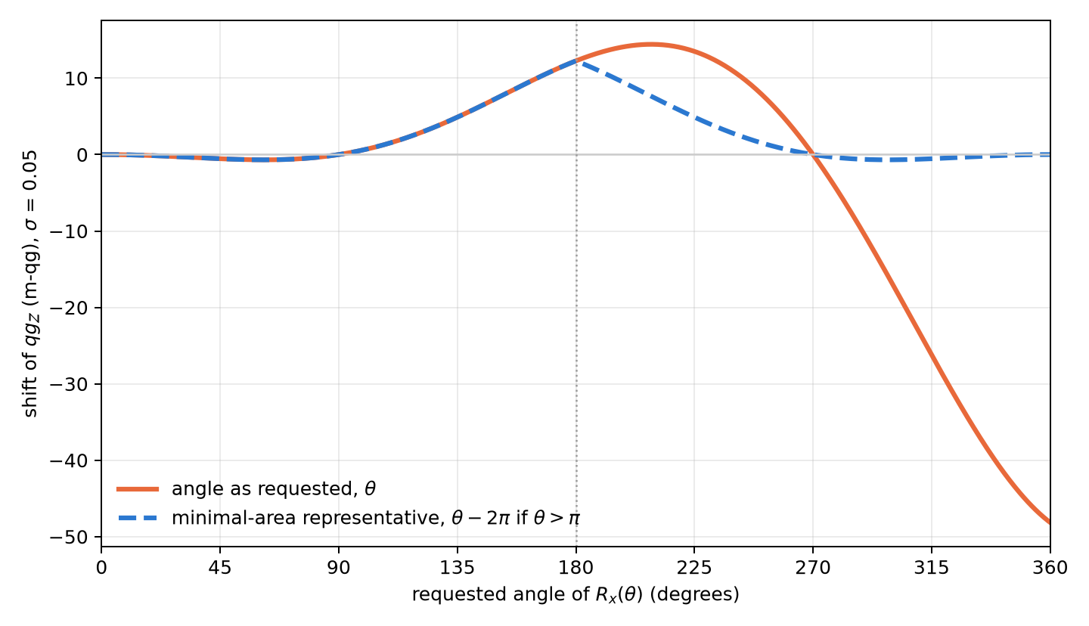
Figure 2.1: Milli-qang error of $R_{x}(θ)$ under a random amplitude error $σ=0.05$: the angle as requested against the minimal-area representative. Below ${180}^{∘}$ they coincide; above it, the short representative avoids the error that grows with the square of the angle.
More interesting: $R_{ZZ}(θ+π)=R_{ZZ}(θ) (−i Z⊗Z)$, and $Z⊗Z$ is two virtual $R_{Z}(π)$ rotations, free on superconducting processors. So $R_{ZZ}$ has period $π$ and its area never needs to exceed $π/2$. The function minimal_area_circuit rewrites a circuit with those representatives and preserves the unitary exactly, global phase included.
On a 4-qubit QAOA model with errors proportional to the area (150 instances), reducing the angles modulo $2π$ cut the total area 4.4× and the error (total variation distance) 4.1×; using the period $π$ of $R_{ZZ}$ as well cut it another 1.14×. The recorded prediction was 1.5× and it failed: half of the area, that of the $R_{X}$ rotations, was already minimal after the first reduction. The general result stands: the error follows the area. Two scope notes: on IBM processors ordinary single-qubit rotations are virtual $R_{Z}$ plus fixed $\sqrt{X}$ pulses, of duration independent of the angle, so the rule applies to fractional gates; and the benefit depends on how strongly the error scales with the area on each platform.

2.7 An exposure screen before running
The symmetry filter (Chapters 20–21) discards the shots that left the conserved Hamming-weight sector. But a decay that happens while part of the state is outside the sector can rotate back in and pass the filter. That suggests a prior measure, computable without noise: the exposure, the population outside the sector right after each two-qubit gate (qang.sectors.sector_exposure).
Over 16 compilations of one step of an XXZ chain, the rank correlation between exposure and T1 leak was exactly 0.80, the recorded threshold, and the zero-exposure compilations removed at least 98% of the T1 error (§68):
Table 2.2: Exposure computed without noise against the measured leak.
compilation | exposure | T1 leak
3 CNOT | 0.42 | 16–52%
Mølmer–Sørensen, ZZ by basis change | 0.16–0.24 | 20–78%
Mølmer–Sørensen rotations | 0.0006–0.047 | 0.4–17%
number-conserving | 0 | 0.0–2.0%

The screen ranks compilations, not time steps: within one compilation the relation is weaker. Its practical value is choosing the compilation before spending shots.

2.8 One qubit order for every kit
A practical detail that causes silent errors: Qiskit writes qubit 0 at the right of the bitstring, while Cirq, PennyLane, Braket and pytket put it first. qang.interop converts any result to $\{(b_{0},…,b_{n−1}):\text{count}\}$ and computes the qg read-outs on that form: per-qubit $qg_{Z}$ with its error, the filter and the register entropy (§130). A 3-qubit W state sampled with 20 000 shots in each kit gave $qg_{Z}$ between 0.316 and 0.343 (ideal $1/3$), all shots in weight 1 and register entropy 0.528 (ideal $\log_{2}3/3$), alike in all three. In milli-qang the readings run from 316 to 343 m-qg against 333 ideal; with 20 000 shots the resolution is $σ_{m}=1000sinθ/\sqrt{N}=6.7$ m-qg, so the largest deviation ($−17$ m-qg) sits at about 2.6σ: it is shot noise, not a difference between kits.

2.9 Without qang and with qang
Table 2.3: The chapter’s actions without the qang scale and with it.
action | without qang | with qang | difference
prepare a state with a given probability | compute $θ=2arccos\sqrt{p_{0}}$ and apply $R_{Y}(θ)$ | the $R_{qg}$ gate takes the target reading directly, in qg or m-qg | convenience: the physical gate is the same
describe a gate’s action on populations | the full unitary, with phases | a doubly stochastic transition matrix set by one number in m-qg, with capacity $1−qg_{S}$ | in favour for populations; against for phases, which the description loses (Chapter 3)
budget the error of a fractional gate | process fidelity | error in m-qg: from $−31.7$ to $−0.4$ m-qg for $R_{X}({324}^{∘})$ with the minimum-area representative | the improvement is the minimum-area principle’s; m-qg makes it comparable with shot noise
generalize to qudits | Gell-Mann matrices | the Cartan subalgebra as a qg identity | none shown: no advantage of reading more levels was found

Balance. For gates, qang is a compact way of writing what happens to the populations, and m-qg is the unit in which pulse error and shot noise are compared. The measured gain, the minimum area one, belongs to the physical principle, not to the unit.

2.10 In code
import math
from qang import algebra, probability, pulse_area
U = algebra.u3_qang(0.0, 0.0, math.pi) # the Hadamard as the point (q, φ, λ) = (0, 0, π)
algebra.transition_matrix(0.3) # [[0.65, 0.35], [0.35, 0.65]]: p0 = 0.65, +300 m-qg
algebra.cartan_values([0.5, 0.3, 0.2]) # the two qg values of a qutrit
pulse_area.minimal_area_angle(3.5, math.pi) # (0.358, 1): RZZ(3.5) = RZZ(0.358) · (Z ⊗ Z) · phase
pulse_area.rx_qg_z_random_amplitude(math.pi, 0.05) # -0.988 instead of -1
probability.pulse_error_milliqang(math.pi, 0.05) # 12.3 m-qg of error on an X

2.11 Summary
- Preparation by polar bias is native in Qiskit, Cirq and PennyLane, with the same convention and a signed variant.
- Every single-qubit gate is an algebraic function of $q=qg_{Z}$ and two phases; its transition matrix is doubly stochastic, does not depend on the phases and is the probability equation of Chapter 1: a single m-qg number fixes its action on the populations, and the channel capacity is $1−qg_{S}$.
- The Cartan subalgebra of $su(d)$ generalizes $qg_{Z}$ to qudits as an identity; no advantage of a multi-level readout was shown.
- In fractional gates the error follows the pulse area; choosing the shortest representative reduces it (from $−31.7$ to $−0.4$ m-qg for $R_{X}({324}^{∘})$), and the budget is stated in m-qg, the same scale as the shot noise.
- The exposure outside the sector, computed without noise, ranks compilations by how much T1 the filter will let through.

3. Reflections, Householder and Grover dynamics
Grover’s algorithm is, at heart, a sequence of reflections. Written in qg units, each reflection is an algebraic matrix in the polar bias, the trajectory of the algorithm is a Chebyshev polynomial and the information each iteration brings has a closed form. Everything rests on the base of Chapter 1: the transition probability between two states is a probability like $p_{0}$, with its own qang angle and m-qg reading, and the bias of Grover’s flag is read on the same scale. This chapter develops that reading and sets it against what happens when the gates are noisy, where the qg reading loses to the simplest tool.

3.1 Transition matrices without transcendental functions
Chapter 2 showed that every single-qubit gate has the transition matrix
$$T(q)=\left(\begin{matrix}{1+q}/2 & {1−q}/2 \\ {1−q}/2 & {1+q}/2\end{matrix}\right),$$
doubly stochastic and rational in $q$. By construction it is unistochastic: it comes from a unitary. Its composition shows the difference between classical probability and quantum amplitude. Two classical channels with biases $q_{1}$ and $q_{2}$ compose by multiplication: $T(q_{1})T(q_{2})=T(q_{1}q_{2})$. Two successive quantum rotations instead give
$$q_{12}=cos(θ_{1}+θ_{2})=q_{1}q_{2}−\sqrt{(1−q_{1}^{2})(1−q_{2}^{2})}.$$
The term $−\sqrt{(1−q_{1}^{2})(1−q_{2}^{2})}$ is the interference: the transverse part of each state, invisible in $T$, adding up in amplitude. With $q_{1}=0.3$ and $q_{2}=−0.5$, the classical composition gives $−0.15$ and the quantum one $−0.976$: in milli-qang, $−150$ against $−976$, an interference of 826 m-qg, close to half the scale. The transition matrix describes each gate on its own, but not the sequence: that needs the phases.

3.2 The Householder reflector in qg space
A reflection with respect to the state $|ψ⟩$ is the Householder operator $I−2|ψ⟩⟨ψ|$. For $|ψ(q)⟩=\sqrt{{1+q}/2}|0⟩+\sqrt{{1−q}/2}|1⟩$ it is
$$H(q)=I−2|ψ(q)⟩⟨ψ(q)|=−q σ_{z}−\sqrt{1−q^{2}} σ_{x},$$
a Hermitian, unitary matrix with $H(q)^{2}=I$, whose coefficients are the state’s own qg values: $q$ on $σ_{z}$ and its transverse part $\sqrt{1−q^{2}}$ on $σ_{x}$ (§166). On the Bloch sphere it is the rotation by $π$ about the axis of the state, together with an overall sign change.

3.3 The Grover diffuser as a qg reflection
The Grover diffuser reflects about the initial state: $D=2|ψ⟩⟨ψ|−I$. Comparing with the previous section,
$$D(q)=−H(q)=q σ_{z}+\sqrt{1−q^{2}} σ_{x}.$$
In the two-dimensional plane of the algorithm (the “good” state being searched for and the “bad” one, its complement), the oracle is the reflection about the bad axis and the diffuser the reflection about the initial state. The product of two reflections is a rotation by twice the angle between their axes: that is the whole of Grover’s dynamics.

3.4 Transition probability between qg states
The fidelity of two pure states is written with their qg vectors $r=(qg_{X},qg_{Y},qg_{Z})$:
$$|⟨ψ_{1}|ψ_{2}⟩|^{2}=\frac{1+r_{1}⋅r_{2}}{2}.$$
If the two states share a meridian (the same azimuthal phase), it depends on the polar biases alone:
$$P(q_{1}→q_{2})=\frac{1+q_{1}q_{2}+\sqrt{(1−q_{1}^{2})(1−q_{2}^{2})}}{2}.$$
The condition matters: with different azimuths the polar biases are not enough and the full transverse part is needed. The formula was checked against the inner product on 200 random pairs (§166).
The transition probability in the equation of Chapter 1. $P$ is a probability, so it has its own qang readings. If $γ$ is the angle between the two Bloch vectors, $r_{1}⋅r_{2}=cosγ$ and $P=\cos^{2}(γ/2)$: it is Born’s rule with $γ$ in place of $θ$. Therefore
$$2arccos\sqrt{P}=γ, m_{P}=2000 P−1000=1000 r_{1}⋅r_{2} \text{m-qg}:$$
the qang angle of the transition probability is the angle between the states, and its milli-qang reading is a thousand times the dot product of their qg vectors. It is Chapter 1’s Wootters statistical distance applied to two states (Section 1.3). With $q_{1}=0.3$ and $q_{2}=−0.5$ on the same meridian, $P=0.838$, $m_{P}=+676$ m-qg and $γ=0.828$ rad, which is exactly $|θ_{1}−θ_{2}|=|arccos0.3−arccos(−0.5)|$.

3.5 The Grover trajectory as a Chebyshev polynomial
Let $a=\sin^{2}t$ be the fraction of good states, read with a flag qubit whose initial bias is $qg_{0}=1−2a=cos2t$. Each iteration advances the amplitude angle by $2t$, so after $k$ iterations the angle is $(2k+1)t$ and
$$qg_{k}=cos\left((2k+1) 2t\right)=T_{2k+1}(qg_{0}),$$
with $T_{m}$ the Chebyshev polynomial of the first kind, $T_{m}(cosx)=cosmx$ (§37). By the probability equation, the success probability is $P_{k}=(1−qg_{k})/2$, and certain success is the pole at $−1000$ m-qg. For instance, with $a=0.1$, $qg_{0}=0.8$ and the successive iterations give $+800$, $−352$, $−997$ and $−206$ m-qg: the bias crosses the pole at $k=2$ ($P_{2}=0.9986$) and then moves away (Figure 3.1).
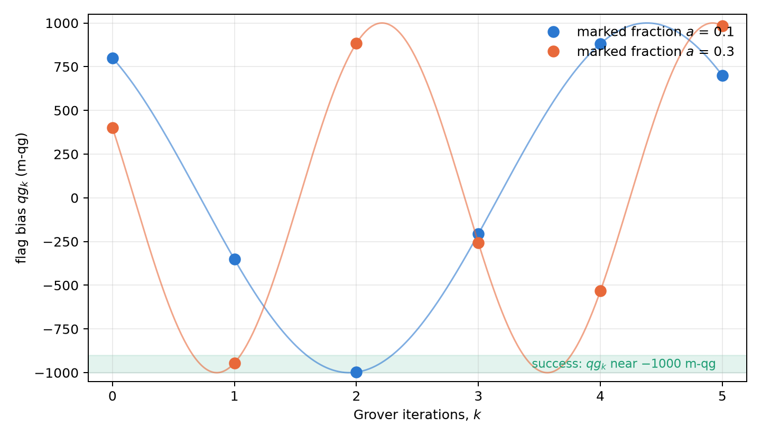
Figure 3.1: The Grover trajectory in milli-qang: the flag bias samples a cosine at the odd points $(2k+1) 2t$. With $a=0.1$ success arrives at $k=2$; with $a=0.3$ the angle is coarse, success arrives at $k=1$ and by $k=2$ the bias has overshot the pole.
The Chebyshev structure yields for free the one-shot Fisher information at depth $m=2k+1$. Since $T_{m}^{′}=mU_{m−1}$ and $1−T_{m}^{2}=(1−q^{2})U_{m−1}^{2}$,
$$F_{m}=\frac{m^{2}}{1−qg_{0}^{2}}:$$
depth multiplies the qg information of Chapter 1 by $m^{2}$, uniformly along the fringe. It is the qg form of the known factor $4m^{2}$ for the angle (Suzuki and co-workers, 2020). On the milli-qang scale, the resolution on $qg_{0}$ with $N$ shots at depth $m$ is $1000\sqrt{1−qg_{0}^{2}}/(m\sqrt{N})$ m-qg: with $a=0.1$ and 100 shots, 60 m-qg without iterating and 12 m-qg at depth $m=5$.

3.6 Analytic limits: coarse angles and overshoot
The optimal number of iterations is $k^{*}=round​\left(π/{4t}−1/2\right)$. When the searched fraction $a=M/N$ is small, $t$ is small, $k^{*}≈π/4\sqrt{N/M}$ and the rounding hardly matters. When $M/N$ is not negligible, the angle per iteration is coarse: the bias jumps in large steps along the curve $cos((2k+1)2t)$ and can overshoot the pole. Iterating more does not help; it hurts, because the rotation keeps going. The qg reading makes this behaviour visible: $qg_{k}$ samples a cosine at odd points. With $a=0.3$, $k^{*}=1$ gives $−944$ m-qg ($P=0.972$) and one more iteration jumps to $+884$ m-qg ($P=0.058$), the orange curve of Figure 3.1.

3.6.1 Grover with noise
With noisy gates the picture changes, and it is worth recording as it came out (§63). In searches on 4 to 6 qubits, with each multi-controlled Z compiled to 14, 36 and 84 CNOTs and depolarizing noise on every CNOT:
- Noise moves the best iteration earlier and eats the speed-up. With $n=6$ and $p_{2}=0.005$ the best iteration drops from 4 to 1 and the cost per verified success rises from 6.1 to 27.6 oracle calls, against 32 for classical search.
- The qg formula fails under gate noise. If the unmarked outcomes were uniform, each qubit would have $qg_{Z,i}=±(NP−1)/(N−1)$, and the signs would give the answer and the magnitude the success probability without knowing it. Depolarizing noise is not uniform after the diffuser, and the label-free estimate was worse than the frequency of the most common outcome in every case.
- Reading the answer from signs loses. With $n=5$, 100 shots find the marked item 66% of the time with the qg signs and 91% with the most frequent bitstring.
The honest balance: in Grover search the outcome histogram is a better estimator than the per-qubit qg reading. qg provides the Chebyshev picture and the information factor, not a better estimator.

3.7 Amplitude estimation
Where the Chebyshev structure does pay off is in amplitude estimation: using increasing depths to estimate $a$ with fewer oracle queries than direct sampling. With maximum-likelihood estimation (depths 0, 1, 2, 4, …, 100 shots each), without noise, the error falls as queries$​^{−0.93…−1.12}$ against queries$​^{−0.5}$ for Monte Carlo, and is 8.4–9.3 times lower at 26 200 queries (§37).
Noise sets limits. With depolarization $p=0.01$ per iteration, a likelihood that ignores the noise ends worse than Monte Carlo ($6.8⋅{10}^{−3}$ against $2.7⋅{10}^{−3}$), while one that includes it keeps a 4× advantage. With $p=0.05$, not even the noise-aware likelihood beats Monte Carlo: beyond a depth of order $1/p$ the iterations carry almost no signal.
On IonQ’s calibrated noisy simulator (3 qubits, $a=0.3$, 36 000 queries), the estimate was accurate, with an RMS error of 0.0005–0.0015 and a fitted visibility of 0.965–0.985 per iteration, and 7 to 30 times better than a realistic Monte Carlo, whose depth-zero circuit is biased by the device noise (§39).

3.8 Without qang and with qang
Table 3.1: The chapter’s actions without the qang scale and with it.
action | without qang | with qang | difference
transition probability between two states | $|⟨ψ|ϕ⟩|^{2}$​ | $(1+r_{1}⋅r_{2})/2$, with qang angle equal to the angle between the states and reading $1000 r_{1}⋅r_{2}$ m-qg | none in value; qang makes it geometric
Grover trajectory | $\sin^{2}((2k+1)θ_{0})$​ | $qg_{k}=T_{2k+1}(qg_{0})$, success at $−1000$ m-qg | equivalent; the Chebyshev form shows that the m-qg resolution improves by a factor $m$ with depth
read the search with noise | bit-string histogram | per-qubit qg reading | against: the qg reading loses to the histogram
estimate an amplitude with noise | maximum likelihood on counts | the same, with the noise written into the qg likelihood | in favour up to a depth near $1/p$, not beyond

Balance. The chapter’s identities are exact, but none gives a number that the usual amplitude does not. The only comparison with real noise in the chapter is unfavourable to the qg reading, and it is written down as such.

3.9 In code
from qang import algebra, probability
algebra.householder_qg(0.45) # -0.45 Z - 0.893 X, a reflection: H @ H = I
algebra.grover_diffuser_qg(0.45) # +0.45 Z + 0.893 X
P = algebra.transition_probability(0.3, -0.5) # 0.838, same meridian
algebra.transition_probability(0.3, -0.5, 0.0, 1.2) # different azimuths
probability.readings_from_p0(P) # theta = 0.828 rad (the angle between the states), +676 m-qg

3.10 Summary
- The transition matrix of a gate is rational in $q$, but it does not compose like the gate: the difference between $q_{1}q_{2}$ and $cos(θ_{1}+θ_{2})$ is the interference.
- The Householder reflector and the Grover diffuser are $∓(q σ_{z}+\sqrt{1−q^{2}} σ_{x})$.
- The transition probability between two states is $(1+r_{1}⋅r_{2})/2$; on a common meridian it depends on the polar biases alone. Read with the equation of Chapter 1, its qang angle is the angle between the states and its reading is $1000 r_{1}⋅r_{2}$ m-qg.
- The Grover trajectory is $qg_{k}=T_{2k+1}(qg_{0})$, with certain success at $−1000$ m-qg, and the Fisher information at depth $m$ is $m^{2}/(1−qg_{0}^{2})$: the m-qg resolution improves by a factor $m$.
- With noise, the per-qubit qg reading loses to the histogram in search; in amplitude estimation the advantage holds if the noise enters the likelihood, and ends near depth $1/p$.

4. Sampling statistics, Bayesian inference and the Haar distribution
Every number a quantum processor delivers is an estimate made from a finite number of shots. This chapter gathers the statistical tools of the qg unit: how shot noise propagates, which prior is the natural one for an unknown qubit, how to build intervals that do not collapse near the poles, how to correct the bias of quadratic quantities and how many shots to plan for. All of them rest on the base of Chapter 1: what is estimated is always the probability $p_{0}$, and since the milli-qang is linear in it, every interval and every shot plan is stated directly in m-qg. It closes with the mathematical foundation that explains why $qg_{Z}$ is the canonical read-out.

4.1 Propagating shot noise
With $N$ shots and $k_{0}$ outcomes 0, the natural estimator is ${\hat{qg}}_{Z}=2k_{0}/N−1$. It is unbiased and its variance is exactly
$$Var({\hat{qg}}_{Z})=\frac{1−qg_{Z}^{2}}{N}=\frac{\sin^{2}θ}{N},$$
which attains the Cramér–Rao bound for the parameter $qg_{Z}$: no unbiased estimator does better with the same information. In milli-qang it is the resolution $σ_{m}=1000\sqrt{1−qg_{Z}^{2}}/\sqrt{N}$ of Chapter 1 (Figure 1.3). Propagated to the angle by the delta method, the variance becomes constant, $Var(\hat{θ})≈1/N$, as seen in Chapter 1 (§5). The two statements are compatible: $qg_{Z}$ is the curved coordinate, with Fisher information $1/(1−qg_{Z}^{2})$ per shot, and $θ$ the flat one, with information 1 (Chapter 23).
The delta method is a first-order approximation and fails where the derivative vanishes. Near a pole, ${\hat{qg}}_{Z}$ is exactly $±1$ in a sizeable fraction of experiments, and the estimated standard error $\sqrt{(1−{\hat{qg}}_{Z}^{2})/N}$ becomes zero: the interval collapses exactly where the state is most extreme.

4.2 The Haar distribution in qg space
What is known about a qubit before it is measured? If its state is “any state”, the natural distribution is the Haar measure, the only one invariant under rotations. In qg units it takes a remarkable form: $qg_{Z}$ is uniform on $[−1,1]$. This is Archimedes’ hat-box theorem: the area of a band of the sphere between two latitudes is proportional to the difference of heights, not of angles. It was checked on 200 000 Haar states (§15).
The statistical consequence is direct. A uniform prior on $qg_{Z}$ is equivalent to $p_{0}∼Beta(1,1)$, and with $k_{0}$ zeros in $N$ shots the posterior is
$$p_{0}∣k_{0} ∼ Beta(k_{0}+1, N−k_{0}+1),$$
from which a credible interval for $qg_{Z}=2p_{0}−1$ follows with a beta function alone (bayes_qg_estimate, implemented without external dependencies and checked against scipy.stats.beta).
The probability equation of Chapter 1 explains why this prior is so simple. Since $m=2000 p_{0}−1000$ is linear, a distribution uniform in $qg_{Z}$ is uniform in milli-qang and uniform in $p_{0}$: the three statements are one. In the angle, by contrast, the same measure has density $1/2sinθ$ and piles up at the equator (Figure 4.1). The “uninformative” prior depends on the scale it is written in, and Haar’s is flat exactly on the scale that is measured.
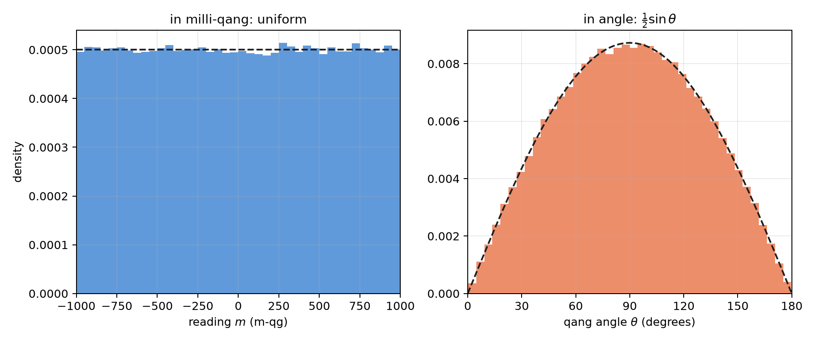
Figure 4.1: Two hundred thousand Haar states read in milli-qang (left) and in angle (right). The dashed line is the theoretical density: $1/2000$ per m-qg and $1/2sinθ$ in the angle.

4.3 Exact intervals near the poles
The comparison with 50 shots shows where the choice of interval matters (§15):
Table 4.1: Coverage of 95% intervals with 50 shots.
case | delta method | Wilson | Bayes–Haar
near a pole ($θ=0.08$): coverage of the 95% interval | 7.6% | 92.4% | 92.4%
Haar-random states: coverage | 89.8% | 95.1% | 94.9%

Near the pole the delta method covers the true value in fewer than one experiment in ten; Wilson and the Haar posterior recover the nominal coverage. On Haar states the posterior mean has a 4% lower mean squared error than the raw frequency.
Figure 4.2 shows the cause in milli-qang. With 50 shots, the width of the delta-method interval drops to zero at the ends of the scale: with 50 zeros in 50 shots it gives $[+1000,+1000]$ m-qg, an interval with no width. With 48 zeros it gives $[+811,+1029]$ m-qg, which runs off the top of the scale. Wilson gives $[+731,+978]$ and Bayes–Haar $+885$ $[+731,+975]$ m-qg: widths that do not collapse and stay inside $[−1000,+1000]$.
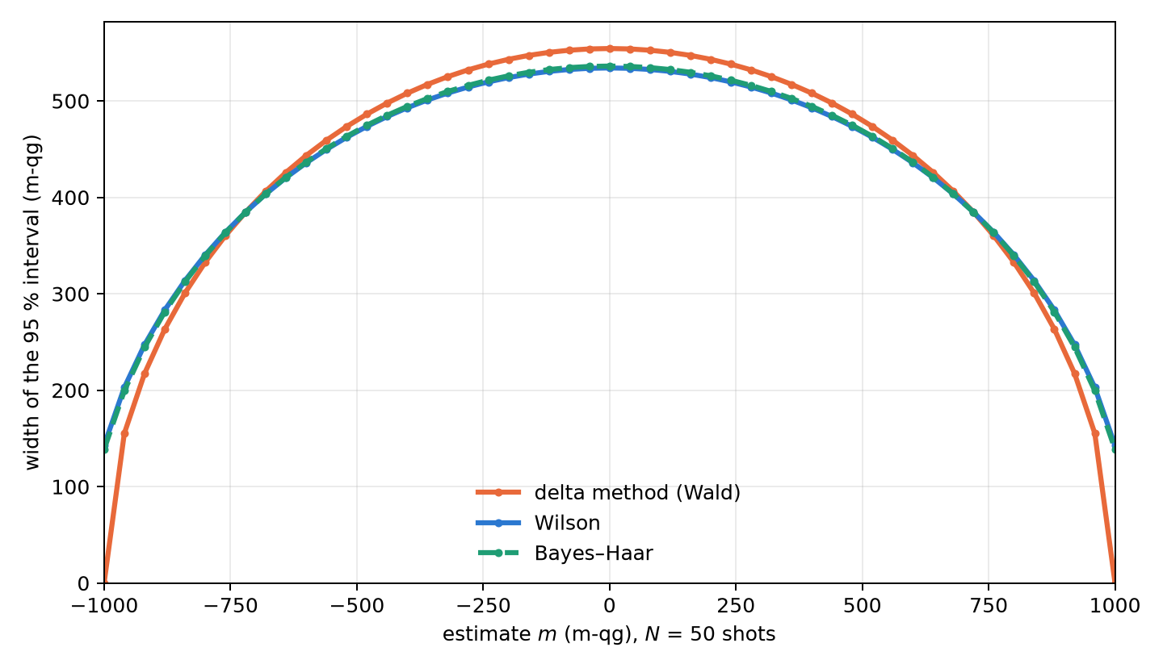
Figure 4.2: Width of the 95 % interval with 50 shots, in milli-qang, against the estimate. The delta method collapses at the poles; Wilson and Bayes–Haar do not.
The honest reading of the table has two parts. The Haar prior repairs the collapse of the delta method and has a clean geometric justification; but the Wilson interval, standard in statistics, achieves the same coverage, and the gain over good frequentist practice is in the point estimate and is modest. The qg unit does not reduce the number of shots a given precision requires; what it brings is making the cost explicit and choosing the interval well.

4.4 Second-order unbiased estimators
Quadratic quantities have a systematic bias. The plug-in estimator ${\hat{qg}}^{ 2}$ overestimates $qg^{2}$ by $(1−qg^{2})/N$, because shot noise always adds variance. The correction is exact:
$$\hat{qg^{2}}=\frac{N {\hat{qg}}^{ 2}−1}{N−1}, E\left[\hat{qg^{2}}\right]=qg^{2},$$
valid for $N≥2$ (qg2_unbiased). It can go negative when $qg≈0$, the price of being unbiased. With $N=20$ and $qg=0.6$, the plug-in estimator averages 0.390 and the corrected one 0.358, against the true value 0.36.
It matters because the Bloch radius of Chapter 5, $r^{2}=qg_{X}^{2}+qg_{Y}^{2}+qg_{Z}^{2}$, is a sum of squares: without the correction each axis adds its bias, and an entangled state looks purer than it is (§97). The same correction enters the reading of the gravitational redshift with two clocks (§126, Chapter 8).

4.5 Planning the shots
The inverse relation, how many shots a given error needs, is the one used when preparing an experiment. plan_shots turns a target standard error of the filtered $qg_{Z}$ into shots and estimated processor seconds, taking into account the fraction of shots the filter will keep (§143). For a target of 0.02 (20 m-qg) on two circuits per device it planned 3000–3400 shots, and over 30 repetitions the error of the worst qubit was 0.021–0.023 (21–23 m-qg): the plan held. For reference, Chapter 1’s formula without the filter gives $N=(1000sinθ/δ)^{2}=2500$ shots for 20 m-qg on the equator; the plan asks for more because it discounts the shots the filter will discard.
The per-qubit prediction, however, was 1.4–1.6 times optimistic on average, and its analysis is instructive: the qubits that missed were those near a pole ($|qg|>0.8$, with ratios of 2.4–3.1), whose $qg_{Z}$ the noise pulls away from $±1$ and whose real variance is larger than the ideal one. The plan uses the worst qubit and therefore holds; the safe option, assuming no value of qg, is to plan for the worst case, $qg=0$.

4.6 Few-shot tomography and classical shadows
The full Bloch vector is $(qg_{X},qg_{Y},qg_{Z})$, one per measurement axis. With 10 shots per axis, six estimators were compared on 2000 states (§35). The qg version applies the Haar prior axis by axis, ${\hat{r}}_{a}=(2k_{a}−N)/(N+2)$, and projects onto the ball:
Table 4.2: Mean squared Bloch-vector error with 10 shots per axis.
ensemble | linear inversion | LI + projection | max. likelihood | qg-Haar | Jeffreys
Haar pure | 0.203 | 0.157 | 0.150 | 0.165 | 0.159
uniform mixed | 0.247 | 0.211 | 0.210 | 0.185 | 0.196
pure near a pole | 0.199 | 0.159 | 0.109 | 0.163 | 0.159
strongly mixed ($|r|<0.3$) | 0.298 | 0.293 | 0.293 | 0.208 | 0.245

Linear inversion gives unphysical states in 52–88% of the runs on pure states. On mixed states the qg-Haar estimator is the best closed form (12–29% below maximum likelihood); on pure states its shrinkage towards the centre is a mistake, and it loses to maximum likelihood, by up to 50% near a pole. The right prior depends on which states are expected.
Would classical shadows (random Pauli measurements) do better than measuring the bases directly? For the quantities qang uses, no (§62). With exact per-shot variances on 6-qubit states, shadows need 3–41 times more shots for the same error: 3.0–4.3× for all the $qg_{Z}$, 5.8–8.1× for the register-mean weight witness, 9–12.6× for all the $ZZ$ correlators and 41× for the filtered imbalance. They only match direct measurement when the target is all one- and two-qubit quantities at once. And the shot-level filter does not exist with shadows: only $3^{−6}=0.14\%$ of the random shots have every qubit measured in $Z$.

4.7 The foundation: Riesz–Fréchet
A conceptual question remains: why $qg_{Z}$ and not some other function of the populations? The operators of an $n$-qubit register form a finite-dimensional Hilbert space under the Hilbert–Schmidt product $⟨A,B⟩=Tr(A^{†}B)$, and density matrices live in it. The Riesz–Fréchet representation theorem says that every continuous linear functional $f$ on a Hilbert space has the form $f(x)=⟨y_{f},x⟩$ for a unique $y_{f}$; in finite dimension continuity is automatic and the theorem reduces to linear algebra (Appendix F).
The application is immediate. $ρ↦qg_{Z}(ρ)=Tr(ρ σ_{z})$ is linear in $ρ$, so it has a unique representative, $σ_{z}$. Every linear read-out of a state (an expectation value, a population, a per-shot average) has that form, and $qg_{Z}$ is the one whose representative is the $Z$ observable. By contrast, $qg_{S}(ρ)=H(⟨0|ρ|0⟩)$ is strictly concave in $ρ$: no operator represents it. Two properties already seen follow from this structural fact: linear functionals have unbiased sample-mean estimators and the entropy does not (Jensen’s inequality), and the identity $qg_{S}=H((1+qg_{Z})/2)$ shows that $qg_{S}$ carries no information about the state beyond what the representative of $qg_{Z}$ already extracts.
The milli-qang inherits this property: $m(ρ)=1000 Tr(ρ σ_{z})$ is linear too, with representative $1000 σ_{z}$, which is why its estimator is the shot average, without bias. It is the underlying reason Chapter 1 defined the unit on probability and not on angle: $θ=arccos(qg_{Z})$ is not linear in $ρ$, has no representative and its direct estimator is biased.

4.8 Without qang and with qang
Table 4.3: The chapter’s actions without the qang scale and with it.
action | without qang | with qang | difference
confidence interval near a pole | delta method: coverage below 10% | Bayes–Haar, $Beta(1,1)$: uniform in m-qg, nominal coverage | in favour of the method, not only of qang: the Wilson interval, without qang, also recovers it; qang justifies the prior (Haar is uniform in m-qg)
quadratic quantities (radii, $qg^{2}$) | square the estimate: biased upward | $(N{\hat{qg}}^{ 2}−1)/(N−1)$​ | the standard unbiased estimator; qang packages it and applies it in every chapter
how many shots to take | binomial variance of the state | $N=(1000sinθ/δ)^{2}$ to resolve $δ$ m-qg | equivalent; the m-qg formula is the one used for planning
measure qang quantities | classical shadows | direct $Z$ measurement | 3–41 times fewer shots, but it is a measurement choice, not an effect of the unit
justify the reading | — | Riesz–Fréchet: $qg_{Z}$ is the canonical linear reading | in favour: explains why $qg_{Z}$ is averaged and not the angle

Balance. The chapter’s statistics are the classical statistics of proportions. qang contributes the choice of coordinate (uniform under Haar, linear by Riesz–Fréchet) that says which prior to use and what to average; the coverage improvement exists without qang too.

4.9 In code
import math
from qang import probability, statistics
statistics.bayes_qg_estimate(48, 50) # Haar posterior: qg_Z 0.885, interval [0.731, 0.975]
statistics.wilson_qg_estimate(48, 50) # the frequentist alternative
statistics.qg2_unbiased(16, 20) # qg^2 without the (1 - qg^2)/N bias
probability.analyze(48, 50).milliqang # (920.0, 730.8, 977.9) m-qg with the Wilson interval
probability.shots_for_resolution(20, math.pi / 2) # 2500 shots for 20 m-qg on the equator

4.10 Summary
- ${\hat{qg}}_{Z}$ is unbiased and attains the Cramér–Rao bound; the delta method collapses near the poles, where its m-qg interval loses its width or runs off the scale.
- Under the Haar measure $qg_{Z}$ is uniform on $[−1,1]$, that is, uniform in milli-qang and in $p_{0}$; the matching prior is $Beta(1,1)$ and gives exact intervals with a beta function.
- Wilson and Bayes–Haar recover the nominal coverage where the delta method covers less than 10%; neither reduces the shots required.
- Quadratic quantities need the correction $(N{\hat{qg}}^{ 2}−1)/(N−1)$; without it, Bloch radii are overestimated.
- Planning on the worst qubit meets the target; the qubits near a pole are the ones the noise pulls away most.
- For qang’s quantities, measuring directly in $Z$ costs 3–41 times fewer shots than classical shadows.
- $qg_{Z}$, and with it the milli-qang, is the canonical linear read-out by the Riesz–Fréchet theorem; $qg_{S}$ and the angle are not linear and have no representative.

5. The local Bloch radius as a measure of purity and entanglement
Part I treated the qubit as a point on the surface of the sphere: a pure state, a probability $p_{0}$ and its four readings. A qubit that belongs to a register is almost never pure: it is mixed by noise or by its entanglement with the others, and it sits inside the sphere. This chapter adds to the base of Chapter 1 the missing quantity, the local radius $r$, and shows that the probability equation still holds with a single change: the polar bias is no longer $cosθ$ but $rcosθ$. From the radius come an entanglement measure, a way to separate the direction of the state from its purity, and wave–particle duality, all read in qg units.

5.1 The probability equation with a radius
For a qubit in a mixed state, its Bloch vector $(qg_{X},qg_{Y},qg_{Z})$ has length $r≤1$, and Born’s rule in the $Z$ basis reads
$$p_{0}=\frac{1+qg_{Z}}{2}=\frac{1+rcosθ}{2}.$$
It is the probability equation of Chapter 1 with the radius inside: the readings $qg_{Z}=2p_{0}−1$ and $m=2000 p_{0}−1000$ m-qg do not change, but they no longer fix the angle, because the same $p_{0}$ can come from a tilted pure state or from a mixed one closer to the pole. Each axis has its own probability, $p_{0}^{(a)}$ in the basis $a∈\{X,Y,Z\}$, and the squared radius is the sum of the three readings squared (§97):
$$r^{2}=qg_{X}^{2}+qg_{Y}^{2}+qg_{Z}^{2}=\frac{m_{X}^{2}+m_{Y}^{2}+m_{Z}^{2}}{{10}^{6}}=2Trρ^{2}−1.$$
The radius is linear in the purity $Trρ^{2}$: it is 1 on the surface (pure state) and 0 at the centre (maximally mixed state). The sphere of radius $r$ has area $4πr^{2}$, and the surface deficit $4π(1−r^{2})$ is the area the qubit has lost; the library works with $1−r^{2}$, which carries the same information.

5.2 The deficit as an entanglement measure
If the whole register is in a pure state, all the radius a qubit lacks is due to its entanglement with the rest. Then $1−r_{q}^{2}=4detρ_{q}$ is the one-tangle of qubit $q$, which for two qubits is the squared concurrence (Coffman, Kundu and Wootters, 2000), and its mean over the qubits is the global entanglement of Meyer and Wallach (2002):
Q=1nq​1−rq2.
Two examples set the scale. In the Bell state each qubit sits at the centre of its sphere, $r=0$, and $Q=1$. In the 3-qubit W state each has $r^{2}=1/9$ and $Q=0.889$. If the global state is mixed, the deficit mixes entanglement and noise and cannot separate them: the radius measures entanglement only when the register is known, or guaranteed, to be pure. Reading $r^{2}$ takes three measurement settings for the whole register (every qubit in $X$, in $Y$ and in $Z$), not three per qubit.

5.3 The radius under gates and algorithms
A single-qubit gate rotates the sphere and preserves the radius, also for mixed qubits. SWAP exchanges the radii of two qubits. CNOT, CZ, iSWAP, Toffoli and Fredkin can take a qubit of a product input to the centre ($r=0$, from inputs of the type $|+0⟩$ or $|++⟩$) and can also bring it back to the surface; on computational-basis states they create no deficit, because they act as classical permutations (§97). In algorithms, the radius of the read-out qubits says where the answer is:
Table 5.1: The radius of the read-out qubits in standard algorithms (§97).
algorithm | $r^{2}$ of the read-out qubits | reading
Bernstein–Vazirani, constant Deutsch–Jozsa | 1 on every qubit | product output: the local $qg_{Z}$ is the whole answer
Simon ($s=110$) | 0 on every qubit | the answer lies entirely in the correlations
Grover ($n=5$), $k=0…4$ | $1→0.82→0.66→0.84→0.998$​ | entangles and disentangles; back to 1 at the optimum
counting ($N=16$, $M=3$) | $(1−2M/N)^{2}=0.39$​ | deficit $4(M/N)(1−M/N)=0.61$
QAOA, ring of 4, $p=1$ | 0.25 | the cost lives in $ZZ$

5.4 Definite weight: the radius from the Z basis
In a state of definite Hamming weight every local $qg_{X}$ and $qg_{Y}$ is zero, so $r_{q}=|qg_{Z}^{(q)}|$ and the radius is read from $Z$ shots alone. With the probability equation, the deficit becomes
$$1−r^{2}=1−{\left(\frac{m}{1000}\right)}^{2}=4 p_{0} (1−p_{0}):$$
four times the binomial variance of the outcome, the same $p_{0}(1−p_{0})$ that governs the shot noise of Chapter 1. Figure 5.1 shows it on the milli-qang scale. The deficit is zero at the poles, largest on the equator and very sensitive near a pole: a qubit at 990 m-qg has a deficit of 0.02, and one at 800 m-qg, which is what 10 % of misplaced shots on a basis state gives, already reads 0.36.
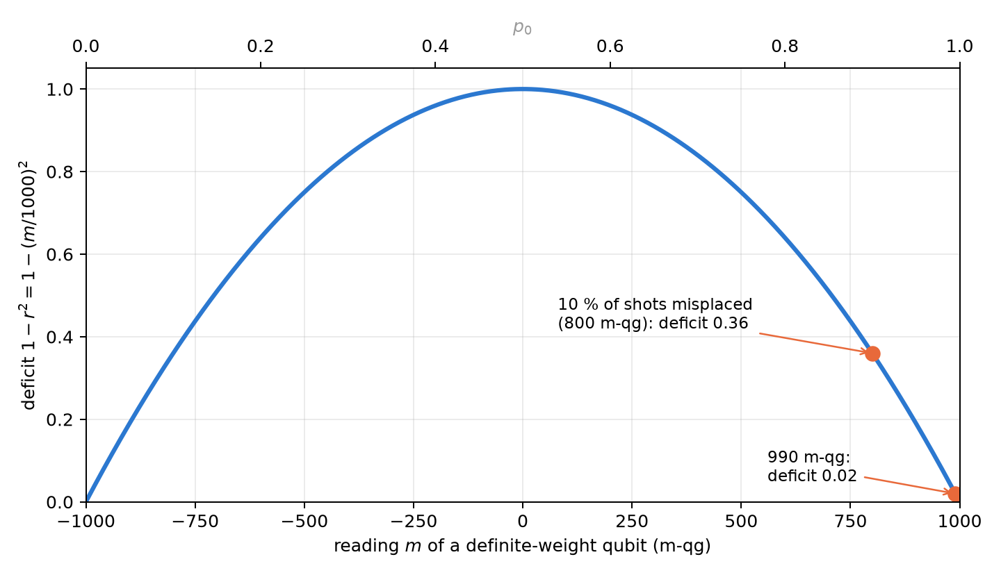
Figure 5.1: The deficit of a definite-weight qubit against its milli-qang reading (bottom) and its probability (top). Near a pole, a few misplaced shots produce a large deficit.
This is where the symmetry filter (Chapters 20–21) and the radius meet. Under equal T1 on every qubit the filtered state is the noiseless pure state, so the filtered deficit is an exact entanglement measure. The predictions were committed before running (§98); on RBS circuits of 4 and 6 qubits:
Table 5.2: The deficit as an entanglement measure under noise, with and without the qg filter (§98).
noise | exact error of the deficit, with qang | without qang | filter MSE lower
equal T1 | $<3⋅{10}^{−15}$​ | 0.061–0.370 | 30 of 30
unequal T1 | 0.013–0.045 | 0.070–0.342 | 30 of 30
dephasing 0.01 | 0.031–0.307 | 0.080–0.352 | 24 of 30

On product states the filtered deficit is exactly 0 under all three noise models, while the raw read-out shows 0.60–0.95 on every excited qubit from decay alone: false entanglement. One prediction failed: the raw error was expected to be smaller at half filling, and it was larger (0.177 against 0.074), because the first-order cancellation holds only at exactly $p=1/2$.
On noise models of real devices (three from IBM and two from IonQ, §100), the filter cut the error of the deficit 3.2–4.0× where the deficit is large, but it did not work as a test of “no entanglement”: on a product state it removed only 15–33 % of the false deficit. The cause is the one in Figure 5.1: errors inside the sector leave 10–21 % of misplaced shots, and near the pole that already reads as 0.36. A small deficit needs an echo calibration before it is interpreted.

5.5 Direction and radius apart
The polar bias $qg_{Z}=rcosθ$ mixes the direction of the vector with its length. The usual reading $θ=arccos(qg_{Z})$ drifts towards the equator whenever noise shortens the vector. With the radius the two separate (§102):
$$θ=atan2​\left(\sqrt{qg_{X}^{2}+qg_{Y}^{2}}, qg_{Z}\right)=arccos\frac{qg_{Z}}{r}.$$
A state at ${30}^{∘}$ shortened to $r=0.8$ by depolarizing noise has $qg_{Z}=0.693$: $arccos(qg_{Z})$ reads ${46.1}^{∘}$, and the separated angle reads the true ${30}^{∘}$. Figure 5.2 shows the effect for several radii: the naive angle flattens towards ${90}^{∘}$, and the separated one does not depend on $r$.
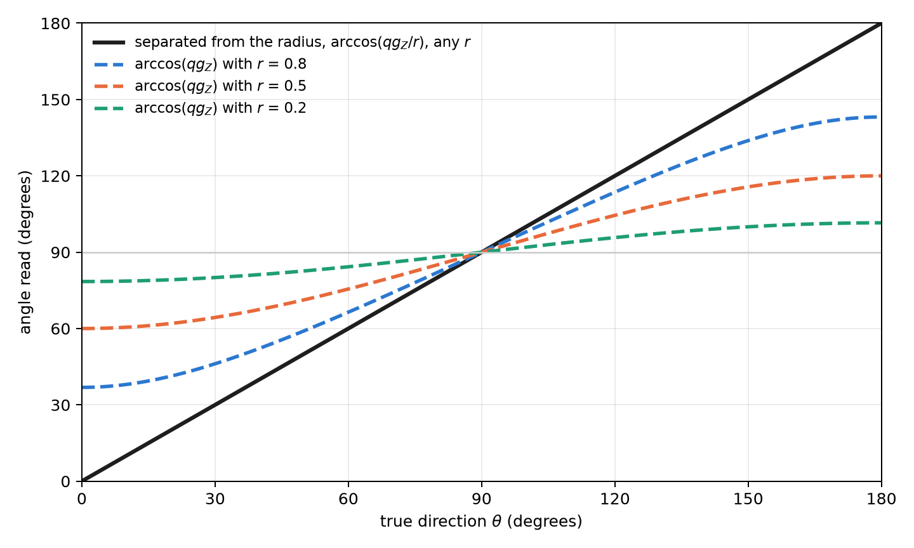
Figure 5.2: The angle read against the true direction. The dashed curves are $arccos(qg_{Z})$ for shortened vectors; the straight line is the angle separated from the radius, exact for any $r$ under depolarizing noise.
The separation has a cost and does not always win. With the same total number of shots split over three bases:
- Depolarizing: the separated angle is exact and $arccos(qg_{Z})$ errs by up to 0.70 rad near the poles; with shots, the root-mean-square error drops 5.8×.
- Dephasing: this is where it loses. Dephasing does not shorten $qg_{Z}$, so $arccos(qg_{Z})$ is exact, and the separated angle is pulled 0.03–0.12 rad towards the poles.
- No noise: measuring three bases costs 1.6× in root-mean-square error.
- Devices: on the IBM models the vector shrinks almost uniformly and the separated angle is 5–9× more accurate. On IonQ, $arccos(qg_{Z})$ won at first, because the compiler had removed pairs of identical CX gates; in the native gate set the separated angle wins there too, 8.7–9.0× (§103).
The practical rule: if the measured radius is close to 1, use $arccos(qg_{Z})$ with all shots in $Z$; if it is clearly below 1 and the noise is not pure dephasing, use the separated angle.

5.6 Wave–particle duality and entropic uncertainty
The radius also orders a classical result of the foundations. The predictability $P=|qg_{Z}|=|m|/1000$ measures how much is known about the path (particle) and the visibility $V=\sqrt{qg_{X}^{2}+qg_{Y}^{2}}$ measures the contrast of the interference (wave). Their relation is exactly the radius (Greenberger and Yasin, 1988; Englert, 1996):
$$P^{2}+V^{2}=r^{2}≤1.$$
The duality inequality is, in qg units, the statement that the state lies inside the sphere, and it is an equality for pure states (Figure 5.3). A state at ${60}^{∘}$ with $r=0.9$ has $P=0.45$, $V=0.779$ and $P^{2}+V^{2}=0.81$. It was checked on 2000 random states with a largest deviation of $2.2⋅{10}^{−16}$ (§127).
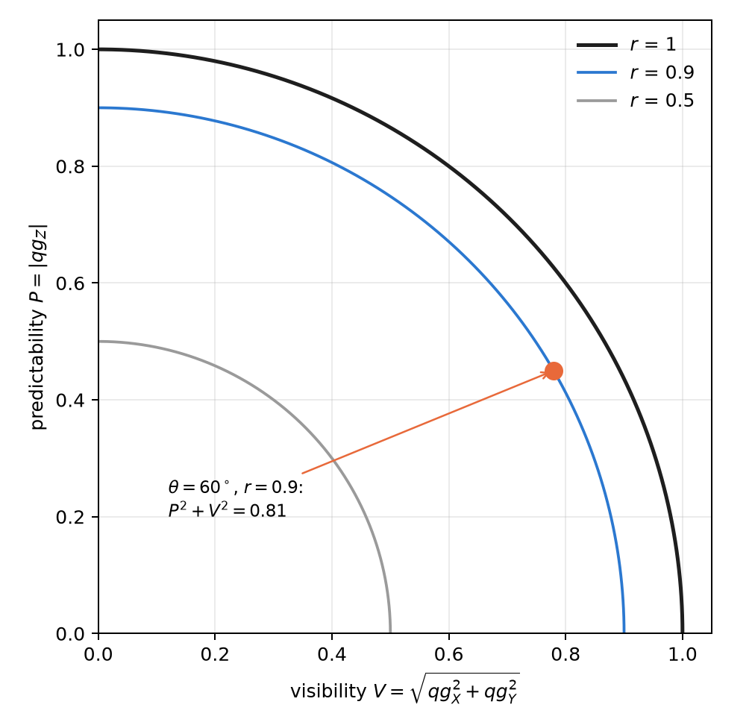
Figure 5.3: Wave–particle duality in qg units: each state is a point of the quarter disc, at distance $r$ from the origin. Pure states lie on the arc $r=1$.
The entropic version uses Chapter 1’s spread $qg_{S}$ in two bases. The Maassen–Uffink relation, with the correction of Berta and co-workers for mixed states, says
$$qg_{S}(Z)+qg_{S}(X) ≥ 1+S(ρ), S(ρ)=H​\left(\frac{1+r}{2}\right).$$
For the state above the sum is 1.349 and the bound 1.286. The bound is tight: the state $|0⟩$ meets it with equality. That gives a practical warning. With plain (uncorrected) entropy estimates, a pure state seems to violate the relation in 93 % of runs at 100 shots, because the estimated entropy is biased downwards; with the Miller–Madow correction, in 37 %. A test of the bound needs corrected estimators or intervals, like those of Chapter 4.

5.7 Estimating the radius from shots
Since $r^{2}$ is a sum of squares, it inherits the bias of the quadratic estimators of Chapter 4 (Section 4.4): each axis adds $(1−qg^{2})/N$, and an entangled state looks purer than it is. The exact correction $(N{\hat{qg}}^{ 2}−1)/(N−1)$ is applied axis by axis (radius2_estimate), and in a definite-weight state the $Z$ axis is enough.

5.8 Without qang and with qang
Table 5.3: The chapter’s actions without the qang scale and with it.
action | without qang | with qang | difference
measure local purity | tomography in three bases and $Trρ^{2}$ | $r^{2}=qg_{X}^{2}+qg_{Y}^{2}+qg_{Z}^{2}$; at definite weight, $1−r^{2}=4p_{0}(1−p_{0})$ from a single basis | in favour: one basis instead of three, thanks to the probability equation together with the definite weight
measure the entanglement of a pure register | one-tangle and Meyer–Wallach by definition | the deficit $1−r^{2}$, averaged | none in value; with a mixed global state the deficit mixes entanglement and noise, like the one-tangle
direction of a noisy state | $θ=arccosqg_{Z}$​ | $θ=arccos(qg_{Z}/r)$​ | in favour with depolarizing noise; against with pure dephasing
wave–particle duality | visibility and predictability separately | $P^{2}+V^{2}=r^{2}$​ | reformulation: the same relation

Balance. The practical difference is reading purity at definite weight with a single measurement basis. The rest are known identities written on the qang scale, and the direction–radius split wins or loses depending on the noise.

5.9 In code
import math
import numpy as np
from qang import complementarity, formulation, statistics
bell = np.array([1, 0, 0, 1]) / math.sqrt(2)
formulation.radius_profile(bell, 2) # [0.0, 0.0]: each qubit at the centre
w = np.zeros(8); w[[1, 2, 4]] = 1 / math.sqrt(3)
formulation.meyer_wallach(w, 3) # 0.889: global entanglement of the W state
formulation.weight_sector_radius([0.99, 0.8]) # [0.0199, 0.36]: deficit from qg_Z (990 and 800 m-qg)
formulation.direction_from_qg(0.4, 0.0, 0.6928) # (0.524, 0.0, 0.8): θ = 30° separated from r = 0.8
complementarity.duality_sum(0.779, 0.0, 0.45) # 0.81 = P² + V² = r²
complementarity.entropic_sum(0.45, 0.779) # 1.35 ≥ bound 1.29
The figures are generated by tools/make_cap05_figures.py.

5.10 Summary
- For a mixed state, Chapter 1’s probability equation still holds with $qg_{Z}=rcosθ$; the local radius $r^{2}=qg_{X}^{2}+qg_{Y}^{2}+qg_{Z}^{2}=2Trρ^{2}−1$ is the missing reading.
- If the register is pure, the deficit $1−r^{2}$ is the one-tangle and its mean is the Meyer–Wallach measure; with a mixed global state, it mixes entanglement and noise.
- At definite weight, $1−r^{2}=4p_{0}(1−p_{0})$ is read in $Z$ alone, and with the filter under equal T1 it is exact; near a pole a few misplaced shots inflate it, and on devices a small deficit needs calibration.
- $θ=arccos(qg_{Z}/r)$ separates direction from purity: it wins under depolarizing noise and loses under pure dephasing.
- Wave–particle duality is $P^{2}+V^{2}=r^{2}$, and entropic uncertainty bounds $qg_{S}(Z)+qg_{S}(X)$ by $1+S(ρ)$.

6. Optical polarization and Stokes parameters in qg units
The polarization of a photon is a qubit, and classical polarization optics is, unchanged, the physics of a qubit written with other names. This chapter reads that optics with the base of Chapter 1. The key piece is that a polarizer is a two-outcome measurement, pass or block, and its transmission is exactly the probability $p_{0}$ of the qang equation. From there follow Malus’s law, the Stokes parameters, the degree of polarization and photon-counting polarimetry, all in qg and in milli-qang (§83).

6.1 Malus’s law as a probability equation
Light linearly polarized at an angle $α$ goes through a polarizer set at $ϑ$. With $Δ=ϑ−α$, the transmitted fraction is Malus’s law, which for a single photon is a probability:
$$p_{0}=\cos^{2}Δ.$$
The comparison with Born’s rule in Chapter 1, $p_{0}=\cos^{2}(θ/2)$, is immediate: the qang angle is twice the physical angle, $θ=2Δ$, and the milli-qang reading is $m=1000cos2Δ$. That is why two orthogonal polarizations, H and V, ${90}^{∘}$ apart in the laboratory, are opposite points of the sphere, ${180}^{∘}$ apart (Figure 6.1). An analyser turned ${30}^{∘}$ from the light transmits $p_{0}=0.75$: it is the state at $θ={60}^{∘}$ and $+500$ m-qg of Chapter 1’s qang circle (Figure 1.1).
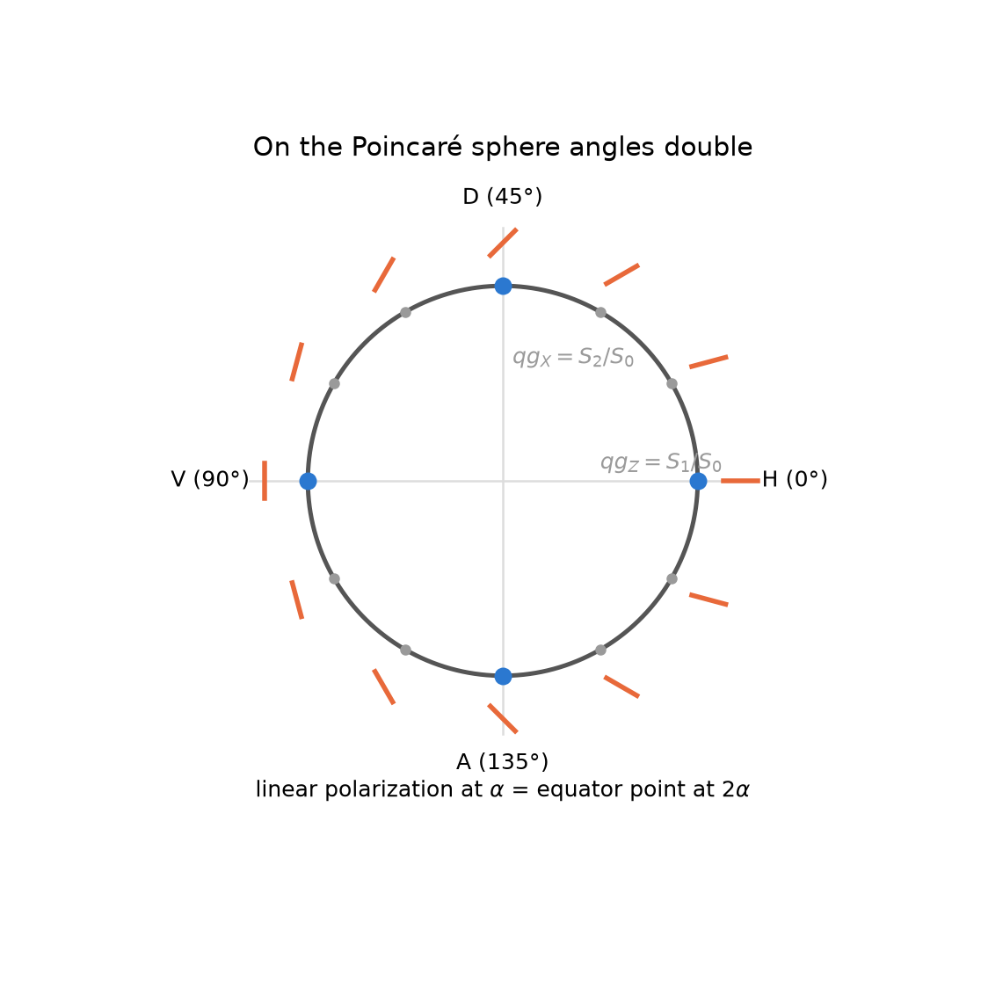
Figure 6.1: Angle doubling. Each orange stroke is the physical direction of linear polarization at $α$; its point on the equator of the sphere is at $2α$. H and V, perpendicular in the laboratory, sit at opposite poles of the $qg_{Z}$ axis.
For light with any polarization, pure or partial, the transmission through a linear polarizer at $ϑ$ is
$$p_{0}=\frac{1+qg_{Z}cos2ϑ+qg_{X}sin2ϑ}{2}=\frac{1+r⋅a}{2}, a=(sin2ϑ, 0, cos2ϑ),$$
with $r=(qg_{X},qg_{Y},qg_{Z})$ the qg vector of the light and $a$ that of the state the analyser lets through. It is Chapter 3’s transition probability between two qg vectors (Section 3.4), and its milli-qang reading is $m=1000 r⋅a$. Figure 6.2 shows four cases: H light ($\cos^{2}ϑ$), D light (the same curve shifted ${45}^{∘}$), unpolarized light (always $1/2$, that is, 0 m-qg) and partially polarized light with $qg_{Z}=0.6$ and $qg_{X}=0.3$. The last transmits 0.80 at $0^{∘}$, a maximum of 0.835 at ${13.3}^{∘}$ and a minimum of 0.165 at ${103.3}^{∘}$; the difference between maximum and minimum, 0.671, is its degree of polarization.
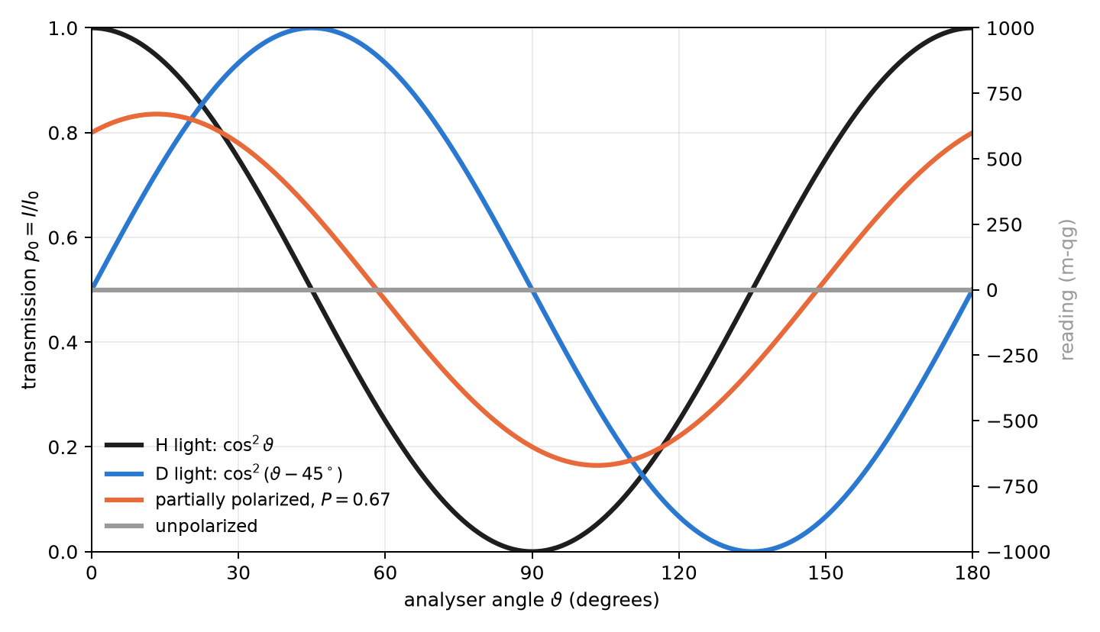
Figure 6.2: Malus’s law as a probability equation: transmission of a linear polarizer against its angle, with its milli-qang reading on the right.

6.2 The Stokes parameters are qg values
The Poincaré sphere is the Bloch sphere. With $|H⟩=|0⟩$ and $|V⟩=|1⟩$, the normalized Stokes parameters are the three qg values, each the difference of the two probabilities of an analyser:
Table 6.1: The normalized Stokes parameters as qg values (§83).
qg value | Stokes | analyser | reading
$qg_{Z}$​ | $S_{1}/S_{0}$​ | H / V | $p_{H}−p_{V}$​
$qg_{X}$​ | $S_{2}/S_{0}$​ | D / A, at $±{45}^{∘}$ | $p_{D}−p_{A}$​
$qg_{Y}$​ | $S_{3}/S_{0}$​ | R / L, circular | $p_{R}−p_{L}$​

The convention for right circular light varies between texts; here $R=(|H⟩+i|V⟩)/\sqrt{2}$, so $S_{3}>0$ means $qg_{Y}>0$ (the library takes the opposite convention with circular_sign=-1). Since each parameter is $2p_{0}−1$ in its own basis, each is expressed in milli-qang with the equation of Chapter 1.
The polarization ellipse is read from the angles of the qg vector, halved: its orientation is $ψ=1/2atan2(qg_{X},qg_{Z})$ and its ellipticity $χ=1/2arcsin(qg_{Y}/P)$. For the partial light of the example, $ψ={13.3}^{∘}$: the angle where Figure 6.2 has its maximum.

6.3 Degree of polarization and purity
Partially polarized light is a mixed state. Its degree of polarization is the length of the qg vector, the radius of Chapter 5 (Section 5.1):
$$P=\sqrt{qg_{X}^{2}+qg_{Y}^{2}+qg_{Z}^{2}}=r, Trρ^{2}=\frac{1+P^{2}}{2}.$$
Unpolarized light sits at the centre of the sphere. An ideal depolarizer has Mueller matrix $diag(1,d,d,d)$: it shortens the vector by a factor $d$ and does not change its direction. It is the case in which Chapter 5 separates direction and radius (Section 5.5): with $d=0.7$, the light of the example goes from $P=0.671$ to $P=0.470$, and the orientation of its ellipse stays at ${13.3}^{∘}$.

6.4 Lossless elements: the Mueller matrix is the gate rule
A Mueller matrix acts on $(S_{0},S_{1},S_{2},S_{3})$; in the order $(I,Z,X,Y)$ it is the Pauli transfer matrix. For a lossless element, with a unitary Jones matrix $U$, it is exactly qang’s gate rule:
$$qg_{P}^{′}=qg_{U^{†}PU}.$$
Wave plates are single-qubit gates, and Chapter 2 applies as is (Section 2.3): a half-wave plate with its axis at ${22.5}^{∘}$ takes H to D ($qg_{X}=1$), because it turns the physical polarization by ${45}^{∘}$ and the point on the sphere by ${90}^{∘}$; a quarter-wave plate at ${45}^{∘}$ takes H to a circular polarization ($qg_{Y}=−1$ with the convention above). The polarizer, by contrast, is not unitary: it is the measurement. All these identities are checked numerically in tests/test_polarization.py.

6.5 Photon-counting polarimetry
With weak or single-photon sources, the Stokes parameters are estimated by counting: $n_{H},n_{V}$ in the H/V basis, $n_{D},n_{A}$ in the diagonal one and $n_{R},n_{L}$ in the circular one. Each pair gives a qg value with its interval, just like a qubit measurement (Chapter 4). With 1000 photons per basis and counts $(800,200)$, $(650,350)$ and $(500,500)$:
$$qg_{Z}=0.599 [0.548, 0.647], qg_{X}=0.299 [0.240, 0.358], qg_{Y}=0.000 [−0.062, 0.062],$$
95 % Bayes–Haar intervals. In milli-qang, $qg_{Z}$ is $+599$ m-qg with a resolution of $σ_{m}=1000sinθ/\sqrt{N}=25$ m-qg.
The degree of polarization needs more care. $P$ is the square root of a sum of squares, and each square inherits the bias $(1−qg^{2})/N$ of Chapter 4 (Section 4.4): with few photons, unpolarized light looks polarized. Figure 6.3 quantifies it with a simulation from this chapter (4000 repetitions per point). With unpolarized light, the plug-in estimator averages $\hat{P}≈0.50$ with 10 photons per basis, $0.16$ with 100 and $0.05$ with 1000. Using the unbiased squares brings it down about three times ($≈0.18$, $0.055$ and $0.017$), but does not remove it: the square root and the clipping at zero leave a residual bias. With light of $P=0.5$, the plug-in estimator overestimates at few photons and the unbiased one slightly underestimates; from about 200 photons per basis both match the true value.
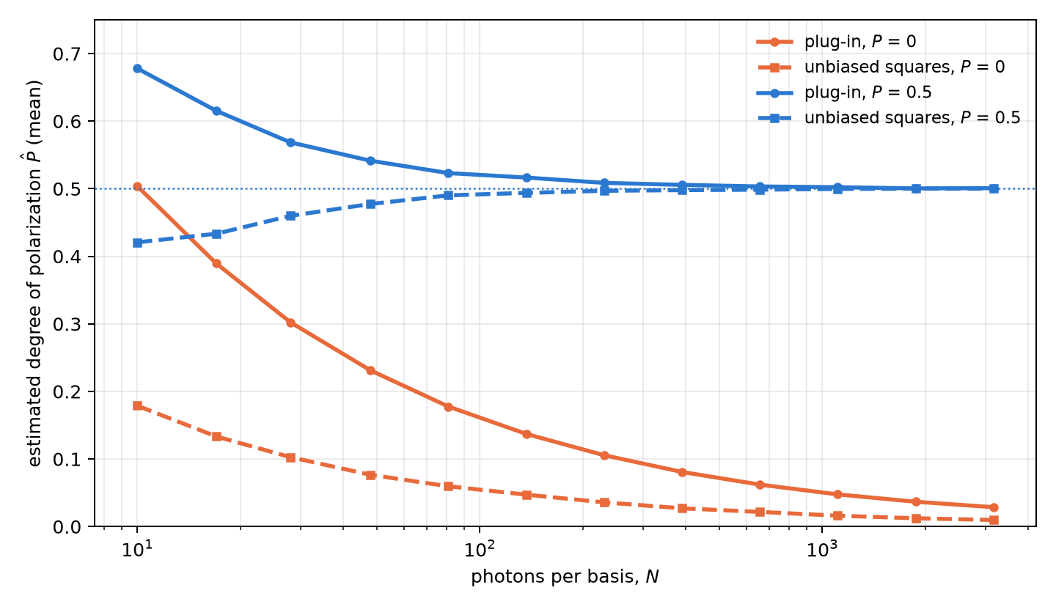
Figure 6.3: Bias of the degree of polarization estimated by counting, against the photons per basis. Solid lines: plug-in estimator; dashed: with the unbiased squares of Chapter 4. The horizontal dotted lines mark the true value.
The practical consequence: to claim that a source is polarized from few photons, one needs an interval for $P$ or a threshold calibrated with unpolarized light, not the point value.

6.6 Without qang and with qang
Table 6.2: The chapter’s actions without the qang scale and with it.
action | without qang | with qang | difference
transmission of a polarizer | Malus’s law, $I=I_{0}\cos^{2}Δ$ | $p_{0}=\cos^{2}Δ$ with $θ=2Δ$; reading $1000 r⋅a$ m-qg | none in value; qang ties it to the transition probability of Chapter 3
describe the polarization | normalized Stokes parameters $S_{1},S_{2},S_{3}$ | they are $qg_{Z}$, $qg_{X}$, $qg_{Y}$ | identity: the same numbers under another name
degree of polarization with few photons | $\sqrt{S_{1}^{2}+S_{2}^{2}+S_{3}^{2}}$: biased upward | the unbiased squares of Chapter 4 | in favour: the bias drops about three times, without vanishing
wave plates | Mueller matrices | the gate rule $qg_{P}^{′}=qg_{U^{†}PU}$ | reformulation

Balance. Polarization optics already works with qg values under another name (Stokes). The measurable difference is statistical: correcting the squares reduces the bias of the degree of polarization with few photons.

6.7 In code
import math
import numpy as np
from qang import polarization as pz
light = {"Z": 0.6, "X": 0.3, "Y": 0.0}
pz.malus_intensity(light, 0.0) # 0.80: transmission at 0°
pz.malus_intensity(light, math.radians(13.28)) # 0.835: the maximum, at the orientation of the ellipse
H = np.array([1, 0])
pz.jones_to_qg(pz.half_wave_plate(math.radians(22.5)) @ H) # {'X': 1.0, ...}: H → D
pz.jones_to_qg(pz.quarter_wave_plate(math.radians(45)) @ H) # {'Y': -1.0, ...}: H → circular
c = pz.qg_from_counts(800, 200, 650, 350, 500, 500, method="bayes")
c["Z"], c["X"], c["P"] # 0.6, 0.3, 0.671 and the intervals in c["intervals"]
The figures are generated by tools/make_cap06_figures.py.

6.8 Summary
- A polarizer is a two-outcome measurement: its transmission is $p_{0}=\cos^{2}Δ$, Chapter 1’s probability equation with the qang angle equal to twice the physical one, $θ=2Δ$.
- For any light, Malus’s law is the transition probability $(1+r⋅a)/2$ between the light and the analyser; its reading is $1000 r⋅a$ m-qg.
- The normalized Stokes parameters are $qg_{Z}$, $qg_{X}$ and $qg_{Y}$; the ellipse is read from half the angles of the qg vector.
- The degree of polarization is the radius of Chapter 5; a depolarizer shortens it without turning the ellipse.
- Wave plates are gates: the lossless Mueller matrix is the rule $qg_{P}^{′}=qg_{U^{†}PU}$.
- From photon counts each parameter has its interval; the degree of polarization is biased upwards at few photons, and the unbiased squares cut that bias about three times without removing it.

7. Geometric phases and Stokes’ theorem on the sphere
A phase is not a probability. Chapter 2 showed that the phases of a gate do not appear in its transition matrix: a $Z$ measurement does not see them. This chapter deals with a phase that does carry physical meaning, the geometric phase a qubit picks up when carried around a closed loop, and shows that the base of Chapter 1 reaches it twice. First, its value: for a loop at constant height, the phase in turns is the probability $p_{0}$. Then, its measurement: an interferometer turns it into a probability, and the qang angle of that probability is the phase (§84).

7.1 The Berry connection and curvature
If a state $|ψ(R)⟩$ depends on parameters $R$ and is carried slowly around a closed path, besides the dynamical phase it picks up a phase that depends only on the geometry of the path. Its density is the Berry connection, $A=i⟨ψ|∇ψ⟩$, and its curl is the curvature. For a qubit, with the state described by its qg vector on the sphere, the curvature is a monopole of strength $1/2$ at the centre: on the unit sphere its normal component is $1/2$ everywhere.

7.2 Stokes on the sphere
Stokes’ theorem turns the line integral of the connection around the loop $C$ into the flux of the curvature through the surface it encloses. Since the curvature is uniform, the flux is $1/2$ times the area, that is, the solid angle $Ω(C)$:
$$γ(C)=−\frac{Ω(C)}{2} (mod 2π).$$
The phase is gauge invariant (it does not depend on the phase chosen for each state along the path) and changes sign when the loop is run backwards.

7.3 Loops at constant height: the phase is the probability
A loop around the $Z$ axis at constant polar bias $qg_{Z}$ encloses the cap above it, of solid angle $Ω=2π(1−qg_{Z})$. In turns, the library’s $qg_{Φ}$ unit,
$$φ=\frac{γ}{2π}=\frac{qg_{Z}−1}{2}=−p_{1}≡p_{0} (mod 1), φ=\frac{1000+m}{2000} \text{turns}.$$
The geometric phase of a loop at constant height, measured in turns, is the probability $p_{0}$ of its height, and with the milli-qang it is a linear function of the reading. The reason is the same that made the Haar distribution uniform in Chapter 4 (Section 4.2): by Archimedes’ theorem, the fraction of the sphere in the cap above the height $qg_{Z}$ is $(1−qg_{Z})/2=p_{1}$. The solid angle is $4πp_{1}$ and the phase $−2πp_{1}$.
Some values: a loop at $+500$ m-qg ($p_{0}=0.75$) picks up $0.75$ turns, that is, $−1/4$ of a turn; one on the equator picks up half a turn, $π$; one hugging the pole $|0⟩$, nothing. Figure 7.1 shows the line together with the three independent computations of the next section.
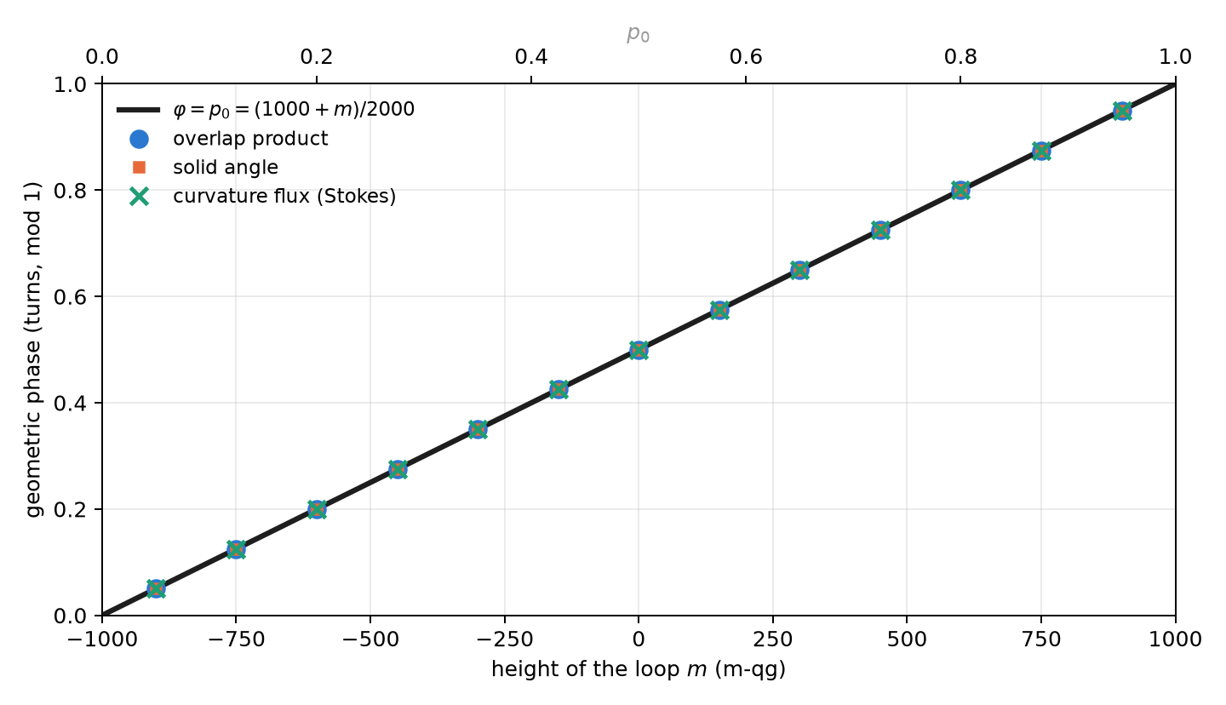
Figure 7.1: The geometric phase of a loop at constant height against its milli-qang reading (bottom) and its probability (top). The line is $φ=p_{0}$; the symbols are the three independent computations.
The equator deserves a note. There the phase is $π$, and $+π$ and $−π$ are the same angle. A numerical computation can return either one depending on rounding, and a comparison that ignores this fails although the result is right. That is exactly what happened to one of the library’s tests, now fixed to compare on the circle.

7.4 Three independent computations
The library computes the phase in three ways that share no code and checks that they agree (14 tests):
- Overlap product (Pancharatnam): γ=−argk​⟨ψk|ψk+1⟩ over the discretized loop, gauge invariant.
- Solid angle, as a fan of spherical triangles (Van Oosterom and Strackee’s formula). It agrees with the overlap product to ${10}^{−10}$.
- Curvature flux through the cap, integrated numerically. It agrees with the line integral to ${10}^{−5}$: Stokes’ theorem checked in numbers.

7.5 Measuring the phase: the interferometer and the probability equation
A $Z$ measurement does not see the phase. Measuring it takes an interferometer: a control qubit in $|+⟩$ decides whether the system runs the loop, and at the end the control is measured in the $X$ basis (Hadamard test). With the dynamical phase cancelled, for instance by an echo, the probability of reading 0 on the control is
$$p_{0}=\frac{1+cosγ}{2}=\cos^{2}\frac{γ}{2}:$$
Born’s rule of Chapter 1 with $γ$ in place of $θ$. Therefore the qang angle of the measured probability is the geometric phase, $\hat{γ}=2arccos\sqrt{{\hat{p}}_{0}}$, and its milli-qang reading is $m=1000cosγ$.
Everything the base says about that angle applies to the phase. In particular, being the arcsine transformation (Section 1.8), its uncertainty is $1/\sqrt{N}$ for any value of the phase. Figure 7.2 checks it with a simulation from this chapter: with 1000 shots per point, the standard deviation of $\hat{γ}$ stays around 32 mrad (about ${1.8}^{∘}$) from ${10}^{∘}$ to ${170}^{∘}$. At $0$ and $π$ it is zero because the outcome is deterministic, always 0 or always 1, and there the exact intervals of Chapter 4 are needed.
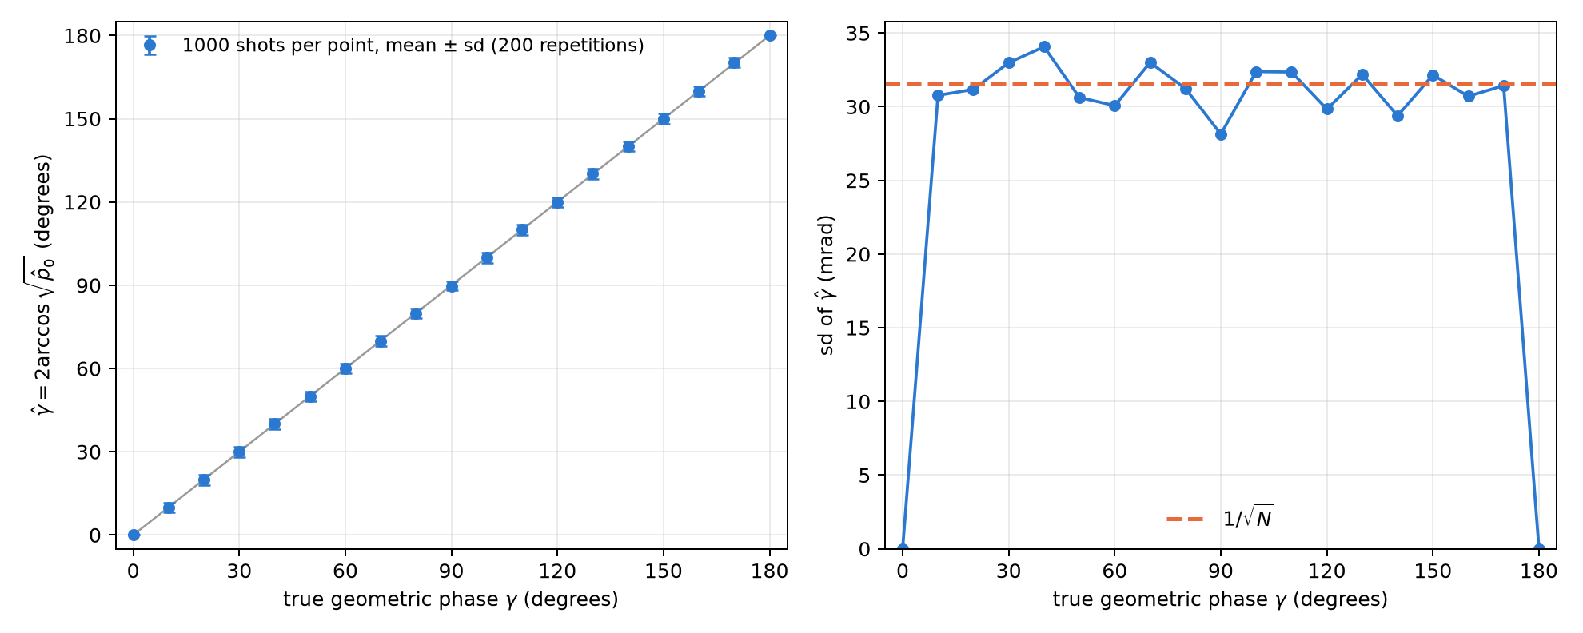
Figure 7.2: Interferometric measurement of the geometric phase with the probability equation. Left: the phase estimated as the qang angle of the measured probability, against the true one. Right: its standard deviation, equal to $1/\sqrt{N}$ over the whole range.
There is a limit, the same as in Chapter 1. Since $cosγ$ is even, a single probability gives $|γ|$ in $[0,π]$, not its sign. The remedy is the branch sign (Section 1.5): measure the other quadrature too, shifting the reference phase by a quarter turn, which gives $sinγ$. The two probabilities together fix the phase on the whole circle.

7.6 Pancharatnam’s phase and the octant
For polarized light the same phase is Pancharatnam’s on the Poincaré sphere, and Chapter 6 already set up the coordinates (Section 6.1). The circuit H → D → R → H runs around an octant of the sphere: three quarter arcs of great circles enclosing one eighth of its area, $Ω=4π/8=π/2$. The phase is $γ=−π/4$, one eighth of a turn backwards ($0.875$ turns mod 1), and the library reproduces it from the three qg vectors.

7.7 Without qang and with qang
Table 7.1: The chapter’s actions without the qang scale and with it.
action | without qang | with qang | difference
geometric phase of a constant-height loop | $−1/2$ of the solid angle, $Ω=2π(1−cosθ)$ | the phase in turns is $p_{0}=(1000+m)/2000$ | equivalent; with qang it is read from a single measured probability
measure the phase in an interferometer | invert $\cos^{2}(γ/2)$ with the delta method | the qang angle is the phase, with uncertainty $1/\sqrt{N}$ for any value | same result in the interior: the delta method also gives $1/\sqrt{N}$; qang gives it without a derivative. At $0$ and $π$ both give zero width and the intervals of Chapter 4 are needed
the sign of the phase | second quadrature | second quadrature | none: the limit is the same

Balance. The Berry phase is the same with or without qang; what the scale adds is reading it from a single probability and having its error bar without deriving anything. It adds no precision.

7.8 In code
import math
import numpy as np
from qang import geometric
geometric.cone_phase_turns(0.5) # 0.75 turns = p0 at +500 m-qg
geometric.cone_phase_turns(0.0) # 0.5: the equator, half a turn
# discretized loop at qg_Z = 0.8: the phase from overlaps, in turns
r = math.sqrt(1 - 0.8 ** 2)
loop = [np.array([r * math.cos(a), r * math.sin(a), 0.8]) for a in np.linspace(0, 2 * math.pi, 400, endpoint=False)]
geometric.geometric_phase_qg(loop).phi # 0.9 (= p0 = 0.9)
octant = [np.array([0, 0, 1.0]), np.array([1.0, 0, 0]), np.array([0, 1.0, 0])] # H, D, R
geometric.geometric_phase_qg(octant).phi # 0.875: -1/8 of a turn
The figures are generated by tools/make_cap07_figures.py.

7.9 Summary
- The geometric phase of a closed loop is minus half the solid angle it encloses: Stokes’ theorem with the Berry curvature, a monopole of strength $1/2$.
- For a loop at constant height, the phase in turns is $p_{0}$ (mod 1), that is, $(1000+m)/2000$: the same Archimedean reason that makes the Haar measure uniform in m-qg.
- Three independent computations (overlaps, solid angle, curvature flux) agree to ${10}^{−10}$ and ${10}^{−5}$.
- An interferometer turns the phase into the probability $\cos^{2}(γ/2)$; its qang angle is the phase, with uncertainty $1/\sqrt{N}$ for any value, and the sign needs a second quadrature.
- The polarization circuit H → D → R → H encloses an octant and picks up $−π/4$.

8. Fisher information, clocks, gravity and metrology
Metrology is the discipline of measuring a parameter with the smallest possible uncertainty, and its central tool is the Fisher information: how much each shot teaches about the parameter. This chapter writes it on the base of Chapter 1. The probability equation $p_{0}=\cos^{2}(θ/2)$ fixes how much information each reading carries, and from it follow the resolution in milli-qang, the operating point of an interferometer, the comparison of two atomic clocks one metre apart in height, the advantage (and the limits) of entanglement, and the thermometry of a qubit.

8.1 From the base: the information in one shot
A shot in the $Z$ basis is a coin with probability $p_{0}$. Its Fisher information about the angle is
$$F_{θ}=\frac{(dp_{0}/dθ)^{2}}{p_{0}(1−p_{0})}=\frac{\sin^{2}θ/4}{\sin^{2}θ/4}=1,$$
constant over the whole sphere; about the reading $qg_{Z}=cosθ$, by contrast, it is $F_{qg}=1/(1−qg_{Z}^{2})$, growing towards the poles. The qang angle is the flat coordinate of the information and $qg_{Z}$ the curved one (Figure 8.1). The two descriptions are the same physics: the $1/N$ variance of the angle in Chapter 1 is the Cramér–Rao bound in the flat coordinate (§167).
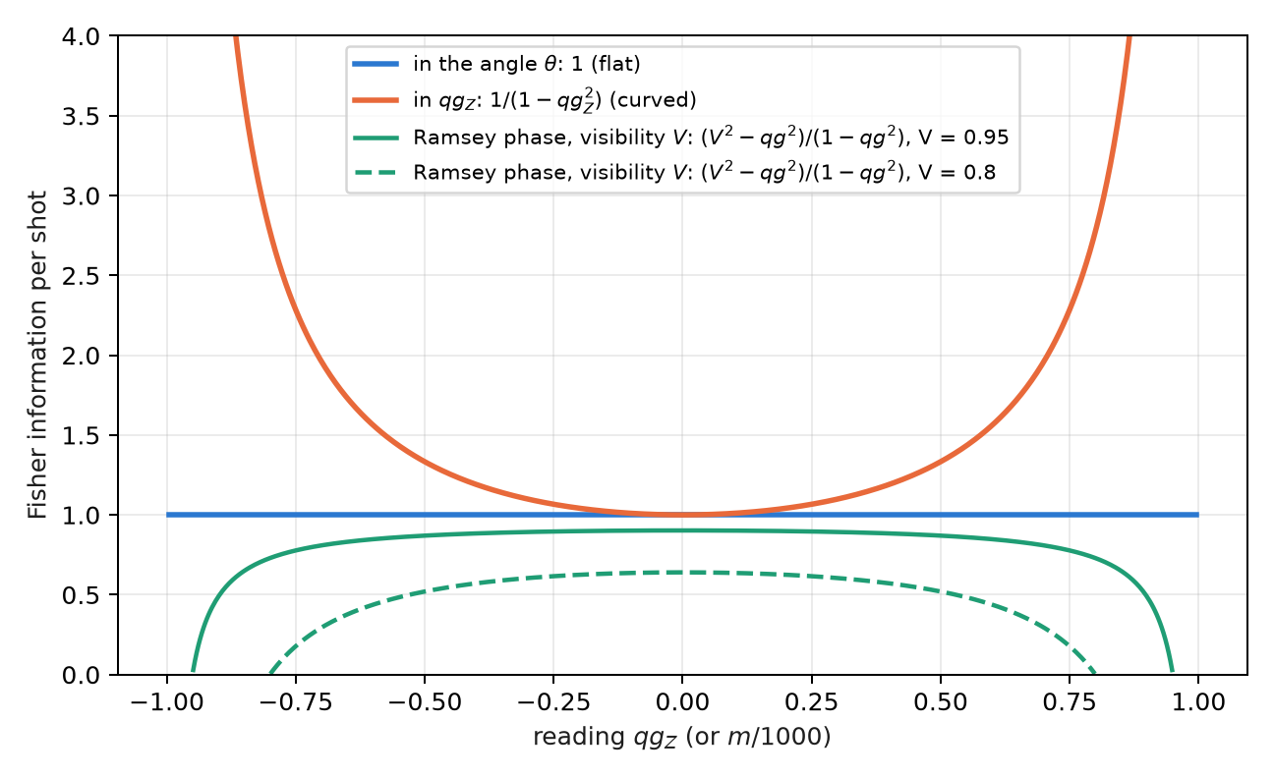
Figure 8.1: Fisher information per shot. In the angle it is constant; in $qg_{Z}$ it grows towards the poles. In a Ramsey interferometer with visibility $V<1$ (green) the information about the phase falls to zero at the extreme fringes and peaks in the middle.
Expressed in milli-qang, the bound gives the resolution of a reading:
$$σ_{m}=\frac{1000 |sinθ|}{\sqrt{N}} \text{m-qg}, N={\left(\frac{1000sinθ}{δ}\right)}^{2} \text{shots to resolve }δ \text{m-qg}.$$
On the equator, resolving 10 m-qg takes ${10}^{4}$ shots and resolving 1 m-qg, ${10}^{6}$; at 60° from the pole, 5 m-qg cost 30 000. Near a pole the reading is more precise in m-qg, but one m-qg there corresponds to a larger angle: a state $δ$ m-qg from the pole is $arccos(1−δ/1000)≈\sqrt{2δ/1000}$ radians away, 2.56° for 1 m-qg.

8.2 Information geometry and the natural gradient
The many-parameter version of the Fisher information is the Fubini–Study metric, and it governs the natural gradient: descent that measures its steps in distance between states, not between parameters. In a real ansatz of $R_{Y}$ rotations and CZ gates, every state of the circuit is real, $⟨Y_{k}⟩=0$ before each rotation and every diagonal entry of the metric is exactly $1/4$: the angles are flat one by one, and all the curvature sits in the off-diagonal terms, which within a layer are correlators $⟨Y_{i}Y_{j}⟩/4$, measurable with one circuit per layer (§159).
Two practical consequences, checked on a 4-qubit Ising chain with 20 seeds: descent in qg coordinates never converges (0 of 20), because the curved coordinate distorts the steps; and the natural gradient with the qg$​_{YY}$ block metric is 1.3 times faster than descent in the angle, and 4.6 times with the full metric. The gain comes from the metric, not from changing coordinates: the natural gradient in qg is Euclidean descent in $θ$. The rule is to optimize in the angle and read out in qg.

8.3 Two clocks and gravity
An atomic clock measures a phase, and two clocks at different heights tick at different rates: the gravitational redshift. Read with the same laser, they give $qg_{Z,1}=cos(φ+δ)$ and $qg_{Z,2}=cos(φ−δ)$, where $φ$ is a random common phase (the laser noise) and $2δ$ the difference sought. Even with $φ$ unknown, the pairs of readings lie on the ellipse
$$x^{2}+y^{2}−2xy c=1−c^{2}, c=cos2δ,$$
so the difference is read from the shape of the cloud, without controlling the common phase (Figure 8.2). For two strontium clocks 1 m apart, $2δ=2πν gh t/c^{2}=0.294$ rad in one second.
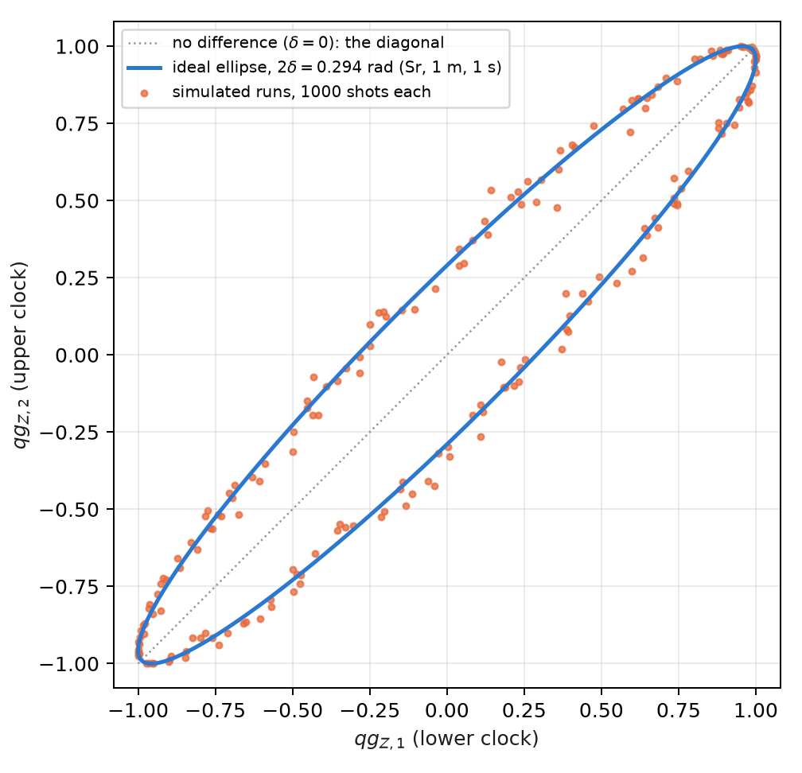
Figure 8.2: Readings of two clocks with a random common phase. The height difference opens the diagonal into an ellipse; its shape gives the phase difference without knowing the common phase.
Fitting the ellipse needs the squares of the readings, and there the unbiased estimator of $qg^{2}$ from Chapter 4 comes in: without the correction, the shot-noise bias flattens the ellipse. All four recorded predictions passed (§126):
Table 8.1: Clock comparison by ellipse fitting, simulated.
check | result
relative bias, 1000 shots, 200 runs, four values of $δ$ | +0.09%, +0.12%, +0.05%, −0.07%
spread of the ellipse fit against the moment estimator ($δ=0.15$) | 0.0022 against 0.0075
bias with 100 shots, without and with the correction | +11.8% and +0.9%
strontium, 1 m, 1 s | $δ=0.1471$; estimate $0.1472±0.0022$ (68σ)

In this idealized model the spread corresponds to about 1.5 cm of height per 200 runs. The limits are stated: no laser decoherence during the Ramsey time, contrast 1 and binomial projection noise.

8.4 Ramsey sensing: where to operate
A Ramsey interferometer turns a phase into a probability: $qg=a+bVcos(φ−α)$, with visibility $V$, operating point $α$ and the read-out map $(a,b)$ of Chapter 27. With ideal read-out, the information per shot about the phase is
$$F=\frac{V^{2}−qg^{2}}{1−qg^{2}}.$$
With $V=1$ it is flat, $F=1$ everywhere: the $1/(1−qg^{2})$ gain at the poles is exactly cancelled by the Jacobian. With $V<1$ the optimum is the middle of the fringe, $qg=0$, and the information vanishes at the bright fringe (Figure 8.1). This is the known practice of operating at quadrature, written in qg (§36). Three measured nuances:
- Read-out asymmetry moves the optimum, but it does not matter: moving to the new optimum gains 0.17% with the calibrated read-out, and 1.6% even with a 10% read-out error.
- With few shots a prior helps: with 10 shots, the Bayesian posterior mean is about 2 times better than direct inversion, because the prior range of the phase carries information.
- With visibility 0.9, operating at the pole gets worse with more shots (the scaled error goes from 1.09 to 2.50 between 10 and 1000 shots): small phases become invisible there. The middle of the fringe tracks its bound (1.11–1.24, with bound 1.12).

8.5 GHZ metrology: when entanglement wins
With $N$ qubits a frequency $ω$ can be measured in two ways: $N$ independent Ramsey clocks, or a GHZ state, whose parity $X_{1}⋯X_{N}$ is a single qg value of the whole register, $qg_{P}=V_{N}cos(Nωt)$, oscillating $N$ times faster. The advantage is paid for in visibility, which falls as the $N$-th power of that of one qubit. At mid-fringe the information per shot is $V^{2}$, and per unit time (§58):
$$\text{independent: }N t e^{−2t/T_{2}}(1−2e)^{2}, \text{GHZ: }N^{2} t e^{−2Nt/T_{2}}(1−2e)^{2N},$$
with $e$ the read-out error per qubit. Optimizing the interrogation time:
Table 8.2: Gain in the Fisher-information rate, GHZ over independent qubits.
$N$​ | Markovian, $e=0$ | $e=0.002$​ | $e=0.01$​ | Gaussian, $e=0$ | $e=0.002$​ | $e=0.01$​
2 | 1.000 | 0.992 | 0.960 | 1.414 | 1.403 | 1.358
10 | 1.000 | 0.930 | 0.695 | 3.162 | 2.942 | 2.198
30 | 1.000 | 0.793 | 0.310 | 5.477 | 4.341 | 1.697
100 | 1.000 | 0.452 | 0.018 | 10.00 | 4.522 | 0.183

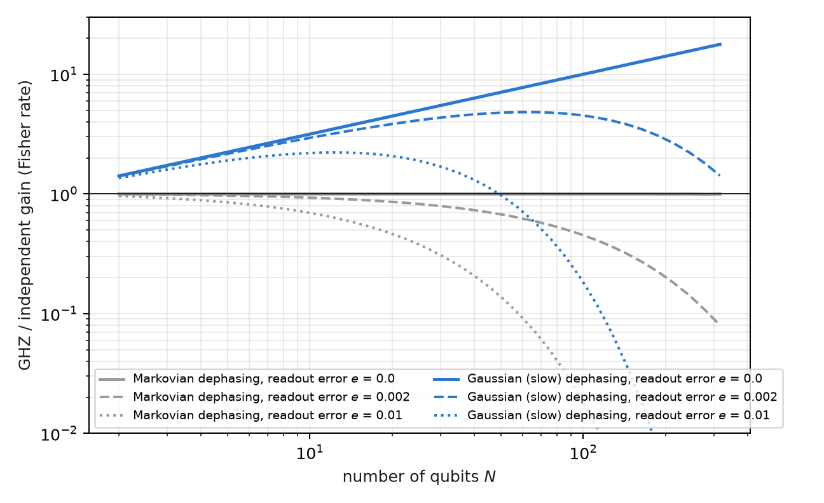
Figure 8.3: The gain of the GHZ state by type of dephasing and read-out error. With Markovian dephasing there is no gain for any N; with Gaussian dephasing it grows as √N, until the read-out error, raised to the N, eats it.
The table sums up three known results, here in a single qg reading. With Markovian dephasing there is no gain for any $N$ (Huelga and co-workers, 1997), and with read-out error independent qubits are strictly better. With Gaussian, slow dephasing the gain grows as $\sqrt{N}$, the Zeno-type limit (Matsuzaki and co-workers, 2011; Chin, Huelga and Plenio, 2012). And the read-out caps it: the parity carries $(1−2e)^{N}$, so there is an optimal size of the GHZ state, beyond which adding qubits makes the measurement worse (Figure 8.3).

8.6 Thermal states: $qg_{Z}=tanh(βh)$
A qubit with $H=−hZ$ in equilibrium at temperature $T$ (with $k_{B}=1$) is in the Gibbs state, and its polar bias is
$$qg_{Z}=tanh(βh), β=1/T.$$
The whole thermodynamics of the qubit is then a function of a single reading (§25):
Table 8.3: Thermodynamics of a qubit in qg units.
quantity | in qg
energy | $U=−h qg$​
entropy (bits) | $S=qg_{S}(qg)$, exact because $ρ$ is diagonal in $Z$
free energy | $F=−Tln​\left(2/\sqrt{1−qg^{2}}\right)$​
heat capacity | $C/k_{B}=artanh(qg)^{2} (1−qg^{2})$​
preparation angle | $θ=arccos(qg)=π/2−gd(βh)$ (Gudermannian)

Thermometry. A $Z$ measurement is an energy measurement, and therefore the optimal one on a Gibbs state; its Fisher information about $T$ is $C/T^{2}$. The best relative precision is at the maximum of the heat capacity:
$$qg⋅artanh(qg)=1 ⇒ qg^{*}=0.8336, βh=1.1997,$$
the peak of the Schottky anomaly, the known optimal operating point of a two-level thermometer (Correa and co-workers, 2015), here as a one-line condition on the reading. The section is an exact rewriting of textbook thermodynamics, checked against $e^{−βH}$ to $5⋅{10}^{−12}$; no advantage was expected or found.

8.7 Without qang and with qang
Table 8.4: The chapter’s actions without the qang scale and with it.
action | without qang | with qang | difference
resolution of a reading | variance of $⟨Z⟩$, $(1−⟨Z⟩^{2})/N$, different at each point | information 1 per shot in the angle; $σ_{m}=1000|sinθ|/\sqrt{N}$ | it is the usual Cramér–Rao bound; the angle makes it uniform
optimize a variational circuit | descent in the gate angles | descent in qg coordinates: does not converge (0 of 20); natural gradient with $qg_{YY}$ correlators: 1.3× to 4.6× | against using $qg_{Z}$ as a coordinate; the gain is the metric’s, not qang’s
compare two clocks | ellipse fit with naive squares: bias +11.8% at 100 shots | with unbiased $qg^{2}$: +0.9% | in favour of the estimator; it is the standard correction, applied on the qg scale
optimal thermometry point | maximum of the heat capacity (Schottky) | $qg⋅artanh(qg)=1$, $qg^{*}=0.8336$ | same point; qang gives it as a one-line condition on the reading
GHZ gain | Fisher rates | the same rates, with a qg parity | none: the three results are known

Balance. In metrology qang organizes: it puts the Cramér–Rao bound in a flat coordinate and gives one-line conditions. The single result against the qg coordinate is explicit: for optimization, the angle and the metric, not $qg_{Z}$.

8.8 In code
from qang import probability
r = probability.analyze(750, 1000) # 750 zeros in 1000 shots, in every qang unit
# p0, qg_Z, m = 500.0 [444.5, 551.7] m-qg, theta = 60.0° [56.5°, 63.6°], qg_S, with intervals

8.9 Summary
- Per shot, the information is 1 in the angle and $1/(1−qg_{Z}^{2})$ in $qg_{Z}$; the resolution in m-qg is $1000|sinθ|/\sqrt{N}$, the Cramér–Rao bound.
- The natural-gradient metric in a real ansatz has diagonal $1/4$ and $qg_{YY}$ correlators; optimizing in qg coordinates does not converge, and the gain comes from the metric.
- Two clocks with a random common phase trace an ellipse; its shape gives the gravitational redshift at 1 m with 68σ in the model, if the bias of the squares is corrected.
- A Ramsey interferometer with visibility $V<1$ is operated at mid-fringe; its information is $(V^{2}−qg^{2})/(1−qg^{2})$.
- The GHZ state gains nothing with Markovian dephasing, gains $\sqrt{N}$ with slow dephasing and loses it to the read-out error raised to the $N$.
- A thermal qubit has $qg_{Z}=tanh(βh)$; its best thermometry point is $qg^{*}=0.8336$, the Schottky peak.

9. Quantum kinematics of flavour oscillation in vacuum
A neutrino is born and detected in a flavour state ($ν_{e}$, $ν_{μ}$ or $ν_{τ}$), but it travels in mass states. Since the mass states pick up different phases, the flavour changes on the way: this is flavour oscillation, and in vacuum it is exactly a two- or three-level rotation. This chapter writes it on the base of Chapter 1. An oscillation probability is a qang probability like any other, with its angle, its milli-qang reading and its error bar; two-flavour oscillation is a precession on a cone of the sphere; and three flavours fit on three qubits with a circuit that conserves the weight, so the qg filter applies. The chapter ends with the project’s first real-hardware data point, taken on IQM Garnet.
Everything in this chapter is in vacuum. A 1300 km baseline crosses the Earth and has sizeable matter effects; those are the subject of Chapter 10.

9.1 From the base: the oscillation probability in m-qg
With two flavours on one qubit, $|0⟩=ν_{e}$ and $|1⟩=ν_{μ}$, the survival probability is $p_{0}=1−P$, with $P=P(ν_{e}→ν_{μ})$. The probability equation of Chapter 1 gives all its readings:
$$qg_{Z}=1−2P, m=1000 (1−2P) \text{m-qg}, ϑ=arccosqg_{Z}=2arcsin\sqrt{P},$$
and its shot resolution, $σ_{m}=1000 |sinϑ|/\sqrt{N}=2000\sqrt{P(1−P)}/\sqrt{N}$ m-qg. A 1% appearance probability is 20 m-qg; a probability difference of 0.025 is 50 m-qg. With three flavours on three qubits (below) each qubit carries the probability of one flavour and is read the same way: $m_{β}=1000 (1−2P_{β})$.
The scale adds no physics: it is the same probability. What it adds is a common ruler for comparing the signal with shot noise and, as shown next, a coordinate in which the mixing angle is read directly.

9.2 Oscillation as a rotation on a cone
In the flavour basis, going to the mass basis is a rotation $R_{Y}(−2θ)$, with $θ$ the mixing angle; in the mass basis the two states acquire the relative phase
$$Δ=\frac{Δm^{2}L}{2E}=2×1.267 \frac{Δm^{2}[{eV}^{2}] L[km]}{E[GeV]},$$
which is an $R_{Z}(Δ)$; and returning to flavour is $R_{Y}(2θ)$. The one-qubit circuit is then $R_{Y}(2θ) R_{Z}(Δ) R_{Y}(−2θ)$, and its reading is (§151)
$$qg_{Z}=\cos^{2}2θ+\sin^{2}2θ cosΔ, P(ν_{e}→ν_{μ})=\sin^{2}2θ \sin^{2}\frac{Δ}{2}.$$
The first formula is the spherical law of cosines. The mass axis is $2θ$ from the pole; the Bloch vector, which starts at the pole, precesses about that axis on a cone of half-angle $2θ$, and after turning by $Δ$ it is an arc distance $ϑ=arccosqg_{Z}$ from the pole. It is the spherical triangle with two sides $2θ$ and included angle $Δ$. The qang angle of the reading is the distance travelled on the sphere (Figure 9.1).
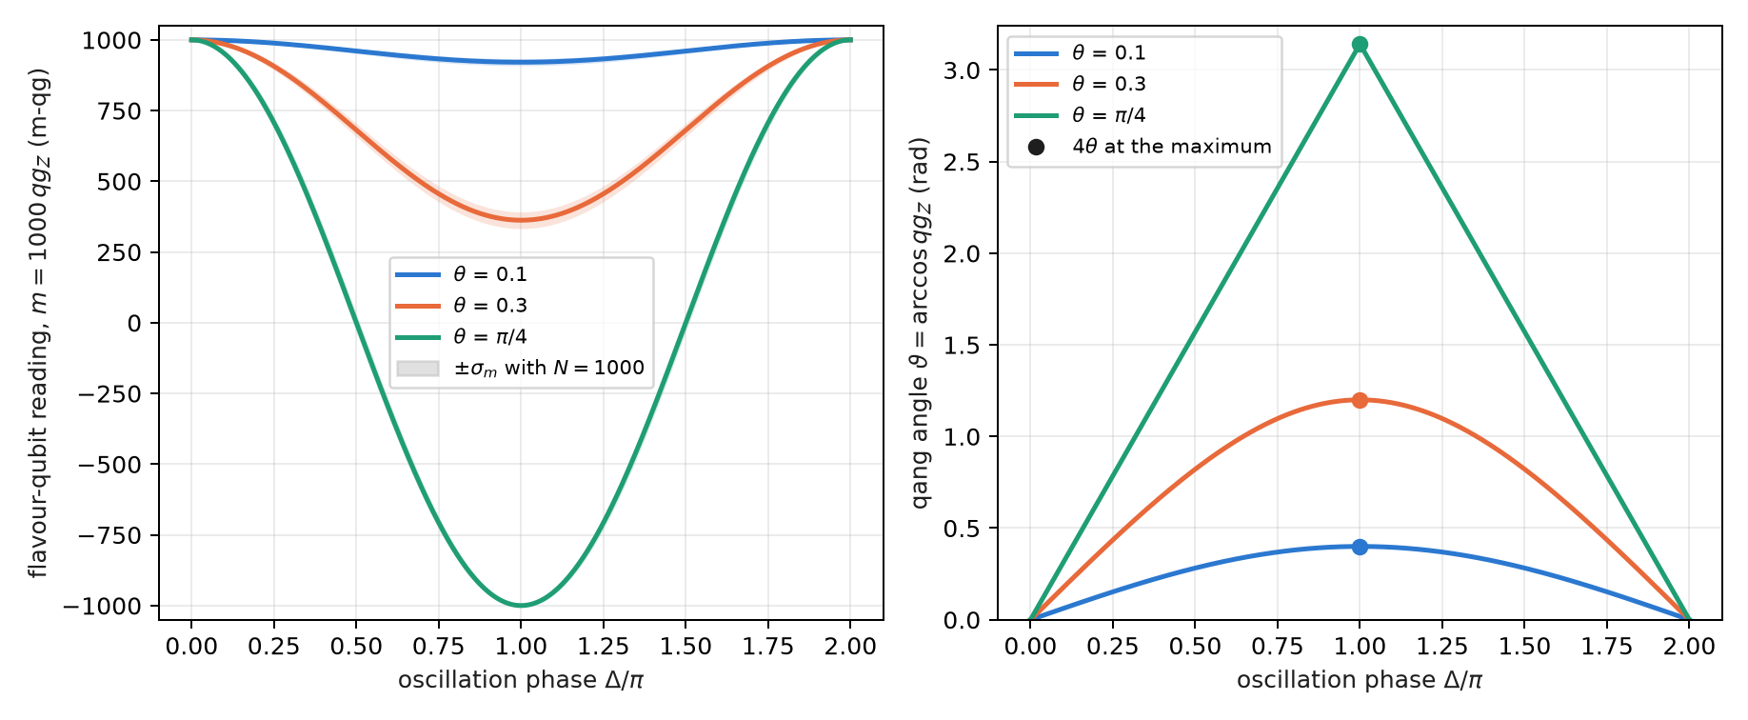
Figure 9.1: Two flavours on one qubit. Left, the m-qg reading as a function of the phase, with the shot-noise band for 1000 shots. Right, the qang angle $ϑ=arccosqg_{Z}$: at the oscillation maximum ($Δ=π$) it is exactly $4θ$.

9.3 The mixing angle is a quarter of the qang angle
At the oscillation maximum, $Δ=π$, the law of cosines reduces to $qg_{Z}=\cos^{2}2θ−\sin^{2}2θ=cos4θ$, and therefore
$$θ_{\text{mix}}=\frac{ϑ}{4}=\frac{arccosqg_{Z}}{4} (θ≤π/4).$$
The mixing angle is read as a quarter of a qang angle, without inverting any $\sin^{2}$. It must be said precisely what this is and what it is not. It is exact only at the maximum: at any other phase the relation between $ϑ$ and $θ$ is not linear, and the trigonometry is still there. And it is not new physics: it is the arcsine transformation of a proportion from Chapter 4 (§125), which at the maximum coincides with the geometry of the cone.
The condition $θ≤π/4$ is not a detail either. For $θ>π/4$ the angle $4θ$ exceeds $π$ and $arccos$ returns $2π−4θ$, that is, $π/2−θ$. Since $\sin^{22}θ$ is symmetric under $θ→π/2−θ$, no two-flavour measurement can tell the two values apart: this is the octant degeneracy, the same one the atmospheric angle $θ_{23}$ has (49° in the values used here; the reading at the maximum would give 41°). The qg scale makes it visible; it does not resolve it.

9.4 Error bars that do not depend on the angle
The qang angle inherits the stabilized variance of the arcsine transformation: its shot-noise standard deviation is $1/\sqrt{N+\frac{1}{2}}$, the same over the whole sphere (Chapter 4, §125). Divided by four:
$$σ_{θ}=\frac{1}{4\sqrt{N+\frac{1}{2}}},$$
which does not depend on $θ$. With 1000 shots it is 0.0079 rad (0.45°). Read in milli-qang, the same measurement does depend on the point: for $θ=0.1$ the maximum is at $m=1000cos0.4=921$ m-qg with $σ_{m}=12$ m-qg. The pre-registered prediction (N1) held over 2000 binomial repetitions:
Table 9.1: The mixing angle read as $arccos(qg_{Z})/4$ at the maximum, 1000 shots, 2000 repetitions.
$θ$ (rad) | 0.1 | 0.3 | 0.5 | 0.7
mean of $\hat{θ}$ | 0.0999 | 0.2999 | 0.5000 | 0.7006
std of $\hat{θ}$ (theory 0.0079) | 0.0079 | 0.0077 | 0.0078 | 0.0081

9.5 Three flavours on three qubits
With three flavours, flavour state $k$ is the weight-1 state with only qubit $k$ excited: $ν_{e}=|100⟩$, $ν_{μ}=|010⟩$, $ν_{τ}=|001⟩$ (in qubit order 0, 1, 2). The PMNS matrix in its standard form,
$$U=R_{23} U_{δ} R_{13} U_{δ}^{†} R_{12}, U_{δ}=diag(1,1,e^{iδ_{CP}}),$$
is three real rotations and two phases. Each rotation $R_{ij}$ is an RBS gate (an $XX+YY$) between qubits $i$ and $j$; each phase is a phase gate on one qubit; and propagation, in the mass basis, is one phase gate per qubit. Every gate conserves the Hamming weight, so a shot with weight other than 1 is an error and can be discarded: this is the qg symmetry filter of Chapter 21 (§77). For antineutrinos, $δ_{CP}→−δ_{CP}$ is enough. The circuit reproduces the analytic vacuum probabilities to ${10}^{−15}$.
Figure 9.2 shows the case of the prediction: an initial $ν_{μ}$, $L=1300$ km (a DUNE-like baseline), $δ_{CP}=−π/2$ and NuFIT-like mixing values in normal ordering. The first oscillation maximum is at 2.63 GeV, where survival drops to $P(ν_{μ}→ν_{μ})=0.013$, that is, $m_{μ}=974$ m-qg.
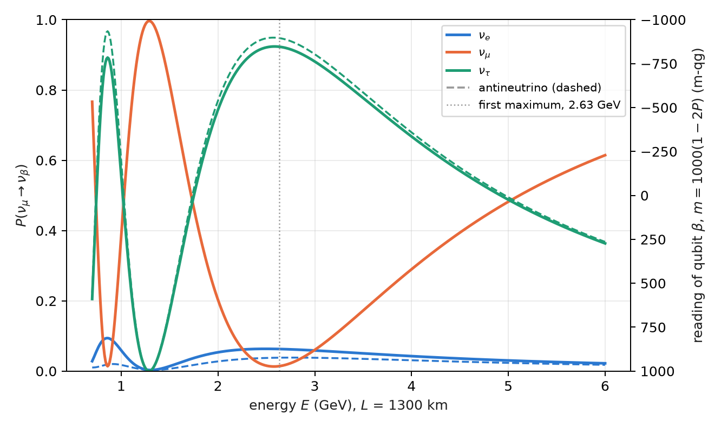
Figure 9.2: Three-flavour probabilities for an initial $ν_{μ}$ at 1300 km, in vacuum; on the right, the m-qg reading of each flavour’s qubit. Dashed lines are antineutrinos: $ν_{μ}$ survival is identical (CPT), $ν_{e}$ appearance is not (CP).

9.6 Noise suppression with the qg filter
The compiled three-flavour circuit has 18 two-qubit gates on IBM. It was run on simulated noise models of three devices (FakeBrisbane with ECR gates, FakeTorino and FakeFez with CZ), at 8 energies between 0.8 and 5 GeV with 4000 shots. The error is the mean of $|\hat{P}−P|$ over the three flavours and eight energies (§151):
Table 9.2: Mean error of the three-flavour probabilities, simulated noise models.
simulated device | raw | readout correction | qg filter | filter + readout | kept | raw / filter + readout
FakeBrisbane | 0.048 | 0.038 | 0.014 | 0.013 | 85–87% | 3.8×
FakeTorino | 0.034 | 0.028 | 0.010 | 0.010 | 90–92% | 3.4×
FakeFez | 0.025 | 0.024 | 0.009 | 0.009 | 93–94% | 3.0×

The error falls between 3.0 and 3.8 times, and almost all of the gain is the filter, not the readout correction. All four pre-registered predictions held, including the position of the minimum of $P(ν_{μ}→ν_{μ})$ at 2.6 GeV on all three devices.
On real hardware (§165). The same circuit was run on IQM Garnet, a 20-qubit superconducting processor, compiled to its native gates with 12 CZ; 8 energies, 300 shots each, with predictions recorded before the job. All four held, and Figure 9.3 shows the data:
Table 9.3: The three-flavour circuit on IQM Garnet, 8 × 300 shots, no readout correction.
check | result
filtered error below raw | 0.039 < 0.062
ratio raw / filtered $≥1.5$ | 1.59 (narrowly)
filtered minimum of $P(ν_{μ}→ν_{μ})$ at 2.6 GeV | yes; raw puts it at 0.8 GeV
kept fraction $≥0.5$ | 0.88

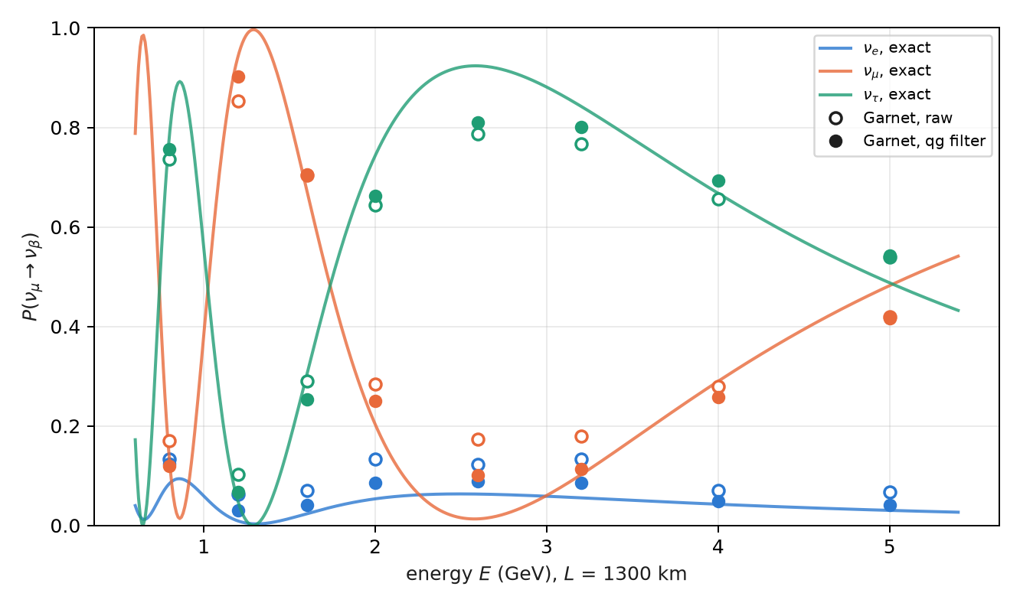
Figure 9.3: The three-flavour circuit on IQM Garnet. Curves are exact; open circles are raw readings, filled ones filtered. Without the filter, $ν_{μ}$ survival (orange) is lowest at 0.8 GeV; with it, at 2.6 GeV, where the oscillation maximum is.
Three readings of this data point. On real hardware the filter puts the oscillation maximum back where it is. The chip did better than its simulated model (0.062 raw against 0.126) and so the filter gained less (1.6× against 2.2× in the rehearsal): fewer shots leave the sector, so there is less to remove. And what remains is inside the sector, where the filter cannot see: at the maximum, $P(ν_{μ}→ν_{μ})$ reads 0.10 against an exact 0.013 (about 175 m-qg apart), and the $ν_{τ}$ error barely moves (0.062 → 0.052). It is one run on one day, with 300 shots per circuit.

9.7 The CP asymmetry in vacuum
CP violation shows up as a difference between neutrinos and antineutrinos:
$$A_{CP}=P(ν_{μ}→ν_{e})−P({\overset{‾}{ν}}_{μ}→{\overset{‾}{ν}}_{e}).$$
At 2.6 GeV with $δ_{CP}=−π/2$ it is 0.0250 (0.0630 against 0.0380), that is, 50 m-qg on the $ν_{e}$ qubit. With 20 000 shots per circuit, the shot noise of the difference is about 4.4 m-qg: the signal is about 11σ. Survival, on the other hand, cannot tell them apart: in vacuum CPT imposes $P(ν_{μ}→ν_{μ})=P({\overset{‾}{ν}}_{μ}→{\overset{‾}{ν}}_{μ})$ (the orange curves of Figure 9.2 coincide).
Table 9.4: CP asymmetry at 2.6 GeV, exact 0.0250 (50 m-qg), 20 000 shots, simulated noise models.
simulated device | raw | filter + readout
FakeBrisbane | 0.024 (48 m-qg) | 0.026 (51 m-qg)
FakeTorino | 0.017 (35 m-qg) | 0.022 (44 m-qg)
FakeFez | 0.020 (41 m-qg) | 0.022 (44 m-qg)

The asymmetry survives even without the filter. It is the difference of two nearly identical circuits (only the sign of two phases changes), so the shift that noise produces in common cancels in the subtraction, as in the fidelity classifier of §149. What does not cancel is the contraction, which shrinks both probabilities and the difference with them: that is why FakeTorino’s raw value reads 35 m-qg and not 50. The filter halves the error on the CZ devices.

9.8 What the link between neutrinos and qang is, and is not
It is modelling: the oscillation is a rotation, and the qang angle reads the mixing angle directly at the maximum, with a known error bar. It does not remove the trigonometry in general, and it does not speed up variational methods for dense neutrino gases: those are many-body problems (Chapter 10). The limits are stated: vacuum only, fixed parameters, simulated device noise except for the single IQM Garnet run.

9.9 Without qang and with qang
Table 9.5: The chapter’s actions without the qang scale and with it.
action | without qang | with qang | difference
read the mixing angle at the maximum | $θ=1/2arcsin\sqrt{P}$ and the delta method | $θ=arccos(qg_{Z})/4$, $σ_{θ}=1/(4\sqrt{N+\frac{1}{2}})$ | same leading order: the delta method also gives $1/(4\sqrt{N})$; qang gets it without a derivative, with the $+\frac{1}{2}$ correction for few shots; at exactly $P=0$ or $1$ both need the intervals of Chapter 4
see the octant degeneracy | symmetry of $\sin^{22}θ$ | the reading at the maximum returns $π/2−θ$ | none: the scale makes it visible, it does not resolve it
compare the CP signal with noise | $ΔP=0.025$ against $σ_{P}$ | 50 m-qg against 4.4 m-qg | unit: the ratio (11σ) is the same
reduce the error of the three-flavour circuit | readout correction: little effect | weight filter: 3.0–3.8× (simulated), 1.6× on Garnet | the gain is the symmetry filter’s, not the qang scale’s

Balance. The geometry of the cone and the reading of the mixing angle are qang’s own contribution, with an error bar that need not be derived. The improvement against noise, the chapter’s largest number, belongs to the filter.

9.10 In code
import math
from qang import neutrino as nu
# two flavours: the reading and the mixing angle at the maximum
q = nu.two_flavour_qg_z(theta=0.1, delta=math.pi) # cos(0.4) = 0.921 -> 921 m-qg
nu.mixing_angle_from_maximum(q) # 0.1
nu.mixing_angle_std(1000) # 0.0079 rad
# three flavours: exact probabilities, weight-1 circuit and CP asymmetry
P = nu.three_flavour_probabilities(L=1300, E=2.6, delta_cp=-math.pi / 2) # P[mu] = [0.063, 0.013, 0.924]
qc = nu.three_flavour_circuit("mu", L=1300, E=2.6, delta_cp=-math.pi / 2)
nu.cp_asymmetry(L=1300, E=2.6, delta_cp=-math.pi / 2) # 0.0250

9.11 Summary
- An oscillation probability $P$ is read as $m=1000(1−2P)$ m-qg, with angle $2arcsin\sqrt{P}$ and resolution $2000\sqrt{P(1−P)/N}$ m-qg.
- With two flavours, $qg_{Z}=\cos^{22}θ+\sin^{22}θcosΔ$ is the spherical law of cosines of the precession on a cone of half-angle $2θ$.
- At the maximum, $θ=arccos(qg_{Z})/4$ with standard deviation $1/(4\sqrt{N+\frac{1}{2}})$, independent of $θ$; for $θ>π/4$ the reading returns $π/2−θ$ (octant degeneracy).
- Three flavours are three qubits in the weight-1 sector; PMNS is three RBS gates and two phases, and the qg filter lowers the error 3.0–3.8 times on simulated models.
- On IQM Garnet the filter gains 1.6× and puts the oscillation maximum back at 2.6 GeV; the error that remains is inside the sector.
- The CP asymmetry at 2.6 GeV is 50 m-qg and survives without the filter, because the common shift cancels in the subtraction.

10. Matter effects, solar neutrinos and collective oscillations
Chapter 9 left the neutrino in vacuum. But a 1300 km beam crosses the Earth, solar neutrinos are born at the centre of the Sun, and in a supernova neutrinos are so dense that they interact with each other. In all three cases the medium adds a term to the flavour Hamiltonian, and the chapter’s question is the same in all three: which number is still conserved, because that decides whether the qg filter applies, and in which basis. On the base of Chapter 1, each effect of the medium is read as a shift in milli-qang, on the same scale as shot noise.

10.1 From the base: the medium as a shift in m-qg
Each flavour (or mass) qubit is read as in Chapter 9, $m=1000 (1−2P)$ m-qg, so an effect of the medium that changes a probability by $δP$ is a shift of $2000 δP$ m-qg, directly comparable with the resolution $σ_{m}=2000\sqrt{P(1−P)/N}$. Three examples from this chapter, on that scale:
Table 10.1: Effects of the medium as shifts in milli-qang.
effect | $δP$​ | in m-qg
matter on $P(ν_{μ}→ν_{e})$, 1300 km, 2.6 GeV, normal ordering | 0.063 → 0.087 | 48
fake asymmetry from matter at $δ_{CP}=0$ | 0.042 | 84
solar MSW drop of $P_{ee}$, 0.5 → 10 MeV, read on the $ν_{2}$ qubit | $p_{2}$: 0.35 → 0.93 | 1173

With 1000 shots and $P≈0.07$ the resolution is about 16 m-qg: the Earth’s effect shows at 3σ in a single circuit, and the solar drop spans most of the scale.

10.2 The MSW effect in the Earth
Electrons in the Earth forward-scatter $ν_{e}$ and add to the flavour Hamiltonian a potential $A=2\sqrt{2} G_{F}N_{e}E$, which in oscillation units is
$$A=1.52×{10}^{−4} Y_{e} ρ[g/cm^{3}] E[GeV] {eV}^{2},$$
with the opposite sign for antineutrinos (Mikheyev–Smirnov–Wolfenstein). In the crust ($ρ=2.85$ g/cm³, $Y_{e}=0.5$) and at 2.6 GeV, $A=5.6×{10}^{−4}$ eV², 22% of $Δm_{31}^{2}$: not a small correction.
The potential acts on $ν_{e}$ only, that is, it is a phase on qubit 0. The circuit alternates the exact vacuum step of Chapter 9 with that phase (second-order, or Strang, Trotter), and every gate still conserves the weight: the qg filter applies just as in vacuum (§152). With $L=1300$ km and between 0.8 and 5 GeV:
Table 10.2: The MSW effect as a Trotter circuit, simulated noise models.
check | result
M1 noiseless Trotter error, $r=2$ / $4$ (needed $<0.005$ / $<0.001$) | 0.0052 / 0.0011 — failed narrowly
M2 matter-only asymmetry at $δ_{CP}=0$, 2.6 GeV | 0.042 (the vacuum CP signal was 0.025)
M3 best error raw / filter + readout | Brisbane 0.046 / 0.017, Torino 0.027 / 0.009, Fez 0.023 / 0.014 (median 2.8×)
M4 optimal steps with filter $≥$ without | $r^{*}=1$ everywhere (holds vacuously)
M5 $A_{CP}(δ_{CP}=0)$, filter + readout, $r=2$ | 0.035, 0.035, 0.029 (exact 0.042; Trotter $r=2$: 0.033)

Three lessons. Matter fakes CP violation: at $δ_{CP}=0$, where vacuum gives no asymmetry at all, the Earth produces 84 m-qg of difference between $ν$ and $\overset{‾}{ν}$, more than the 50 m-qg of Chapter 9’s CP signal; that is why long-baseline experiments must model matter, and the filtered circuit sees it. There is no depth trade-off: a single Trotter step already has less error (0.012) than the noise, so $r^{*}=1$ with or without the filter, and M4 holds only because both are 1. And M5’s gap to the exact value is Trotter error, not noise: the filtered values sit within 0.004 of the $r=2$ Trotter value.

10.3 The mass ordering read through matter
Vacuum cannot tell the sign of $Δm_{31}^{2}$; matter can, because what matters is the sign of the product $A Δm_{31}^{2}$. In normal ordering ($Δm_{31}^{2}>0$) matter enhances $ν_{μ}→ν_{e}$ and suppresses the antineutrino channel; in inverted ordering, the reverse (Figure 10.1). With the exact values at 2.6 GeV:
Table 10.3: $P(ν_{μ}→ν_{e})$ at 1300 km and 2.6 GeV, $δ_{CP}=−π/2$.
 | $ν$, vacuum | $ν$, matter | $\overset{‾}{ν}$, vacuum | $\overset{‾}{ν}$, matter
normal | 0.063 | 0.087 | 0.038 | 0.021
inverted | 0.063 | 0.041 | 0.039 | 0.058

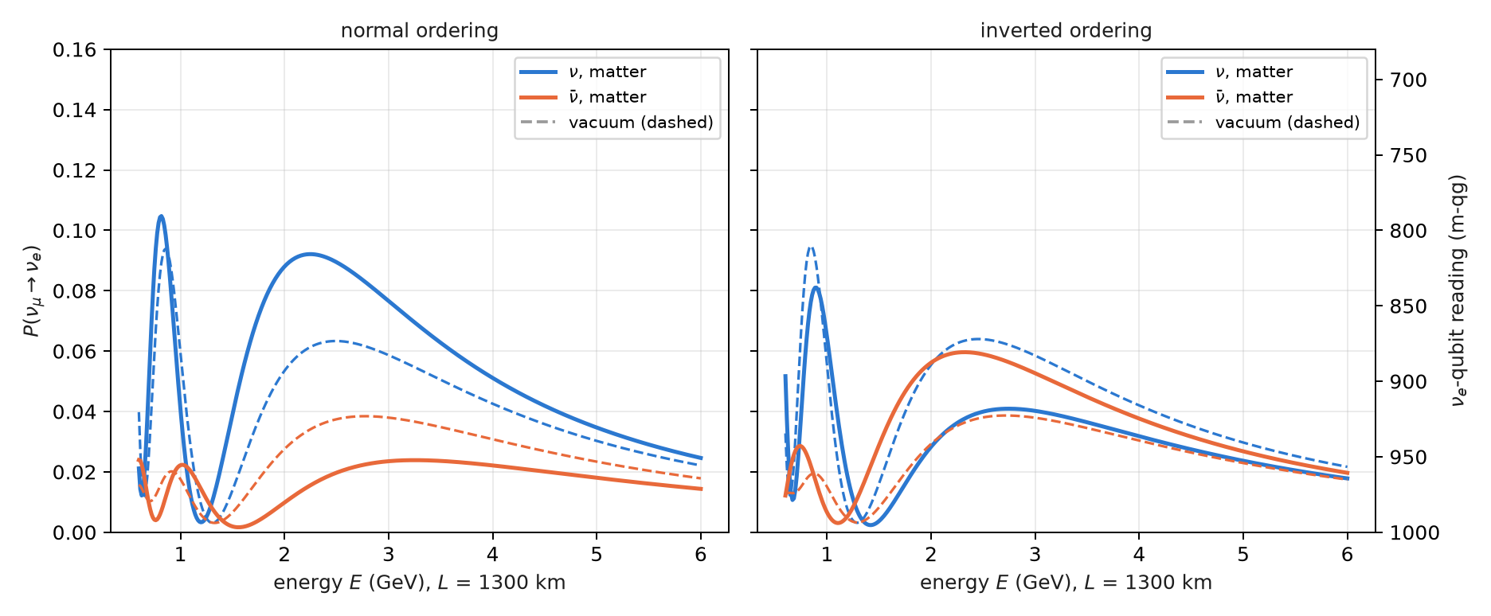
Figure 10.1: $P(ν_{μ}→ν_{e})$ at 1300 km in matter (solid) and in vacuum (dashed), for neutrinos and antineutrinos, in both orderings. On the right, the $ν_{e}$-qubit reading in m-qg. The sign of the matter shift flips with the ordering.
On the simulated noise models, with the $r=2$ Trotter circuit and the filter, the ordering is read correctly on all three devices, with the right sign of the $ν/\overset{‾}{ν}$ asymmetry (§163). The filtered values sit 0.010–0.033 above the noiseless-circuit reference (prediction O3 failed): noise inside the sector moves probability toward the other flavours. But the bias is common, and the difference between orderings survives: 0.034–0.036 against 0.037 in the reference.

10.4 Solar neutrinos: the whole Sun is one rotation
A $ν_{e}$ is born at the solar core, where $(ρY_{e})≈100$ g/cm³, and travels out to vacuum. At low energy matter barely matters and it reaches the Earth with the averaged vacuum probability; above the resonance (about 2 MeV at the core), the central density turns the matter mixing angle $θ_{m}$ almost to 90°, the neutrino adiabatically follows the heavy eigenstate and leaves the Sun as $ν_{2}$. The phases are lost on the way to the Earth, so what arrives is a population in the mass basis, and the survival probability (§156)
$$P_{ee}=c_{13}^{4}\left(\cos^{2}θ_{12} p_{1}+\sin^{2}θ_{12} p_{2}\right)+s_{13}^{4}$$
is linear in $qg_{Z}$ of the $ν_{2}$ qubit. It falls from 0.54 to 0.30 between 0.5 and 15 MeV (Figure 10.2); on the $ν_{2}$ qubit that is going from $+304$ to $−868$ m-qg, more than half of the scale.
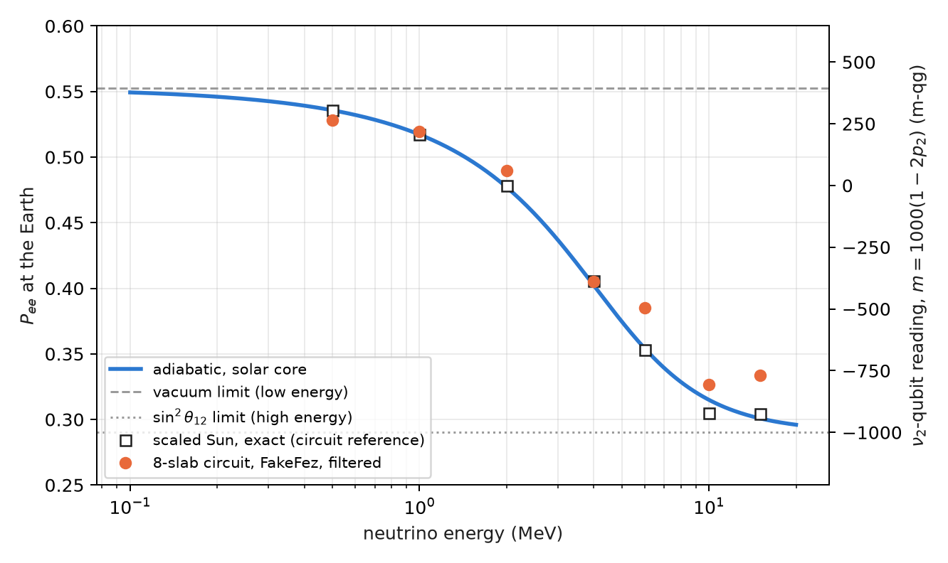
Figure 10.2: Survival probability of solar $ν_{e}$. The curve is the adiabatic conversion from the core; the squares, the exact reference of the scaled Sun the circuit uses; the circles, the 8-slab circuit on the FakeFez noise model with the filter. On the right, the same reading in m-qg of the $ν_{2}$ qubit.
The circuit uses two effective flavours ($ν_{3}$ decoupled; it agrees with three flavours to 0.001) and a scaled Sun: an exponential profile with a 100 km scale height, cut into $r$ slabs uniform in $θ_{m}$. Each slab is one exact $2×2$ propagator, $R_{Z}⋅RBS⋅R_{Z}$ on two qubits in the weight-1 sector, and the filter applies. All six pre-registered predictions held:
Table 10.4: Solar neutrinos on simulated noise models.
read-out (mean $P_{ee}$ error against the noiseless circuit) | Brisbane | Torino | Fez
slabs $r=8$, raw / filter + readout | 0.025 / 0.011 | 0.018 / 0.008 | 0.027 / 0.015
compiled (a single RBS), raw / filter + readout | 0.008 / 0.002 | 0.005 / 0.002 | 0.006 / 0.003
one qubit, raw / readout | 0.004 / 0.002 | 0.031 / 0.003 | 0.004 / 0.002
MSW drop $P_{ee}(0.5)−P_{ee}(10 \text{MeV})$, $r=8$ filtered (exact 0.231) | 0.218 | 0.218 | 0.202

The filter gains 1.9–2.3× on the slab circuit, as in the Earth. But the important result is another one: the physics makes the circuit unnecessary. Because the phases are lost before detection, the observable is a single population, and the compiled circuit (the whole Sun in the one RBS that loads $p_{2}$) beats every slab circuit even without the filter; with two flavours, one qubit with readout correction is as good as anything. The adiabatic answer is classical, $\sin^{2}θ_{m}$ at the core. A quantum computer could add something only where coherence survives: day–night regeneration in the Earth, or the collective effects of the next section.
Open: the real Sun. The profile is scaled (the real one has a scale height of about $6×{10}^{4}$ km and is far more adiabatic, with the same adiabatic answer), and the slab discretization error (0.009 at $r=8$) is of the size of the filtered noise. The comparison with a Standard Solar Model density profile has not been done: it stays a proposal, not a result.

10.5 Collective oscillations: what is conserved is the mass number
In a supernova the neutrino density is so high that neutrinos scatter off each other. With $N$ two-flavour neutrinos, one qubit each, in the single-angle approximation, the Hamiltonian in the mass basis is
Hm=−i​ωi2Zi+μ2Ni<j​σi⋅σj,
with $ω_{i}=Δm^{2}/2E_{i}$ and $μ$ the neutrino–neutrino coupling. Section §151 had named these gases a natural target for the filter because “the total flavour number is conserved”. That holds only for the neutrino–neutrino term. The product $σ_{i}⋅σ_{j}$ is the same in every basis, but the vacuum term is diagonal only in the mass basis: what is conserved is the number of $ν_{2}$, not the flavour number (§154). Figure 10.3 shows it with the exact evolution of four neutrinos: the number of $ν_{2}$ is constant and the number of $ν_{x}$ moves, a little at the experiment’s angle and more at a large angle.
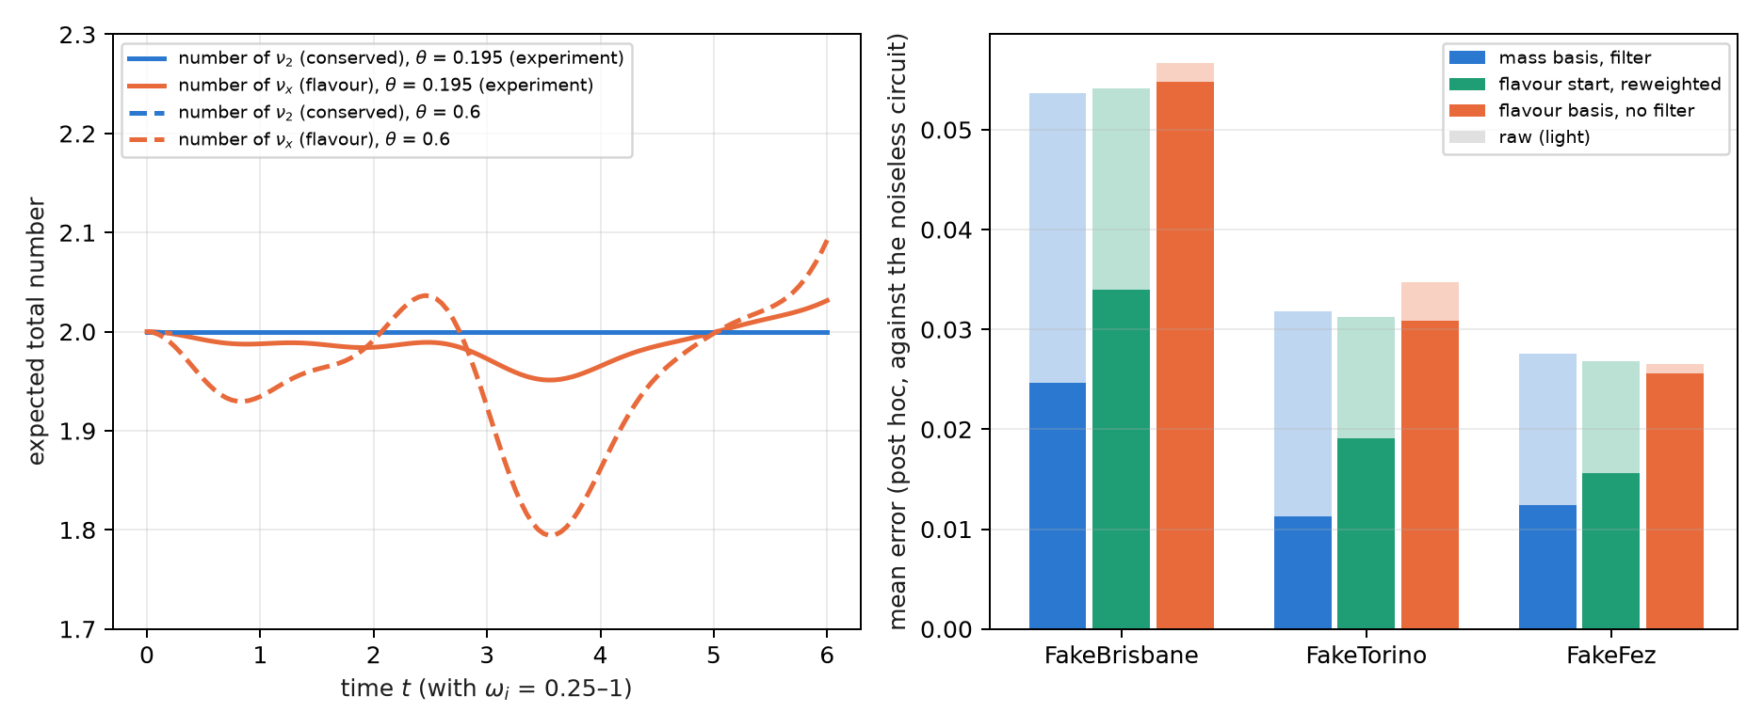
Figure 10.3: Left: exact evolution of four neutrinos ($ω$ = 0.25–1, $μ$ = 4, initial $ν_{e}ν_{e}ν_{x}ν_{x}$). The number of $ν_{2}$ is conserved; the flavour number is not. Right: the error of the three read-outs on simulated noise models (post hoc analysis, not pre-registered), raw in light and corrected in dark.
A flavour initial state is a superposition of mass sectors with known, conserved probabilities (for $ν_{e}ν_{e}ν_{x}ν_{x}$ at $θ=0.195$: 0.863 in the two-$ν_{2}$ sector and 0.067 in each neighbour). The function reweight_sectors rescales each sector to its probability; when the distribution is a delta, it is the filter.
All seven pre-registered predictions failed, for one reason: the noiseless Trotter error (0.095) was larger than the whole noisy error against the exact evolution (0.074–0.088), so every read-out was scored mostly on Trotter error. A post hoc analysis, not pre-registered, scored against the noiseless circuit, gives what the predictions meant to measure:
Table 10.5: Collective oscillations, $N=4$, post hoc analysis against the noiseless circuit.
simulated device | mass basis, raw / filter | flavour start in mass basis, raw / reweighted | flavour basis, raw / readout
FakeBrisbane | 0.054 / 0.025 | 0.054 / 0.034 | 0.057 / 0.055
FakeTorino | 0.032 / 0.011 | 0.031 / 0.019 | 0.035 / 0.031
FakeFez | 0.028 / 0.012 | 0.027 / 0.016 | 0.027 / 0.026

The filter on the conserved mass number gains 2.2–2.8×; the known distribution over sectors, 1.6–1.7×; and in the flavour basis, where nothing is conserved, there is no gain beyond readout correction. The lesson for the next pre-registration is on record: score against the noiseless circuit when the Trotter error is not known to be small, or measure that error before fixing the predictions.

10.6 Without qang and with qang
Table 10.6: The chapter’s actions without the qang scale and with it.
action | without qang | with qang | difference
quantify an effect of the medium | probability change $δP$ | shift of $2000 δP$ m-qg | unit: lets the Earth, the fake asymmetry and the Sun be tabulated on one scale with the noise
read solar survival | $P_{ee}$ linear in the population $p_{2}$ | linear in $qg_{Z}$ of the $ν_{2}$ qubit | equivalent
simulate the Earth with noise | unfiltered Trotter circuit | with the weight filter: 2.8× in the median | the filter’s, not qang’s
collective oscillations | flavour-basis reading: no gain | filter in the mass basis: 2.2–2.8× (post hoc) | the conserved number’s; qang does not decide which number is conserved

Balance. In this chapter qang is the presentation scale. Everything that improves the simulation comes from identifying the conserved number and filtering on it, and the table says so.

10.7 In code
import math
from qang import neutrino as nu
from qang.sectors import reweight_sectors
# the Earth: exact matter probabilities and the weight-preserving Trotter circuit
P = nu.matter_probabilities(L=1300, E=2.6, delta_cp=-math.pi / 2, rho=2.85) # P[mu, e] = 0.087
qc = nu.matter_trotter_circuit("mu", L=1300, E=2.6, delta_cp=-math.pi / 2, rho=2.85, steps=2)
nu.cp_asymmetry(L=1300, E=2.6, delta_cp=0.0, rho=2.85) # 0.042: matter, not CP
Pio = nu.matter_probabilities(1300, 2.6, -math.pi / 2, 2.85, params=nu.NUFIT_IO) # P[mu, e] = 0.041
# the Sun: the adiabatic answer and the compiled circuit (a single RBS)
nu.solar_pee_adiabatic(0.010) # 0.315 at 10 MeV
qc_sun = nu.solar_circuit(0.010, h=100.0, X=800.0, r=8, compiled=True)
# collective oscillations: the conserved mass sectors of a flavour state
nu.mass_sector_probabilities("eexx", theta=0.195) # [0.001, 0.067, 0.863, 0.067, 0.001]

10.8 Summary
- An effect of the medium that changes a probability by $δP$ is a shift of $2000 δP$ m-qg, comparable with shot noise on the same scale.
- The Earth adds a phase on the $ν_{e}$ qubit; the Trotter circuit conserves the weight, the filter gains 2.8× in the median, and a single step is enough.
- Matter fakes CP violation (84 m-qg at $δ_{CP}=0$) and reveals the mass ordering: the sign of the shift flips between normal and inverted.
- In the Sun, $P_{ee}$ is linear in $qg_{Z}$ of the $ν_{2}$ qubit and falls by 1173 m-qg; since the phases are lost, the whole Sun is one rotation, and the answer is classical.
- In collective oscillations the number of $ν_{2}$ is conserved, not the flavour number: the filter works in the mass basis (2.2–2.8×, post hoc) and not in the flavour basis; all seven pre-registered predictions failed on Trotter error.
- The comparison with a realistic solar density profile is still open.

11. Majorana phases, neutrinoless double beta decay and sterile neutrinos
Chapters 9 and 10 read what an oscillation circuit sees: mixing angles, the CP phase, the mass ordering through matter. This chapter takes two open questions of neutrino physics that have a clear answer in qg terms, one negative and one positive. Majorana phases change no oscillation probability, and therefore no qang reading: the compiler deletes them. A sterile neutrino, on the other hand, is one more qubit in the weight-1 sector, and the filter treats it like any other flavour. At the end, closing Part III, the four quantum numbers of the atom written with the same rule.

11.1 From the base: what changes no probability changes no reading
All the readings of Chapter 1 are functions of probabilities: $qg_{Z}=2p_{0}−1$, $m=1000 qg_{Z}$, the angle $arccosqg_{Z}$ and the entropy $qg_{S}$. So a physical parameter that changes no measurement probability is invisible to all of them at once, without exception and with any number of shots. The question “does a circuit see it?” reduces to “does it change any probability?”, and is answered before running anything.
Conversely, a parameter that does change a probability by $δP$ shows up as $2000 δP$ m-qg on the qubit of the corresponding flavour, as in Chapters 9 and 10. The sterile neutrino of this chapter is of that kind: with the hypothetical parameters used below, it lowers $ν_{μ}$ survival by 0.085, that is, 171 m-qg.

11.2 Majorana phases are invisible to oscillations
If the neutrino is its own antiparticle (a Majorana particle), the mixing matrix has two more phases,
$$U_{M}=U diag​\left(1, e^{iα_{21}/2}, e^{iα_{31}/2}\right).$$
The added matrix is diagonal in the mass basis, and so is propagation. The two commute, and in the evolution operator $U_{M} D U_{M}^{†}$ the phase cancels against its inverse: $U_{M}DU_{M}^{†}=UDU^{†}$. No oscillation probability depends on $α_{21}$ or $α_{31}$, in vacuum or in matter (in matter the Hamiltonian is $U_{M} diag(0,Δm_{21}^{2},Δm_{31}^{2}) U_{M}^{†}+V$, and the cancellation already happens in the first term, before the potential is added). Numerically the largest difference among the nine probabilities with and without the phases is $4×{10}^{−16}$, machine rounding (§163).
In the three-flavour circuit of Chapter 9 the phases are phase gates in the mass basis, inserted on either side of propagation (majorana_circuit). What is instructive is what the transpiler does: on all three simulated devices, the circuit compiled with phases $(α_{21},α_{31})=(π/2, 3π/4)$ is identical to the one compiled without them (on FakeFez, 18 CZ, 48 $R_{Z}$ and 47 $\sqrt{X}$ in both). The optimizer merges each phase gate with its inverse and deletes them. It is not an “analytic elimination” designed by anyone, but the direct consequence of the operator not changing: a compiler that simplifies consecutive phases finds the identity on its own.

11.3 Majorana phases in neutrinoless double beta decay
Where the phases do show is in a process that violates lepton number: neutrinoless double beta decay, $(A,Z)→(A,Z+2)+2e^{−}$, possible only if the neutrino is Majorana. Its rate is proportional to the square of the effective mass
mββ=i​Uei2 mi,
and since $U_{ei}^{2}$ enters and not $|U_{ei}|^{2}$, the phases do not cancel: they can add the three contributions or make them interfere destructively. With a massless lightest neutrino, scanning the two phases gives (§163)
Table 11.1: Effective mass of neutrinoless double beta decay with a massless lightest neutrino, scanning the Majorana phases.
ordering | masses (meV) | $m_{ββ}$ (meV)
normal | 0; 8.6; 50.1 | 1.4 to 3.7
inverted | 49.2; 49.9; 0 | 18.7 to 48.3

Figure 11.1 shows both bands as a function of the lightest mass. In inverted ordering the band has a floor of about 19 meV, which is the target of the next generation of experiments. In normal ordering, for a lightest mass between about 2 and 7 meV, the phases can make $m_{ββ}$ vanish completely: a cancellation that no double beta experiment could tell apart from a Dirac neutrino.
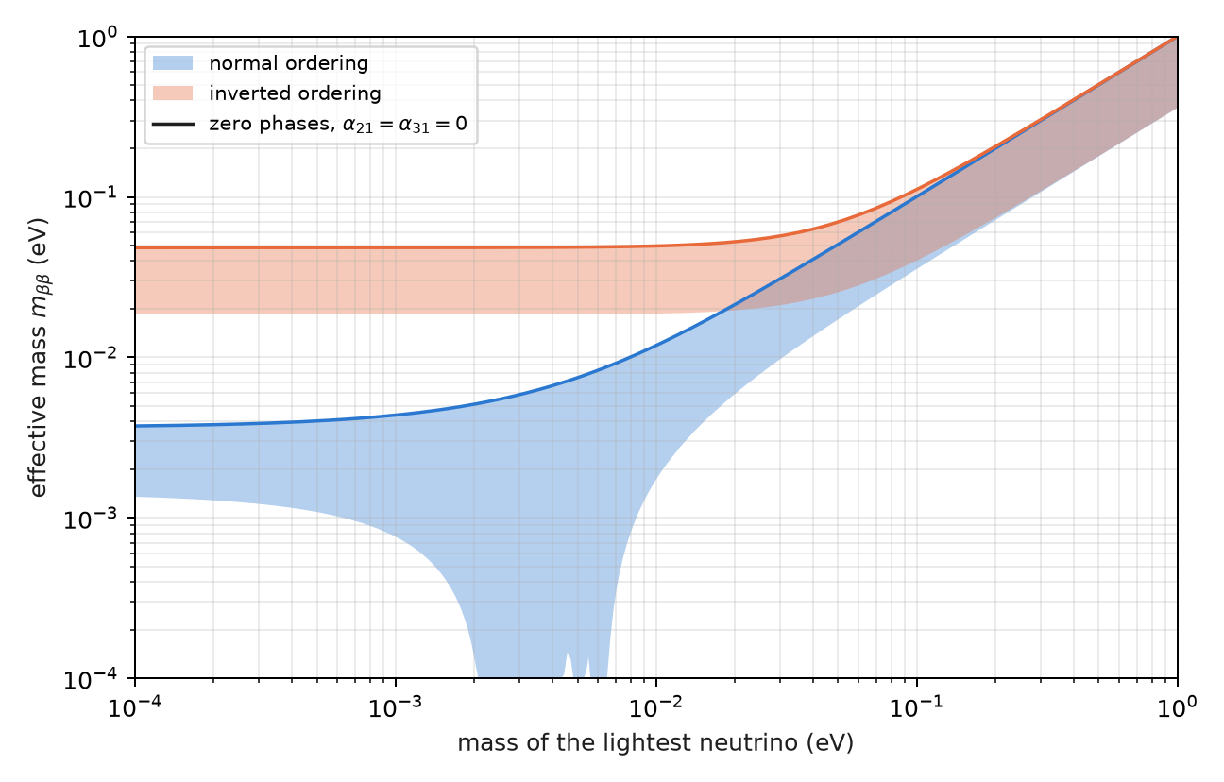
Figure 11.1: The effective mass $m_{ββ}$ as a function of the lightest neutrino mass, scanning the two Majorana phases (bands), and with zero phases (lines). In normal ordering the phases can cancel it between about 2 and 7 meV.
The qg reading of this section is just the previous section said the other way round: an oscillation circuit cannot measure what this figure plots. What the scale does do is separate the two questions cleanly, the oscillation one (probabilities, qang readings) and the mass one (an amplitude with phases, outside any reading of a flavour qubit).

11.4 The sterile neutrino: a fourth qubit in the weight-1 sector
A sterile neutrino $ν_{s}$ is a fourth flavour that does not interact through the weak force, but mixes with the other three. In the 3+1 model there is a fourth mass state with $Δm_{41}^{2}∼1$ eV², much larger than the other two, and the real mixing is a sequence of six rotations,
$$U=R_{34} R_{24} R_{14} R_{23} R_{13} R_{12}$$
(without CP phases, to keep it simple). In the circuit each flavour is a qubit with a single 1: the sterile one is simply one more qubit in the weight-1 sector (sterile_circuit). Each rotation is an RBS and propagation is one phase gate per qubit; everything conserves the weight and the filter applies unchanged.
At short distances, where the three-flavour oscillations have not started yet, survival is effectively two-level,
$$P(ν_{μ}→ν_{μ})≈1−4|U_{μ4}|^{2}\left(1−|U_{μ4}|^{2}\right)\sin^{2}\frac{Δ_{41}}{2}.$$
With the hypothetical values $θ_{14}=θ_{24}=0.15$ and $Δm_{41}^{2}=1$ eV², $|U_{μ4}|^{2}=0.022$ and the amplitude is 0.085; at $L=0.5$ km the first minimum falls at 0.40 GeV (Figure 11.2). It is the same case as Chapter 9, with the same geometry: a precession cone with an effective mixing angle, now between $ν_{μ}$ and $ν_{s}$.
On the simulated noise models, all three pre-registered predictions for the sterile neutrino held:
Table 11.2: The 3+1 sterile neutrino on simulated noise models, 4 qubits, 8000 shots.
check | result
S1 filtered error below raw at all 18 (energy, device) combinations | yes
S2 median raw / filtered ratio $≥2$ | 5.5
S3 filtered minimum of $P(ν_{μ}→ν_{μ})$ at 0.4 GeV on all three devices | yes

At the minimum (exact 0.915), FakeBrisbane reads 0.678 raw and 0.879 filtered; FakeTorino, 0.749 and 0.890; FakeFez, 0.792 and 0.890. The gain is larger than with three flavours (5.5× against 3.0–3.8×) because the circuit has four qubits: there are more ways for a shot to leave the weight-1 sector, and the filter discards them all.
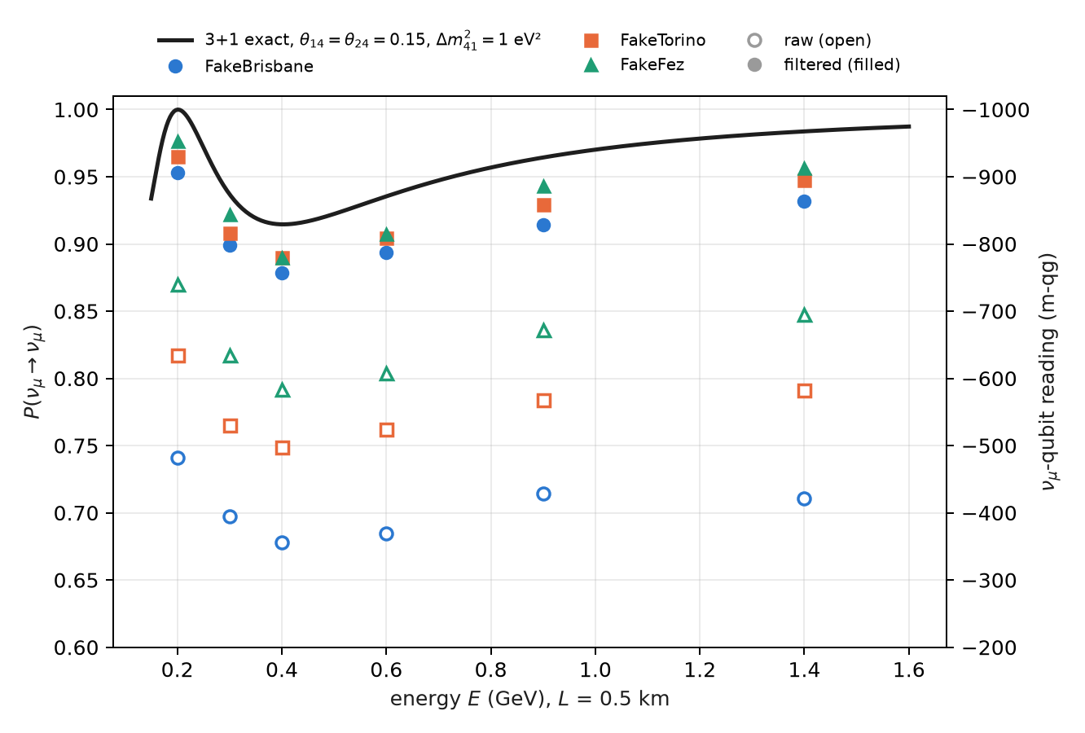
Figure 11.2: $ν_{μ}$ survival at 0.5 km with a hypothetical sterile neutrino. The curve is exact; open markers are raw readings, filled ones filtered, on three simulated noise models. On the right, the $ν_{μ}$-qubit reading in m-qg.
What remains is, again, inside the sector: the filtered values still sit 0.025 to 0.036 below the exact value at the minimum, because noise that moves a 1 from one qubit to another conserves the weight and the filter cannot see it.
Open: the data. The mixing angles in this section are hypothetical, chosen so that the signal is visible; they are not a fit. Phenomenological limits and the comparison of 3+1 models with short-baseline experiments have not been done: they stay a proposal.

11.5 The four quantum numbers in qg terms
Chapter 10 ended on the question of which number is conserved. The same question, applied to the atom, gives a qg reading of the four quantum numbers (§155). It is a translation, not new physics.
- The magnetic number. A register of $n$ qubits in its symmetric subspace is a spin $j=n/2$, and in each shot the magnetic number is read from the Hamming weight: $m=n/2−w$. The weight filter is the projection onto one value of $m$, and $qg_{Z}=⟨J_{z}⟩/j$ for any angular momentum.
- $m_{s}$ is one qubit, with $qg_{Z}=2m_{s}$. $m_{l}$ of an $l$ orbital is the weight of a symmetric register of $2l$ qubits: the three complex $p$ orbitals are $|00⟩$, $(|01⟩+|10⟩)/\sqrt{2}$ and $|11⟩$. The real $p_{x}$ and $p_{y}$ mix $m_{l}=±1$, which is why they have $qg_{Z}=0$ like $p_{z}$, but with entropy 0.63 instead of zero.
- $l$ is the permutation symmetry, and is read with qg values of SWAP: for two qubits, $⟨J^{2}⟩=1+qg_{\text{SWAP}}$.
- $n$: by hydrogen’s hidden SO(4) symmetry, shell $n$ is two spins $(n−1)/2$, that is, two symmetric registers of $n−1$ qubits; $m_{l}$ is $(n−1)$ minus the total weight of the $2(n−1)$ qubits, and the weight filter fixes it.
The qang angle of an eigenstate $|l,m⟩$ is $arccos(m/l)$. The textbook vector-model angle is $arccos​\left(m/\sqrt{l(l+1)}\right)$, and always lies closer to the equator (Figure 11.3), because $|l,m⟩$ has a transverse spread $⟨J_{x}^{2}+J_{y}^{2}⟩=l(l+1)−m^{2}>0$:
Table 11.3: The qang angle of $|l,m⟩$ against the vector-model angle.
$l$, $m$ | qang angle | vector model | $⟨J_{x}^{2}+J_{y}^{2}⟩$​
1, +1 | 0° | 45.0° | 1
2, +2 | 0° | 35.3° | 2
2, +1 | 60.0° | 65.9° | 5
3, +3 | 0° | 30.0° | 3
3, +1 | 70.5° | 73.2° | 11

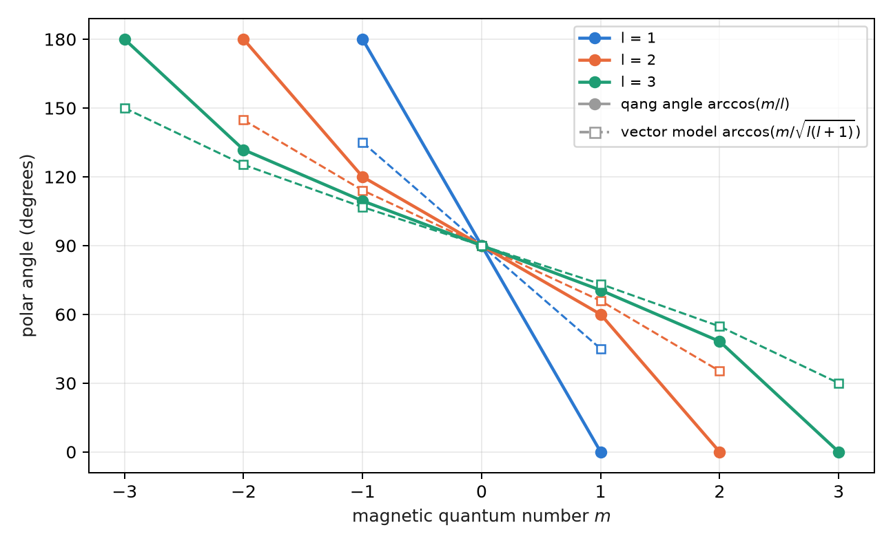
Figure 11.3: Polar angle of the eigenstates $|l,m⟩$: the qang angle $arccos(m/l)$ (circles) and the vector-model one (squares). They agree only at $m=0$; the qang angle is the direction of $⟨J⟩$, the vector model draws a vector of length $\sqrt{l(l+1)}$.
$qg_{Z}$ measures where $⟨J⟩$ points; the vector model draws a vector of length $\sqrt{l(l+1)}$. The two agree only at $m=0$. In a demonstration (not pre-registered) on the FakeTorino noise model, $p_{z}$ ($m_{l}=0$) leaks to $m_{l}=±1$ in 19% of shots on the default qubit layout and in 2.2% on the chain chosen by ibm.best_chain; in both cases the weight filter returns $P(m_{l}=0)=1$.

11.6 Without qang and with qang
Table 11.4: The chapter’s actions without the qang scale and with it.
action | without qang | with qang | difference
decide whether a parameter is observable | check whether any probability depends on it | “what changes no probability changes no reading” | equivalent; the qang rule says it for all readings at once
compute $m_{ββ}$ | $|∑U_{ei}^{2}m_{i}|$​ | — | qang does not apply: it is an amplitude with phases, not a probability
quantify the sterile signal | $δP=0.085$​ | 171 m-qg | unit
reduce the error with four flavours | raw reading | weight filter: 5.5× | the filter’s
compare the qang angle with the vector model | $arccos(m/\sqrt{l(l+1)})$​ | $arccos(m/l)$​ | in favour of qang as a reading: it is the direction of $⟨J⟩$, which is what a $qg_{Z}$ measures; the vector model draws something else

Balance. The chapter has one case where qang has nothing to say ($m_{ββ}$), and it is worth having it written. Its own contribution is interpretive: what a reading sees and does not see, and which angle a $qg_{Z}$ really measures.

11.7 In code
import math
from qang import neutrino as nu
from qang import angular
# Majorana: no probability changes, in vacuum or in matter
nu.majorana_invisible(1300, 2.6, -math.pi / 2, math.pi / 2, 3 * math.pi / 4, rho=2.85) # 4e-16
nu.m_bb(0.0, a21=0.0, a31=0.0, ordering="IO") # 0.048 eV
# the sterile neutrino: a fourth qubit in the weight-1 sector
P = nu.sterile_probabilities(L=0.5, E=0.4, dm41=1.0, theta14=0.15, theta24=0.15) # P[mu, mu] = 0.915
qc = nu.sterile_circuit("mu", L=0.5, E=0.4, dm41=1.0, theta14=0.15, theta24=0.15)
# the quantum numbers: the qang angle and the vector-model angle
math.degrees(angular.qang_angle_of_eigenstate(2, 1)), math.degrees(angular.vector_model_angle(2, 1)) # 60.0, 65.9

11.8 Summary
- Every qang reading is a function of probabilities: a parameter that changes no probability is invisible to all of them at once.
- Majorana phases cancel in $U_{M}DU_{M}^{†}$ (difference $4×{10}^{−16}$); the transpiler outputs the same circuit with and without them.
- Neutrinoless double beta decay does see them: $m_{ββ}$ ranges from 1.4 to 3.7 meV (normal) and from 18.7 to 48.3 meV (inverted) with a massless lightest neutrino, and can vanish in normal ordering.
- A sterile neutrino is a fourth qubit in the weight-1 sector; with hypothetical mixing, the filter gains 5.5× and places the minimum at 0.4 GeV. Limits from real data are still open.
- The four quantum numbers are read in qg: $m$ from the Hamming weight, $l$ from SWAP, $n$ from the register size; the qang angle $arccos(m/l)$ is not the vector-model one.

12. Optical teleportation and the Bell-pair limit
Part IV takes the qang scale to quantum communication networks. This chapter deals with teleporting a qubit through a passive optical network: a central office shares an entangled state with a user through a fibre and a passive $1:N$ splitter, and the photon arrives with low probability. The question is which state to share. The usual answer, a Bell pair, stops being optimal as soon as the channel loses photons, and the optimal state is fixed by a single number: the $qg_{Z}$ reading of one of its qubits. The chapter closes with the qg reading of Bell pairs in a network, which is what Chapter 13 uses as a predictor of the fidelity.

12.1 From the base: the fidelity is a probability
The fidelity of teleporting an input state is the probability that Bob, after undoing the preparation, measures 0: it is a $p_{0}$ of Chapter 1, with its reading $m=1000(2p_{0}−1)$ m-qg and its error bar. The average fidelity over the Bloch sphere is obtained exactly with six inputs, the cardinal states $|0⟩$, $|1⟩$, $|±⟩$, $|±i⟩$, because they form a spherical 3-design.
The shared state is $cosα|00⟩+sinα|11⟩$, and each of its qubits has
$$qg_{Z}=\cos^{2}α−\sin^{2}α=cos2α, α=\frac{arccosqg_{Z}}{2}.$$
The resource angle is half the qang angle of either of its qubits. The Bell pair, $α=π/4$, is the equator: $qg_{Z}=0$, $m=0$. A less entangled resource leans toward $|00⟩$ ($m>0$); a “more than maximally entangled” one, in the sense of this section, leans toward $|11⟩$ ($m<0$). The whole design rule of this chapter is an m-qg reading of a single qubit.

12.2 Teleportation with a Bell pair
In the protocol of Bennett and co-workers (1993), Alice measures her input qubit and her half of the resource in the Bell basis, sends Bob two classical bits, and Bob applies one of four Pauli corrections. With a perfect Bell pair the fidelity is 1. With an imperfect resource, the average fidelity depends only on its singlet fraction $f=⟨Φ^{+}|ρ|Φ^{+}⟩$:
$$F=\frac{2f+1}{3},$$
and teleportation beats every classical strategy (measure and resend) only if $F>2/3$, that is, $f>1/2$. In the circuit the Bell measurement is in deferred form (CX, H, CX, CZ), with no mid-circuit measurements.

12.3 A channel that loses photons
In a downlink passive optical network (§157) the resource’s second qubit is a photon present or absent (single rail) that travels through a fibre of transmission $T={10}^{−0.02L}$ ($L$ in km, 0.2 dB/km) and reaches a $1:N$ splitter. For Bob’s mode both are beam splitters, that is, RBS gates that conserve the photon number, and the photon arrives with probability
$$η=\frac{T}{N}.$$
A lost photon leaves Bob in $|0⟩$: the channel is amplitude damping, which does not treat the two branches of the resource alike. The $|00⟩$ branch has nothing to lose; the $|11⟩$ branch loses its photon with probability $1−η$. So it pays to put less weight on the fragile branch, and the optimum moves away from $α=π/4$.

12.4 The design rule
The singlet fraction of the resource after the channel is
$$f=\frac{(cosα+\sqrt{η} sinα)^{2}}{2 (\cos^{2}α+κ\sin^{2}α)},$$
with $κ=1$ in the non-assisted protocol, in which only Alice and Bob act. In the assisted protocol the other $N−1$ users report whether the photon reached them, and those shots are discarded: it is a sector filter on the other users’ register, and the only loss left unheralded is the fibre loss, with $κ=η+1−T$. Maximizing $f$ gives
$$tanα^{*}=\frac{\sqrt{η}}{κ}, F^{*}=\frac{2+η/κ}{3}, qg_{Z}^{*}=cos2α^{*}=\frac{κ^{2}−η}{κ^{2}+η}.$$
The original master index wrote the rule as $\sqrt{η/κ}$; the correct form is $\sqrt{η}/κ$, which is what the code verifies. The whole rule is the third formula: one resource qubit measured in $Z$ fixes $α$. On the four links of the experiment:
Table 12.1: The design rule on the four links; in bold, the cases where the Bell pair does not beat the classical limit.
link | protocol | $η$​ | $α^{*}$ (rad) | $F^{*}$​ | $m^{*}$ (m-qg) | Bell pair | kept at $α^{*}$
0 km, 1:4 | non-assisted | 0.250 | 0.464 | 0.750 | +600 | 0.708 | 1
0 km, 1:4 | assisted | 0.250 | 1.107 | 1.000 | −600 | 0.933 | 0.40
0 km, 1:8 | non-assisted | 0.125 | 0.340 | 0.708 | +778 | 0.639 | 1
0 km, 1:8 | assisted | 0.125 | 1.231 | 1.000 | −778 | 0.876 | 0.22
20 km, 1:4 | non-assisted | 0.100 | 0.306 | 0.700 | +819 | 0.622 | 1
20 km, 1:4 | assisted | 0.100 | 0.423 | 0.714 | +663 | 0.672 | 0.95
20 km, 1:8 | non-assisted | 0.050 | 0.219 | 0.683 | +905 | 0.583 | 1
20 km, 1:8 | assisted | 0.050 | 0.330 | 0.692 | +790 | 0.635 | 0.96

Three readings of the table. Without assistance, the Bell pair may be useless: on a 1:8 splitter, or at 20 km, it falls below 2/3, and only the optimal resource, leaning toward $|00⟩$, beats the classical limit. With assistance and no fibre, the optimum has $F^{*}=1$ at $tanα^{*}=\sqrt{N}>1$: the resource leans further toward $|11⟩$ than a Bell pair, and the splitter’s filtering brings it back to exactly a Bell pair; the price is the kept fraction. In that case $κ=η$ and $qg_{Z}^{*}=−(1−η)/(1+η)$, exactly the opposite reading of the non-assisted case: $−600$ against $+600$ m-qg at $N=4$. With fibre, the unheralded loss dominates again and the assisted optimum returns to the $|00⟩$ side (Figure 12.1).
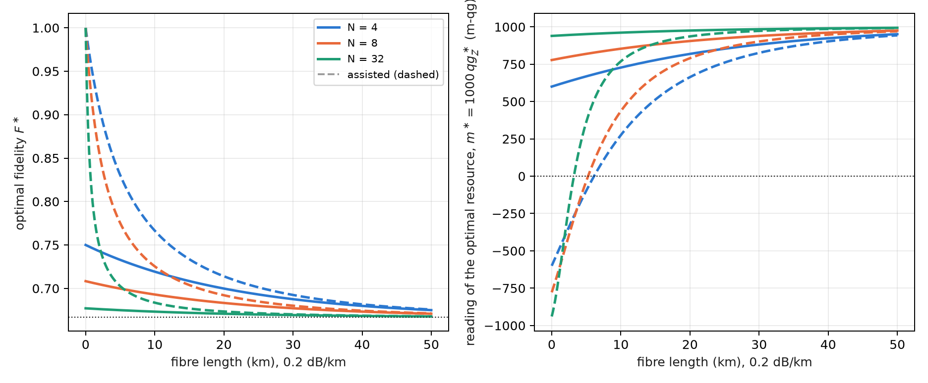
Figure 12.1: Left: optimal fidelity as a function of fibre length for three splitters; dashed lines are the assisted protocol. Right: the reading of the optimal resource in m-qg. Without fibre the assisted optimum is on the $|11⟩$ side ($m^{*}<0$); a few kilometres of fibre bring it back to the $|00⟩$ side.
It is the discrete-variable version of a continuous-variable result: in a passive optical network, non-assisted teleportation has a finite optimal squeezing, and assisted teleportation one that goes to infinity at short distance (Yaghoobianzadeh and Salehi, 2026). The non-maximally entangled resource is the analogue of finite squeezing.

12.5 The rule on simulated devices
The circuit has five qubits (input, Alice, Bob, the fibre’s environment and the other users), with the fibre and the splitter as RBS gates. It was run with 14 resource angles plus $π/4$, six inputs and 4000 shots, on three simulated noise models (§157). Five of the six pre-registered predictions held:
Table 12.2: The design rule on three simulated noise models.
check | result
Q1 best non-assisted angle within 0.1 rad of $α^{*}$ | 12 of 12
Q2 0 km, 1:8: Bell pair below 2/3, best angle above | 0.624–0.627 and 0.690–0.701 on all 3
Q3 assisted beats non-assisted | 12 of 12
Q4 assisted optimum above $π/4$ at 0 km | 1.0–1.2 rad on all 3
Q5 $|F_{\text{best}}−F^{*}|<0.05$ | failed: 19 of 24; the 5 misses are assisted at 0 km ($F^{*}=1$, measured 0.897–0.957)
Q6 kept fraction within 0.03 of $\cos^{2}α+κ\sin^{2}α$ | 12 of 12 (largest gap 0.028)

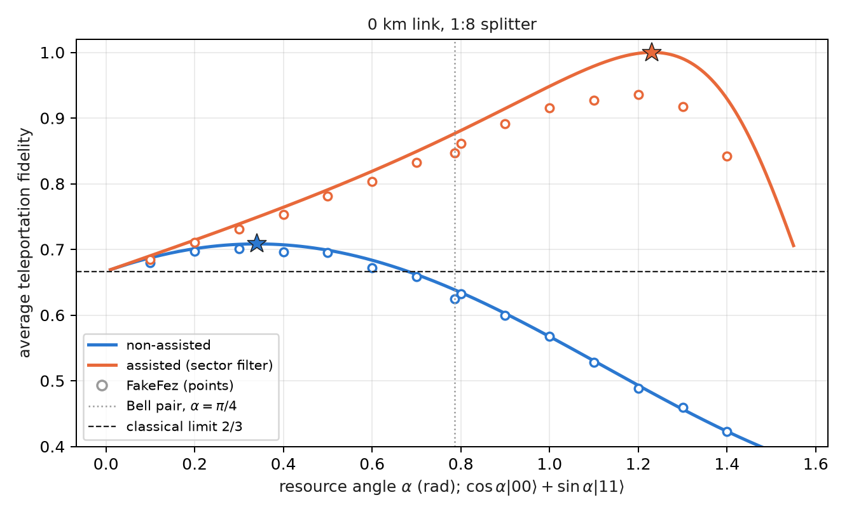
Figure 12.2: Average fidelity as a function of the resource angle, 0 km link with a 1:8 splitter. Exact curves, circles from the FakeFez noise model, stars at the optimum. The Bell pair (dotted line) falls below the classical limit without assistance; the optimal resource stays above it.
The design rule survives device noise (Figure 12.2): on a 1:8 splitter only the optimal resource beats the classical 2/3. And the qang scale, here, adds nothing against the noise: the teleportation circuit (H, CX) does not conserve the weight, so the only filter is the other users’ heralding. That is why the Q5 misses are where $F^{*}$ is near 1: gate noise weighs more the higher the fidelity one is after. Chapter 13 asks what changes when every gate conserves the photon number.
The limits are stated: downlink only, single rail, simulated device noise, and no detector inefficiency or dark counts beyond the readout errors of the models.

12.6 Bell pairs in a network, read in qg
Before teleporting it pays to know how good the shared pair is. A pair meant to be $|Φ^{+}⟩$ is described by five qg readings: three two-qubit correlators, $qg_{XX}$, $qg_{YY}$, $qg_{ZZ}$, and the polar biases of each side, $m_{A}=⟨Z_{A}⟩$ and $m_{B}=⟨Z_{B}⟩$. Three measurement settings are enough (§57). The fidelity with $|Φ^{+}⟩$ is exact for any state,
$$F_{Φ^{+}}=\frac{1+qg_{XX}−qg_{YY}+qg_{ZZ}}{4},$$
and with it the teleportation fidelity the pair will give, $F=(2F_{Φ^{+}}+1)/3=(3+qg_{XX}−qg_{YY}+qg_{ZZ})/6$, without running the teleportation (Chapter 13 puts it to the test). The weights of the four Bell states say which error dominates: $Φ^{−}$ is a phase flip, $Ψ^{+}$ a bit flip, $Ψ^{−}$ both. With noise $p=0.1$ on each half:
Table 12.3: qg signatures of noise on a Bell pair, $p=0.1$ on each half.
noise | $qg_{XX}$​ | $qg_{YY}$​ | $qg_{ZZ}$​ | $m_{A}=m_{B}$​ | $F_{Φ^{+}}$​ | dominant error
dephasing | +0.64 | −0.64 | +1.00 | 0 | 0.820 | $Φ^{−}$​
X flip | +1.00 | −0.64 | +0.64 | 0 | 0.820 | $Ψ^{+}$​
Y flip | +0.64 | −1.00 | +0.64 | 0 | 0.820 | $Ψ^{−}$​
depolarizing | +0.81 | −0.81 | +0.81 | 0 | 0.858 | all equal
amplitude damping | +0.90 | −0.90 | +0.82 | +0.10 | 0.905 | $Ψ^{+}$​

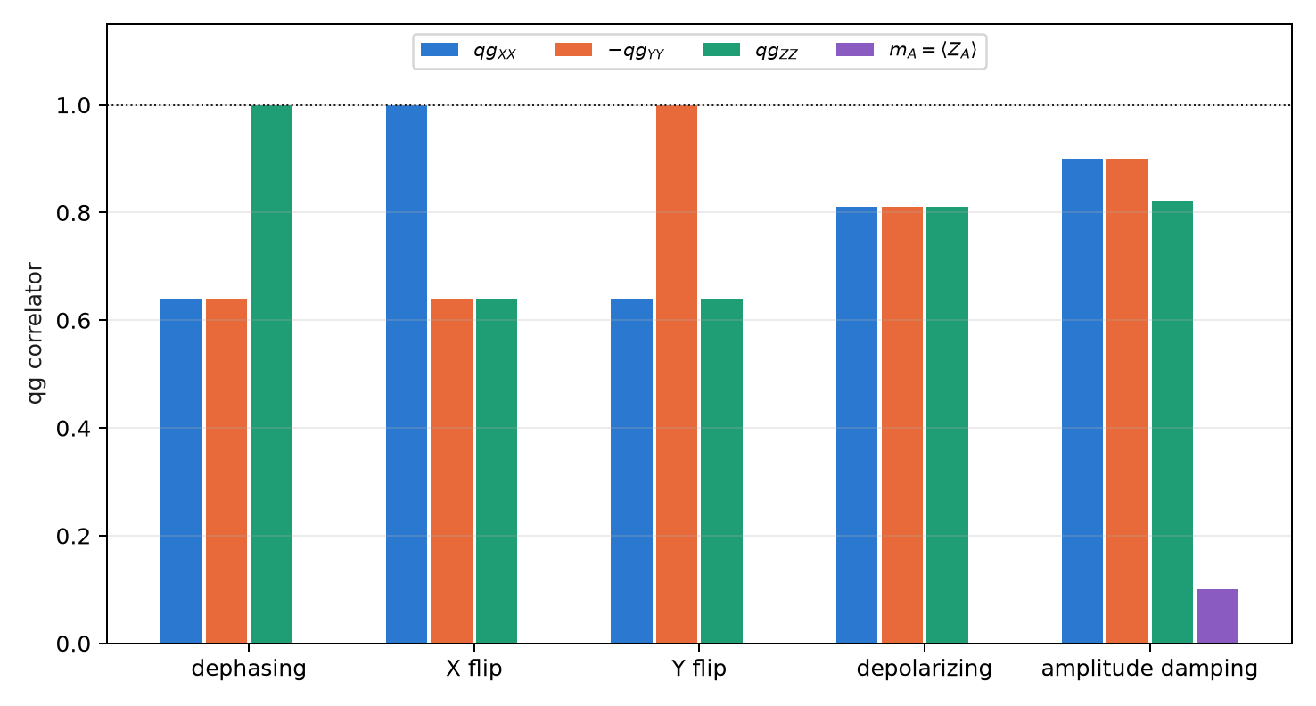
Figure 12.3: The signatures of the table: each Pauli noise leaves one correlator at its ideal value (the dotted line), and only amplitude damping moves the local polar biases.
Each Pauli noise leaves one correlator untouched, and only damping (the T1 relaxation of a memory) moves the local biases (Figure 12.3). That reading decides how to distil. The DEJMPS protocol combines the $Φ^{+}$ weight with the error sitting in a fixed slot, and local rotations choose which error goes there. The textbook order can make things worse: with Y-flip noise, one round lowers the fidelity from 0.820 to 0.705, and with damping it gains almost nothing (0.828). The rule “smallest estimated error in that slot”, read from the three correlators with 200 shots per setting, reaches the best output in all three cases: 0.954, 0.954 and 0.915 (against an optimum of 0.920).

12.7 Without qang and with qang
Table 12.4: The chapter’s actions without the qang scale and with it.
action | without qang | with qang | difference
choose the optimal resource | optimize the Schmidt coefficient $α$ | one reading: $qg_{Z}^{*}=(κ^{2}−η)/(κ^{2}+η)$ on one qubit; the sign of $m^{*}$ says which side of the Bell pair it is on | in favour for design and verification: it is calibrated by measuring one qubit in $Z$
decide whether the Bell pair works | compute $F(π/4)$ | the Bell pair is $m=0$; the optimum, $m^{*}$ | equivalent in value; qang places it on the scale
reduce device noise | — | the filter does not apply: teleportation does not conserve the weight | none
diagnose a Bell pair | full tomography | three qg correlators and two biases; the signature picks the distillation (0.705 → 0.954 with Y flips) | in favour: three settings instead of nine, and a direct decision rule

Balance. This is the chapter where the qang reading looks most like an engineering tool: one number sets the resource and three correlators diagnose the pair. Against noise it contributes nothing, and that is said.

12.8 In code
import math
from qang import qpon
eta, kappa = qpon.link(length_km=0, n_users=8, assisted=False) # (0.125, 1.0)
qpon.optimal_angle(eta, kappa) # 0.340 rad
qpon.optimal_fidelity(eta, kappa) # 0.708
qpon.average_fidelity(math.pi / 4, eta, kappa) # 0.639: the Bell pair, below 2/3
qpon.optimal_qg_z(eta, kappa) # 0.778 -> +778 m-qg
qpon.resource_angle_from_qg_z(0.778) # 0.340: the resource, from one reading
qc = qpon.teleport_circuit(alpha=0.340, transmission=1.0, n_users=8, input_index=2) # input |+>
qpon.fidelity_from_correlators(xx=0.81, yy=-0.81, zz=0.81) # 0.905 = (2 F_Phi+ + 1)/3, F_Phi+ = 0.858

12.9 Summary
- The teleportation fidelity is a probability; the resource $cosα|00⟩+sinα|11⟩$ has $qg_{Z}=cos2α$ on each qubit, and the Bell pair is $m=0$.
- On a channel that loses photons ($η=T/N$) the optimum is not the Bell pair: $tanα^{*}=\sqrt{η}/κ$, $F^{*}=(2+η/κ)/3$, $qg_{Z}^{*}=(κ^{2}−η)/(κ^{2}+η)$.
- Without assistance, on a 1:8 splitter or at 20 km the Bell pair falls below 2/3 and the optimal resource stays above; with assistance and no fibre, $F^{*}=1$ with a resource on the $|11⟩$ side.
- The rule survives simulated noise (five of six predictions); the qg filter does not help here because teleportation does not conserve the weight.
- A Bell pair is read with three correlators and two biases; each Pauli noise leaves one untouched, and that signature picks the right distillation round.

13. Dual rail, the sector filter and long-distance fidelity
Chapter 12 ended on a limitation: the qg filter did not help against device noise, because the teleportation circuit does not conserve the weight. This chapter asks the two questions that follow. The first is whether the fidelity a resource will give can be read before teleporting, with few measurements; the answer is yes, with three qg correlators. The second is what happens if every gate conserves the photon number; the answer is dual rail, in which the filter heralds every loss, and which at 20 km beats the noiseless single-rail optimum until false heralds set a floor. The chapter closes Part IV with entanglement swapping along a chain, read with the same correlators.

13.1 From the base: three qg readings predict a fidelity
Each two-qubit correlator is a qg reading like those of Chapter 1: the parity of two bits measured in a basis, $qg_{PP}=1−2P(\text{odd parity})$, with its m-qg reading and its error bar $\sqrt{(1−qg^{2})/N}$. Chapter 12 showed that the fidelity with $|Φ^{+}⟩$ is linear in three of them; so is the average teleportation fidelity (§158):
$$F=\frac{3+qg_{XX}−qg_{YY}+qg_{ZZ}}{6}.$$
It is a linear read-out of the resource alone, without the Bell measurement: three circuits with 4–5 two-qubit gates, against 10–11 for the teleportation. Being linear, its error bar combines the three: with $N$ shots per correlator, $σ_{F}=\sqrt{∑(1−qg^{2})/N}/6$, about 0.0025 with $N=10 000$ near $F≈0.7$.

13.2 The fidelity from three correlators
On the four links of Chapter 12, with both protocols and on three simulated noise models, the fidelity predicted by the correlators was compared with the teleported one. In all 24 combinations the difference is at most 0.029 (Figure 13.1): three short circuits predict the teleported fidelity.
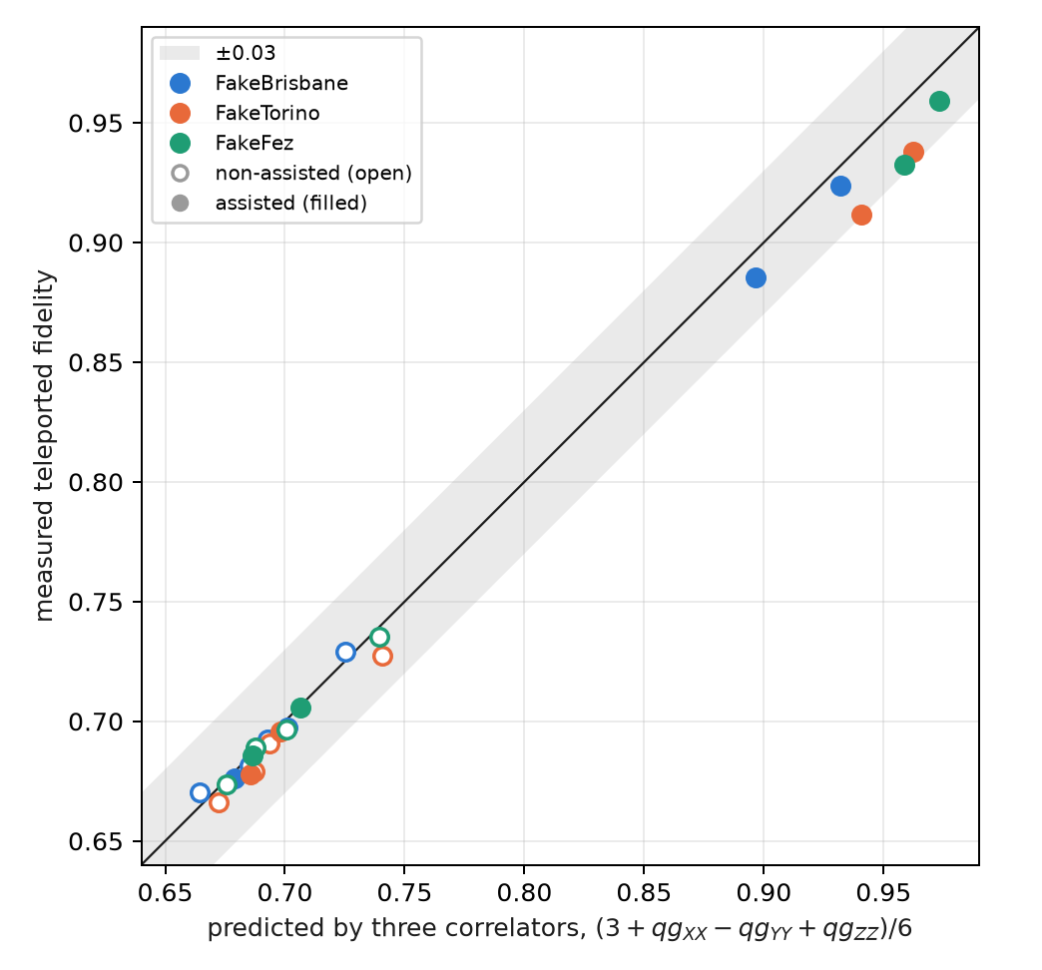
Figure 13.1: Measured teleported fidelity against the one predicted by three correlators, 4 links × 2 protocols × 3 simulated noise models. All 24 fall within ±0.03 of the diagonal.
The pre-registered predictions wanted more: that the difference would isolate the noise of the Bell measurement. That failed. The prediction fell below the noiseless optimum in 5 of 24 cases (A1), was not always above the teleported one (A2, 3 of 24, all within two shot errors), and the difference was not always larger with assistance (A3, 2 of 12). The reason is that the three correlator circuits read two data qubits and the herald, so they carry almost all the noise the teleportation sees. They work as a predictor, not as a decomposition.

13.3 Dual rail: every loss is heralded
In single rail a qubit is a photon present or absent, and losing the photon turns a $|1⟩$ into a valid $|0⟩$: the loss is invisible. In dual rail each qubit is one photon in two modes, $|0_{L}⟩=|10⟩$ and $|1_{L}⟩=|01⟩$. The logical gates are built to conserve the photon number: the logical CNOT is a controlled SWAP of the target’s modes, the logical CZ a CZ between modes, and one-qubit gates act on the subspace $\{|10⟩,|01⟩\}$. Every loss leaves Bob’s pair with weight 0, and the qg filter (weight 1 on each pair) heralds every loss, fibre included, without help from the other users.
Without gate noise, the result is clean:
$$F_{\text{filtered}}=1 \text{at any distance}, \text{kept}=η, F_{\text{raw}}=\frac{1+η}{2},$$
where the raw value assumes Bob guesses when no photon arrives, and falls below the single-rail optimum $(2+η)/3$. The filter turns loss into rate: the fidelity does not fall with distance; the number of useful pairs does. The price is the circuit: 65–66 two-qubit gates, six times those of single rail.

13.4 What dual rail measures on simulated devices
With the Bell pair ($α=π/4$), six inputs and 10 000 shots (§158), only one of the five dual-rail predictions held (B4: the raw value is below single rail in all 12 combinations, 0.516–0.595). The other four failed, mostly for the same reason:
Table 13.1: Dual rail with the qg filter on three simulated noise models; links in the order (0, 4), (0, 8), (20, 4), (20, 8).
simulated device | filtered, (0 km, 1:4) → (20 km, 1:8) | kept / $η$ | 20 km: filtered vs noiseless single-rail $F^{*}$
FakeBrisbane | 0.786; 0.720; 0.709; 0.650 | 0.91 → 1.98 | 0.709 / 0.714 (1:4); 0.650 / 0.692 (1:8)
FakeTorino | 0.847; 0.790; 0.783; 0.727 | 0.97 → 2.14 | 0.783 / 0.714; 0.727 / 0.692
FakeFez | 0.869; 0.814; 0.791; 0.710 | 0.98 → 1.74 | 0.791 / 0.714; 0.710 / 0.692

False heralds set a floor (B1, B2 and B5 failed). When the photon is lost, a gate or readout error can still leave Bob’s pair with weight 1: at 20 km, $(\text{kept}−η)/(1−η)$ is 3 to 6%. Those shots carry a fidelity of about 1/2, and as $η$ falls they weigh more among the kept ones. With a false-herald probability $p_{f}$, the filtered fidelity is
$$F_{\text{filtered}}=\frac{η F_{0}+(1−η) p_{f}/2}{η+(1−η) p_{f}},$$
which falls with distance even though the channel adds no error (Figure 13.2). It is the dark-count floor of a real heralded link, produced here by gate and readout errors.
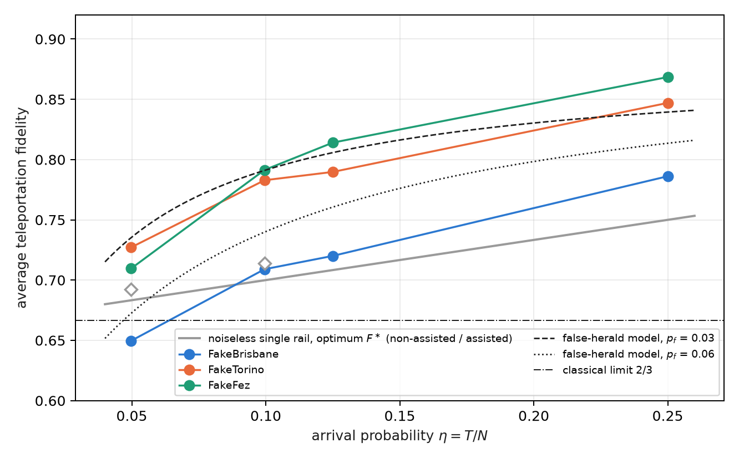
Figure 13.2: Filtered dual-rail fidelity as a function of the arrival probability, on three simulated noise models, against the noiseless single-rail optimum (grey line; the diamonds are the assisted one at 20 km). The black curves are the false-herald model with $F_{0}=0.87$, an illustration, not a fit.
Heralding still wins at 20 km. In a post hoc analysis, not pre-registered, on FakeTorino and FakeFez the filtered dual rail beats the noiseless single-rail optimum on both splitters: 0.783 and 0.791 against 0.714 at 1:4; 0.727 and 0.710 against 0.692 at 1:8. It does so with six times the two-qubit gates. The raw value loses everywhere (B4), so the gain is the filter’s. B3, the pre-registered version of that comparison (against the noisy teleported fidelity), failed only on FakeBrisbane at (20 km, 1:8).
The comparison with the continuous-variable work is qualitative: there the fidelity is deterministic and falls with distance and with $N$; here the filter keeps the fidelity high and pays in rate (kept $≈η$), until false heralds, not loss, set the limit.

13.5 Entanglement swapping along a chain
To go further than one link, a network chains pairs: an intermediate node makes a Bell measurement between its two halves, and the ends become entangled (entanglement swapping). This section is new in the book: it is exact density-matrix algebra, verified in the figure script, with no device run.
For pairs diagonal in the Bell basis, which are what the Pauli noises of Chapter 12 leave, the result in qg is a one-line rule: the correlators multiply. After swapping two pairs, with the Pauli correction that belongs to each outcome,
$$qg_{PP}^{(1→3)}=qg_{PP}^{(1→2)}⋅qg_{PP}^{(2→3)}, P∈\{X,Y,Z\},$$
and along a chain of $n$ equal links each correlator is raised to the $n$-th power. With depolarized pairs of parameter $w$ ($qg_{XX}=qg_{ZZ}=w$, $qg_{YY}=−w$), the teleportation fidelity of the final pair is $F=(1+w^{n})/2$, and it beats the classical limit while $w^{n}>1/3$, that is, up to $n≤ln3/ln(1/w)$: 21 links at $w=0.95$, 10 at $w=0.9$ and 4 at $w=0.8$ (Figure 13.3).
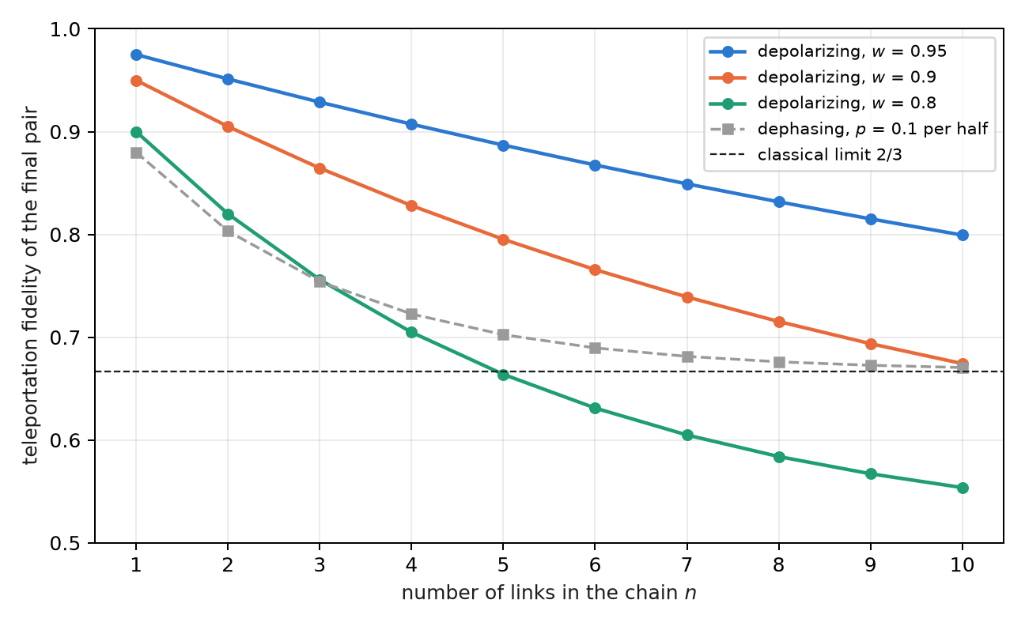
Figure 13.3: Teleportation fidelity of the final pair of a chain of $n$ links without distillation. With depolarizing noise it falls as $(1+w^{n})/2$ and crosses the classical limit; with dephasing, $qg_{ZZ}$ stays at 1 and the fidelity tends to 2/3 without crossing it.
The correlator reading also says which error accumulates. With dephasing, $qg_{ZZ}=1$ on every link and therefore along the whole chain, while $qg_{XX}$ and $qg_{YY}$ decay as ${0.64}^{n}$: the final pair keeps its $Z$ correlations and loses its phase ones, and its fidelity tends to 2/3 from above. It is the same signature as in the noise table of Chapter 12, propagated along the chain, and it is what decides where to distil.
The link with dual rail is direct: in a chain of dual-rail pairs, every intermediate Bell measurement also conserves the photon number, and the filter heralds the losses of all links at once. That experiment has not been done.

13.6 What remains open
Three topics of the index have no support in the repository yet, and stay proposals, not results:
- routing and passive quantum switching in multi-carrier metropolitan topologies;
- a dual-rail repeater chain with the filter on simulated devices, which would test this section’s multiplication rule against real gate noise;
- gate teleportation and its reading in qg correlators.

13.7 Without qang and with qang
Table 13.2: The chapter’s actions without the qang scale and with it.
action | without qang | with qang | difference
predict the teleportation fidelity | teleport and measure (10–11 two-qubit gates) | three correlators of the resource (4–5 gates): largest error 0.029 over 24 cases | in favour in circuit cost; the formula is known, qang makes it a linear reading with an error bar
herald losses | single rail: the loss is invisible | dual rail with the weight filter: every loss is heralded | the filter and the encoding’s, not the scale’s
propagate noise along a chain of swaps | compose channels | the qg correlators multiply; $F=(1+w^{n})/2$ | in favour in clarity: a one-line rule and the signature of which error accumulates

Balance. The qg correlators are the part of qang that pays most in networks: they predict and propagate with linear rules. The chapter’s large gain, dual rail, belongs to the encoding and the filter.

13.8 In code
from qang import qpon
# the teleportation fidelity, from three correlators of the resource
qpon.fidelity_from_correlators(xx=0.84, yy=-0.81, zz=0.73) # 0.897
qc = qpon.resource_circuit(alpha=1.231, transmission=1.0, n_users=8, basis="X")
# dual rail: noiseless closed forms and the 8-qubit circuit
qpon.dual_rail_fidelities(alpha=0.7854, eta=0.05) # filtered 1.0, raw 0.525, kept 0.05
qc_dual = qpon.dual_rail_teleport_circuit(alpha=0.7854, eta=0.05, input_index=2)

13.9 Summary
- The teleportation fidelity is linear in three qg correlators of the resource, $F=(3+qg_{XX}−qg_{YY}+qg_{ZZ})/6$; in 24 simulated cases it predicts the teleported one to 0.029, although it does not isolate the noise of the Bell measurement.
- In dual rail every gate conserves the photon number and the filter heralds every loss: without noise, $F=1$ at any distance with rate $η$.
- With noise, false heralds (3–6% at 20 km) set a floor and the filtered fidelity falls with distance; even so, on two of three models it beats the noiseless single-rail optimum at 20 km (post hoc analysis).
- Along a chain of swaps, the correlators of Bell-diagonal pairs multiply; with depolarization $F=(1+w^{n})/2$, and with dephasing $qg_{ZZ}$ survives whole.
- Routing, repeaters on devices and gate teleportation remain open.

14. Postselected closed timelike curves (P-CTC) and the resolution of paradoxes
Part V deals with two information-theory models that use the vocabulary of relativity: time loops and black-hole evaporation. It is worth saying from the start: they are models of information theory, not statements about spacetime (§164). Both are teleportation with postselection on a Bell outcome, that is, a filter on the Bell sector, and that is why they belong in this book. This chapter treats the time loop in its two known formulations, the postselected one (P-CTC) and Deutsch’s (D-CTC), and what a qg reading tells apart between them.

14.1 From the base: the success probability has qang angle $φ$
In the simplest model the qubit that “travels to the past” undergoes a rotation $R_{X}(φ)$, and the postselection succeeds with probability
$$P_{\text{success}}=\cos^{2}\frac{φ}{2}.$$
It is the probability equation of Chapter 1 with $p_{0}=P_{\text{success}}$, so its qang angle is exactly the rotation, $arccos(2P−1)=φ$, its reading is $m=1000cosφ$, and the success rate measured over $N$ attempts gives $φ$ with uncertainty $1/\sqrt{N}$. The grandfather paradox, $φ=π$, sits at the south pole: $P=0$, $m=−1000$.

14.2 Two ways to close a time loop
Deutsch (D-CTC, 1991). The system in the loop must be self-consistent: its state $ρ_{C}$ is a fixed point of the evolution, $ρ_{C}={Tr}_{S}[U(ρ_{S}⊗ρ_{C})U^{†}]$. At least one fixed point always exists, so there is never a paradox, but there may be several, and an extra rule is needed to choose; the usual one takes the maximum-entropy fixed point.
Postselection (P-CTC; Bennett and Svetlichny, Lloyd and co-workers, 2011). The qubit sent to the past, $C$, is half of a Bell pair $(C,A)$. After $C$ interacts with the system $S$, $(C,A)$ is projected back onto the Bell state: it is a teleportation of $C$ to its own past, with the Bell measurement forced to its trivial outcome. The effective evolution of $S$ is
$$ρ_{S}↦\frac{{Tr}_{C}(U) ρ_{S} {Tr}_{C}(U)^{†}}{Tr[…]},$$
which is not linear because of the normalization. In the circuit the projection is a Bell measurement keeping the shots that read 00: a filter on the Bell sector.

14.3 The success law and the grandfather paradox
With $R_{X}(φ)$ on $C$ alone, ${Tr}_{C}(U)=TrR_{X}(φ)/2=cos(φ/2)$, and the success is $\cos^{2}(φ/2)$. At $φ=π$ the qubit flips its own past: it is the grandfather paradox, and in P-CTC it has probability zero. It is not resolved: it does not happen. In D-CTC the same case has the maximally mixed state as its fixed point, and it happens with probability 1, like a coin.
On three simulated noise models, with 8000 shots (§164), the success law holds within 0.05 except at $φ=0$ on two devices (C1 failed: 0.950 and 0.931 against 1), and the paradox is suppressed to the noise floor on two of three (C2 failed on FakeTorino):
Table 14.1: The P-CTC success law at the extremes, simulated noise models.
simulated device | success at $φ=0$ (exact 1) | success at $φ=π$, the paradox (exact 0)
FakeBrisbane | 0.950 | 0.019
FakeTorino | 0.931 | 0.056
FakeFez | 0.983 | 0.009

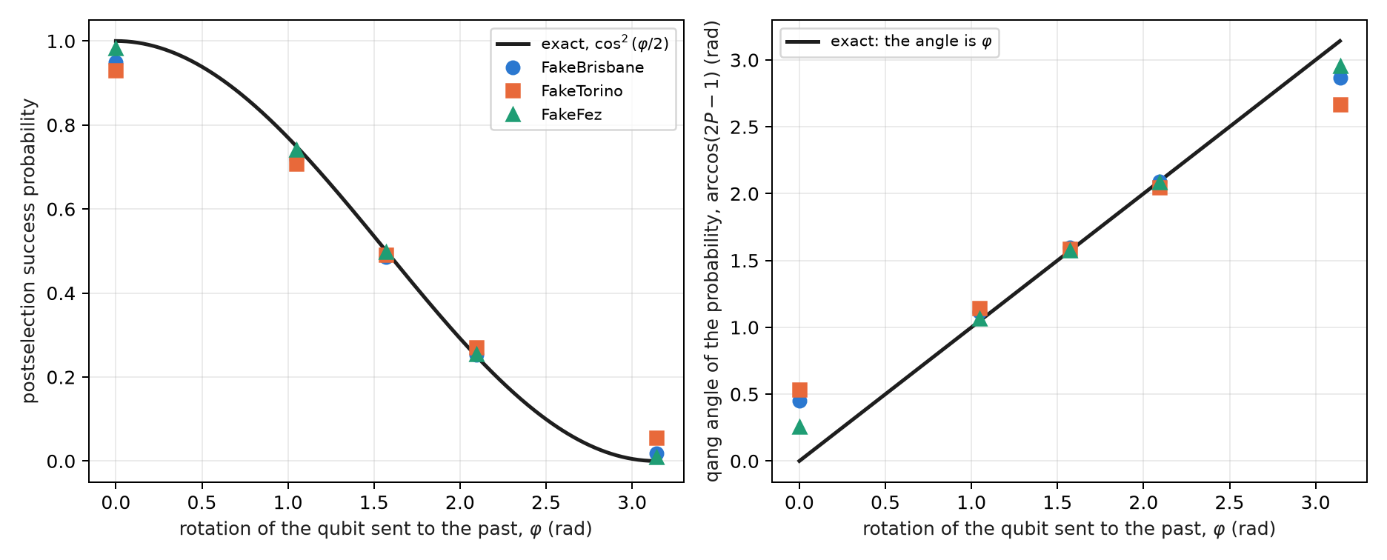
Figure 14.1: Left: postselection success probability against the rotation, exact and on three simulated noise models. Right: its qang angle, which is the rotation itself; the largest deviations are at the poles, where a small probability error is a large angle error.
Figure 14.1 shows something specific to the angle reading. In the interior, the qang angle of the measured rate reproduces $φ$ to a few hundredths of a radian; at the poles it deviates by up to half a radian. It is the non-linearity of the milli-qang in angle from Chapter 1: next to the pole, 1 m-qg is 2.56°, and the devices’ 34–138 m-qg of error at $φ=0$ become 0.26–0.53 rad.

14.4 The rotation controlled by the system
If it is the system $S$ that controls the rotation of $C$, the partial trace is an operator on $S$:
$${Tr}_{C}(U)=diag​\left(1, cosφ/2\right),$$
and the branch of $S$ that would produce the paradox is damped by $c=cos(φ/2)$. From $|+⟩$, the postselected state of $S$ has
$$qg_{Z}(S)=\frac{1−c^{2}}{1+c^{2}}, qg_{X}(S)=\frac{2c}{1+c^{2}},$$
with success $(1+c^{2})/2$. At $φ=π$, $qg_{Z}(S)=1$: the system is forced into the branch that does not flip the past. On the simulated models FakeFez follows the curve within 0.061 over the whole range, FakeBrisbane reads 0.903 at $φ=π$, and FakeTorino loses most of the suppression (0.600): prediction C3 failed.

14.5 What a qg reading tells apart between D-CTC and P-CTC
This section is new in the book: it is exact density-matrix algebra, computed in the figure script, with no device run. The same controlled circuit is taken, with $S$ in $|+⟩$, and the output of $S$ is computed in both formulations.
In D-CTC the channel on $C$ is $ρ_{C}↦1/2ρ_{C}+1/2R_{X}ρ_{C}R_{X}^{†}$, and every state that commutes with $R_{X}(φ)$ is a fixed point. With the maximum-entropy rule, $ρ_{C}=I/2$, and the output of $S$ is
$$qg_{Z}(S)=0, qg_{X}(S)=cos\frac{φ}{2}, r=cos\frac{φ}{2}.$$
The two formulations separate in different readings (Figure 14.2):
Table 14.2: The system S after the controlled loop, in both formulations.
$φ$​ | P-CTC: $m_{Z}$, $m_{X}$ (m-qg) | D-CTC: $m_{Z}$, $m_{X}$ (m-qg) | P-CTC success
0 | 0, 1000 | 0, 1000 | 1
$π/3$​ | 143, 990 | 0, 866 | 0.875
$π/2$​ | 333, 943 | 0, 707 | 0.750
$2π/3$​ | 600, 800 | 0, 500 | 0.625
$π$​ | 1000, 0 | 0, 0 | 0.500

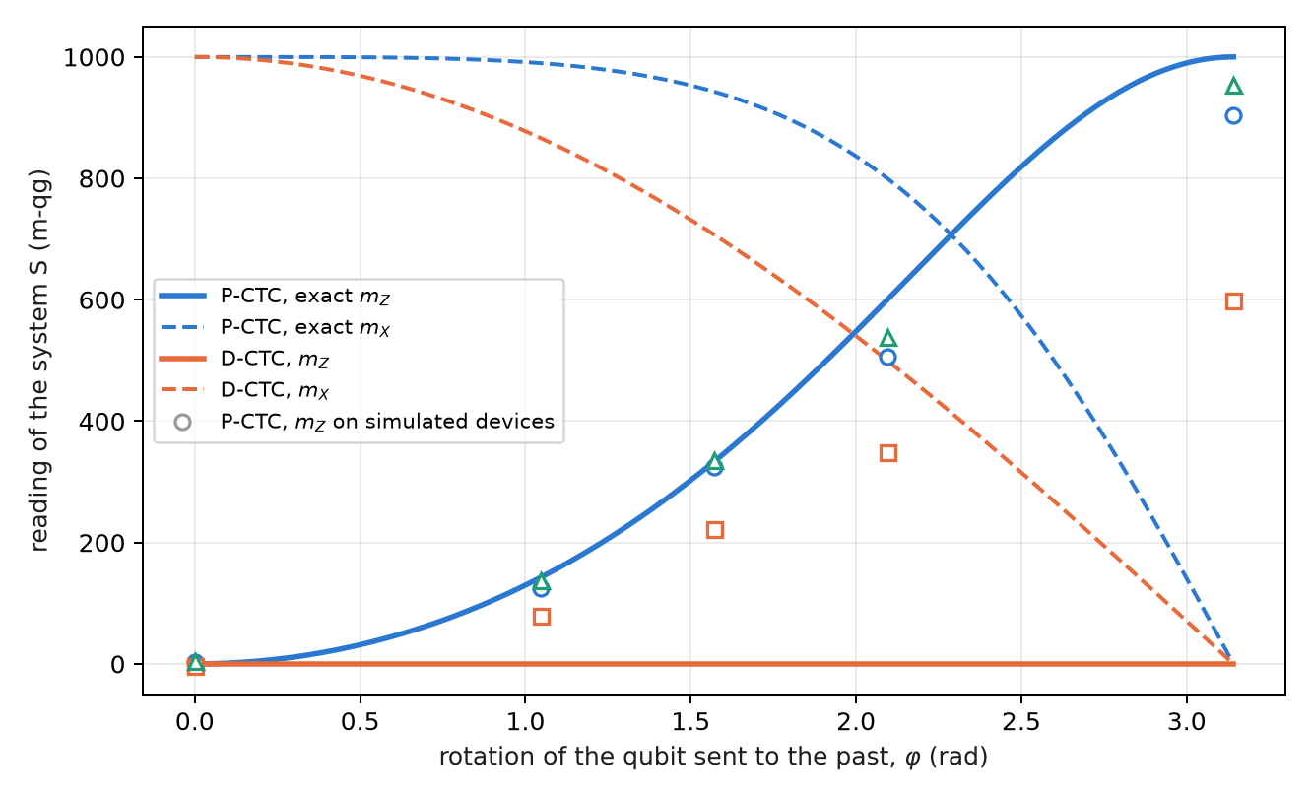
Figure 14.2: Readings of the system S after the controlled loop. P-CTC (blue) moves the population, $m_{Z}$, toward the paradox-free branch; D-CTC (orange) leaves $m_{Z}=0$ and only decoheres, lowering $m_{X}$. The markers are the P-CTC on three simulated noise models.
The difference is qualitative. P-CTC changes the populations of $S$ (the paradoxical branch loses weight) and leaves a pure state; D-CTC does not touch the populations and only removes coherence. A $Z$ reading of $S$ already decides between the two models, and the simulated devices, with all their noise, sit on the P-CTC side, as they must, because the circuit is the P-CTC one.
Deutsch’s ambiguity can be read too. At $φ=π/2$ the state $|+⟩$ is also a fixed point, and it gives the same $qg_{Z}(S)=0$ and the same $qg_{X}(S)=0.707$, but $qg_{Y}(S)=−0.707$ and radius 1, against $qg_{Y}=0$ and radius 0.707 with $I/2$. The two D-CTC solutions differ in the local radius of Chapter 5: the maximum-entropy rule picks the fixed point that leaves $S$ most mixed.

14.6 The cost of postselection
“Time travel” in this model costs shots. Each useful shot needs, on average, $1/P_{\text{success}}$ shots: 2 at $φ=π/2$, 4 at $2π/3$, 400 at a tenth of a radian from the paradox (Figure 14.3). With the controlled rotation the cost never exceeds 2, because half of the superposition of $S$ pays nothing. It is the same accounting as the sector filter of the previous chapters, with one difference: here the discarded fraction is not noise but the model’s physics, and it cannot be reduced.
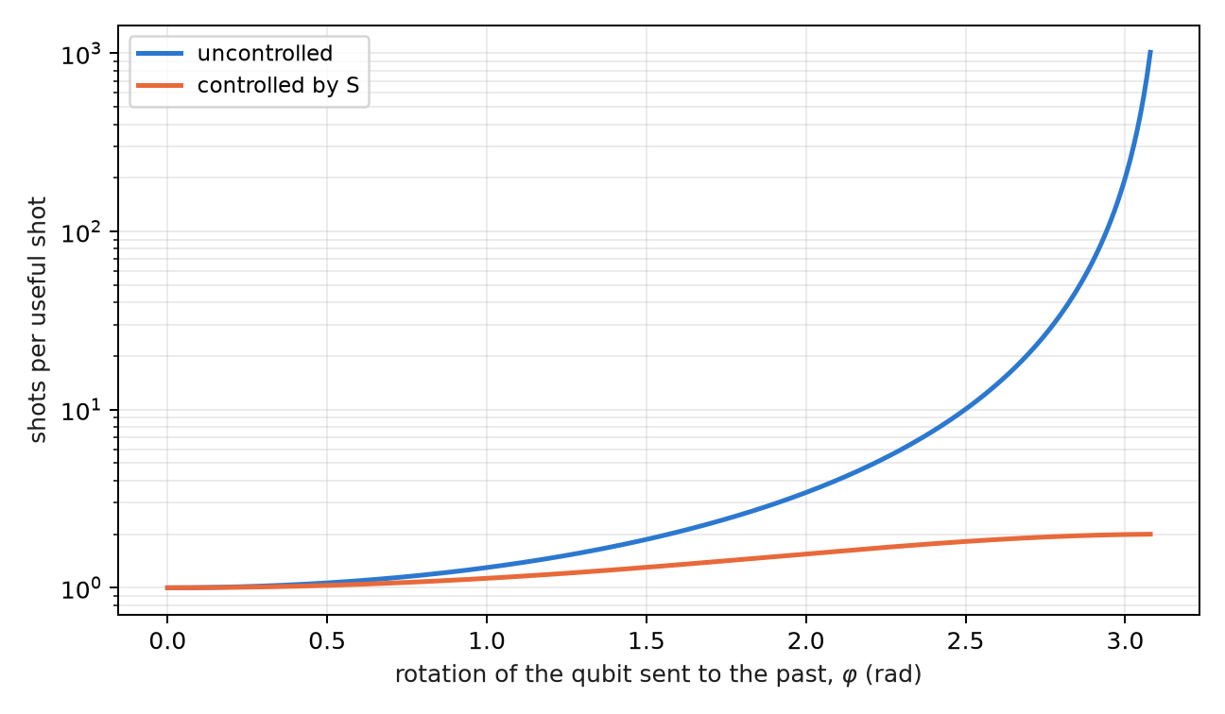
Figure 14.3: Shots needed per useful postselected shot, uncontrolled and with the rotation controlled by S.

14.7 What remains open
Two topics of the index have no support yet and stay proposals: the non-linearity of P-CTCs applied to discriminating non-orthogonal states (the circuit and the prediction are missing), and a device run of the D-CTC against P-CTC comparison, which would require preparing Deutsch’s fixed point and not only postselecting.

14.8 Without qang and with qang
Table 14.3: The chapter’s actions without the qang scale and with it.
action | without qang | with qang | difference
read the loop’s rotation | invert $\cos^{2}(φ/2)$ | the qang angle of the success rate is $φ$, with $σ=1/\sqrt{N}$ | equivalent in the interior; at the poles the angle reading amplifies the error (34–138 m-qg become 0.26–0.53 rad), which counts against
verify the suppression of the paradox | success probability and the state of S by tomography | $m_{Z}(S)$: 903, 600 and 955 m-qg against 1000 | unit; the suppression is the postselection’s
tell D-CTC from P-CTC | compare density matrices | P-CTC moves $m_{Z}$; D-CTC does not and lowers $m_{X}$ | in favour: a single $Z$ reading decides the model
tell apart the D-CTC fixed points | entropy of each solution | the local radius of Chapter 5: 0.707 against 1 | in favour: the ambiguity becomes a reading
reduce noise | — | the postselection is the filter; the qang scale adds nothing | none

Balance. In this chapter qang pays as a diagnostic tool: with one or two readings it says which loop model is operating and which of Deutsch’s solutions was chosen. The success law is the probability equation of Chapter 1, and with it come its limits next to the poles.

14.9 In code
import math
from qang import postselection as ps
ps.pctc_success(2 * math.pi / 3) # 0.25: postselection success
math.acos(2 * ps.pctc_success(2.0) - 1) # 2.0: the qang angle is the rotation
ps.pctc_controlled_qg_z(math.pi) # 1.0: the paradoxical branch, suppressed
qc = ps.pctc_circuit(math.pi, controlled=True) # S, C, A; success = C and A read 0

14.10 Summary
- The time loops of this chapter are information models: teleportation with postselection on a Bell outcome.
- In P-CTC the success probability is $\cos^{2}(φ/2)$ and its qang angle is $φ$; the grandfather paradox has probability zero and, on two of three simulated models, sits at the noise floor.
- With the controlled rotation, $qg_{Z}(S)=(1−c^{2})/(1+c^{2})$: the paradoxical branch is suppressed; FakeTorino loses most of the suppression.
- D-CTC does not change the populations of S and only removes coherence; a $Z$ reading separates the two models, and the local radius separates Deutsch’s fixed points.
- Postselection costs $1/P$ shots per useful shot; it is the model’s physics, not noise, and it cannot be reduced.

15. Black-hole thermodynamics, quantum chaos and the Yoshida–Kitaev decoder
This is the second model of Part V, and the warning of chapter 14 holds again: it is an information-theoretic model, not a statement about real black holes (§164). A black hole of a few qubits, a unitary that scrambles information, and a teleportation postselected on a Bell outcome: the same filter on the Bell sector as in the previous chapter, now set to recover a message that fell into the horizon.

15.1 From the base: success 1/4 and the equator of the fidelity
The protocol produces two numbers, and both are probabilities, so the probability equation of chapter 1 reads them directly. The postselection succeeds with probability $P=1/4$: its reading is $m_{P}=1000(2P−1)=−500$ and its qang angle $arccos(−1/2)=2π/3$. The fidelity $F$ of the recovered pair with a Bell pair is the probability that the Bell measurement gives its trivial outcome, and it reads the same way, $m_{F}=1000(2F−1)$.
The scale has a concrete virtue here: the threshold that matters falls on the equator. A Bell fidelity above $1/2$ certifies entanglement, and $F=1/2$ is $m_{F}=0$. Without scrambling the pair comes out maximally mixed, $F=1/4$, and reads $−500$; with scrambling, $F=1$, and it reads $1000$. Decoding is crossing the equator.

15.2 The information paradox and complementarity
Hawking (1976) showed that a black hole radiates with a thermal spectrum, and that the radiation does not seem to depend on what fell in. If the hole evaporates completely, a pure state would end as a mixed one: evolution would not be unitary. Complementarity (Susskind, Thorlacius and Uglum, 1993) and, above all, Page’s argument (1993) led to the opposite position, the majority one today: the information comes out in the radiation, encoded in fine correlations.
Hayden and Preskill (2007) asked when it comes out. Their answer, for a black hole past the middle of its life whose dynamics scrambles information fast, is “almost at once”: a message of a few qubits thrown into the hole can be rebuilt from just a few more qubits of radiation, given the early radiation. Yoshida and Kitaev (2017) gave an explicit decoder, and it is the one run in this chapter.

15.3 Scrambling: a 3-qubit micro black hole
The toy black hole has 3 qubits: the message $A$ and two qubits $B_{1},B_{2}$ that were already inside. Its dynamics is a unitary $U$ on the three, and “$U$ scrambles information” has an operational definition: every single-qubit Pauli operator ends up, after $U$, acting on all three qubits. For a Clifford this is checked with no approximation, by evolving the 9 Paulis $X,Y,Z$ of each qubit. find_scrambler takes the first random Clifford (seed 164) that meets the condition, and its 9 Paulis have weight 3.
Scrambling is the quantum version of chaos: a local error (a Pauli) becomes, after the dynamics, an error of the whole system, and no measurement of one qubit detects it. So it is no surprise that a black hole “hides” the message, and it is a surprise that the message can be recovered.

15.4 The Hayden–Preskill protocol and the decoder
The circuit has 8 qubits. The message $A$ is entangled with a reference $R$, the one who throws it; the black hole $B$ is entangled with the early radiation $B^{′}$, held by the outside observer. After $U$ on $(A,B_{1},B_{2})$, one qubit $D$ (the output of $B_{2}$) is radiated. The observer holds $D$ and $B^{′}$, and prepares a copy of the experiment: a pair $(A^{′},R^{′})$ and the conjugate unitary $U^{*}$ on $(A^{′},B_{1}^{′},B_{2}^{′})$. Then $(D,D^{′})$ is postselected on the Bell state. On success, the entanglement of $A$ with $R$ has moved to $R^{′}$: the message was teleported out of the interior.
For a scrambler, the postselection succeeds with probability $1/d_{A}^{2}=1/4$ and the fidelity of the pair $(R,R^{′})$ is 1. Without scrambling ($U=I$), the postselection almost always succeeds, because $D$ carries nothing of $A$, and the fidelity is that of a random pair, $1/4$. The postselection is, as in chapter 14, a filter on the Bell sector of $(D,D^{′})$.

15.5 The exact law $P⋅F=1/4$
This section is new in the book. In Yoshida and Kitaev’s probabilistic decoder, the success and the fidelity are not independent:
$$P F=\frac{1}{d_{A}^{2}}=\frac{1}{4}.$$
The figure script checks it on exact states over 60 random Cliffords and 25 Haar unitaries of 3 qubits, and at every size of the next section: on 3 qubits the largest deviation is $3×{10}^{−16}$. On the chapter 1 scale the law is a hyperbola,
$$(1000+m_{P})(1000+m_{F})={10}^{6}, \text{or} cos\frac{θ_{P}}{2} cos\frac{θ_{F}}{2}=\frac{1}{2},$$
with a practical consequence: without noise, the success already tells the fidelity. A success of $1/4$ ($m_{P}=−500$) forces $F=1$; a success of 1 ($m_{P}=1000$) forces $F=1/4$. Among random 3-qubit Cliffords, 27 of 60 decode perfectly.
With noise the law breaks, and the direction in which it breaks is what makes it useful. Full noise takes $(D,D^{′})$ to the mixed state, whose success is also $1/4$, with $F=1/4$: the success alone does not tell a perfect decoder from one destroyed by noise. The product does: $4PF$ is 1 for the first and $1/4$ for the second.

15.6 On simulated noise models
With 8000 shots on three simulated noise models (§164), the circuit with the scrambler, 90 two-qubit gates after transpilation, gives:
Table 15.1: The Yoshida–Kitaev decoder on three simulated noise models.
simulated device | success $P$ ($m_{P}$) | fidelity $F$ ($m_{F}$) | $4PF$​ | no scrambling: $F$ ($m_{F}$)
exact | 0.250 (−500) | 1 (1000) | 1 | 0.250 (−500)
FakeBrisbane | 0.260 (−481) | 0.547 (93) | 0.568 | 0.248 (−504)
FakeTorino | 0.248 (−504) | 0.578 (156) | 0.573 | 0.250 (−501)
FakeFez | 0.246 (−508) | 0.742 (484) | 0.731 | 0.250 (−500)

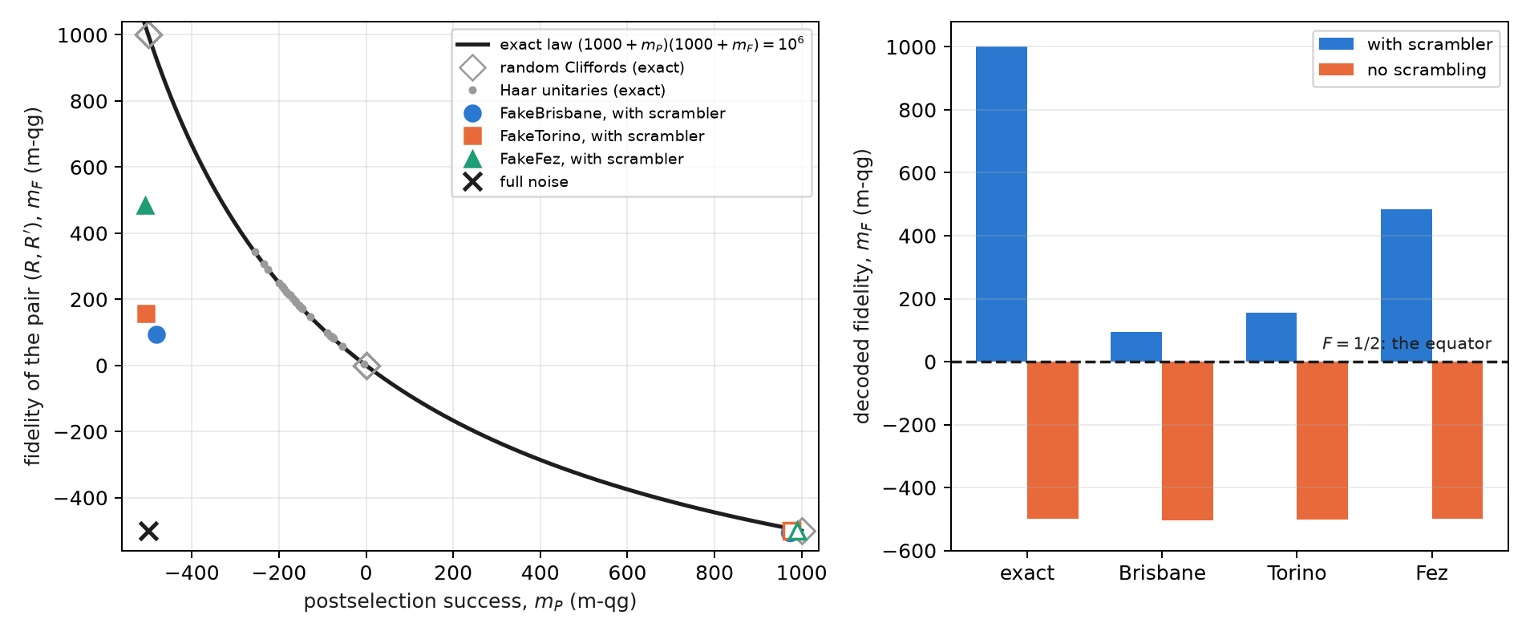
Figure 15.1: Left: the success–fidelity plane in m-qg. The curve is the exact law $PF=1/4$; Cliffords and Haar unitaries fall on it; the devices with the scrambler (filled markers) fall below it, towards the full-noise point; without scrambling (open) they stay on it, at $m_{P}≈1000$. Right: the decoded fidelity in m-qg; the three devices with the scrambler cross the equator.
The three runs with the scrambler cross the equator (H3), and the success stays within 0.05 of $1/4$ (H2). But Figure 15.1 shows why H2 is no evidence of decoding: the success of the three devices is the one full noise would give. What sets FakeFez apart from the other two is the fidelity, and $4PF$ sums it up in one number: 0.73 against 0.57. Prediction H1 (a fidelity advantage above 0.3 over the unscrambled case on all three) missed by 0.001 on FakeBrisbane.

15.7 Larger black holes
This section is new as well: exact states, gate counts and a simulation with the FakeFez noise model, no device run. The circuit is generalised to an $n$-qubit black hole with $k$ radiated qubits: $2n+2$ qubits in all, 16 for $n=7$.
Two results organise the topic. The first: with a single radiated qubit, a generic black hole is not enough. For a Haar unitary the average success is $P≈1/4+4^{−k}−4^{−k−1}$, and by the law $F=1/(4P)$: with $k=1$, $F≈4/7=0.57$, barely above the equator, whether $n=3$, 5 or 7. One has to radiate a little more than the message: with $k=2$, $F≈0.84$; with $k=3$, $F≈0.95$ (Figure 15.2, left). It is the quantitative version of Hayden and Preskill’s “a few more qubits”. The 3-qubit Clifford scrambler, with $F=1$ at $k=1$, is a special case, not the typical one.
The second: the gate cost separates the two kinds of scrambler. A Clifford scrambler is transpiled as a Clifford circuit: 35, 126 and 252 two-qubit gates for $n=3$, 5 and 7. A Haar unitary is synthesised as a generic unitary, and its cost grows as $4^{n}$: 92, 1908 and 32 680 (Figure 15.2, right). There is also a lesson for the §164 run: the same 3-qubit scrambler, handed to the transpiler as a matrix, was synthesised with 90 gates; handed over as a Clifford, with 35, and on the FakeFez model the fidelity rises from 0.742 to 0.887 (a new simulation with another seed, not the saved run).
Table 15.2: The decoder with perfect Clifford scramblers of 3, 5 and 7 qubits, exact and on the FakeFez noise model.
black hole | radiated qubits | two-qubit gates (FakeFez) | success on FakeFez (exact 0.25) | $F$ on FakeFez ($m_{F}$; exact 1) | $4PF$ on FakeFez
3 qubits | 1 | 35 | 0.253 | 0.887 (773) | 0.899
5 qubits | 2 | 126 | 0.191 | 0.802 (605) | 0.613
7 qubits | 3 | 252 | 0.105 | 0.882 (764) | 0.370

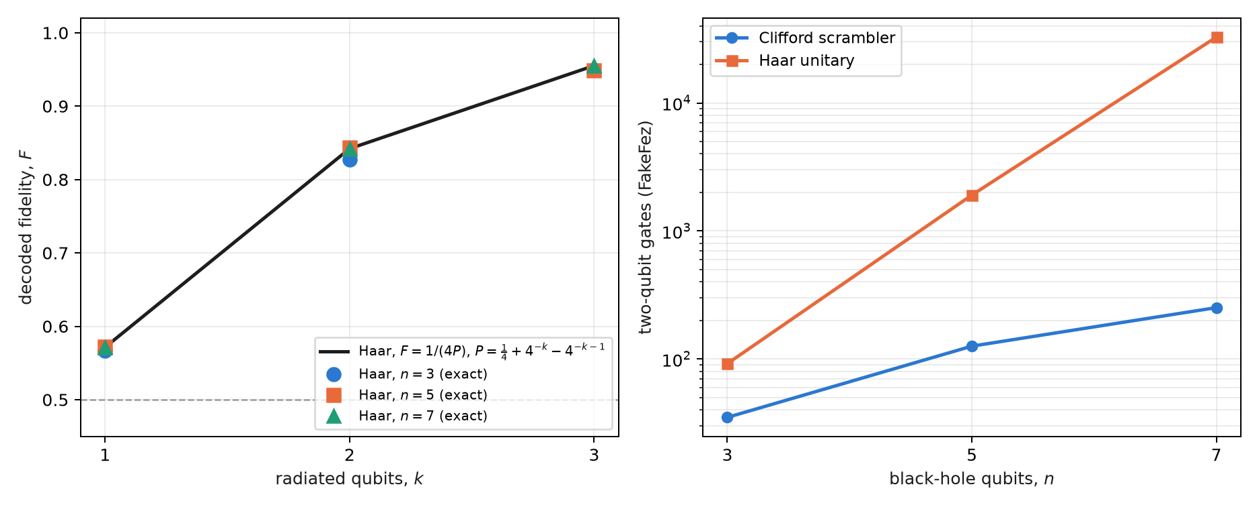
Figure 15.2: Left: decoded fidelity of Haar unitaries against the number of radiated qubits, exact for $n=3,5,7$ and the large-$n$ formula. Right: two-qubit gates of the decoder transpiled for FakeFez, with a Clifford scrambler and with a Haar unitary.
Table 15.2 shows how far the filter reaches. The fidelity stays between 0.80 and 0.89 even with 252 gates, and not because noise does not act: the postselection on $k$ Bell pairs discards the shots in which noise touched $(D,D^{′})$, and with more pairs it discards more. The success falls from 0.253 to 0.105 against the exact $1/4$ (with full noise it would be $4^{−k}$, $1/64$ for $k=3$). The fidelity alone would say the 7-qubit decoder is as good as the 3-qubit one; $4PF$ says it delivers 0.37 of what it should, because it pays in shots what the fidelity does not show. It is the rule of the sector filters of earlier chapters: the filter improves what is kept at the cost of the rate, and $4PF$ puts both in one number. With noise the law now breaks on the other side: on 3 qubits the fidelity drops, on 7 the success does.

15.8 A toy Page curve
Page (1993) predicted how the entanglement of the radiation of a unitarily evaporating black hole grows: it rises while the radiation is the smaller part, peaks when half has been radiated, and falls to zero at the end, because the total state is pure. An exact toy: a Haar state of 8 qubits, with the first $k$ as the radiation.
The index proposed reading this curve with $qg_{S}$. It does not work, and it is worth saying why. $qg_{S}$ is the Shannon entropy of a $Z$ reading, and a random state looks random in any basis: the joint reading of the $k$ radiated qubits has entropy close to $k$ through the whole evaporation, including when the radiation is already nearly pure (Figure 15.3, triangles). It is the limit qang.circuits already documents with graph states as the counterexample: $qg_{S}$ depends on the basis and does not measure entanglement.
What does work uses the same qg readings, squared. The purity of the radiation is the sum of the squares of its Pauli correlators,
Trρ2=12kP∈{I,X,Y,Z}k​qgP 2,
and $S_{2}=−\log_{2}Trρ^{2}$, the Rényi entropy of order 2, is a lower bound on the von Neumann entropy that follows the Page curve: at $k=4$, the half, $S_{2}=2.98$ bits against $S=3.24$, and both return to zero at $k=8$, while the Shannon entropy of the $Z$ reading reaches 7.46. The cost is the unfavourable side: $4^{k}−1$ correlators, 255 for $k=4$. (The script computes it from the correlators up to $k=4$; beyond that it uses $Trρ^{2}$ directly, the same quantity.)
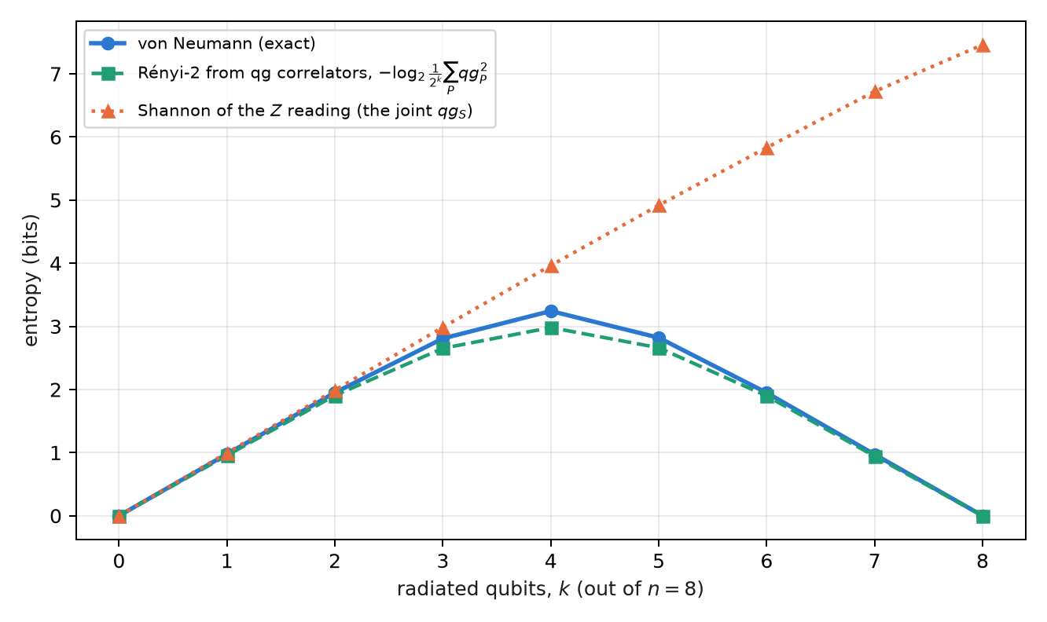
Figure 15.3: A toy Page curve, 8 qubits. The von Neumann entropy of the radiation and the Rényi-2 entropy computed from the qg correlators rise and fall; the Shannon entropy of the $Z$ reading keeps rising and does not see the curve.

15.9 Traversable wormholes
The Yoshida–Kitaev decoder is, as a circuit, the same protocol that the holographic literature calls teleportation through a traversable wormhole (Gao, Jafferis and Wall, 2017; Maldacena, Stanford and Yang, 2017): two entangled systems, a scrambling dynamics on each (one side conjugated) and a coupling between them that lets a qubit through. The ER = EPR conjecture (Maldacena and Susskind, 2013) proposes that such entangled pairs are, in a dual gravitational theory, an Einstein–Rosen bridge. The circuit decides none of that; it does let the result be read with the tools of this book.
The fidelity of the recovered pair is linear in three qg correlators, as in chapter 13:
$$F=\frac{1+qg_{XX}−qg_{YY}+qg_{ZZ}}{4}.$$
On the exact state, with the scrambler, $(qg_{XX},qg_{YY},qg_{ZZ})=(1,−1,1)$ and $F=1$; without scrambling, $(0,0,0)$ and $F=1/4$. The experiment of Jafferis and collaborators (2022) on a Google processor used a learned 7-qubit model to mimic this physics, and its reading as a wormhole was disputed (Kobrin and collaborators, 2023). This book does not run that experiment; the correlator reading stays a tool, not evidence.

15.10 What remains open
None of the new results of this chapter (the law $PF=1/4$ as a diagnostic, the 5- and 7-qubit black holes, the Page curve from correlators) has a device run. A real-hardware run of the 3-qubit decoder, with 90 two-qubit gates, would be the next step and costs credits; it stays outside this book for now.

15.11 Without qang and with qang
Table 15.3: The actions of the chapter without the qang scale and with it.
action | without qang | with qang | difference
decide whether the message was recovered | compare $F$ with 1/2 | the sign of $m_{F}$: decoding is crossing the equator | unit: the threshold sits at zero, but it is the same threshold
judge the quality of the decoder | $P$ and $F$ separately | the law $(1000+m_{P})(1000+m_{F})={10}^{6}$ and its summary $4PF$ | in favour, with a caveat: the law is Yoshida and Kitaev’s, not qang’s; the scale turns it into a readable hyperbola and shows that $m_{P}=−500$ proves nothing
predict how much radiation is needed | the Haar formula | the same formula, $F=1/(4P)$ | none
the Page curve | von Neumann entropy by tomography | $qg_{S}$ in $Z$ | against: $qg_{S}$ does not see the curve
the Page curve, again | tomography | Rényi-2 from the sum of $qg_{P}^{2}$ | equivalent: it is Pauli tomography written in qg, with its $4^{k}−1$ cost
the wormhole fidelity | Bell measurement of the pair (one setting) | three qg correlators | none in cost, since the Bell measurement already gives $F$; in favour as a diagnostic: the three correlators tell which component fails
reduce noise | — | the postselection is the filter; the scale adds nothing | none

Balance. The clearest contribution of qang in this chapter is one of reading: the decoder’s exact law becomes a curve in the plane of the two readings, and in that plane one sees at once that the right success is no evidence of decoding. Where the index promised more, the Page curve with $qg_{S}$, the result is negative, and what replaces it is Pauli tomography, not a property of the scale.

15.12 In code
from qiskit.quantum_info import Statevector
from qang import postselection as ps
scr = ps.find_scrambler() # 3-qubit Clifford, seed 164
qc = ps.yk_decoder_circuit(scr, measure=False) # 8 qubits: R, A, B1, B2, B1', B2', A', R'
probs = Statevector(qc).probabilities_dict()
ps.yk_from_counts({k: round(1e6 * v) for k, v in probs.items()})
# {'success': 0.25, 'fidelity': 1.0}: P F = 1/4

15.13 Summary
- The Yoshida–Kitaev decoder is teleportation postselected on the Bell sector of a radiated qubit and its copy: a model of information, not of gravity.
- On the chapter 1 scale, the success $1/4$ is $m_{P}=−500$ and the fidelity that certifies recovery, $F>1/2$, is $m_{F}>0$: decoding is crossing the equator.
- The exact law $PF=1/4$ is a hyperbola in m-qg; with noise, the success stays at $1/4$ but the fidelity drops, and $4PF$ (0.57–0.73 on three simulated models) measures the quality of the decoder.
- With a single radiated qubit, a generic black hole gives $F≈0.57$; 2 or 3 radiated qubits are needed for $F≈0.84$–$0.95$.
- A Clifford scrambler costs 35, 126 and 252 two-qubit gates on 3, 5 and 7 qubits; with 7, the fidelity on FakeFez stays at 0.88 but the success falls to 0.105 and $4PF$ to 0.37: the filter keeps the quality and charges in rate.
- $qg_{S}$ does not see the Page curve; the Rényi-2 entropy from the qg correlators does, at the cost of $4^{k}−1$ readings.

16. Demarcation: quantum cryptography against post-quantum cryptography (PQC)
Part VI is about security. Before reading quantum key distribution (Chapter 17) and certified random numbers (Chapter 18) in qg, it is worth drawing the border. There are two answers to the quantum computer that share the word “quantum” and little else. Quantum cryptography (QKD, QRNG) uses qubits: its security rests on a physical measurement, and so it enters the probability equation of Chapter 1. Post-quantum cryptography (PQC) is classical software that runs on ordinary computers: its security rests on the hardness of a mathematical problem, and there is no qubit to read. This chapter says where the line runs, with numbers, and what qang reads on each side.

16.1 From the base: which probabilities exist on each side
Any probability $p_{0}$ enters the equation of Chapter 1: it has qang angle $θ=2arccos\sqrt{p_{0}}$ and reading $m=1000(1−2p_{1})$ m-qg. The question is not whether it can be written down, but whether the reading says anything.
- In QKD, the probability that decides security is the quantum bit error rate (QBER) of a measurement in one basis. It is the probability of a qubit, and its reading is the one of Chapter 17: $Q=(1−|qg|)/2$, that is, $m=1000 |qg|=1000(1−2Q)$.
- In PQC, the only probability in the scheme is that decryption fails, $δ$. For ML-KEM, the FIPS 203 standard bounds it by $2^{−138.8}$, $2^{−164.8}$ and $2^{−174.8}$ for the three levels. Written in m-qg it is $m=1000−3.3×{10}^{−39}$ at best: it sits against the pole, and there is no Hermitian operator, measurement basis or Bloch sphere behind that number.
The security of PQC, moreover, is not that probability: it is the hardness of a lattice problem (module learning with errors, MLWE), which is not the frequency of anything. That is the demarcation in one line: qang reads probabilities of measurements; PQC has no measurements.

16.2 The nature of PQC
NIST’s standards of August 2024 are three: ML-KEM (FIPS 203, formerly Kyber), a lattice key-encapsulation mechanism; ML-DSA (FIPS 204, formerly Dilithium), lattice signatures; and SLH-DSA (FIPS 205, formerly SPHINCS+), signatures built only on hash functions. In 2025 HQC, based on error-correcting codes, was also chosen as a second key mechanism. All of them are integer arithmetic: polynomials modulo $q=3329$ in ML-KEM, hash trees in SLH-DSA. None of them prepares a state, applies a gate or measures.
In ML-KEM, decrypting is subtracting and rounding: the message survives if an accumulated noise (the sum of many products of small coefficients) stays within $±q/4$. If not, decryption fails. That is the $δ$ above.

16.3 Decryption failure is counted, not measured on a qubit
To see what qang would do with $δ$, the figure script builds a toy scheme with the same mechanism: noise e=i<2n​aibi+c with $a_{i},b_{i},c$ from ML-KEM’s centred binomial distribution, $n=256$, $q=3329$, without the standard’s compression (which in ML-KEM accounts for most of the failure), and with the width $η$ as the knob. The failure probability is computed exactly (a convolution modulo $q$) and counted over 200,000 simulated encryptions.
Table 16.1: Decryption failure of the toy scheme, exact and counted.
$η$​ | $σ/q$​ | exact failure | counted | reading (m-qg, 95% CI)
16 | 0.054 | $5.1×{10}^{−6}$​ | 1 of 200,000 | 1000.0 [999.9, 1000.0]
20 | 0.068 | $2.5×{10}^{−4}$​ | 60 | 999.4 [999.2, 999.5]
24 | 0.082 | $2.2×{10}^{−3}$​ | 437 | 995.6 [995.2, 996.0]
32 | 0.109 | $2.2×{10}^{−2}$​ | 4360 | 956.4 [955.1, 957.7]
40 | 0.136 | $6.6×{10}^{−2}$​ | 13,072 | 869.3 [867.1, 871.4]

The count agrees with the exact sum, and qang.probability.analyze reads it in m-qg with its interval. But that reading is the Wilson proportion in another unit: there is no angle of a state behind it. And no count reaches where real PQC lives (Figure 16.1, right). Seeing a single ML-KEM-512 failure takes on the order of $1/δ≈6×{10}^{41}$ decryptions; with ${10}^{12}$ trials, about the most one can count, the floor sits 30 orders of magnitude above. The shot rule of Chapter 1 says the same in m-qg: next to the pole, $σ_{m}≈2000\sqrt{δ/N}$, and to bring it below the offset $2000 δ$ one needs $N>1/δ$. PQC’s $δ$ is proved, not measured.
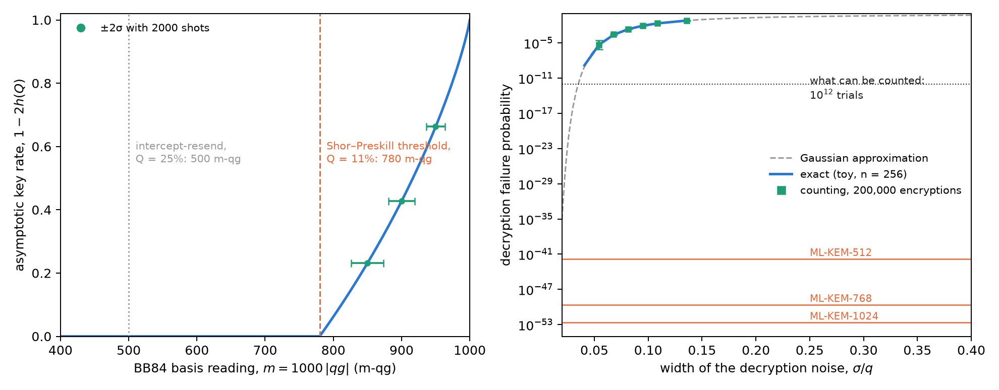
Figure 16.1: Left: the security frontier of BB84 is a line in m-qg; the Shor–Preskill asymptotic key rate vanishes at 780 m-qg (Q = 11%), and with 2000 shots the reading has ±2σ of 14–24 m-qg. Right: the decryption failure of a toy ML-KEM-like scheme (n = 256, no compression), exact, Gaussian and counted; the orange lines are the FIPS 203 bounds, 30 to 41 orders of magnitude below what can be counted.
On the other side of the line (Figure 16.1, left), the quantity that decides BB84’s security sits in the middle of the scale. The Shor–Preskill asymptotic rate, $1−2h(Q)$, vanishes at $Q=11.0\%$, which is $m=780$ m-qg; intercept-resend gives $Q=25\%$, $m=500$. With 2000 shots, $σ_{m}$ is 11.8, 9.7 and 7.0 m-qg at 850, 900 and 950 m-qg: the margin to the threshold is resolved comfortably. It is the probability of a qubit, readable and with an error bar; Chapter 17 uses it to separate the eavesdropper from the noise.

16.4 The quantum attack vector: Grover
The quantum computer is quantum, and its attacks do enter the base. Grover’s attack on an $n$-bit key has, after $k$ iterations, failure probability
$$p_{\text{fail}}=\cos^{2}​\left((2k+1) β\right), β=arcsin2^{−n/2},$$
which is the probability equation with qang angle $2(2k+1)β$: each iteration advances the qang angle by $4β$, in a straight line. This was checked with the circuits of qang.algorithms for $n=4$, 6, 8 and 10: the angle of the exact probability matches the law to ${10}^{−10}$ rad (Figure 16.2). In m-qg, the failure goes from +1000 to −1000 along a cosine and crosses the equator (success 1/2) halfway.
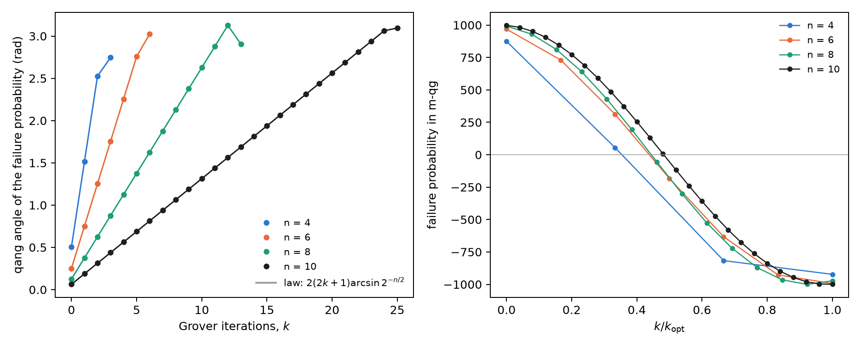
Figure 16.2: Left: the qang angle of the probability that Grover fails grows linearly with the iterations, $4arcsin2^{−n/2}$ per step (dots: exact circuits; lines: the law). Right: the same probability in m-qg against the fraction of the optimal iterations.
For AES-128 the step is $4arcsin2^{−64}=2.2×{10}^{−19}$ rad per iteration, and reaching the pole takes $1.4×{10}^{19}$ serial iterations, each a full AES circuit; for AES-256, $2.7×{10}^{38}$. PQC’s answer to this attack is to double the symmetric key length, and the geometry explains it: the angle advances as $2^{−n/2}$, so Grover halves the security bits and nothing more.

16.5 The quantum attack vector: Shor and phase estimation
The attack that breaks RSA and elliptic curves, and that PQC sidesteps, is Shor’s algorithm: phase estimation (QPE) on modular multiplication. The notes (§13) show that QPE recovers exact phases, and the book’s index said that “the eigenstate register projects onto $qg_{Z}=−1$ without resolving the phase”. That holds for the QPE of an eigenstate, and the exact computation of this chapter says how far a qg reading goes in Shor’s case (Figure 16.3).
QPE of an eigenstate. With the $T$ gate on $|1⟩$ ($φ=1/8$), the target register stays at $m_{Z}=−1000$ and carries no information: the phase lives in the counting register. There, before the inverse QFT, qubit $k$ has $m_{X}=1000cos(2π2^{k}φ)$: 707, 0 and −1000 m-qg. Each qubit carries one bit of the phase in its qang angle, which is Kitaev’s iterative phase estimation.
Shor for $N=15$. The work register is not in an eigenstate but in a superposition of the $r$ eigenstates, and the counting qubits end up entangled with it. With four counting qubits:
Table 16.2: Single-qubit readings of the counting register in Shor’s algorithm (exact state).
case | local radius of each counting qubit, before (m-qg) | $m_{Z}$ of each qubit, after | outcomes
$a=7$ ($r=4$) | 0, 0, 1000, 1000 | 1000, 1000, 0, 0 | 0, 4, 8, 12
$a=11$ ($r=2$) | 0, 1000, 1000, 1000 | 1000, 1000, 1000, 0 | 0, 8
$N=21$, $a=2$ ($r=6$), six qubits | 0, 0, 0, 0, 0, 0 | 0, 250, 312, 328, 332, 0 | peaks at 0, 11, 21, 32, 43, 53

For $N=15$ the order can be read qubit by qubit: the number of qubits with zero radius before the QFT, or with $m_{Z}=0$ after it, is $\log_{2}r$. But that is an accident of $N=15$, where $r$ is a power of 2. With $N=21$ and $r=6$, every local radius is zero and the $m_{Z}$ after do not say 6: the order is in the joint distribution, and is extracted with continued fractions. The work register does not help either: for $a=7$ its qubits read $m_{Z}=±500$, the mixture of 1, 7, 4 and 13.
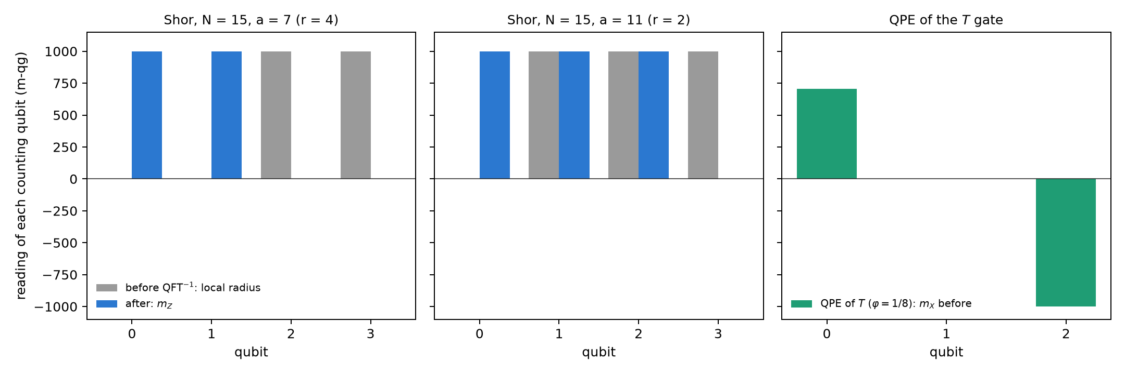
Figure 16.3: Single-qubit readings of the counting register. Grey: local radius before the inverse QFT; blue: $m_{Z}$ after. For N = 15 the number of zeros is $\log_{2}r$; for the QPE of $T$, each qubit carries one bit of the phase in $m_{X}$.
The conclusion holds for the whole chapter: single-qubit readings see the phase when there is an eigenstate, and lose it when the information is in the correlations. It is limitation 3 of the notes (§14) in another form.

16.6 The demarcation
Table 16.3: Where the line runs.
 | quantum cryptography (QKD, QRNG) | post-quantum cryptography (PQC) | quantum attack (Grover, Shor)
substrate | qubits, photons | integers, polynomials, hashes | qubits
security rests on | a physical measurement | the hardness of MLWE, of codes or of the hash | —
the key probability | QBER, in the middle of the scale (780 m-qg) | $δ≤2^{−138.8}$, against the pole | Grover’s failure, Shor’s success
does qang read it? | yes: Chapters 17 and 18 | no: there is no qubit; $δ$ can only be counted, and cannot be | partly: Grover yes; Shor per qubit only with an eigenstate

qang is a physical-layer tool: it reads what comes out of a measurement on a qubit. It says nothing about the hardness of a lattice, and a module claiming to “measure in qg” the security of ML-KEM would be a category error.

16.7 What remains open
There is no qang.crypto module, and this chapter does not propose one. The project’s cryptography lives in examples/ (bb84_qg_eve_vs_noise.py, bb84_finite_key_qg.py, bb84_attacks_beyond_ir_qg.py, qrng_qg_certified.py, ionq_sim_bb84.py, ionq_sim_qrng.py) and in manuscript/crypto. Two questions remain open: whether the per-qubit reading of iterative QPE (one recycled counting qubit) saves shots against QPE with a QFT when there is noise, and a run of Shor for $N=15$ on a device, read per qubit; neither has a circuit or a written prediction yet.

16.8 Without qang and with qang
Table 16.4: The chapter’s actions without the qang scale and with it.
action | without qang | with qang | difference
read BB84’s security | QBER and $1−2h(Q)$ | threshold at 780 m-qg, $σ_{m}$ 7–12 m-qg with 2000 shots | unit; the detail is in Chapter 17
estimate PQC’s decryption failure | counting with a Wilson interval | the same proportion in m-qg | none: it is the same statistic, and there is no state behind it
ML-KEM’s failure | mathematical proof ($≤2^{−138.8}$) | $1000−3×{10}^{−39}$ m-qg, with no possible resolution | none; qang does not apply
describe Grover’s attack | $\sin^{2}((2k+1)β)$​ | the qang angle advances $4β$ per iteration, in a straight line | equivalent: it is the standard Grover geometry under another name, though it reads at a glance
read the phase in the QPE of an eigenstate | histogram of the register after the QFT | $m_{X}$ of each counting qubit: one bit per qubit | in favour, modestly: iterative QPE read on the Chapter 1 scale
read the order in Shor | continued fractions on the histogram | local radii and $m_{Z}$ per qubit | against except for $r$ a power of 2: with $N=21$ everything reads zero

Balance. This is the chapter where qang contributes least, and its value lies in saying so. On the PQC side there is nothing to read; on the attack side, Grover is a probability equation and reads cleanly, and Shor shows the known limit of single-qubit readings. On the quantum side, the QBER is a qang reading, and the next two chapters use it.

16.9 In code
import math
from qang import algorithms as al
from qang import probability as pb
pb.milliqang_from_p0(1 - 0.11) # 780: the BB84 threshold in m-qg
pb.analyze(200_000 - 437, 200_000).milliqang # (995.6, 995.2, 996.0): a counted failure, in m-qg
p = 1 - al.grover_success_probability(8, 1, 5)
math.acos(2 * p - 1) # 2(2*5+1) asin(2**-4) = 1.376: Grover's angle

16.10 Summary
- Quantum cryptography has measurements and enters the probability equation; PQC is classical arithmetic and does not.
- BB84’s security is a line in m-qg: the key rate vanishes at 780 m-qg, in the middle of the scale.
- ML-KEM’s only probability, the decryption failure, is $3×{10}^{−39}$ m-qg from the pole: it is proved, not measured; counting it is impossible, and reading it in m-qg is the same proportion in another unit.
- Grover’s attack advances the qang angle by $4arcsin2^{−n/2}$ per iteration, in a straight line; hence doubling the key is enough.
- In the QPE of an eigenstate each counting qubit carries one bit of the phase in $m_{X}$; in Shor the information is in the correlations, and single-qubit readings see the order only when it is a power of 2.

17. Quantum key distribution (QKD) and BB84 in qg space
Chapter 16 left BB84’s QBER on the side of what qang reads: it is the probability of a qubit, and the security threshold sits in the middle of the scale, at 780 m-qg. This chapter opens it up. The QBER is a single number, and a real link has four: each state Alice sends reaches Bob with its own error probability. On the scale of Chapter 1 those four readings say where the image of the Bloch sphere ended up after the channel, and the shape of that image tells apart two causes the QBER confuses: a memory that degrades and an eavesdropper who intercepts. The chapter says how far that distinction goes, with finite key blocks, with subtler attacks and with trapped-ion noise, and where it does not go.

17.1 From the base: four readings and the image of the sphere
In BB84 Alice sends $|0⟩$ or $|1⟩$ (Z basis) or $|+⟩$ or $|−⟩$ (X basis); the qubit waits in a memory or travels through a channel, and Bob measures. After sifting only the rounds in which Bob measured in Alice’s basis remain. For each sent state, Bob’s reading in its own basis is a reading of Chapter 1:
$$m(0)=1000 (1−2e_{0→1}), m(1)=−1000 (1−2e_{1→0}),$$
and likewise for $|±⟩$ in X. An ideal channel gives $±1000$. A real channel maps the sphere to an ellipsoid, and in each basis the two readings give its centre and its semi-axis:
$$c_{Z}=\frac{m(0)+m(1)}{2}, r_{Z}=\frac{m(0)−m(1)}{2}, Q_{Z}=\frac{1}{2}\left(1−\frac{r_{Z}}{1000}\right).$$
The QBER is exactly the semi-axis, with no approximation. The index’s formula, $Q=(1−|qg|)/2$, is the symmetric case, in which the two readings of a basis have the same modulus; in general $|m(0)|≠|m(1)|$, and the difference is the centre. The asymmetry $A_{Z}=qg(0)+qg(1)$ of the notes (§40) is $2c_{Z}$: the T1 witness of §24.
The two causes move the image in different directions. T1 relaxation of the memory is affine, $z↦(1−γ)z+γ$: it leaves $|0⟩$ at the pole and lifts $|1⟩$, so that $c_{Z}$ goes up and $r_{Z}$ goes down by the same amount. An eavesdropper who intercepts and resends a fraction $f$ of the qubits, measuring in a random basis, shrinks the sphere before the memory: $r_{Z}$ goes down and $c_{Z}$ does not move, exactly, because the affine memory puts the centre at a place that depends only on $γ$. In the $(c_{Z},r_{Z})$ plane the drift is a line of slope $−1$ and the eavesdropper a vertical (Figure 17.1, left).
The channel of the notes: a memory with $γ_{0}=0.02$ (T1), dephasing $p_{0}=0.01$ and an asymmetric detector ($e_{01}=0.005$, $e_{10}=0.01$, calibrated as in §31).
Table 17.1: The four BB84 readings in m-qg (the centre in X is $c_{X}=5.0$ in every case, from the detector). The secret fraction is Shor–Preskill’s asymptotic one, $1−h(Q_{Z})−h(Q_{X})$.
scenario | $m(0)$​ | $m(1)$​ | $c_{Z}$​ | $r_{Z}$​ | $r_{X}$​ | $Q_{Z}$​ | $Q_{X}$​ | secret fraction
baseline | 990.0 | −940.6 | 24.7 | 965.3 | 955.6 | 1.74% | 2.22% | 0.720
T1 drift, $γ=0.04$ | 990.0 | −901.2 | 44.4 | 945.6 | 945.8 | 2.72% | 2.71% | 0.640
T1 drift, $γ=0.06$ | 990.0 | −861.8 | 64.1 | 925.9 | 935.9 | 3.70% | 3.21% | 0.567
intercept-resend, $f=0.05$ | 965.9 | −916.5 | 24.7 | 941.2 | 931.7 | 2.94% | 3.41% | 0.594
intercept-resend, $f=0.10$ | 941.7 | −892.3 | 24.7 | 917.0 | 907.8 | 4.15% | 4.61% | 0.481

In a window of $N$ compared bits, $N/4$ per state, the shot noise of $c_{Z}$ and of $r_{Z}$ is 16.4, 8.2 and 3.7 m-qg for $N=500$, 2000 and 10,000. The memory going from $γ=0.02$ to $0.04$ moves the centre by 19.7 m-qg: with 2000 bits, 2.4 standard deviations.
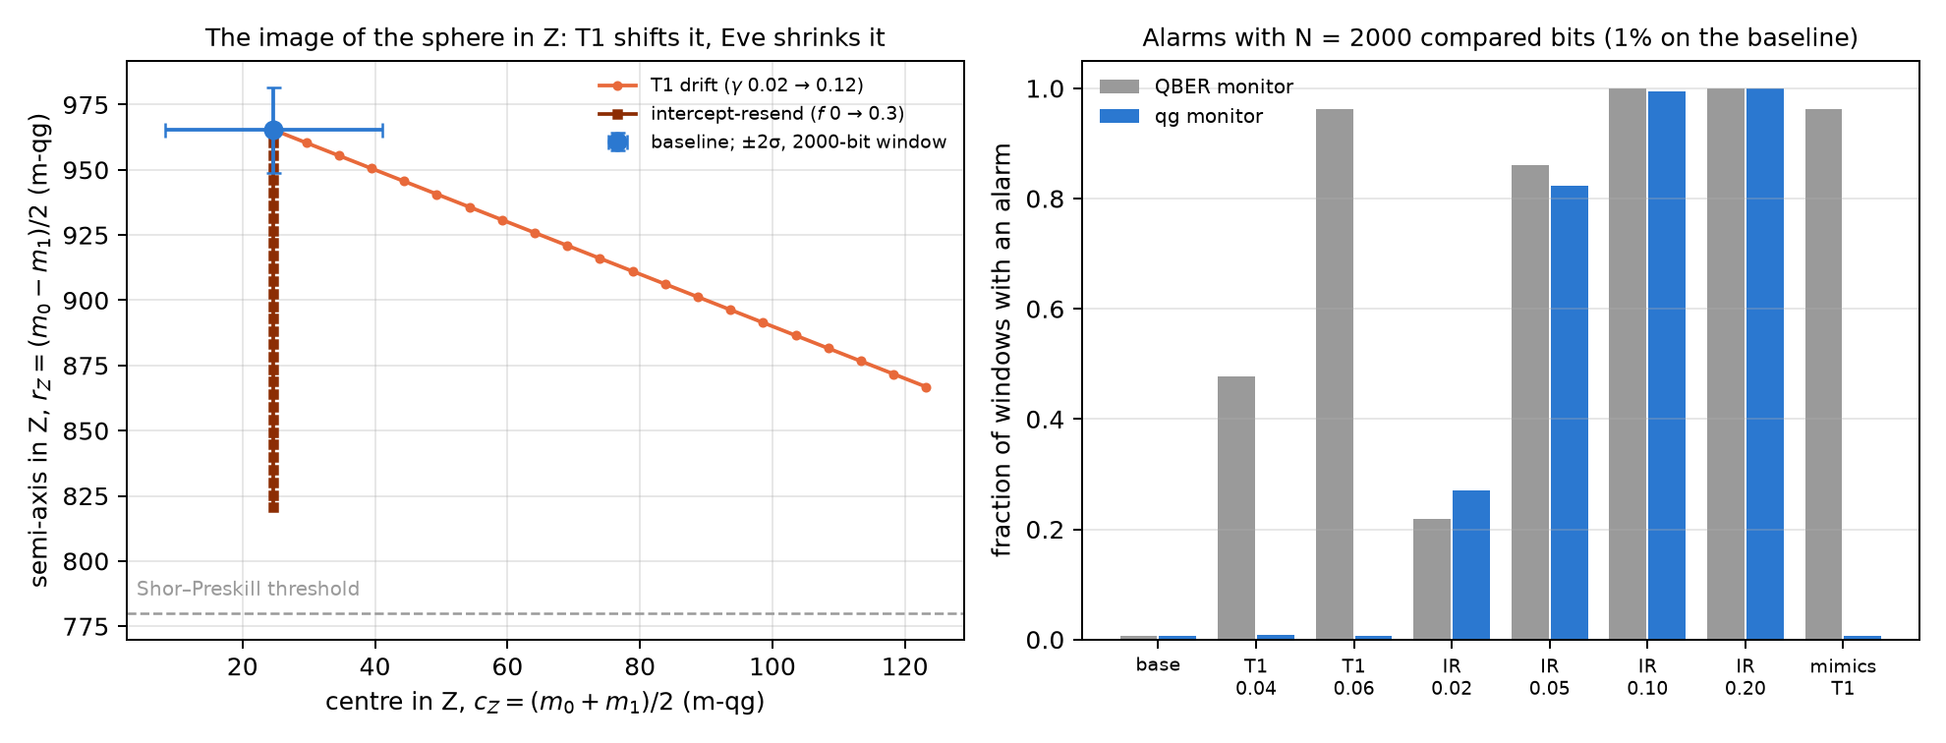
Figure 17.1: Left: the image of the sphere in the Z basis, centre against semi-axis (m-qg). T1 drift runs along a line of slope −1; intercept-resend lowers the semi-axis without moving the centre; the bar is ±2σ with a 2000-bit window. Right: alarms of the two monitors with N = 2000 compared bits, tuned to 1% false alarms on the baseline.

17.2 The monitor: drift or eavesdropper
The notes (§40) compare two monitors on windows of $N$ sifted and compared bits, both tuned to 1% false alarms on the baseline:
- QBER monitor: a one-sided test on the total error count;
- qg monitor: a generalized likelihood ratio on the four error counts, where “attack” ($f>0$) must beat both “baseline” and “T1 drift” ($γ$ free).
Table 17.2: Fraction of windows with an alarm (1000 windows per scenario).
scenario | QBER, $N=500$ | qg, $N=500$ | QBER, $N=2000$ | qg, $N=2000$ | QBER, $N={10}^{4}$ | qg, $N={10}^{4}$
baseline | 0.007 | 0.004 | 0.007 | 0.006 | 0.010 | 0.007
T1 drift, 0.04 | 0.147 | 0.009 | 0.478 | 0.009 | 0.992 | 0.000
T1 drift, 0.06 | 0.463 | 0.009 | 0.962 | 0.006 | 1.000 | 0.000
intercept, $f=0.02$ | 0.072 | 0.065 | 0.218 | 0.271 | 0.847 | 0.848
intercept, $f=0.05$ | 0.337 | 0.338 | 0.861 | 0.823 | 1.000 | 1.000
intercept, $f=0.10$ | 0.821 | 0.730 | 1.000 | 0.994 | 1.000 | 1.000
T1-mimicking attack | 0.463 | 0.009 | 0.962 | 0.006 | 1.000 | 0.000

Three things can be read from the table.
- Detection is the same; false alarms are not. The qg monitor catches the naive eavesdropper as well as the QBER monitor, at every $N$ and $f$, within the sampling spread. When the memory degrades, the QBER monitor fires in 48% and 96% of windows ($N=2000$) and the qg monitor stays at 0.9% and 0.6%, at the baseline level. The reduction in false alarms holds for T1 drift, which is in the qg monitor’s model, and not for any degradation whatsoever.
- The price, by design. An eavesdropper who couples the qubit to her ancilla through an amplitude-damping interaction produces exactly the counts of a T1 drift, because in the $(c_{Z},r_{Z})$ plane she runs along the same line. The qg monitor misses her (0.6%, the same figure as the drift, because the counts are identical), and the QBER monitor does not (96%). The two are complementary: QBER says “something changed”; qg says “symmetric (attack-like)” or “T1-like (drift, or an eavesdropper hiding as one)”.
- No security gain. The secret fraction falls the same way in both cases (0.720 → 0.567 with drift to 0.06; 0.720 → 0.594 with $f=0.05$). A security proof must charge every error to Eve, and the qg reading does not change that.
The setting is a link with matter qubits, or an on-chip demonstration, where the qubit waits with T1 and T2 before Bob measures. In a photon-polarization link the noise is nearly unital, the centre does not move, and the distinction does not exist.

17.3 Finite blocks
A real link cuts the key into blocks. The notes (§43) use the finite-key bound of Tomamichel, Lim, Gisin and Renner (Nat. Commun. 3, 634, 2012) on the same channel:
$$ℓ=n\left[1−h(Q_{\text{tol}}+μ)\right]−1.1 n h(Q_{Z})−\log_{2}\frac{2}{ε_{\text{sec}}^{2}ε_{\text{cor}}}, μ=\sqrt{\frac{n+k}{nk} \frac{k+1}{k} ln\frac{2}{ε_{\text{sec}}}},$$
with $ε={10}^{−10}$, $n$ key bits in Z and $k$ test bits in X. The protocol aborts if the test error exceeds $Q_{\text{tol}}$; $k$ and $Q_{\text{tol}}$ are optimised for each $n$.
Table 17.3: Secret bits per signal with a finite key.
scenario | minimum $n$ | $n={10}^{4}$​ | ${10}^{5}$​ | ${10}^{6}$​ | ${10}^{7}$​ | asymptotic
baseline | $1.2⋅{10}^{3}$​ | 0.120 | 0.268 | 0.407 | 0.516 | 0.707
T1 drift, 0.04 | $1.6⋅{10}^{3}$​ | 0.091 | 0.223 | 0.348 | 0.446 | 0.622
T1 drift, 0.06 | $2.0⋅{10}^{3}$​ | 0.068 | 0.182 | 0.294 | 0.383 | 0.544
intercept, $f=0.05$ | $1.7⋅{10}^{3}$​ | 0.079 | 0.201 | 0.318 | 0.410 | 0.575

A block of ${10}^{4}$ bits keeps 17% of the asymptotic rate; ${10}^{5}$, 38%; ${10}^{6}$, 58%; ${10}^{7}$, 73%. Below about ${10}^{3}$ bits there is no key. Drift and attack cost key alike.
Where qg enters, at no key cost. After error correction and its check, Bob knows Alice’s bits: he has the four error counts, that is the four readings, over the $n$ key bits, without disclosing anything. Announcing an alarm bit costs at most one key bit, and the bits of an aborted block are discarded anyway. Two nested likelihood ratios on the joint model ($γ$ and $f$ free) give an “attack-like” flag (symmetric error beyond any T1) and a “drift-like” flag (T1 beyond the baseline, attack or not), each with 1% false alarms.
With the protocol tuned on the baseline for $n={10}^{5}$ ($k=7609$, $Q_{\text{tol}}=2.67$%, that is, abort if the semi-axis in X falls below 946.6 m-qg), 400 blocks per scenario:
Table 17.4: Protocol aborts and the qg diagnosis of the same blocks ($n={10}^{5}$).
scenario | protocol aborts | qg: attack-like | qg: drift-like
baseline | 0.010 | 0.020 | 0.015
T1 drift, 0.03 | 0.100 | 0.005 | 1.000
T1 drift, 0.04 | 0.557 | 0.005 | 1.000
T1 drift, 0.06 | 0.995 | 0.007 | 1.000
intercept, $f=0.02$ | 0.495 | 1.000 | 0.043
intercept, $f=0.05$ | 1.000 | 1.000 | 0.040
drift 0.04 + intercept 0.02 | 0.995 | 1.000 | 1.000
T1-mimicking attack | 0.995 | 0.013 | 1.000

- An abort does not say why; qg does. With ${10}^{5}$ key bits the attribution is nearly exact: every drifting block, aborted or not, comes out as drift and not as an attack, and every intercepted block comes out as an attack, including the half that did not abort. With $n={10}^{4}$ the flags are already at 0.97–1.00 (0.81 for drift 0.03).
- An attack hidden under drift is caught. Intercepting with $f=0.02$ on a memory with $γ=0.04$ raises both flags in every block. The one-parameter test of the previous section misses it: it gives 0.5% attack flags and calls 99% “drift”. The joint model fixes a real weakness of §40.
- Early warning. At $γ=0.03$ only 10% of blocks abort, but the drift flag is up in all of them: the memory can be serviced before the link stops. A $Q_{Z}$ trend would also warn; what qg adds is the attribution.
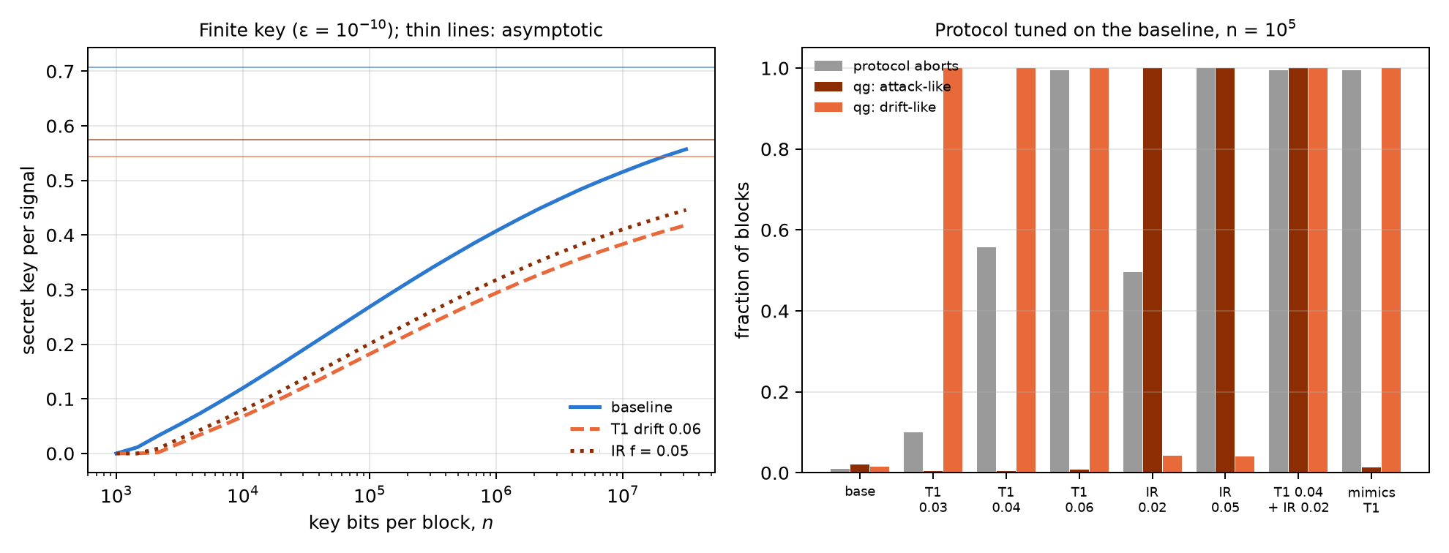
Figure 17.2: Left: finite-key rate against block size for the baseline, T1 drift to 0.06 and an eavesdropper with f = 0.05; thin lines are the asymptotic rates. Right: with n = 10⁵, what fraction of blocks aborts and what fraction raises each qg flag.

17.4 Beyond intercept-resend
The flags know two error families. Seen from Bob, every individual attack is a Pauli channel $(p_{x},p_{y},p_{z})$, and on the image of the sphere a Pauli channel shrinks the axes without moving the centre: the semi-axis in Z is multiplied by $1−2(p_{x}+p_{y})$ and the one in X by $1−2(p_{z}+p_{y})$. That explains the table of the notes (§49):
Table 17.5: Individual attacks as Pauli channels. The identities hold to ${10}^{−16}$.
attack | $(p_{x},p_{y},p_{z})$​ | what it shrinks | same counts as
intercept in both bases, fraction $f$ | $(f/4,0,f/4)$​ | Z and X | —
optimal phase-covariant cloner, disturbance $D$ | $(0,D,0)$​ | Z and X | intercept with $f=4D$
Z-only intercept, fraction $f$ | $(0,0,f/2)$​ | X only | T2 drift, $(1−2p^{′})=(1−2p_{0})(1−f)$
X-only intercept, fraction $f$ | $(f/2,0,0)$​ | Z only | no natural noise

T2 dephasing also shrinks only the X axis. Hence the third family: with $n={10}^{5}$, $k=7609$ and 400 blocks, the model adds a dephasing family and three one-sided nested flags: attack-like, T1-like ($γ>γ_{0}$) and T2-like ($p>p_{0}$).
Table 17.6: Flags with three error families ($n={10}^{5}$, 400 blocks).
scenario | attack-like | T1-like | T2-like | two-family model: attack
baseline | 0.020 | 0.005 | 0.033 | 0.020
T1 drift, 0.04 | 0.018 | 1.00 | 0.033 | 0.015
T2 drift, $p=0.02$ / $0.03$ | 0.007 / 0.020 | 0.01 | 1.00 | 0.075 / 0.268
intercept, $f=0.05$ | 1.00 | 0.055 | 0.028 | 1.00
cloner, $D=0.0125$ / $0.025$ | 1.00 | 0.055 | 0.02–0.04 | 1.00
Z-only, $f=0.02$ / $0.04$ | 0.013 | 0.02–0.03 | 1.00 | 0.06 / 0.27
X-only, $f=0.04$ | 1.00 | 0.048 | 0.000 | 1.00
T2 drift + cloner | 1.00 | 0.043 | 0.995 | 1.00

- Partial cloning is caught. The optimal cloner comes out as an attack in every block, like intercepting with $f=4D$, because Bob sees the same counts. What no error statistic shows is that the cloner gives Eve more information per error; the key rate, which charges every error to Eve, already accounts for it.
- The two-family model had a false alarm. Without the dephasing family, T2 drift raised the attack flag in 7.5% and 27% of blocks. With the family, the false alarm drops to 0.7–2% and the verdict is T2 in every block.
- A second blind spot, by construction. A Z-only intercept shrinks only the X axis, like T2: it comes out as T2 drift and not as an attack. It is the twin of the T1-mimicking attack: an eavesdropper hiding in the error type the hardware makes by itself. An X-only intercept has no natural twin, and is always caught.
- Mixtures are resolved: T2 drift plus a cloner raises both flags.
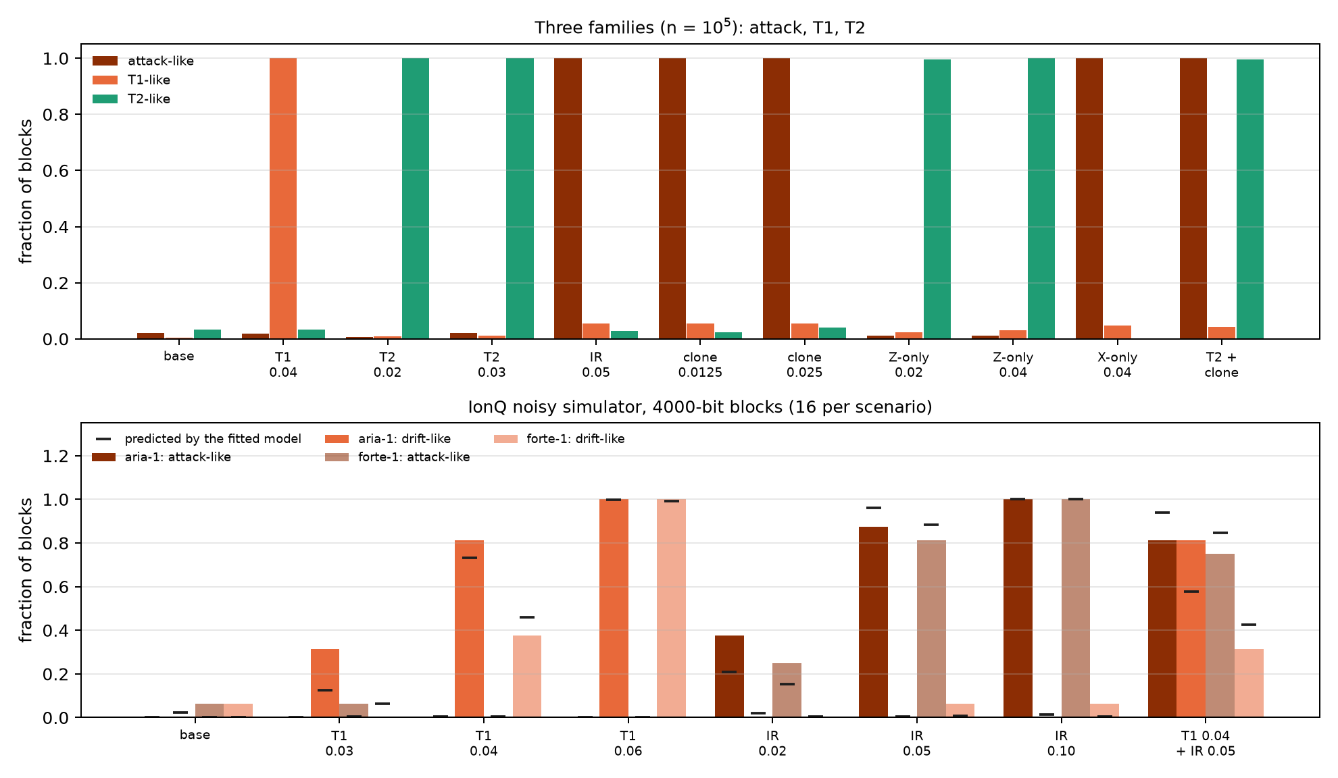
Figure 17.3: Top: flags of the three-family model with n = 10⁵. T2 drift and the Z-only intercept get the same verdict, because they shrink the same axis. Bottom: flags on IonQ’s noisy simulator (aria-1 and forte-1), observed in 16 blocks of 4000 bits; the black ticks are what the fitted model predicts.

17.5 On IonQ’s noisy simulator
So far the channel was analytic. In the notes (§44) every part of BB84 is a circuit run on the aria-1 and forte-1 noise models of IonQ’s simulator (free; nothing was sent to a QPU), and the model behind the flags is fitted, not given.
- The memory is amplitude damping built with an ancilla, CRY$(2arcsin\sqrt{γ})$ followed by CX, with a healthy $γ_{0}=0.02$ and drifts from 0.03 to 0.06.
- Eve measures and resends (CX to her ancilla in Z, H·CX·H in X), never reading the ancilla; a fraction $f$ of the rounds is taken from those circuits.
- The runs: 32 circuits in native gates, 4 copies of each (12 qubits), 2000 shots, 4 repetitions per noise model. Each copy is a block of $n=k=4000$ bits.
- The flag model is the joint one ($γ$, $f$) plus two symmetric device flip rates, $ε_{Z}$ and $ε_{X}$, fitted leaving out each repetition, with thresholds from a parametric bootstrap at 1%.
The device adds a nearly symmetric error of 2.3–2.4% per bit (aria-1) and 2.8–3.1% (forte-1), mostly from the two MS gates of the memory circuit. On the image of the sphere that is a shrinking, not a shift. The designed healthy memory gives $c_{Z}=20$, $r_{Z}=980$ and $r_{X}=990$ m-qg; the simulator gives $c_{Z}=18.5$ and $20.6$ m-qg (aria-1, forte-1), with the semi-axes 46–62 m-qg lower; with $γ=0.06$ the centre rises to 60.5 and 56.5 m-qg, where the design says 60. The device noise leaves the centre in place, which is what the T1 witness needs to keep working. The fit recovers the designed $γ_{0}$ (0.020–0.0225) in every fold.
Table 17.7: Flags on IonQ’s simulator, observed / predicted by the fitted model (16 blocks per scenario).
scenario | aria-1 QBER | aria-1 attack | aria-1 drift | forte-1 QBER | forte-1 attack | forte-1 drift
baseline | 0.00/0.01 | 0.00/0.00 | 0.00/0.02 | 0.00/0.01 | 0.06/0.00 | 0.06/0.00
drift 0.03 | 0.56/0.36 | 0.00/0.00 | 0.31/0.12 | 0.06/0.20 | 0.06/0.01 | 0.00/0.06
drift 0.04 | 0.94/0.93 | 0.00/0.01 | 0.81/0.73 | 0.38/0.75 | 0.00/0.01 | 0.38/0.46
drift 0.06 | 1.00/1.00 | 0.00/0.00 | 1.00/1.00 | 1.00/1.00 | 0.00/0.00 | 1.00/0.99
intercept, $f=0.02$ | 0.62/0.58 | 0.38/0.21 | 0.00/0.02 | 0.31/0.38 | 0.25/0.15 | 0.00/0.01
intercept, $f=0.05$ | 1.00/1.00 | 0.88/0.96 | 0.00/0.01 | 1.00/0.99 | 0.81/0.88 | 0.06/0.01
intercept, $f=0.10$ | 1.00/1.00 | 1.00/1.00 | 0.00/0.01 | 1.00/1.00 | 1.00/1.00 | 0.06/0.01
drift 0.04 + $f=0.05$ | 1.00/1.00 | 0.81/0.94 | 0.81/0.58 | 1.00/1.00 | 0.75/0.84 | 0.31/0.42

- The attribution transfers. A drifting memory is never taken for an attack on aria-1 (0 of 48 blocks), and once in 48 on forte-1. An attack is taken for drift in at most 1 of 16 blocks. Large changes (drift 0.06, $f=0.10$) are attributed in every block.
- Small blocks, noisy device. With 4000 bits and 2–3% of its own noise, small changes are seen only in part: 31–81% for drift 0.03–0.04 and 81–88% for $f=0.05$. The QBER monitor sees changes as often or more often, but cannot say which kind.
- The model predicts which flag rises. Almost every observed rate falls within the ±0.12 spread of 16 blocks; the largest misses are near threshold. Extrapolated with the fitted noise to $n={10}^{5}$, the regime of the finite-block section, every scenario is attributed correctly in 99–100% of blocks.
These are vendor noise models on a simulator, not hardware; the memory and the attack are designed circuits.

17.6 What remains open
There is no hardware run: the Forte-1 plan (notes, §46) was rejected by the provider before the job was accepted, and the IQM credits at hand do not stretch to blocks of ${10}^{5}$ bits. Collective attacks, detector attacks and photon links, where the noise does not move the centre, are not modelled. Nor is there a qang.crypto module (Chapter 16): everything lives in examples/bb84_*.py and examples/ionq_sim_bb84.py.

17.7 Without qang and with qang
Table 17.8: The chapter’s actions without the qang scale and with it.
action | without qang | with qang | difference
decide whether there is a key | QBER and $1−h(Q_{Z})−h(Q_{X})$, or the finite-key bound | the semi-axis $r$ in m-qg; abort if $r_{X}<946.6$ | unit: it is the same computation
describe the channel | four error rates | centre and semi-axis of the image of the sphere in each basis | in favour, modest: T1 shifts the centre, the eavesdropper shrinks, T2 shrinks X only; the geometry says which model is needed
tell drift from eavesdropper | total QBER: cannot | likelihood ratio on the four counts | in favour, but the gain belongs to the likelihood model on per-state counts; a standard asymmetric analysis would do the same without the word qg
false alarms from T1 drift ($N=2000$) | 48% and 96% | 0.9% and 0.6% | in favour, at a price: the T1-mimicking attack gets through (0.6% against 96%)
security | every error is charged to Eve | the same | none: the key does not grow
attack hidden under drift | only an abort | both flags, 100% of blocks ($n={10}^{5}$) | in favour of the joint model
noise of a real device (simulated) | QBER jumps with everything | attribution with 0–1 errors in 48 blocks | in favour, still partial with 4000-bit blocks

Balance. The contribution that belongs to the Chapter 1 base is the geometry: reading the four probabilities as the centre and semi-axes of the image of the sphere says at once which error families can be told apart (those that move different things) and which cannot (those that shrink the same axis). The detection power comes from the statistics on per-state counts, which does not need qang. And security does not change: this is an operational diagnostic, not a proof.

17.8 In code
import sys
sys.path.insert(0, "examples")
import bb84_qg_eve_vs_noise as B
e = B.error_probabilities(gamma=0.04) # error rates of 0, 1, +, -
m = 1000 * B.qg_per_state(e) # [990.0, -901.2, 950.8, -940.8] m-qg
c_z, r_z = (m[0] + m[1]) / 2, (m[0] - m[1]) / 2
c_z, r_z, (1 - r_z / 1000) / 2 # 44.4, 945.6 and Q_Z = 0.0272

17.9 Summary
- In BB84 each sent state has its reading; in each basis, the two readings give the centre and the semi-axis of the image of the sphere, and the QBER is exactly the semi-axis: $Q=(1−r/1000)/2$.
- T1 drift shifts the centre and shrinks by the same amount; an intercepting eavesdropper shrinks without moving the centre. Hence the qg monitor stays quiet under drift (0.6–0.9% against 48–96%) and sees the eavesdropper as well as the QBER does.
- By construction, an eavesdropper who mimics T1, or who intercepts only in Z (and looks like T2), comes out as drift.
- With finite blocks of ${10}^{5}$ bits the attribution is nearly exact, at no key cost, and an attack hidden under drift raises both flags; IonQ’s simulator confirms it with 4000-bit blocks, in part.
- The secret key does not grow: the qg reading is a diagnostic, not security.

18. Certified quantum random numbers (QRNG) and channel auditing
A one-qubit quantum random number generator (QRNG) is the simplest experiment in the book: prepare $|+⟩$, measure in Z, write down the bit. The result is a fair coin, and that is what the usual analysis measures. But a fair coin is not the same as a private coin. If the qubit lost coherence, the output still comes out 50/50, and yet someone holding the environment can know every bit in advance. This chapter reads that difference on the scale of Chapter 1. The output lives in one reading and privacy in the other two, and what the adversary knows is one more reading: the one the state lacks to reach the sphere. The chapter adds the readout calibration needed to avoid overestimating, and the same certifier against a designed leak on IonQ’s simulator.

18.1 From the base: output and privacy are different readings
The source qubit has three readings, $m_{X}$, $m_{Y}$ and $m_{Z}$. The QRNG output is the measurement in Z, and the usual analysis looks only at its bias: with $p_{0}=(1000+m_{Z})/2000$ it certifies
$$H_{\text{naive}}=−\log_{2}max(p_{0},p_{1})=−\log_{2}\frac{1000+|m_{Z}|}{2000}$$
bits per shot, 1 bit when $m_{Z}=0$. But $m_{Z}=0$ is given by $|+⟩$ and by the completely mixed state alike, and in the second case nothing is private: the environment holds the other half of the purification and knows what came out.
With a trusted measurement and an adversary (Eve) holding the purification, Eve’s two conditional states are pure, and their overlap depends only on the transverse radius $r_{⟂}=\sqrt{qg_{X}^{2}+qg_{Y}^{2}}$. By Helstrom, her guessing probability is (notes, §41)
$$P_{\text{guess}}=\frac{1+\sqrt{1−r_{⟂}^{2}}}{2}, H_{min}(Z|E)=−\log_{2}P_{\text{guess}}.$$
On the scale of Chapter 1, that probability is one more reading. Its value in m-qg is
$$m_{E}=1000\sqrt{1−r_{⟂}^{2}}=\sqrt{{1000}^{2}−m_{X}^{2}−m_{Y}^{2}},$$
what the transverse radius lacks to reach the sphere, and its qang angle is $arcsinr_{⟂}$. The formula does not depend on $m_{Z}$. A pure state on the equator has $m_{⟂}=1000$ and leaves Eve at $m_{E}=0$: she guesses with probability 1/2, and the bit is private. A state that lost coherence has $m_{⟂}<1000$, and the length it lost is what Eve knows (Figure 18.1, left).
Table 18.1: The private randomness of a qubit measured in Z, as a function of its transverse radius.
$m_{⟂}$ (m-qg) | 1000 | 990 | 950 | 900 | 800 | 500 | 200
what Eve knows, $m_{E}$ (m-qg) | 0 | 141 | 312 | 436 | 600 | 866 | 980
private bits per shot | 1.000 | 0.810 | 0.608 | 0.478 | 0.322 | 0.100 | 0.015

The shape of the formula has a practical consequence. Ten m-qg less of transverse radius, from 1000 to 990, give Eve 141 m-qg and take 0.19 bits per shot from the source. It is the pole of Chapter 1 seen from the other side: near $m_{⟂}=1000$, the square root has infinite slope.

18.2 The output-bias analysis fails; the qg reading does not
The qg certifier estimates $m_{X}$ and $m_{Y}$ with test rounds (rotations that bring X and Y to the measurement basis) and uses a 3σ lower bound on $r_{⟂}$. The notes (§41) compare four estimators with ${10}^{4}$ test rounds per setting, 300 runs per scenario and the asymmetric readout of §31 ($e_{01}=0.015$, $e_{10}=0.04$):
- naive: the bias of the output;
- qg, one rotation: $m_{X}$ and $m_{Y}$ measured with one rotation each;
- qg, ± pairs: each axis with both rotations, so that the readout offset cancels;
- qg calibrated: the ± pairs, divided by the readout scale factor $b$ measured with the protocol of §31.
Table 18.2: Certified bits per shot: mean estimate and, in parentheses, the fraction of runs above the truth (unsafe).
scenario | $m_{⟂}$​ | truth | naive | qg, one rotation | qg, ± pairs | qg calibrated
ideal $|+⟩$ | 1000 | 1.000 | 0.965 (0) | 0.578 (0) | 0.512 (0) | 0.681 (0)
T2: $V=0.8$ | 800 | 0.322 | 0.964 (1.00) | 0.269 (0) | 0.245 (0) | 0.286 (0)
T2: $V=0.5$ | 500 | 0.100 | 0.965 (1.00) | 0.087 (0) | 0.077 (0) | 0.087 (0)
T2: $V=0.2$ | 200 | 0.015 | 0.965 (1.00) | 0.013 (0.07) | 0.009 (0) | 0.010 (0)
thermal $p=0.05$, $V=0.9$ | 810 | 0.334 | 0.965 (1.00) | 0.279 (0) | 0.254 (0) | 0.297 (0)
strongly asymmetric readout, $e_{10}=0.10$, $V=0.95$ | 950 | 0.608 | 0.876 (1.00) | 0.498 (0) | 0.341 (0) | 0.513 (0)

- The usual estimator is unsafe whenever the state is not pure. At $V=0.2$ it certifies 0.97 bits per shot where only 0.015 are private, in 100% of runs. Dephasing and thermal mixing leave the output unbiased.
- The qg estimator with ± pairs is safe in every run, because the readout offset $a$ cancels. With one rotation, the offset inflates $r_{⟂}$ and overestimates in 7% of runs at $V=0.2$. So the “100% against 0%” safety holds for the paired estimator, not for any qg reading whatsoever.
- Calibrating $b$ with §31 recovers 10 to 50% more certified bits (0.286 against 0.245 at $V=0.8$; 0.513 against 0.341 with the strongly asymmetric readout), without losing safety.
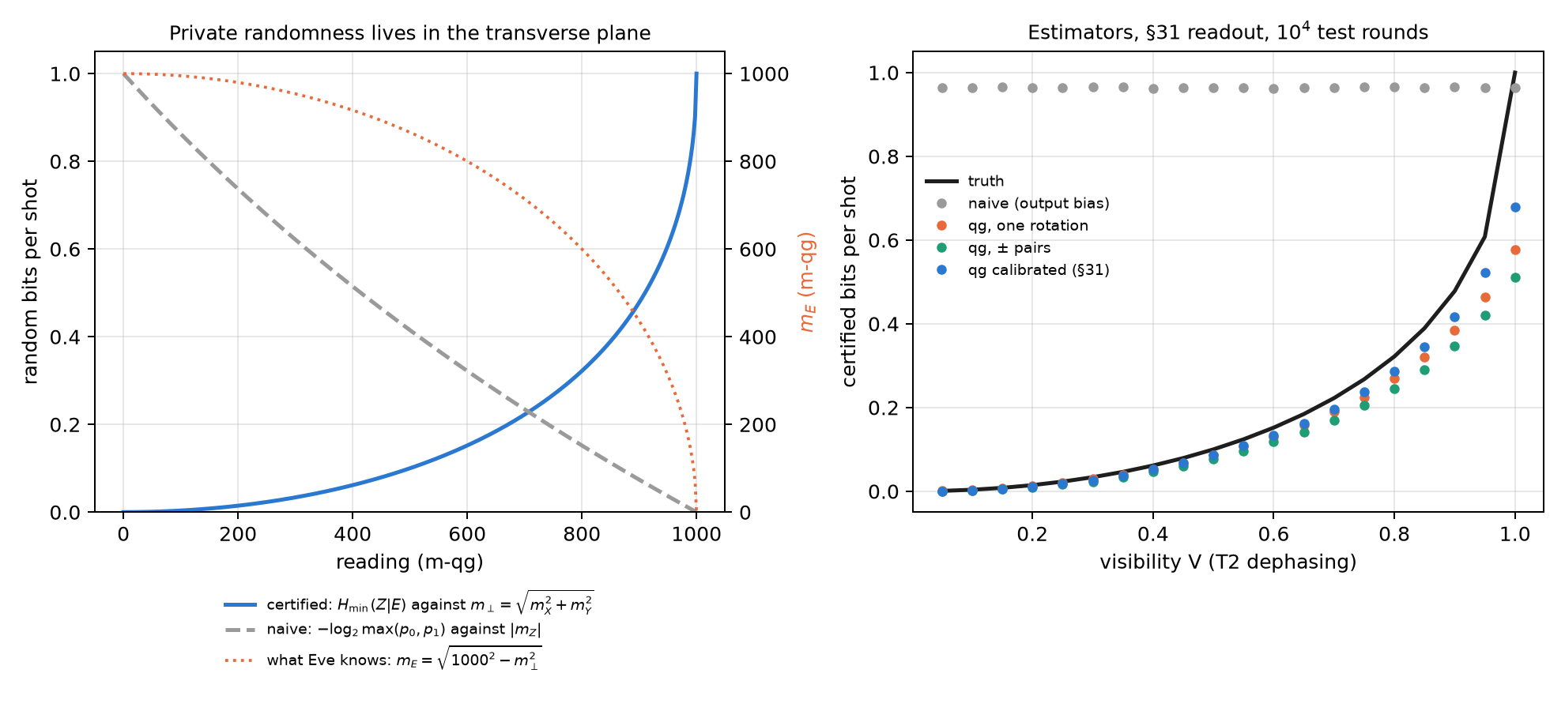
Figure 18.1: Left: random bits per shot. The naive estimator reads $|m_{Z}|$; the certified one reads the transverse radius $m_{⟂}$; the dotted curve is what Eve knows, $m_{E}=\sqrt{{1000}^{2}−m_{⟂}^{2}}$ (right axis). Right: the four estimators against visibility, with the readout of §31 and ${10}^{4}$ test rounds.

18.3 Near the pole certification is shot-hungry
A 3σ bound with $n$ rounds per setting lowers the radius by $3000/\sqrt{n}$ m-qg, and near the pole that is expensive. For a perfect source, without readout error:
Table 18.3: Certified bits with a 3σ bound, closed form.
test rounds | ${10}^{3}$​ | ${10}^{4}$​ | ${10}^{5}$​ | ${10}^{6}$​ | ${10}^{7}$​
bound on $m_{⟂}$ (m-qg) | 905 | 970 | 991 | 997 | 999
what is conceded to Eve, $m_{E}$ (m-qg) | 425 | 243 | 137 | 77 | 44
certified bits (truth: 1) | 0.489 | 0.686 | 0.814 | 0.892 | 0.939
with $m_{⟂}=950$ (truth: 0.608) | 0.397 | 0.523 | 0.578 | 0.598 | 0.605

With the §31 readout and the calibrated certifier, the simulation gives 0.68, 0.81 and 0.89 bits with ${10}^{4}$, ${10}^{5}$ and ${10}^{6}$ rounds, the same. Away from the pole the bound converges fast: with $m_{⟂}=950$, ${10}^{5}$ rounds already give 95% of the truth (Figure 18.2, left). A nearly perfect source is the most expensive to certify.

18.4 Readout calibration: temperature or detector error
The calibrated certifier divides by the readout scale factor $b$, and the question is where $b$ comes from. On the scale of Chapter 1 the readout is affine (notes, §31):
$$m_{\text{measured}}=1000 a+b m, a=e_{10}−e_{01}, b=1−e_{01}−e_{10}.$$
A real qubit starts with thermal population $p$, that is with $m_{\text{eq}}=1000(1−2p)=1000tanh(hf/2k_{B}T_{\text{eff}})$. The standard calibration measures “$|0⟩$” and “$|1⟩$”, which are really the thermal state and X on it: two readings for three unknowns ($a$, $b$, $m_{\text{eq}}$). It assumes $m_{\text{eq}}=1000$ and charges the thermal population to the readout: it reports $e_{01}+p b$ and $e_{10}+p b$, exactly.
Table 18.4: The standard calibration against the qg protocol of §31 ($e_{01}=0.015$, $e_{10}=0.04$). The standard column is exact; the qg column is the median of 100 repetitions from §31.
$p$​ | $T_{\text{eff}}$ (5 GHz) | $m_{\text{eq}}$ (m-qg) | standard $e_{01}$ | qg protocol $e_{01}$ (§31)
0 | 0 mK | 1000 | 0.0150 | 0.0149
0.01 | 52 mK | 980 | 0.0245 | 0.0151
0.03 | 69 mK | 940 | 0.0434 | 0.0148
0.08 | 98 mK | 840 | 0.0906 | 0.0152

The qg protocol adds the third equation. It measures, reads again and uses the covariance of the two readings, $V=b^{2}(1−qg_{\text{eq}}^{2})$, which separates $b$ from $m_{\text{eq}}$ in closed form. According to the notes, it recovers the temperature to ±1 mK from 52 mK up. Chapter 27 develops it. What matters here is its consequence for the QRNG: calibrating with the standard suite makes the certifier unsafe. With a thermal source ($V=0.9$), dividing by the standard $b$, which is $b(1−2p)$, returns $r_{⟂}$ without the thermal contraction and certifies too much.
Table 18.5: Thermal source with $V=0.9$, ${10}^{4}$ test rounds, 300 runs: the certifier with each calibration.
$p$​ | truth | calibrated with the standard $b$ | calibrated with the true $b$
0.01 | 0.443 | 0.418 (0.01 unsafe) | 0.390 (0)
0.03 | 0.383 | 0.414 (1.00 unsafe) | 0.339 (0)
0.05 | 0.334 | 0.413 (1.00 unsafe) | 0.297 (0)

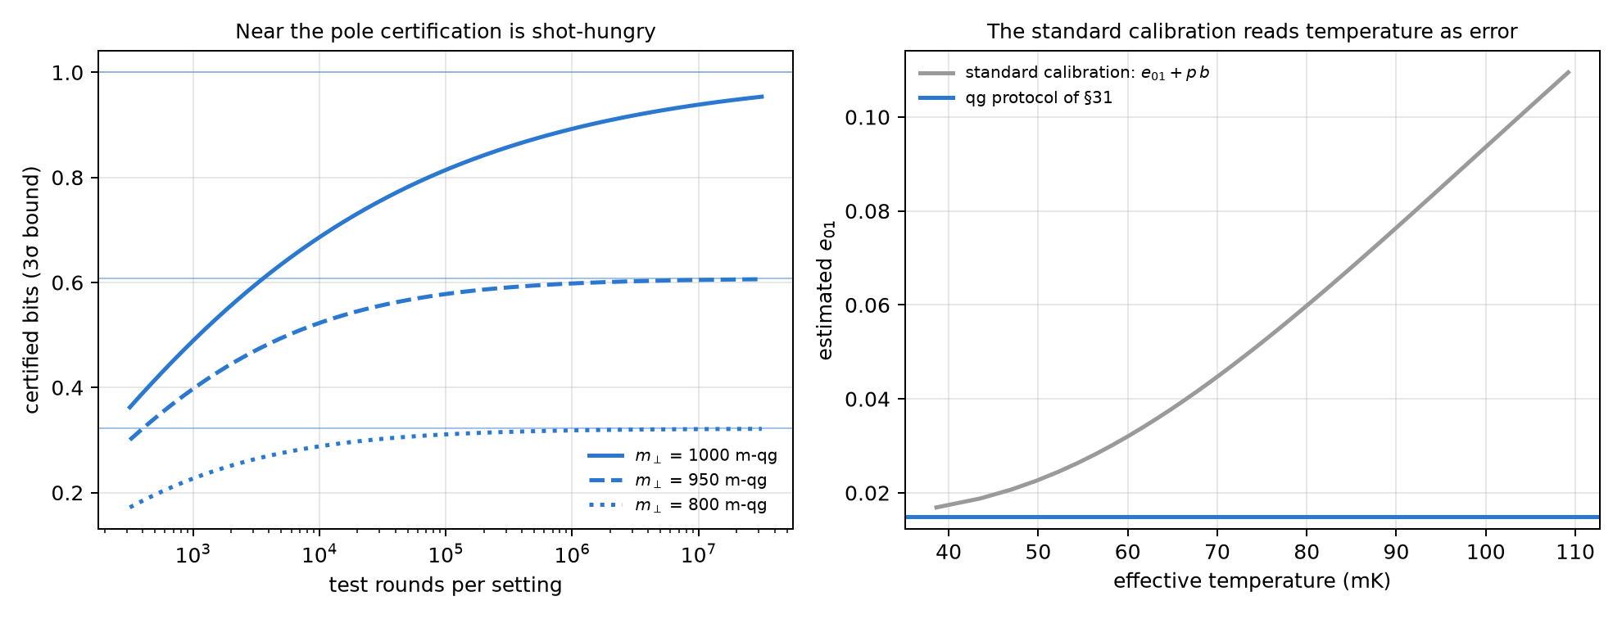
Figure 18.2: Left: certified bits with a 3σ bound against the number of test rounds, for three transverse radii; the thin lines are the truth. Right: the $e_{01}$ reported by the standard calibration grows with the effective temperature, $e_{01}+p b$; the qg protocol of §31 keeps it at its value.

18.5 On IonQ’s noisy simulator, with a leak
In the notes (§42) the leak is real: an ion $q$ is the source and a second ion $e$ plays the environment. An MS$(0,0,θ)$ interaction lets $e$ learn the X value of $q$, and the output is read in X. It is still a fair coin, but the private randomness falls to the formula above with $r=|cos2πθ|$ (X and Z exchanged). Test rounds measure ±Z and ±Y, and two circuits calibrate the readout. Everything is in native gates (GPI, GPI2, MS), with 5 pairs per circuit, ${10}^{4}$ samples per setting and three repetitions per noise model, on the free simulator. Nothing was sent to a QPU.
Table 18.6: Certified bits per shot, mean of 3 runs (aria-1 / forte-1 where they differ; $m_{⟂}$ from aria-1).
$θ$ (turns) | truth | naive | qg, one rotation | qg, ± pairs | measured / ideal $m_{⟂}$
0 (no leak) | 1.000 | 0.98 | 0.69 | 0.73 | 1000 / 1000
0.04 | 0.680 | 0.99 / 0.98 | 0.53 | 0.56 / 0.55 | 954 / 969
0.08 | 0.433 | 0.98 / 0.97 | 0.37 / 0.36 | 0.38 / 0.37 | 866 / 876
0.12 | 0.248 | 1.00 / 0.98 | 0.22 / 0.21 | 0.22 | 721 / 729

- The naive estimator does not see the leak: 0.97–1.00 bits per shot in every run, above the truth in 100% of runs with $θ>0$. At $θ=0.12$ it certifies four times the private randomness.
- The qg estimator is safe in all 24 cells (run × $θ$) and captures 81–90% of the truth when there is a leak, and 73% without one, because of the pole of the previous section.
- Calibration adds nothing here. The simulator’s readout is almost perfect ($b=0.9998$–$1.0000$, $|a|≤2⋅{10}^{−4}$). The 10–50% gain needs hardware-like readout errors, and this is a limit of the noise model that only a QPU can check.
- Gate noise is counted as lost privacy: the measured $m_{⟂}$ sits 1–2% below the ideal, which is the MS error. That is as it should be, because the certifier cannot know who took that length.
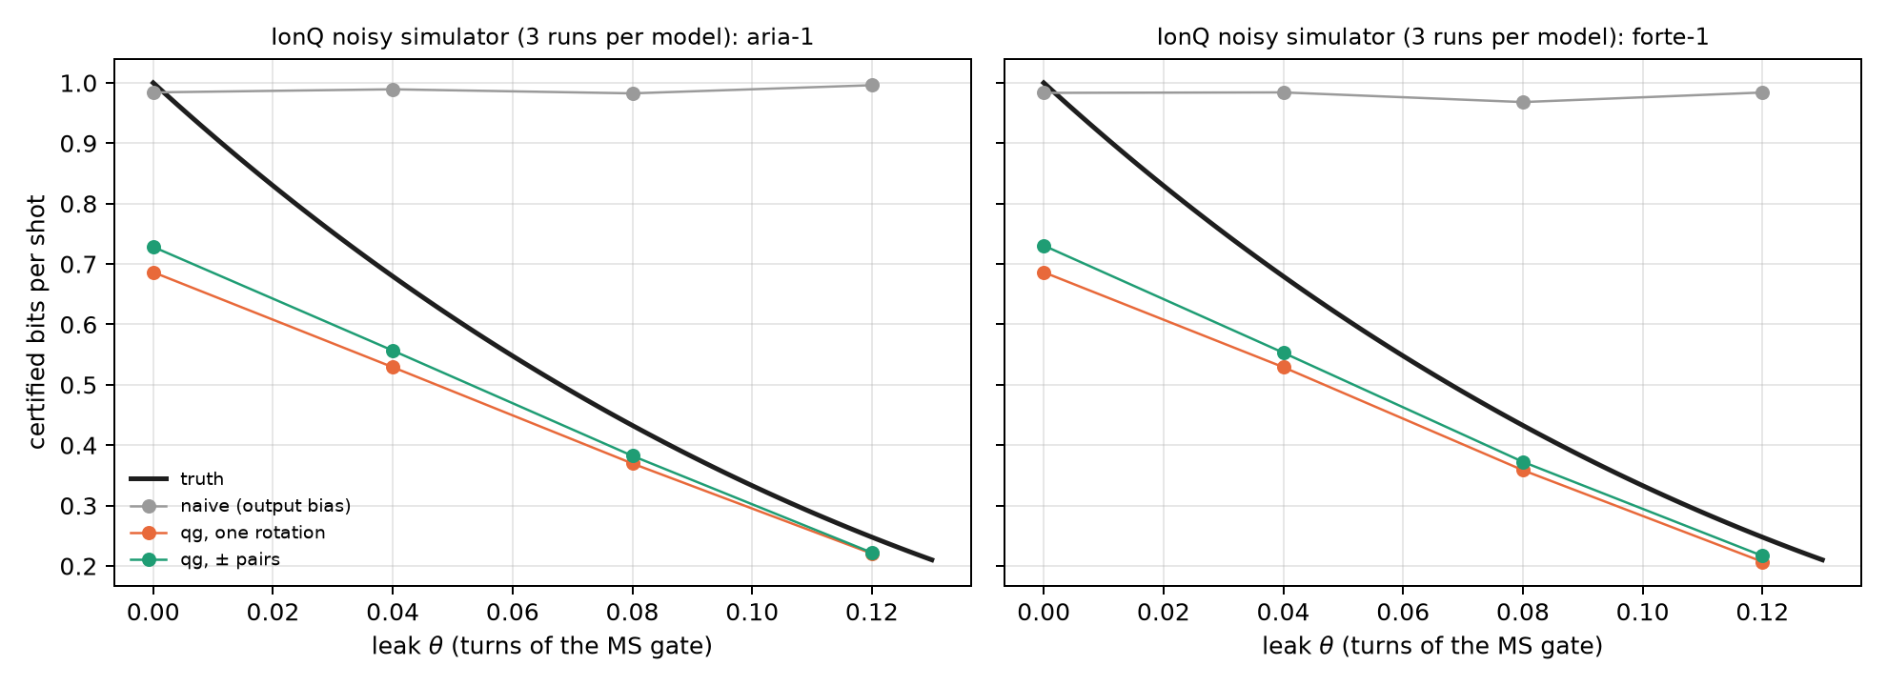
Figure 18.3: Certified bits per shot against the strength of the leak on IonQ’s simulator (aria-1 and forte-1). The naive estimator stays near 1; the qg estimators always stay below the truth.

18.6 What remains open
There is no hardware run. The missing test is a QRNG on a device with real readout errors, where the §31 calibration should show its 10–50% gain. It is a device-dependent QRNG (trusted measurement, independent and identical rounds), not device-independent randomness. And the leak of §42 is a designed interaction, not an adversary’s best strategy.

18.7 Without qang and with qang
Table 18.7: The chapter’s actions without the qang scale and with it.
action | without qang | with qang | difference
certify bits from the output bias | $−\log_{2}max(p_{0},p_{1})$​ | the same in $m_{Z}$ | none: both fail alike, 100% unsafe under dephasing
certify private bits | Helstrom’s $H_{min}(Z∣E)$ with the purification | $m_{E}=\sqrt{{1000}^{2}−m_{⟂}^{2}}$: what Eve knows is the missing length | equivalent in the computation (the formula is standard); in favour in the reading: privacy is in the transverse plane and is measured with two rotations
how many test rounds are needed | error propagation on $H_{min}$ | the pole of Chapter 1: 10 m-qg of radius give Eve 141 m-qg | in favour, modest: it shows at a glance why the perfect source is the most expensive
calibrate the readout | two circuits; temperature is read as error | affine readout and a third equation (§31) | in favour: it avoids an unsafe certifier (100% of runs with $p≥0.03$) and recovers 10–50% of bits
detect a leak (simulated IonQ) | the bias does not see it | safe in 24 of 24 cells, 81–90% of the truth | in favour of the transverse estimator, which is standard in device-dependent QRNGs

Balance. The entropy bound is the usual one, and a QRNG expert already measures transverse coherence. What the Chapter 1 base adds is the reading: what the adversary knows is a reading in m-qg, $m_{E}$, the length the state lacks to reach the sphere. Two things follow that can be seen at a glance: the drop of certification near the pole and the danger of calibrating the readout with two circuits. The second is the chapter’s most concrete gain, and it is owed to the §31 protocol, not to the unit.

18.8 In code
import math
import sys
sys.path.insert(0, "examples")
import qrng_qg_certified as Q
m_x, m_y = 800.0, 0.0 # transverse readings (m-qg)
m_perp = math.hypot(m_x, m_y)
m_e = math.sqrt(1000**2 - m_perp**2) # 600: what Eve knows
-math.log2((1000 + m_e) / 2000) # 0.322 private bits per shot
Q.h_min_certified(m_perp / 1000) # 0.322, the same computation

18.9 Summary
- The output of a one-qubit QRNG is the reading $m_{Z}$; its privacy is the transverse radius $m_{⟂}$. What an adversary holding the purification knows is one more reading, $m_{E}=\sqrt{{1000}^{2}−m_{⟂}^{2}}$.
- The output-bias analysis certifies almost 1 bit per shot even when the state is almost mixed: unsafe in 100% of runs with dephasing or thermal mixing. The qg estimator with ± pairs is safe in all of them.
- Near the pole certification is expensive: 10 m-qg of radius are worth 0.19 bits, and a perfect source gives 0.69 certified bits with ${10}^{4}$ rounds and 0.89 with ${10}^{6}$.
- The standard calibration reads temperature as readout error, and using it makes the certifier unsafe. The §31 protocol separates them and recovers 10–50% of bits.
- On IonQ’s simulator, with a designed leak, the naive estimator does not see it and the qg one is safe in every cell.

19. Quantum batteries and networks
A quantum battery is a system that stores energy to deliver it later as work. The smallest one is a qubit with $H=ω|1⟩⟨1|$: charging it means bringing it towards $|1⟩$, and discharging it means returning it to $|0⟩$ with a unitary operation. The practical question is not how much energy the qubit has, but how much can be taken out, which is its ergotropy. This chapter reads it on the scale of Chapter 1. Energy, ergotropy and the part nobody can take out are three distances between readings. With that, the chapter answers how to charge a battery that will wait with T1 and T2, how much it costs to certify its charge from shots, and where the charge of a qubit register sits when it lives in the correlations. The last section turns to networks: a Bell pair stored in two memories is another thing stored with T1 and T2, and its useful time is read the same way.

19.1 From the base: three distances between readings
A qubit with readings $(m_{X},m_{Y},m_{Z})$ and radius $m_{r}=\sqrt{m_{X}^{2}+m_{Y}^{2}+m_{Z}^{2}}$ has energy $ω(1000−m_{Z})/2000$: the distance of its Z reading from the north pole, which is the ground state. Its ergotropy, the maximum work a unitary operation extracts, is (notes, §56)
$$W=ω \frac{m_{r}−m_{Z}}{2000},$$
and what is left unextracted, the energy of the passive state, is $ω(1000−m_{r})/2000$. The energy splits between how far the state sits below the top of its own sphere, $m_{r}−m_{Z}$, and how much radius the sphere lost, $1000−m_{r}$. A unitary rotates the state without changing its radius, so the best it can do is bring it to the top of its sphere, $m_{Z}=m_{r}$. The part lost to mixing is out of reach of any unitary.
For a pure state, $m_{r}=1000$ and $W=ω\sin^{2}(θ/2)=ω p_{1}$: the ergotropy is the probability equation of Chapter 1, with the qang angle as the charging angle (checked to $2⋅{10}^{−16}$). The notes also split $W=W_{\text{inc}}+W_{\text{coh}}$, with $W_{\text{inc}}=ωmax(0,−qg_{Z})$ (population inversion) and $W_{\text{coh}}=ω/2(r−|qg_{Z}|)$ (coherence). The formulas match the general eigenvalue expression to $3⋅{10}^{−16}$ on 200 random states.
Table 19.1: The energy of a qubit in units of $ω$, split according to its readings.
state | $m_{Z}$​ | $m_{r}$​ | energy | extractable | locked by mixing
pure, inverted | −1000 | 1000 | 1.000 | 1.000 | 0
pure, on the equator | 0 | 1000 | 0.500 | 0.500 | 0
pure, $θ=2π/3$ | −500 | 1000 | 0.750 | 0.750 | 0
mixed, down | −500 | 500 | 0.750 | 0.500 | 0.250
mixed, on the equator | 0 | 500 | 0.500 | 0.250 | 0.250
inverted and aged, $t=0.8 T_{1}$ | +101 | 101 | 0.449 | 0 | 0.449

The last row is a passive battery: it has almost half a unit of energy and delivers nothing, because it sits at the top of its sphere ($m_{Z}=m_{r}$). This happens to every inverted battery when its Z reading crosses the equator upwards.

19.2 Storage with T1 and T2: inversion dies at the equator
A battery charged at angle $θ$ ages as
$$m_{Z}(t)=1000\left[1−(1−cosθ) e^{−t/T_{1}}\right], m_{⟂}(t)=1000sinθ e^{−t/T_{2}}.$$
The inverted battery ($θ=π$) has no coherence and stores only inversion: $m_{Z}=1000(1−2e^{−t/T_{1}})$, which crosses the equator at $t=T_{1}ln2$. There its ergotropy is zero, and it does not come back. A tilted battery stores less at first, but its coherence keeps it below the top of its sphere after the crossing, as long as $T_{2}$ allows.
Table 19.2: Best charging angle and stored ergotropy (best / inverted / equator, in units of $ω$).
$T_{2}/T_{1}$​ | crossover $t_{c}$ | $t=0.5 T_{1}$​ | $t=T_{1}$​ | $t=2 T_{1}$​
2 | $0.288 T_{1}=ln(4/3)$​ | $0.70π$: 0.297 / 0.213 / 0.240 | $0.58π$: 0.129 / 0 / 0.122 | 0.038 / 0 / 0.038
1 | $0.405 T_{1}=ln(3/2)$​ | $0.78π$: 0.234 / 0.213 / 0.165 | $0.59π$: 0.054 / 0 / 0.050 | 0.005 / 0 / 0.005
0.5 | $0.618 T_{1}$​ | $π$: 0.213 / 0.213 / 0.073 | $0.60π$: 0.008 / 0 / 0.007 | ≈ 0
0.2 | $0.692 T_{1}$​ | $π$: 0.213 / 0.213 / 0.004 | ≈ 0 | ≈ 0

- The charging rule. If the battery will be used before $t_{c}$, charge it fully ($θ=π$). Otherwise tilt it, to about $0.6π$ at $t=T_{1}$. The crossover solves $x^{2T_{1}/T_{2}−1}=2(2x−1)$ with $x=e^{−t_{c}/T_{1}}$, which comes from a small-tilt analysis and matches the numerical optimum to ${10}^{−6}$; for $T_{2}=2T_{1}$ and $T_{2}=T_{1}$ it gives the closed forms $ln(4/3)$ and $ln(3/2)$.
- The crossover tends to the equator. As $T_{2}$ shrinks, $t_{c}$ tends to $T_{1}ln2=0.693 T_{1}$, the moment the Z reading of the inverted battery crosses the equator. Without coherence there is nothing to tilt.
- Coherence buys time only when $T_{2}$ is comparable to $T_{1}$. At $t=T_{1}$ a tilted battery stores $0.13 ω$ ($T_{2}=2T_{1}$) or $0.05 ω$ ($T_{2}=T_{1}$), where the inverted one stores nothing. At $T_{2}=0.2 T_{1}$ it buys nothing. In trapped ions, where T1 hardly exists, always charge fully.
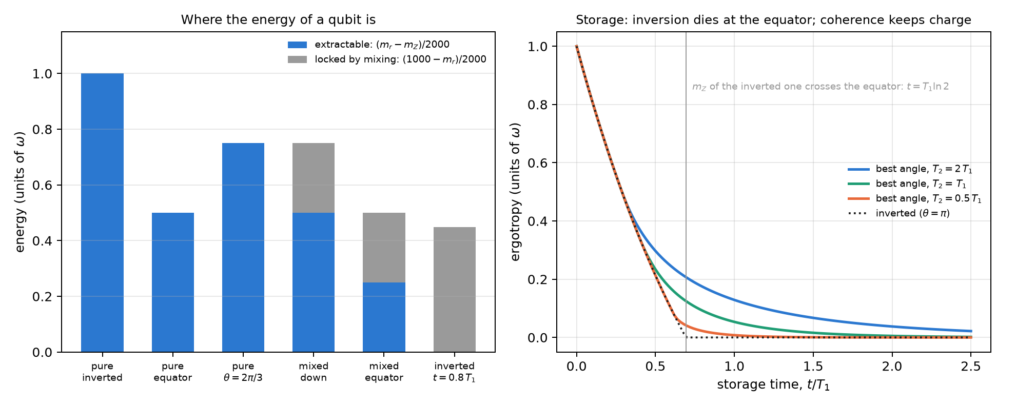
Figure 19.1: Left: the energy of six states, split between the extractable part, $(m_{r}−m_{Z})/2000$, and the part locked by mixing, $(1000−m_{r})/2000$; the mixed states have radius 500 m-qg. Right: the ergotropy stored with the best charging angle for three ratios $T_{2}/T_{1}$, and that of the inverted battery, which dies when its $m_{Z}$ crosses the equator.

19.3 Certifying the charge from shots
Ergotropy is estimated from shots on the three axes, and the formula has a trap. The estimated radius comes out inflated, because the noise of the three axes adds in quadrature: $E[{\hat{r}}^{2}]=r^{2}+3σ^{2}$. And a passive battery sits right at the top of its sphere, so any inflation of the radius makes it look charged.
Table 19.3: Estimated ergotropy (units of $ω$), mean of 4000 runs; in parentheses, the fraction of runs above the truth.
shots per axis | 100 | 300 | 1000 | 3000 | 10,000
inverted, $t=0.5 T_{1}$ (truth 0.213): plug-in | 0.237 (0.60) | 0.220 (0.54) | 0.215 (0.52) | 0.214 (0.52) | 0.213 (0.50)
inverted: 3σ lower bound | 0.005 | 0.025 | 0.086 | 0.139 | 0.172
passive, $t=0.8 T_{1}$ (truth 0): plug-in | 0.042 (0.99) | 0.016 (1.00) | 0.005 (1.00) | 0.002 (1.00) | 0.001 (1.00)
passive: 3σ lower bound | 0 | 0 | 0 | 0 | 0

- The plug-in estimate overestimates in more than half of the runs, and reports charge in a passive battery in 99–100% of them.
- The 3σ bound is never unsafe, but it is expensive: with 1000 shots per axis it certifies 0.086 of $0.213 ω$, and with ${10}^{4}$ still only 81%. A nearly discharged battery cannot be certified with any reasonable number of shots.
It is the same problem as the QRNG of Chapter 18: a quantity that depends on the radius, read next to an edge.

19.4 Registers: charge locked in the correlations
In a register of qubits the charge can live in the correlations. The notes compare two batteries of 4 qubits with 2 excitations, both with energy $2ω$, aged with local noise ($T_{2}=T_{1}$):
- the Dicke state $D(4,2)$, the even superposition of the six registers with two ones;
- a product of four qubits on the equator, with the same energy.
Read qubit by qubit, they are opposites. In the Dicke state each qubit reads $(m_{X},m_{Y},m_{Z})=(0,0,0)$: local radius zero, the centre of the sphere, a passive qubit. In the product each qubit reads $(1000,0,0)$: radius 1000, ergotropy $ω/2$. Yet the mean Z reading of the register is identical in both at all times (0, 95, 259, 503 and 777 m-qg for $t=0$, 0.1, 0.3, 0.7 and 1.5 $T_{1}$), and does not tell them apart.
Table 19.4: 4-qubit register with 2 excitations (ergotropy in units of $ω$).
$t/T_{1}$​ | 0 | 0.1 | 0.3 | 0.7 | 1.5
Dicke: global ergotropy | 2.000 | 1.489 | 0.710 | 0.049 | 0
Dicke: sum of the local ones | 0 | 0 | 0 | 0 | 0
product: global = sum of the local ones | 2.000 | 1.629 | 1.051 | 0.407 | 0.063
mean $m_{Z}$ of the register (m-qg) | 0 | 95 | 259 | 503 | 777

- The Dicke charge is locked. All of it is extractable with a global operation, and none with one-qubit operations: the sum of the local ergotropies is zero. The product’s charge is all local.
- The local radius tells them apart; the mean reading does not. The sum of the local ergotropies, which comes from the three readings of each qubit, separates one battery from the other.
- Locked charge is more fragile under local noise: 0.71 against $1.05 ω$ at $0.3 T_{1}$, and 0.05 against $0.41 ω$ at $0.7 T_{1}$.
Local radius zero is not new in the book. It is what the qubits of a Bell pair in a network read (Chapter 12, §57), and the counting qubits of Shor with $N=21$ before the QFT (Chapter 16). In all three cases what matters is in the correlations, and a one-qubit reading can only say that it is not in that qubit.
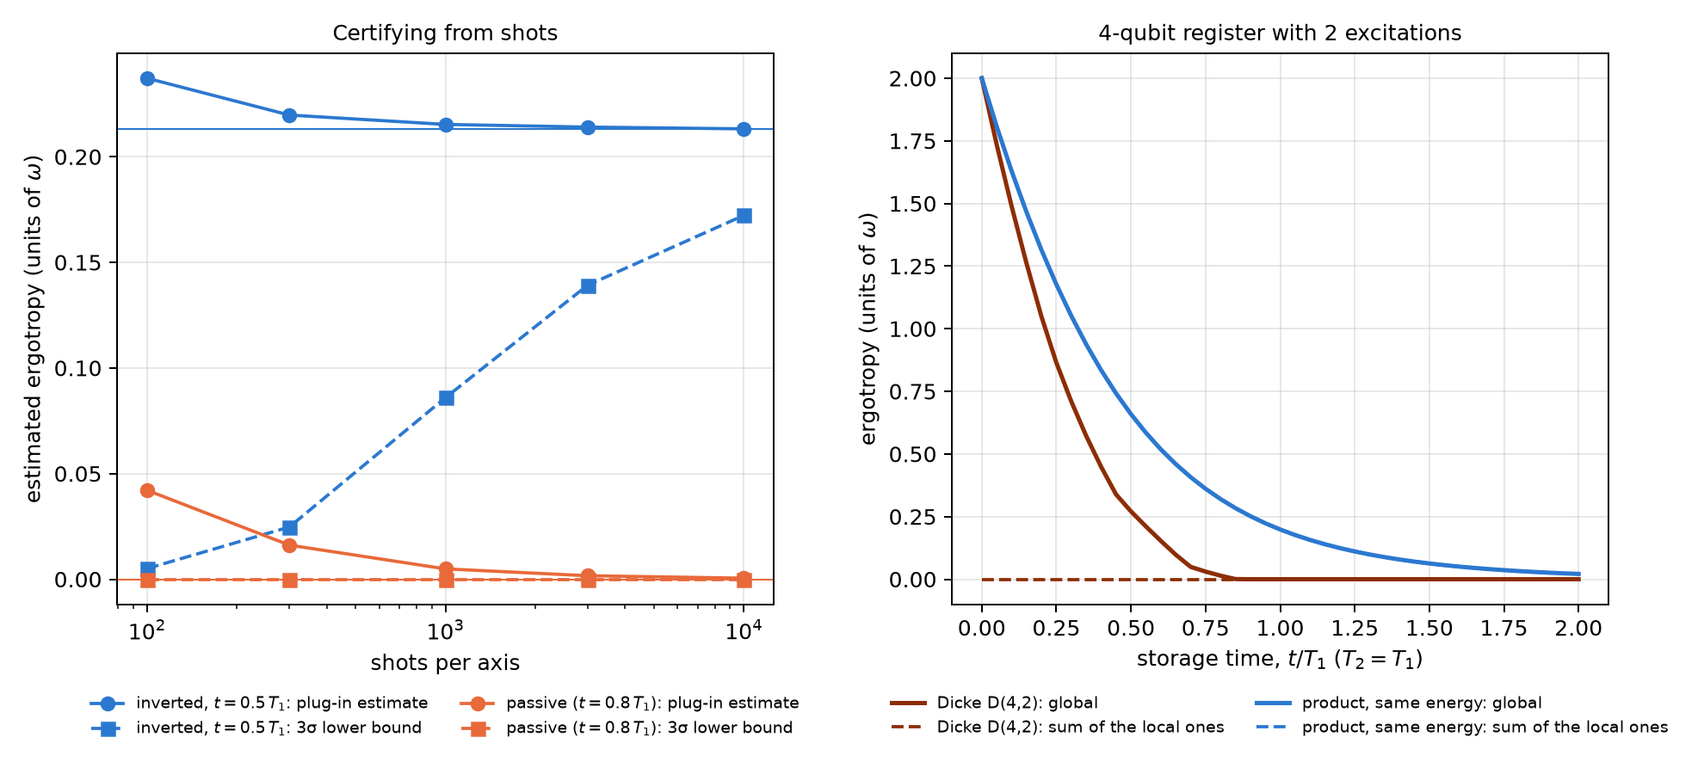
Figure 19.2: Left: plug-in estimate and 3σ lower bound of the ergotropy against shots per axis, for an inverted battery at $t=0.5 T_{1}$ and a passive one at $t=0.8 T_{1}$; the thin lines are the truth. Right: global ergotropy and sum of the local ones for the Dicke register and the product with the same energy; for the product the two curves coincide.

19.5 Networks: a Bell pair stored in two memories
A quantum network also stores something in memories with T1 and T2: the Bell pairs it distributes among its nodes. Chapter 12 read a pair in qg (three correlators and two local biases) and used that reading to choose how to distil it. The question of this section is still open, and it is the battery’s question: how long a pair can wait in memory before it is no longer useful. For $|Φ^{+}⟩$ with both halves stored for a time $t$, the readings have closed forms (notes, §57; they match the density matrix to $5⋅{10}^{−16}$):
$$c_{x}=−c_{y}=e^{−2t/T_{2}}, c_{z}=1−2g+2g^{2}, m_{A}=m_{B}=1000 g, g=1−e^{−t/T_{1}}.$$
The local biases $m_{A}$ and $m_{B}$ rise from zero: it is the T1 witness on a shared pair, the same reading that shifted the centre of the image of the sphere in BB84 (Chapter 17). The pair is good for a BBM92 key while $1−h(Q_{X})−h(Q_{Z})>0$, with $Q_{X}=(1−c_{x})/2$ and $Q_{Z}=(1−c_{z})/2$.
Table 19.5: How long a stored Bell pair can wait, for a BBM92 key (positive secret fraction per input pair).
$T_{2}/T_{1}$​ | 2 | 1 | 0.5 | 0.2
cutoff without distillation ($T_{1}$) | 0.184 | 0.129 | 0.088 | 0.051
readings at the cutoff: $1000 c_{x}$ / $1000 c_{z}$ / $m_{A}$ (m-qg) | 832 / 720 / 168 | 773 / 787 / 121 | 702 / 845 / 85 | 598 / 905 / 50
cutoff with one DEJMPS round ($T_{1}$) | 0.395 | 0.232 | 0.144 | 0.076
distilling pays after ($T_{1}$) | 0.085 | 0.083 | 0.056 | 0.032

- A pair lasts much less than a battery. The inverted battery keeps charge up to $0.69 T_{1}$; the pair stops giving key at $0.05$–$0.18 T_{1}$, because the key needs correlators near the Shor–Preskill threshold of Chapter 16: 780 m-qg when the error is equal in both bases, and here shared between them (832 and 720 m-qg at $T_{2}=2T_{1}$). What is stored is a correlation, and the key needs it nearly intact.
- One distillation round almost doubles the useful time when T1 limits it (0.184 → 0.395 at $T_{2}=2T_{1}$). It costs half the pairs, so with fresh pairs it lowers the key per input pair. Distil only after the crossover in the last row, and that crossover is read from the aged correlators.
- Both memories follow the same underlying rule. In the battery, coherence ($T_{2}$) buys time after the inversion crossing. In the pair, distillation buys time after its own crossover. In both cases the crossover comes from the readings.
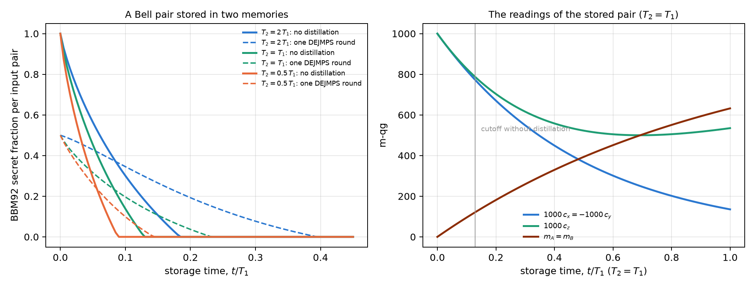
Figure 19.3: Left: BBM92 secret fraction per input pair of a stored Bell pair, without distillation and with one DEJMPS round, for three ratios $T_{2}/T_{1}$. Right: the readings of the stored pair with $T_{2}=T_{1}$; the local biases $m_{A}=m_{B}$ rise from zero (the T1 witness), and the grey line is the cutoff without distillation.

19.6 What remains open
Everything is exact or simulated: there is no hardware run. Missing are a real battery charged at different angles on a device with $T_{2}≈T_{1}$, where the charging rule can be tested, and the preparation of a Dicke $D(4,2)$ with a measurement of its local ergotropy. On the network side, distillation is computed on the twirled (Bell-diagonal) state with perfect local gates, and the cutoff assumes equal memories at the two nodes.

19.7 Without qang and with qang
Table 19.6: The chapter’s actions without the qang scale and with it.
action | without qang | with qang | difference
compute the ergotropy | eigenvalues of $ρ$ and the passive energy | $(m_{r}−m_{Z})/2000$​ | equivalent: it is the standard one-qubit formula written in readings
know how much energy nobody can take out | energy of the passive state | $(1000−m_{r})/2000$, the lost radius | in favour, modest: the split is read at a glance
ergotropy of a pure state | $ω\sin^{2}(θ/2)$​ | the probability equation of Chapter 1, $ω p_{1}$ | equivalent; it shows the Chapter 1 base is the base of the charge
decide how to charge | numerical optimisation of the angle | closed crossover $x^{2T_{1}/T_{2}−1}=2(2x−1)$; inversion dies at the equator crossing | in favour: a closed rule and a picture (the equator); the rule is a contribution of the notes, not of the unit
certify the charge | plug-in estimate | the passive battery sits at the top of its sphere, and the inflated radius makes it “charged” | in favour as a diagnosis; the cure, the 3σ bound, is standard statistics
tell local from locked charge | global and local ergotropy by tomography | local radius of each qubit; the mean reading is useless | equivalent in the computation, in favour in the reading: it is the same local radius zero of Chapters 12 and 16
decide how long to store a Bell pair | fidelity and key rate of the aged state | closed-form correlators and biases; cutoff and distillation crossover read from them | equivalent in the computation; cutoffs are known, the closed form and the crossover are contributions of the notes

Balance. The formulas are the standard ones for the ergotropy of a qubit, and batteries with coherence-assisted storage or locked charge are already in the literature. What the Chapter 1 base adds is the reading: the energy splits between how far the state sits below the top of its sphere and how much radius it lost. With that reading one sees why the inverted battery dies at the equator, why the plug-in estimate sees charge where there is none, and why a Dicke register looks discharged qubit by qubit. The charging rule with its closed crossover is a contribution of the notes.

19.8 In code
import math
import sys
sys.path.insert(0, "examples")
import battery_ergotropy_qg as BT
m_x, m_y, m_z = 500.0, 0.0, 0.0 # mixed, on the equator (m-qg)
m_r = math.sqrt(m_x**2 + m_y**2 + m_z**2)
(1000 - m_z) / 2000, (m_r - m_z) / 2000, (1000 - m_r) / 2000 # energy 0.5, extractable 0.25, locked 0.25
BT.ergotropy(0.5, 0.0, 0.0) # 0.25, the same computation
BT.crossover_time_analytic(1.0), math.log(1.5) # 0.405 and 0.405: the crossover with T2 = T1

19.9 Summary
- The energy of a qubit splits between the extractable part, $(m_{r}−m_{Z})/2000$, and the part locked by mixing, $(1000−m_{r})/2000$; for a pure state the ergotropy is the probability equation of Chapter 1, $ω p_{1}$.
- An inverted battery dies when its Z reading crosses the equator, at $t=T_{1}ln2$. A tilted battery keeps charge after that if $T_{2}$ is comparable to $T_{1}$, and the charging rule has a closed crossover: $ln(4/3)$ for $T_{2}=2T_{1}$, $ln(3/2)$ for $T_{2}=T_{1}$.
- The plug-in estimate of the ergotropy overestimates, and reports charge in a passive battery in almost every run; the 3σ bound is safe but expensive.
- In a Dicke register all the charge is in the correlations: each qubit reads the centre of the sphere, the sum of the local ergotropies is zero, and the mean reading does not tell it apart from a product with the same energy.
- A stored Bell pair gives key only up to $0.05$–$0.18 T_{1}$, much less than a battery; one distillation round almost doubles that time, and pays only after a crossover read from the correlators.

20. Weight-conserving quantum neural networks (WeightQNN)
Part VII is about quantum machine learning, and it starts with the network that fits the base of Chapter 1 best. A quantum neural network (QNN) that conserves the Hamming weight (the number of ones in the register) lives in a fixed sector, and that has two consequences. The first is good: the qg filter, which discards the shots that left the sector, makes the readout exact under T1 relaxation. The second is honest: such a network can be simulated on an ordinary computer, and cannot give a quantum advantage. This chapter reads the network in m-qg, checks its structural properties with code, and summarises the classification experiments of the notes (§75–§114), all with predictions committed before running, with and without qang.

20.1 From the base: a sector and its readings
The RBS gate (reconfigurable beam splitter) rotates the pair $|01⟩,|10⟩$ by an angle $θ$ and leaves $|00⟩$ and $|11⟩$ alone: it is a Givens rotation, and it does not change the number of ones. In the weight-1 sector of $n$ qubits the state is a unit vector $u∈R^{n}$, a layer of RBS gates is an orthogonal matrix, and each qubit has the reading of Chapter 1:
$$m_{Z}(q)=1000 (1−2u_{q}^{2}),$$
because $u_{q}^{2}$ is the probability that the excitation is on qubit $q$. The notes’ network E (§76) loads the data as amplitudes, $v=(x_{1},…,x_{4},1)/|(x,1)|$ on 5 qubits (the constant keeps the norm of $x$), applies 3 layers of RBS gates (9 sublayers, 15 parameters) and reads z=q​cq qgZ(q)+b. Network W does the same in the weight-2 sector.
The filter under T1. T1 relaxation takes a weight-$k$ state to weight $k−1$ and, if every qubit has the same T1, damps all weight-$k$ amplitudes by the same factor. Keeping only the weight-$k$ shots then returns the noiseless distribution, exactly, for any strength (notes, §76 F1 and §78 F4). The price is known before running: the filter keeps a fraction $K=(1−γ)^{k d}$ of the shots, with $d$ the number of sublayers, whatever the data or the parameters (§77).
Table 20.1: The filter under equal T1 ($γ=0.08$ per qubit and per sublayer, 9 sublayers), in m-qg, over 40 random inputs and parameters. The last two columns are the filter’s mean bias with unequal T1 (spread 0.5) and with dephasing 0.01 per sublayer, which the filter does not correct.
model | max $|$filtered − noiseless$|$ | mean $|$raw − noiseless$|$ | simulated $K$ | $(1−γ)^{kd}$​ | bias with unequal T1 | bias with dephasing
E, 5 qubits, weight 1 | $6⋅{10}^{−13}$​ | 211 | 0.4722 | 0.4722 | 33 | 64
W pairs, 5 qubits, weight 2 | $8⋅{10}^{−13}$​ | 426 | 0.2229 | 0.2229 | 45 | 75
W dual with $qg_{ZZ}$, weight 2 | $8⋅{10}^{−13}$​ | 506 | 0.2229 | 0.2229 | 31 | 89
E, 8 qubits, weight 1 | $7⋅{10}^{−13}$​ | 132 | 0.4722 | 0.4722 | 29 | 48
W ring, 8 qubits, weight 2 | $5⋅{10}^{−13}$​ | 264 | 0.2229 | 0.2229 | 38 | 35

On the scale of Chapter 1 one sees what the noise does without the filter. A shot that decayed has one fewer one, and its qubits read $+1000$: raw readings drift towards the north pole. In the example of Figure 20.1 (weight 2, dual encoding), the five noiseless readings lie between 157 and 260 m-qg, the raw ones under T1 between 543 and 664, and the filtered ones return exactly to 157–260. The filter does not correct what does not change the weight: unequal T1 and dephasing leave biases of 30 to 90 m-qg.
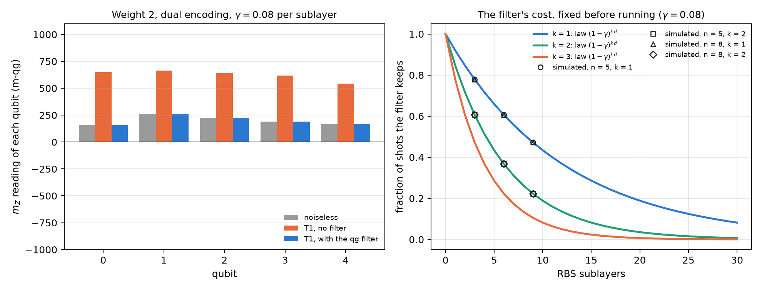
Figure 20.1: Left: $m_{Z}$ reading of each qubit of a weight-2 network (dual encoding), noiseless, under T1 without the filter and under T1 with the filter; the raw readings drift towards the north pole and the filtered ones match the noiseless ones. Right: the fraction of shots the filter keeps against the number of sublayers; the lines are the law $(1−γ)^{kd}$ and the points, simulations on 5 and 8 qubits.

20.2 Architectures and encodings
The notes compare, on four real datasets with 4 features (iris, breast cancer, wine and digits 3 against 8), a standard QNN (A: angle encoding, Ry/Rz layers with a CZ ring) with the weight-conserving networks. The first weight-1 network (D, §75) dropped the norm of $x$ and was the weakest (0.765). Network E, which keeps it, closes the gap (§76):
Table 20.2: Mean test accuracy (5 splits, notes §76).
dataset | RBF-SVM | MLP | quadratic twin | A | D | E
iris | 0.913 | 0.920 | 0.900 | 0.907 | 0.647 | 0.913
cancer | 0.967 | 0.973 | 0.957 | 0.980 | 0.910 | 0.983
wine | 0.979 | 0.990 | 0.969 | 0.964 | 0.795 | 0.985
digits | 0.967 | 0.960 | 0.943 | 0.957 | 0.813 | 0.960
mean | 0.957 | 0.961 | 0.942 | 0.952 | 0.791 | 0.960

With 60 runs per model (5 seeds × 3 splits × 4 datasets, §80), the central result is this:
Table 20.3: Mean accuracy over 60 runs (notes §80).
reading | E with qang | E without qang | W with qang | W without qang
noiseless | 0.952 |  | 0.922
T1, trained noiseless | 0.952 | 0.928 | 0.922 | 0.757
T1, trained under the noise | 0.952 | 0.951 | 0.922 | 0.924
dephasing, trained noiseless | 0.918 | 0.792 | 0.882 | 0.656

- Trained on a simulator and run under T1, qang decides: +2.5 points at weight 1 [0.8, 4.1] and +16.5 at weight 2 [11.8, 21.2] (95% CI across seeds). Without the filter, W falls to 0.76 because 78% of its shots decayed.
- Trained under the calibrated noise, qang adds nothing measurable (+0.1 and −0.1 points). The network without the filter learns the decay.
- Dephasing requires training under the noise (+3.2 and +4.5 points), although the filter still removes its T1 part (+12.6 and +22.6 points when trained noiseless).
- Weight 2 cost 3 points, and the cause turned out to be the encoding, not the circuit (§87). The pair product distorts the data: its information ceiling, measured with a regression on all products of amplitudes, is 2.4 points lower. With the dual encoding, which puts $v$ on the ring of pairs and $u=(x^{2},1)/|(x^{2},1)|$ on the chords and covers all 10 weight-2 states, and with the $qg_{ZZ}$ readout, weight 2 reaches weight 1: 0.947 = 0.947 (§90). Its gain with qang under T1 is 14 to 20 points, against 3 at weight 1.

20.3 Readouts: $qg_{Z}$, $qg_{ZZ}$ and two channels
The readout is a linear function of the sector distribution, and its rank says how much of that distribution it sees:
Table 20.4: Rank of the readout on the sector distribution (with the constant term).
sector | states | rank of the $qg_{Z}$ readout | rank of $qg_{Z}$ plus $qg_{ZZ}$
weight 1, 5 qubits | 5 | 5 | 5
weight 2, 5 qubits | 10 | 5 | 10

At weight 1 the five $m_{Z}$ readings already determine the whole distribution, and the correlations add nothing. At weight 2 the five readings see only 5 of the 10 directions, and the correlations $qg_{ZZ}=⟨Z_{i}Z_{j}⟩$ are needed. But rank was not the cause of the gap: with the pair encoding, adding $qg_{ZZ}$ changed nothing (§81). Both things were needed together, an encoding that does not distort and a full-rank readout (§90).
The shots that decayed. In §81 there was one case against qang: with the pair encoding, the $qg_{ZZ}$ readout and training under T1, the network without the filter scored 1.2 points more [0.4, 2.0], because the decayed shots still say where the excitations were. The two-channel readout (§95), which gives the classifier the filtered and the raw readings together, recovered nothing, and with 60 new runs the effect dropped to +0.5 [−0.7, 1.6] (§101). No readout trained under T1 beat the filter significantly, and with the simple readout the filter was better by 0.6 points [0.1, 1.0].

20.4 Classical simulability: no quantum advantage
In the weight-1 sector the whole network is an $n×n$ orthogonal matrix $O$. With $u=Ov$,
z=q​cq (1−2uq2)+b,
a quadratic classifier in $v$ that is computed in $O(n^{2})$ (§76 F2). The chapter’s script checks it: the network’s output and the quadratic twin’s agree to $9⋅{10}^{−16}$. At weight $k$ the sector has dimension $\left({n \atop k}\right)$, and the network stays simulable as long as that number is manageable. That is why the notes say it plainly: on real data, the best classical model ties or beats the best QNN (§75: RBF-SVM 0.963 against 0.933 on digits), and a well-regularised quadratic twin sits within 0.3–1.6 points of E (§76). What these networks offer is robustness on noisy hardware, not quantum advantage.

20.5 Scaling and multiclass
With 5, 6 and 8 qubits and a fixed depth of 9 sublayers (§111), the filter keeps every network at its noiseless accuracy. Without it, the weight-1 loss stays at 3.1–3.4 points, but the weight-2 loss grows from 8.7 to 26.0 points: an 8-qubit weight-2 network falls from 0.965 to 0.705 (Figure 20.2, left). Training under the noise still catches up with the filter (within 0.9 points in every cell).
In the multiclass version each qubit is a class (qang.qml.MultiClassQNN, §110 and §114). With 8 qubits and 3, 5 and 8 classes of digits, the filter keeps every model exactly at its noiseless accuracy; without it, the linear-head readout loses 0.7, 15.9 and 11.1 points. Unlike at 5 qubits, training under the noise no longer fully catches up: it stays 2–3 points behind with 5 and 8 classes.
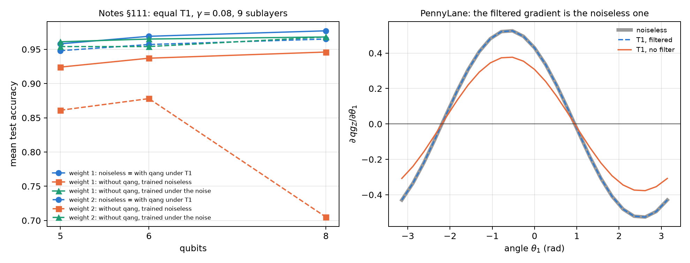
Figure 20.2: Left: mean test accuracy against the number of qubits (table of the notes, §111), with the filter under T1 (equal to the noiseless accuracy), without qang trained noiseless, and without qang trained under the noise, for weight 1 and weight 2. Right: gradient of one qubit’s $qg_{Z}$ with respect to the first angle in a three-qubit PennyLane circuit with Givens gates and amplitude damping ($γ=0.08$); the filtered gradient matches the noiseless one, and the raw one is the noiseless one times the kept fraction.

20.6 Training under noise or with the filter
If the filtered readout under T1 is the noiseless one for every parameter, so are the loss and every gradient. That is why training under T1 with the filter gives exactly the parameters of noiseless training (§77 F3: to $5⋅{10}^{−9}$ after 120 Adam steps). The script checks it in PennyLane, with Givens gates (SingleExcitation) and amplitude damping on default.mixed: the gradient of the filtered readout matches that of the noiseless circuit to ${10}^{−16}$, and the gradient of the raw readout is the noiseless one multiplied by $K=0.716393=(1−γ)^{4}$, component by component (Figure 20.2, right). At weight 1 the raw gradient is $K$ times smaller; with many qubits the sector itself flattens the gradient (§112), with or without the filter.

20.7 The ecosystem: Qiskit, qiskit-machine-learning and PennyLane
The network does not live in NumPy only. The notes take it to three environments:
- Qiskit. qang.interop reads the qg readings from a SamplerV2, and writes the filtered readout as a ratio of two diagonal observables, $⟨P_{w}Z_{i}⟩/⟨P_{w}⟩$, for an EstimatorV2 (§131). qang.ibm.qnn_template writes the weight-1 network as one parameterised circuit of native XX+YY gates and sends a whole test set in one job (§139).
- qiskit-machine-learning. qang.qiskit_ml.qang_sampler_qnn turns the network into a SamplerQNN (§140). The notes found that qiskit-machine-learning 0.9.1 reads the measured bits at the physical positions of the layout, so a circuit measured before transpilation reads every shot as 0; qang transpiles by itself and drops the layout.
- PennyLane. qang.pennylane_gate.filtered_qg_z acts on qml.probs() with qml.math, so the filtered readout is differentiable and can be the loss of a training loop (§131). Checking it for this chapter turned up a problem in PennyLane 0.45.1: on default.mixed, the backprop mode returns NaN for the jacobian of qml.probs through SingleExcitation (with RY it works, and on default.qubit too). The parameter-shift rule gives the right value.
qml.math also covers PennyLane’s JAX interface, but JAX is not installed in the book’s environment, and the filtered readout was not tested with it. Those two library problems and the path to JAX are proposed at the end of the book, together with the new version of qang.

20.8 The qg encoding and quantum signal processing
Encoding a feature $x∈[−1,1]$ with $θ=arccosx$ is the encoding of Chapter 1: the state has $m_{Z}=1000 x$, and the encoding angle is its qang angle (§16). Loaded $L$ times, the model is a Chebyshev polynomial of degree $L$ ($cosLθ=T_{L}(x)$, checked to $7⋅{10}^{−16}$), so $L$ layers fit any bounded polynomial of degree $L$ to machine precision and $L−1$ layers do not. It is a polynomial inductive bias, not an advantage: with periodic targets angle encoding wins by 1.5 to 4.5 orders of magnitude.
The same rotation is the signal rotation of quantum signal processing (QSP), and qang.qsp builds it in qg terms (§134). As activations of a one-layer Kolmogorov–Arnold network, weighted QSP gets 179 of 189 inputs right, 182 with odd and even activations, against 185 for qang’s network E (§135–§136): the limit is the parity of the activations, not the number of phases.

20.9 What remains open
The accuracies in this chapter are those of the notes, with predictions committed before running; they were not rerun here, because the book’s environment has no scikit-learn. What was checked with code is structural: the filter’s exactness, the law of the kept fraction, the readout ranks, the quadratic twin and the gradient in PennyLane. A run of a filtered network on real hardware is missing (Chapter 21 develops the filter and Chapter 32 the execution on devices), and so is a test of the filtered readout with JAX.

20.10 Without qang and with qang
Table 20.5: The chapter’s actions without the qang scale and with it.
action | without qang | with qang | difference
read the network under T1 | every reading; they drift towards the north pole (132–506 m-qg mean error) | the sector only: exact readout (${10}^{−12}$ m-qg) | in favour: exactness by construction, with equal T1
know how many shots it costs | estimate the loss of each run | $K=(1−γ)^{kd}$, before running | in favour: the cost depends only on depth and the calibrated T1
train on a simulator and run under T1 | loses 2.5 (weight 1) and 16.5 points (weight 2) | the noiseless accuracy | in favour, decisive at weight 2 and with more qubits (26 points at 8 qubits)
train under the calibrated noise | catches up with the filter | the same | none measurable (±1 point); the filter saves the noise model and the noisy runs
unequal T1 and dephasing | — | biases of 30–90 m-qg | against if ignored: the filter does not correct them; with dephasing, train under the noise
gradient under T1 | $K$ times the noiseless one | the noiseless one, exactly | in favour: the filtered readout is differentiable in PennyLane
quantum advantage | — | — | none: the network is a simulable quadratic classifier; classical models match it

Balance. qang’s contribution in this chapter is not accuracy but robustness: the qg filter makes noiseless training remain valid under T1, exactly, and says in advance how many shots it costs. That gain belongs to the sector filter, and the base of Chapter 1 explains it: the shots that decay drift the readings towards the north pole. The networks are known (Landman et al. 2022), they are simulable, and with calibrated noise a noise-aware training reaches the same place without qang.

20.11 In code
import numpy as np
from qang import qml as QML
m = QML.WeightQNN(n_qubits=5, weight=2, encoding="dual", readout="zz")
rng = np.random.default_rng(0)
psi = m.encode(rng.uniform(-1, 1, size=(3, 4)))
theta = rng.uniform(-np.pi, np.pi, size=m.n_theta)
clean = m.qg_z(m.probs(theta, psi), qang=False)
noisy = m.probs(theta, psi, gamma=0.08)
np.abs(m.qg_z(noisy, qang=True) - clean).max() # ~1e-15: the filter is exact under equal T1
QML.kept_fraction(0.08, m.weight, m.depth) # 0.2229 = 0.92**18: the cost, before running

20.12 Summary
- In the weight-1 sector the network is an orthogonal matrix and each qubit reads $m_{Z}=1000(1−2u_{q}^{2})$. Under equal T1 the qg filter returns the noiseless readout exactly, at a cost $K=(1−γ)^{kd}$ known before running; without it, the readings drift towards the north pole.
- Trained on a simulator, the network gains 2.5 points with qang at weight 1 and 16.5 at weight 2; trained under the calibrated noise, it gains nothing measurable. The filter does not correct unequal T1 or dephasing.
- Weight 2 reaches weight 1 with an encoding that does not distort and a full-rank readout ($qg_{ZZ}$).
- The network is a simulable quadratic classifier: robustness on noisy hardware, not quantum advantage.
- In PennyLane the filtered gradient under T1 is the noiseless one; the check turned up two library problems (PennyLane and qiskit-machine-learning) and a path to JAX, which are proposed at the end of the book.

21. The qg symmetry filter and exactness under T1 relaxation
Chapter 20 used the qg filter as a tool: discarding the shots that left the Hamming-weight sector returns the noiseless readout under T1. This chapter treats it as an object. First the theorem and why it holds, on the scale of Chapter 1. Then what it costs, with a closed rule that predicts before running when it pays, and what it does not correct: unequal T1 across qubits, dephasing, and gate and readout errors. For each limit there is an exact property (F5 and F6 in the notes) that says how to go on. The structural facts are checked with code on random states; the classification results are those of the notes, with predictions committed before running.

21.1 From the base: decay pushes the readings to the north pole
Amplitude damping of one qubit has two Kraus operators:
$$K_{0}=\left(\begin{matrix}1 & 0 \\ 0 & \sqrt{1−γ}\end{matrix}\right), K_{1}=\sqrt{γ} |0⟩⟨1|.$$
$K_{1}$ is the jump: the qubit falls to $|0⟩$, and its reading goes to $+1000$ m-qg, the north pole. $K_{0}$ is the no-jump evolution: it leaves $|0⟩$ alone and multiplies the amplitude of $|1⟩$ by $\sqrt{1−γ}$. In a register, the product of the $K_{0}$ multiplies every basis state with $k$ ones by $(1−γ)^{k/2}$, the same factor for every state of the weight-$k$ sector. And any jump lowers the weight by one.
Hence the theorem (notes, §77 and §78 F4): with the same T1 on every qubit, keeping the weight-$k$ shots returns the noiseless state. The no-jump factor is a scalar on the sector, and it disappears on normalising; everything that jumped is in another sector. It holds between layers of weight-conserving gates, for any strength and any depth. The fraction of shots that survives is $K=(1−γ)^{k d}$, with $d$ the number of damping steps.
Table 21.1: The theorem in every sector of 6 qubits: 20 random states, 2 RBS layers (6 sublayers), $γ=0.08$.
sector (6 qubits) | dimension | max $|$filtered − noiseless$|$ (m-qg)
weight 1 | 6 | $4⋅{10}^{−13}$​
weight 2 | 15 | $7⋅{10}^{−13}$​
weight 3 | 20 | $6⋅{10}^{−13}$​
weight 4 | 15 | $7⋅{10}^{−13}$​
weight 5 | 6 | $9⋅{10}^{−13}$​

For a weight-2 state with three damping steps, the fraction left in the sector is 0.606355, exactly ${0.92}^{6}$. The filter is a postselection, and what it returns is a conditional probability: the equation of Chapter 1 applied inside the sector.

21.2 What it costs: the mean-squared-error rule
The filter removes the bias and pays in shots: of $S$ shots only $KS$ remain. The notes (§94) wrote down before running a closed rule for the mean squared error of the qubits’ readings $m$:
$${\text{MSE}}_{\text{qang}}≈\frac{{1000}^{2}−m^{2}}{KS}, {\text{MSE}}_{\text{raw}}={\text{bias}}^{2}+\frac{{1000}^{2}−m_{\text{raw}}^{2}}{S}.$$
The first is the shot noise of Chapter 1 with $KS$ shots; the second adds the bias towards the north pole, which does not shrink with more shots. The chapter’s script checks it with 10 random circuits of 6 qubits, weight 2, 12 sublayers and $γ=0.02$ ($K=0.616$), 200 repetitions per point:
Table 21.2: The rule of §94 against simulation (Figure 21.1, right).
shots $S$ | 30 | 100 | 300 | 1000 | 3000 | 10,000
MSE with qang, simulated / rule | 1.05 | 1.01 | 1.02 | 1.00 | 1.01 | 1.00
MSE without qang / MSE with qang | 1.3 | 3.0 | 7.9 | 25 | 74 | 249

The raw error stalls at about 31,000 m-qg² (a bias of about 175 m-qg), while the filtered one keeps falling as $1/S$. Setting the two expressions equal gives the break-even number of shots $S^{*}$: above it, the filter wins. For the circuits of this chapter $S^{*}$ runs from 9 to 61 shots (Figure 21.2, left); on the notes’ grid, from 3 to 110 (108 configurations up to 8 qubits, weight 4 and depth 24, with up to 1000 times less error with the filter).
With very few shots kept (§96, 405 configurations with $K$ down to $2.6⋅{10}^{−7}$) the generalised rule, which includes the bias left in the filtered readout, picks the winner in 342 of 342 cases with $KS≥5$, also with unequal T1 and dephasing. When less than one shot survives, the filter returns 0 for lack of data, and even so it beats the raw readout in 51 of 57 cases, because the raw one collapsed towards $|0…0⟩$, the north pole, which is a worse guess than the equator. No regime was found where the shot cost decides against the filter.
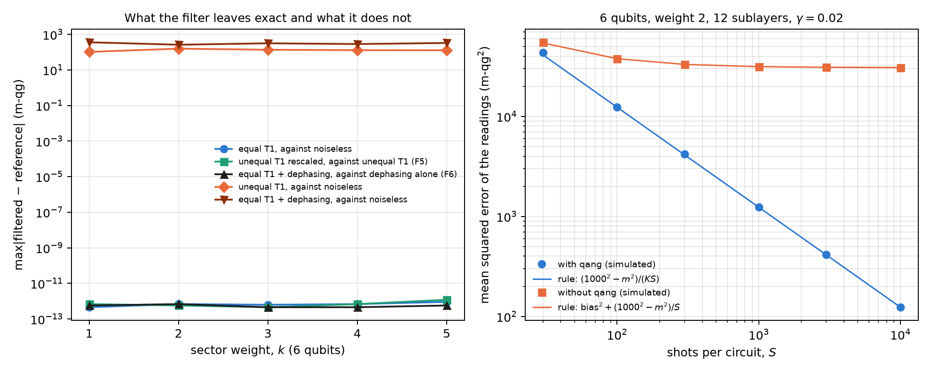
Figure 21.1: Left: maximum deviation of the filtered readout from its reference, by sector weight (6 qubits), on a log scale. With equal T1, with rescaled unequal T1 (F5) and with T1 plus dephasing against dephasing alone (F6) the deviation is rounding; with unequal T1 or with dephasing, against the noiseless readout, a bias of 100 to 360 m-qg remains. Right: mean squared error of the readings with and without the filter against shots, simulated (points) and from the rule of §94 (lines).

21.3 Training through the filter
Since the filtered readout under equal T1 is the noiseless one for every parameter, so are the loss and its gradients, and training with filtered noise is training without noise (§77; Chapter 20 checked it in PennyLane to ${10}^{−16}$). The notes repeated it training from shots (§109), with 100 or 1000 fresh shots per evaluation and SPSA gradients:
Table 21.3: Network E under equal T1 ($γ=0.08$, $K=0.47$), trained from shots (notes §109).
training | with qang | without qang
exact noiseless probabilities | 0.945 | –
shots, $S=1000$ | 0.939 | 0.929
shots, $S=100$ | 0.930 | 0.915

The prediction was that at 100 shots the filter’s cost would show. It did not: the network trained with qang ended 1.5 points ahead (CI [−1.6, 4.6]). The gradient flattens with the size of the sector, with or without the filter (§112).

21.4 F5: unequal T1 depends only on the ratios
With a different T1 on each qubit, the no-jump factor is no longer a scalar on the sector: it is the product of the $\sqrt{1−γ_{q}}$ of the excited qubits, different for each state. The filter then leaves a bias: 100 to 160 m-qg with a ±50% spread of the $γ_{q}$ (Figure 21.1). But the notes found an exact property (§117 F5): a common factor in all the $(1−γ_{q})$ cancels on normalising, so the filtered readout depends only on the ratios $(1−γ_{q})/(1−γ_{r})$. The script checks it by multiplying all the $(1−γ_{q})$ by 0.85: the filtered readout moves by no more than ${10}^{−12}$ m-qg in any sector, and the raw one moves by 640 to 850 m-qg.
The practical consequence is a recipe. Training with the filter under the calibrated rates needs only the relative T1s, tolerates calibration errors and survives a common drift of all the T1s:
Table 21.4: Unequal T1, spread 1 ($γ_{q}$ from 0 to 0.16), notes §117. A: trained noiseless, with the filter; B: trained noiseless, raw; C: trained with the filter under the calibrated rates (10% error); C*: under the exact rates; D: trained raw under the calibrated rates. Drift: all T1s 1.5 times shorter.
weight | noiseless | A | B | C | C* | D | drift: A / B / C / D
1 | 0.950 | 0.931 | 0.873 | 0.951 | 0.945 | 0.952 | 0.913 / 0.770 / 0.942 / 0.950
2 | 0.945 | 0.918 | 0.797 | 0.940 | 0.941 | 0.941 | 0.903 / 0.663 / 0.932 / 0.841

With recipe C the network lands within 0.5 points of its noiseless accuracy. Under drift, at weight 2 the raw network trained under noise loses 10.0 points and the filtered one 0.7: the raw one learned the absolute rates, the filtered one only their ratios. If one does not want to train under noise, the rule of §82 says how much is tolerated: with the filter alone the loss stays below one point as long as the qubits’ $1/T_{1}$ differ by up to ±80% from their mean.

21.5 F6: dephasing, with the filter and extrapolation
Dephasing does not change the weight, so the filter does not see it. But the notes proved another exact property (§118 F6): with equal T1 and dephasing, the filtered readout is the readout with dephasing alone. The no-jump factor is a scalar on the sector and commutes with the dephasing channel, which is diagonal. The script checks it in every sector of 6 qubits, to $7⋅{10}^{−13}$ m-qg (Figure 21.1). The filter turns two noises into one, and that one can be extrapolated to zero (ZNE):
Table 21.5: ZNE of the filtered readings over 40 random states, exact probabilities (Figure 21.2, right).
readout (5 qubits, weight 2, T1 0.08 + dephasing 0.03) | mean error (m-qg)
raw | 442
filtered | 152
filtered, linear extrapolation (scales 1 and 2) | 69 (45%)
filtered, Richardson (scales 1, 2 and 3) | 31 (20%)

In the notes’ classifiers (§118, §122, at 5 and 8 qubits) linear extrapolation leaves 50–58% of the error of the filtered readings and Richardson 26–35%; without the filter, ZNE must extrapolate T1 and dephasing together and ends 3 to 10 points behind. With 1000 shots per scale, at weight 2, ZNE loses to the filter alone, because its shot cost eats the gain. What corrects dephasing best in a classifier is something else: training with the filter under the calibrated noise, which recovers the noiseless accuracy (0.951–0.963).
One subtlety (§132–§133): dephasing between RBS gates commutes with the weight and the filter does not see it, but dephasing inside the decomposition of an RBS into native gates turns a phase error into a change of weight. To predict the kept fraction on a device, the simulator has to place that error inside each RBS.
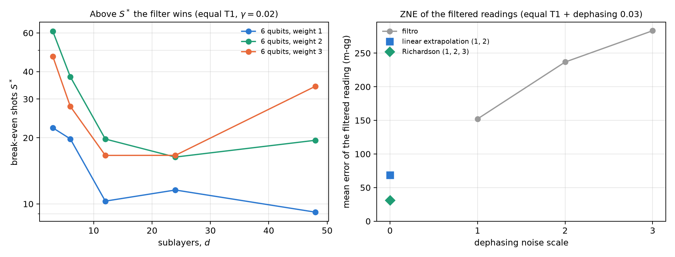
Figure 21.2: Left: break-even shots $S^{*}$ from the rule of §94 against depth, for weights 1, 2 and 3 on 6 qubits ($γ=0.02$); above $S^{*}$ the filter has less error. Right: mean error of the filtered readout with equal T1 and dephasing 0.03 at dephasing scales 1, 2 and 3, and its linear and Richardson extrapolation to zero.

21.6 Gate and readout errors
In IBM device noise models gate errors dominate, and they are not T1. The notes added them to qang’s simulator (§124: a two-qubit depolarising channel after each RBS, with the published error of the native gate) and then each qubit’s asymmetric readout error (§129). Their interest here is one: predicting the kept fraction before running.
Table 21.6: Kept fraction of a weight-1 network on three IBM noise models (notes §124, §129).
simulated device | device $K$ | predicted with T1, T2 and gates | + readout error
fake brisbane | 0.671 | 0.703 | 0.665
fake sherbrooke | 0.697 | 0.774 | 0.694
fake torino | 0.724 | 0.845 | 0.783

With readout error, the prediction comes within 0.006 of the device on the two devices with ECR gates. On torino (CZ gates) a gap of 0.059 remains, which §132–§133 attribute to dephasing inside the gates. In accuracy, the simplest recipe was the best on those models: train noiseless and run with the filter (182–185 of 189 correct, against 185 noiseless); training with the gate errors helped the raw readout (+1.2 points) but not the filtered one.

21.7 What remains open
The filter’s properties (the theorem, the law of $K$, F5, F6 and the error rule) are checked with code; the classification accuracies are those of the notes. A run on real hardware is missing, where unequal T1, dephasing inside the gates and readout error act together. And a tool is missing from the libraries: weight postselection with its cost rule is proposed at the end of the book, together with the new version of qang.

21.8 Without qang and with qang
Table 21.7: The chapter’s actions without the qang scale and with it.
action | without qang | with qang | difference
read under equal T1 | bias towards the north pole, which does not shrink with shots | exact readout ($≤{10}^{−12}$ m-qg) in every sector | in favour: exactness by a theorem
decide whether filtering pays | try both readouts | closed rule; the winner is predicted in 99–100% of cases | in favour: the decision is taken before running
shot cost | — | exact $K=(1−γ)^{kd}$; break-even at 3–110 shots | in favour: the cost never decided against it on the notes’ grids
unequal T1 | the raw network learns the absolute rates; under drift it loses 10 points (weight 2) | depends only on the ratios (F5); training with the filter lands within 0.5 points; drift: 0.7 | in favour with the recipe; against if the filter is used alone with a large spread (up to 2 points)
dephasing | ZNE of T1 and dephasing together | the filter leaves dephasing only (F6); ZNE takes it to 20–58% | in favour in readout error; with few shots ZNE does not pay
gate and readout errors | — | the simulator predicts $K$ within 0.006 (ECR) | in favour as a prediction; the filter does not correct them

Balance. The filter is symmetry postselection, a known mitigation technique. What the notes add are the exact properties (the theorem in every sector, F5 and F6), the closed cost rule, and the recipe for each noise the filter does not correct. The base of Chapter 1 gives the picture: the jump takes the readings to the north pole, and the filter returns the conditional probability on the sector. When the noise is not equal T1, the filter alone is no longer enough, and the answer is to train with it under the calibrated noise.

21.9 In code
import numpy as np
from qang import qml as QML
m = QML.WeightQNN(n_qubits=6, weight=3, layers=2)
rng = np.random.default_rng(0)
psi = np.zeros((1, m.dim))
psi[0, m.idx[3]] = rng.normal(size=20)
psi /= np.linalg.norm(psi)
theta = rng.uniform(-np.pi, np.pi, size=m.n_theta)
g = 0.08 * (1 + 0.5 * np.linspace(-1, 1, 6)) # unequal T1
f = lambda gam: m.qg_z(m.probs(theta, psi, gamma=gam), qang=True)
np.abs(f(1 - 0.85 * (1 - g)) - f(g)).max() # ~1e-15: F5, only the ratios count

21.10 Summary
- The jump takes the readings to the north pole and lowers the weight; the no-jump evolution multiplies every weight-$k$ state by $(1−γ)^{k/2}$. With equal T1, the filter returns the noiseless state in every sector, with $K=(1−γ)^{kd}$.
- The rule $\text{MSE}≈({1000}^{2}−m^{2})/(KS)$ against bias$​^{2}+({1000}^{2}−m^{2})/S$ predicts before running when filtering pays; the break-even is at a few tens of shots, and the cost never decided against it.
- With unequal T1 the filtered readout depends only on the ratios of the rates (F5): training with the filter under the calibrated rates recovers the accuracy and withstands a common drift.
- With T1 plus dephasing the filter leaves dephasing only (F6), which is extrapolated to zero or, in a classifier, corrected by training with the filter under the noise.
- With gate and readout errors, qang’s simulator predicts a device’s kept fraction; the filter does not correct them.

22. Echo calibration and the noise bias (pull effect)
The qg filter of Chapter 21 makes the readout exact under equal T1, but it does not correct everything. Two things remain, and this chapter deals with them. The first are errors that conserve the weight and move the excitation from one qubit to another: they pass the filter, and must be measured separately, with echo circuits. The second is what decayed shots do to a classifier without the filter: they do not add random noise, they pull every decision towards the same class. Both are read on the scale of Chapter 1, and for both the chapter checks the mechanism with code and quotes the notes’ results on device noise models, with predictions committed before running.

22.1 From the base: two errors the filter treats differently
In the weight-1 sector, each qubit reads $m_{Z}(q)=1000(1−2p_{q})$, with $p_{q}$ the probability that the excitation is on it. There are two ways to go wrong:
- A T1 jump takes the shot out of the sector: the excitation disappears and every qubit reads $+1000$, the north pole. The filter discards those shots. Without the filter, the raw readout is a mixture: with probability $K$ the noiseless readout, and with probability $1−K$ the north pole on every qubit.
- An in-sector error moves the excitation from one qubit to another: the shot still has weight 1, passes the filter and changes the readings of two qubits at once. On the probabilities $p_{q}$ it acts as a stochastic matrix $M$.
The first is corrected by discarding; the second, by inverting $M$, as a readout confusion matrix is inverted.

22.2 In-sector errors and the echo
An echo circuit prepares a basis state of the sector, $|e_{j}⟩$, applies the network’s gates and then their inverses. Without errors it returns to $|e_{j}⟩$; with errors, its filtered distribution over the sector states is column $j$ of a transfer matrix $M$ (notes, §105). Since the real circuit has half the echo’s gates, the correction uses $M^{1/2}$: the filtered distribution $f$ is unmixed by solving $M^{1/2}x=f$ with $x≥0$ (qang.sectors.unmix_sector).
The chapter’s script tests it with a controlled in-sector error: after every sublayer, each pair of qubits of an RBS is swapped with probability $p$ (it keeps the weight and moves the excitation). Five qubits, weight 1, 9 sublayers, 60 random inputs:
Table 22.1: Mean error of the $m_{Z}$ readings (m-qg) with exact probabilities.
$p$​ | echo diagonal | error with the filter | + echo with $M^{1/2}$ | + echo with $M$
0.005 | 0.93–0.94 | 15.0 | 5.7 (−62%) | 13.4 (−11%)
0.01 | 0.87–0.89 | 29.4 | 11.3 (−61%) | 25.5 (−13%)
0.02 | 0.76–0.80 | 56.4 | 22.4 (−60%) | 47.4 (−16%)
0.04 | 0.58–0.65 | 104.2 | 43.7 (−58%) | 87.4 (−16%)
0.08 | 0.38–0.45 | 178.8 | 84.5 (−53%) | 164.3 (−8%)

$M^{1/2}$ removes a bit more than half of the error the filter leaves; the full $M$ over-corrects and removes little. On the notes’ device noise models, the echo removes 38–47% of the filtered error at weight 1 with 5 qubits (§105, five simulated devices), 37–43% at weight 2 with a 10×10 matrix (§107) and 27–38% at weight 2 with 8 qubits, a 28×28 matrix (§115). The larger the sector, the dirtier and harder to recover: the echo diagonal drops from 0.77–0.92 to 0.50–0.80. Filter plus echo ends 3.4 to 7 times below the raw readout.

22.3 Does it reach the classifier?
With the weight-1 network on 189 test inputs and 1000 shots (§106), on three simulated IBM devices and the IonQ simulator:
Table 22.2: Echo calibration in the classifier (notes §106; noiseless accuracy 0.979).
device | accuracy (raw / qang / qang + echo) | decisions differing from noiseless | decision-value error
fake brisbane | 0.968 / 0.974 / 0.979 | 2 / 1 / 0 | 1.53 / 0.76 / 0.33
fake sherbrooke | 0.963 / 0.974 / 0.979 | 3 / 1 / 0 | 1.26 / 0.61 / 0.29
fake torino | 0.963 / 0.979 / 0.979 | 3 / 0 / 0 | 1.08 / 0.47 / 0.27
IonQ aria-1 | 0.958 / 0.963 / 0.968 | 4 / 3 / 2 | 1.67 / 0.87 / 0.44
IonQ forte-1 | 0.963 / 0.968 / 0.974 | 3 / 2 / 1 | 1.60 / 0.80 / 0.43

The echo cuts the decision-value error left by the filter by 43 to 56%, and filter plus echo ends 3.7 to 4.6 times below the raw readout. Decisions move only towards the noiseless network: 15 differ without qang, 7 with the filter and 3 with filter plus echo, over 945 readings.
When it does not help (§108). With narrow-margin inputs, the echo added nothing (19 flipped decisions against 17 with the filter alone). The filtered decision-value error was 0.26 to 0.35, barely above its shot noise (0.22): little bias was left, and inverting the matrix adds variance. The notes’ rule is to use the echo when the filtered error is well above its shot-noise level. In this chapter’s model, with 1000 shots and 4000 per echo, the echo kept helping even at $p=0.005$ (22 → 17 m-qg); at $p=0$ it changes nothing (15 m-qg, pure shot noise).
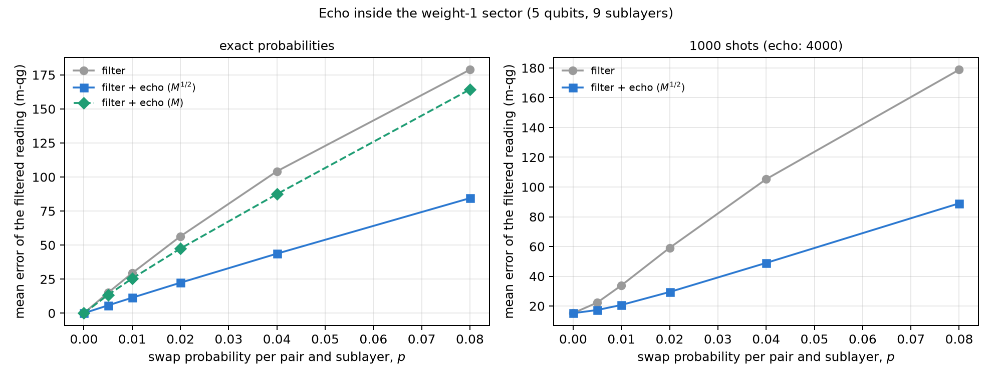
Figure 22.1: Mean error of the filtered readings in a weight-1 sector with in-sector swaps, against the swap probability. Left: exact probabilities; the echo with $M^{1/2}$ removes more than half of the error and the full $M$ over-corrects. Right: with 1000 shots per circuit and 4000 per echo; at $p=0$ shot noise remains.

22.4 The pull: why the loss without qang varies between seeds
In the multiclass network of Chapter 20, the loss without the filter varied a lot from one seed to another (from −0.7 to 41.7 points). The notes explained it with an exact property (§121 F7). At weight 1 under equal T1, every decayed shot lands in $|0…0⟩$, where each qubit reads $+1000$. Since the logits are linear in the readings, the raw logits are
$${\text{logits}}_{\text{raw}}=K L+(1−K) v,$$
with $L$ the noiseless logits and $v$ the logits of the north pole, a constant vector fixed by training (for the linear head, $v=W^{⊤}1+b$). Without the filter, every input is pulled towards the class with the largest $v_{c}$, and how much that weighs is measured by a pull index: $(1−K)/K$ times the range of $v$, over the median training margin.
The script checks it on 40 five-class models with random parameters ($K=0.472$, 300 inputs each):
- the formula for the raw logits holds to $7⋅{10}^{−15}$;
- without the filter, 0 to 60% of the decisions flip depending on the model, and the flips grow with the pull index (Spearman 0.60; in the notes, 0.65 with the head and 0.98 with the qubit readout);
- with the filter, none flips.
The spread between seeds is not bad luck: it is the $v$ that training left, and it can be read before running anything.
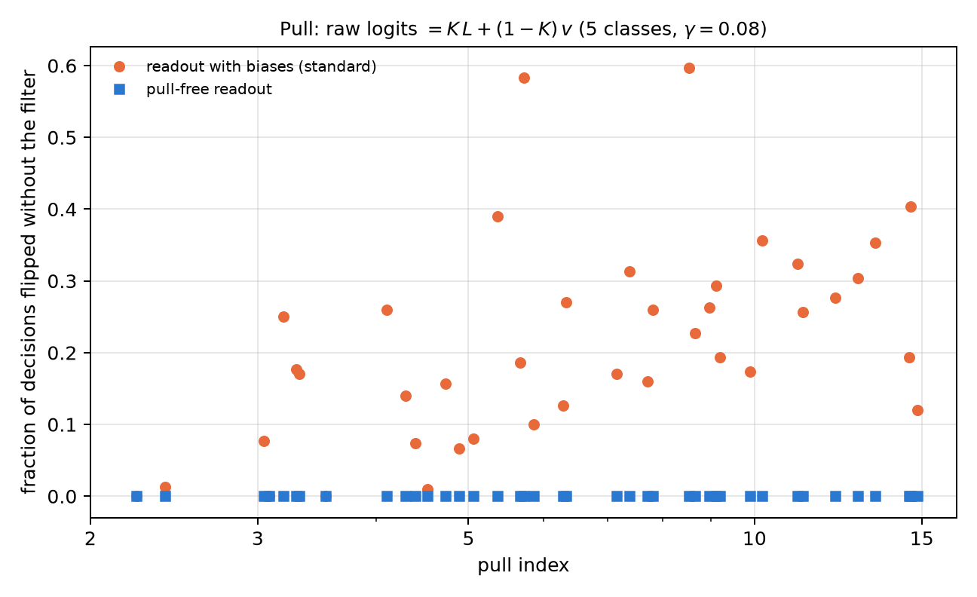
Figure 22.2: Fraction of decisions that flip without the filter against the pull index, for 40 five-class models under equal T1. With biases (standard readout), the flips grow with the pull; the pull-free readout flips none.

22.5 The pull-free readout
If the pull comes from $v$, it can be removed by design: logits linear in the excitation probabilities with no constant term (for the head, $W^{⊤}(qg_{Z}−1)$; for the qubit readout, $a p_{c}$). Then the north pole contributes zero, decayed shots only rescale the logits by $K$, and the raw decision is the noiseless one. The script checks it on the 40 models: no decision flips, and the raw logits are $K$ times the noiseless ones to $6⋅{10}^{−15}$. The notes (§123, 10 seeds, 5-class digits) confirm it in accuracy:
Table 22.3: The pull-free readout (notes §123).
readout | model | noiseless | T1 (qang / raw) | unequal T1 (qang / raw) | 1000 shots (qang / raw)
qubit | standard | 0.860 | 0.860 / 0.725 | 0.849 / 0.688 | 0.861 / 0.724
qubit | pull-free | 0.862 | 0.862 / 0.862 | 0.851 / 0.851 | 0.863 / 0.863
head | standard | 0.932 | 0.932 / 0.653 | 0.932 / 0.624 | 0.927 / 0.651
head | pull-free | 0.938 | 0.938 / 0.938 | 0.928 / 0.928 | 0.932 / 0.932

Dropping the biases costs no accuracy, and the pull-free readout is immune to decay without filtering: it carries the filter inside it. Without the filter, the pull-free head is 28.5 points above the standard one. It is the picture of Chapter 1 carried into design: if the north pole is worth zero, falling into it does not pull.

22.6 Calibrating with the device itself
The notes tried two more ways of using calibration on IBM noise models (§119, §120): training with qang under the published T1 and T2, and measuring the device itself (with the echo matrix inside the model, or refitting the readout on 40 inputs run on the device). None beat the simple recipe: train noiseless and run with the filter (0.972 mean accuracy against 0.979 noiseless), plus the echo for the decision values. The reason is that gate errors dominate on those models, and a T1/T2 calibration does not describe them (the per-sublayer $γ$ are only 0.002–0.017).

22.7 What remains open
The echo mechanism and property F7 are checked with code, and the results on simulated devices are those of the notes. A package is ready to run the multiclass network with the echo on an IonQ QPU (§116: 55 circuits, 60,000 shots, with predictions committed before sending anything); its rehearsal on the simulator gave 4 flipped decisions with the filter and 1 with the echo, against 8 raw. The hardware run is pending credits and an explicit approval of the cost.

22.8 Without qang and with qang
Table 22.4: The chapter’s actions without the qang scale and with it.
action | without qang | with qang | difference
in-sector errors | invisible: they pass any weight filter | echo matrix and unmixing with $M^{1/2}$: −27 to −62% of the filtered error | in favour, at a cost: $\left({n \atop k}\right)$ extra echo circuits
decision-value error | — | −43 to −56% with the echo over the filter (§106) | in favour when the filtered error exceeds its shot noise; none with narrow margins (§108)
understand the spread between seeds | bad luck | raw logits $=KL+(1−K)v$, exact; the pull index predicts it | in favour: the pull is read before running
correct the pull | train under the noise | the filter removes it exactly | in favour
design an immune readout | — | no biases: the north pole is worth zero, identical decisions with or without the filter | in favour, at no accuracy cost
calibrate with the device | train with the calibration | equal to or worse than noiseless training + filter | none on those models: gate errors dominate

Balance. Echo calibration is known mitigation, of the kind that inverts readout confusion matrices, applied inside a sector. What the notes add is its measured reach (how much it removes depending on the sector size) and the rule for when it does not help. The cleanest contribution of the chapter is the pull: an exact property that explains the spread between seeds, and a bias-free readout that avoids it without filtering. Both come from reading decay as Chapter 1 reads it: every qubit at the north pole.

22.9 In code
import numpy as np
from qang import qml as QML
m = QML.MultiClassQNN(n_qubits=5, n_classes=5, readout="head")
rng = np.random.default_rng(0)
psi = m.encode(rng.uniform(-1, 1, size=(4, 4)))
th = rng.uniform(-np.pi, np.pi, size=m.n_theta)
head = rng.normal(size=m.n_head)
K = QML.kept_fraction(0.08, 1, m.depth)
L = m._logits(m.qg_z(m.probs(th, psi), qang=False), head)
raw = m._logits(m.qg_z(m.probs(th, psi, gamma=0.08), qang=False), head)
v = m._logits(np.ones((1, 5)), head) # the north pole: +1000 m-qg on every qubit
np.abs(raw - (K * L + (1 - K) * v)).max() # ~1e-15: F7

22.10 Summary
- A T1 jump takes every qubit to the north pole and the shot out of the sector; an in-sector error moves the excitation and passes the filter. The first is discarded; the second is measured with echoes and inverted.
- The echo with $M^{1/2}$ removes more than half of the filtered error in the chapter’s model and 27–47% on the notes’ simulated devices; the full $M$ over-corrects. It helps when the filtered error exceeds its shot noise.
- Without the filter, the raw logits are exactly $K L+(1−K) v$: decay pulls every decision towards one class, and the pull index predicts how much.
- A bias-free readout makes the north pole worth zero: the raw decisions are the noiseless ones, without filtering and without losing accuracy.
- On IBM noise models, training noiseless and running with the filter (and the echo) was the best recipe; calibrating with the device did not improve it.

23. Information geometry, the natural gradient (QNG) and kernels
Chapters 20 to 22 read in qg what comes out of a circuit. This chapter asks about what goes in: the parameters an optimizer moves. An attractive idea circulates: if qg is the natural readout, writing the circuit in qg coordinates should speed up the gradient and flatten the landscape. The chapter shows with code that it is the other way round, and why. The coordinate to optimize in is the qang angle $θ$, and qg is the coordinate to read out in. Four honest uses of qang follow from that distinction: regularizing the pole singularity, reading the natural-gradient metric from qg correlators, damping the step near the poles, and writing a local cost that flattens more slowly. The structural results are checked with code; the kernel results on device noise models are the notes’, with predictions committed before running.

23.1 From the base: the angle and the readout
In Chapter 1, a qubit prepared with $R_{y}(θ)|0⟩$ reads $m_{Z}=1000cosθ$ m-qg, and $θ$ is the qang angle. Both coordinates describe the same state, but they are not equivalent for optimizing, because the change between them is not linear:
$$\frac{d qg_{Z}}{dθ}=−sinθ, \frac{dE}{d qg_{Z}}=−\frac{1}{sinθ} \frac{dE}{dθ}.$$
At the poles ($m_{Z}=±1000$) the readout barely moves when $θ$ changes, and so the gradient in qg diverges. The whole chapter follows from that line.

23.2 The singularity and its regularizations
The factor $−1/sinθ$ is $−10$ at $θ=0.1$, $−100$ at $0.01$ and $−1000$ at $0.001$. The notes (§1) propose two bounded versions, in qang.gradients:
- clipping: $−1/(sign(sinθ)max(|sinθ|,ε))$, never larger than $1/ε$;
- Tikhonov: $−sinθ/(\sin^{2}θ+ε^{2})$, smooth everywhere and zero at the pole itself.
With $ε=0.05$, at $θ=0.001$ the raw factor is 1000, the clipped one 20 and the Tikhonov one 0.40. The chapter’s script repeats the notes’ experiment: minimize $E=−sinθ$ (minimum at $π/2$, away from the edges) starting at the pole, $θ_{0}=0.01$, for 150 iterations.
Table 23.1: Descent from a pole (notes §1; the script’s figures match the notes’).
space | rate | final $θ$ | final $E$ | largest step | behaviour
in $θ$ | 0.05 | 1.5698 | −1.0000 | 0.05 | converges to $π/2$
in qg, raw | 0.05 | 3.1416 | 0.0000 | 3.14 | jumps from one pole to the other and never stops
in qg, clipped | 0.01 | 1.4184 | −0.9884 | 0.63 | converges, more slowly
in qg, Tikhonov | 0.01 | 1.4043 | −0.9862 | 0.27 | converges, more slowly, smaller steps

With the same rate as in $θ$, raw descent in qg never recovers: each huge step crosses to the opposite pole, where the gradient is huge again. Both regularizations fix it, but they need a rate about five times smaller (the notes’ rule of thumb is rate $≤ε$) and still end worse than descent in $θ$. Regularizing removes the divergence; it does not make qg a good coordinate to optimize in.

23.3 The angle is the Fisher-flat coordinate
The underlying reason is statistical. Measuring in Z, the Fisher information per shot is (notes §15.1, §159)
$$F_{θ}=1, F_{qg}=\frac{1}{1−qg_{Z}^{2}}=\frac{1}{\sin^{2}θ}.$$
In the angle it is 1 everywhere; in qg it depends on where one is and diverges at the poles. It is the same $1/sinθ$ as in the previous section, now as the Fubini-Study metric written in qg coordinates. In Chapter 1 units, the standard deviation of the readout with $N$ shots is $σ_{m}=1000sinθ/\sqrt{N}$ m-qg (the sample mean attains the Cramér-Rao bound), and that of the estimated angle is $1/\sqrt{N}$ radians, the same all around the circle.
The script checks it with 4000 repetitions of 1000 shots at 12 angles: $σ_{qg}\sqrt{N}$ reproduces $sinθ$ to the third digit (0.149 against 0.149 at $θ=0.15$; 0.995 against 0.992 at $1.70$), and $σ_{θ}\sqrt{N}$ stays between 0.98 and 1.05 at every point (Figure 23.1, left). The angle is the flat coordinate: in it, each optimizer step is worth the same anywhere.
A coordinate does not save evaluations. For a gate $e^{−iθG}$ with $G^{2}=I/4$, the energy is $E(θ)=a+bcosθ+csinθ$. A single shifted evaluation is not enough for the derivative: the script builds two functions of that form that agree at $θ+π/2$ (both $−0.644218$) and have different derivatives at $θ$ ($−0.644$ and $+0.765$). Two evaluations suffice, so two per parameter is the minimum in any coordinate. In qg the same two numbers are used and the pole is added.
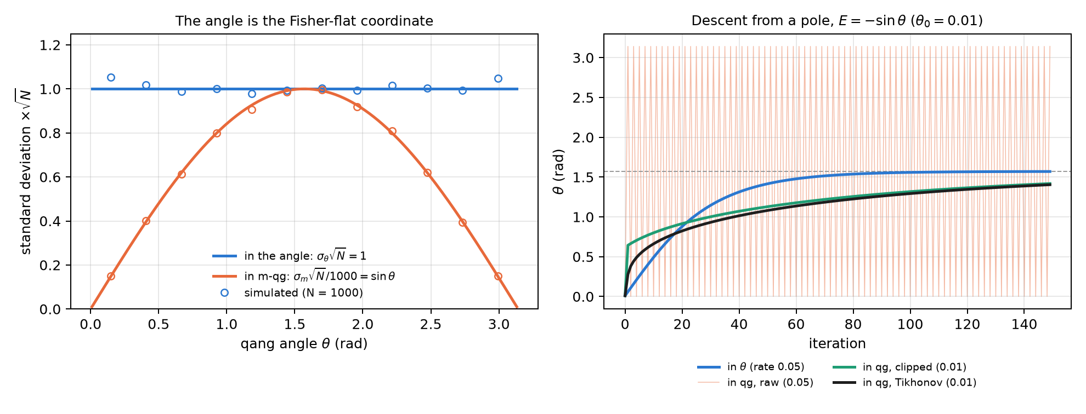
Figure 23.1: Left: standard deviation times $\sqrt{N}$ of the readout in m-qg (divided by 1000) and of the estimated angle, with 1000 shots; the readout follows $sinθ$ and the angle stays at 1. Right: descent from the pole on $E=−sinθ$; in raw qg the optimizer jumps between the poles, and the regularized versions converge more slowly than in $θ$.

23.4 The natural gradient and the qg_YY metric
The natural gradient (QNG, Stokes et al., 2020) corrects the step with the metric: $Δθ=−η g^{−1}∇E$. For one qubit, the natural step in qg is exactly plain descent in $θ$ (notes §15.1): invariance under the change of coordinates means that writing it in qg adds nothing.
With several qubits there is something qang does contribute (§159). In a real ansatz of $R_{y}$ and CZ, every state along the circuit is real, so $⟨Y_{k}⟩=0$ before every $R_{y}$ and every diagonal entry of the metric is exactly 1/4. The angles are flat one by one, and all the curvature sits off the diagonal. Within a layer those terms are $g_{ij}=⟨Y_{i}Y_{j}⟩/4$: qg_YY correlators read from one Y-basis circuit per layer. It is the block-diagonal metric of Stokes et al. written as qg readouts. The script checks it on the 4-qubit TFIM with 3 layers: the diagonal is 1/4 to $1.7⋅{10}^{−16}$, the qg_YY blocks match the full metric within each layer to $1.7⋅{10}^{−16}$, and off the diagonal there are entries up to 0.248, which is where the metric acts.
The notes’ experiment, with predictions committed before running: 4-qubit TFIM ($h=1$), 12 parameters, success if $E−E_{0}≤0.03$ within 300 steps (the ansatz floor is 0.0245), rate chosen on 6 seeds and 20 test seeds. The script re-runs the 20 test seeds with the stored rates and gets the same figures:
Table 23.2: Natural gradient on the 4-qubit TFIM (notes §159, reproduced by the script).
method | steps (median) | successes | rate
descent in $θ$ | 103 | 19/20 | 0.2
descent in qg (clipped Jacobian) | never | 0/20 | 0.005
QNG, qg_YY blocks | 79.5 | 19/20 | 0.05
QNG, full metric | 22.5 | 20/20 | 0.1

- Descent in qg fails at every rate of the grid. One optimizes in the angle and reads out in qg.
- The qg_YY metric helps a little: 1.3 times fewer steps than descent in $θ$. The committed prediction asked for 1.5 and failed. The full metric is 4.6 times faster.
- Counting circuits (24 per gradient, 3 more for the block metric and about 78 more for the full one on hardware), the three methods end within 15% of each other. This count was made after the run.
- With 1000 shots, each entry of the qg_YY metric comes out with an error of 0.013 to 0.022.

23.5 Pole-damped descent
If the problem is at the poles, one can brake there without leaving the angle (notes §9):
$$θ←θ−η max(|sinθ|,ε) \frac{dE}{dθ}.$$
The factor is $|d qg_{Z}/dθ|$, the same geometry as in the first section, and it needs no tuning. It is the natural step multiplied by $|sinθ|$, which for these real states is also the coherence $2|ρ_{01}|$: the optimizer slows down the less coherence the qubit has left. It is not a new class of optimizer: it is a position-dependent step, of the trust-region kind.
The script repeats the robustness test: 300 random landscapes $E=h_{z}cosθ+h_{x}sinθ$ per rate, starting near a pole.
Table 23.3: Success fraction starting near a pole (300 landscapes per rate, seed 0).
rate | descent in $θ$ | damped | damped, trapped
0.3 | 1.000 | 1.000 | 0.000
1 | 0.773 | 1.000 | 0.000
2 | 0.193 | 0.440 | 0.013
3 | 0.087 | 0.327 | 0.017
5 | 0.043 | 0.203 | 0.030
10 | 0.007 | 0.093 | 0.077

At safe rates nothing changes; at rate 1 it always succeeds against 77%; from rate 2 on it wins by 2.3 to 13 times, although at large rates both fail almost always. The fraction trapped oscillating at its pole grows with the rate, up to 7.7% at rate 10. The figures differ somewhat from the notes’ (§9.2): there, at rate 0.3, the damped version lost a few points (0.963 against 0.997), and the gains from rate 2 were 2.5 to 5 times. The pattern is the same; the exact figures depend on the landscapes drawn.
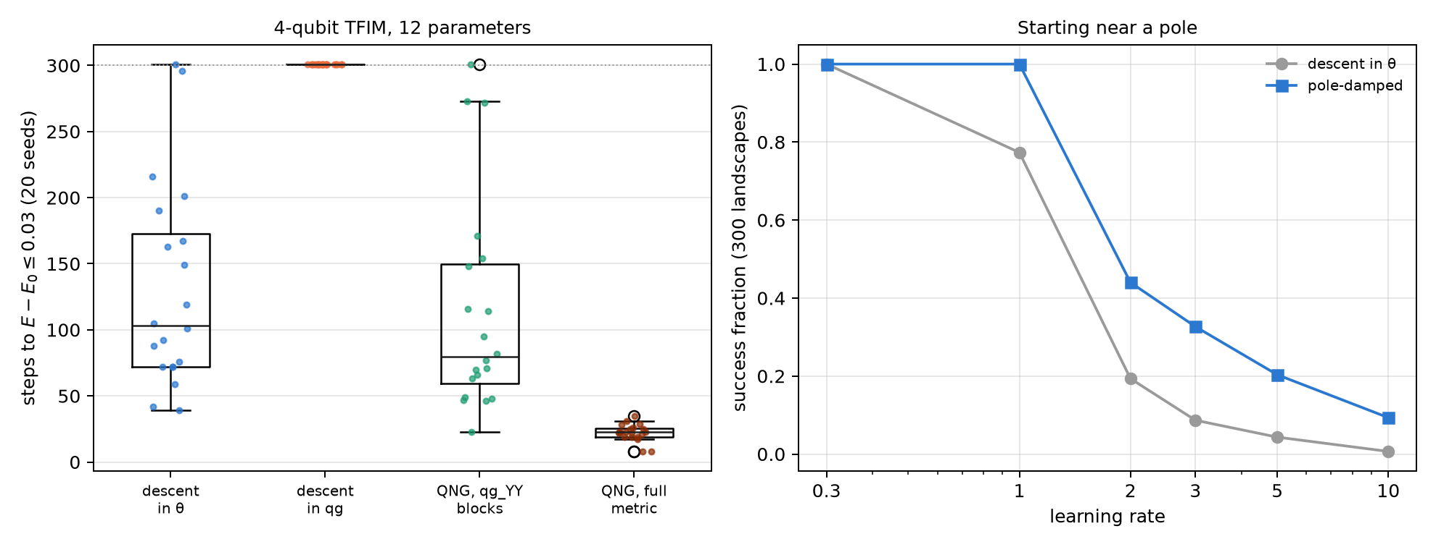
Figure 23.2: Left: steps to $E−E_{0}≤0.03$ on the 4-qubit TFIM for 20 seeds (300 = did not get there); descent in qg never gets there and the full metric is the fastest. Right: success fraction starting near a pole, with and without damping.

23.6 Quantum kernels and the qg filter
A fidelity kernel $K_{ij}=|⟨ψ(x_{i})|ψ(x_{j})⟩|^{2}$ estimated on a noisy device comes out shrunk ($K_{ii}<1$) and pulled towards the noise value. The usual repair, $K_{ij}/\sqrt{K_{ii}K_{jj}}$, costs the diagonal circuits. If the kernel circuit conserves the Hamming weight, the qg filter of Chapter 21 is another repair (notes §161). With the weight-1 encoding (one qubit per component of the normalized vector), the kernel is $K=(x⋅y)^{2}$, and in qg it is a qang angle: $arccos(2K−1)=2φ$, with $φ$ the angle between the two vectors. The script checks it to $1.3⋅{10}^{−15}$.
The notes’ experiment: breast-cancer data reduced to 4 components plus a constant (5 qubits), 40 + 40 points, SVM with a precomputed kernel, 2000 shots and three IBM device noise models.
Table 23.4: The weight-1 kernel with the qg filter (notes §161).
backend | Gram-matrix error (raw / normalized / filtered / both) | correct (exact 35/40) | diagonal (raw / filtered)
FakeBrisbane | 0.097 / 0.016 / 0.016 / 0.015 | 32 / 34 / 34 / 35 | 0.674 / 0.944
FakeTorino | 0.101 / 0.021 / 0.017 / 0.014 | 34 / 35 / 34 / 34 | 0.717 / 0.971
FakeFez | 0.039 / 0.027 / 0.011 / 0.011 | 34 / 34 / 35 / 35 | 0.953 / 1.000

- The filter repairs the Gram matrix best: 2.4 to 6 times below raw, and 1.0 to 2.5 times below the normalization, without the 80 diagonal circuits. Normalizing after the filter adds almost nothing.
- Accuracy barely notices: an SVM compares kernel values, and a common shrink cancels. The committed prediction on accuracy failed on one raw kernel, by three points.
- Kernel-target alignment does not see the shrink, because it divides by $∥K∥$.
- This kernel is a degree-2 polynomial, easy to compute classically: it is a test of repair, not of advantage.

23.7 Barren plateaus: global cost against the qg local cost
With many qubits, the gradient of a random circuit becomes exponentially small (McClean et al., 2018). The notes looked at it in qg twice. In §12, converting the gradient to qg changes nothing: the plateau stays exponential, regularization only rescales it, and at the poles the singularity is added on top. The two are independent and compound.
In §23 the coordinate does matter, by another route: the cost. An ansatz is trained to reach a product state, and two costs that vanish only at the target are compared: the global one, $C_{G}=1−P(0…0)$, and the local one of Cerezo et al. (2021), which on the Chapter 1 scale is the register’s mean readout, $C_{L}=(1−\overline{qg_{Z}})/2$. The script recomputes the variance of the derivative with respect to the first parameter over 200 random initialisations:
Table 23.5: Variance of $∂C/∂p_{0}$ (200 initialisations).
 | $n=2$​ | $n=4$​ | $n=6$​ | $n=8$​ | $n=10$​
global, $L=2$ | $2.7⋅{10}^{−2}$​ | $2.5⋅{10}^{−3}$​ | $2.5⋅{10}^{−4}$​ | $2.6⋅{10}^{−5}$​ | $1.2⋅{10}^{−6}$​
qg local, $L=2$ | $1.8⋅{10}^{−2}$​ | $3.3⋅{10}^{−3}$​ | $1.7⋅{10}^{−3}$​ | $9.4⋅{10}^{−4}$​ | $5.6⋅{10}^{−4}$​
global, $L=4n$ | $2.4⋅{10}^{−2}$​ | $1.9⋅{10}^{−3}$​ | $1.2⋅{10}^{−4}$​ | $6.7⋅{10}^{−6}$​ | $5.7⋅{10}^{−7}$​
qg local, $L=4n$ | $1.6⋅{10}^{−2}$​ | $1.9⋅{10}^{−3}$​ | $3.4⋅{10}^{−4}$​ | $7.3⋅{10}^{−5}$​ | $1.7⋅{10}^{−5}$​

- With short circuits ($L=2$), the qg local cost decays like a polynomial and the global one like an exponential: at $n=10$ the local one has 470 times more variance (in the notes, 5600 times at $n=12$), that is, about 470 times fewer shots for the same signal-to-noise ratio.
- With deep circuits ($L=4n$) the local cost does not cure the plateau: both decay exponentially.
- With finite shots (notes §23, 100 shots per circuit), the global gradient comes out exactly zero in 22% of the initialisations at $n=10$ and 35% at $n=12$; the local one, never. Training at $n=10$, the local cost reaches fidelity 0.5 in a median of 11 steps against 20 for the global one.
- The classical control. With depth $L$, each $⟨Z_{i}⟩$ depends only on the $2L+1$ qubits in its light cone, so the local cost and its gradient are computed classically in time $O(n 2^{2L+1})$. The notes train 50 and 100 qubits that way, without shots. Where the qg local cost escapes the plateau it is also simulable: the advantage is in training, not quantum.
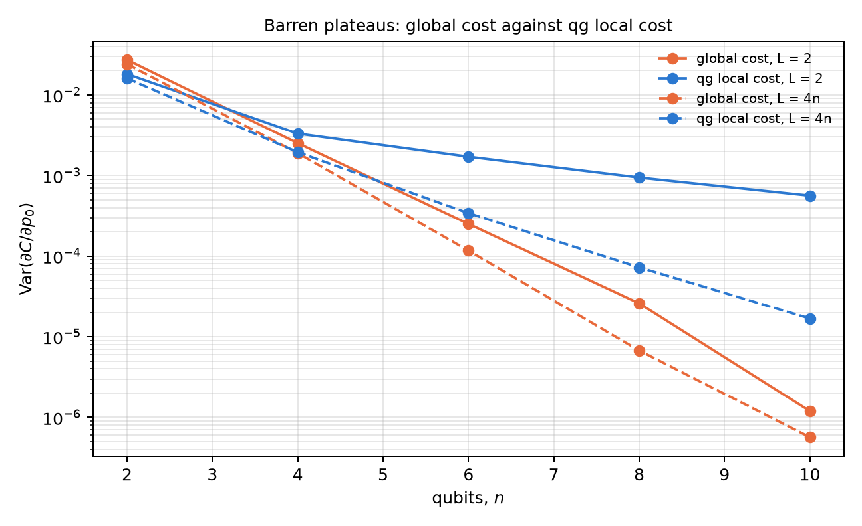
Figure 23.3: Gradient variance against the number of qubits for the global cost and the qg local cost, with short ($L=2$) and deep ($L=4n$) circuits. Only the local cost with short circuits escapes exponential decay.

23.8 What remains open
Everything in this chapter is noiseless or on noise models. The §159 natural gradient was tested with exact gradients on one small model; measuring the qg_YY metric with shots on hardware, and seeing whether the 1.3× gain survives the metric’s shot noise, is still to do. The filtered kernel was tested on one small, easy kernel, without the exponential concentration that appears with more qubits.

23.9 Without qang and with qang
Table 23.6: The chapter’s actions without the qang scale and with it.
action | without qang | with qang | difference
optimize the parameters | descent in the angle | descent in qg: diverges at the poles and fails (0/20) | against: optimize in $θ$, read out in qg
regularize near the poles | — | clipping or Tikhonov on $1/sinθ$ | none against not using qg: it only repairs the problem qg creates
understand why | Fubini-Study metric | $F_{qg}=1/(1−qg_{Z}^{2})$: the qg singularity is the metric; $σ_{m}=1000sinθ/\sqrt{N}$ | in favour as a reading: it explains the failure and gives each readout’s error
count gradient evaluations | 2 per parameter | 2 per parameter | none: no coordinate goes below two
natural-gradient metric | block-diagonal metric (Stokes et al.) | the same, read as qg_YY correlators; diagonal exactly 1/4 | none in the method; in favour in the reading: one circuit per layer
step near the poles | fixed rate | damped by $|sinθ|$, no tuning | in favour at aggressive rates (2.3 to 13 times more successes from rate 2); costs little or nothing at safe rates
repair a noisy kernel | normalize by the diagonal | qg filter on fixed-weight circuits | in favour: Gram 1.0 to 2.5 times better without the diagonal circuits; none in accuracy
training cost | global fidelity | local cost $(1−\overline{qg_{Z}})/2$ | in favour with short circuits (470 times more variance at $n=10$); none with deep circuits

Balance. The chapter is largely a correction: qg is not a coordinate to optimize in, and Fisher geometry says exactly why. What remains in qang’s favour is not a coordinate but a reading: the natural-gradient metric as qg_YY correlators, damping as $|d qg_{Z}/dθ|$, the kernel as a qang angle repaired by the filter, and the local cost as the register’s mean readout. They are known results (Stokes et al., Cerezo et al.) written on the Chapter 1 scale, plus two measured gains: the kernel repair with the filter and the robustness of pole damping.

23.10 In code
import math
import numpy as np
from qang import fisher as F
from qang import gradients as GR
F.fisher_theta(1.0), F.fisher_qg(math.cos(1.0)) # 1 in the angle; 1/sin^2(1) = 1.41 in qg
GR.inverse_jacobian_raw(0.001) # -1000: the singularity
GR.inverse_jacobian_tikhonov(0.001) # -0.40: regularized
th = np.random.default_rng(0).uniform(0, 2 * np.pi, 12)
B = F.block_metric(th, 4, 3) # qg_YY blocks / 4
G = F.full_metric(th, 4, 3) # full Fubini-Study
np.diag(G) # all 0.25
np.abs(B[:4, :4] - G[:4, :4]).max() # ~1e-16 within the layer

23.11 Summary
- On the Chapter 1 scale, $dE/d qg_{Z}=−(1/sinθ) dE/dθ$ diverges at the poles. Raw descent in qg jumps from pole to pole; clipping and Tikhonov fix it, but converge more slowly than descent in $θ$.
- The Fisher information is 1 in the angle and $1/(1−qg_{Z}^{2})$ in qg: the qang angle is the flat coordinate. Optimize in $θ$ and read out in qg, with $σ_{m}=1000sinθ/\sqrt{N}$ m-qg.
- No change of coordinate goes below two evaluations per parameter.
- In a real ansatz the metric’s diagonal is exactly 1/4 and the blocks are qg_YY correlators. The block metric helps a little (1.3 times); the full one, 4.6 times; counting circuits, the three methods end within 15%.
- Damping by $|sinθ|$ is not a new optimizer, but it withstands aggressive rates when starting near a pole.
- The qg filter repairs the Gram matrix of a fixed-weight kernel better than the normalization and without its circuits; accuracy barely changes.
- The qg local cost escapes the plateau only with short circuits, and there it is also classically simulable.

24. Hamiltonian simulation, quantum walks and VarQTE
Simulating the time evolution of a quantum system is the most natural application of a quantum computer, and it is also where the qg filter of Chapter 21 reaches furthest: many Hamiltonians of physics conserve the number of excitations, and so do their Trotter circuits. Then the Hamming weight of each shot is a free witness, and the filter applies to every observable read in Z. This chapter goes through time evolution on the Chapter 1 scale: XY and XXZ chains, a quantum walk, noise channels as maps of the readouts, variational evolution at fixed depth and, more briefly, differential equations, Hubbard, a gauge theory, coherence in Ising and Boltzmann machines. The structural results are checked with code; the results on device noise models are those of the notes’ committed runs, read from their stored files.

24.1 From the base: conserving N means having a filter
On the Chapter 1 scale, each qubit reads $m_{Z}=1000(1−2p)$, with $p$ the probability that it is excited. The number of excitations of a shot is its Hamming weight, and the register’s mean readout counts it: N=i​(1−qgZ,i)/2. If the Hamiltonian conserves $N$ and so does every gate of the circuit, every shot with the wrong weight had an error, and the filter discards it (Chapter 21).
With a single excitation, the state lives in $n$ amplitudes, one per qubit: the excitation hops between neighbouring qubits. It is a continuous-time quantum walk, and each qubit’s readout says where the walker is.

24.2 Trotter and the quantum walk on the XY chain
The XY chain with fields, H=Jk​(XkXk+1+YkYk+1)/2+k​hkZk/2, conserves $N$, and its first-order Trotter circuit uses only $R_{Z}$ and XX+YY gates, which conserve it too (notes, §147).
How many steps. More Trotter steps lower the Trotter error and add noise, so on a device the error has a minimum at a number of steps $r^{*}$. Noiselessly, with $n=5$, random fields and $T=3$, the script recomputes the Trotter error: 0.381, 0.363, 0.221, 0.140, 0.078, 0.054 and 0.033 with 1, 2, 3, 4, 6, 8 and 12 steps. On the notes’ 21 IBM device noise models, the filter (plus readout correction) halved the best error (median 0.147 → 0.067; 1.6 to 2.8 times depending on the device) and moved $r^{*}$ from 8 to 12 steps in the median: the filter lets the simulation use deeper circuits. On 11 devices the optimum was 12, the deepest tested.
The walk. With $n=7$ and the walker in the middle, the variance of its position $σ^{2}(t)$ grows like $t^{2}$ in a quantum (ballistic) walk and like $t$ in a classical (diffusive) one. The script computes it with the exact evolution in the weight-1 sector:
Table 24.1: $σ^{2}(t)$ of the walk on 7 qubits; the exponent is the slope of $logσ^{2}$ against $logt$.
$t$​ | 0.4 | 0.8 | 1.2 | 1.6 | exponent
exact quantum walk | 0.320 | 1.278 | 2.832 | 4.759 | 1.96
with the Trotter steps | 0.327 | 1.291 | 2.832 | 4.737 | 1.94
classical walk, same rate | 0.791 | 1.513 | 2.113 | 2.585 | 0.86

On the simulated devices, raw data look like a classical walk: median exponent 0.87, because noise spreads the walker from the start. With the filter it is ballistic again: median exponent 1.84, and $σ^{2}$ stays within 20% of the exact value at all four times on 15 of 21 devices (raw: none). The committed prediction asked for an exponent of at least 1.5 on 18 devices and it held on 16: it failed. The four noisiest ended between 1.26 and 1.38, and FakeKyoto at zero.
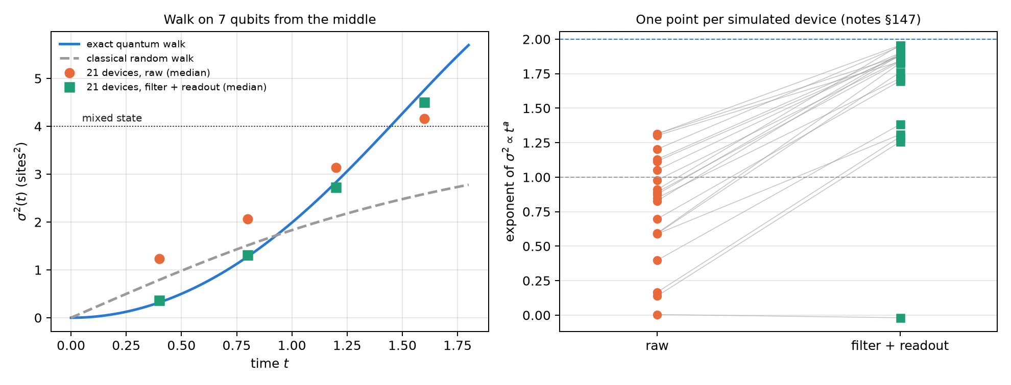
Figure 24.1: Left: $σ^{2}(t)$ of the walk on 7 qubits; the exact one is ballistic, the classical one diffusive; the medians of 21 simulated devices sit near the classical curve without the filter and near the exact one with it. Right: exponent of $σ^{2}∝t^{a}$ per device, raw and with filter plus readout (notes §147).

24.3 Several excitations: the XXZ chain
The XXZ chain adds an interaction $V Z_{k}Z_{k+1}/4$: the excitations interact and everything still conserves $N$. Here the compilation matters (notes §60). The script measures, with exact density matrices ($n=6$, 4 steps), what share of the imbalance error the filter removes with one noise source at a time:
Table 24.2: Share of the error the filter removes on the XXZ chain (notes §60, recomputed by the script).
noise | 3 CNOT per bond | N-conserving gates
2-qubit depolarizing, 0.01 | 41.1% | 41.1%
amplitude damping (T1), 0.01 | 48.5% | 99.5%
Z dephasing, 0.01 | 1.6% | 0.0%
readout, 0.02 | 93.8% | —

- T1 leaks through the CNOTs. Each decay lowers $N$, and the filter catches it if the state is in the sector when it happens. Inside a three-CNOT bond the intermediate states are not in the sector, and a decay mid-gate can be rotated back to $N=n/2$ and pass. With gates that conserve $N$ at every point, the filter removes 99.5%.
- Z dephasing does not change $N$, and the filter does not see it.
- With mixed noise, filter plus ZNE sits 2.6 to 8 times below the best single method up to 4 steps (§60).
On the 21 simulated IBM devices with $n=6$ (§148), the filter’s gain falls from 5.6 times with one excitation to 2.6 with two and with three: sectors with more excitations keep more shots, but more of the noise lands inside them. The prediction that the filter never makes things worse failed in one of 63 cases (FakeKyoto at half filling). On IonQ’s forte-1 noise model (§61), the filter removed about half of the error in both XY compilations, with a ratio of 0.82 between them, inside the committed band: on trapped ions, without dominant T1, the CNOT leak does not appear.

24.4 Channels as affine maps of the readouts
A qubit is $ρ=(I+r⋅σ)/2$ with $r=(qg_{X},qg_{Y},qg_{Z})$. Every channel with Kraus operators acts as $r^{′}=Mr+c$ (notes §162, qang.channels.bloch_affine): the readouts after any noise are affine in those before it. The script checks it on 800 random states to $2.8⋅{10}^{−16}$. On the Chapter 1 scale:
- amplitude damping $γ$: $m_{Z}→(1−γ)m_{Z}+1000γ$, and $m_{X},m_{Y}$ are multiplied by $\sqrt{1−γ}$ (with $γ=0.3$: 0.7 and 0.837);
- dephasing: leaves $m_{Z}$ alone; depolarizing: multiplies the three readouts by the same number and keeps the qang angle;
- T1/T2 relaxation for a time $t$: $m_{Z}→e^{−t/T_{1}}m_{Z}+(1−e^{−t/T_{1}})(1−2p_{1})⋅1000$ and $m_{X,Y}→e^{−t/T_{2}}m_{X,Y}$ (with $t=0.5$, $T_{1}=1$, $T_{2}=0.8$: 0.6065 and 0.5353, which are $e^{−0.5}$ and $e^{−0.625}$).
It is the Chapter 1 picture carried over to noise: every channel moves the readout point inside the sphere by a linear rule.

24.5 Variational evolution at fixed depth
Trotter grows with time: more time, more steps, more gates. Variational evolution (VarQTE, McLachlan’s principle) fixes the circuit and changes only its angles (notes §162). With a weight-preserving ansatz (6 layers of RBS and $R_{Z}$, 54 parameters, 48 two-qubit gates), the filter still applies. The integration is classical; the device prepares and reads the state. The script recomputes the noiseless fidelity of the angles stored by the notes’ run (XXZ chain, $n=5$, $V=2$, two excitations): 0.9999, 0.9956, 0.967 and 0.934 at $t=0.5$, 1, 1.5 and 2, equal to the stored ones.
Table 24.3: VarQTE against Trotter on three noise models (notes §162).
backend | filtered error at $t=2$: variational / best Trotter (72 gates) | variational error, $t=0.5→2$
FakeBrisbane | 0.036 / 0.076 | 0.052, 0.030, 0.030, 0.036
FakeTorino | 0.030 / 0.042 | 0.034, 0.022, 0.012, 0.030
FakeFez | 0.022 / 0.032 | 0.017, 0.008, 0.005, 0.022

At late times fixed depth wins, on all three devices, even though its noiseless fidelity is only 0.934 (the prediction that it would exceed 0.95 failed). The variational error stays flat and the best Trotter error grows 2.6 to 11 times. Before $t≈1$ a short Trotter circuit wins. Limit: at $n=5$ everything is classically trivial, and on hardware the integration would need metric and gradient circuits at every step.

24.6 Differential equations
A one-qubit re-uploading circuit can solve a differential equation: $u(x)=u_{0}+s(f(x)−f(0))$ with $f=⟨Z⟩$, trained on the residual (notes §22). The qang question is how to encode $x$: in the angle, or with $arccos$, so that $x$ is a qg readout. The notes’ result: qg wins clearly on exponential decay (2.3, 17 and 6.6 times better than the best angle scale with 2, 3 and 4 layers) and does not win in general: on the logistic equation the angle is about 2 times better, and on the sine 25 times. qg has no scale to tune; the angle does (with scale $π$ it fails everywhere). The classical control, Chebyshev collocation with as many coefficients as parameters, solves everything to ${10}^{−7}$ or better. The result says which encoding to use, not that the circuit beats a classical method.

24.7 Hubbard and a gauge theory: symmetry filters on every observable
1D Hubbard (notes §29): 4 sites on 8 qubits, one register per spin. The Hamiltonian conserves $N_{↑}$ and $N_{↓}$, so each register has zero mean readout at all times, and every observable (charge imbalance, double occupancy) is in Z. The script checks it noiselessly: mean readout 0 in both registers and kept fraction 1 at 1, 2, 4 and 8 steps. In the notes, the filters roughly halve the error on a device without routing, and ZNE plus spin filters gives the best double occupancy (6 to 9 times below raw). On the heavy-hex lattice, routing creates spin leak (8 to 47% of the right-$N$ shots land in the wrong spin sector), and there the second filter pays. From 4 steps on everything sits on the noise floor.
$Z_{2}$ lattice gauge theory (§66): 4 matter sites and 3 links. The Gauss law $G_{j}$ is a product of Z’s, so it is the qg readout of a parity: the same Z shots give the local Gauss witnesses and three filters ($N$, Gauss and both). The script checks that noiselessly each $⟨G_{j}⟩$ is exactly $±1$ and no shot is lost. In the notes, with 2 steps, the Gauss filter removes more than the $N$ filter (80 against 64% under depolarizing noise) and both together 90%. Under T1, 58–65%: the same CNOT leak. The local witnesses do not locate errors in this homogeneous model. Gauss-law post-selection is known; what qang adds is reading it as qg of parities from the same shots.

24.8 Coherence in the transverse-field Ising model
The difference between the Z-basis entropy and the entropy of the state is a known measure: the relative entropy of coherence $C(ρ)$ (Baumgratz, Cramer and Plenio, 2014). It needs the entropy of the state, which counts do not give. The notes (§34) propose a bound from two readouts per qubit:
C≥i​qgS(qgZ,i)−qgS(|ri|), |ri|=qgX,i2+qgY,i2+qgZ,i2.
The script evaluates it on thermal states of the 6-qubit Ising ring at 20 points ($β$ from 0.25 to 3, field $g$ from 0.25 to 2): it captures 92.3 to 99.8% of the coherence (Figure 24.2, right). The single-qubit bound captures 15–17% (1/6 of the sum, by symmetry), and the basis-entropy bound is useless: it goes down to −5.9 bits. With 1000 shots the bound reads to ±0.04 bits. Where it fails: on a graph state every reduced qubit is $I/2$ and the bound gives 0 with $C=6$ bits. The tightness is a property of these thermal states, not a law.
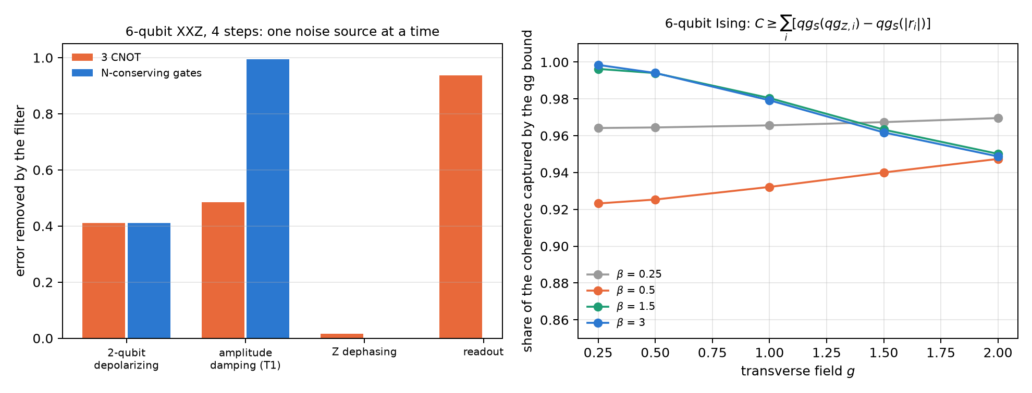
Figure 24.2: Left: share of the imbalance error the filter removes on the XXZ chain, one noise source at a time; under T1 the CNOTs let half through and N-conserving gates almost nothing. Right: share of the coherence of Ising thermal states captured by the qg bound.

24.9 Boltzmann machines: the I–η plane
A recent review (Singh et al., 2026) looks at each visible–hidden pair of an RBM through two numbers: the covariance $η$ and the mutual information $I$, which lie between two bounds $LB(η)$ and $UB(η)$, and observes that trained RBMs sit on $LB$. In qg (notes §47), a pair of spins is fixed by three numbers, $qg_{v}$, $qg_{h}$ and $η$, and the script checks: $LB$ is exactly the case of zero marginals ($2.2⋅{10}^{−16}$) and the minimum of $I$ at fixed $η$; $UB$ is the locked pair with $|qg_{v}|=|qg_{h}|=\sqrt{1−η}$ ($2.9⋅{10}^{−15}$). In between, to leading order, $I−LB≈η^{2}(qg_{v}^{2}+qg_{h}^{2})/(2ln2)$; with $η=0.2$–$0.4$ the formula sits 10–14% above the exact value, because it is leading order in $η$ too.
The explanation: the Ising driver has $Z_{2}$ symmetry, a symmetric RBM has zero marginals, and so it sits on $LB$ by symmetry, not by a learning principle. The prediction, which could have failed, held: a longitudinal field moves the same learner off $LB$ by the amount the marginals set.

24.10 What remains open
No result in this chapter ran on hardware. The three clearest things to test on a QPU are the filtered walk (§147, the change of exponent from 0.87 to 1.84), the T1 leak through CNOTs (§60, which does not show up on an ion simulator) and fixed-depth VarQTE against Trotter at late times (§162).

24.11 Without qang and with qang
Table 24.4: The chapter’s actions without the qang scale and with it.
action | without qang | with qang | difference
simulate N-conserving dynamics | raw readout or ZNE | weight filter on every Z observable | in favour: best error 1.6–2.8 times lower and deeper circuits (§147)
tell a quantum walk from a classical one | raw $σ^{2}$: exponent 0.87, looks classical | filtered: 1.84 (exact 1.96) | in favour: the filter recovers the physics
choose the compilation | CNOTs | N-conserving gates: the filter removes 99.5% of T1 against 48.5% | in favour on platforms with T1; none on ions (§61)
several excitations | — | gain 5.6 times with one, 2.6 with two or three | in favour, decreasing with $N$
describe a channel | Kraus matrices | $r^{′}=Mr+c$ on the readouts | none in content (it is the Bloch representation); in favour as a reading
late-time evolution | growing Trotter | fixed-depth VarQTE with the filter | in favour after $t≈1$; against before
encode an ODE | angle with a scale | $arccos$, no scale | in favour on exponential decay; against on others; a classical method beats all
Hubbard and gauge | known post-selection | witnesses and filters as qg of parities, from the same shots | in favour in cost (no extra circuits); the idea is known
bound the coherence | basis entropies: useless (−5.9 bits) | qg bound from two readouts per qubit: 92–100% | in favour on these states; none on graph states
I–η plane of an RBM | a learning principle | the bounds are the qg marginals; saturation is symmetry | in favour: explains and predicts

Balance. Most of what this chapter gains belongs to the weight filter, not to the scale: conserving $N$ turns every shot into a witness, which recovers a ballistic walk, allows deeper circuits and makes the compilation matter. What belongs to qang is the reading: channels as affine maps of $m_{X},m_{Y},m_{Z}$, Gauss witnesses as qg of parities, a coherence bound from two readouts per qubit and the RBM bounds as marginals. The gains that depend on the scale itself (the ODE) are partial, and the chapter says so.

24.12 In code
import numpy as np
from qang import channels as CH
M, c = CH.bloch_affine(CH.amplitude_damping(0.3))
np.diag(M), c # (0.837, 0.837, 0.7) and (0, 0, 0.3): m_Z -> 0.7 m_Z + 300
r = np.array([0.2, -0.1, 0.5]) # (qg_X, qg_Y, qg_Z)
CH.qg_after(CH.amplitude_damping(0.3), r) # = M @ r + c

24.13 Summary
- If the Hamiltonian and the gates conserve $N$, each shot’s weight is a witness and the filter reaches every Z observable.
- On the XY chain, the filter halves the best error and moves the Trotter optimum to deeper circuits; the raw walk looks classical (exponent 0.87) and the filtered one is ballistic (1.84; exact 1.96).
- Under T1, CNOTs let half the error through and N-conserving gates almost none (99.5% removed).
- Every channel is an affine map of the readouts; fixed-depth VarQTE wins at late times.
- Differential equations, Hubbard, gauge, coherence in Ising and RBMs: the filter and the qg readouts help where the chapter measures it, and where they do not, it says so.

25. Quantum spectroscopy, PCA and molecular chemistry
Chapter 24 used the conservation of the number of excitations to filter dynamics. This one does the same with spectra and molecules, where the conserved number is the number of electrons. The register’s mean readout, on the Chapter 1 scale, counts the electrons of each shot; if the circuit conserves them, that number is both a reference-free error witness and a filter. The chapter follows that idea from a data PCA to 12-qubit molecules, and also shows where it stops reaching: when the error lives in terms that are not measured in Z. The structural results are checked with code; the noise-model results are those of the notes’ committed runs.

25.1 From the base: counting electrons with the register readout
In the Jordan-Wigner encoding each qubit is a spin-orbital, and its occupation is $(1−qg_{Z})/2$, that is $(1000−m_{Z})/2000$ in m-qg. Summing over the register,
Ne=i​1−qgZ,i2, qgZ=1−2Nen.
For any circuit that conserves the number of electrons, the ideal mean readout is known before running (0 for H$​_{2}$: 2 electrons on 4 qubits). A departure from it is a witness that the hardware added or removed electrons (T1 pushes it towards $+1$), and shot by shot it is a filter. The filter is the known symmetry verification (Bonet-Monroig et al., 2018; McArdle et al., 2019); what qang adds is the witness and its reading.

25.2 PCA in the weight-1 sector
Quantum PCA diagonalizes $ρ=C/tr C$. In the unary encoding, a mixture of the loaded data vectors (with weights $|x_{j}|^{2}$) is exactly that $ρ$, and an RBS circuit applying the PCA rotation leaves eigenvalue $λ_{k}$ on qubit $k$ (notes §146). The script checks it with exact states: for 5 components and 16 data points, each qubit’s excitation probability is the normalized eigenvalue (0.640, 0.203, 0.122, 0.023, 0.011) to $2.2⋅{10}^{−16}$, with 10 RBS in the rotation. Every gate conserves the weight, so the filter applies. It is not the quantum-PCA speed-up (5 components use 5 qubits and the rotation is computed classically): it tests how well a device reads a known spectrum.
On the notes’ 21 IBM device noise models, with all four committed predictions passing, the raw estimate is biased upwards: shots leaving the sector add excitations on every qubit (median L1 error 0.266). Filter plus readout correction brings it to 0.048 (4.6 times lower; 1.6 to 7.7 depending on the device) and orders all five eigenvalues correctly on 18 of 21 devices (raw: 13). What is left is a flattening of the spectrum that grows when few shots are kept (FakeKyoto keeps 15% and fails).

25.3 H$​_{2}$: the witness and the filter
The script checks the structure on the notes’ H$​_{2}$ Hamiltonian (STO-3G, 0.735 Å, 4 qubits): it commutes exactly with $N$, $N_{↑}$ and $N_{↓}$; the $N$-conserving ansatz reaches the exact (FCI) energy to $5⋅{10}^{−11}$ mHa, and the register’s ideal mean readout is 0. Hartree-Fock sits 20.3 mHa above. The notes (§21) ran fake brisbane’s noise model with 20,000 shots and an idle delay before measurement that amplifies T1:
Table 25.1: H$​_{2}$ energy error against FCI, in mHa (notes §21).
method | 0 µs | 20 µs | 50 µs
classical Hartree-Fock | 20.3 | 20.3 | 20.3
quantum, raw | 74 | 140 | 231
+ readout correction | 18 | 90 | 188
+ readout + qg filter | 5.5 | 20 | 30
witness: mean readout (ideal 0) | +0.011 | +0.057 | +0.122
shots kept | 91% | 83% | 72%

The witness rises as electrons are lost. With the filter the energy is 3.2 times better than with readout correction alone without delay (6 times at 50 µs) and 3.7 times better than Hartree-Fock, but still 3.4 times above chemical accuracy: the rest sits in the 4 XXYY-type terms, which a Z filter cannot reach, and in errors that conserve $N$. FCI is exact and cheap at this size: the table measures what the correction buys a noisy quantum computation, not an advantage.
Spin filters (§28). The Hamiltonian conserves $N_{↑}$ and $N_{↓}$ separately, and each spin register has its own mean readout. A second free filter, from the same shots: under depolarizing noise it removes a further 34–37% of the error the total filter leaves, but on fake brisbane the gain is within the seed spread (6.5 → 5.9 mHa), because the spin leak is below 1%. The leak witness says when it pays.

25.4 Why the filter helps H$​_{2}$ and not LiH
With LiH (6 qubits) the §21 filter did nothing. The notes (§50) separated the causes: reach (the filter acts only on Z shots), routing and depth.
Table 25.2: Where the error sits, in mHa against the noiseless circuit (notes §50).
case | 2q gates | Z group raw → filtered | X/Y groups raw | total raw → filtered
H$​_{2}$, all-to-all | 3 | 13.0 → 4.9 | 0.9 | 13.9 → 5.9
H$​_{2}$, brisbane | 6 | 20.6 → 2.8 | 2.4 | 23.0 → 5.2
LiH, all-to-all, 1 layer | 20 | −2.2 → −1.9 | 26.2 | 24.0 → 24.3
LiH, brisbane, 3 layers | 60 | −30.5 → −18.0 | 165.8 | 135.3 → 147.9

Reach is the main reason. In H$​_{2}$ the error is in the Z group, where the filter acts; in LiH it is in the 16 X/Y groups, where a Z filter does not look, and not even a perfect filter would go below that column. Routing is not the cause: the LiH ansatz is nearest-neighbour and needs the same gates on an all-to-all device. The qang attempt to rescale the X/Y groups by the kept fraction failed: it over-corrects 2–3 times, because local gate noise is not a global depolarization.

25.5 Checks that reach every group
If the problem is reach, the remedy is a check that commutes with every term (§52): the parity of the electron number on an ancilla (6 CNOTs), and $N$ modulo 4 on a second ancilla, which also catches the errors that change $N$ by 2. With 3-layer LiH and all-to-all noise, parity plus mod 4 take the error from 83.9 to 13.4 mHa (§50’s best was 76.6), discarding 28% of the shots: for the first time in the repository, LiH ends (on that model) below Hartree-Fock. On IonQ’s forte-1 model (§53) the mod-4 check survives (3.8 times less error, parity alone 1.25 times), but the result stays above Hartree-Fock.
Larger molecules (§54, §55, §69), with ideal projections:
Table 25.3: The ladder of checks, error in mHa against the noiseless circuit (notes §69).
molecule | qubits | raw | $N$​ | $N_{↑}$, $N_{↓}$ | $+ S^{2}=0$​
H$​_{2}$O | 8 | 363.9 | 54.6 | 43.3 | 26.7
H$​_{4}$ | 8 | 287.5 | 79.9 | 70.5 | 44.7

- Number checks keep working up to 12 qubits, but they reach a shrinking share of the error: the part that changes $N$ falls from 92% (LiH, 60 CX) to 67% (H$​_{6}$, 132 CX). The rest conserves $N$ and no number check sees it.
- Splitting by spin recovers part of it (from 75.7 to 66.8 mHa on H$​_{4}$).
- The projection onto the singlet $S^{2}=0$ removes a further 37–38%, the largest gain since §52, but $S^{2}$ is not diagonal in Z: it needs 640 Pauli strings for the projector and 2064–3456 for the projector times $H$, against 105–185 for $H$.
Λ as a third filter (§153). A linear molecule conserves $Λ$, the projection of the orbital angular momentum on its axis. With the π orbitals written as π± ($m_{l}=±1$), $Λ$ is diagonal and is checked shot by shot with only the four π qubits, so it reaches 29 of LiH’s 317 measurement groups (10 qubits), against 1 for the number filter. The committed prediction half held: where $N_{↑},N_{↓}$ already applies, $Λ$ adds almost nothing (13.9 → 13.3 mHa on FakeBrisbane), because changing $Λ$ without changing $N$ takes two errors. The extra reach is real and does not pay: in the 28 groups where only $Λ$ acts, it discards 4–10% of the shots and their error barely moves, because the error that matters there is on the σ qubits measured in X/Y.
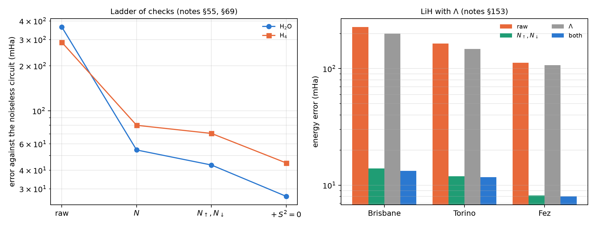
Figure 25.1: Left: ladder of checks on H$​_{2}$O and H$​_{4}$ (notes §55 and §69); each symmetry removes a smaller share. Right: 10-qubit LiH with the spin filter, the $Λ$ filter and both, on three noise models (notes §153); $Λ$ alone barely moves the error.

25.6 Overlaps: inversion test against swap test
The fidelity $F=|⟨x|y⟩|^{2}$ of two unary states can be estimated two ways (§149). The inversion test loads $x$, undoes the loader of $y$ and reads the probability of one basis state: 5 qubits, everything conserves the weight. The swap test uses 11 qubits and an ancilla, and reads $P(\text{ancilla}=0)=(1+F)/2$. The script checks both formulas with exact states ($3⋅{10}^{−16}$ and $6⋅{10}^{−16}$). On six IBM noise models:
- with the filter, the inversion test cuts its error 3.8 to 11.2 times, down to 0.010–0.036;
- in the swap test the answer is on the ancilla, outside the symmetry, and the filter gains only 1.4–1.8 times (error 0.089–0.239);
- a fidelity classifier (40 flowers) keeps its noiseless accuracy with both methods, because comparing two fidelities cancels the common shrink;
- but the test “are they equal?” needs the absolute value: for identical states the filtered inversion test reads 0.92–1.00 and the raw swap test 0.20–0.65.
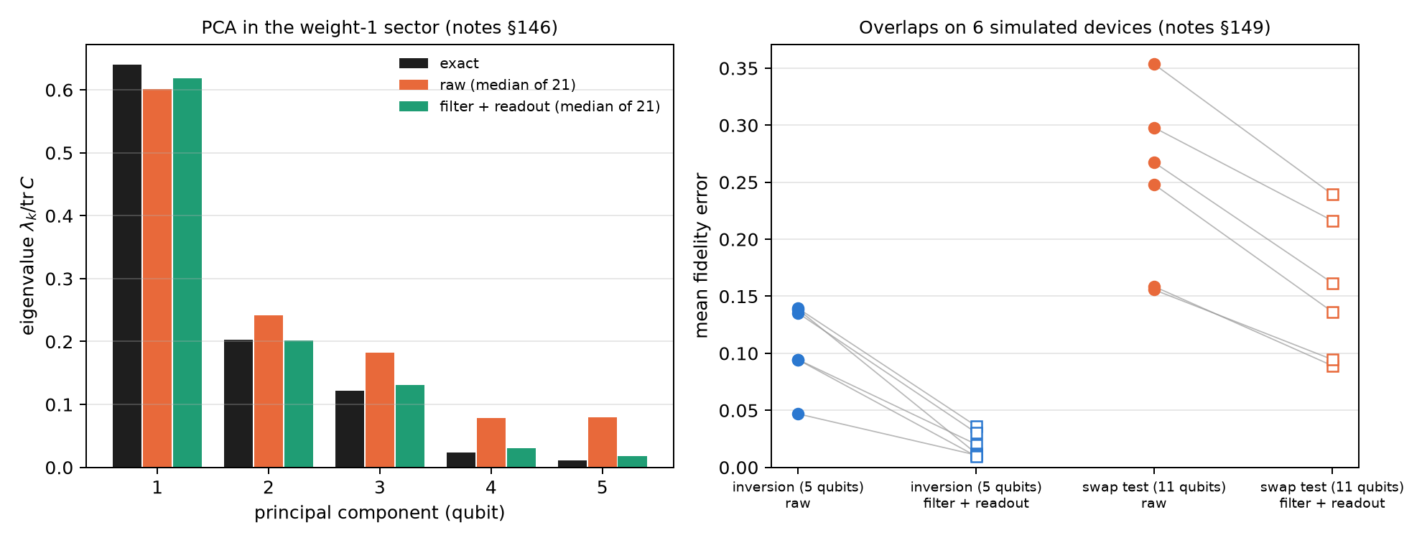
Figure 25.2: Left: PCA spectrum, exact and median of 21 simulated devices without the filter and with filter plus readout (notes §146); raw data lift the small eigenvalues. Right: fidelity error on six devices, inversion test and swap test, raw and filtered (notes §149).

25.7 Constrained optimization: QAOA with “exactly K”
Choosing exactly $K$ of $n$ vertices is the same identity as the number of electrons: $\overline{qg_{Z}}=1−2K/n$, 0.25 for $K=3$ of $n=8$ (notes §30). The script checks that with the XY mixer (which conserves the weight, from a Dicke state) the ideal distribution is 100% feasible at random angles, while penalty QAOA leaves 10 to 45% feasible mass. On an all-to-all device the filter doubles the XY mixer’s probability of finding the optimum (0.150 → 0.278 at $p=1$; 0.177 → 0.366 at $p=2$), and on the IonQ models too (1.8–2.6 times, §38). On fake brisbane, with routing, everything falls to the level of picking a random feasible set, and the kept fraction warns of it (0.24–0.33, close to 0.22 for a mixed register). Classical wins: a greedy algorithm reaches 98.5% of the optimum. The qg ingredients improve QAOA against QAOA, not against classical optimization.

25.8 What remains open
No result in this chapter ran on hardware. The notes committed a criterion for LiH with the mod-4 check on an IonQ QPU (§53: it holds if parity plus mod 4 cut the error at least 2.5 times in every run and parity alone less than 1.5), at an estimated cost of about 1,100–2,200 dollars, which did not fit in the budget.

25.9 Without qang and with qang
Table 25.4: The chapter’s actions without the qang scale and with it.
action | without qang | with qang | difference
read a PCA spectrum | raw: biased upwards (L1 0.266) | weight filter: L1 0.048 | in favour: 4.6 times less error; it belongs to the filter
detect electron loss | compare with a reference | register mean readout, known ideal | in favour: reference-free witness
H$​_{2}$ energy | readout correction: 18 mHa | + filter: 5.5 mHa | in favour: 3.2 to 6 times; symmetry verification is known
LiH energy with a Z filter | — | no gain: the error is in X/Y | none: the witness diagnoses, the filter does not reach
rescale X/Y by the kept fraction | — | over-corrects 2–3 times | against
ancilla checks | parity: a third | + $N$ mod 4: 6–8 times less error | in favour, with 1–2 ancillas; an extension of known methods
larger molecules | — | the reachable share falls from 92 to 67% | in favour, decreasing
$Λ$ filter | — | reaches 29 more groups and does not pay | none where a spin filter already applies
absolute fidelity | raw swap test: 0.20–0.65 for equal states | filtered inversion: 0.92–1.00 | in favour of the filtered inversion test
constrained QAOA | penalty: chance level | XY mixer + filter: doubles success | in favour against QAOA; against against classical greedy

Balance. As in Chapter 24, almost everything gained belongs to symmetry verification, which is known. What belongs to qang is the witness: the register’s mean readout says how many electrons there are, and its kept fraction says how much is left to filter. That witness is what led from the §21 failure on LiH to the §50 reach diagnosis and the §52 checks. The chapter also leaves the measured limits: the error that conserves every symmetry grows with size, and one more symmetry ($Λ$) can reach more groups without lowering the error.

25.10 In code
import numpy as np
from qiskit.quantum_info import Statevector
from qang import ibm
x = np.array([0.3, -0.5, 0.2, 0.7, 0.4])
y = np.array([0.1, 0.6, -0.3, 0.5, 0.5])
x, y = x / np.linalg.norm(x), y / np.linalg.norm(y)
sv = Statevector(ibm.unary_overlap_circuit(x, y, measure=False)).data
abs(sv[1]) ** 2, (x @ y) ** 2 # inversion test: P(only qubit 0 excited) = F

25.11 Summary
- In Jordan-Wigner, the register’s mean readout counts the electrons: $\overline{qg_{Z}}=1−2N_{e}/n$. Its ideal value is known before running, so it is a reference-free witness and, shot by shot, a filter.
- In the unary PCA, the filter cuts the error of the read spectrum 4.6 times; on H$​_{2}$, the energy error 3.2 to 6 times.
- On LiH the Z filter does not reach the error, which sits in the X/Y groups; ancilla checks (parity and $N$ mod 4) do, and cut the error 6–8 times.
- With larger molecules each symmetry reaches a smaller share of the error; $S^{2}$ removes a further 37–38% at the cost of many more measurements, and $Λ$ adds reach without lowering the error.
- The filtered inversion test gives the absolute fidelity; the raw swap test does not. In constrained QAOA the filter doubles the XY mixer’s success, and a classical algorithm still wins.

26. Error correction and continuous syndromes
 Note
Chapter in preparation. Planned contents:

- 26.1 Leung’s 4-qubit code for T1-dominated channels and the T2 > T1 criterion — §27, §32
- 26.2 The syndrome as a continuous qg witness: tracking drift and switching codes — §33, §88, §92, §93, §99
- 26.3 A T1-aware decoder under circuit-level noise; the d = 3 surface code in qg — §59, §64
- 26.4 Qutrits and erasure qubits: the |2⟩ flag, the (1 − h) rule — §70, §70b, §71, §72, §73, §74
- 26.5 Circuit knitting: the shot multiplier γ = 1 + 2√(1 − qg²) for RZZ — §26
- 26.6 Randomized benchmarking and ZNE in qg units; qg_S as a benchmarking signal — §10, §11

27. Hardware characterization in qg
Note
Chapter in preparation. Planned contents:

- 27.1 T1, T2, effective temperature and readout in a single sweep — §31, §86
- 27.2 Which noise is it? Mean qg_Z against XEB/HOP — §18
- 27.3 Coherent conditional-phase errors and always-on ZZ crosstalk — §145, §150
- 27.4 Control quantization: the even qg grid lowers the error in 43 of 45 distributions (median 1.56×) — §17

28. Methodology: the pre-registered falsification protocol
Note
Chapter in preparation. Planned contents:

- 28.1 The discipline of pre-registration: hypotheses and predictions committed (commit or sha256) before running — §46, §75–§164
- 28.2 Passes and failures: “123 passed / 53 failed” covers only §75–§123 (the QML line)
- 28.3 Test beds: calibrated noise models of IBM (Brisbane, Sherbrooke, Torino, Fez, a fleet of 21) and IonQ (Aria-1, Forte-1) — §20, §137, §144
- 28.4 Real-hardware runs: IonQ Forte-1 (§128) was refused by the provider before the job was accepted; the first real data point is the three-flavour neutrino run on IQM Garnet — §165
- 28.5 The falsification criterion for QPUs: variance of the inversion echo Var_θ(F_echo) over continuous trajectories
- 28.6 First run on real hardware: IQM Resonance (Garnet/Emerald) — see Chapter 31

29. The confirmed empirical advantages (where qg brings a measurable benefit)
Note
Chapter in preparation. Planned contents:

- 29.1 Exact restoration under T1: ideal accuracy recovered in paired runs — §80
- 29.2 Lower error of polar observables on simulated noisy IBM and IonQ backends — §85, §144
- 29.3 In-sector leakage mitigated by echo: wrong decisions in 945 readings — §106–§108
- 29.4 Control quantization (see 27.4) — §17
- 29.5 T1 diagnosis without classical simulation (see 27.2) — §18
- 29.6 Mitigation without extra circuits: 3× for 3-flavour neutrinos and 5.5× with sterile neutrinos (simulated) — §151, §163
- 29.7 Operational cybersecurity: fewer BB84 false alarms under thermal drift — §40, §43

30. Structural limits, equivalences and negative results
Note
Chapter in preparation. Planned contents:

- 30.1 Blindness to relative phases and multipartite entanglement in the Z basis: graph states — §8
- 30.2 The non-monotonicity of qg_S under pure amplitude damping, and the fix with the pair (qg_S, mean qg_Z) — §10, §14
- 30.3 The QNG equivalence: no intrinsic speed-up from a change of coordinate — §159
- 30.4 The filter fails in deep circuits: LiH with 60 entangling gates and Hubbard at L ≥ 4 — §29, §50
- 30.5 WeightQNN is not quantum supremacy against classical quadratic models — §75
- 30.6 Inapplicability to pure phase estimation (QPE, Shor, HHL) and to PQC — §13
- 30.7 The P-CTC paradox on Torino, the decoder fidelity and the other pre-registered failures of §157–§164 — §157–§164
- 30.8 The consolidated list of known limitations — §14

31. First experiment on real hardware: IQM Resonance
Note
Chapter in preparation. Planned contents:

- 31.1 Why IQM: native PRX and CZ gates, a square lattice; how RBS and XX+YY gates compile
- 31.2 The qang/iqm.py module (analogous to qang/ibm.py): readout errors from calibration, choice of qubit chain, the qg filter
- 31.3 A free rehearsal on IQM’s simulated backends before spending credits
- 31.4 Budget: a minimal probe job (≈10%), the main experiment (≈60%), a reserve (≈30%); the token only in an environment variable
- 31.5 The pre-registered main experiment: 3-flavour neutrinos (§151) — 3 qubits, ~18 two-qubit gates
- 31.6 Next candidates: single-qubit P-CTC (§164), the Yoshida–Kitaev decoder (§164), H2 (§20/§128)
- 31.7 Result, passes and failures, and comparison with the simulated models

32. Software architecture, the multi-SDK ecosystem and physical execution
Note
Chapter in preparation. Planned contents:

- 32.1 The unified qang.interop order (Qiskit, Cirq, PennyLane, Braket, pytket) — §130
- 32.2 Qiskit V2 primitives (SamplerV2, EstimatorV2) with filtered observables — §131
- 32.3 Sector-aware compilation on IBM Runtime and chain selection (best_chain); predicting the kept fraction from calibration — §137, §138, §141
- 32.4 Static ZZ: ibm.add_static_zz simulates the crosstalk to measure how much the filter sees; it does not mitigate it — §150
- 32.5 ZNE with the filter, and shot planning — §142, §143
- 32.6 Guidelines for superconducting (IBM, IQM) and trapped-ion (IonQ Cloud / AWS Braket) hardware — §128, §137, Ch. 31

33. Nanoquantum: transmission, partition noise and qubits at the nanoscale
Note
Chapter in preparation. Planned contents. There is no qang module or research-notes section for this chapter yet: each item rests on the probability equation of chapter 1 and needs its own development and verification.

- 33.1 The tunnelling transmission probability $T$ as a qang probability: $θ_{T}=2arccos\sqrt{T}$ and its reading in m-qg
- 33.2 The Landauer formula G=(2e2/h)n​Tn: each channel of a quantum point contact is a qang reading; conductance quantization as channels at the poles
- 33.3 Partition noise: $S=2eI(1−T)$ and the Fano factor $F=1−T$ carry the binomial variance $T(1−T)$ of $p_{0}(1−p_{0})$; the qang angle stabilizes it (arcsine transformation, chapter 1)
- 33.4 Coulomb blockade and the single-electron transistor: the occupation of a level as $p_{0}$ and $qg_{Z}=−tanh(x/2)$, the same thermal state as $qg_{Z}=tanh(βh)$ in chapter 8
- 33.5 Quantum dots as charge and spin qubits: Rabi oscillations and charge-sensor read-out in qg; read-out fidelity in m-qg
- 33.6 NV centres in nanodiamond: the ODMR contrast as $qg_{Z}$ and nanoscale magnetometry with m-qg resolution

Appendix A — Catalogue of the 15 fundamental gates in qg representation
Note
Appendix in preparation.

Appendix B — Transition formulas, Gell-Mann matrices
Note
Appendix in preparation.

Appendix C — The echo-calibration protocol and matrix inversion in Hamming sectors — §105–§108
Note
Appendix in preparation.

Appendix D — Quick reference to the qang 0.12.0 API: core, formulation, sectors, qml, ibm, interop, pulse_area, neutrino, postselection, qpon, fisher, kernels, varqte, channels, angular, qsp, knitting, qec, statistics, polarization, geometric, clock_comparison, complementarity, proportions ( no crypto; iqm)
Note
Appendix in preparation.

Appendix E — Falsification statement and the register of pre-registered predictions (full count §1–§164)
Note
Appendix in preparation.

Appendix F — Functional-analysis foundation: Riesz–Fréchet — Appendix A of the notes
Note
Appendix in preparation.

