Symmetry-filtered read-out on IBM quantum devices:
the qg filter on twenty device noise models through IBM Runtime
Vicente Humberto Monteverde
Universidad del Museo Social Argentino (UMSA), Argentina
ORCID 0000-0001-8884-4811
Draft of 13 October 2026
Abstract
Circuits built from gates that conserve the Hamming weight keep their state in one weight sector, so the shots that left the sector can be discarded at read-out: the qg filter of the open-source library qang (Monteverde 2026a), a form of symmetry verification (Bonet-Monroig et al. 2018; McArdle, Yuan, and Benjamin 2019). We make it usable on IBM devices through IBM Runtime and Qiskit, and measure it on the noise models of twenty IBM devices. The library adds a Qiskit transpiler pass that decides whether the filter applies, read-out correction from each device’s published per-qubit errors, qg read-outs of IBM Runtime Sampler and Estimator results, zero-noise extrapolation by gate folding that stacks with the filter, a prediction of the filter’s kept fraction from the calibration, qubit selection with that prediction, a shot planner, and the weight-conserving quantum neural network (QNN) of qang as one parameterized job and as a qiskit-machine-learning SamplerQNN. Every prediction was committed before its run and is reported as passed or failed. On ten five-qubit weight-1 circuits the filter lowers the error of the measured $qg_{Z}=⟨Z⟩$ from 0.065–0.104 to 0.018–0.023 on three devices (0.013–0.022 with read-out correction), and filter plus zero-noise extrapolation reaches 0.011–0.015. On seventeen further devices never used before, the filter cuts the error 2.4–8.9$×$ on every one (median 3.1$×$ with read-out correction). Choosing the qubits by the predicted kept fraction keeps 6–17 points more shots than Qiskit’s default layout on chain circuits, avoids a qubit published as reading 1 always, and the shot planner met a 0.02 target precision on three devices. For classification the gain is small: the QNN recovers 5–6 of the 10 decisions noise costs it. Reading a known five-component principal-component spectrum out of the data’s density matrix in the weight-1 sector, filter plus read-out correction lowers the error 4.6$×$ (median over twenty-one devices) and orders the spectrum correctly on 18 of 21 (13 raw). Two interoperability bugs were found, one in qiskit-machine-learning and one in the library. All results are on device noise models; no hardware run is reported.
Keywords: quantum error mitigation; symmetry verification; post-selection; IBM Quantum; quantum machine learning.

Introduction
When every gate of a circuit conserves the number of excitations (the Hamming weight of the computational state), noise that changes that number moves shots out of the sector the circuit started in. Discarding them is symmetry verification by post-selection (Bonet-Monroig et al. 2018; McArdle, Yuan, and Benjamin 2019). In qang it is the qg filter, read in the unit $qg_{Z}=⟨Z⟩∈\left[−1,1\right]$ (Monteverde 2026a); a companion note studies it for quantum neural networks under relaxation (Monteverde 2026b).
This paper asks what the filter is worth on IBM devices and gives the tools to use it there: everything runs through IBM Runtime (IBM Quantum 2026) and Qiskit (Javadi-Abhari et al. 2024), here in local testing mode on the device noise models (fake backends), unchanged on a device. Each experiment fixed its circuits, settings and predictions in a commit before running; failures are reported as such. Sections §137–§146 refer to the research notes of the repository, where every number below is reproduced by a script in examples/.

Methods

Applicability.
WeightPreservationCheck is a Qiskit analysis pass. It marks a circuit as weight-preserving when every gate conserves the excitation number (by name for gates such as RZ, CZ, SWAP or XX+YY, otherwise from its matrix), and returns the initial weight prepared by leading X gates. It is run on the logical circuit: after transpilation the native gates are not weight-preserving one by one.

Read-out.
For a circuit transpiled to a device, ibm_qg reads the measured physical qubits, takes their published asymmetric read-out errors $P\left(1|0\right)$, $P\left(0|1\right)$, and inverts the tensor product of the per-qubit confusion matrices on the measured distribution (Bravyi et al. 2021). It returns $qg_{Z}$ per qubit raw, read-out corrected, filtered (weight-$w$ shots of the raw distribution) and filtered after correction (the weight-$w$ part of the corrected quasi-distribution, renormalized). Qubits whose confusion matrix cannot be inverted are left uncorrected and reported.

Kept fraction and qubit selection.
predict_kept_fraction multiplies the probability that each calibrated channel leaves the weight unchanged: a single-qubit gate of error $e$ changes it with probability $e$, a two-qubit gate with $5e/6$, relaxation over the busy time $t$ of a qubit with $\left(1−e^{−t/T_{1}}\right) w/n$, pure dephasing during the gates with $2z/3$, $z=\left(1−e^{−t/T_{ϕ}}\right)/2$, and read-out with $w/nP\left(0|1\right)+\left(1−w/n\right)P\left(1|0\right)$. Adding the shots that return to the sector as for a fully mixed state gives kept_mixed_floor. best_chain and best_layout choose the initial layout with the highest prediction; best_layout scores the circuit as it will run, routing included, and counts Qiskit’s default layout among the candidates.

Zero-noise extrapolation.
IBM Runtime’s own mitigation has no effect in local mode, so zne_qg folds every two-qubit gate ($G→GG^{†}G$, scale 3) (Giurgica-Tiron et al. 2020), runs both scales and extrapolates linearly to zero (Temme, Bravyi, and Gambetta 2017). Folding keeps a weight-preserving circuit weight-preserving, so it stacks with the filter.

Shot planning.
A filtered $qg_{Z}$ read from $Nk$ kept shots has standard error $\sqrt{\left(1−qg_{Z}^{2}\right)/\left(Nk\right)}$. plan_shots returns the $N$ that brings the worst qubit to a target error with the predicted $k$, and the device time $N$(circuit duration + repetition delay).

QNN.
The weight-1 QNN of qang (Monteverde 2026b) (an amplitude loader and three layers of Hamming-weight-preserving RBS gates on five qubits, ring-coupled) is written as one parameterized circuit of native XX+YY gates, $RBS\left(t\right)=XXPlusYY\left(2t,π/2\right)$, equal to the library’s simulator to ${10}^{−9}$. run_qnn sends a whole test set as one Sampler pub. qang_sampler_qnn wraps the same circuit as a qiskit-machine-learning SamplerQNN (Qiskit community 2026). The model is trained noiselessly on four datasets (iris, cancer, wine, digits; 189 test inputs; 185 correct noiselessly).

PCA spectrum.
In the unary encoding a real vector $x$ is k​xk|ek⟩, $e_{k}$ the state with only qubit $k$ excited, prepared by $d−1$ RBS gates. Loading the centred data vectors $x_{j}$ with probabilities xj2/i​xi2 gives $ρ=C/tr C$, C=1mj​xjxjT: the density matrix that quantum PCA diagonalizes (Lloyd, Mohseni, and Rebentrost 2014). unary_orthogonal decomposes a real orthogonal matrix into at most $d\left(d−1\right)/2$ nearest-neighbour RBS gates (up to output signs); with the PCA basis it sends eigenvalue $λ_{k}$ to qubit $k$, so $P\left(\text{qubit }k\text{ excited}\right)=λ_{k}/∑λ$, read by unary_spectrum from the four read-outs of ibm_qg. The rotation is computed classically and $d$ features use $d$ qubits: this tests read-out, not a speed-up.

Test circuits.
Ten random five-qubit weight-1 circuits: X on qubit 0 and two layers of XX+YY gates on neighbours with angles uniform in $\left[0.3,2.8\right]$ (seeds 0–9). Error is the mean $\left|qg_{Z}−qg_{Z}^{ideal}\right|$ over qubits and circuits. Transpilation uses optimization level 1 and seed 137.

Results

Read-out on three devices (§137, §142)
Mean $qg_{Z}$ error, ten circuits; 8000 shots per circuit (and per noise scale for ZNE). The first four columns are §137, the ZNE columns §142 (separate runs).
 | raw | read-out | filter | filter + read-out | ZNE | filter + ZNE
FakeBrisbane | 0.104 | 0.074 | 0.023 | 0.022 | 0.053 | 0.012
FakeSherbrooke | 0.065 | 0.038 | 0.019 | 0.016 | 0.034 | 0.011
FakeTorino | 0.102 | 0.036 | 0.018 | 0.013 | 0.085 | 0.015
All three predictions of §137 passed: read-out correction lowers the raw error (by 29–64%), the filter does more than read-out correction alone, and the two together are best (Table 1). Read-out correction raises the weight-1 mass from 0.69–0.82 to 0.82–0.92: a third to two thirds of the shots the filter would discard were read-out errors. With ZNE (§142) the filter does 2–7$×$ more than ZNE alone (passed); ZNE lowered the filtered and corrected error on two devices but not on Torino, and the best combination was filter + ZNE on two devices and filter + read-out on Torino (so both of those predictions failed).

Twenty devices (§144)
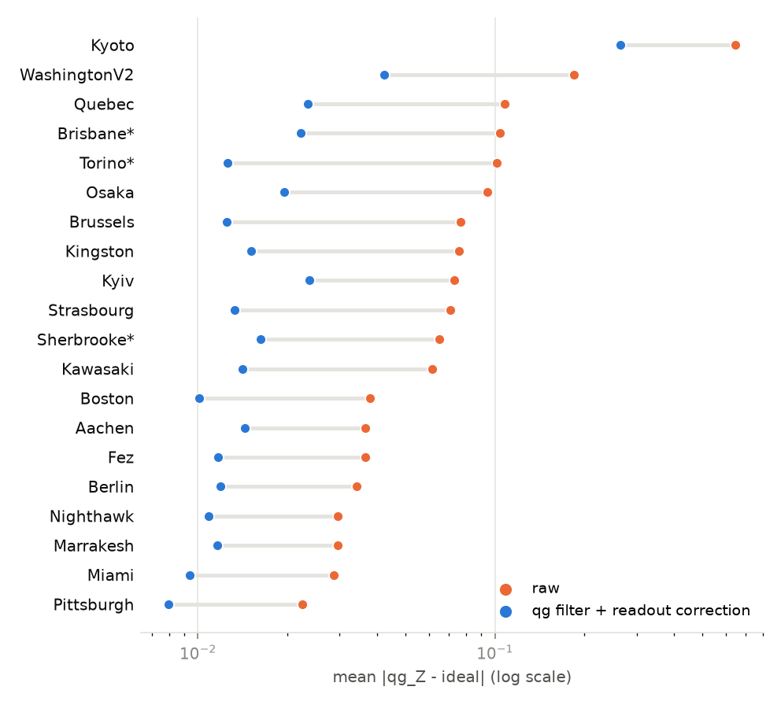
Raw and filtered (+ read-out corrected) $qg_{Z}$ error on twenty IBM device noise models. Starred: §137 (ten circuits, 8000 shots); the others: §144 (five circuits, 4000 shots), devices not used before.
On the eighteen other fake backends with at least 100 qubits (ECR, CZ and CX devices of 120–156 qubits), the filter cut the error 2.4–8.9$×$ on every one of the seventeen that ran (Fig. 1; median raw / filtered + read-out 3.12). The three predictions nonetheless failed as written: one device crashed (two predictions required all eighteen), and filter + read-out was lowest on 10 of 17, the filter alone on the other 7, where read-out errors are small and correcting them adds variance. The crash was a bug of the library: FakeCusco publishes a qubit that always reads 1, the transpiler placed the circuit on it, and the read-out inverse was singular. After the fix, best_layout avoids that qubit and brings the filtered error from 0.098 to 0.021 (exploratory).

Predicting the kept fraction and choosing qubits (§138, §141)
Over ten layouts per device the prediction ranked the layouts correctly (Spearman 0.94–0.98, passed) and best_chain kept 6–17 points more shots than Qiskit’s default (passed), but the raw prediction was low by 0.08–0.13 (failed): it ignored shots that return to the sector. With the mixed-state floor, added after scoring, the error is 0.023–0.041. For the ring-coupled QNN, best_chain scored a different circuit from the one that ran and kept fewer shots on two devices (§139); best_layout fixes this: it was never worse than the default and gained 2.2 points where it chose a different layout (§141, two of three predictions passed).

Shot planning (§143)
For a target error of 0.02 the planner asked for 3000–3400 shots (0.8–0.9 device seconds); over 30 repetitions the worst qubit’s error was 0.021–0.023 (passed). The per-qubit prediction was 1.4–1.6$×$ too low on average (failed): qubits near a pole ($\left|qg_{Z}\right|>0.8$) are underestimated 2.4–3.1$×$, because noise pulls their $qg_{Z}$ away from $±1$; the plan is set by the worst qubit and still met the target.

The QNN (§139–§141)
Correct decisions of 567 (189 inputs on each of three devices; 555 noiselessly), 1000 shots.
 | raw | filter | filter + read-out
run_qnn, default layout (§139) | 545 | 550 | 549
run_qnn, best_chain (§139) | 547 | 551 | 551
run_qnn, best_layout (§141) | 545 | 549 | 550
qiskit-machine-learning SamplerQNN (§140) | 547 | 548 | –
The one-job template agrees with per-input circuits (550 against 551, passed) and qiskit-machine-learning reproduces the library’s own path (548, passed), but the filter recovers only 5–6 of the 10 decisions noise costs, and read-out correction changes no decision (Table 2). Runs with the identical layout differ by up to two decisions, so differences of that size are shot noise. Wrapping the QNN in qiskit-machine-learning 0.9.1 exposed that, with a device pass manager, SamplerQNN reads measured bits at the physical-qubit positions of the layout, so a circuit measured before transpilation reads every shot as 0 unless its layout is $\left[0,…,n−1\right]$; the library transpiles itself and drops the layout, and the issue was reported upstream.

A PCA spectrum (§146)
Five features, 16 samples from a Gaussian with standard deviations $\left(2.0,1.4,1.0,0.6,0.35\right)$ on random axes; exact spectrum $\left(0.640,0.203,0.122,0.023,0.011\right)$; one circuit per sample (4 + 10 RBS, 26–28 native two-qubit gates), 2000 shots, on the three devices of §137 and the eighteen of §144, FakeCusco included after the fix. Error is L1=k​λk−λk/∑λ. All four predictions passed: noiselessly $L_{1}=0.020$; all twenty-one ran and filter + read-out was below raw on every one; the median ratio raw / filter + read-out was 4.6 (1.6–7.7); and the five eigenvalues came out in order on 18 of 21 (raw 13, read-out 14, filter 18). Median $L_{1}$: raw 0.266, read-out 0.166, filter 0.062, filter + read-out 0.048. The raw estimate is biased upwards for every eigenvalue, because shots that leave the sector add excitations on all qubits (the raw spectrum sums to more than 1); the filter removes that bias. What remains is a flattening of the spectrum that grows as the kept share falls: on FakeKyoto (15% kept) the order is lost, and on FakeBrisbane only the two smallest eigenvalues, 0.012 apart, swap. Quantum PCA’s exponential speed-up rests on the assumption that copies of $ρ$ are given (Tang 2021); this experiment makes no claim on it.

Discussion
As a read-out tool the filter is robust: on every one of twenty IBM device noise models it lowered the $qg_{Z}$ error by a factor of 2.4 or more, and it combines with read-out correction and with zero-noise extrapolation. Which combination is best depends on the device: read-out correction helps where read-out errors are large and adds variance where they are small. The calibration also tells, before any device time is spent, how many shots the filter will keep, which qubits keep most, and how many shots a target precision needs.
The limits are as clear. The gain in classification accuracy is small, because the model’s decisions are mostly far from threshold; spectrum estimation, where the answer is a set of probabilities rather than a decision, gains more (4.6$×$). Nine of the twenty-seven predictions failed as written, several through the analysis rather than the filter: a prediction that ignored returning shots, a per-qubit error model that ignored the poles, and an experiment that required every device to run. And all results are on device noise models, which model gate, relaxation, dephasing and read-out errors as independent channels; leakage, crosstalk and drift are absent. A run on hardware is the next step.

Code and data availability
Everything is in the open-source library qang (MIT license), version 0.9.0 and later (the functions of §146 are in the repository and in the next release): https://github.com/Viny2030/qang, pip install qang. The module is qang.ibm (with qang.qiskit_ml); each section has a script in examples/ and its output in examples/data/; docs/ibm_quickstart.md shows the workflow.
from qang import ibm
t = transpile(qc, backend) # qc: weight-preserving, measured
res = Sampler(mode=backend).run([t]).result()[0]
ibm.ibm_qg(res, t, backend, weight=1)["filtered_readout"]
Bonet-Monroig, Xavier, Ramiro Sagastizabal, M. Singh, and Thomas E. O’Brien. 2018. “Low-Cost Error Mitigation by Symmetry Verification.” Physical Review A 98: 062339.
Bravyi, Sergey, Sarah Sheldon, Abhinav Kandala, David C. Mckay, and Jay M. Gambetta. 2021. “Mitigating Measurement Errors in Multiqubit Experiments.” Physical Review A 103: 042605. https://doi.org/10.1103/PhysRevA.103.042605.
Giurgica-Tiron, Tudor, Yousef Hindy, Ryan LaRose, Andrea Mari, and William J. Zeng. 2020. “Digital Zero Noise Extrapolation for Quantum Error Mitigation.” In 2020 IEEE International Conference on Quantum Computing and Engineering (QCE), 306–16. https://doi.org/10.1109/QCE49297.2020.00045.
IBM Quantum. 2026. “Qiskit IBM Runtime Client, Version 0.50.” https://github.com/Qiskit/qiskit-ibm-runtime.
Javadi-Abhari, Ali et al. 2024. “Quantum Computing with Qiskit.” https://doi.org/10.48550/arXiv.2405.08810.
Lloyd, Seth, Masoud Mohseni, and Patrick Rebentrost. 2014. “Quantum Principal Component Analysis.” Nature Physics 10: 631–33. https://doi.org/10.1038/nphys3029.
McArdle, Sam, Xiao Yuan, and Simon Benjamin. 2019. “Error-Mitigated Digital Quantum Simulation.” Physical Review Letters 122: 180501.
Monteverde, Vicente Humberto. 2026a. “The Qang (Qg): A Unified Angular-Probability Unit and Metric for Parametric Quantum Circuit Design.” https://doi.org/10.5281/zenodo.22832150.
———. 2026b. “Training Quantum Neural Networks for T1-Limited Hardware: What the Qg Symmetry Filter Does and Does Not Do.”
Qiskit community. 2026. “Qiskit Machine Learning, Version 0.9.1.” https://github.com/qiskit-community/qiskit-machine-learning.
Tang, Ewin. 2021. “Quantum Principal Component Analysis Only Achieves an Exponential Speedup Because of Its State Preparation Assumptions.” Physical Review Letters 127: 060503. https://doi.org/10.1103/PhysRevLett.127.060503.
Temme, Kristan, Sergey Bravyi, and Jay M. Gambetta. 2017. “Error Mitigation for Short-Depth Quantum Circuits.” Physical Review Letters 119 (18): 180509. https://doi.org/10.1103/PhysRevLett.119.180509.

