The register-mean polar bias as a symmetry witness:
error mitigation, constrained optimization and qubit characterization in qg units
Vicente Humberto Monteverde
Universidad del Museo Social Argentino (UMSA), Argentina
ORCID 0000-0001-8884-4811
Keywords: Symmetry witness, Quantum error mitigation, Qubit characterization, Symmetry verification, Zero-noise extrapolation, Trapped-ion qubits
Draft of 29 September 2026
Abstract
In the qg framework [1] a qubit is described by its polar bias $qg_{Z}=⟨σ_{z}⟩$. When a circuit conserves a Hamming weight, the average of $qg_{Z}$ over the register is fixed in advance: ${\overline{qg}}_{Z}=1−2N/n$ for $N$ excitations on $n$ qubits. This one number is a reference-free witness of noise that changes the conserved quantity, and its shot-level version is the known symmetry-verification filter [2], [3]. We measure when the witness and the filter help, and when they do not, on seven problems with classical controls and on four molecules for the rotated-basis extension, using calibration-based and vendor noise models. (i) On H$​_{2}$ the filter lowers the energy error from 18 to 5.5 mHa, below Hartree–Fock (20.3 mHa), and it stays below Hartree–Fock along the dissociation curve. (ii) Across noise channels the witness predicts the outcome: it moves under T1 and the filter removes 94–95% of the error for free, while under dephasing it stays at its ideal value and the filter does nothing. Zero-noise extrapolation is complementary and fails on idle decoherence; the combination reaches $2.0±3.9$ mHa. (iii) With separate spin-up and spin-down witnesses, a second filter pays off only when a spin-leak witness is nonzero. Qubit routing on a heavy-hex device creates such leak in 1D Hubbard dynamics. (iv) In QAOA with an “exactly $K$” constraint, the filter doubles the success probability of the constraint-preserving ansatz. Penalty QAOA at depth $≤2$ does not beat a random feasible guess, and a greedy algorithm beats all quantum variants. (v) The witness relies on calibrated readout. A heralded sweep separates thermal population from asymmetric readout error, which the standard calibration conflates, and gives an unbiased effective temperature ($±1$ mK) together with $T_{1}$ and $T_{2}$. (vi) On IonQ’s trapped-ion noise models the filter doubles the constraint-preserving QAOA success and halves the H$​_{2}$ error in every run, while zero-noise extrapolation, which must fold native gates because CX folding is undone by the compiler, is nearly unbiased but too noisy at the 2000-shot limit. (vii) Beyond symmetries, every stabilizer expectation of the repetition and Leung codes is a power of one single-qubit qg, so the syndromes track noise drift for free and choose between codes by the rule $T_{2}>T_{1}$. (viii) Z-basis filtering cannot reach Hamiltonian terms measured in rotated bases, which hold most of the LiH error. Parity and $N$ mod 4 checks on two ancillas do reach them: they cut the LiH error $6×$ (below Hartree–Fock on a generic model, $3.8×$ on IonQ’s forte-1 model) and approach the full number-projection ceiling up to 12 qubits (H$​_{4}$, H$​_{2}$O, H$​_{6}$). That ceiling shrinks with depth, because number-conserving errors grow. Coherent over-rotation of the entangling gate passes through native-gate ZNE untouched, while the filter removes 94% of it. (ix) In Heisenberg-chain dynamics every observable is read in Z, so the filter reaches all of it. It removes 99.5% of the T1 error when the two-qubit gates conserve the excitation number at every point, but only 38–49% with a 3-CNOT compilation, where a decay inside the gate can re-enter the sector. On IonQ’s forte-1 model, MS and ZZ compilations give the same gain, as predicted before the run. (x) In a circuit-level surface-code memory (distance 3 and 5), a decoder that reweights decay faults by the final data readout lowers the logical error $2.2×$ and $3.3×$ under T1, and costs 15% when depolarizing noise dominates; the register-mean $qg_{Z}$ of that readout, divided by the detector rate, picks the better decoder in all eight cases tested. We also report where the method stops: Hubbard circuits beyond $∼$190 two-qubit gates, where the witness correctly reports unital scrambling. No result is a quantum advantage over classical computation. Every number is reproduced by a script and pinned by a regression test.

1 Introduction
Near-term quantum computations are limited by noise, and error mitigation trades extra measurements or post-processing for lower bias [4], [5], [6]. When the target state has a known symmetry, such as particle number in a fermionic simulation or a cardinality constraint in optimization, outcomes that break it can be discarded. This is symmetry verification [2], [3].
This paper reads that symmetry in the language of the qg framework [1], where a qubit is described by $qg_{Z}=cosθ=⟨σ_{z}⟩$. The contribution is not the filter, which is known, but three things around it:
- a single, reference-free number, the register mean ${\overline{qg}}_{Z}$, that tells before any mitigation whether noise is breaking the symmetry and in which direction;
- a systematic comparison, with classical baselines and a standard mitigation method (zero-noise extrapolation), of when the filter helps and when it cannot;
- a calibration protocol for the readout on which the witness depends, written in the same units.
We state limits alongside results. In particular, every problem studied is classically easy at the sizes used, so the comparisons rank strategies for a quantum computation and do not claim a quantum advantage.

2 The witness
Proposition 1. Let W=i​1−Zi/2 count the qubits in $|1⟩$. For any state supported on the eigenspace $W=N$, $${\overline{qg}}_{Z}≡\frac{1}{n}\sum_{i=1}^{n}{Tr}\left(ρ Z_{i}\right)=1−\frac{2N}{n}. \text{(1)}$$
Proof. 1ni​Zi=1−2nW, and $W=N$ on the support of $ρ$. ◻
In the Jordan–Wigner encoding $W$ is the electron number. In a “choose exactly $K$” problem it is the cardinality. For a circuit that conserves $W$, the ideal ${\overline{qg}}_{Z}$ is therefore known for every value of the parameters. We use four quantities, all read from the same Z-basis shots:
- the witness ${\overline{qg}}_{Z}$. Amplitude damping (T1) moves it towards $+1$. Unital noise (depolarizing, dephasing) moves it towards the value of a maximally mixed register, 0;
- the kept fraction, i.e. the probability of the shots with $W=N$. It is 1 ideally and $\left({n \atop N}\right)/2^{n}$ for a maximally mixed register, which marks the noise floor;
- the filter: keep only those shots and renormalize (symmetry verification);
- for two conserved numbers (spin up and spin down), one witness per register and a spin leak, the fraction of right-$N$ shots in the wrong spin sector.
Observables measured in rotated bases, such as the $XXYY$ terms of a molecular Hamiltonian, cannot be filtered this way. The witness is linear in $ρ$, so its estimator from counts is an unbiased sample mean.
Readout. Readout errors enter as an affine map. If a qubit reads 1 when in $|0⟩$ with probability $e_{01}$ and 0 when in $|1⟩$ with probability $e_{10}$, then
$$qg_{Z}^{meas}=a+b qg_{Z}, a=e_{10}−e_{01}, b=1−e_{01}−e_{10}. \text{(2)}$$
An asymmetric readout ($a≠0$) therefore shifts the witness the way T1 does. Section 8 shows how to calibrate $a$ and $b$ without confusing them with the thermal population of the qubit.

3 Methods
Noise models. (a) fake_brisbane: Qiskit Aer [7] with the noise model built from an IBM device’s calibration data (ECR gates, heavy-hex connectivity, thermal relaxation during scheduled idle times, readout errors), on a chain of the best-calibrated qubits. An optional idle delay before readout amplifies T1. (b) Controlled channels applied to every CX (so that gate folding scales them exactly): amplitude damping, phase damping or two-qubit depolarizing noise of strength $p$, or symmetric readout error only. (c) A generic all-to-all device dominated by depolarizing two-qubit error (0.6% per CX, 0.1% dephasing, 0.5% readout), with trapped-ion-like figures but not a vendor calibration. (d) IonQ’s aria-1 and forte-1 noise models, run on IonQ’s cloud simulator.
Mitigation. All quantum estimates include tensored readout-error mitigation unless stated. Zero-noise extrapolation (ZNE) [4], [5] folds every two-qubit gate $G$ into $G^{3}$ and $G^{5}$ and extrapolates to zero noise with Richardson weights $\left(15,−10,3\right)/8$. “ZNE + qg” filters at every noise scale and then extrapolates.
Statistics. Unless stated, 20,000 shots per circuit and mean $±$ standard deviation over 10 simulator seeds. The references are exact classical results (FCI, exact diagonalization, brute force) at these sizes.

4 Chemistry
H$​_{2}$ (STO-3G, 0.735 Å) in the Jordan–Wigner encoding uses 4 qubits and 2 electrons, so the ideal ${\overline{qg}}_{Z}$ is 0. A number-conserving ansatz with one parameter reaches the FCI energy without noise. On fake_brisbane (Table 1) the witness rises with the idle delay, in step with the fraction of shots that lost an electron. The filter lowers the error $3.2×$ below readout mitigation alone and $3.7×$ below classical Hartree–Fock. Its gain grows with T1. Along the dissociation curve Hartree–Fock fails increasingly, while the filtered quantum estimate stays within 6–20 mHa, $11×$ below Hartree–Fock at 2.5 Å.
Table 1: H$​_{2}$ on fake_brisbane, energy error vs FCI (mHa), mean of 3 seeds. Hartree–Fock: 20.3 mHa.
idle delay | ${\overline{qg}}_{Z}$ | kept | raw | + readout | + readout + qg filter
0 $μ$s | $+0.011$ | 0.91 | 74 | 18 | 5.5
20 $μ$s | $+0.057$ | 0.83 | 140 | 90 | 20
50 $μ$s | $+0.122$ | 0.72 | 231 | 188 | 30
Trapped-ion noise. On IonQ’s aria-1 and forte-1 noise models (2000 shots, 3 runs) the witness barely moves ($+0.004$, $+0.005$) and only 2–3% of the shots violate the electron number. Dropping them still lowers the error from $∼$30 to $∼$12 mHa, because number-violating outcomes sit at very high energy. The run-to-run spread is about $±8$ mHa.
Spin-resolved witnesses. H$​_{2}$ also conserves $N_{↑}$ and $N_{↓}$ separately. Keeping one up and one down electron removes two more bit strings. Under depolarizing noise on the CXs the spin leak is 1.5–5%, and the second filter removes a further 34–37% of the error (23.2 $→$ 14.7 mHa at $p=0.03$). On fake_brisbane the leak is below 1% and the gain is within the seed spread (6.5 $→$ 5.9 mHa). The residual $∼$5 mHa of Table 1 is in the $XXYY$ terms and in errors that preserve both numbers, not in spin leak.
Where it stops. For LiH at 3.0 Å (6 qubits, ideal ${\overline{qg}}_{Z}=1/3$) the ansatz needs 60 ECR gates. Every quantum estimate is then $∼9×$ worse than Hartree–Fock, and the filter does not help. The witness explains why: ${\overline{qg}}_{Z}$ falls from $+0.333$ to $+0.18$, towards 0 and not towards $+1$. The dominant error is unital scrambling, which leaves the kept shots scrambled too.

5 Which noise does the filter fix?
Table 2 compares the filter with ZNE on the same H$​_{2}$ state. Three regularities appear (Fig. 1).
- The witness predicts whether the filter works. Dephasing preserves the electron number. The witness stays at 0, every shot is kept, and the filter changes nothing; only ZNE helps. T1 moves ${\overline{qg}}_{Z}$ up by about $p$, and the filter removes 94–95% of the error with no extra circuits and less spread than ZNE.
- The methods are complementary. ZNE overshoots under T1, by $−4$ to $−6$ mHa, because amplitude damping is not linear in the fold count, and it doubles or triples the spread. Under strong depolarizing noise only the combination comes within a few mHa.
- Idle decoherence defeats ZNE. Gate folding does not scale a 50 $μ$s idle period (189 $→$ 177 mHa). The witness flags it ($+0.122$), and the filter removes 84% of the error.
This gives a decision rule. If ${\overline{qg}}_{Z}$ leaves $1−2N/n$ or the kept fraction drops, apply the filter, which is free. If the error stays large with the kept fraction near 1, the remaining noise preserves the symmetry and needs ZNE.
Coherent gate errors. Vendor noise models are stochastic, but real two-qubit gates also over-rotate. We scaled every native Mølmer–Sørensen angle by $1+ϵ$ in an exact density-matrix simulation of the native H$​_{2}$ circuits, with Forte-like stochastic noise on top. Native folding cannot amplify such an error: $MS\left(ϕ_{0}+1/2\right)$ is the exact inverse of the same over-rotated gate, so $MS {MS}^{−1}MS=MS$ to ${10}^{−16}$.
- ZNE passes the coherent error through. At $ϵ=5\%$ its result moves by $+2.96$ mHa, which is the coherent-only error (2.97 mHa).
- The filter removes 94% of it. An over-rotated CX leaks weight out of the two-electron sector to first order, and the filter removes that leaked weight.
- The combination is the most robust. ZNE + filter stays at 1.6–1.8 mHa over the whole range.
- Drift. When $ϵ$ drifts between jobs, the filter does not move, while ZNE’s spread grows.
Table 2: H$​_{2}$, error vs FCI (mHa), mean $±$ std over 10 seeds. Controlled noise acts on every CX.
noise | ${\overline{qg}}_{Z}$ | kept | readout-mitigated | + qg filter | + ZNE | + ZNE + qg
T1, $p=0.03$ | $+0.029$ | 0.94 | 36.6 | $2.0±1.6$ | $−4.0±3.1$ | $−2.0±2.9$
T1, $p=0.10$ | $+0.099$ | 0.81 | 128.9 | $7.4±1.5$ | $−5.7±5.3$ | $−0.6±3.5$
dephasing, $p=0.10$ | $0.000$ | 1.00 | 10.2 | $10.2±1.7$ | $2.1±3.3$ | $2.1±3.3$
depolarizing, $p=0.03$ | $+0.007$ | 0.96 | 60.8 | $23.2±2.3$ | $0.3±4.5$ | $−2.3±3.8$
depolarizing, $p=0.10$ | $+0.021$ | 0.86 | 193.5 | $81.3±3.8$ | $17.5±8.2$ | $−3.3±8.8$
readout, $p=0.03$ | $0.000$ | 0.89 | $−0.6$ | $−0.6±1.2$ | $−1.9±2.9$ | $−1.9±2.1$
fake_brisbane | $+0.011$ | 0.90 | 20.6 | $6.5±1.6$ | $6.8±5.9$ | $2.0±3.9$
fake_brisbane, 50 $μ$s idle | $+0.122$ | 0.72 | 189.3 | $31.1±1.3$ | $176.6±4.1$ | $27.2±4.1$
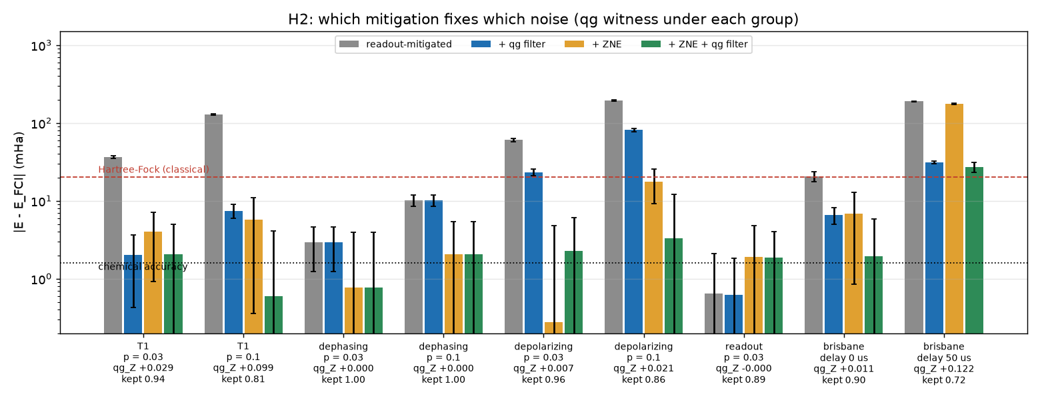
Figure 1: Energy error of H$​_{2}$ by noise type and mitigation (log scale). Under each group, the qg witness and the kept fraction read from the unmitigated shots.

6 Materials: 1D Hubbard dynamics
The Fermi–Hubbard chain with $L=4$ sites ($J=1$, $U=2$, 8 qubits, spin blocks in Jordan–Wigner) evolves by first-order Trotter steps ($dt=0.25$) from a charge-density wave with sites 0 and 2 doubly occupied, a standard hardware benchmark [8]. The Hamiltonian conserves $N_{↑}$ and $N_{↓}$, and here every observable of interest (charge imbalance $I$, double occupancy $D$) is diagonal in $Z$, so the filters act on all of them. The reference is the noiseless output of the same Trotter circuit.
On the all-to-all device (20 CX per step) the filters roughly halve the error. The spin filters add a further 30% at depth, as the spin leak grows from 0 to 8%. ZNE + spin filters gives the best double occupancy: time-averaged error 0.003 vs 0.019 raw. The witnesses stay at 0 because the noise is unital, but the kept fraction falls from 0.88 to 0.50.
On fake_brisbane routing the ladder of hops and interactions costs 56 ECR per step, and routing creates spin leak: 8, 16, 41, 45 and 47% of the right-$N$ shots sit in the wrong spin sector after 1, 2, 4, 6 and 8 steps (H$​_{2}$: $<1\%$). The spin filters therefore beat the $N$ filter clearly (Table 3). From 4 steps ($≥188$ ECR, 18% of shots kept) every method sits on the noise floor. $D→1/4$, the value of the maximally mixed state inside the spin sector, and $I→0$ (Fig. 2). With the current fake_brisbane snapshot mostly the spin-down register drifts towards $+1$; with an older snapshot both do. The per-register witnesses report the calibration, not a property of the method.
Table 3: 1D Hubbard on fake_brisbane: absolute error of $D$ and $I$ vs the noiseless Trotter circuit (5 seeds).
 | $D$, 1 step | $D$, 2 steps | $I$, 1 step | $I$, 2 steps
readout-mitigated | .081 | .056 | .206 | .111
+ $N$ filter | .050 | .029 | .124 | .070
+ spin filters | .039 | .016 | .100 | .047
+ ZNE | .031 | .031 | .036 | .010
+ ZNE + spin filters | .009 | .006 | .035 | .071
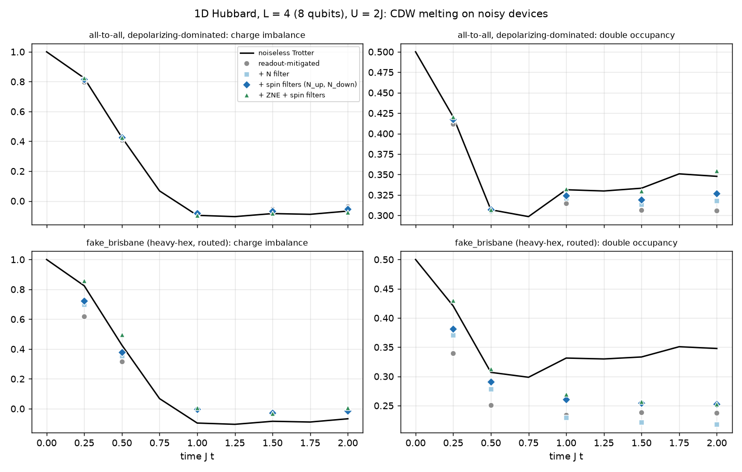
Figure 2: Charge-density-wave melting in the 1D Hubbard model on two simulated devices. Black: noiseless Trotter circuit.

7 Constrained optimization: QAOA with “exactly $K$”
Maximum $K$-vertex cover asks for exactly $K$ of $n$ vertices that touch the most edges. With $x_{i}=\left(1−Z_{i}\right)/2$ the constraint is ${\overline{qg}}_{Z}=1−2K/n$ (0.25 for $n=8$, $K=3$). We compare standard penalty QAOA [9]; a budget start, with every qubit at $qg_{Z}=1−2K/n$ and the mixer rotated about that axis, which needs no classical pre-solve; a warm start with $qg_{Z}^{\left(i\right)}=1−2c_{i}$ from the LP relaxation $c$ [10], clipped to $\left|qg_{Z}\right|≤0.5$ (Egger’s $ε=0.25$); and the constraint-preserving XY-mixer ansatz [11] started from a Dicke state [12]. Angles are optimized without noise, and 4000 shots are taken on 5 random graphs $G\left(8,1/2\right)$.
On the all-to-all device (Fig. 3) the filter doubles the probability that a shot is optimal for the XY ansatz: 0.150 $→$ 0.278 at depth 1 and 0.177 $→$ 0.366 at depth 2. Because that ansatz is 100% feasible without noise, its kept fraction (0.54) is a pure error witness. Penalty QAOA at depth $≤2$ does no better than a random feasible guess after filtering (probability of the optimum 0.10–0.18 vs 0.096, approximation ratio 0.78 vs 0.77). The budget start raises the raw feasibility but not the quality. The warm start is the best penalty variant, but its LP relaxation is already integral on 3 of 5 graphs, so its value is classical. On fake_brisbane (134–497 ECR) every variant ends at the random-feasible level. The kept fraction (0.24–0.33) is then close to $\left({8 \atop 3}\right)/2^{8}=0.22$, which tells the user that no signal is left. A greedy algorithm reaches 98.5% of the optimum, and brute force is instant.
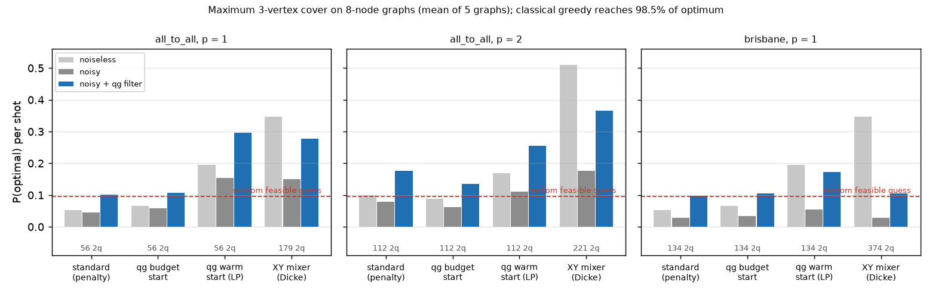
Figure 3: Probability that one shot is an optimal cover, noiseless, noisy, and noisy + qg filter. The dashed line is a random feasible guess. The number of two-qubit gates is under each group.

8 Calibrating what the witness relies on
Eq. (2) makes the witness depend on $a$ and $b$. A real qubit also idles with an excited population $p$, with $qg_{Z}^{eq}=1−2p=tanh\left(hf/2k_{B}T_{eff}\right)$ [13]. The standard calibration prepares “$|0⟩$” (the thermal state) and “$|1⟩$” (X on it). From Z-basis data alone it sees only $a+b qg_{Z}^{eq}$ and $b qg_{Z}^{eq}$, so it counts thermal population as readout error.
Heralded sweep. Measure once (herald), apply I, X or $R_{y}\left(π/2\right)$, wait $t$, rotate back and measure again. For outcomes $r_{1},r_{2}=±1$ at $t=0$ and a QND herald,
$$m=E\left[r_{1}\right]=a+bq, V=E\left[r_{1}r_{2} | I\right]−m^{2}=b^{2}\left(1−q^{2}\right), C_{X}=E\left[r_{1}r_{2} | X\right]=a^{2}−b^{2}, \text{(3)}$$
with $q=qg_{Z}^{eq}$. Hence $u=bq=\left(m^{2}−V−C_{X}\right)/\left(2m\right)$, $b=\sqrt{V+u^{2}}$ and $a=m−u$. The delays add $T_{1}$ (after X) and $T_{2}$ (the decay of $qg_{X}$ after $R_{y}\left(π/2\right)$). A joint maximum-likelihood fit of all joint counts returns $\left(a,b,q,T_{1},T_{2}\right)$ with the same circuit and shot budget as the standard suite. The model is checked against a Qiskit Aer circuit that prepares the thermal state by purification.
Result. With $T_{1}=100 μ$s, $T_{2}=70 μ$s, $e_{01}=0.015$, $e_{10}=0.04$ and a 5 GHz qubit (Fig. 4), the standard suite reports $T_{eff}=0$ at every temperature and overestimates $e_{01}$ by exactly $pb$ (0.0915 at $p=0.08$). The heralded sweep is unbiased: $e_{01}$ is $0.0148$–$0.0152$ and $T_{eff}$ is $52.3±1.0$, $69.0±0.8$ and $98.2±0.9$ mK at true 52, 69 and 98 mK. Both protocols give unbiased $T_{1}$ and $T_{2}$; the joint fit is about $1.5×$ more precise. If the herald is not QND, with 5% relaxation of $|1⟩$ during it, the estimates move by about 0.001. Separating thermal population by repeated measurement is known practice. What qg adds is the closed form and $T_{eff}$ read directly from $qg_{Z}^{eq}$. The protocol needs mid-circuit measurement.
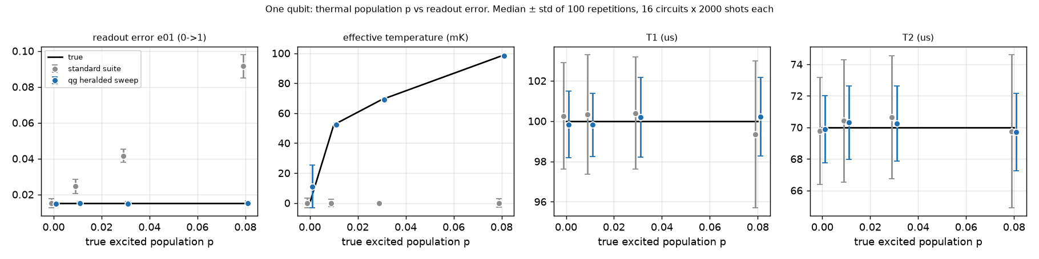
Figure 4: Standard calibration (gray) vs heralded qg sweep (blue); black: truth. Median $±$ std of 100 repetitions, 16 circuits $×$ 2000 shots each.

9 Trapped-ion noise models
IonQ devices are all-to-all, so the routing that dominated Sections 6 and 7 disappears. We reran the Hubbard, QAOA and H$​_{2}$ experiments on IonQ’s cloud simulator with its aria-1 and forte-1 noise models (2000 shots per circuit, the simulator’s limit; vendor noise models, not hardware).
Hubbard. Without routing the spin leak is small at shallow depth (0.1% at one step, against 8% on fake_brisbane), as expected. It still grows with depth (8.3% and 11.5% at six steps), and there the spin filters beat the $N$ filter. Averaged over 1, 2, 4 and 6 steps, the error of the double occupancy is 0.022 / 0.016 / 0.013 (readout-mitigated / $N$ filter / spin filters) on aria-1 and 0.029 / 0.021 / 0.017 on forte-1. The register witnesses stay at 0 (unital noise); the kept fraction does the reporting.
QAOA. The filter raises the probability that a shot is optimal for the XY ansatz from 0.155 to 0.276 (depth 1) and from 0.174 to 0.363 (depth 2) on aria-1, and from 0.120 to 0.256 and 0.111 to 0.293 on forte-1. This reproduces the all-to-all result of Section 7, while on fake_brisbane the same circuits fell to the random-guess level: connectivity is what keeps the signal.
H$​_{2}$: filter vs ZNE at a small shot budget. Folding CX gates does not amplify the noise on IonQ: the service recompiles circuits written in the standard gate set and the folded pairs vanish (a Bell pair keeps $P\left(00\right)+P\left(11\right)=0.99$ with 1 to 21 CX). We therefore fold the native Mølmer–Sørensen gates, $MS→MS MS\left(ϕ_{0}+1/2,ϕ_{1}\right) MS$, which the service runs as written (raw error 31 $→$ 84 $→$ 133 mHa at scales 1, 3, 5). Over six runs per model (Table 4) the filter halves the error in every run and its mean is below Hartree–Fock, whereas ZNE is nearly unbiased but its extrapolation amplifies shot noise to $±$17–20 mHa, so its typical error is larger. This reverses Section 5, where 20,000 shots per circuit favoured ZNE + qg: the preferred method depends on the shot budget.
Table 4: H$​_{2}$ on IonQ noise models, error vs FCI (mHa), mean $±$ std over 6 runs, 2000 shots per circuit. Hartree–Fock: 20.3 mHa.
noise model | readout-mitigated | + qg filter | + ZNE (MS folding) | + ZNE + qg
aria-1 | $31.5±7.8$ | $14.7±5.8$ | $4.2±20.3$ | $5.5±16.9$
forte-1 | $34.8±6.3$ | $13.9±5.4$ | $6.6±19.0$ | $3.0±17.8$

10 Reaching the rotated bases: parity and $N$ mod 4 checks
The filter acts on Z-basis shots only. Every Hamiltonian group measured in a rotated (X/Y) basis is untouched. This is why it failed on LiH, and it was not the reason given earlier. We split the energy error of the 6-qubit LiH circuit (60 two-qubit gates, error against the noiseless circuit) by measurement group:
- Where the error sits. In H$​_{2}$, 13.0 of 13.9 mHa sit in the single Z group, which the filter reaches. In LiH, 26–166 mHa sit in the 16 X/Y groups.
- Why it is not routing. The ansatz is nearest-neighbour and needs the same 20/40/60 gates on an all-to-all device.
- A witness-based fix fails. Rescaling the X/Y groups by the depolarizing strength read from the kept fraction overcorrects by 2–3$×$, because local gate noise is not global depolarizing.
Two checks do reach every group, because both commute with every number-conserving term. They are measured on ancillas before the basis rotation:
- Parity. The electron-number parity $Z_{0}⋯Z_{n−1}$, read with $n$ CNOTs.
- $N$ mod 4. A Hadamard test of eiπN/2=j​Sj, read with $n$ controlled phases. On the even sector it gives $N$ mod 4, so it also rejects the errors that change $N$ by two, which parity cannot see.
Table 5 gives the ideal projections on the noisy density matrix and the full number-projection ceiling.
Table 5: Error vs the noiseless circuit (mHa) with ideal projections on the noisy density matrix (generic all-to-all model, 3 ansatz layers).
molecule | qubits | CX | no check | parity | $N$ mod 4 | $N$ (ceiling)
LiH | 6 | 60 | 76.1 | 49.4 | 6.9 | 6.2
H$​_{4}$ (1.5 Å) | 8 | 84 | 238.5 | 146.4 | 72.2 | 70.5
H$​_{2}$O (4e, 4o) | 8 | 84 | 292.2 | 187.5 | 48.8 | 44.0
H$​_{6}$ (1.5 Å) | 12 | 132 | 407.6 | 279.9 | 143.8 | 135.2
- Once the checks reach every group, symmetry verification works for LiH. Built with two real (noisy) ancillas and 18 extra CNOT-equivalents, the checks cut the error from 83.9 to 13.4 mHa. That is about 14 mHa above FCI, just below Hartree–Fock (16.3) on this noise model. Parity alone recovers only about a third.
- On IonQ’s forte-1 model (5 runs, 2000 shots), the same checks cut the error from $145±10$ to $39±9$ mHa (3.8$×$), which stays above Hartree–Fock. We record this as a pre-registered hardware prediction.
- Scaling. $N$ mod 4 comes within 2–10% of the full number projection up to 12 qubits, so two ancillas suffice. What shrinks is the ceiling itself: the share of the error that changes $N$ falls from 92% (LiH, 60 CX) to 67% (H$​_{6}$, 132 CX). The rest conserves the electron number and needs a partner method (ZNE, or other symmetries).
- Spin-resolved checks. The Hamiltonian also conserves $N_{↑}$ and $N_{↓}$ separately. With an ansatz that respects this, checking both (four ancillas, the same 24 extra two-qubit gates as the total check) removes a further 12–21% of the error beyond the total-number ceiling with ideal projections, and 16–29% with real ancillas. The gain is modest because most of the residual error conserves both quantities.
- Stretched hydrogen chains. There Hartree–Fock fails, and the checked estimates fall below it (H$​_{4}$ with ancillas: about 151 vs 167 mHa above exact).
Parity checks with an ancilla are standard symmetry verification [2], and $N$ mod 4 is its direct extension. What the qg analysis adds is the diagnosis that led to them and the measurement of how their reach and ceiling scale.

11 Where the filter reaches everything: Heisenberg-chain dynamics
In LiH most of the error sits in terms measured in rotated bases, which a Z-basis filter cannot see (Sec. 10). The opposite case is the dynamics of an XXZ chain, H=i​JXiXi+1+YiYi+1+ΔZiZi+1, started from a Néel state and followed through the imbalance It=1ni​−1i qgZ,i. $H$ conserves $N$, every observable is in Z, and every shot can be checked. We simulated $n=6$ and 8 qubits, 1–8 Trotter steps, with each bond compiled either to three CNOTs or to two number-conserving gates (an XY and a ZZ interaction), at equal noise budget per bond.
Table 6: Share of the imbalance error removed by the filter, one noise at a time (4 Trotter steps, $n=6$; $n=8$ in brackets).
noise | 3 CNOT per bond | number-conserving gates
two-qubit depolarizing | 41% (36%) | 41% (36%)
readout | 94% | —
Z dephasing | 2% | 0%
amplitude damping | 49% (38%) | 99.5% (99.4%)
Table 6 shows the new point. Every decay lowers $N$, and the no-jump part of amplitude damping is uniform on a fixed-$N$ sector: with decay applied between Trotter steps the filter removes it to ${10}^{−15}$. Inside a 3-CNOT bond, however, the intermediate states leave the sector, and a decay there can be rotated back into it and pass the filter. With gates that keep $N$ at every point the leak closes. Small-angle MS rotations leak little (99.6% removed at $dt=0.1$, 83% at $dt=0.75$); what leaks is a basis change around a two-qubit gate. For mixed noise, filter plus ZNE is 2.6–8$×$ below the best single method up to 4 steps with CNOTs; with number-conserving gates the filter alone has the lowest error at 2000 shots, because ZNE then only adds variance. The kept fraction falls to 11% at 8 steps.
On IonQ’s forte-1 model (5 runs of 12 circuits, 2000 shots), the XY model compiled with MS gates or with native ZZ gates wrapped in basis changes gives the same share of error removed (0.45 and 0.55, ratio 0.82). The prediction, written before the run, was a ratio within 0.8–1.25 if the vendor model is depolarizing-type: trapped ions have no T1 on these time scales, so the compilation leak is a T1 effect for platforms such as superconducting qubits. Symmetry verification with number-conserving gates was used in Google’s Fermi–Hubbard experiment [8]; the contribution here is the per-noise reach and the measured leak.

12 Beyond symmetries: syndromes as qg witnesses
In a code-capacity model with amplitude damping $γ$ and dephasing $p$ per round, the single-qubit witness is $qg_{X}=\sqrt{1−γ} \left(1−2p\right)$ for $|+⟩$ and $qg_{Z}=−1+2γ$ for $|1⟩$. Every stabilizer expectation of the codes we consider is a power of it: $⟨X_{1}X_{2}⟩=qg_{X}^{2}$ for the phase-flip code, and $⟨XXXX⟩=qg_{X}^{4}$, $⟨Z_{0}Z_{1}⟩=1−2γ\left(1−γ\right)$ for the 4-qubit amplitude-damping code of Leung et al. So the qg of each syndrome ancilla inverts in one line to $\left(γ,p\right)$ while the code runs.
Which code. Repetition codes do not correct T1; the Leung code does, with logical infidelity $≈0.92γ^{2}$ instead of $γ/3$, but it is fragile to dephasing and beats no code only for $p<γ/4$. For one idle round ($γ=t/T_{1}$, $p=t/2T_{ϕ}$) this is a rule on $T_{2}/T_{1}$ alone: Leung code if $T_{2}>T_{1}$, no code if $0.4 T_{1}<T_{2}<T_{1}$, phase-flip code if $T_{2}<0.4 T_{1}$. A transmon with $T_{1}=100 μ$s and $T_{2}=70 μ$s is in the “no code” band; trapped ions (no T1) never need the Leung code.
Tracking drift. When $T_{2}/T_{1}$ switches between the three regimes (telegraph model, 400 windows of 1000 rounds), choosing the code from the running syndromes costs 13% more infidelity than an oracle with essentially no extra shots, against 20% for recalibrating every 10 windows and 58% for calibrating once. A hybrid that probes only while no code is running reaches 7%, within 0.6 points of probing every window with $4×$ fewer probe shots. These are idealized models (perfect syndrome extraction, synthetic drift), and the codes are known; the contribution is the qg reading and the rules.
A witness that chooses the decoder. In a circuit-level Z-memory of the rotated surface code (distance $d=3$ and 5, $d$ rounds of syndrome extraction, decay, depolarizing and readout noise), amplitude damping only turns 1 into 0. A data qubit read as 1 at the end has therefore almost never decayed. A matching decoder whose decay faults are reweighted per shot by the final data readout lowers the logical error $2.2×$ ($d=3$) and $3.3×$ ($d=5$) under T1, and $1.6$–$2.0×$ when T1 dominates; the gain grows with distance. When depolarizing noise dominates it costs 15% at $d=3$. The register-mean $qg_{Z}$ of the final readout is 0 for any symmetric flip and positive under decay; divided by the detector firing rate, measured on a separate batch, it is 1.3–2.6 where the reweighted decoder wins and 0.34–0.54 where it loses. The rule “reweight if the ratio exceeds 1” picks the better decoder in all eight cases (the threshold was chosen after seeing them). The X-stabilizer circuits are left out of this simulation, and bias- and erasure-aware decoders are known; the contribution is a reweighting that needs only the final readout, and the qg witness as the switch.

13 Discussion and limitations
- No quantum advantage. FCI, exact diagonalization, brute force and greedy search are exact or near-exact at every size studied. The comparisons rank strategies for a quantum computation.
- The filter is known [2], [3]. The contributions are the witness as a decision rule, the systematic comparison with ZNE and with classical baselines, and the calibration protocol.
- Walls. Beyond $∼$190 noisy two-qubit gates on heavy-hex (Hubbard), unital scrambling dominates and no method helps. The witness then reports a drift towards 0 and a kept fraction near $\left({n \atop N}\right)/2^{n}$. In chemistry, the share of the error that any number check can remove falls from 92% to 67% between 60 and 132 two-qubit gates.
- Rotated-basis terms cannot be filtered with Z-basis shots. Reaching them requires parity or $N$ mod 4 ancillas coupled to every qubit: natural on trapped ions, SWAP-heavy on heavy-hex, and 14–44% of the shots are discarded.
- Compilation. The filter catches a decay only if the circuit stays in the conserved sector around it: basis changes around two-qubit gates (CNOT compilations, a ZZ built from MS) let part of the T1 error through.
- Coherent errors. Native-gate ZNE is blind to a coherent over-rotation of the entangling gate. Only the part of that error that breaks the symmetry is removed by the checks.
- Simulation only. All devices are calibration-based or vendor noise models, including the IonQ runs, which used IonQ’s own simulator. Hardware runs are prepared (IBM, IonQ) but not yet performed. The characterization protocol assumes perfect gates and a nearly QND herald.
- Shot budget. Whether the filter or ZNE is preferable depends on the number of shots: at 2000 shots per circuit ZNE’s variance dominates, at 20,000 its lower bias wins.
- Snapshot dependence. Per-register asymmetries depend on the calibration snapshot of the fake backend.

14 Code availability
All scripts, data and the regression tests that pin every number (1050 tests at the time of writing) are at https://github.com/Viny2030/qang (MIT license): examples/chemistry_*.py, error_mitigation_qg_vs_zne.py, hubbard_trotter_qg_filters.py, qaoa_k_constraint_qg.py, hardware_characterization_qg.py, qec_leung_code_t1_qg.py, qec_syndrome_drift_tracking_qg.py, ionq_validation.py, ionq_sim_hubbard_qaoa.py, ionq_sim_zne_grover.py, coherent_drift_filter_zne.py, filter_scaling_lih_qg.py, lih_parity_verification_qg.py, ionq_sim_lih_mod4.py, symmetry_checks_scaling_qg.py, spin_checks_qg.py, xxz_trotter_filter_qg.py, ionq_sim_xxz_filter.py and surface_code_circuit_t1_qg.py; the IonQ simulator results are recorded in examples/data/ionq_sim_results.json. Sections 20, 21, 24, 28–33, 38, 39, 48, 50–55, 60, 61 and 64 of RESEARCH_NOTES.md give further detail, and notebooks/qang_avances_colab.ipynb reproduces fast versions in Colab.

Acknowledgments and use of AI tools
Generative AI tools (Anthropic Claude Opus 5.5) assisted with code generation, numerical experiments, test expansion and drafting of this text. The author framed the research questions, made the design decisions, and reviewed, edited and validated all AI-assisted output, including every number reported here.

References
[1] V. H. Monteverde, “The Qang (qg): A unified angular-probability unit and metric for parametric quantum circuit design,” 2026, doi: 10.5281/zenodo.22832150.
[2] X. Bonet-Monroig, R. Sagastizabal, M. Singh, and T. E. O’Brien, “Low-cost error mitigation by symmetry verification,” Physical Review A, vol. 98, p. 062339, 2018.
[3] S. McArdle, X. Yuan, and S. Benjamin, “Error-mitigated digital quantum simulation,” Physical Review Letters, vol. 122, p. 180501, 2019.
[4] K. Temme, S. Bravyi, and J. M. Gambetta, “Error mitigation for short-depth quantum circuits,” Physical Review Letters, vol. 119, no. 18, p. 180509, 2017, doi: 10.1103/PhysRevLett.119.180509.
[5] Y. Li and S. C. Benjamin, “Efficient variational quantum simulator incorporating active error minimization,” Physical Review X, vol. 7, p. 021050, 2017.
[6] A. Kandala, K. Temme, A. D. Córcoles, A. Mezzacapo, J. M. Chow, and J. M. Gambetta, “Error mitigation extends the computational reach of a noisy quantum processor,” Nature, vol. 567, pp. 491–495, 2019.
[7] A. Javadi-Abhari et al., “Quantum computing with Qiskit.” 2024. doi: 10.48550/arXiv.2405.08810.
[8] F. Arute et al., “Observation of separated dynamics of charge and spin in the Fermi-Hubbard model.” 2020.
[9] E. Farhi, J. Goldstone, and S. Gutmann, “A quantum approximate optimization algorithm.” 2014.
[10] D. J. Egger, J. Mareček, and S. Woerner, “Warm-starting quantum optimization,” Quantum, vol. 5, p. 479, 2021.
[11] S. Hadfield, Z. Wang, B. O’Gorman, E. G. Rieffel, D. Venturelli, and R. Biswas, “From the quantum approximate optimization algorithm to a quantum alternating operator ansatz,” Algorithms, vol. 12, no. 2, p. 34, 2019.
[12] A. Bärtschi and S. Eidenbenz, “Deterministic preparation of Dicke states,” in Fundamentals of computation theory (FCT 2019), in Lecture notes in computer science, vol. 11651. Springer, 2019, pp. 126–139.
[13] X. Y. Jin et al., “Thermal and residual excited-state population in a 3D transmon qubit,” Physical Review Letters, vol. 114, p. 240501, 2015.

