What the polar bias can and cannot do for cryptography:
telling drift from eavesdropping in BB84, and certified quantum randomness
Vicente Humberto Monteverde
Universidad del Museo Social Argentino (UMSA), Argentina
ORCID 0000-0001-8884-4811
Keywords: Quantum key distribution (BB84), Polar bias, Certified quantum randomness, Finite-key analysis, Min-entropy, Eavesdropping detection
Draft of 26 September 2026; revised 30 September 2026
Abstract
We ask where the qg description of a qubit, $qg_{Z}=⟨σ_{z}⟩$ and its companions $qg_{X},qg_{Y}$ [1], is useful for cryptography. Post-quantum cryptography (lattice-based key encapsulation such as ML-KEM [2]) is classical and has no place for it. Quantum cryptography does, because its raw data are qg values. (i) In BB84 [3] over a qubit channel with relaxation, the sum $A_{Z}=qg\left(0\right)+qg\left(1\right)$ of the received polar biases is a T1 witness. Natural relaxation raises it, while intercept-resend adds symmetric errors that leave it unchanged. A likelihood-ratio monitor built on it detects intercept-resend as well as the standard QBER monitor, but raises no false alarms when the memory’s T1 degrades, where the QBER monitor fires in 48–100% of windows. By construction it misses an attacker who mimics T1, which the QBER monitor catches, so the two are complementary and neither changes the secret-key rate. With finite keys [4] the diagnosis comes free from the error-corrected block: at ${10}^{5}$ key bits it attributes every block correctly, including a small attack hidden under drift. (ii) For a qubit random-number generator with a trusted measurement, the certified min-entropy is $H_{min}\left(Z|E\right)=−\log_{2}\left[\left(1+\sqrt{1−qg_{X}^{2}−qg_{Y}^{2}}\right)/2\right]$, independent of $qg_{Z}$. The usual output-bias estimate is unsafe whenever the state is mixed: it certifies 0.97 bits per shot where 0.015 are private. A qg estimate from $±$-rotation test rounds is safe in every run, and a readout calibration recovers 10–50% more certified bits. On IonQ trapped-ion noise models, with an environment ion that learns the output, the naive estimate stays near 1 bit while the qg estimate remains safe and captures 82–90% of the private randomness. All results are simulations, reproduced by scripts and pinned by regression tests.

Where qg does not apply: post-quantum cryptography
Post-quantum schemes such as ML-KEM (Kyber) [2] or lattice and hash-based signatures run on classical computers and are designed to resist quantum attacks. They involve no qubits and no measurement statistics, so a coordinate for qubit measurements has nothing to contribute. The threat they answer, Shor’s algorithm, does not benefit from qg either; the project’s reference notebook documents it as a non-application. We state this first so that the rest is not read as a claim about post-quantum security.

BB84: drift or eavesdropper?
Setting. Alice sends $\left|0⟩,\right|1⟩$ (Z basis) or $|±⟩$ (X basis); the qubit waits in a memory or channel with amplitude damping $γ$ (T1) and dephasing $p$; Bob measures with an asymmetric detector ($e_{01}=0.005$, $e_{10}=0.01$). This fits matter-qubit links and on-chip demonstrations, not photon-polarization links, whose noise is mostly unital. Each sent state gives one qg value at Bob,
$$qg\left(0\right)=1−2e\left(0​→​1\right), qg\left(1\right)=−1+2e\left(1​→​0\right), A_{Z}=qg\left(0\right)+qg\left(1\right)=2 \left[e\left(1​→​0\right)−e\left(0​→​1\right)\right], \text{(1)}$$
and likewise in X. $A_{Z}$ is the register-mean T1 witness of the companion paper [5]: relaxation creates only $1→0$ errors and raises it, while intercept-resend on a fraction $f$ of the qubits adds $f/4$ errors in every category and leaves it unchanged. The baseline channel has $γ_{0}=0.02$, $p_{0}=0.01$.
Monitors. Windows of $N$ compared bits, 1% false alarms on the baseline. The QBER monitor tests the total error count. The qg monitor is a generalized likelihood ratio on the four error counts, in which “attack” ($f>0$) must beat both “baseline” and “T1 drift” ($γ$ free).
Table 1: Alarm rates (1000 windows of $N=2000$ compared bits). The last column is the Shor–Preskill secret fraction $1−h\left(Q_{Z}\right)−h\left(Q_{X}\right)$ [6].
scenario | QBER monitor | qg monitor | secret fraction
baseline | 0.007 | 0.006 | 0.720
T1 drift, $γ$ $0.02→0.04$ | 0.478 | 0.009 | 0.640
T1 drift, $γ$ $0.02→0.06$ | 0.962 | 0.006 | 0.567
intercept-resend, $f=0.02$ | 0.218 | 0.271 | 0.668
intercept-resend, $f=0.05$ | 0.861 | 0.823 | 0.594
intercept-resend, $f=0.10$ | 1.000 | 0.994 | 0.481
T1-mimicking attack (extra $γ=0.04$) | 0.962 | 0.006 | 0.567
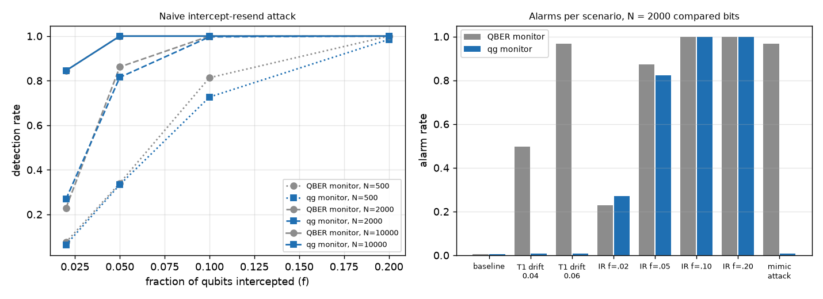
Figure 1: Left: detection of intercept-resend vs the intercepted fraction, for $N=500$, 2000 and 10,000 compared bits. Right: alarm rates per scenario at $N=2000$.
Results (Table 1, Fig. 1).
- Equal detection, fewer false alarms. The qg monitor detects intercept-resend as well as the QBER monitor at every $N$ and $f$, but stays quiet when T1 degrades. The QBER monitor fires in 48–100% of those windows.
- The price, by design. An attacker who couples the qubit to her ancilla through an amplitude-damping interaction is, from Bob’s side, identical to T1 drift. The qg monitor misses her and the QBER monitor does not. Run together, QBER says that something changed and qg says what kind of change it is.
- No security gain. The secret fraction falls in the same way in all cases. A security proof must attribute every error to Eve [7]. The qg monitor is an operational diagnostic.

BB84 with finite keys
Real links distil keys from finite blocks. We use the bound of Tomamichel et al. [4] on the channel of Sec. 2: $n$ key bits in Z, $k$ test bits in X, abort if the test error exceeds $Q_{tol}$, and
$$ℓ=n\left[1−h\left(Q_{tol}+μ\right)\right]−1.1 n h\left(Q_{Z}\right)−\log_{2}\frac{2}{ε_{sec}^{2}ε_{cor}}, μ=\sqrt{\frac{n+k}{nk} \frac{k+1}{k} ln\frac{2}{ε_{sec}}}, \text{(2)}$$
with $ε_{sec}=ε_{cor}=5×{10}^{−11}$, $M={\left(\sqrt{n}+\sqrt{k}\right)}^{2}$ signals, and rate $\left(1−ε_{rob}\right)ℓ/M$, where $k$ and $Q_{tol}$ are optimized for each $n$. On the baseline, ${10}^{4}$, ${10}^{5}$, ${10}^{6}$ and ${10}^{7}$ key bits keep 17%, 38%, 58% and 73% of the asymptotic rate of 0.707 bits per signal, and there is no key below about $1.2×{10}^{3}$ bits (Fig. 2, left). Drift and attack cost key alike.
The diagnosis is free. After error correction and its check, Bob knows Alice’s key bits. He therefore has the four error counts, which are the four qg values of Sec. 2, over all $n$ key bits, without disclosing anything; announcing an alarm costs at most one bit. An aborted block’s key bits are discarded anyway, so they can be revealed. We use two nested likelihood ratios on the joint model (T1 $γ$ and intercept-resend $f$, both free). The attack-like ratio tests for symmetric error beyond any T1; the drift-like ratio tests for T1 beyond the baseline, whatever the attack. Each is calibrated to 1% false alarms on the baseline.
Table 2: Protocol tuned on the baseline at $n={10}^{5}$ ($k=7609$, $Q_{tol}=2.67\%$): fraction of 400 blocks that abort and that raise each qg flag.
scenario | aborts | attack-like | drift-like
baseline | 0.010 | 0.020 | 0.015
T1 drift $γ=0.03$ | 0.100 | 0.005 | 1.000
T1 drift $γ=0.04$ | 0.557 | 0.005 | 1.000
T1 drift $γ=0.06$ | 0.995 | 0.007 | 1.000
intercept-resend $f=0.02$ | 0.495 | 1.000 | 0.043
intercept-resend $f=0.05$ | 1.000 | 1.000 | 0.040
drift 0.04 + intercept 0.02 | 0.995 | 1.000 | 1.000
T1-mimicking attack | 0.995 | 0.013 | 1.000
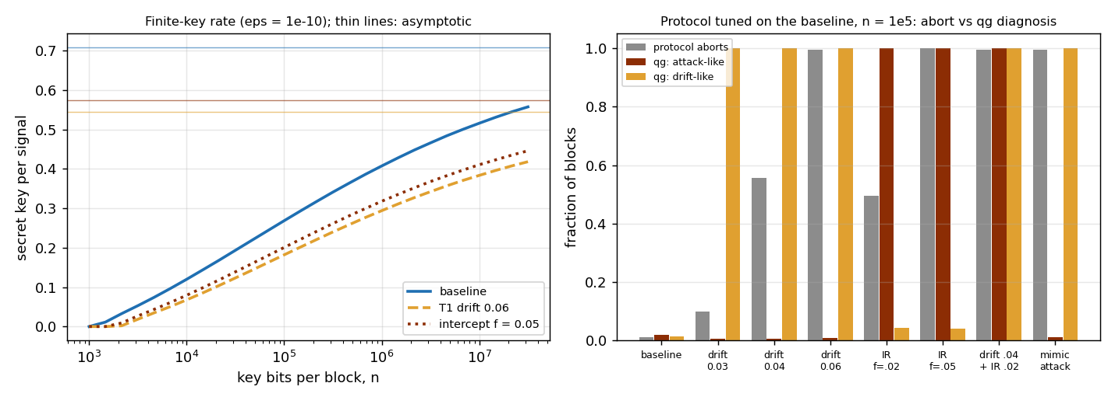
Figure 2: Left: finite-key rate vs block size (thin lines: asymptotic). Right: aborts and qg flags for a protocol tuned on the baseline at $n={10}^{5}$.
Results (Table 2).
- An abort does not say why; the qg flags do. Every drifting block, aborted or not, is flagged as drift and not as an attack. Every intercept-resend block is flagged as an attack, including the half that did not abort. At $n={10}^{4}$ the flags are already 0.97–1.00 (0.81 for $γ=0.03$).
- An attack hidden under drift is caught. Intercept-resend at $f=0.02$ on a drifting memory raises both flags in every block. The one-parameter monitor of Sec. 2 misses it (0.5% attack flags).
- Early warning. At $γ=0.03$ only 10% of blocks abort, but the drift flag is up in all of them. A $Q_{Z}$ trend would also warn; what qg adds is the attribution.
Beyond intercept-resend. From Bob’s side, any individual attack is a Pauli channel $\left(p_{x},p_{y},p_{z}\right)$, with Z-basis errors from $p_{x}+p_{y}$ and X-basis errors from $p_{z}+p_{y}$. The optimal phase-covariant cloner with disturbance $D$, which is $\left(0,D,0\right)$, therefore gives exactly the counts of intercept-resend with $f=4D$, and it is flagged as an attack in every block. A Z-only intercept, $\left(0,0,f/2\right)$, gives exactly the counts of extra dephasing (T2 drift). The two-family model above had no dephasing family, so T2 drift raised false attack alarms in 7.5–27% of blocks. With the family added, T2 drift is flagged as T2-like and the false alarms fall to 0.7–2%. The Z-only intercept then hides as T2 drift: it is a second blind spot, the twin of the T1-mimicking attack.
On a trapped-ion noise model. We rebuilt the whole protocol as circuits on IonQ’s cloud simulator with the aria-1 and forte-1 noise models. The memory is amplitude damping made with an ancilla, $CRY\left(2arcsin\sqrt{γ}\right)$ followed by a CX back, with $γ_{0}=0.02$ healthy and 0.03–0.06 drifting. Eve measures and resends through an unread ancilla (CX, or H–CX–H). There are 16 blocks of $n=k=4000$ bits per scenario and model. The device adds a nearly symmetric 2.3–3.1% error per bit, so the flag model gets two fitted flip rates, $ε_{Z}$ and $ε_{X}$, and a fitted $γ_{0}$, all fitted leave-one-out on baseline blocks.
The attribution transfers (Table 3). A drifting memory is taken for an attack in at most 1 of 48 blocks, and an attack for drift in at most 1 of 16. Drift 0.06 and $f=0.10$ are attributed in every block. At this block size and noise level, small changes are only partly flagged. The fitted model predicts which flag rises, and most rates within the spread of 16 blocks. Extrapolated to $n={10}^{5}$ key bits, it attributes every scenario in 99–100% of blocks.
Table 3: BB84 circuits on IonQ noise models, $n=k=4000$ per block, 16 blocks: fraction of blocks raising the attack-like / drift-like flags, observed (predicted by the fitted model).
scenario | aria-1 | forte-1
baseline | 0.00 / 0.00 | 0.06 / 0.06
drift 0.04 | 0.00 / 0.81 (0.73) | 0.00 / 0.38 (0.46)
drift 0.06 | 0.00 / 1.00 | 0.00 / 1.00
intercept $f=0.05$ | 0.88 (0.96) / 0.00 | 0.81 (0.88) / 0.06
intercept $f=0.10$ | 1.00 / 0.00 | 1.00 / 0.06
drift 0.04 + $f=0.05$ | 0.81 / 0.81 | 0.75 / 0.31

Certified random numbers
A qubit QRNG [8] prepares $|+⟩$ and measures Z. Dephasing and thermal population leave the output unbiased, but then part of the randomness is classical noise that an adversary holding the environment can know. With a trusted measurement and an adversary holding the purification, her two conditional states are pure, with overlap $\left|ρ_{01}\right|=r_{⊥}/2$. By Helstrom [9] and the operational meaning of min-entropy [10],
$$P_{guess}\left(Z|E\right)=\frac{1+\sqrt{1−r_{⊥}^{2}}}{2}, H_{min}\left(Z|E\right)=−\log_{2}P_{guess}, r_{⊥}=\sqrt{qg_{X}^{2}+qg_{Y}^{2}}. \text{(3)}$$
The result is independent of $qg_{Z}$: only the coherence in the measured basis is private. For a pure state it reduces to the classical $−\log_{2}max\left(p_{0},p_{1}\right)$. We checked Eq. (3) against an explicit purification.
Estimators. From ${10}^{4}$ test rounds per setting, with the readout $qg_{Z}^{meas}=a+b qg_{Z}$ ($e_{01}=0.015$, $e_{10}=0.04$) calibrated by the heralded sweep of the companion paper. We compare four estimates. The naive one is the output-bias estimate $−\log_{2}max\left({\hat{p}}_{0},{\hat{p}}_{1}\right)$. The qg one-sided estimate takes $r_{⊥}$ from X and Y test rounds with a single rotation each. The qg $±$ estimate measures each axis with both rotations, so the offset $a$ cancels. The qg calibrated estimate is the $±$ one divided by the calibrated $b$. All qg estimates use a $3σ$ lower bound on $r_{⊥}$.
Table 4: Certified bits per shot: mean estimate and, in parentheses, the fraction of runs above the truth (unsafe). 300 repetitions.
scenario | truth | naive | qg $±$ | qg calibrated
ideal $|+⟩$ | 1.000 | 0.965 (0) | 0.512 (0) | 0.681 (0)
T2, $V=0.8$ | 0.322 | 0.964 (1.00) | 0.245 (0) | 0.286 (0)
T2, $V=0.5$ | 0.100 | 0.965 (1.00) | 0.077 (0) | 0.087 (0)
T2, $V=0.2$ | 0.015 | 0.965 (1.00) | 0.009 (0) | 0.010 (0)
thermal $p=0.05$, $V=0.9$ | 0.334 | 0.965 (1.00) | 0.254 (0) | 0.297 (0)
$e_{10}=0.10$, $V=0.95$ | 0.608 | 0.876 (1.00) | 0.341 (0) | 0.513 (0)
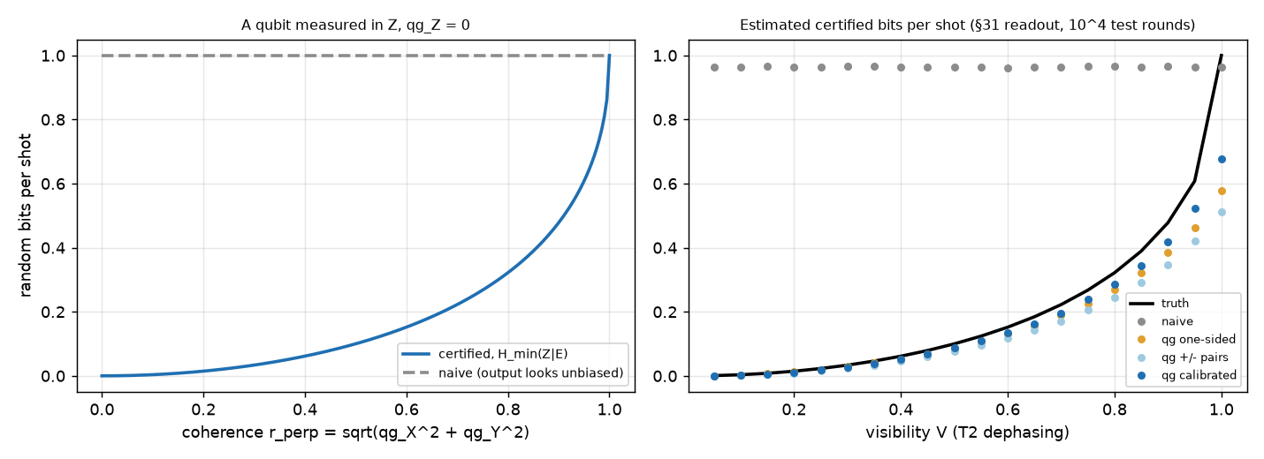
Figure 3: Left: certified bits per shot vs the coherence $r_{⊥}$ at $qg_{Z}=0$, against the naive reading. Right: estimates vs the visibility $V$.
Results (Table 4, Fig. 3).
- The output-bias estimate is unsafe whenever the state is mixed: it overestimates in every run.
- The qg estimate is safe in every run when each axis is measured with both rotations. With a single rotation the readout offset inflates $r_{⊥}$, and at $V=0.2$ the estimate exceeds the truth in 7% of runs.
- Calibration pays. Dividing by the calibrated $b$ recovers 10–50% more certified bits.
- A near-perfect source is shot-hungry to certify. $H_{min}$ has an infinite slope at $r_{⊥}=1$, the qg pole, so the $3σ$ bound gives 0.68, 0.81 and 0.89 bits per shot with ${10}^{4}$, ${10}^{5}$ and ${10}^{6}$ test rounds.
On a trapped-ion noise model. We ran the certifier on IonQ’s cloud simulator with the aria-1 and forte-1 noise models (free; nothing sent to a QPU), with a leak the adversary really holds. A source ion starts in $|0⟩$ and is read in X; a second ion, the environment, learns the X value through a partial Mølmer–Sørensen gate $MS\left(0,0,θ\right)$. The output stays a fair coin, while $H_{min}\left(X|E\right)$ falls as in Eq. (3) with $r=\left|cos2πθ\right|$ (X and Z exchanged). All circuits use native gates, so the service cannot merge rotations; each setting has ${10}^{4}$ samples, three repetitions per model (Table 5). The naive estimate stays at 0.97–1.00 bits and overestimates in every run with a leak (four times the truth at $θ=0.12$). The qg $±$ estimate is safe in all 24 cells and captures 82–90% of the truth with a leak. The simulator’s readout is almost perfect ($b≥0.9998$), so calibration adds nothing there: the gain of Table 4 needs hardware-like readout errors and remains to be checked on a device. The measured $r$ sits 1–1.5% below the ideal, which is the MS gate error, correctly counted as lost privacy.
Table 5: Certified bits per shot on IonQ noise models (mean of 3 runs; aria-1 / forte-1 where they differ). No qg estimate exceeds the truth in any run.
$θ$ (turns) | truth | naive | qg one-sided | qg $±$
0 (no leak) | 1.000 | 0.98 | 0.69 | 0.73
0.04 | 0.680 | 0.99 (unsafe) | 0.53 | 0.56 / 0.55
0.08 | 0.433 | 0.98 / 0.97 (unsafe) | 0.37 / 0.36 | 0.38 / 0.37
0.12 | 0.248 | 0.99 (unsafe) | 0.22 / 0.21 | 0.22

Limitations
(i) Everything is simulation: single-qubit models with i.i.d. rounds, and vendor noise models on IonQ’s simulator, not hardware. (ii) The QRNG is device-dependent (trusted measurement), not device-independent. (iii) Eq. (3) and the BB84 security bounds, asymptotic and finite-key, are standard results; qg writes them in measured quantities. (iv) The BB84 monitor is a diagnostic: an attacker who mimics relaxation is invisible to it, and the key rate is unchanged. (v) The BB84 setting needs a relaxation mechanism (matter qubits); it does not describe photon-polarization links. (vi) The finite-key diagnosis models only two error families (T1 and intercept-resend); other attacks may fall outside both flags. (vii) The IonQ runs use the vendor noise models on a simulator, and the memory and the attack are designed circuits.

Code availability
examples/bb84_qg_eve_vs_noise.py, examples/bb84_finite_key_qg.py, examples/ionq_sim_bb84.py, examples/bb84_attacks_beyond_ir_qg.py, examples/qrng_qg_certified.py and examples/ionq_sim_qrng.py in https://github.com/Viny2030/qang (MIT license), with regression tests. Sections 40–44 and 49 of RESEARCH_NOTES.md give more detail, and notebooks/qang_criptografia_colab.ipynb reproduces fast versions in Colab.

References
[1] V. H. Monteverde, “The Qang (qg): A unified angular-probability unit and metric for parametric quantum circuit design,” 2026, doi: 10.5281/zenodo.22832150.
[2] National Institute of Standards and Technology, “Module-lattice-based key-encapsulation mechanism standard.” FIPS 203, 2024.
[3] C. H. Bennett and G. Brassard, “Quantum cryptography: Public key distribution and coin tossing,” in Proceedings of the IEEE international conference on computers, systems and signal processing, 1984, pp. 175–179.
[4] M. Tomamichel, C. C. W. Lim, N. Gisin, and R. Renner, “Tight finite-key analysis for quantum cryptography,” Nature Communications, vol. 3, p. 634, 2012, doi: 10.1038/ncomms1631.
[5] V. H. Monteverde, “The register-mean polar bias as a symmetry witness: Error mitigation, constrained optimization and qubit characterization in qg units,” Zenodo preprint, 2026, doi: 10.5281/zenodo.23036963.
[6] P. W. Shor and J. Preskill, “Simple proof of security of the BB84 quantum key distribution protocol,” Physical Review Letters, vol. 85, pp. 441–444, 2000.
[7] V. Scarani, H. Bechmann-Pasquinucci, N. J. Cerf, M. Dušek, N. Lütkenhaus, and M. Peev, “The security of practical quantum key distribution,” Reviews of Modern Physics, vol. 81, pp. 1301–1350, 2009.
[8] M. Herrero-Collantes and J. C. Garcia-Escartin, “Quantum random number generators,” Reviews of Modern Physics, vol. 89, p. 015004, 2017.
[9] C. W. Helstrom, Quantum detection and estimation theory. Academic Press, 1976.
[10] R. König, R. Renner, and C. Schaffner, “The operational meaning of min- and max-entropy,” IEEE Transactions on Information Theory, vol. 55, pp. 4337–4347, 2009.

