Lab 7 :

i Using Scheme diagram, Create tables by properly specifying the primary keys and the foreign keys.

CREATE TABLE Supplier (
sid INT PRIMARY KEY,
sname VARCHAR(50),
city VARCHAR(50)
);

CREATE TABLE Parts (
pid INT PRIMARY KEY,
pname VARCHAR(50),
color VARCHAR(20)
);

CREATE TABLE Catalog (
sid INT,
pid INT,
cost DECIMAL(10, 2),
PRIMARY KEY (sid, pid),
FOREIGN KEY (sid) REFERENCES Supplier(sid),
FOREIGN KEY (pid) REFERENCES Parts(pid)
);

- Insert appropriate records in each table.

INSERT INTO Supplier VALUES
(1, 'Acme Widget Suppliers', 'Bengaluru'),
(2, 'Global Traders', 'Mysuru'),
(3, 'Universal Parts Co.', 'Delhi');

INSERT INTO Parts VALUES
(101, 'motor', 'Red'),
(102, 'gear', 'Blue'),
(103, 'hammer', 'Red'),
(104, 'Washer', 'Green');

INSERT INTO Catalog VALUES
(1, 101, 1115.00),
(1, 102, 3000.00),
(2, 101, 2000.00),
(2, 103, 600.00),
(3, 101, 2500.00),
(3, 102, 2200.00),
(3, 103, 4500.00),
(3, 104, 2800.00);

- Find the pnames of parts for which there is some supplier.

SELECT DISTINCT P.pname
FROM Parts P , Catalog C
where P.pid = C.pid;
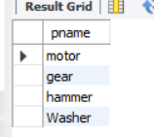

- Find the snames of suppliers who supply every part.
SELECT S.sname
FROM Supplier S
JOIN Catalog C ON S.sid = C.sid
GROUP BY S.sid, S.sname
HAVING COUNT(DISTINCT C.pid) = (SELECT COUNT(*) FROM Parts);

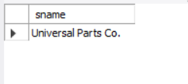

- Find the snames of suppliers who supply every red part.
SELECT S.sname
FROM Supplier S
JOIN Catalog C ON S.sid = C.sid
JOIN Parts P ON C.pid = P.pid
WHERE P.color = 'Red'
GROUP BY S.sid, S.sname
HAVING COUNT(DISTINCT P.pid) = (
SELECT COUNT(*) FROM Parts WHERE color = 'Red'
);
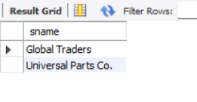

- Find the pnames of parts supplied by Acme Widget Suppliers and by no one else.
SELECT P.pname
FROM Parts P
JOIN Catalog C ON P.pid = C.pid
JOIN Supplier S ON S.sid = C.sid
WHERE S.sname = 'Acme Widget Suppliers'
AND P.pid NOT IN (
SELECT C2.pid
FROM Catalog C2
JOIN Supplier S2 ON S2.sid = C2.sid
WHERE S2.sname <> 'Acme Widget Suppliers'
);
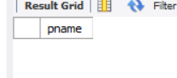

- Find the sids of suppliers who charge more for some part than the average cost of that part
(averaged over all the suppliers who supply that part).

SELECT DISTINCT C1.sid
FROM Catalog C1
WHERE C1.cost > (
SELECT AVG(C2.cost)
FROM Catalog C2
WHERE C2.pid = C1.pid
);
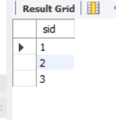

viii. For each part, find the sname of the supplier who charges the most for that part.

SELECT P.pname, S.sname
FROM Parts P
JOIN Catalog C ON P.pid = C.pid
JOIN Supplier S ON S.sid = C.sid
WHERE C.cost = (
SELECT MAX(C2.cost)
FROM Catalog C2
WHERE C2.pid = P.pid
);

