create database insurance;

use insurance;

create table person (driver_id varchar(10),

name varchar(20),

address varchar(30),

primary key(driver_id));

desc person;

create table car(reg_num varchar(10),model varchar(10),year int, primary key(reg_num));

create table accident(report_num int, accident_date date, location varchar(20),primary key(report_num));

desc accident;

create table owns(driver_id varchar(10),reg_num varchar(10),

primary key(driver_id, reg_num),

foreign key(driver_id) references person(driver_id),

foreign key(reg_num) references car(reg_num));

desc owns;

create table participated(driver_id varchar(10), reg_num varchar(10),

report_num int, damage_amount int,

primary key(driver_id, reg_num, report_num),

foreign key(driver_id) references person(driver_id), foreign key(reg_num) references car(reg_num), foreign key(report_num) references accident(report_num));

desc participated;

INSERT INTO person (driver_id, name, address)

VALUES

('A01', 'Richard','Srinivas agar'),

('A02', 'Pradeep','Rajajinagar'),

('A03', 'Smith','Ashoknagar'),

('A04', 'Venu','N R Colony'),

('A05', 'Jhon','Hanumanthnagar');

select*from person;

INSERT INTO car (reg_num, model, year)

VALUES

('KA052250', 'Indica', 1990),

('KA031181', 'Lancer', 1957),

('KA095477', 'Toyota', 1998),

('KA053408', 'Honda', 2008),

('KA041702', 'Audi', 2005);

select*from car;

INSERT INTO owns (driver_id, reg_num)

VALUES

('A01', 'KA052250'),

('A02', 'KA053408'),

('A03', 'KA031181'),

('A04', 'KA095477'),

('A05', 'KA041702');

select*from owns;

INSERT INTO accident (report_num, accident_date, location)

VALUES

(11, '2003-01-01', 'Mysore Road'),

(12, '2004-02-02', 'South end Circle'),

(13, '2003-01-21', 'Bull temple Road'),

(14, '2008-02-17', 'Mysore Road'),

(15, '2005-03-04', 'Kanakpura Road');

select*from accident;

INSERT INTO participated (driver_id, reg_num, report_num, damage_amount)

VALUES

('A01', 'KA052250', 11, 10000),

('A02', 'KA053408', 12, 50000),

('A03', 'KA095477', 13, 25000),

('A04', 'KA031181', 14, 3000),

('A05', 'KA041702', 15, 5000);

select*from participated;

select accident_date, location from accident;

select * from participated;

select driver_id, damage_amount from participated where damage_amount>=25000;

update participated set damage_amount=25000 where report_num=12;

select*from accident;

insert into accident(report_num, accident_date, location)

values (16,'2008-03-15','Domlur');

select accident_date, location from ACCIDENT;

select driver_id from PARTICIPATED where damage_amount >=25000;

/*DBMS LAB 3*/

select accident_date, location from accident;

select*from participated where damage_amount>=25000;

select p.name, pa.reg_num

from person p, participated pa

where p.driver_id=pa.driver_id;

select a.report_num, a.accident_date, a.location, p.name, pa.damage_amount

from accident a, person p, participated pa

where a.report_num=pa.report_num and pa.driver_id=p.driver_id;

select driver_id, sum(damage_amount)

from participated group by(driver_id);

select driver_id

from participated

group by (driver_id) having count(driver_id)>1;

select driver_id

from owns

where driver_id not in (select driver_id

from participated);

select max(accident_date)

from accident;

select driver_id , avg(damage_amount)

from participated group by(driver_id);

update participated set damage_amount=25000

where driver_id="A04";

select car.model , p.damage_amount

from car, participated p

where car.reg_num=p.reg_num and p.damage_amount>=25000;

create view summary as select driver_id, count(driver_id), sum(damage_amount)

from participated

group by(driver_id);

select * from summary;

/*Problems of week 2 dbms lab queries */

desc car;

select * from car order by year;

select car.model, count(p.reg_num) as "No.Accidents"

from car, participated p

where p.reg_num=car.reg_num

group by(p.reg_num);

select count(reg_num) as count

from car where year=2008

group by (reg_num);

/*select car.model, count(p.reg_num), a.accident_date from car, participated p,accident a where p.reg_num=car.reg_num and

a.report_num=p.report_num and a.accident_date like "2008%" group by(p.reg_num);*/

select c.model, count(p.reg_num) as count

from car c, participated p, accident a

where c.reg_num =p.reg_num

and a.report_num=p.report_num

and a.accident_date like "2008%" group by(c.model);

select * from participated order by damage_amount desc;

select avg(damage_amount) from participated;

DELETE p

FROM participated p

JOIN (

SELECT AVG(damage_amount) AS avg_damage

FROM participated

) avg_table

WHERE p.damage_amount < avg_table.avg_damage;

rollback;

select*from participated;

select name from person a , participated b where a.driver_id=b.driver_id and damage_amount>(select avg(damage_amount) from participated);

select max(damage_amount) from participated;

Outputs :

----week 1 outputs-----

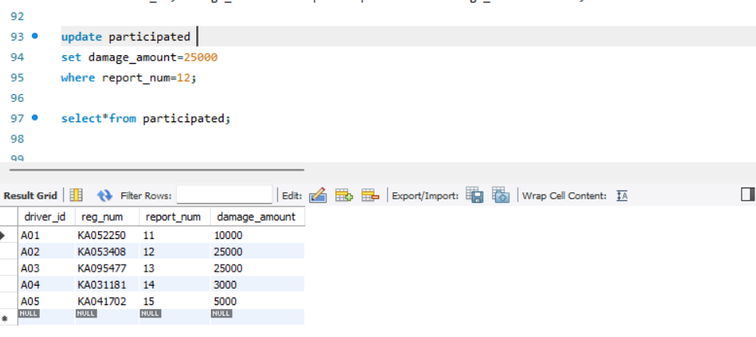

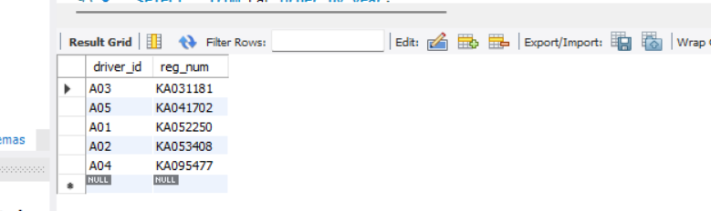

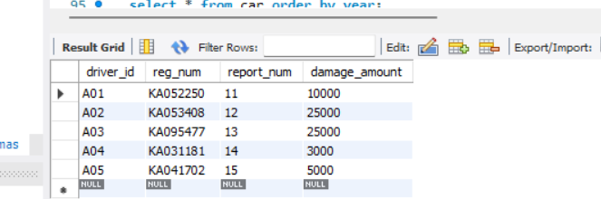

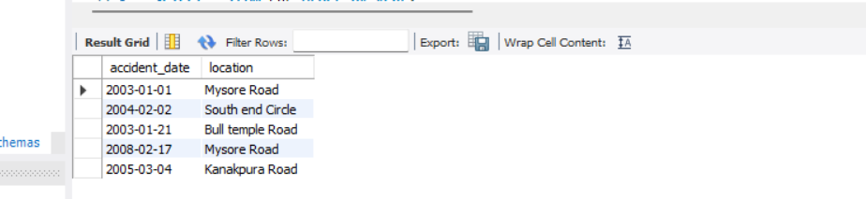

----Week 2 ----- outputs for given queries :

