Steps Overview

1. Create Raspbian image on a SD Card (8 GB or larger, class 10 recommended)
2. First Boot / Setup OS / raspi-config
   1. Expand File System (use entire SD card)
   2. Change password
   3. Change hostname
3. Install needed components
   1. Setup remote session / X11
   2. Setup remote administration / WebMin
   3. Setup a web-browser in kiosk-mode / IceWeasel
   4. Setup the web-engine / NodeJS , NPM, and other required node_modules
   5. Setup …
4. Configure Scheduled Jobs
   1. Enable/Disable HDMI
   2. Enable/Disable web-browser
5. Setup Visual Studio 2015
   1. Get project(s) from Github
   2. Update packages
   3. Install VS plugins
      1. Node.js Tools for Visual Studio <https://www.visualstudio.com/vs/node-js/>
      2. …
      3. …
   4. …
   5. Build program
   6. Install program
6. Configure InfoDisplay

# Create Raspbian image on a SD Card

Download ZIP file from: <https://www.raspberrypi.org/downloads/raspbian/>

UNZIP the Raspbian Jessie image

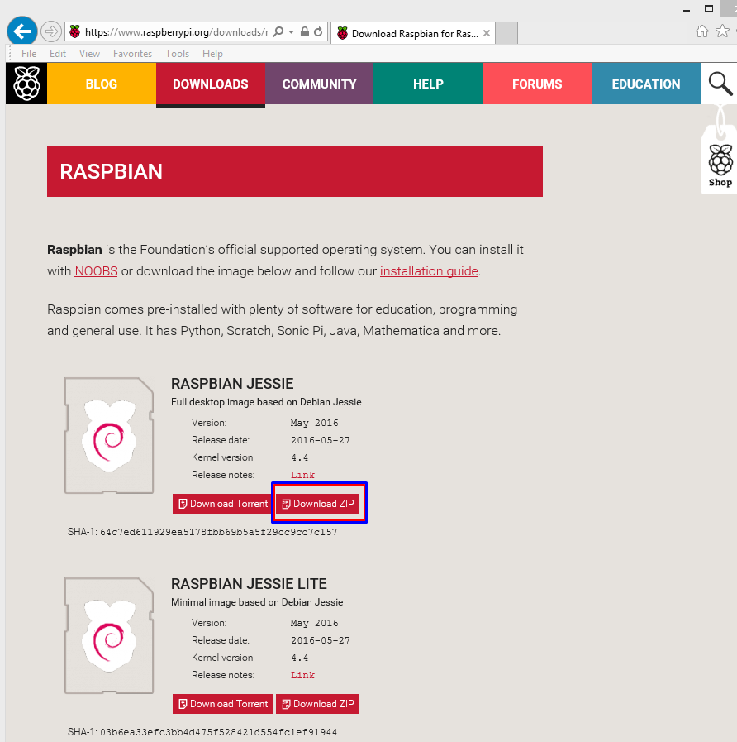

Write the image to the SD card (under windows)

* Make sure you select
  + The Image File (the image you have downloaded)
  + The target “Device”. Select the drive letter which contains the SD card.

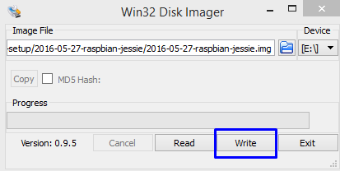

* Select “Write” to write the image to the SD card

# First Boot / Setup OS

Login ***pi*** with default password ***raspberry***

Open a terminal and startup the configuration tool

sudo raspi-config

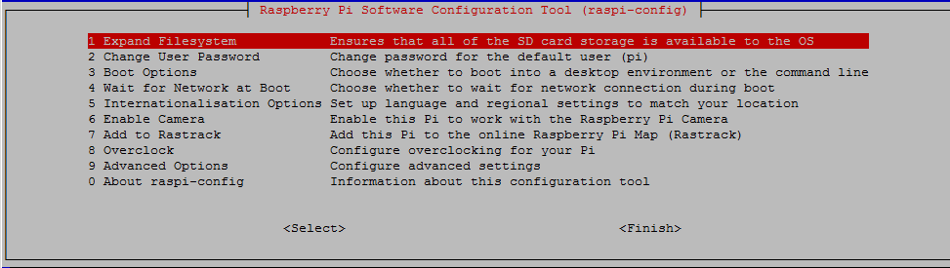

1. Select “Expand File System” (use entire SD card)
2. Select “Change user password” and set (and remember) a new password.
3. From the menu select “Advanced Options”. Select “Hostname” , and set your desired computer name (InfoDisplay01)

# Install needed components

**a. Setup for remote session (headless operation / without a screen)**

Setup X11VNC: <https://blog.tonywall.co/2013/07/setting-up-raspberry-pi-for-headless-mode-with-x11vnc/>

For remote session, where you can access the console/X view (not separate session like in tightvncserver).

sudo apt-get install x11vnc

x11vnc –storepasswd

nano ~/.xsessionrc

#Start X11VNC

x11vnc -bg -nevershared -forever -tightfilexfer -usepw -display :0

chmod 775 ~/.xsessionrc

sudo nano /boot/config.txt

Set the following line to force HDMI to be the only detected connection, i.e. disable the analogue video default:

hdmi_force_hotplug=1

Full HD 1920×1080@60Hz:

hdmi_group=2

hdmi_mode=82

sudo reboot

1. **Setup remote administration / WebMin**
2. **Setup a web-browser in kiosk-mode / IceWeasel**
3. **Setup the web-engine / NodeJS , NPM, and other required node_modules**
4. **Setup …**