• Create a Git repository & share it with

the teacher (2 pts)

Done and shared with the teacher.

• Install Truffle & create a truffle project (2

pts)

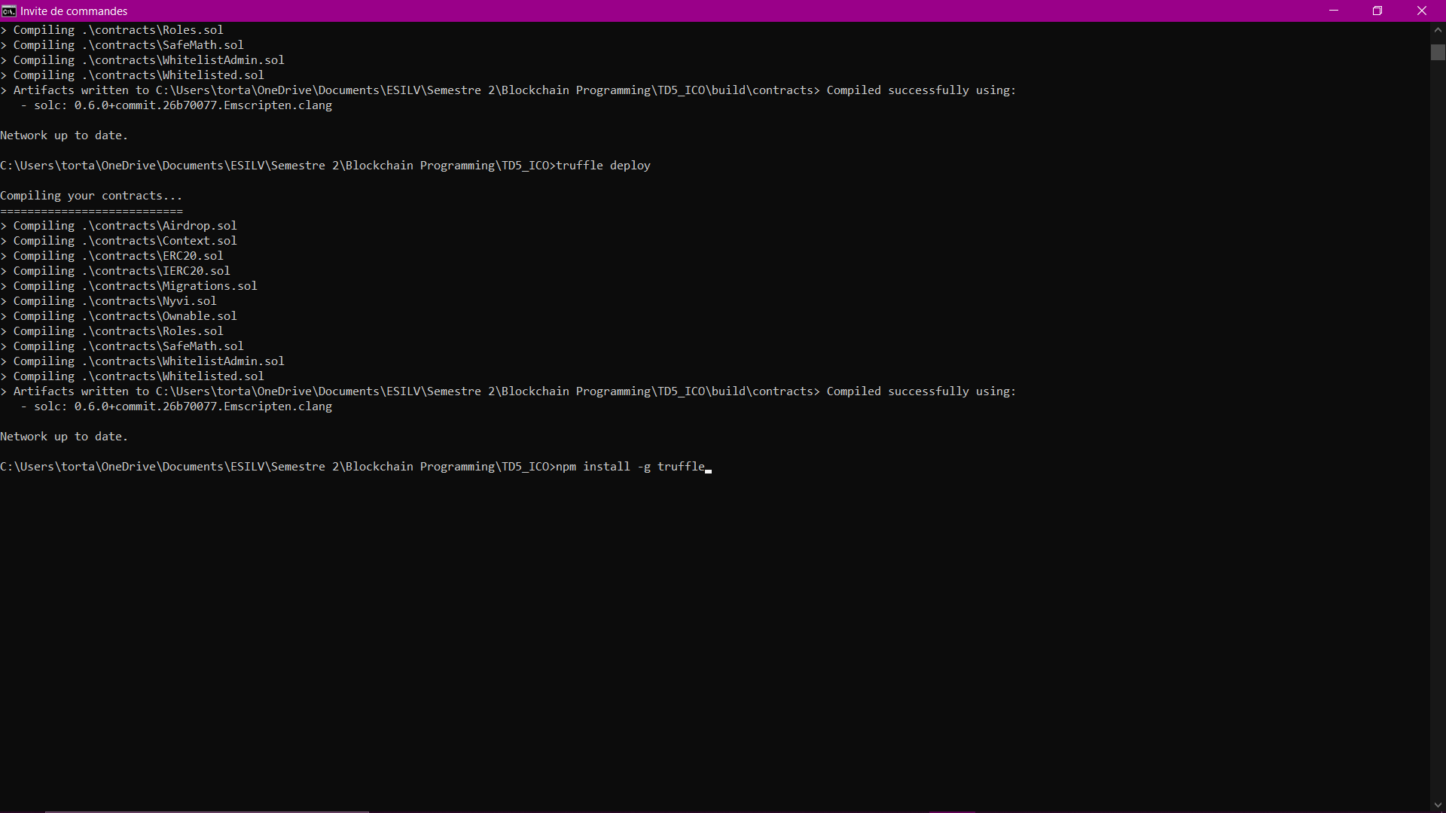

• Create an ERC20 token contract (2 pts)

We took the ERC20 and ERC20 file from Open Zepellin.

• Implement all ERC20 functions (2 pts)

We worked on the functions of the file ERC20.sol in the GIT repository.

• Create a migration to deploy your

contract(s) (2 pts)



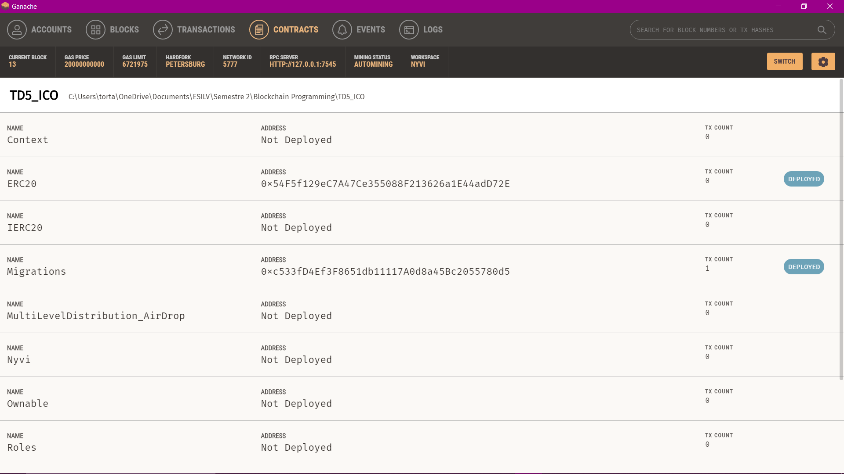

• Implement customer white listing (3 pts)

We created a Role file and then we created files to implement functions for each role: whitelistAdmin and Whitelisted. These functions are used in Nyvi.sol in the Git repository.

• Implement multi level distribution (3 pts)

We used ownable to give permissions to the owner. We implemented a multilevel distribution in Airdrop.sol .

• Implement air drop functions (3 pts)

We tried to implement functions in the Airdrop.sol file.

• Deploy to a testnet (2 pts)

We connected ganache with metamask:

