Name:-Sharan.B
Register no:-192210486

EXPNO 11: CREATE A CLONING OF A VM AND TEST IT BY LOADING THE PREVIOUS VERSION/CLONED VM.

DATE:

AIM:

To create a cloning of a vm and test it by loading the previous version/cloned vm.

PROCEDURE:

STEP 1: GO TO VM AND GOTO MANAGE AND CLICK CLONE

STEP 2: CLICK CLONE

STEP 3: SELECT THE FULL CLONE

STEP 4: AFTER CLONE AGAIN OR VM IS OPENED.

IMPLEMENTATION:

CLONING OF A VM

STEP 1: GO TO VM AND GOTO MANAGE AND CLICK CLONE
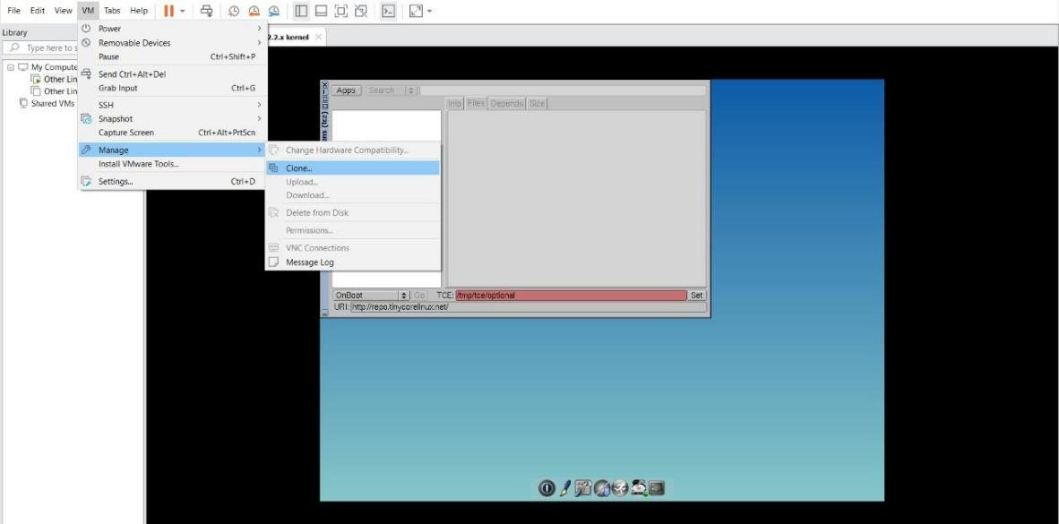
STEP 2: CLICK CLONE
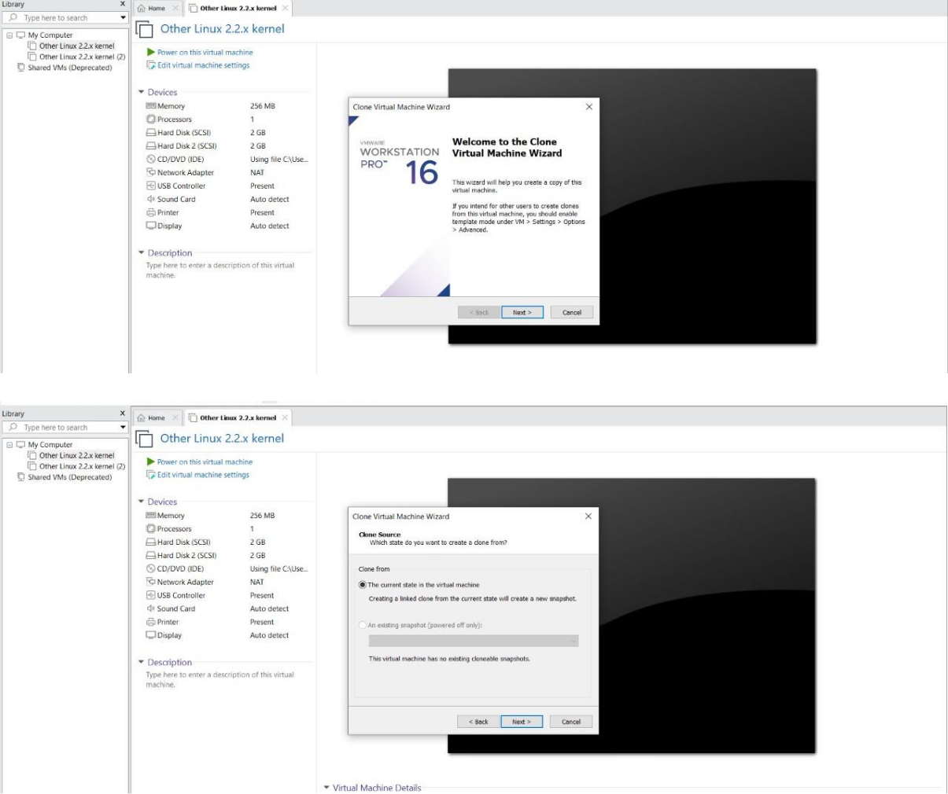

STEP 3: SELECT THE FULL CLONE
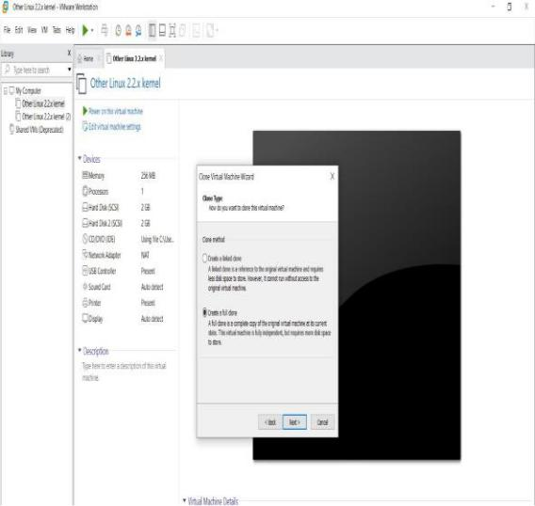
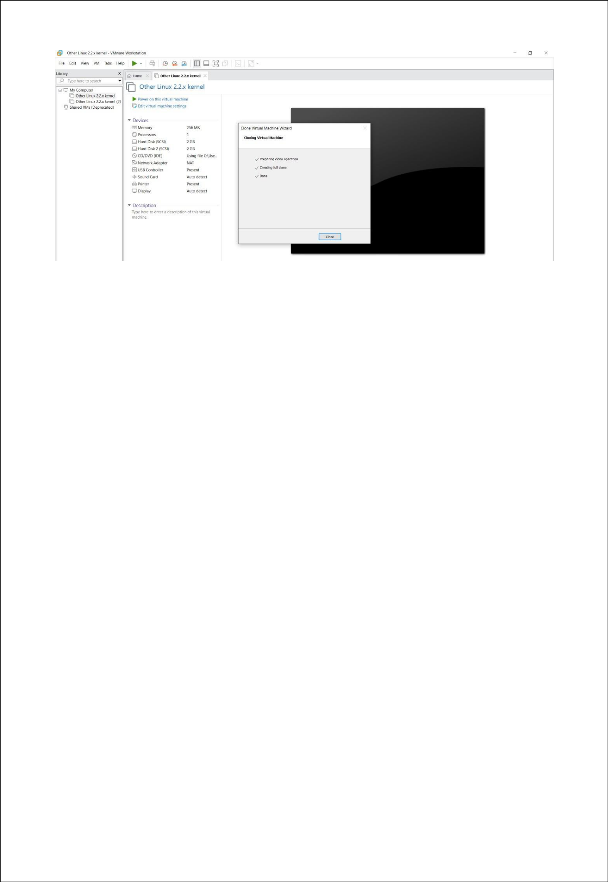

STEP 4: AFTER CLONE AGAIN OR VM IS OPENED.
