Name:-Sharan.B
Register no:-192210486

EXP 12: CHANGE HARDWARE COMPATIBILITY OF A VM (EITHER BY CLONE/CREATE NEW ONE) WHICH IS ALREADY CREATED AND CONFIGURED.

DATE:

AIM:

To Change Hardware compatibility of a VM (Either by clone/create new one) which is already created and configured.

PROCEDURE:

STEP 1:GOTO VM WARE WORKSTATION.

STEP2: RIGHT CLICK THE VM AND GOTO THE SETTINGS.

STEP 3: ADD HARDWARE WIZARD AND SELECT SCSI AND CLICK NEXT.

STEP 4: CREATE NEW VIRTUAL DISK.

STEP 5: SELCT THE DISK SIZE AS 2.0. AND SELCT SPLIT VIRTUAL DISK INTOMULTIFILES.

STEP 6: GIVE NAME AND CLICK THE FINISH.

IMPLEMENTATION:

STEP 1:GOTO VM WARE WORKSTATION
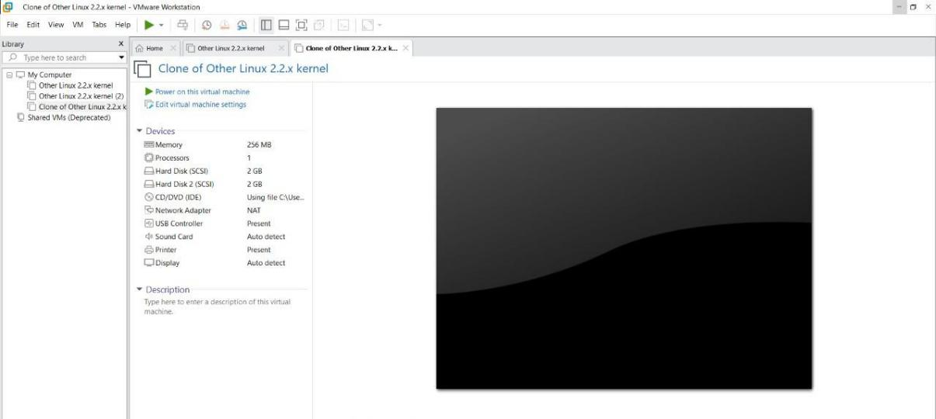

STEP2: RIGHT CLICK THE VM AND GOTO THE SETTINGS
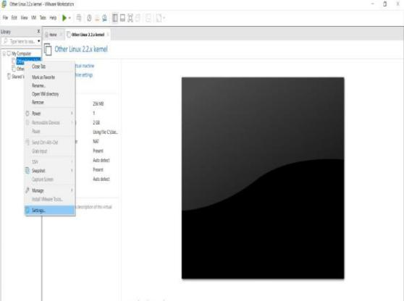

STEP 3: ADD HARDWARE WIZARD AND SELECT SCSI AND CLICK NEXT
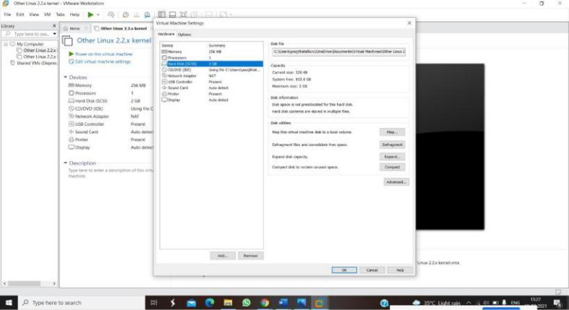

STEP 4: CREATE NEW VIRTUAL DISK
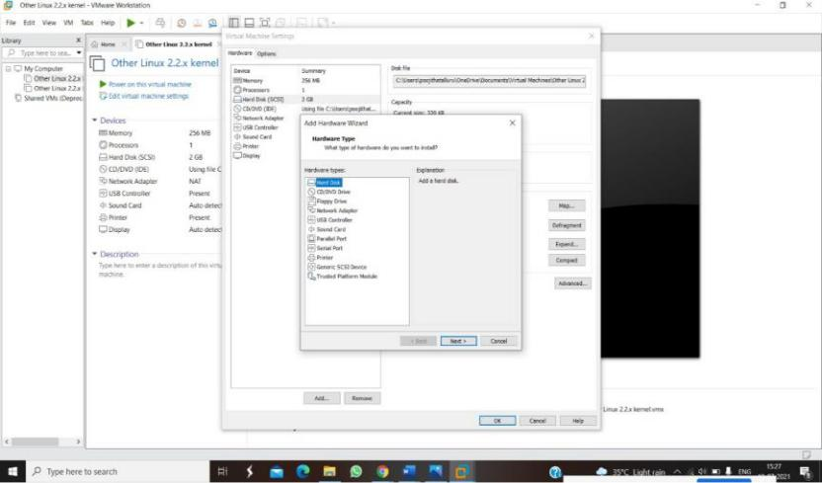
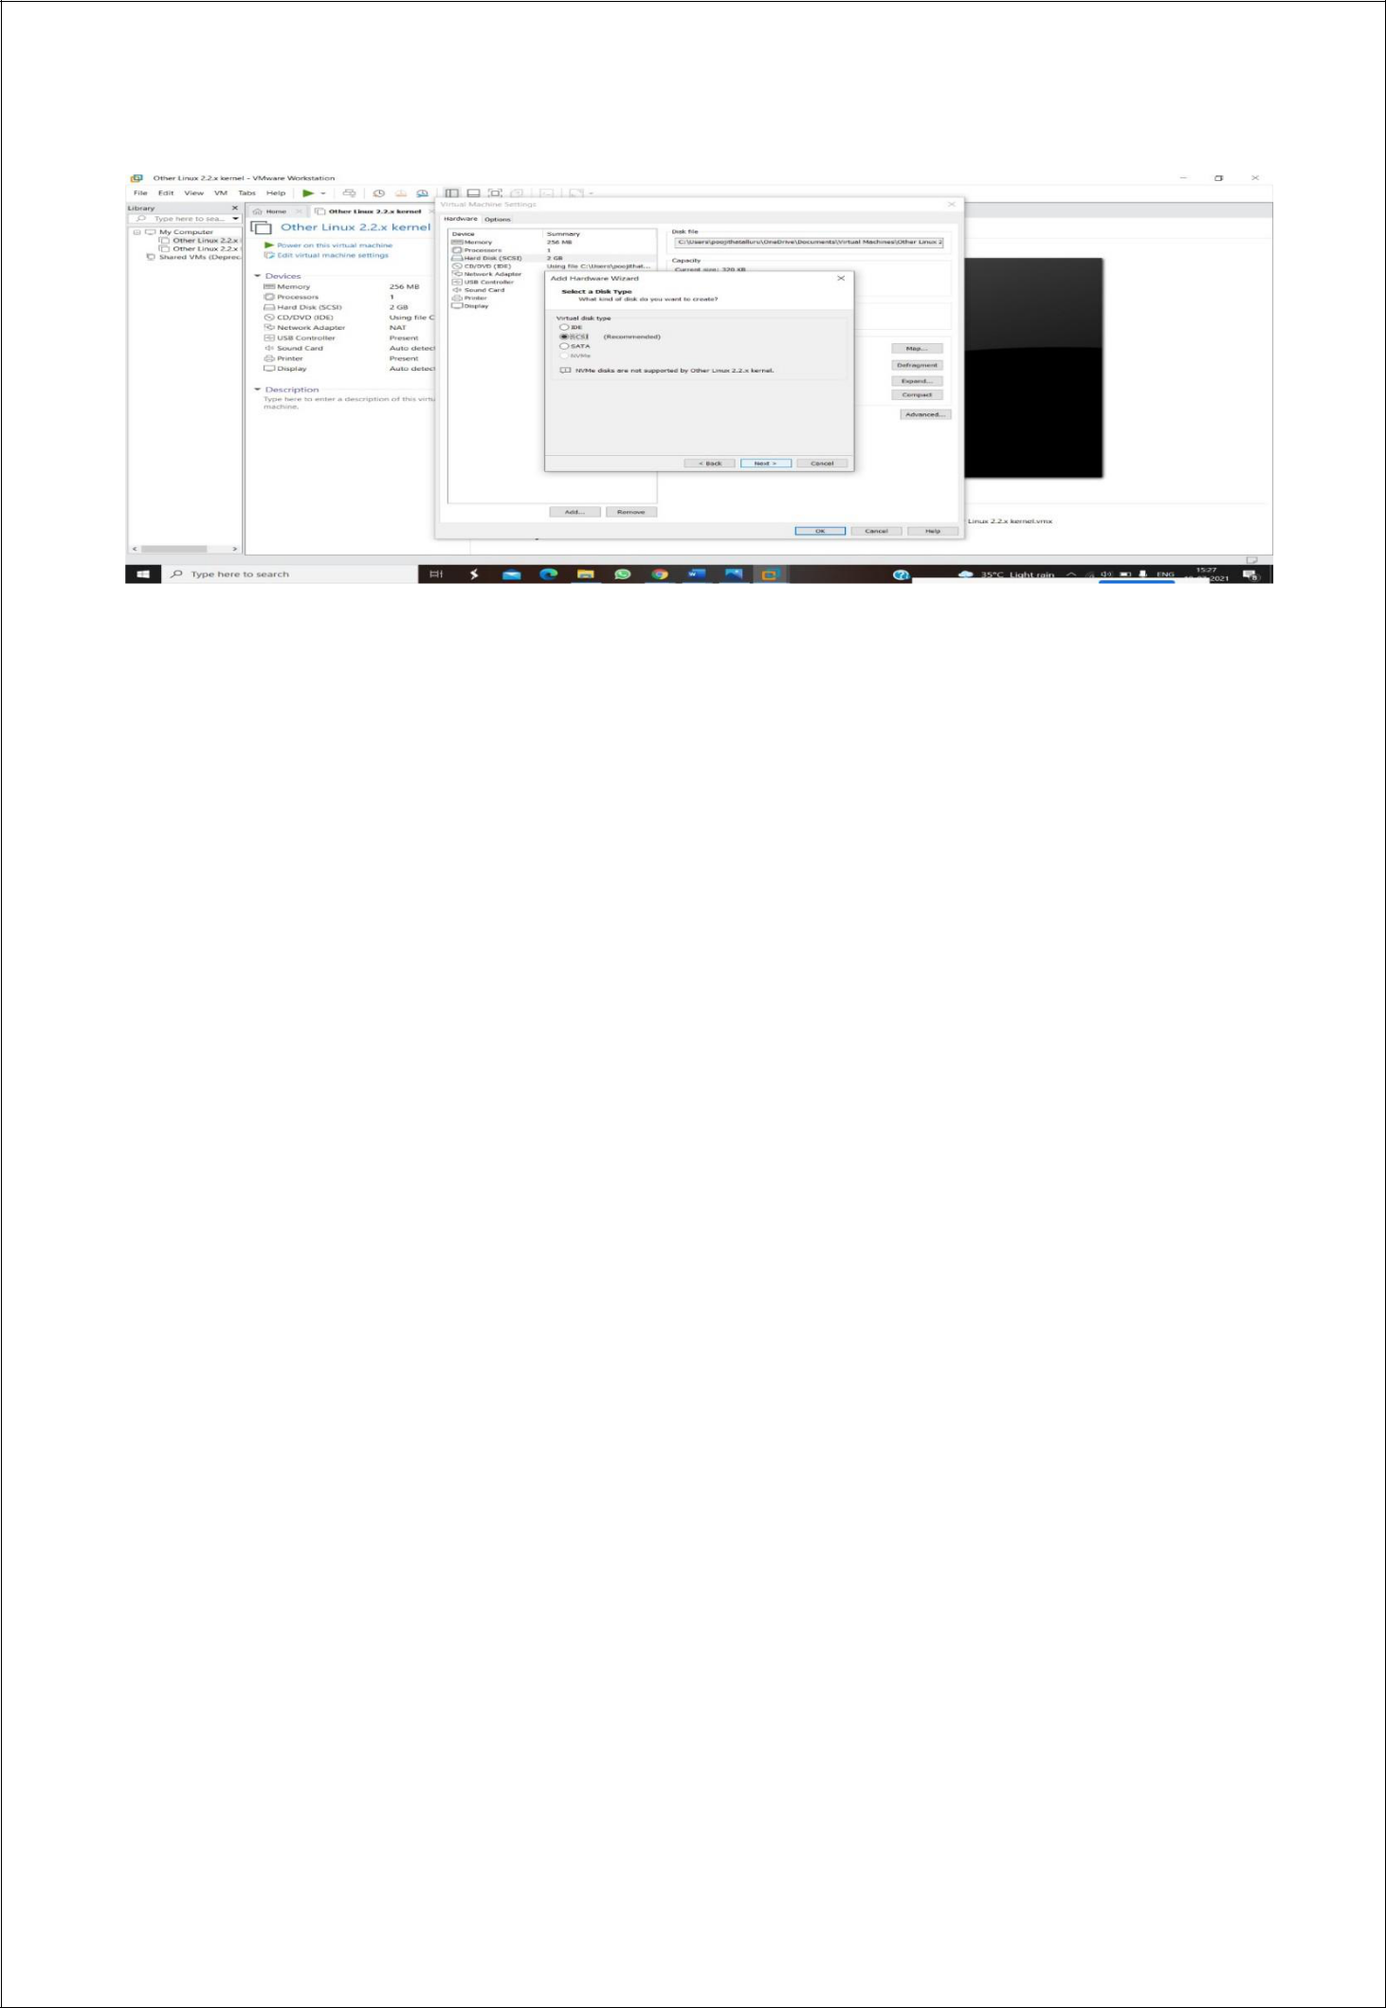

STEP 5: SELCT THE DISK SIZE AS 2.0. AND SELCT SPLIT VIRTUAL DISK INTOMULTIFILES.
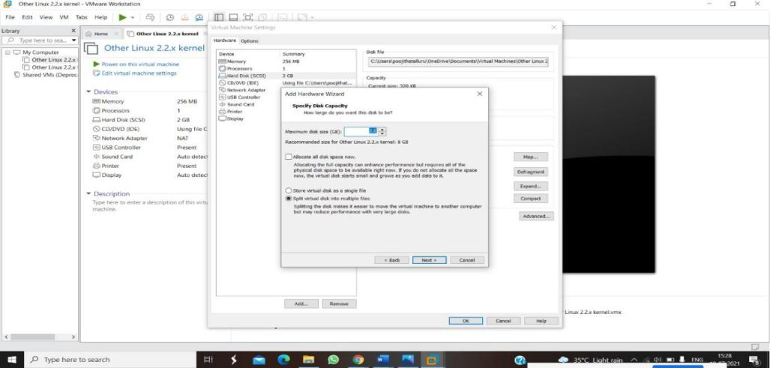

STEP 6: GIVE NAME AND CLICK THE FINISH
