Name:-Sharan.B
Register no:-192210486

EXP 17 .DEMONSTRATE INFRASTRUCTURE AS A SERVICE(IAAS) BY CREATING A VIRTUAL MACHINE USING A PUBLIC CLOUD SERVICE PROVIDER(AZURE/GCP/AWS) CONFIGURE WITH MINIMUM CPU, RAM AND STORAGE AND LAUNCH THE VM IMAGE.

AIM:

To demonstrate infrastructure as a service(iaas) by creating a virtual machine using a public cloud service provider(azure/gcp/aws) configure with minimum cpu,ram and storage and launch the vm image.

PROCEDURE:

STEP1: CREATE AN ACCOUNT IN MICROSOFT AZURE.

STEP2: GOTO RESOURCE GROUPAND CREATE A RESOURCE GROUP.

STEP3: GIVE NECESSARY THINGS FOR RESOURCE GROUP.

STEP4: CREATE A VIRTUAL NETWORK FOR TO CREATE A VIRTUALMACHINE.

STEP5: NOW CREATE A VIRTUAL MACHINE WITH UR IP ADDRESS ANUSERNAME AND PASSWORD FOR YOUR VIRTUAL MACINE.

STEP6: AND YOUR VIRTUAL MACHINE IS DEPLOYED.

STEP7: NOW CONNECT THE VIRTUAL MACHINE AND DOWNLOAD THE RDP FILETO OPEN YOUR WINDOWS VIRTUAL MACHINE.

STEP8: CREATED A NEW WINDOWS VIRTUAL MACHINE

IMPLEMENTATION:

STEP1: CREATE AN ACCOUNT IN MICROSOFT AZURE.

STEP2: GOTO RESOURCE GROUP AND CREATE A RESOURCE GROUP.
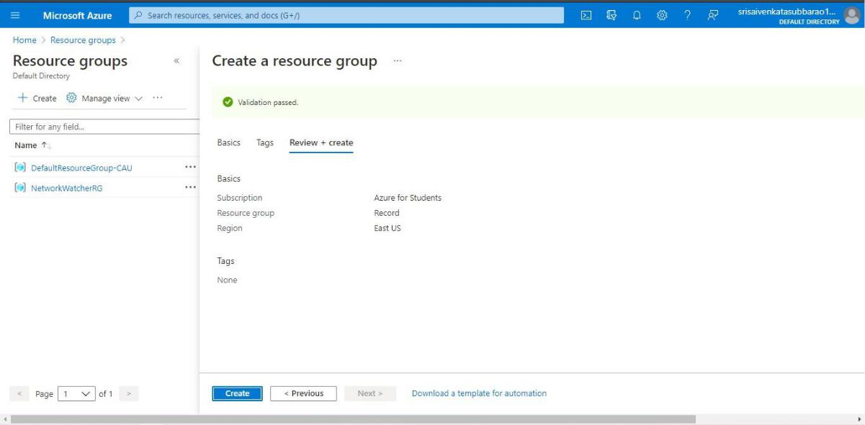

STEP3: GIVE NECESSARY THINGS FOR RESOURCE GROUP.
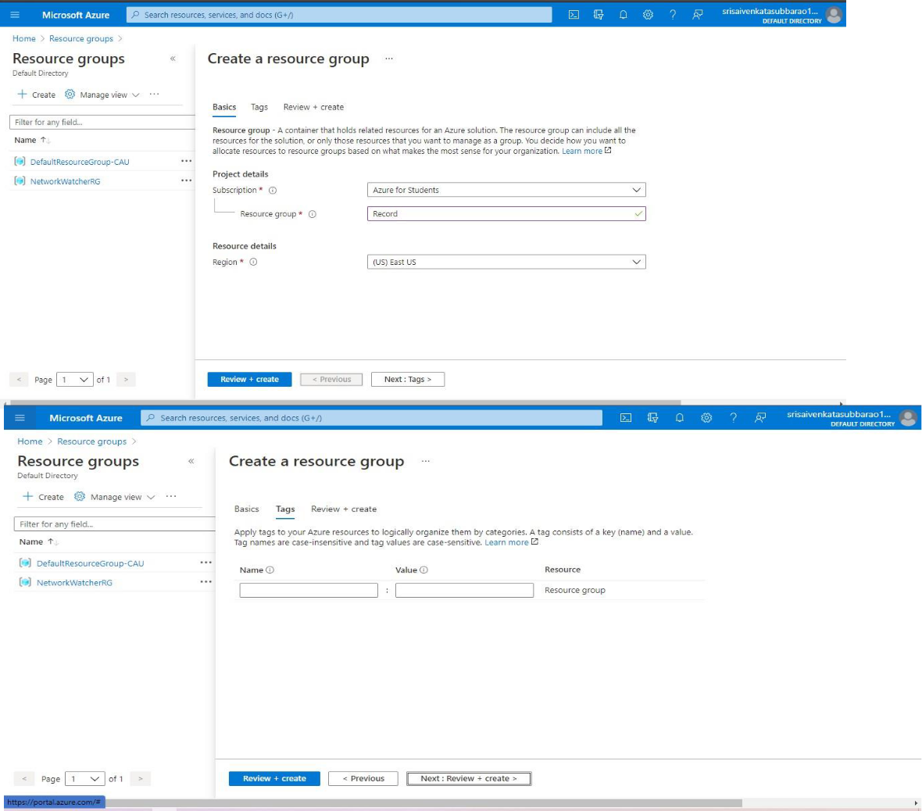

STEP4: CREATE A VIRTUAL NETWORK FOR TO CREATE A VIRTUALMACHINE .
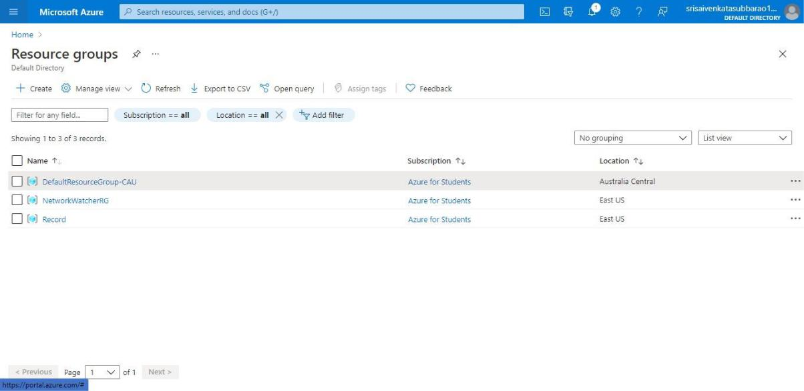

STEP5: NOW CREATE A VIRTUAL MACHINE WITH UR IP ADDRESS ANUSERNAME AND PASSWORD FOR YOUR VIRTUAL MACINE.

STEP6: AND YOUR VIRTUAL MACHINE IS DEPLOYED.
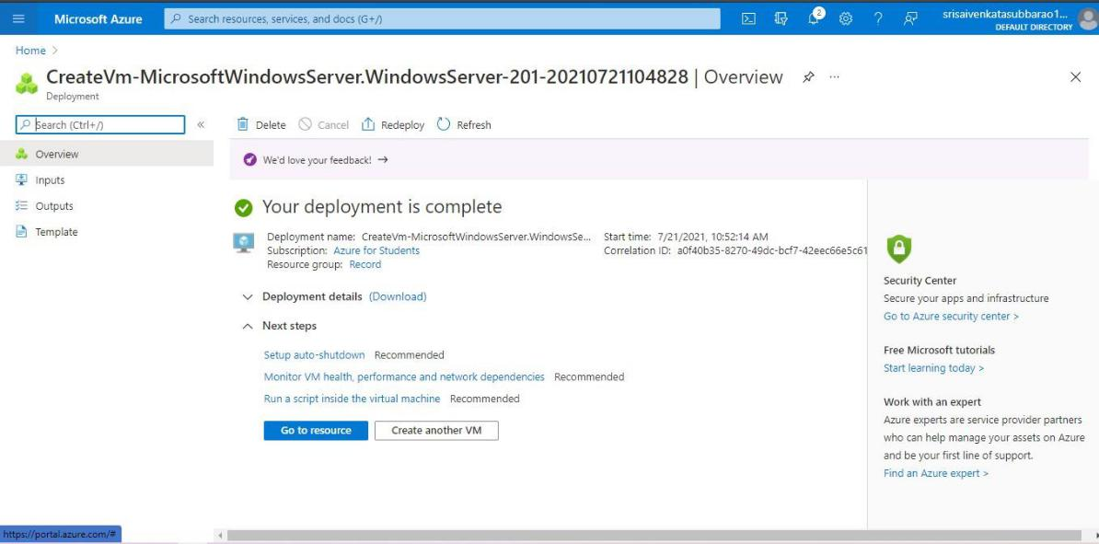

STEP7: NOW CONNECT THE VIRTUAL MACHINE AND DOWNLOAD THE RDP FILETO OPEN YOUR WINDOWS VIRTUAL MACHINE.

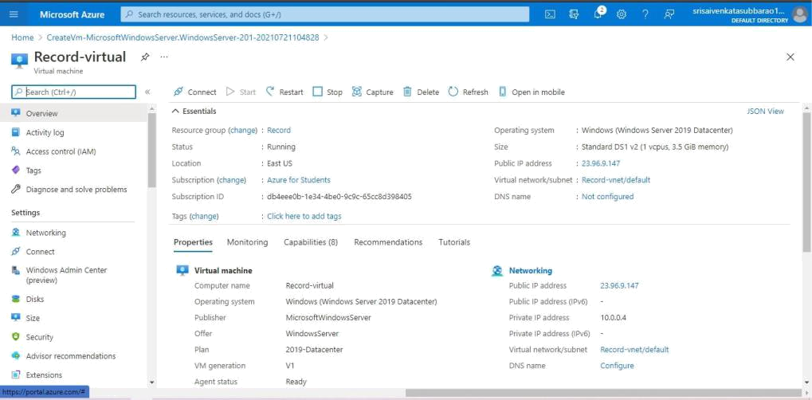

STEP8: CREATED A NEW WINDOWS VIRTUAL MACHINE.
