Name:-Sharan.B
Register no:-192210486

EXP20.CREATE A SQL STORAGE SERVICE AND PERFORM A BASIC QUERY USINGANY PUBLIC CLOUD SERVICE PROVIDER (AZURE/GCP/AWS) TO DEMONSTRATE DATABASE AS A SERVICE (DAAS)

AIM: CREATE A SQL STORAGE SERVICE AND PERFORM A BASIC QUERY USINGANY PUBLIC CLOUD SERVICE PROVIDER (AZURE/GCP/AWS) TO DEMONSTRATE DATABASE AS A SERVICE (DAAS)

PROCEDURE:

STEP1: GOTO AZURE AND GOTO SQLDATABASE.

STEP 02: Now Create a Sql Databse

STEP3: SELECT THE RESOURCE GROUP AND ENTER THE SERVERNAMETHAT APPLICABLE.

STEP4: IN NETWORKING SELECT ALLOW AZURE SERVICES AND RESOURCES TO ACCESS THIS SERVER.

STEP5: IN ADDITIONAL SETTINGS SELECT SAMPLE.

STEP6:AND THE SQL DATABASE IS DEPLOYED

TEP7: NOW GOTO QUERY EDITOR.

STEP8:NOWAGAIN LOGIN TO THE SQLDATADATABASE

STEP9: OUR TABLES WILL SHOWN AND TYPE THE QUERY TO EXCUTED.

IMPLEMENTATION:

STEP1: GOTO AZURE AND GOTO SQLDATABASE.
STEP 02:- Now Create a Sql Databse
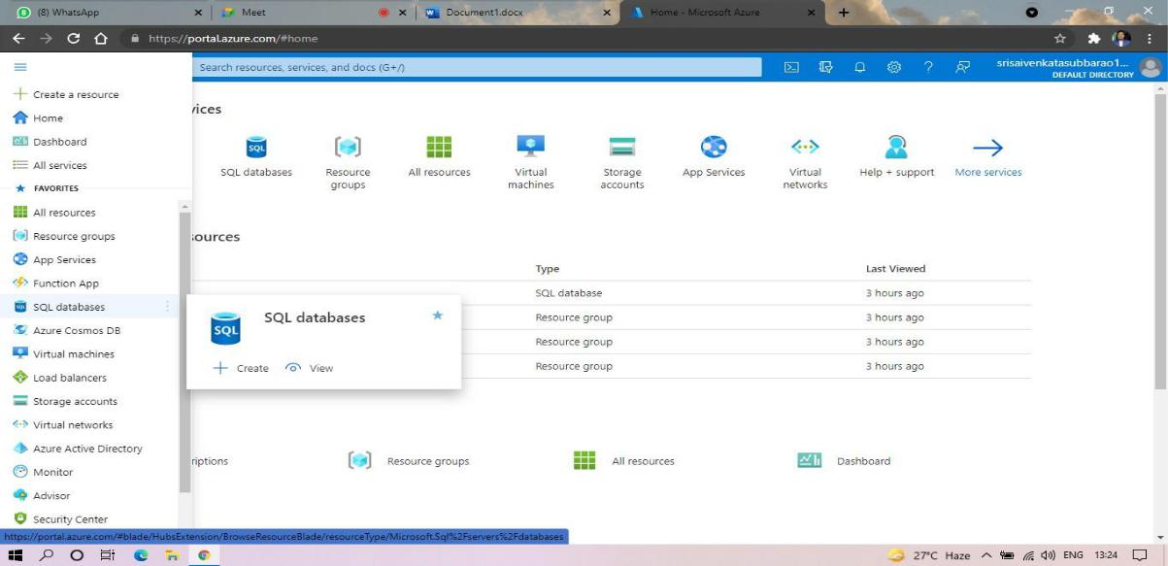
STEP3: SELECT THE RESOURCE GROUP AND ENTER THE SERVERNAMETHAT APPLICABLE.
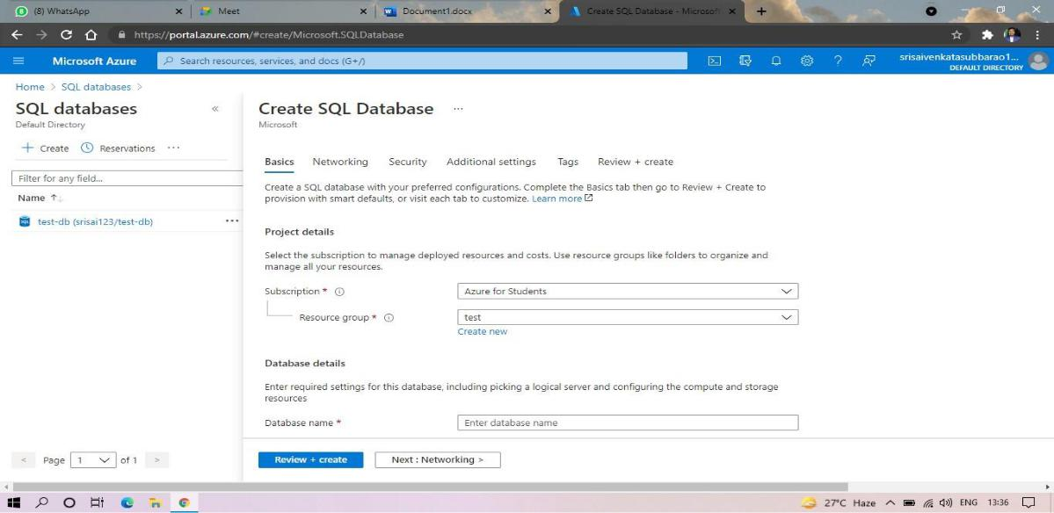

STEP4: IN NETWORKING SELECT ALLOW AZURE SERVICES AND RESOURCES TO ACCESS THIS SERVER.
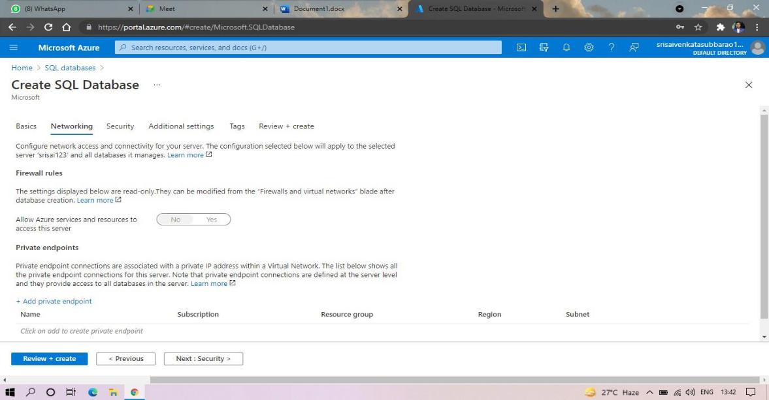

STEP5: IN ADDITIONAL SETTINGS SELECT SAMPLE.



STEP6:AND THE SQL DATABASE IS DEPLOYED.
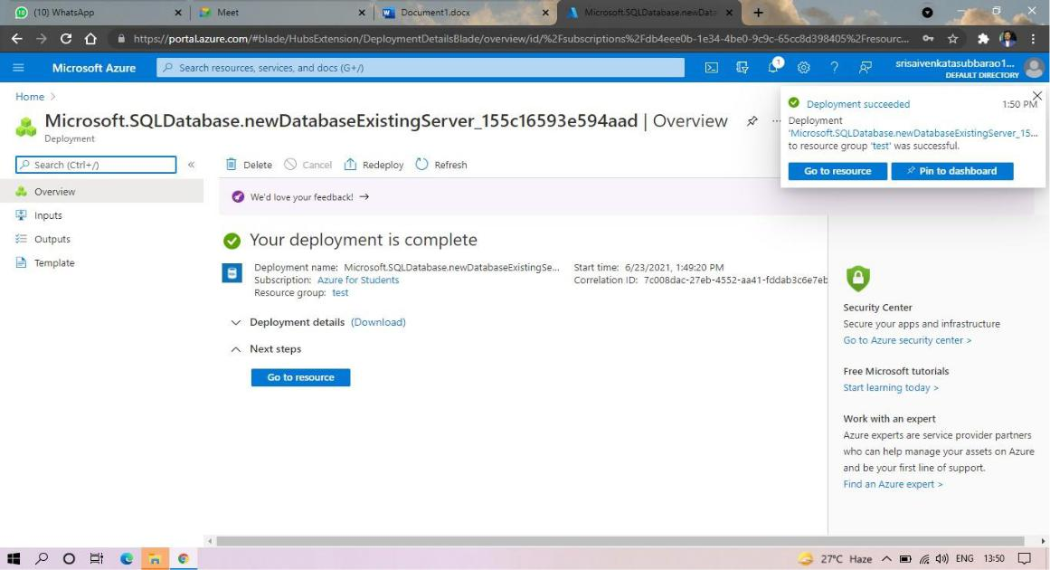
STEP7:AND NOW GOTO QUERY EDITOR.
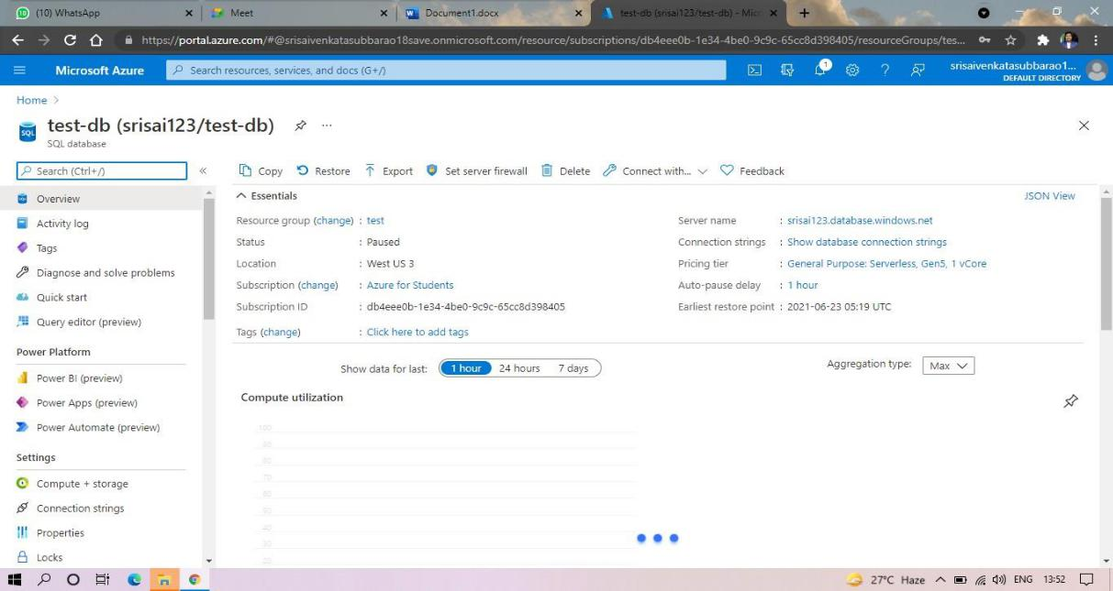

STEP8:AND NOW AGAIN LOGIN TO THE SQLDATADATABASE
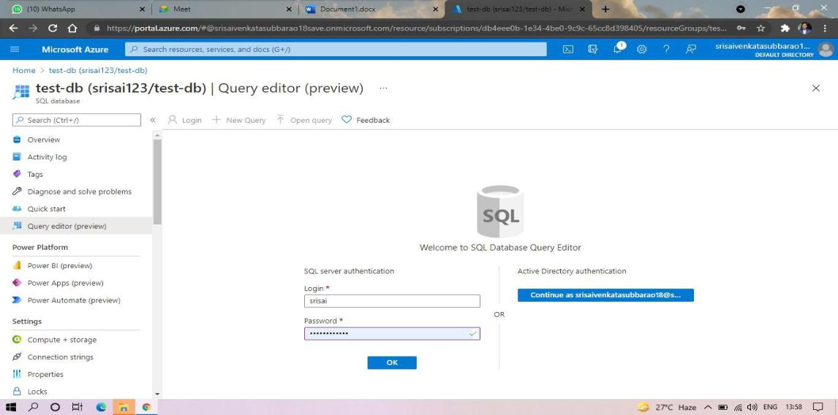
STEP9: AND OUR TABLES WILL SHOWN AND TYPE THE QUERY TOEXCUTED.
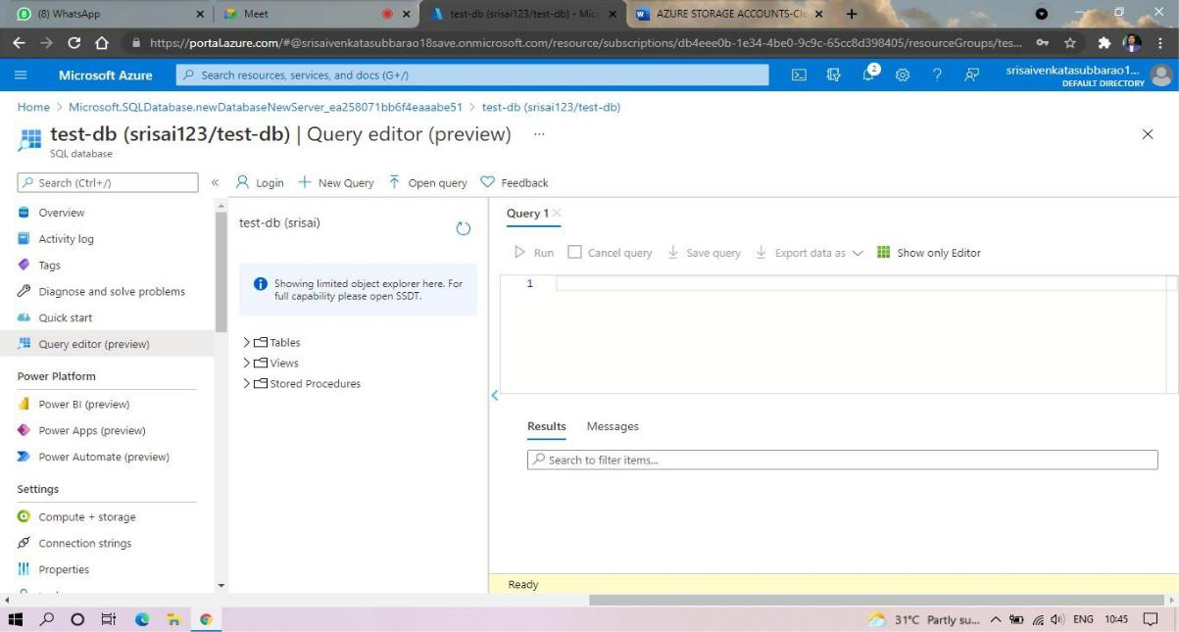

STEP10: AND OUR OUTPUT IS READY.

