Name:-Sharan.B
Register no:-192210486

EXP NO 1: CREATE A SIMPLE CLOUD SOFTWARE APPLICATION AND PROVIDE IT AS A SERVICE USING ANY CLOUD SERVICE PROVIDER TO DEMONSTRATE SOFTWARE AS A SERVICE (SAAS).

DATE:

AIM:

To create a simple cloud software application and provide it as a service using any cloud service provider to demonstrate software as a service (saas).

PROCEDURE:

STEP1: GOTO ZOHO.COM

STEP 2: LOGIN TO THE ZOHO.COM

STEP 3: SELECT ONE APPLICATION

STEP 4: ENTER APPLICATION NAME

STEP 5: CREATED NEW APPLICATION

STEP 6: SELECT ONE FORM

STEP 7: THE SOFTWARE HASE BEEN CREATED.

IMPLEMENTATION:

STEP1: GOTO ZOHO.COM

STEP 2: LOGINTOTHE ZOHO.COM
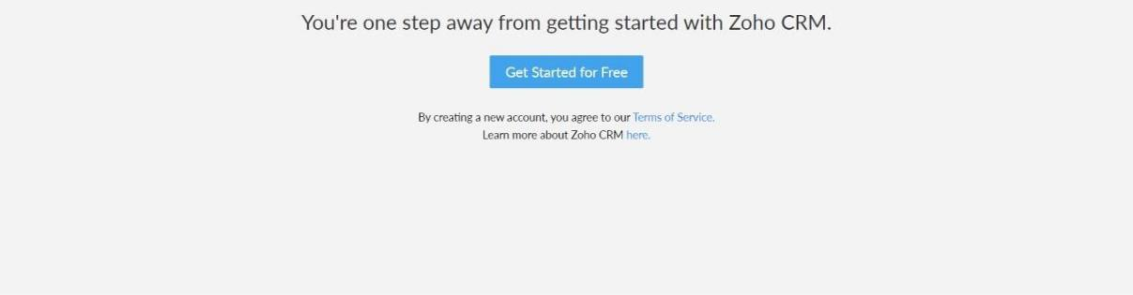

STEP 3: SELECT ONE APPLICATION
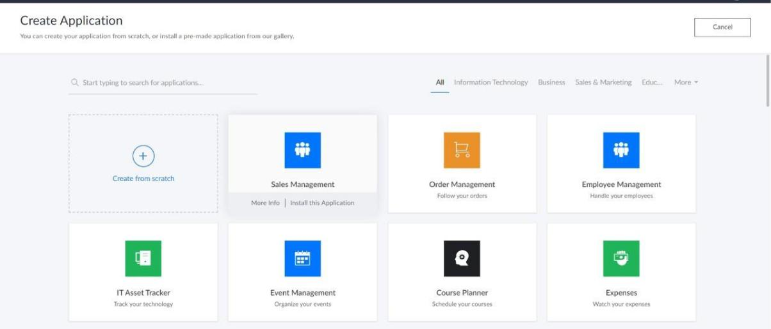

STEP 4: ENTER APPLICATION NAME
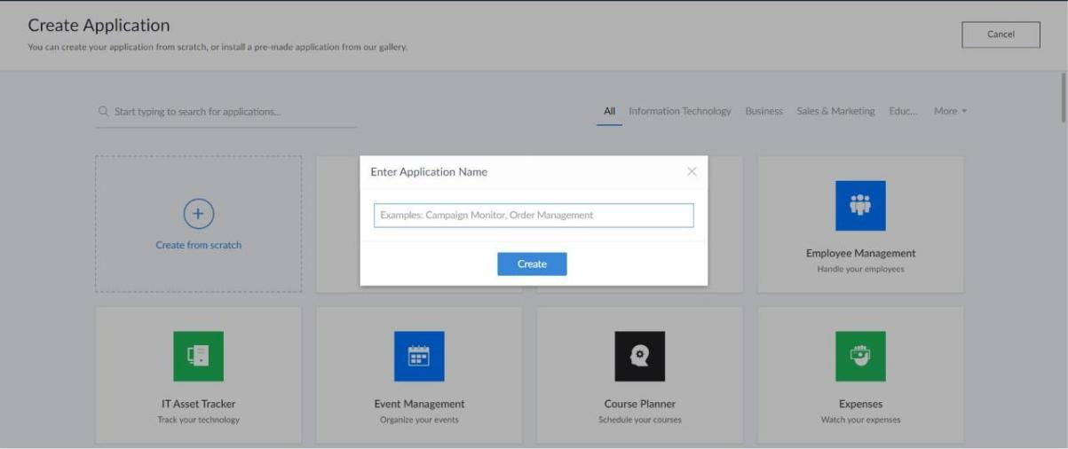
STEP 5: CREATED NEW APPLICATION
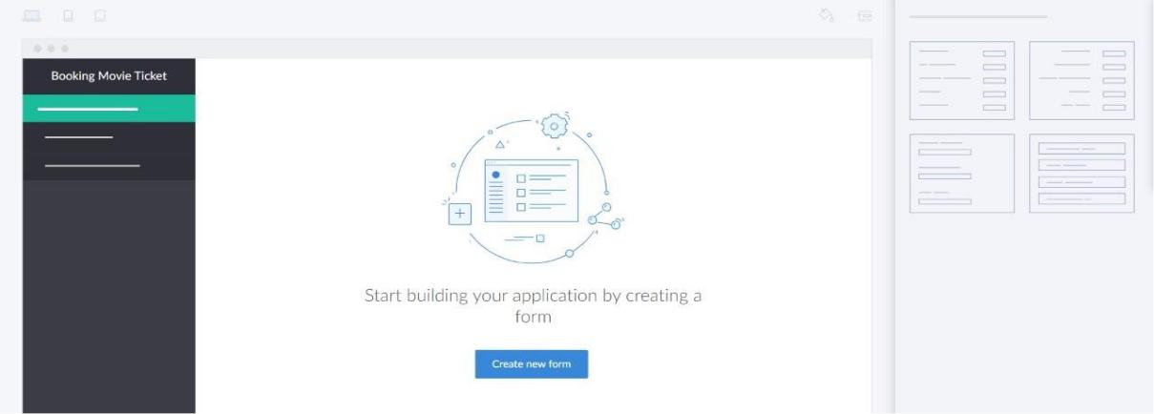

STEP 6: SELECT ONE FORM

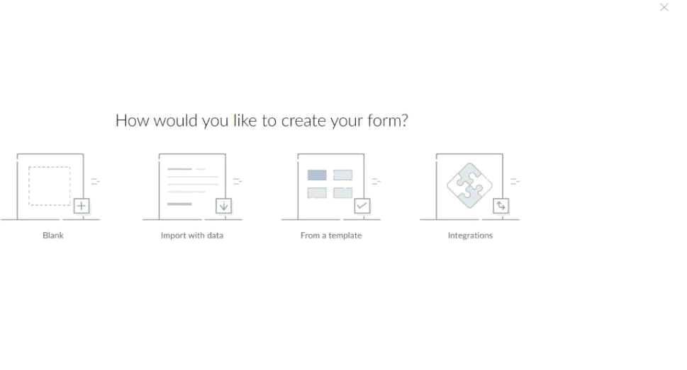

STEP 7: THE SOFTWARE HASE BEEN CREATED.
