Name:-Sharan.B
Register no:-192210486

EXP NO 2: CREATE A SIMPLE CLOUD SOFTWARE APPLICATION FOR FLIGHT RESERVATION SYSTEM USING ANY CLOUD SERVICE PROVIDER TO DEMONSTRATE SAAS.

DATE:

AIM:

To create a simple cloud software application for flight reservation system using any cloud service provider to demonstrate saas.

PROCEDURE:

step1: Go to zoho.com.

step 2: Log into the zoho.com.

step 3: Select one application step.

step4: Enter application name as flight reservation system.

step 5: Created new application flight reservation system.

step 6: Select one form

step 7: The software has been created.

IMPLEMENTATION:

STEP1: GOTO ZOHO.COM

STEP 2: LOGINTOTHE ZOHO.COM
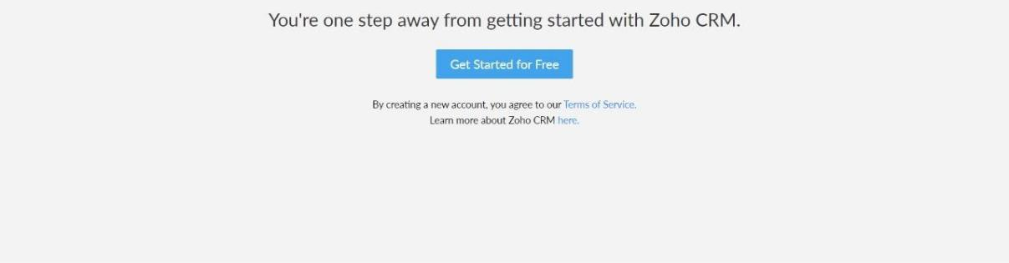

STEP 3: SELECT ONE APPLICATION
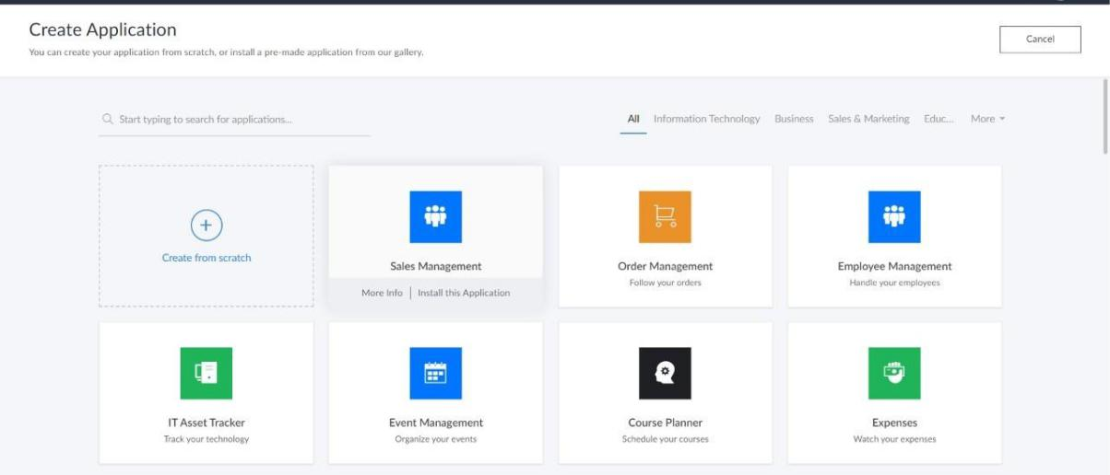

STEP 4: ENTER APPLICATION NAME
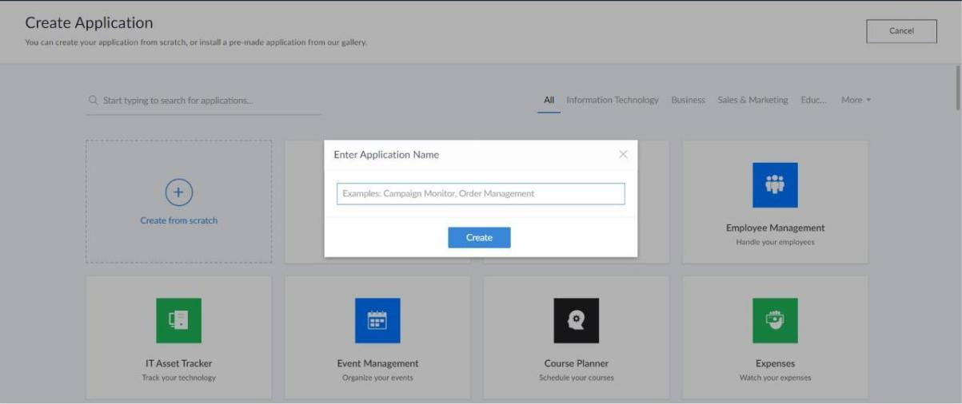
STEP 5: CREATED NEW APPLICATION
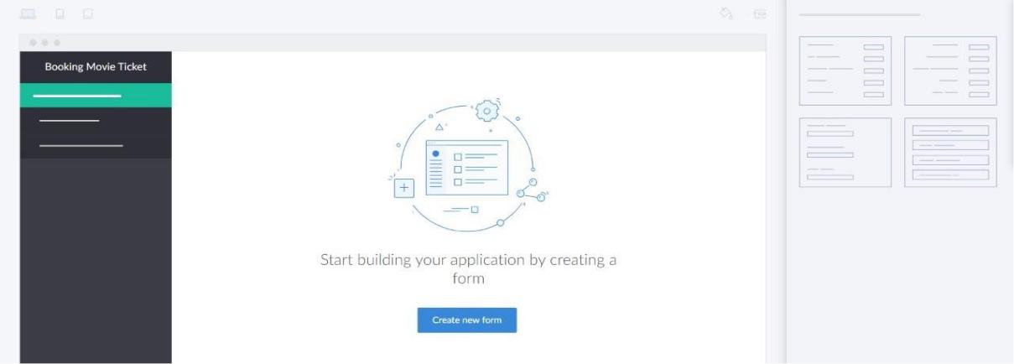

STEP 6: SELECT ONE FORM

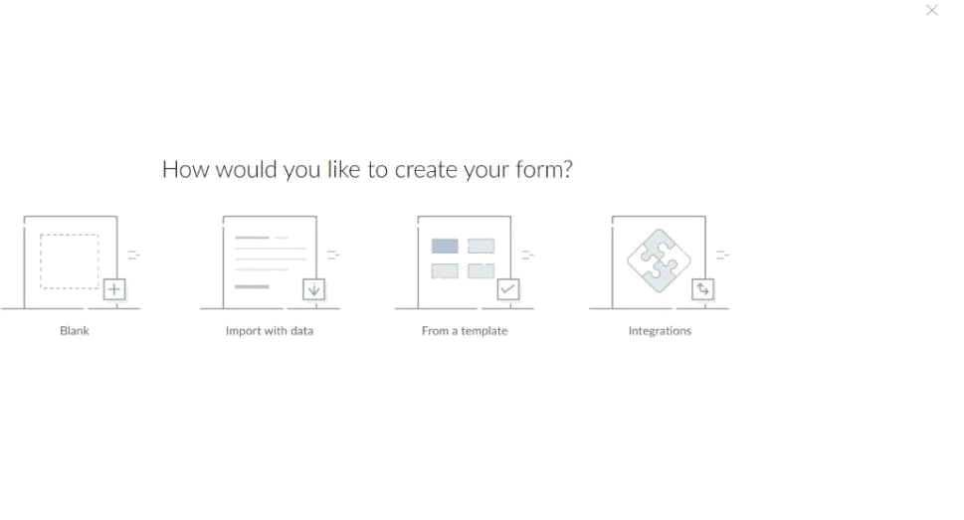

STEP 7: THE SOFTWARE HASE BEEN CREATED.
