Name:-Sharan.B
Register no:-192210486

EXP NO 5: CREATE A SIMPLE CLOUD SOFTWARE APPLICATION FOR LIBRARY BOOK RESERVATION SYSTEM FOR SIMATS LIBRARY USING ANY CLOUD SERVICE PROVIDER TO DEMONSTRATE SAAS

DATE:

AIM:

To Create a simple cloud software application for Library book reservation system for SIMATS library using any Cloud Service Provider to demonstrate SaaS

PROCEDURE:

step1: Go to zoho.com.

step 2: Log into the zoho.com.

step 3: Select one application step.

step4: Enter application name as library book reservation system.

step 5: Created new application as library book reservation system.

step 6: Select one form

step 7: The software has been created.

IMPLEMENTATION:

STEP1: GOTO ZOHO.COM
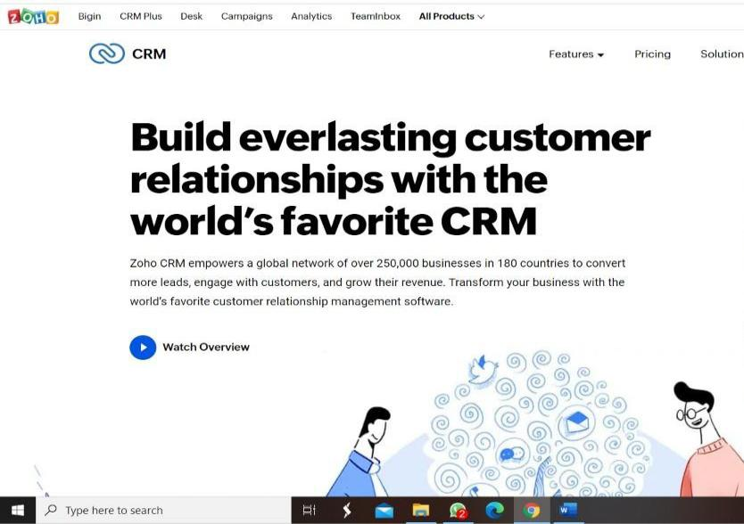
STEP 2: LOGIN TO THE ZOHO.COM
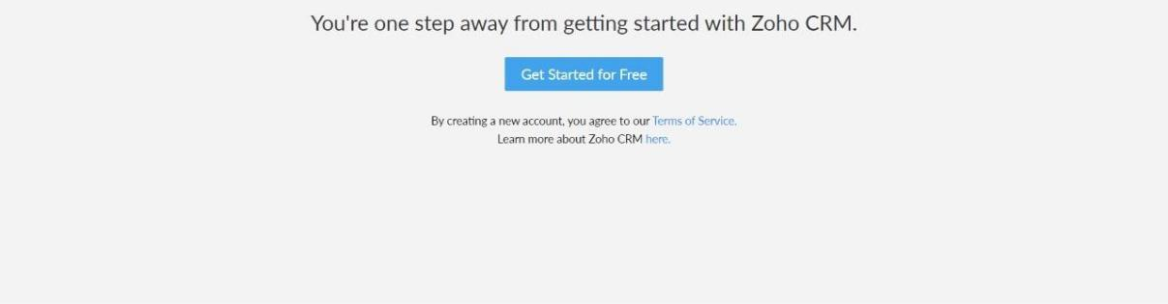

STEP 3: SELECT ONE APPLICATION
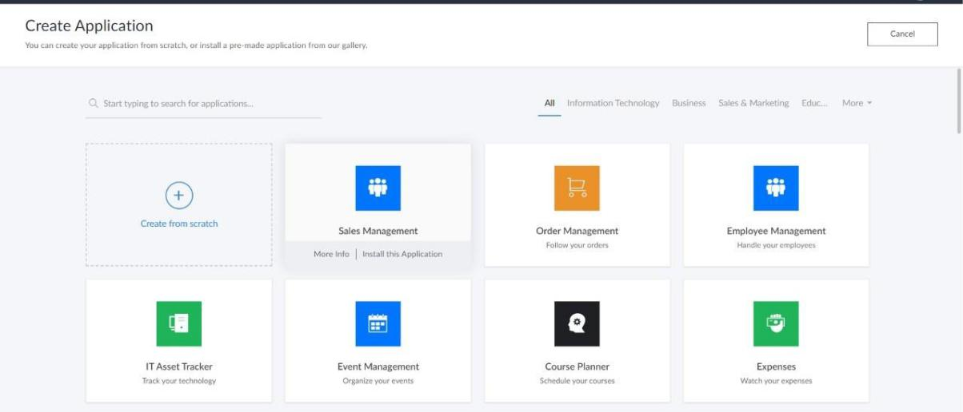

STEP 4: ENTER APPLICATION NAME
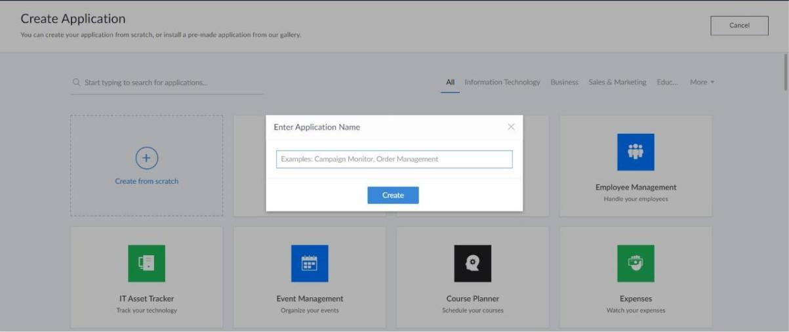
STEP 5: CREATED NEW APPLICATION
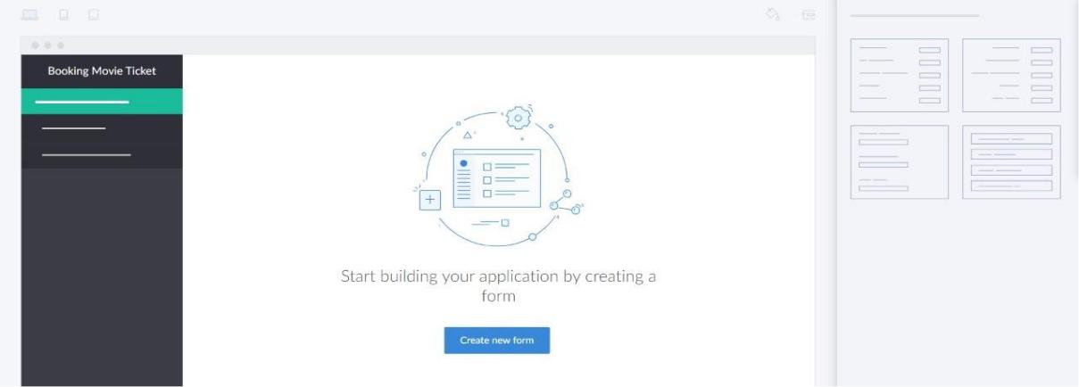

STEP 6: SELECT ONE FORM

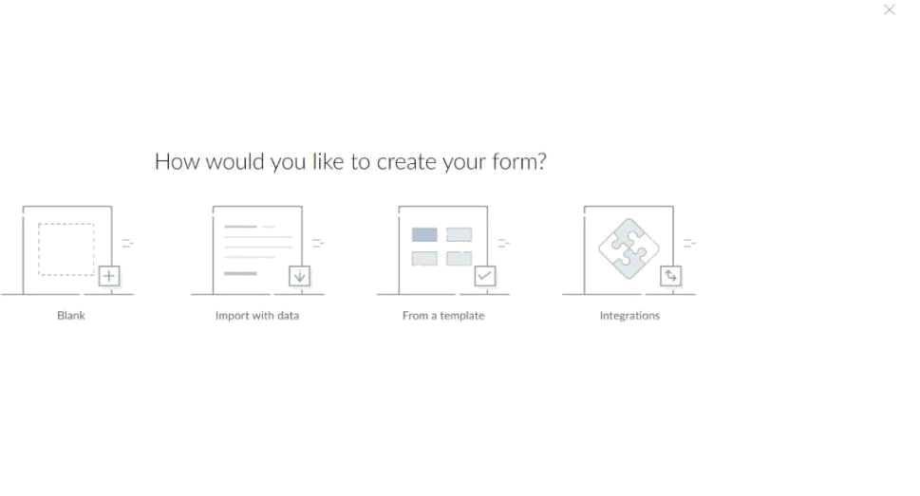

STEP 7: THE SOFTWARE HASE BEEN CREATED.
