Name:-Sharan.B
Register no:-192210486

EXP NO 7: DEMONSTRATE VIRTUALIZATION BY INSTALLING TYPE-2 HYPERVISOR IN YOUR DEVICE, CREATE AND CONFIGURE VM IMAGE WITH A HOST OPERATING SYSTEM (EITHER WINDOWS/LINUX).

DATE:

AIM:

To demonstrate virtualization by installing type-2 hypervisor in your device, create and configure VM image with a host operating system (either windows/linux).

PROCEDURE:

STEP 1:Dowload VMware workstation and installed as type 2hypervisor.

STEP2:Dowload ubuntu or tiny OS as iso image file.

STEP 3: In VMware workstation->create new VM.

STEP 4: Do the basic configuration settings.

STEP 5: Created tiny OS virtual machine.

STEP 6: Launch the VM.

IMPLEMENTATION:

STEP 1:DOWLOAD VMWARE WORKSTATION AND INSTALLED AS TYPE 2HYPERVISOR
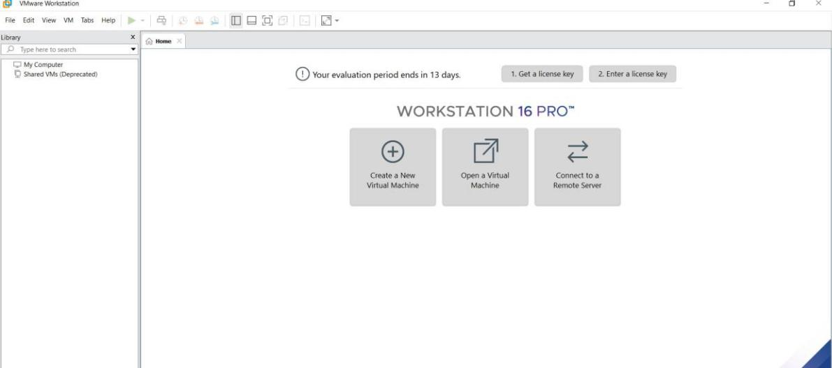
STEP2: DOWLOAD UBUNTU OR TINY OS AS ISO IMAGE FILE
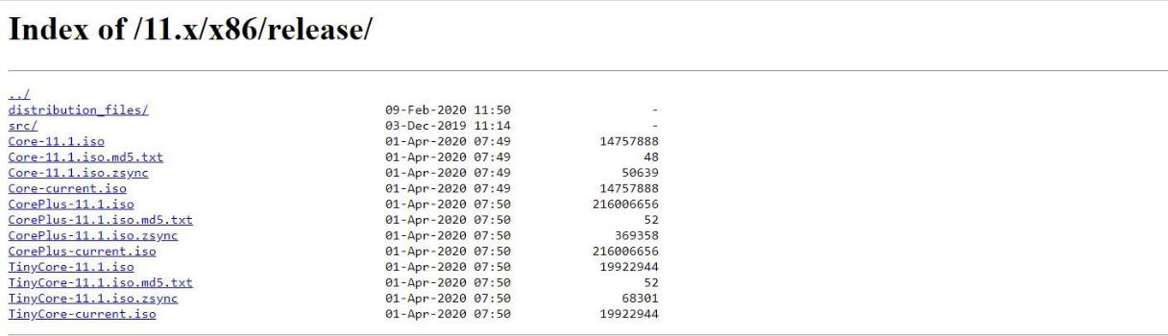

STEP 3: IN VMWARE WORKSTATION->CREATE NEW VM
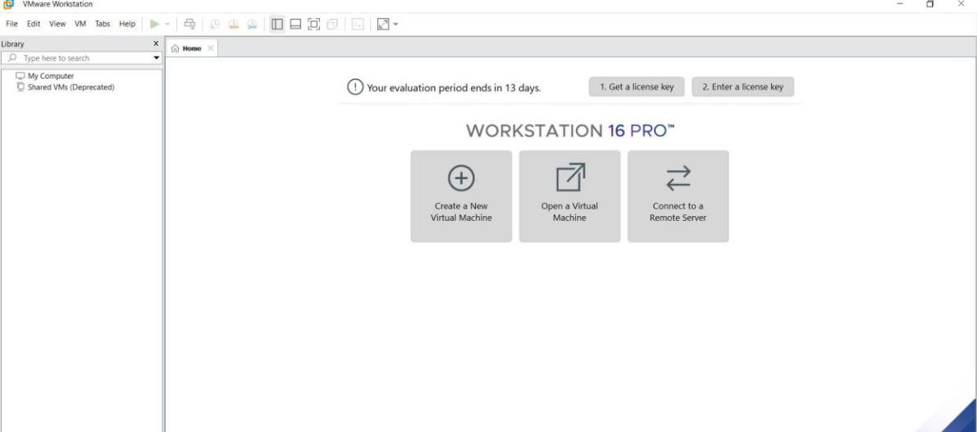

STEP 4: DO THE BASIC CONFIGURATION SETTINGS.
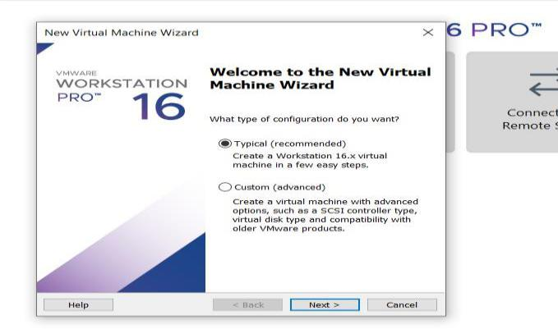
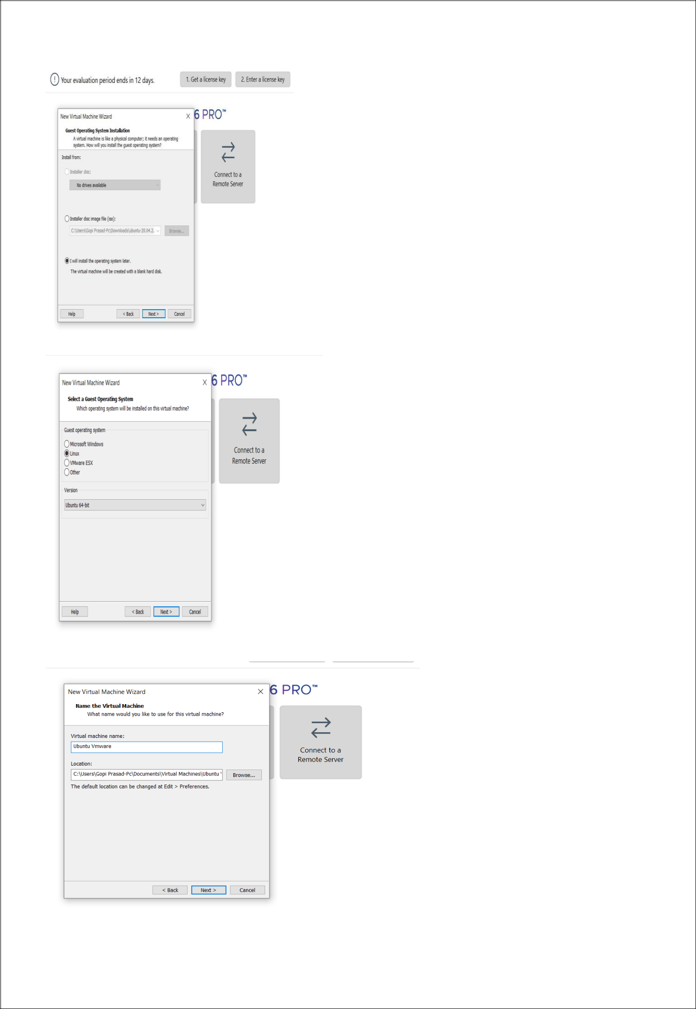
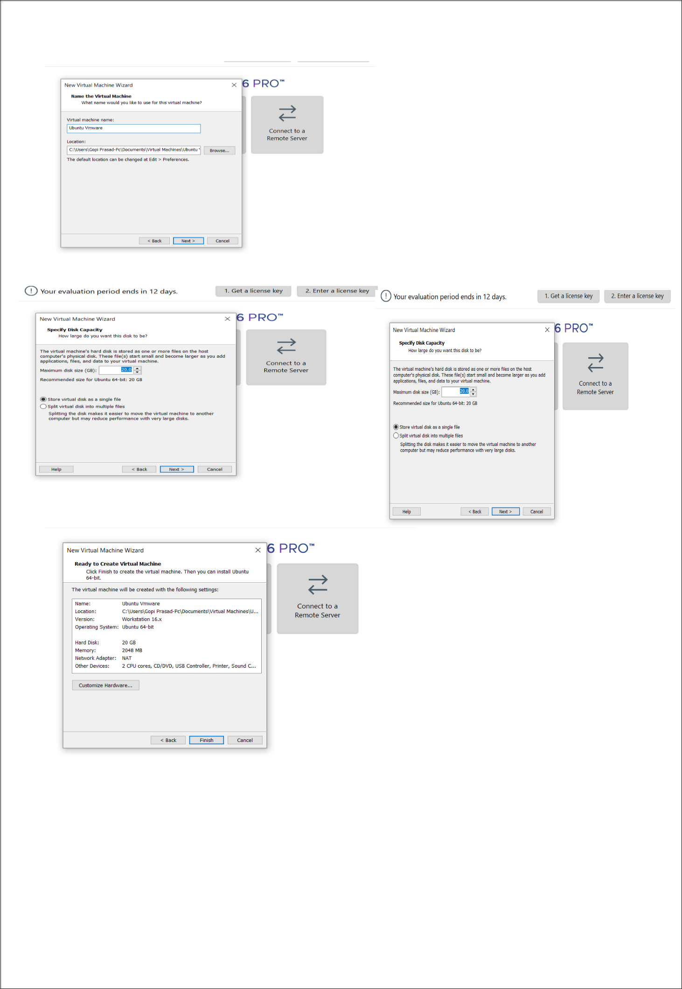

STEP 5: CREATED TINYOS VIRTUAL MACHINE
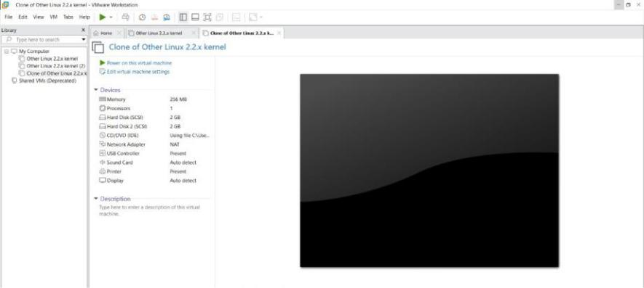

STEP 6: LAUNCH THE VM
