<!DOCTYPE html>

<html lang="en">

<head>

<meta charset="UTF-8">

<title>ctt1</title>

</head>

<body>

<b>&lt&ltSympathy for the peasants&gt&gt</b>

<p>Hoeing millet in mid-day heat,</p>

<p>Sweat dripping to the earth beneaht,</p>

<p>Do you know the food on your plate,</p>

<P>Each grain was hard-earned.</P>

<br />

<br />

<b>&lt&ltA Tranquil Night&gt&gt</b>

<p>Before my bed a pool of light,</p>

<p>Is it hoarfrost up on the ground?</p>

<p>Eyes raised,I see the moon so bright,</p>

<P>Head bent,in homesickness I'm drowned.</P>

</body>

</html>

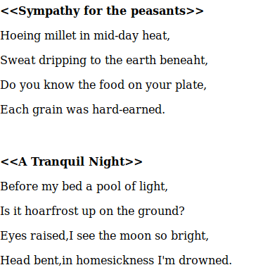

结果：